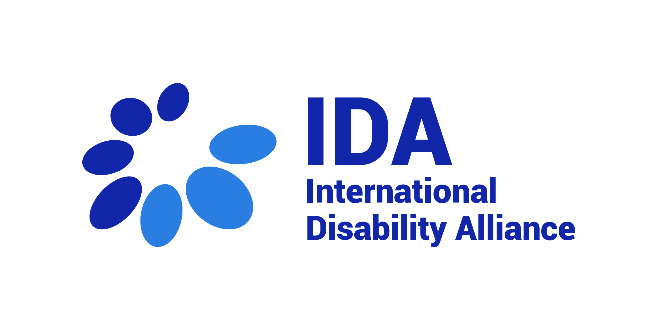
Application Package
WeThe15 Campaign Manager

- Job Advertisement

IDA is seeking a Campaign Manager
- Position Start Date: June 2022
- Location: Flexible
- Gross Monthly Salary: Subject to location and experience
- Contract duration: 1 Year with the possibility of extension
- Employment: Full-time

Background

The International Disability Alliance (IDA) is an alliance of eight global and six regional organizations of persons with disabilities. We advocate at the UN for a more inclusive global environment for persons with disabilities and their organizations. The Convention on the Rights of Persons with Disabilities (CRPD) is our touchstone. We are invested in ensuring that the 2030 Agenda and the Sustainable Development Goals are inclusive and in line with CRPD.

IDA supports organizations of persons with disabilities worldwide to take part in UN and international human rights processes and use international accountability mechanisms. With member organizations globally, IDA represents the estimated one billion people worldwide with disabilities.

On 19 August 2021, IDA, the International Paralympic Committee together with international partners launched the #WeThe15 campaign. The first part of the campaign ran until 5 September 2021 and this 10-year campaign aims to be the biggest ever human rights movement to end discrimination against persons with disabilities and transform the lives of 1.2 billion people.

#WeThe15 brought together a large coalition of international organizations from the world of sport, human rights, policy, business, culture, and entertainment to initiate change for the world’s largest marginalized group.

The WeThe15 Campaign Manager will help to develop and manage WeThe15, often in creative ways and under deadline.

Mission

This is a rare and exciting opportunity to support and enhance the public positioning of the most exciting organization which aims to make persons with disabilities, who make up 15% of the world's population, visible and included.

The WeThe15 Campaign is co-led by the International Paralympic Committee and the International Disability Alliance (IDA). As WeThe15 Campaign Manager you will co-develop and co-implement a campaign strategy, engaging content and develop strategic partnerships. Working under the direction of IDA’s Executive Director, this role is focussed on securing high-profile, positive publicity and media coverage by delivering specialist experiential, multi-channel campaigns to support organisational priorities.

Utilising advanced marketing, journalistic and creative skills and experience to build relationships with new audiences, you will work on campaigns and day-to-day engagement activity including media, communications, social media and marketing initiatives.

You will also support the wider communications and engagement and other departments in all aspects of public engagement; facilitating the development of public relations plans that are informed by a robust understanding of the organisations’ priority external audiences.

- Working Environment
Reports to: Executive Director
Staffs under supervision: none

Main Interfaces:
Main Internal Interfaces
- Senior Communication Manager, Advocacy Unit, IDA Secretariat staff.
Main External Interfaces
- The Head of Brand and Engagement at the IPC
- Job Description

The WeThe15 Campaign Manager will undertake the following duties and tasks in close coordination with the WeThe15 Campaign Manager at IPC:
- Identify campaign priorities and objectives for WeThe15
- Develop campaign strategies, including identifying key targets, audiences, and tactics for effective narratives to engage and influence them
- Help to develop and implement content plans for their digital channels
- Test and update the campaign content, messages, stories, copy and materials
- Follow up on the implementation and further refinement of narratives and strategic messaging to motivate more people and help achieve change
- Co-administer the WeThe15 website and manage the WeThe15 digital communities
- Write, edit, and proofread copy for promotional materials including news articles, press releases, newsletters and more
- Co-ordinate communication activities with the WeThe15 and IDA teams to ensure they are fully informed and supportive of ongoing work
- Liaise with external agencies supporting WeThe15 to devise and implement integrated campaigns that raise the profile of both while engaging global audiences
- Liaise with broadcasters and other media outlets to build awareness and engagement around WeThe15
- Keep abreast of currents campaign trends

- Employment specifications

We are looking for a candidate with relevant experience in creating and implementing marketing campaigns and press work.

- Essential requirements
- Bachelor's degree in Communications, Journalism, Public Relations and/or a relevant field
- Five years' experience in PR, campaigns, digital media, or journalism
- Have a basic knowledge and strong commitment to advance the rights of persons with disabilities
- Excellent level of written and spoken English, with news-writing skills, drafting, and editing skills.
- Excellent attention to detail, strong organisational skills and a proven ability to multi-task and meet deadlines
- An ability to feel comfortable working in a fast-paced, multi-cultural environment and an aptitude to operate with limited supervision
- Be a self-starter, with a track record for developing and maintaining partnerships and working relationships
- A strong sense of diplomacy, and interpersonal communication
- Possess a good knowledge of Microsoft Office and Adobe Suite applications
- Substantive knowledge of social platforms, viral communities, web and digital tools
- Understanding of accessible communications and information requirements
- Understanding of development and human rights

- Desirable requirements
- Knowledge of the UN Convention on the Rights of Persons with Disabilities (CRPD)
- Familiarity with IDA and WeThe15
- Comes with a very good international press list
- Proficiency in another UN language

Other considerations
- Daily access to high-speed internet
- Dynamism, sense of innovation, quick action and response solving eventualities
- Capacity to work under stressful situations, facing tight deadlines and high workloads
- Ability to work within a multi-cultural team in decentralized locations
- Willingness and ability to work occasionally at non-standard hours
- Persons with disabilities are highly encouraged to apply. Reasonable accommodation will be considered.
- Understanding and awareness of IDA safeguarding policies. IDA works in multi-cultural environments and with persons with disabilities, who experience higher rates of discrimination, violence and abuse. Therefore, we expect any staff, consultant or collaborator to understand and fully comply with IDA's Safeguarding policy and IDA’s Code of Conduct (available here: https://www.internationaldisabilityalliance.org/reporting-fraud-abuse). IDA will not tolerate any form of abuse, violence, fraud, corruption, or any breach of IDA policies.

- Application Form

- Confidential. All information given on the application will be treated in a confidential manner.
- Persons with disabilities are strongly encouraged to apply.

How to apply:

- Please send the completed application form below by email to recruitment@ida-secretariat.org, indicating in the subject line: “Job Application: WeThe15 Campaign Manager”, before the 25th of May 2022, 6 pm CEST, 2022.
- Please share your expected gross annual salary in your email.

Please ensure you respect the following:
- Please complete the form in type only.
- Only completed application form will be accepted.
- We kindly ask candidates not to attach a separate CV or motivation letter to the application.
- Please remember to take the time zone into consideration when submitting your application. Any applications received after the closing date will not be considered.

Application process:
- After receiving your application, a confirmation of receipt will be sent to you via email. Should you not receive a confirmation, please contact the IDA Secretariat by email.
- Please be advised that only shortlisted applicants will be informed about the next steps of selection process.
- Please note that a selection process may last several months. No information will be released during this period.

1. PERSONAL DETAILS
First name:
Surname:
Home address (Country):
Telephone (cellular):
E-mail:

2. HIGHER EDUCATION

Name and address of college/university | From/to | Full/part - time | Qualifications obtained

3. PRESENT AND PREVIOUS OCCUPATIONS. Please give details of your occupation(s) starting with the most recent. Include any unpaid work that is relevant to the post and explain any gaps.

Employer's name and address (please start with current/ most recent) | From/to  (month/year) | Position held including brief description of your duties

- TRAINING AND DEVELOPMENT. Please give details of any training courses attended that are of direct relevance to your application.

- MEMBERSHIP TO TECHNICAL OR PROFESSIONAL BODIES

- Language skills, including Sign Language
6.1 Reading skills

Language | Excellent | Very good | Good | Basic

6.2. Writing skills

Language | Excellent | Very good | Good | Basic

6.3. Verbal skills/International sign

Language | Excellent | Very good | Good | Basic

7. Computer literacy
Please indicate your computer knowledge stating all the software programmes you are familiar with.

8. Please explain how you meet the requirements of the employment specifications and provide any further information about yourself that you think is relevant to this application.
(NOTE: This section of the application is one of the most important and will be considered as your motivation letter for the position)

9. SUPPLEMENTARY INFORMATION
What is your preferred reading medium? Please select:
Ordinary print/digital format

10. If you were shortlisted for interview, would you have any special requirements such as timing, wheelchair access or the presence of an interpreter or signer? Please specify.

11. Have you ever been convicted of a criminal offence? Please select:
Yes / No

12. Offers of employment/contracts are subject to receipt of satisfactory references. Please provide the names, addresses and telephone numbers of two referees, one of whom should be your present or most recent employer or an academic referee if more appropriate. Referees will not be contacted without your prior permission.
A. Name:
Position: ……………………………………………………………………………….
Address:
Telephone number……………………………………………………………………………………………….
e-mail:
What is your connection with this referee?...............................................................
May we approach this referee prior to interview?

B. Name:
Position: ……………………………………………………………………………….
Address:
Telephone number……………………………………………………………………………………………….
e-mail:
What is your connection with this referee?...............................................................
May we approach this referee prior to interview?

13. Reasonable accommodation for persons with disabilities
The IDA secretariat will make reasonable accommodations needed for the incumbent to carry out their work, to be arranged in discussion with the incumbent.

IDA is an equal opportunity organisation that does not discriminate in its recruitment programme and, in order to have the strongest possible team, actively seeks a diverse applicant pool. Private data communicated during the application process or administration of the programme will be kept confidential.

DECLARATION

I declare that the information provided on this form is correct to the best of my knowledge and understand that any information submitted in connection with employment and subsequently found to be incorrect or deliberately misleading could lead to dismissal without notice.

Signed Date

