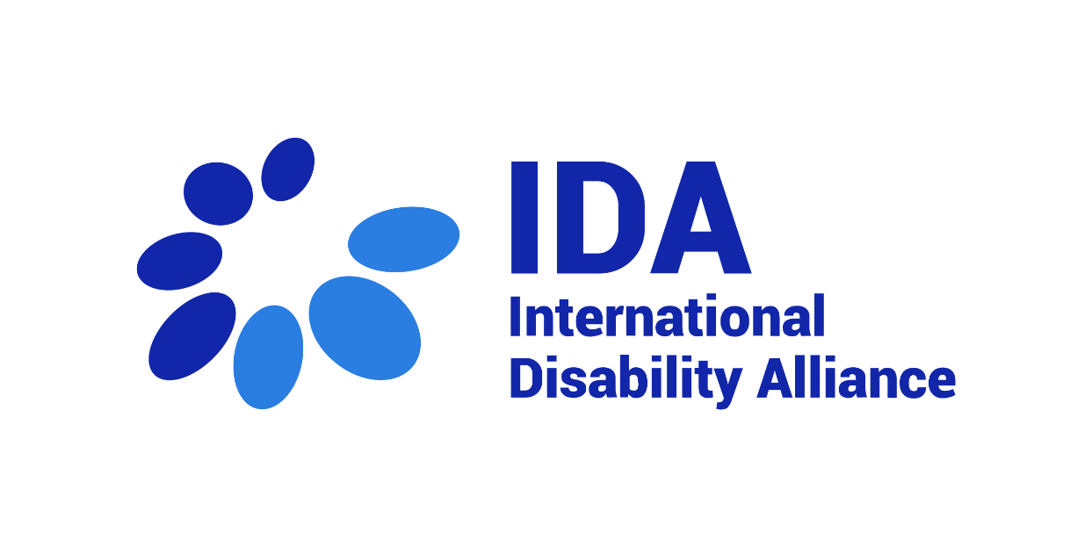

IDA’s Compilation of CRPD Committee’s Concluding Observations

Article 22 CRPD
(Respect for privacy)

October 2022

Article 22 – Right for privacy

1. No person with disabilities, regardless of place of residence or living arrangements, shall be subjected to arbitrary or unlawful interference with his or her privacy, family, or correspondence or other types of communication or to unlawful attacks on his or her honour and reputation. Persons with disabilities have the right to the protection of the law against such interference or attacks.
2. States Parties shall protect the privacy of personal, health and rehabilitation information of persons with disabilities on an equal basis with others.

China
Japan
Lao People's Democratic Republic
Republic of Korea
Singapore
Switzerland
France
India
Spain
Latvia
Armenia
Uganda
Denmark

Please note there are no recommendations in the Concluding Observations on art. 22 on New Zealand, Djibouti, Estonia, Cuba, Niger, Norway, Rwanda, Saudi Arabia, Senegal, Turkey, Vanuatu, The Former Yugoslav Republic of Macedonia, South Africa, Poland, Philippines, Malta, Bulgaria, Algeria, Haiti, Nepal, Oman, Russian Federation, Seychelles, Slovenia, Sudan, Luxembourg, Montenegro, Morocco, Panama, United Kingdom of Great Britain and Northern Ireland, Bosnia and Herzegovina, Canada, Cyprus, Honduras, Iran (Islamic Republic of), Jordan, Republic of Moldova, Bolivia, Colombia, Ethiopia, Guatemala, Italy, United Arab Emirates, Uruguay, Chile, Lithuania, Portugal, Serbia, Slovakia, Thailand, Brazil, European Union, Gabon, Kenya, Mauritius, Qatar, Ukraine, Cook Islands, Croatia, Czech Republic, Dominican Republic, Germany, Mongolia, Turkmenistan, Belgium, Ecuador, Mexico, New Zealand, Republic of Korea, Sweden, Azerbaijan, Costa Rica, Australia, Austria, El Salvador, Paraguay, Argentina, China, Hungary, Peru, Spain, Tunisia, Hungary, Jamaica, Mexico, Venezuela, Bangladesh, Indonesia and New Zealand.

China
46. The Committee is concerned about the insufficient information provided on measures taken to protect persons with disabilities from arbitrary or unlawful interference with their privacy, to protect the privacy of personal data and records of persons with disabilities from arbitrary or unlawful interference, including in the registration system of persons with “mental disorders”, and on the available remedies in case of violation of the right to privacy.
47. The Committee recommends that the State party ensure that the privacy of personal data of persons with disabilities is comprehensively protected by data protection laws across the State party, including a right of action and access to a remedy.

Japan
47. The Committee is concerned that information about persons with disabilities may be collected without neither their consent nor reasonable purpose by service providers within private and public sectors, and that confidentiality and the protection of privacy of persons with disabilities are not fully ensured by existing legislation, including the My Number Act and the Act on the Protection of Personal Information.
48. The Committee recommends that the State party strengthen its legislation on data protection for persons with disabilities by ensuring that it is processed either on the basis of the personal, free and informed consent of the data subject or other legitimate non- discriminatory basis laid down by law, and that it is collected for explicit, specified and legitimate purposes and not processed in a way incompatible with those purposes, that it is processed lawfully, fairly and in a transparent manner, and that the data subject has a right to an effective remedy.

Lao People's Democratic Republic
40. The Committee is concerned about the lack of information in the State party on progress made as regards the protection of the right to privacy of persons with disabilities.
41. The Committee recommends that the State party ensure the privacy of persons with disabilities, in particular persons with intellectual and/or psychosocial disabilities, including the confidentiality of information and of their personal medical records, in institutions and mental health systems and services.

Republic of Korea
The Committee observes with concern that in order to prevent disappearances GPS tracking devices are being issued to autistic persons, persons with intellectual and/or psychosocial disabilities without their free and informed consent, violating their right to privacy.
46. The Committee recommends that the State party:
(a) Take measures to respect the privacy of persons with disabilities, in particular autistic persons, persons with intellectual disabilities, persons with psychosocial disabilities, neurodivergent persons, and to ensure that GPS tracking devices are issued based on their consent;
(b) Take appropriate measures, including policies to prevent disappearances, which are in line with the Convention and the human rights model of disability.

Singapore
43. The Committee is concerned about the protection of data of persons with disabilities in the health care system, including in private practices, hospitals and institutions. It is also concerned about practices that require persons with disabilities to disclose their impairments in relationships with private entities such as employers and insurance providers.
44. The Committee recommends that the State party substantially strengthen its legislation on data protection for persons with disabilities, particularly in the health care system, by ensuring that it is processed either on the basis of the personal, free and informed consent of the data subject or some other legitimate non-discriminatory basis laid down by law, and that it is collected for explicit, specified and legitimate purposes and not processed in a way incompatible with those purposes, that it is processed without discrimination, lawfully, fairly and in a transparent manner, and that the data subject has a right to an effective remedy.

Switzerland
43. The Committee notes with concern:
(a) The unnecessarily large amount of personal data required from persons with disabilities who apply for social insurance and other entitlements;
(b) The lack of a right of action, given that the Disability Discrimination Act does not apply to services provided by cantons and municipalities.
44. The Committee recommends that the State party:
(a) Ensure, through legislation and policy at the federal and cantonal levels, that data collection is limited to data that are specifically relevant, that personal data are disclosed with the consent of the individual only, and that data protection covers the personal data of those living in institutions;
(b) Ensure that the privacy of the personal data of persons with disabilities is comprehensively protected by data protection laws across all cantons, including a right of action and access to remedy.

France
46. The Committee notes with concern provisions in the Decree 2019-412 of 2019 and the Decree 2018-383 of 23 2018, so-called HOPSYWEB hindering the protection of personal data particularly concerning persons with psychosocial disabilities relating them with high risk of radicalisation and terrorism, and reinforcing surveillance and control of their activities, in the areas of employment and public housing.
47. The Committee recommends that the State party repeal regulations and cease discriminatory data collection concerning persons with psychosocial disabilities, including in relating them with high risk of radicalisation and terrorism, and prevent the use of their personal data and their medical records without their consent or following the consent provided by third parties.

India
46. The Committee is concerned that persons with disabilities who are Aadhaar (unique identification number) holders have experienced interference in their privacy, with their personal data having been compromised.
47. The Committee recommends that the State party take measures to ensure that all identification processes guarantee individuals’ privacy, and enact legislation for the protection of the privacy of person with disabilities, particularly in their interaction with service providers or personnel providing support.

Spain
41. The Committee is concerned that the right to privacy of persons with intellectual or psychosocial disabilities is widely violated in institutions and mental health facilities, including by depriving persons of their personal belongings, and an inflexible and minimal regime of visits and contacts with people outside the facilities. The Committee is also concerned by reports of video surveillance cameras placed in the rooms of patients and leaks of confidential information about patients through the mental health care sector.
42. The Committee recommends that the State party implement effective measures to ensure the privacy of persons with intellectual or psychosocial disabilities in institutions and mental health systems and services including the confidentiality of information and of their personal medical records.

Latvia
36. The Committee is concerned about:
(a) The lack of safeguards in place to protect the privacy of persons with psychosocial and/or intellectual disabilities who are listed on the register of patients suffering from certain diseases and the consequent adverse impact of being so listed when accessing particular services or applying for jobs;
(b) The allegedly ineffective means of recourse to contest third-party access to the personal data of persons with intellectual and/or psychosocial disabilities that is collected by hospitals without the authorization of the individuals concerned;
(c) The practice of public officials demanding medical certificates as proof of disability and their consequent disregard of State-issued disability certificates.
37.The Committee recommends that the State party:
(a) Reinforce the protection of privacy, including personal data, in, among other places, psychiatric hospitals and institutions;
(b) Improve public officials’ awareness of a human rights-based approach to disability and sanction the reported practice of demanding medical certificates to prove disability.

Armenia
37. The Committee is concerned that children with disabilities are publicly displayed for medical or charity purposes.
38. The Committee recommends that the State party protect the privacy of all children with disabilities, in particular in relation to their personal, health, habilitation and rehabilitation status.

Uganda
44. The Committee is concerned about the lack of provision of sign language interpreters and information in accessible formats in the health and banking sectors.
45. The Committee recommends that the State party ensure the protection of personal data of persons with disabilities in protocols in the health and banking sectors.

Denmark
50. The Committee is concerned that psychiatric hospitals are allowed, under the Psychiatric Act, to transfer strictly private and confidential information to third parties without the consent of the person concerned.
51. The Committee recommends that the State party amend the Psychiatric Act so as to prohibit the transfer of the private and confidential information of patients in psychiatric hospitals to third parties without the consent of the person concerned, in order to comply with the principle of respect for privacy.

