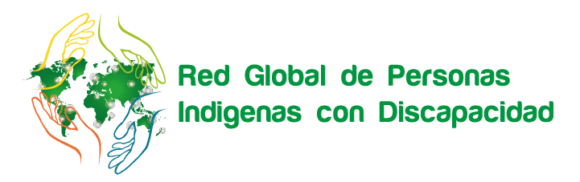
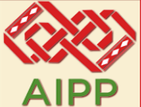
Indigenous Persons with Disabilities Global Network
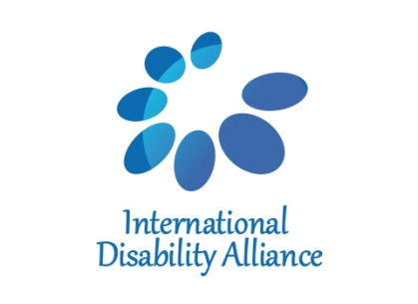

Technical Workshop on ensuring the rights of Indigenous Persons with Disabilities in line with the UNCRPD,
in connection with the UNDRIP and the Agenda 2030
ChaingMai, Thiland
7-9 June, 2018

Final report

“We will include disability policy in indigenous framework and AIPP, include our partners and members organizations to follow this strategy so that we all can be disability sensitive”
Gam Shimrey
General Secretary, Asia Indigenous Peoples Pact

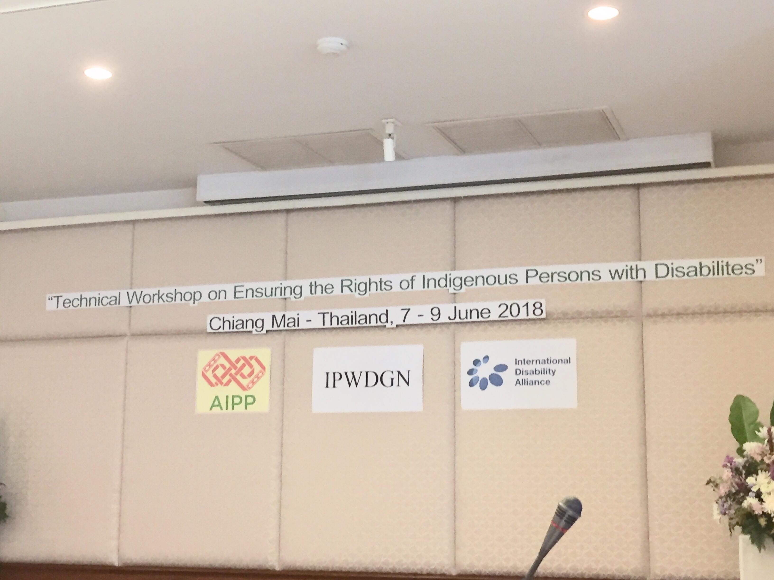
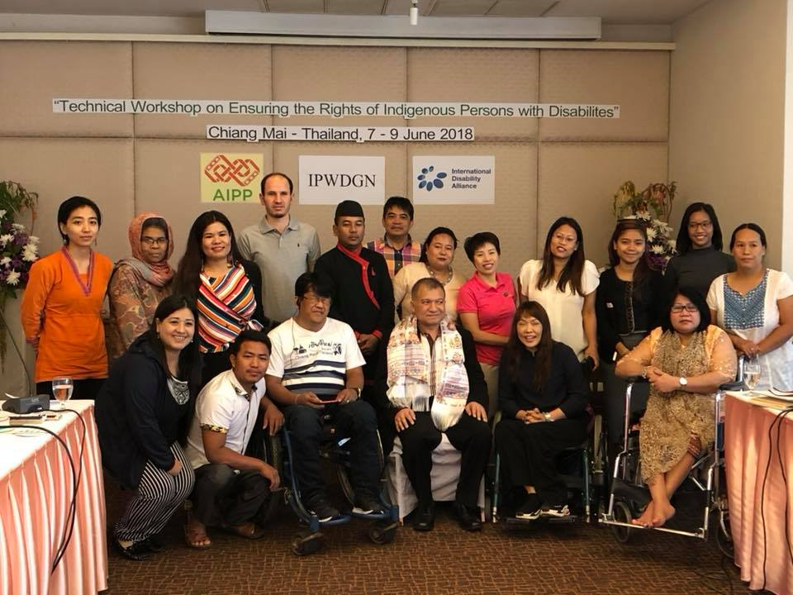
Photo 1: Mr. Mr. Monthian Buntan, Member of CRPD Committee with all the participants from various countries of Asia on the 3rd day

SUMMARY
From 7-9 June, the Indigenous Persons with Disabilities Global Network (IPWDGN), Asia Indigenous Peoples Pact and the International Disability Alliance (IDA) held the Workshop on ensuring the rights of indigenous persons with disabilities in line with the UN CRPD, in connection with the UN Declaration on the Rights of Indigenous People (DRIP) the Agenda 2030, with support from the Disability Rights Advocacy Fund (DRAF).

The objective of the workshop was to strengthen the Asia regional network of IPWDGN and connect with national to global issues and agendas by sensitizing the issues of indigenous peoples with disabilities relating with UN CRPD, UNDRIP, Sustainable Development Goals 2030 Agenda and others mechanism.

The workshop was a unique opportunity bringing indigenous leaders with disabilities (IDPOs) from seven different counties (Nepal, Pakistan, India, Philippines, Thailand, Myanmar, Indonesia) to meet together to discuss critical issues and violation of their rights. The workshop gathered relevant information about the CRPD, UN DRIP and the Sustainable Development Goals 2030 Agenda their relevance to indigenous persons with disabilities. Sessions and discussions were presented and simultaneously interpreted into English, Nepali and Bhasa and Thai to ensure all participants and facilitators were meaningfully included. A privileged moment was the informal discussion and meeting with Asia Indigenous Peoples Pact Secretariat, members and their office based in ChaingMai.

The workshop was co-facilitated by Pratima Gurung, Asia representative of the IPWDGN, Maarie Joyce Godio, Program co-ordinator, Ms. Patricia Wattimena, Mr. Gam Shimray, General Secretary, Ms. Chanda Thapa Deupty Secretary General of Asia Indigenous Peoples Pact, Mr. Monthian Buntan Member of CRPD Committee and Ms, Kachaerewn from Thilaland forming a diverse group of facilitators bringing different local, national, regional and global both disability and indigenous perspectives on human rights and development, embracing, at the same time, the diversity of persons with disabilities and indigenous peoples.

Day First
The workshop was launched with a warm welcome speech by Mr. Gam Shimray, Secretary General of AIPP by welcoming all the participants and updates about the work AIPP. He highlighted the initiation that AIPP has taken to include disability issues. He, in his remarks highlighted that disability policy will be endorse by 2020 in upcoming General Assembly of AIPP.

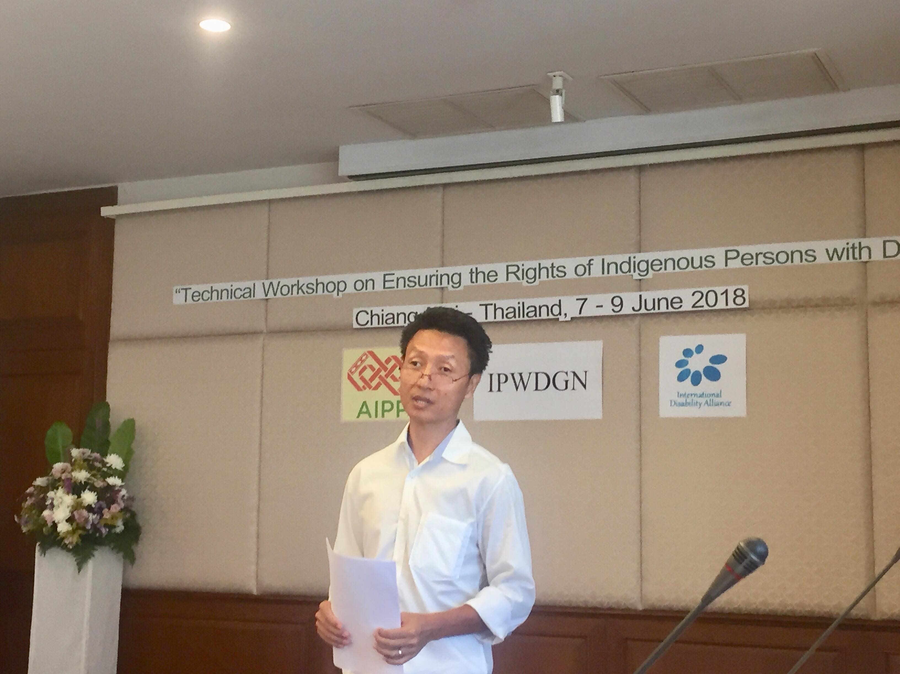
Photo 2: Gam Shrimray, General Secretary of AIPP welcoming all the members.

Similarly Pratima Gurung, Asia regional member focused by providing information on IPWDGN and IDA and its role to ensure the rights of IPWDS. After the official opening, the session was followed by a game of life, where participants discussed about discrimination over the life spam and intersecting forms of discrimination as well as on how to overcome those barriers. The indigenous group discussed their different identities by playing a "game of life" focusing on their identity in different situation and circumstances - being persons with disabilities and indigenous people. All participants shared their challenges, barrier, identity, poverty, lack of awareness, access to education, health, poverty and participation, costumes, traditions, but also challenges and barriers, including in regards to the rights of women and children with disabilities.

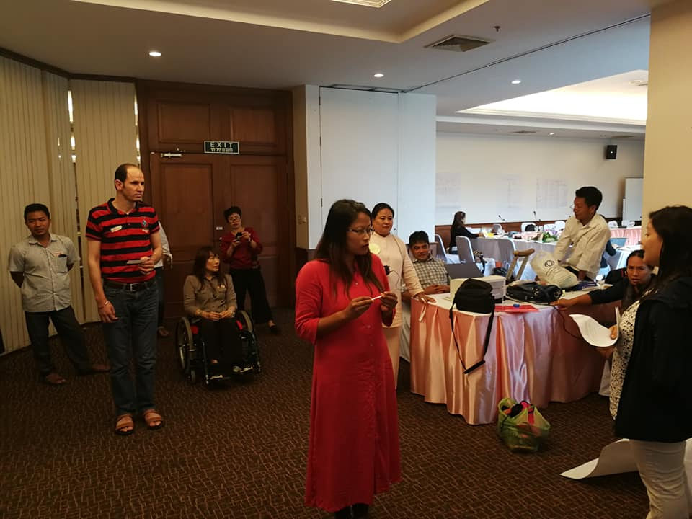
Photo 3: Participants discussion and explaining about their situation and identity in the game of life.

Representatives also shared the work they are undertaken at their community-based, county-based and national levels representing their different identities both as indigenous people and persons with disabilities, and also as women. They focused on the overall scenario of Asia and south Asia and their respective country, the level of understanding the issues of IPWDs, the minimal support, accessibility, lack of awareness on intersectionality, participation and representation and others from all the stakeholders including DPOs and IPOs. Participants also shared their work representing their community in meetings with stakeholders, participating in different government bodies or working groups as a person with disabilities rather than IPs. Pratima Gurung facilitated this session by proving real examples from Nepal, Myanmar and other countries from the ground experience and connecting the situation on the real lives.

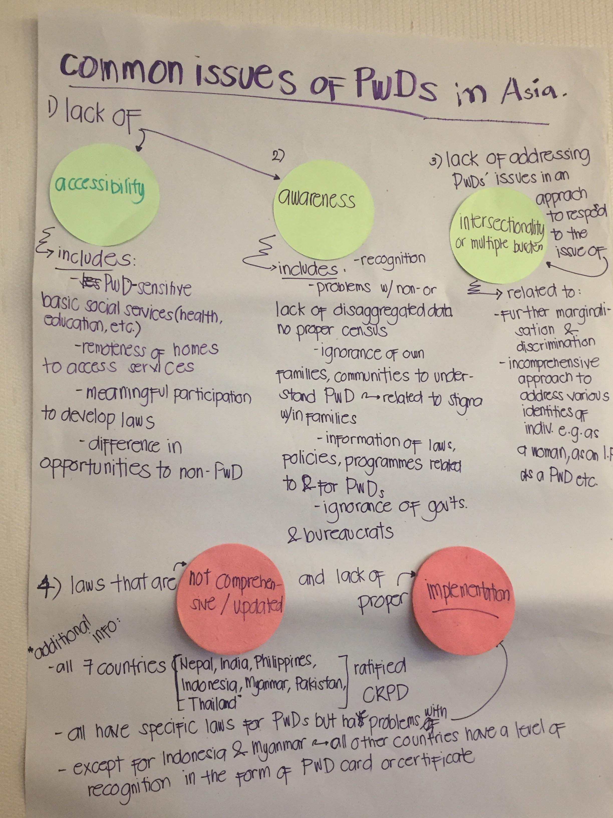
Photo 4: Participants discussion on the IPWDs issues

The next session was followed by providing brief introductory session on treaty body and mechanism connecting with UNCRPD and UN Declaration on the Rights of Indigenous Peoples. Maarie Joyce Godio, facilitated this session with some practical examples. After that the next session was followed by understanding from needs to rights by providing the examples of IPs and PWDs challenges of their day to day lives and Pratima Gurung facilitated this session by linking with day to day issues. The participants also discussed in group exercise on how shift the discussions from needs to rights, and then about the human rights-based approach to disabilities.

The “moodometer” of the day was explained to all the participants and was very positive and excitement with all feedback. The participants also had high expectation of understanding with many questions in Parking Questions about IPWDGN, UNDRIP, UNCRPD and SDG 2030 Agenda. The Day First ended with some exercises to learn about UN Convention on the Rights of Person with Disabilities, UN Declaration on the Rights of Indigenous Peoples and Sustainable Development Goals 2030 Agenda.

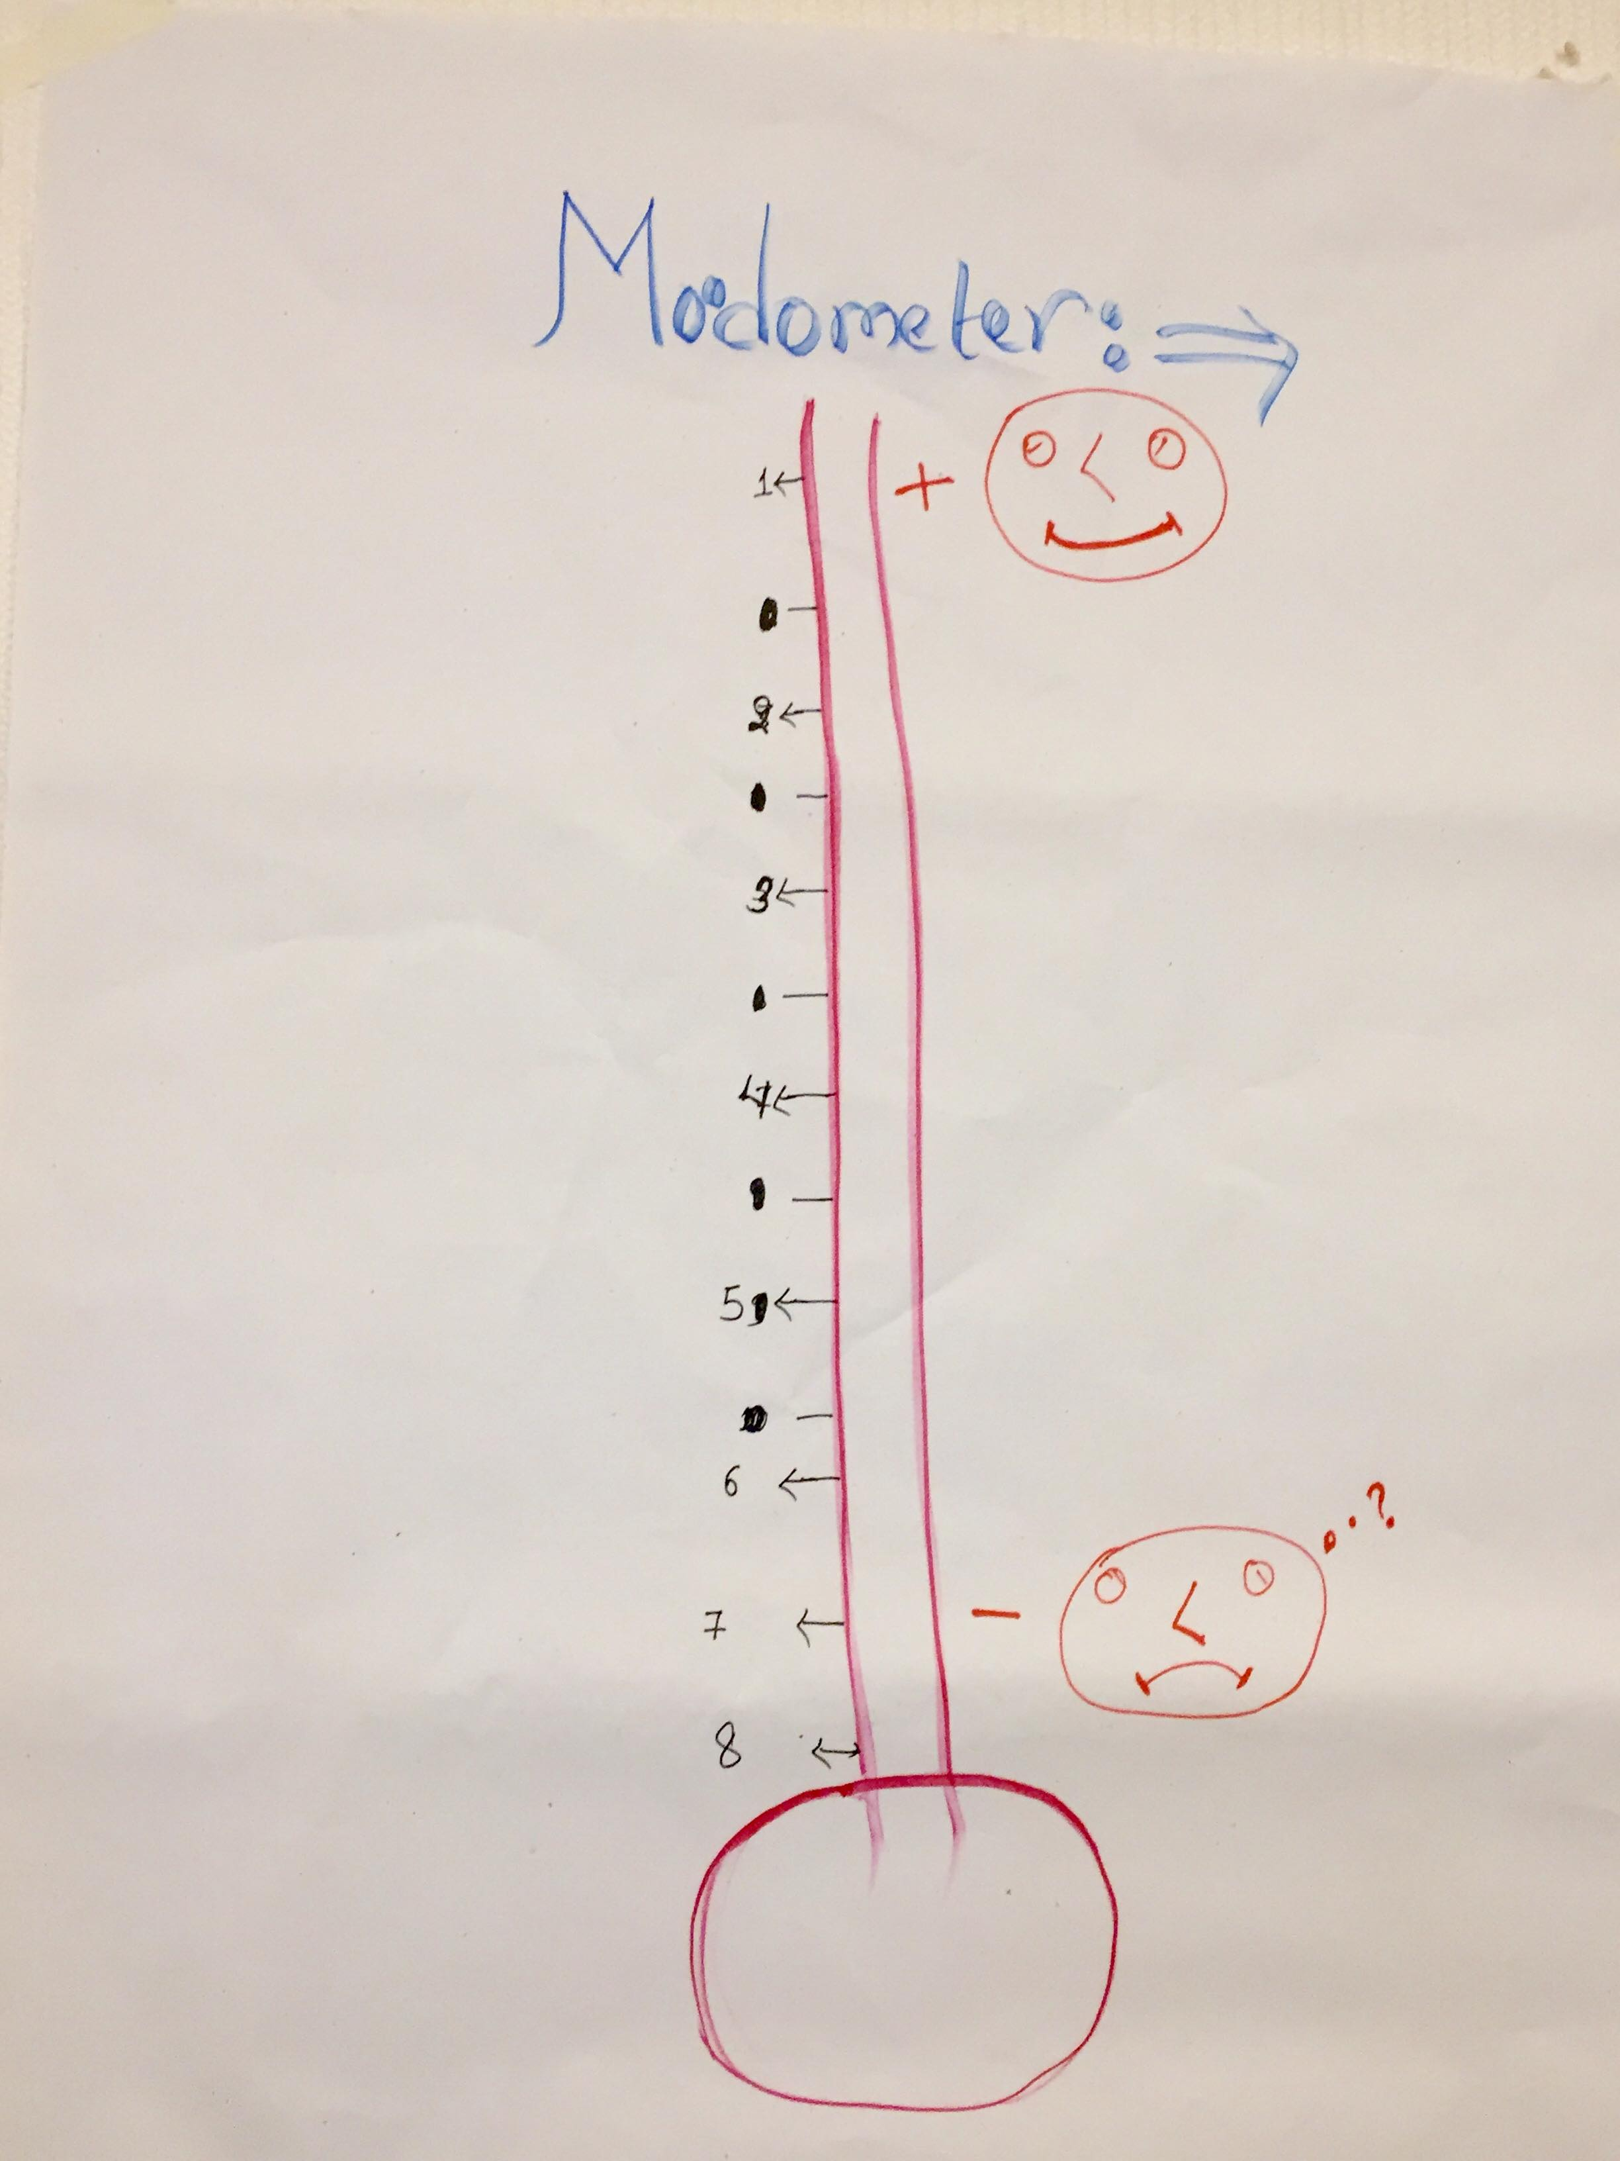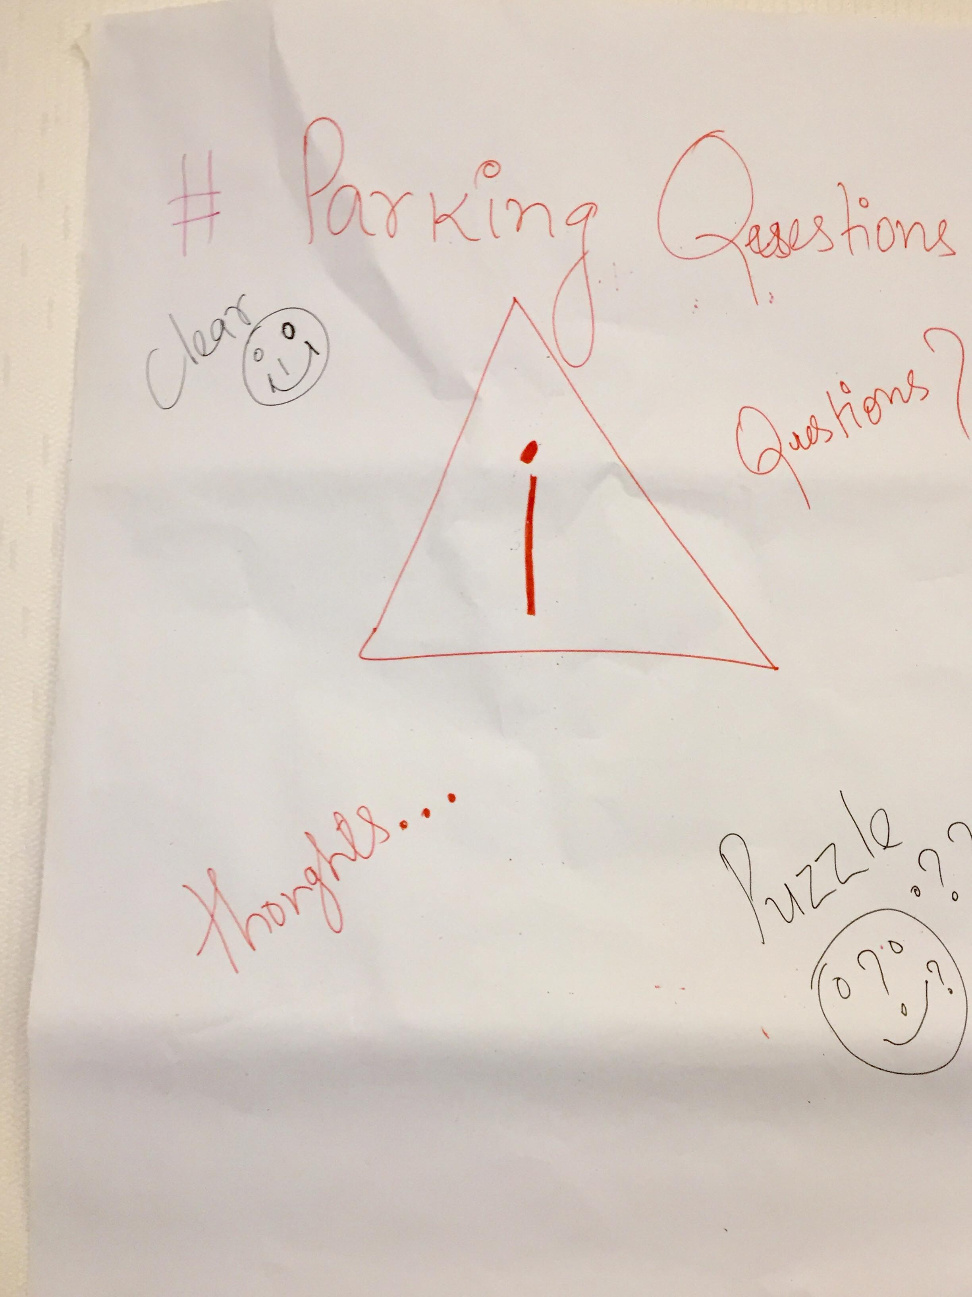

Day Second

The day started by a recap of the precedent day, followed by a general overview of the UNDRIP facilitated by Patricia Wattimena. She reflected on the UN Declaration on the Rights of Indigenous Peoples and its distinctness as focusing on collective rights issues to IPWDs. Then the second session was followed by connecting with UN Declaration on the Rights of Indigenous Peoples and UN Convention on the Rights of Person with Disabilities facilitated by Pratima Gurung.

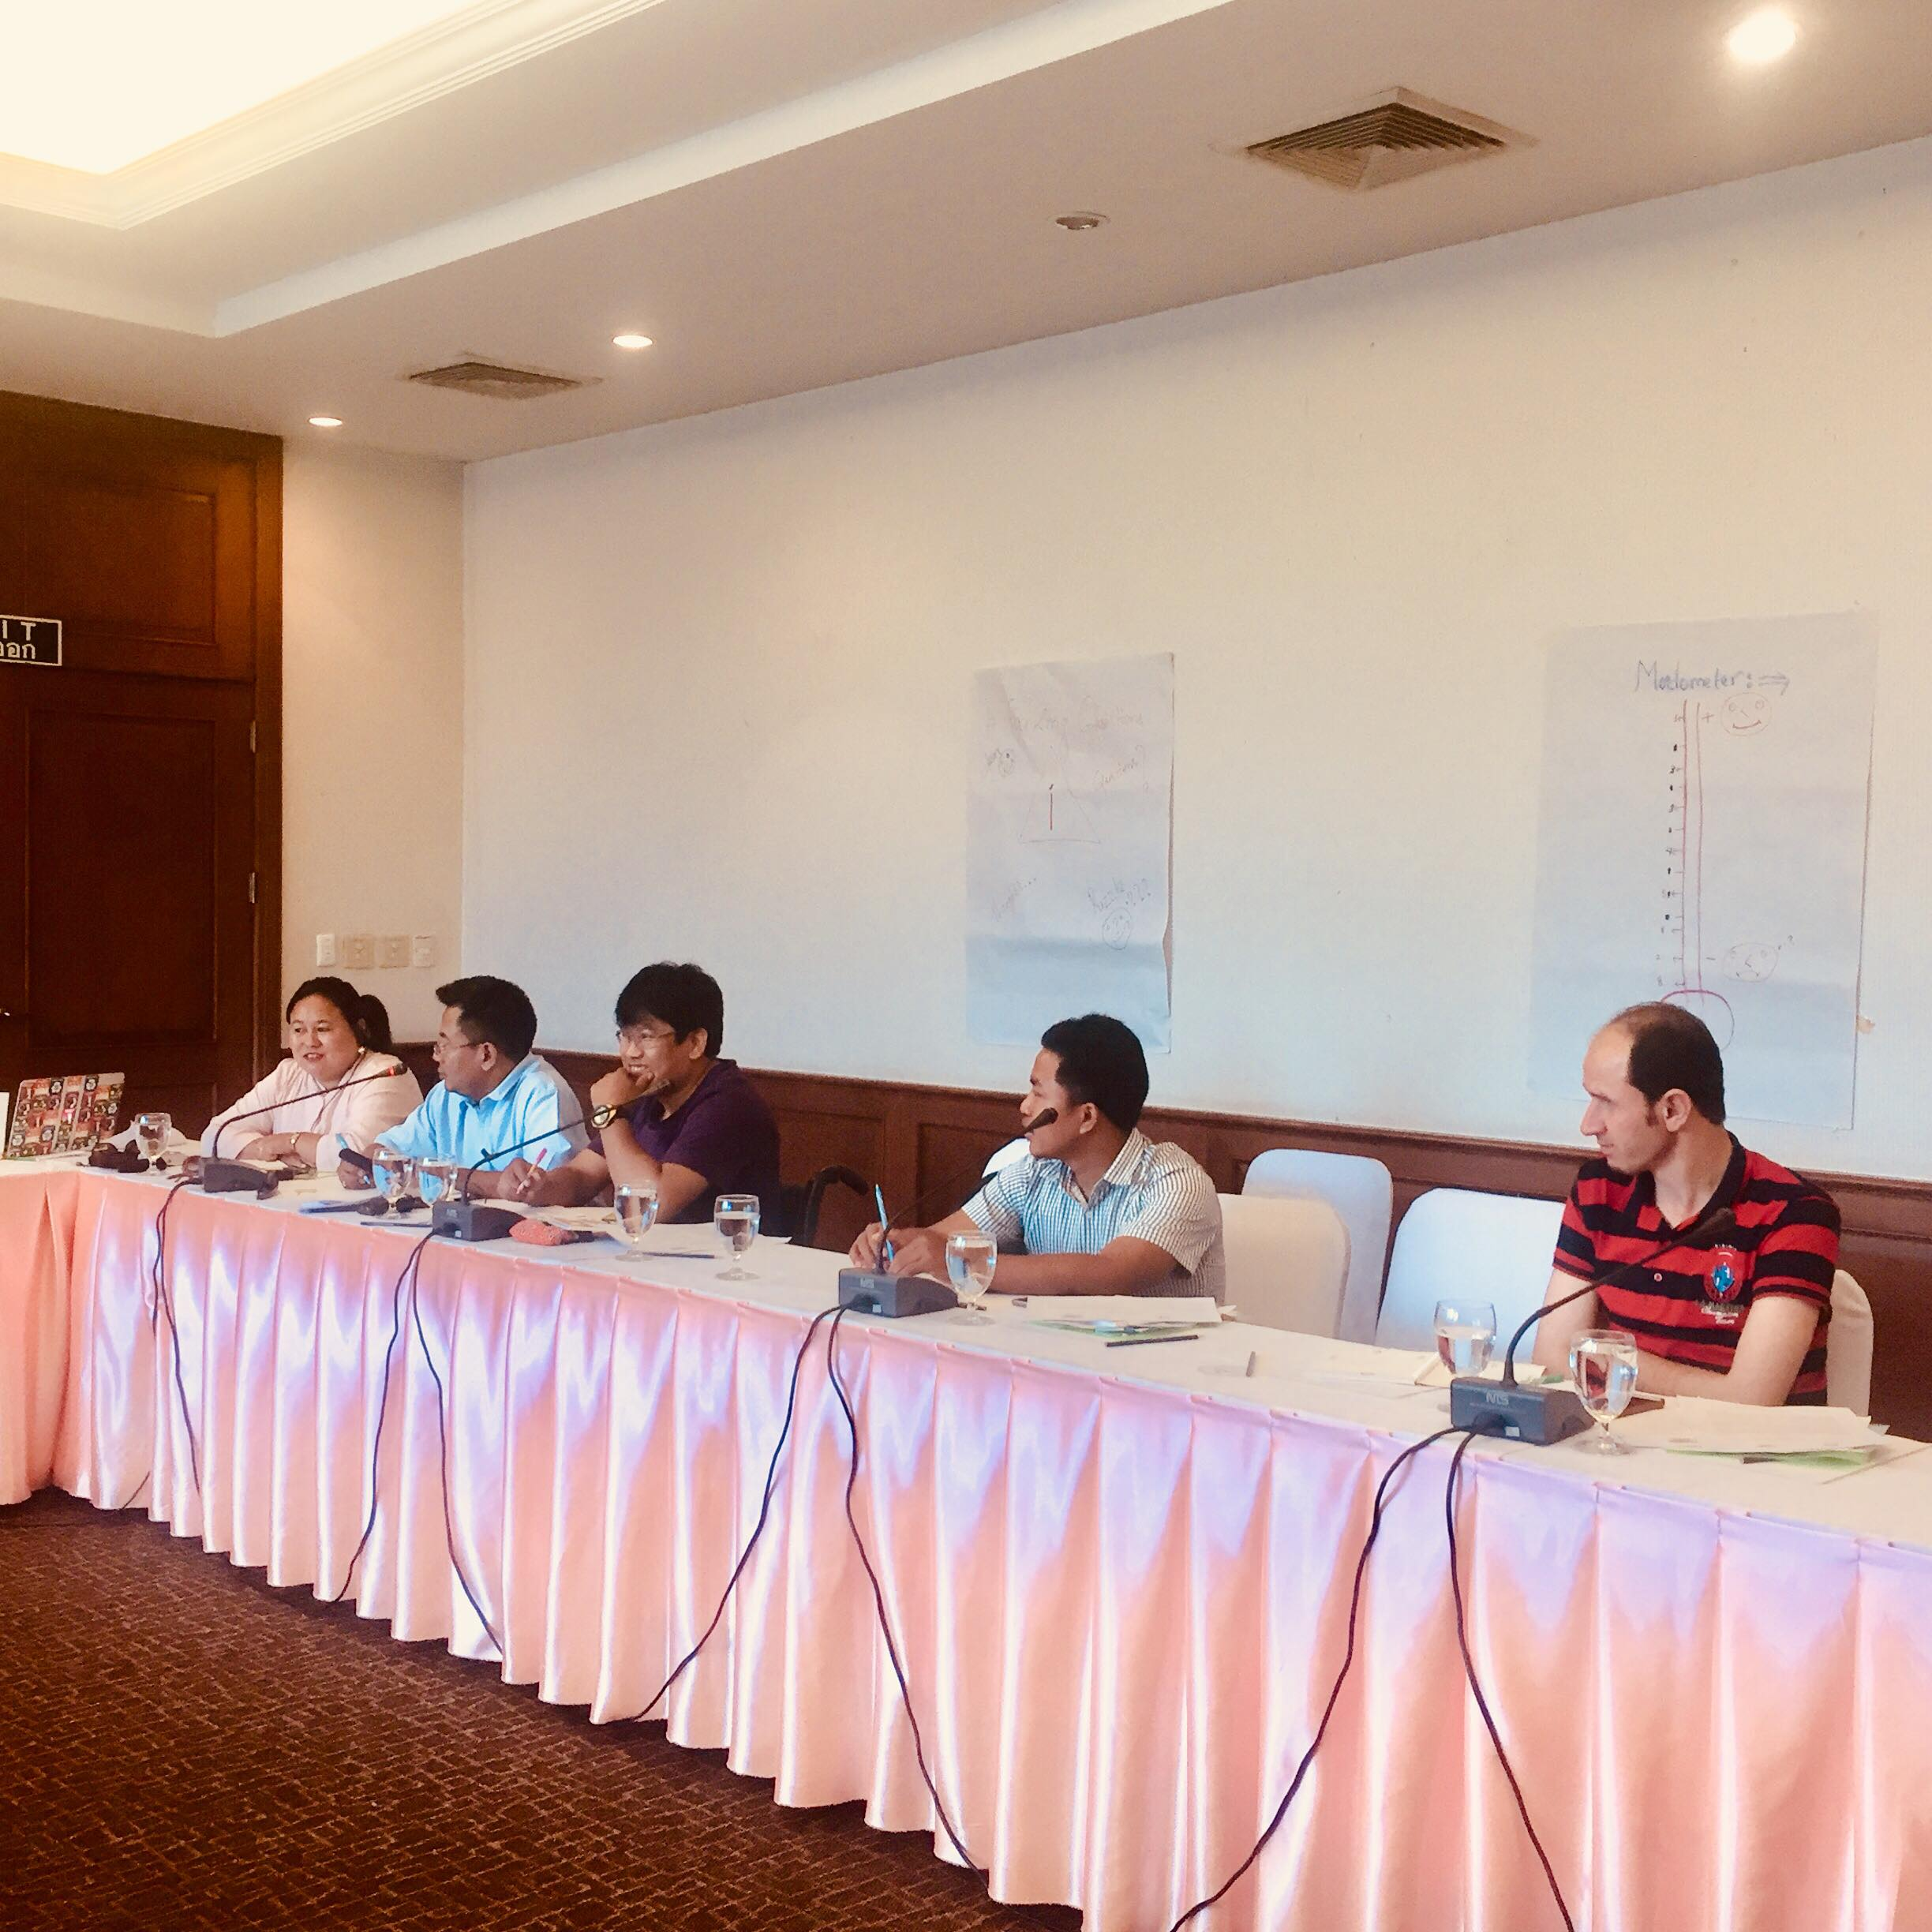
Photo5: Participants expressing their thoughts on UNDRIP

The session was followed by an in-depth debate on practical questions regarding the commonalities and differences on convention and declaration.
Ms. Gurung highlighted the achievement of IPWDs rights in both the instrument and connection on it relating with World Conference on Indigenous Peoples Outcome Document 2014 and other reports.

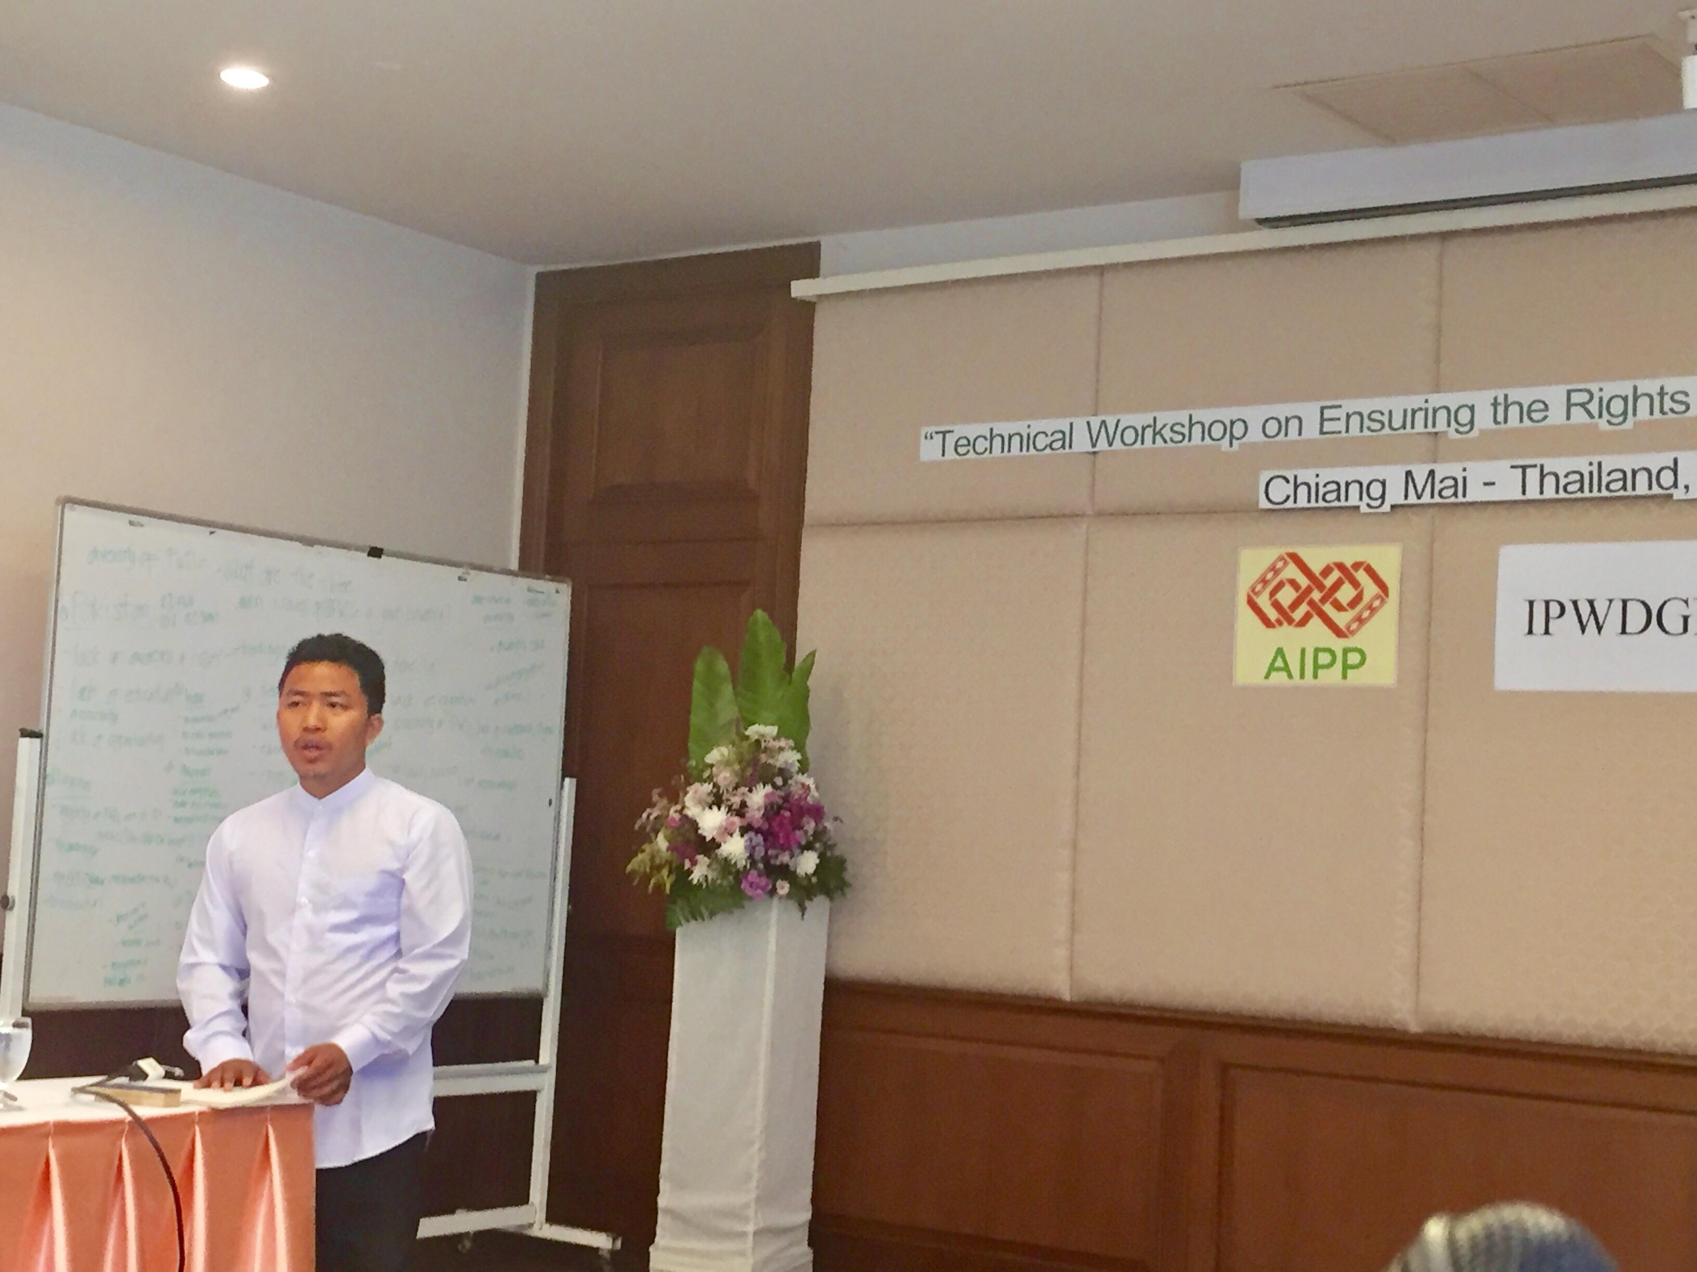
Photo 6 Mr. Joshua from Myanmar highlighting the queries on IPWDG Network and its work at national level.

Subsequently, there was a presentation on the SDG 2030 Agenda by providing an introduction to the Agenda 2030 and its Sustainable Development Goals (SDGs), and its evolution from the MDGs facilitated by Patricia Wattimena. She focused on the goals of SDG and its process. According to participants, indigenous with disabilities were not involved in efforts for the MDGs’ implementation. This introduction was followed by a practical exercise on linking the 17 goals and the CRPD articles. The facilitator focused on the National Voluntary Review Process with country reporting process and with examples. The session was followed by the group work from the participants in connecting Sustainable Development Goals 2030 Agenda and the UN Convention on the Rights of Person with Disabilities.

The day was concluded by a preparatory exercise to facilitate discussions between the indigenous with disabilities representatives and the stakeholders that opened the third day of the workshop. The second day was more interactive, participatory and reflective among the participants. The “moodometer” of the day was again very high with excellent feedback.

Day Third
The day was open by a formal opening by Mr. Monthian Buntan Member of CRPD Committee by giving the examples of Thailand and Person with disabilities engagement in CRPD process. His reflection highlighted on the uniqueness of UN CRPD as a latest treaty with all human rights values and principles.

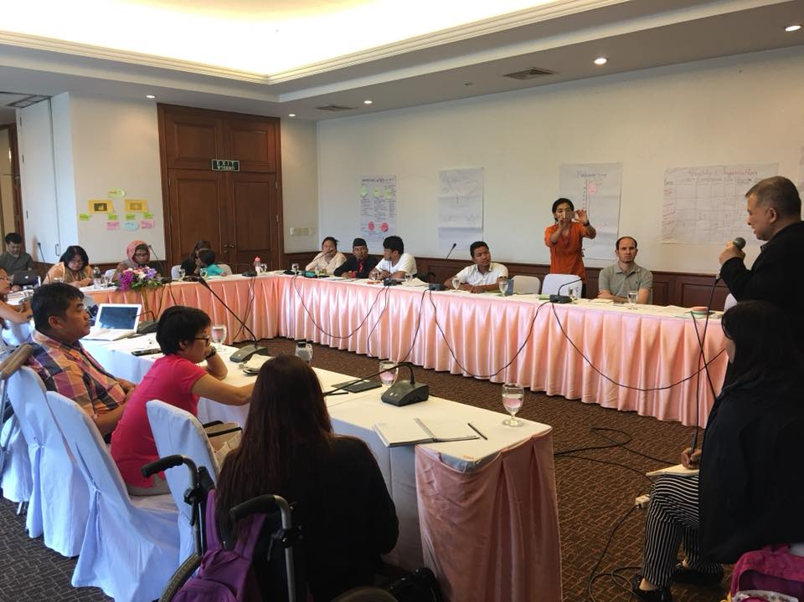
Photo 7. Mr. Monthian Buntan Member of CRPD Committee delivering his presentation on UN CRPD

He connected IPWDs issues with CRPD recommendation provided to members states and its awareness at global context. He also provided some practical examples of Nepal highlighting the shadow report submitted in 2018 from Indigenous person with disabilities perspective and encouraged other states to engage on it.

Then the second session was followed by the presentation of Pratima Gurung, introducing the IPWDG Network and its work. Pratima also presented an overview of the IPWDGN work in advocating towards UN mechanisms, both in Geneva and in New York.

These remarks were followed by a many queries, concerns and follow up of the Network work by all the participants. AIPP including all the participants wanted to know the criteria of representation, procedures and all others structures of the Network and its visibility in global level. All the participants suggested that the Network has to enhance working in effectively at national and regional level to strengthen the network. Then it was followed by the Group work on Planning of activities where each participant had to make plan and commitment related with activities on short term and long term activities, planning followed by organizations that can support for the given activities. The participants highlighted to share and do meeting consultation after their return to their country and also made a long term plan connecting with Asia focal person, AIPP and the IPWDGN.

Following the presentation by each participant focused on
Follow up Activity: Indigenous group/network will be formed, organized and invited to focal person if possible and will connect with AIPP and its work on IPs and SDG, 2030 Agenda. They will enhance their community working on IPWDs issues in their countries. Advocacy and lobby will be the major component for it including the other issues.

Evaluation and Feedbacks:
The day was concluded by a session evaluating the training by online survey questionnaire prepared by AIPP. The evaluation and feedbacks was very positive and can be summarised as following:
- The workshop is important and unique in itself with all the components so it should continue further and enhance IPWDs issues.
- IPWDs need to be focused in both indigenous and disability framework.
- Great opportunity, learning and commitment with work with new friends and work further.
- Good participation of all from all countries and focus more on other countries and focus on indigenous women with disabilities as they are left behind
- Connecting National, regional and Global link was great and need to continue further.
- Need to work collectively, the logistic, travel and stay with disability sensitive was good from Organizer. The workshop should be at least 5 days was suggestion provided.

Field Visit:

After the session, all the participants with great enthusiasm to learn more about AIPP, did field Visit to AIPP office. All the AIPP members and Secretariat members welcomed all of them. Ms. Chanda Thapa, Deputy Secretary member of AIPP welcome all the participants to AIPP and provided a background on AIPP 's work in Asia. There were some queries raised by the participants on networking and communication including the work of AIPP.

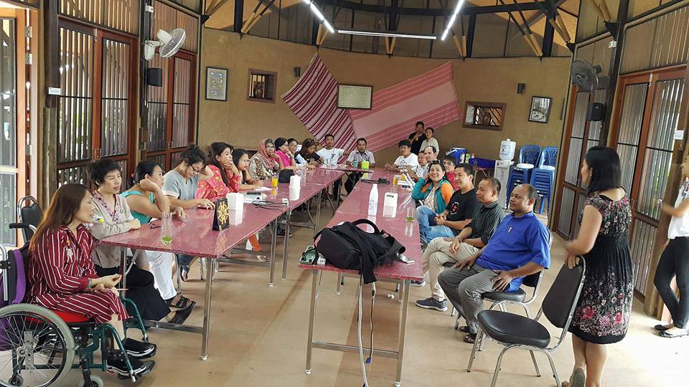
Photo 8: In AIPP Office welcoming all the participants and briefing about AIPP work and IPWDs engagement

After the briefing, Mr Nwang Sherpa presented a token of appreciation a painting made by indigenous person with disabilities from Nepal to AIPP on behalf of National Indigenous Disabled Women Association Nepal and Nepal Indigenous Disabled Association. All the participants expressed their learning and visited the environment friendly office of AIPP.

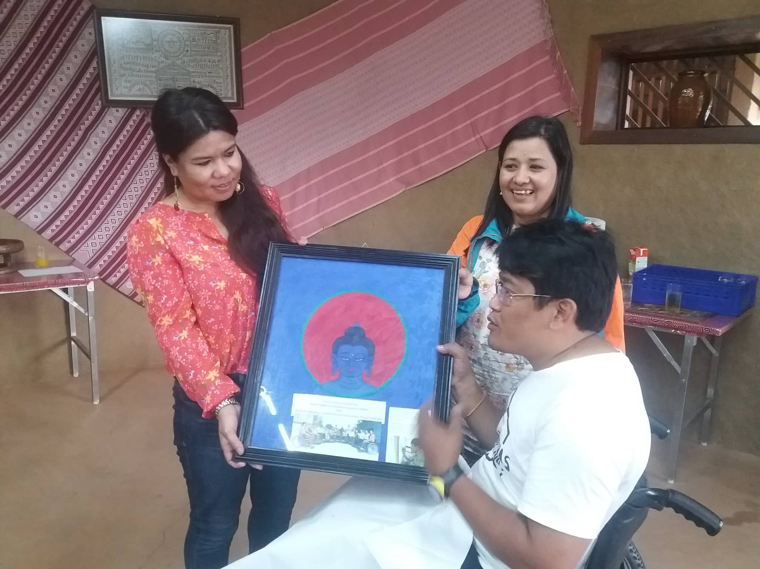
Photo 9: Presenting a Token of Appreciation painting made by indigenous person with disabilities to AIPP from Nepal to AIPP

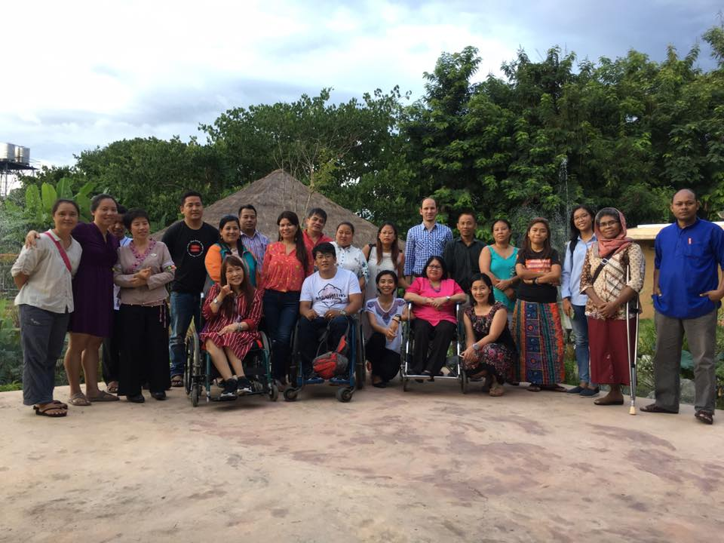
Photo 10: Group photo in AIPP Office with all participants

