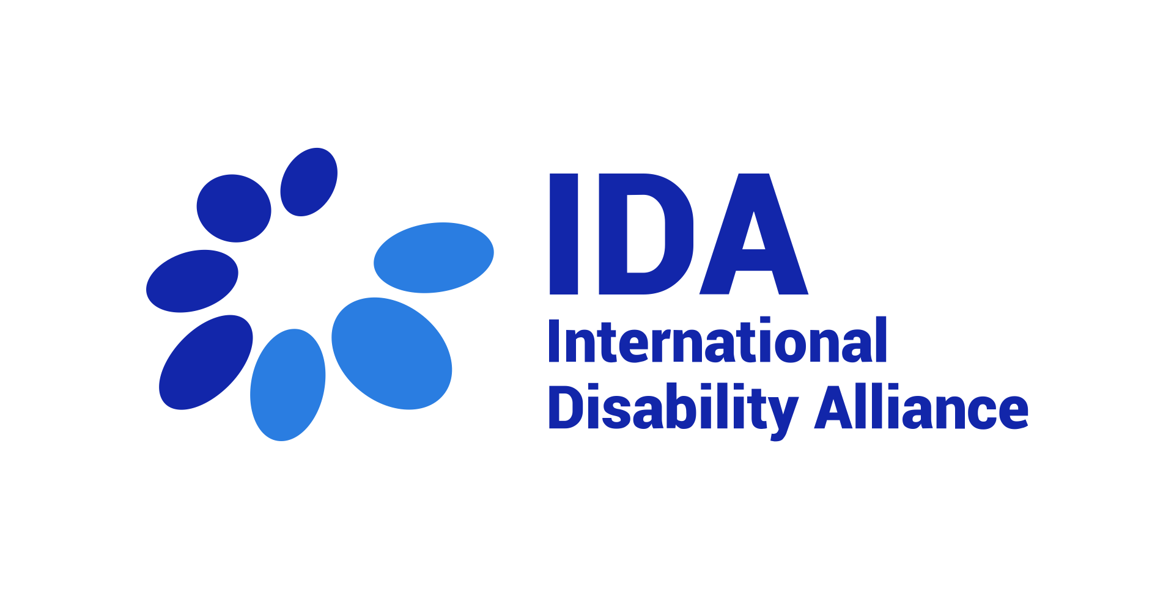

Assistive technology references in Human Rights Council resolutions

16/15 Role of international cooperation in support of national efforts for the realization of the rights of persons with disabilities
10. Encourages States to reinforce international cooperation measures in fields of research or on transfer of technology, such as assistive technologies;

19/11 Rights of persons with disabilities: participation in political and public life
11. Also encourages all relevant actors in undertaking measures of international cooperation, between and among States and, as appropriate, in partnership with relevant international and regional organizations and civil society, to consider appropriate and effective measures in support of national efforts to enhance enjoyment of political rights by persons with disabilities on an equal basis with others, such as by facilitating the use of assistive and new technologies relevant to participation in political and public life;

31/6. The rights of persons with disabilities in situations of risk and humanitarian emergencies
11. Encourages the mobilization of public and private resources on a sustainable basis to mainstream the rights of persons with disabilities in development and underlines the need to promote and strengthen international cooperation at all levels, including with regard to capacity-building, by facilitating access to and sharing of accessible and assistive technology and through the transfer of technologies, as appropriate, the exchange of good practices and partnerships for development that are inclusive of persons with disabilities

32/13. The promotion, protection and enjoyment of human rights on the Internet
7. Encourages all States to take appropriate measures to promote, with the participation of persons with disabilities, the design, development, production and distribution of information and communications technology and systems, including assistive and adaptive technologies, that are accessible to persons with disabilities;

40/14. Rights of the child: empowering children with disabilities for the enjoyment of their human rights, including through inclusive education
Recognizing that global estimates for the number of children with disabilities range from 93 million to 150 million, and deeply concerned about barriers that impede access to inclusive education for children with disabilities and that a significant percentage are either out of school or in school but not learning properly owing to a lack of access to accessible learning materials, inclusive curricula, teacher support and assistive devices, making children with disabilities, especially girls with disabilities, one of the most marginalized and excluded groups with regard to education
13. Urges States to ensure the right of children with disabilities to social protection, including by providing access to appropriate and affordable services, assistive devices and inclusive technologies, and the maintenance thereof, and other assistance for disability-related needs, and to social-inclusion and poverty-reduction programmes, including assistance with disability-related expenses, adequate training, counselling, financial assistance and respite care for families and caregivers, in particular for those living in situations of poverty;
23. Urges States to take appropriate measures to enable children with disabilities to learn life and social-development skills, including through peer support, to facilitate their full and equal participation in education and as members of the community, ensuring that education for children who are autistic, blind, deaf or deafblind is delivered in the most appropriate language and mode and means of communication for the individual, including by facilitating the learning of Braille and other means and formats of communication, the learning of orientation and mobility skills, the use of information and communications technology, including assistive technologies, the learning of sign language and the promotion of the linguistic identity of the deaf community, in environments that maximize academic, social and personal development;
26. Urges States to promote accessibility by children with disabilities to school buildings, and to roads and transportation leading to schools, including by identifying and eliminating existing obstacles and barriers, to undertake or promote research and development of universally designed facilities and school environments, which should require the minimum possible adaptation and the least cost to meet the specific needs of a child with disabilities and should not exclude assistive devices for particular groups of persons with disabilities where needed, and to promote the availability and use of such services, facilities and environments;
30. Further calls upon States to support national efforts to advance inclusive, quality education through international, bilateral and multilateral cooperation, including international development programmes, by facilitating capacity-building and the exchange and sharing of information, experiences, training programmes and best practices, as well as research and access to scientific and technical knowledge, including by promoting the availability, knowledge and use of appropriate, suitable, affordable, accessible and inclusive assistive devices and technologies;

43/23. Awareness-raising on the rights of persons with disabilities, and habilitation and rehabilitation
Recalling in particular that article 26 of the Convention, on habilitation and rehabilitation, calls upon States parties to take effective and appropriate measures, including through peer support, to enable persons with disabilities to attain and maintain maximum independence, full physical, mental, social and vocational ability, and full inclusion and participation in all aspects of life, and also calls upon States parties to organize, strengthen and extend comprehensive habilitation and rehabilitation services and programmes, particularly in the areas of health, employment, education and social services, and to promote the availability, knowledge and use of assistive devices and technologies, including those designed for persons with disabilities, as they relate to habilitation and rehabilitation,
5. Calls upon States to take effective and appropriate habilitation and rehabilitation measures that are person-centred and age- and gender-responsive, and address multiple and intersecting forms of discrimination to enable persons with disabilities to attain and maintain maximum independence, full physical, mental, social and vocational ability, and full inclusion and participation in all aspects of life, such as by:
(c) Promoting and developing a multidisciplinary and trained habilitation and rehabilitation workforce, including by requiring and providing initial and continuing training that takes a human rights-based approach to disability and promotes the availability, knowledge and use of assistive devices and technologies;

47/15. Accelerating efforts to eliminate all forms of violence against women and girls: preventing and responding to all forms of violence against women and girls with disabilities
Recognizing that information and communications technologies, including assistive technology and devices, have shown their potential to strengthen the exercise of human rights, and that they can create conditions enabling the full enjoyment by persons with disabilities of their human rights and can contribute to their social and digital inclusion and digital literacy, empowerment and autonomy, and allow them to live independently on an equal basis with others and to fully, effectively and meaningfully participate in society and in the world of work, while condemning all forms of violence against women and girls with disabilities in digital contexts, including new forms of violence such as cyberviolence, bullying and harassment, and their rising prevalence during the COVID-19 pandemic,
7. Calls upon States to take immediate and effective action to prevent and eliminate all forms of violence against women and girls by:
(d) Implementing and allocating adequate resources to effective and evidence- based programmes and strategies with and for women and girls with disabilities, such as increasing access to assistive devices and technologies and community-based habilitation and rehabilitation services adapted to their requirements, in compliance with States’ international human rights obligations;

47/23. New and emerging digital technologies and human rights
Recognizing that new and emerging digital technologies, in particular assistive technologies, can especially contribute to the full enjoyment of human rights by persons with disabilities, and that these technologies should be designed in consultation with them and with appropriate safeguards to protect their rights,

49/12. Participation of persons with disabilities in sport, and statistics and data collection
Concerned that persons with disabilities experience poorer health outcomes in part because of lack of physical activity, and that persons with disabilities face greater barriers than others in access to physical activity and sport owing to inaccessible infrastructure, inaccessible facilities and services, lack of personal assistance, forms of live assistance and intermediaries or other community support services, lack of financial support and lack of context-appropriate and affordable assistive technology, including assistive technology and devices for physical activity and sports, as well as attitudinal barriers, such as stereotypes, stigma and prejudices about their capabilities, among other reasons,
4. Calls upon all States to take appropriate measures to enable persons with disabilities to participate, on an equal basis with others and without discrimination, in recreational, leisure and sporting activities, applying an approach that is gender-responsive and age-sensitive, such as by:
(m) Conducting, promoting and funding research and data collection, analysis and use, systematizing existing administrative data and considering also community-driven and crowdsourced data collection, disaggregating by age, sex and disability, in order to assess, inter alia, the health outcomes of physical activity of persons with disabilities, the availability and affordability of assistive technology for physical activity and sport, the current participation of persons with disabilities in recreational, amateur and professional sports and the opportunities available and accessible to them;
A/HRC/55/L.8 Support systems to ensure community inclusion of persons with disabilities [*draft – to be adopted by end of the 55th session 6 April 2024]
PP13. Noting that assistive technology, both digital and non-digital, can enable and promote the inclusion, participation and engagement of persons with disabilities in all areas of society, including the political, economic and social spheres;
4. Calls upon all States to take appropriate measures to establish and implement support systems that respect, protect and fulfil human rights, to ensure community inclusion of persons with disabilities, on an equal basis with others and without discrimination, applying an approach that is gender-responsive and age-sensitive, for example by:
(h) Ensuring access to support products, such as assistive technologies, including digital and new technologies and mobility aids to strengthen support systems for persons with disabilities, while at the same time mitigating risks related to lack of access, discrimination, privacy, data protection, safety and transparency,
12. Decides that its next annual interactive debate on the rights of persons with disabilities will be held at its fifty-eighth session, and will focus on the rights of persons with disabilities and digital technologies and devices, including assistive technologies,
14. Requests the Office of the High Commissioner to prepare its next annual thematic study on the rights of persons with disabilities on the rights of persons with disabilities and digital technologies and devices, including assistive technologies

