Bridge CRPD-SDGs Kenya– Module 1

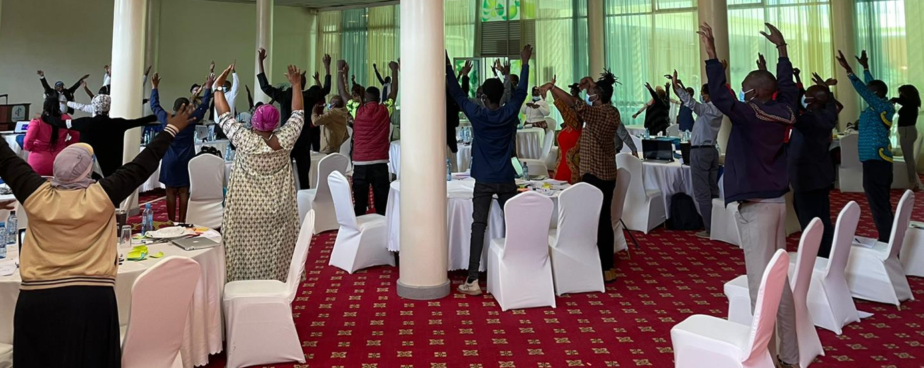

The United Disabled People of Kenya (UDPK), African Disability Forum (ADF), International Disability Alliance (IDA) and International Disability and Development Consortium (IDDC) with their members hosted the Bridge CRPD-SDGs training initiative for the African region in English between the 24th and 30th of June 2021, in Nairobi, Kenya.

The Bridge CRPD-SDGs aims to support organizations of persons with disabilities (DPOs) and disability rights advocates to develop an inclusive (all persons with disabilities) and comprehensive (all human rights) CRPD perspective on development, including the Agenda 2030 and Sustainable Development Goals (SDGs). This will reinforce their advocacy for inclusion and the realization of rights of persons with disabilities.

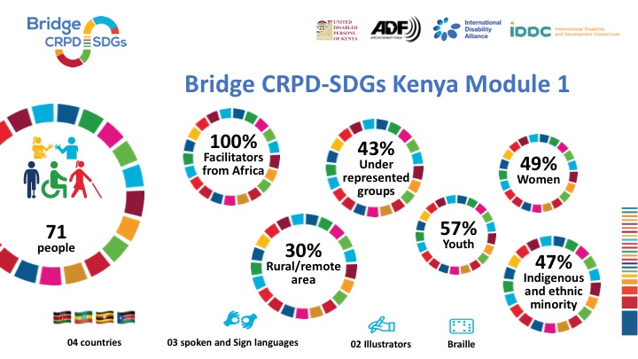
The 35 participants included representatives from DPOs from different counties of Kenya. There were also participants from South Sudan, Ethiopia, and Uganda. All participants brought with them a wide range of experience and included persons with intellectual disabilities, deafblindness, cerebral palsy, albinism, autistic and Deaf persons, among others, as well as indigenous persons with disabilities and persons with disabilities from other ethnic minorities. The training was organized keeping in mind strict COVID-19 protocols to minimize the risks of exposure to participants without compromising on their full and effective participation.

This Bridge CRPD-SDGs Kenya Module 1 was possible thanks to the financial support of the Norwegian Agency for Development Cooperation (Norad), European Union/HELASIA Project ADF-HI, UK Foreign, Commonwealth & Development Office (FCDO), Light for the World (LFTW) and Sightsavers International.

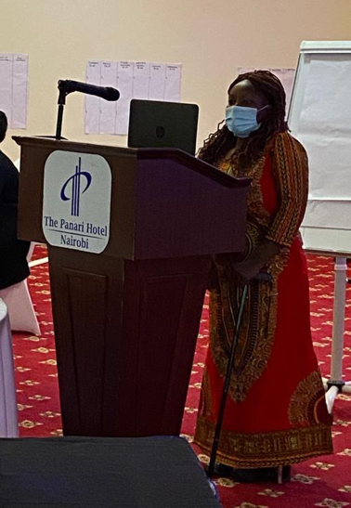
The first day opened with a powerful message from Sarah Kamau, representative of
United Disabled People of Kenya (UDPK), who welcomed all participants, facilitators, and support people, stressing the importance of the training and its tools to equip participants to raise public awareness and advocate for better recognition of the rights of people with disabilities in their regions. She concluded her introduction by thanking IDA and ADF for their financial and technical support to the event.

This was followed by an introduction from Abebe Abebaw, the representative of the African Disability Forum (ADF), the umbrella member organization of persons of disabilities in Africa, on the organization’s main goal to promote an inclusive Africa where all persons with disabilities and their families will fully and effectively participate towards the promotion of their rights.

Afterwards, Tchaurea Fleury, IDA’s Director of Capacity Building introduced IDA and IDDC, and the history of the Bridge CRPD-SDGs training. She explained the structure of Module 1 and shared a powerful message to the participants: “You are the ones selected to be here. You are ambassadors, you represent your people here. We are jointly and individually responsible for sharing the knowledge you receive here. We count on you to enforce the movement!”

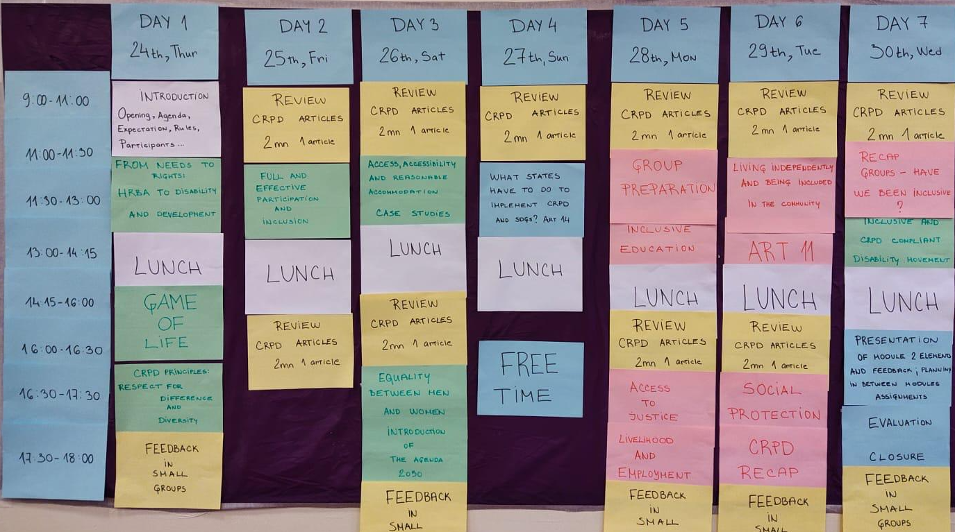

This training was co-facilitated by persons with disabilities from different organizations that worked together to make this workshop meaningful. The facilitation team comprised of Elizabeth Ombati, OPD Engagement Officer Inclusion Works, Fatma Wangari, Regional Coordinator for region of Africa for Inclusion International, Michael Njenga, Executive Director, Users and Survivors of Psychiatry, Kenya, and Jane Akinyi, all being Bridge alumni from Kenya; Kato Mark, Fellow, World Federation of Deafblind and Bridge alumni, Peter Ochieng, Youth Fellow IDA and Agnes Abukito, Fellow, World Federation of Deafblind and Bridge alumni, from Uganda, and Alradi Abdalla, Bridge CRPD-SDGs ToT Officer and Bridge alumni from Sudan.
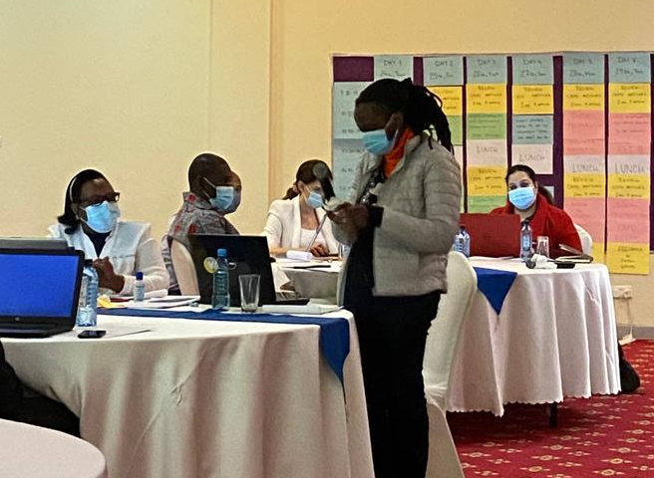
Karen Muriuki, an autistic participant, shared: “It is such a privilege to be here. My experience with barriers lasts more than 20 years. In Kenya, there is no education on autism, so I could not know what was happening to me and what I could do. I started discovering by myself. It was a long journey, but I’m happy to be here to learn more and then share my knowledge with other autistic persons and support them.”

Other participants shared their expectations about the training as well, and they can be summarized into three categories:
1. How to build a strong inclusive team for all people with disability,
2. Networking,
3. To learn how to advocate and continue with advocacy work after the training.

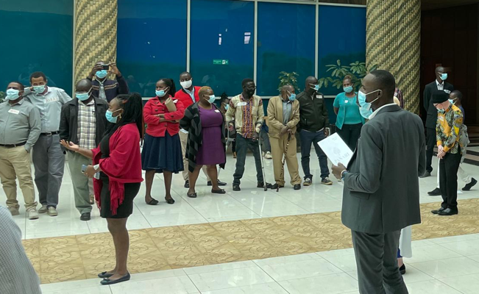
The first day was concluded with the “game of life”. In this game, participants were engaged in an exercise aimed to analyze the difference of opportunities that persons with disabilities have in their lives, depending on their impairments, gender and the barriers presented by the social environment they live in.

Over the 6 days of the workshop, participants were exposed to different topics, such as accessibility and reasonable accommodation, equality between men and women, access to justice, livelihood and employment, social protection etc. They did several group exercises that helped them to better understand and implement the theory they learned into the practical examples.

One of the participants Jane Waithera shared: “Theory is good, but the practice is what matters. We heard about the concepts before, but now we are able to better understand them and know how to use them in advocating for our rights”.

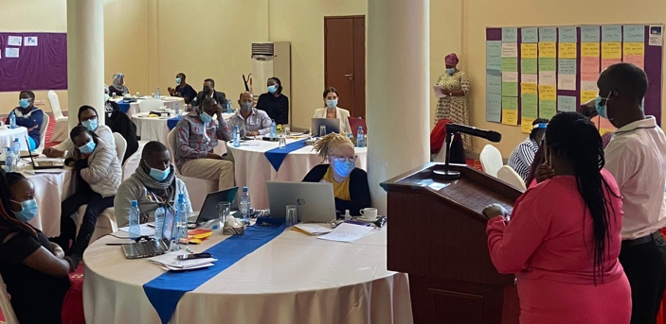
Throughout the workshop participants did ‘’two minutes one article” exercise, with each of them presenting the key elements of the CRPD article that was assigned to them, followed by feedback by peers and facilitators.

Later in the week, participants were introduced to Agenda 2030. They presented in groups what sustainable development means to them, which included:

1. Equality between men and women,
2. Better future for everyone,
3. Commitment of all the members of society,
4. Better connection when it comes to infrastructure and communities where children with and without disability are growing up together,
5. One community where all were respected.

In summary, they envisaged an inclusive environment with equal rights as other persons without disability, to be included and to be able to fully participate in the decision making. No one should be left behind.

Bridge CRPD-SDGs Kenya ended with a high evaluation from participants. The feedback received was very positive, participants were very satisfied, and they found the learning extremely meaningful.

Anderson Gitonga, CEO of the UDPK concluded Bridge CRPD-SDGs sharing their happiness in transforming this dream of 6 years into reality and calling upon all participants to keep the momentum up and to commit to reverting back this knowledge to their communities and networks.

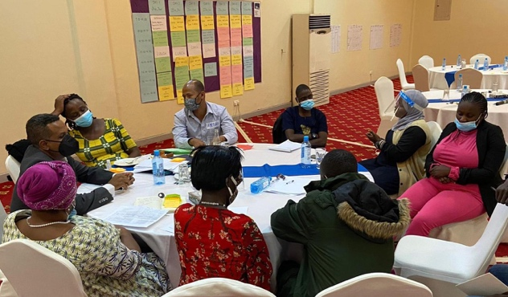
For more information about this workshop please visit the African Disability Forum webpage.

Read here about Bridge CRPD SDGs Module 1 in Kenya in PDF.

