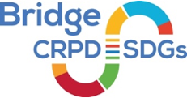
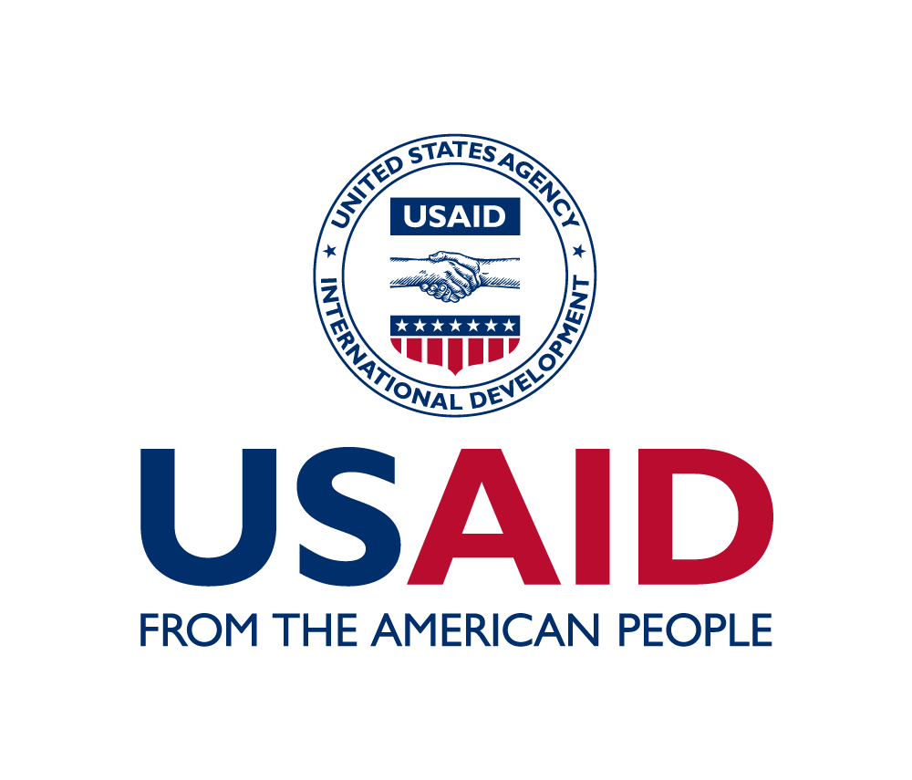
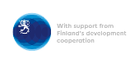
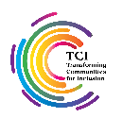

Bridge CRPD-SDGs Module 2 Bangladesh
Pan Pacific Sonargaon Dhaka Hotel
16 to 23 February 2023

 | Thurs 16 Feb | Fri 17 Feb | Sat 18 Feb | Sun 19 Feb | Mon 20 Feb | Tues 21 Feb | Weds 22 Feb | Thurs 23 Feb
9:00 | INTRODUCTION  Opening, agenda,  expectations & reminders | Morning recap | Morning recap | Morning recap | Morning recap | Morning recap | Morning recap | Morning recap
 |  | 2 min 1 article |  |  |  | CRPD Complaint Budget Advocacy | Use of International monitoring mechanisms + Mock session | Feedback meeting with stakeholders
9:30 10:30 |  | Development: Inequalities & inclusion: Making the most of the SDGs | Inclusive Program design  Practice | Legal harmonization with CRPD | Data: Making sure we are counted in
11:00  12:45 |  |  |  |  |  |  |  | GDS Session
12:45 14:00 | LUNCH BREAK
14:00 14:30 | CRPD Recap  Review session | 2 min 1 article |  | OFF | 2 min 1 article |  | Public policy exchange meeting  (Groups and sessions TBC) | Steps towards inclusive disability movement
14:30 15:30 |  | Making the right real: understanding public policy | Policy paper feedback |  | Policy paper feedback
16:00  17:15 |  |  | Gender Equality |  | CRPD perspective on development  “CRPD lenses” | Preparation for Public Policy Exchange |  | Closing
17:15  18:00 | Evaluation and Feedback in small groups |  |  |  | Evaluation and Feedback in small groups
19:00 20:00 | Optional evening session:  Some 1-1 mentoring sessions on assignments with facilitators

Bridge CRPD-SDGs Module 2

Bangladesh National Cycle: Agenda
Date: 16 to 23 February 2023
Venue: Pan Pacific Sonargaon Dhaka Hotel

Training timings
All training days begin at 9:00 am and close at 18:00 pm. There will be two breaks for tea and refreshments (10:30 am to 11:00 am, and from 15:30 pm to 16:00 pm) and a lunch break will be from 12:45 pm to 14:00pm. If there is any planned change to this on a particular day, you will find it on the schedule of that day below. Sometimes, the timings may change because a session spills over beyond its scheduled time.

Preparatory meeting
Two days before the training begins (14 February 2023) there is a preparatory session for all facilitators.

One day before the training begins (15 February 2023) there is a preparatory session for participants from certain underrepresented constituencies such as the deafblind, the Deaf, and others.

Agenda – Module 2
Sessions are divided into categories depending on the subject matter.
Morning recap: Volunteers from amongst participants will present the recap and feedback of the previous day.
2 min 1 Article: This is an exercise wherein individual participants will be asked to present one article of the CRPD each in 2 minutes. This will be explained and demonstrated by the trainers on the first day.
Policy Paper Feedback: Participants will present the key points of their policy paper in 2 minutes for feedback and questions from colleagues.
Feedback: At the end of each day, participants will discuss and provide their feedback to the facilitation team. This process will be explained on the first day.
Optional evening session: On 16 and 17 February, in the evenings the facilitators will be available to discuss assignments with facilitators.
Evening sessions: Depending on the priority areas of participants we may schedule evening sessions on topics that require clarity, between 7:00 pm and 8:00pm.

Agenda in detail

Day 1 – 16 February – Thursday
9:00 am to 12:45 pm, Session 1 - Formal Session; Brief Opening ceremony, Introduction to the training module, explaining the agenda, expectations, rules and introduction of participants.
14:00 pm to 17:15 pm, Session 2 - CRPD Recap
17:15 pm to 18:00 pm - Evaluation and Feedback

Day 2 – 17 February– Friday
9:00 am to 09:30 am, Session 1 - Morning recap, 2 minutes 1 Article
09:30 am to 12:45 pm, Session 2 - Development: Inequalities & Inclusion: Making the Most of the SDGs
14:00 pm to 14:30 pm, Session 3 - 2 minutes 1 Article
14:30 pm to 17:15 pm, Session 4 - Making the right real: understanding public policy
17:15 pm to 18:00 pm – Evaluation and Feedback

Day 3 – 18 February – Saturday
9:00 am to 09:30 am, Session 1 - Morning recap, 2 minutes 1 Article
09:30 am to 12:45 pm, Session 2 - Inclusive Program Design
14:00 pm to 14:30 pm, Session 3 - 2 minutes 1 Article
14:30 pm to 15:30 pm, Session 4 - Policy Paper Feedback
16:00 pm to 17:15 pm, Session 5 - Gender Equality
17:15 pm to 18:00 pm - Evaluation and Feedback

Day 4 – 19 February– Sunday
9:00 am to 09:30 am, Session 1 - Morning recap, 2 minutes 1 Article
09:30 am to 12:45 pm, Session 2 - Inclusive Program Design
The rest of the day is free, after lunch.

Day 5 – 20 February– Monday
9:00 am to 09:30 am, Session 1 - Morning recap, 2 minutes 1 Article
09:30 am to 12:45 pm, Session 2 - Data: Making sure we are counted in
14:00 pm to 14:30 pm, Session 3 - 2 minutes 1 Article
14:30 pm to 15:30 pm, Session 4 - Policy Paper Feedback
16:00 pm to 17:15 pm, Session 5 - CRPD perspective on Development “CRPD Lens”
17:15 pm to 18:00 pm - Evaluation and Feedback

Day 6 – 21 February– Tuesday
09:00 am to 09:30 am, Session 1 - Morning recap
09:30 am to 12:45 pm, Session 2 - CRPD Compliant Budget Advocacy
14:00 pm to 14:30 pm, Session 3 - 2 minutes 1 Article
14:30 pm to 15:30 pm, Session 4 - Policy Paper Feedback
16:00 pm to 17:15 pm, Session 5 - Preparation for Public Policy Exchange
17:15 pm to 18:00 pm - Evaluation and Feedback

Day 7 – 22 February– Wednesday
09:00 am to 09:30 am Session 1 - Morning recap
09:30 am to 12:45 pm Session 2 - Use of International Monitoring Mechanisms
14:30 pm to 17:15 pm Session 3 - Public Policy Exchange Meeting
17:15 pm to 18:00 pm - Evaluation and Feedback

Day 8 – 23 February– Thursday
09:00 am to 09:30 am, Session 1 - Morning recap
0930am to 12:45 pm, Session 2 - Feedback meeting with stakeholders
14:00 pm to 14:30 pm, Session 3 - Steps towards inclusive disability movement
Evaluation and closure

