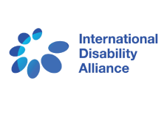
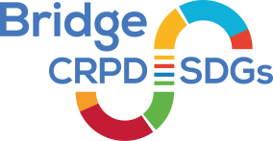

Bridge CRPD-SDGs training INITIATIVE

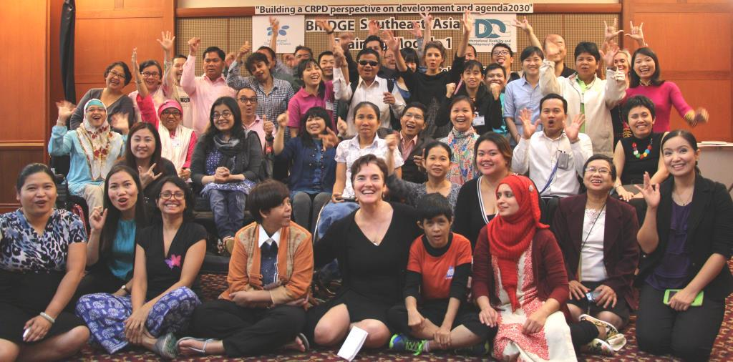
Caption: Group picture of Bridge CRPD-SDGs South East Asia trainees,
Module 1, Bangkok, October 2015. © Abed Al Jubeh

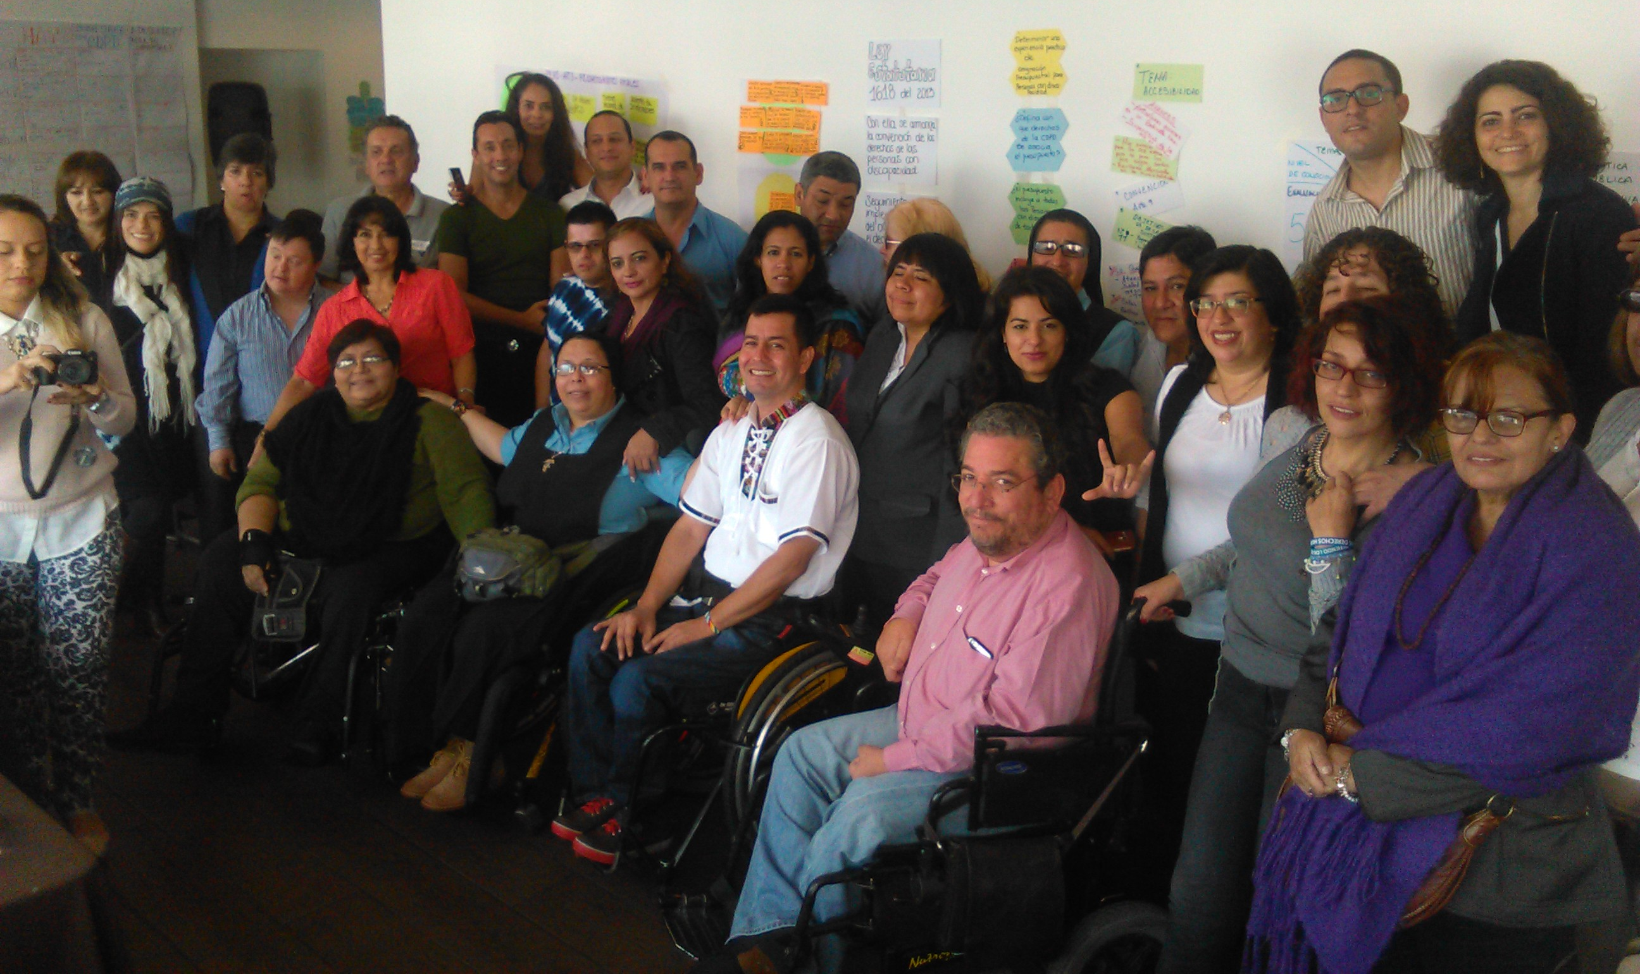
Caption: Group picture of Bridge CRPD-SDGs Latin America,
Module 2, Lima, June/July 2016

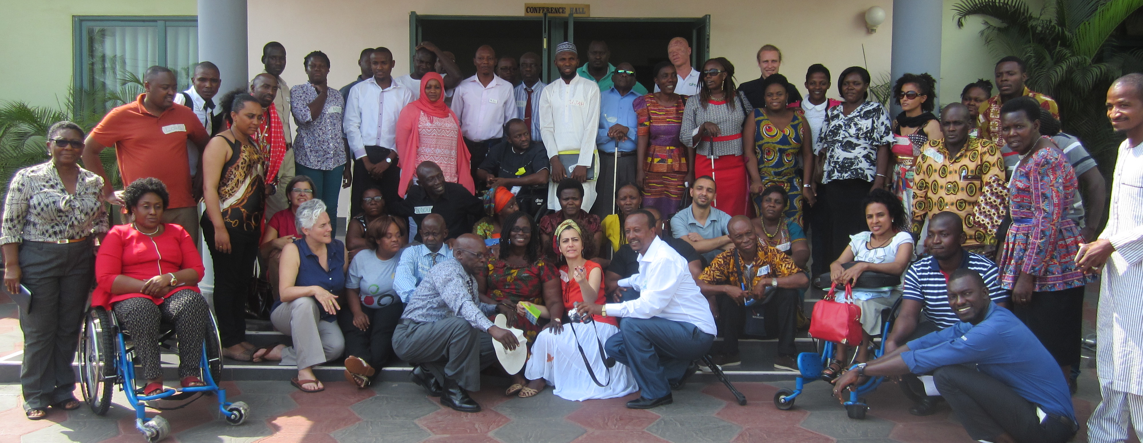
Caption: Group picture of Bridge CRPD-SDGs East & West Africa, Module 1, Ghana, Nov 2016

Bridge CRPD-SDGs training Initiative

Table of content

1. INTRODUCTION 3
2. rationale ….. 4
3. Background 5
4. ObjectiveS 10
5. DEVELOPMENT OF the TRAINING PROGRAMME 8
6. TRAINING approach 14
7. CURRICULUM STRUCTURE 24
8. training of trainers 17
9. HOW TO ENGAGE IN BRIDGE CRPD-SDGs? 224

Annex 1 – Bridge CRPD-SDGs Module 1

Annex 2 - Bridge assignment between Module 1 and 2

Annex 3 - Bridge CRPD-SDGs Module 2

Annex 4 – List of contributors to pilot Bridge CRPD-SDGs

- INTRODUCTION
Bridge CRPD-SDGs is an intensive training programme that aims to support organisations of persons with disabilities (DPOs) and disability rights advocates to develop an inclusive (all persons with disabilities) and comprehensive (all human rights) CRPD perspective on development, including the post-2015 agenda and Sustainable Development Goals (SDGs), to reinforce their advocacy for inclusion and realisation of the rights of all persons with disabilities.
It is a joint initiative by the International Disability Alliance (IDA) and the International Disability and Development Consortium (IDDC), and is supported by the Disability Rights Fund (DRF), Ford Foundation, the UK National Lottery Community Fund, among others.
The programme was devised to respond to increasing demands for trainings on the implementation of the Convention on the Rights of Persons with Disabilities (CRPD) and inclusive development, and how this links to achieving Agenda 2030 and the SDGs. It is a coordinated training investment, drawing from the resources and experiences of IDA and IDDC networks and their members.
Indeed, Bridge CRPD-SDGs adopts an integrated approach to bridge between human rights and inclusive development perspectives; aiming to support organisations of persons with disabilities to translate the highest aspirations, norms and standards to full and effective participation and inclusion of all, in the reality of resource-constrained environments, inadequate governance, competing agendas, and politics at both national and local levels. The curriculum is also built to support DPOs to make the most of the SDGs momentum, to further implement the CRPD and use the CRPD to frame implementation of the SDGs.

This intensive training programme was developed to set standards on CRPD and SDGs trainings, and ensure consistency across the regions, with the principles and provisions of the CRPD as well as with the evolving jurisprudence of the CRPD Committee and key learning from the implementation of the CRPD and SDGs.
This document therefore presents the Bridge CRPD-SDGs Training Initiative as a work in progress, about four years after its start.

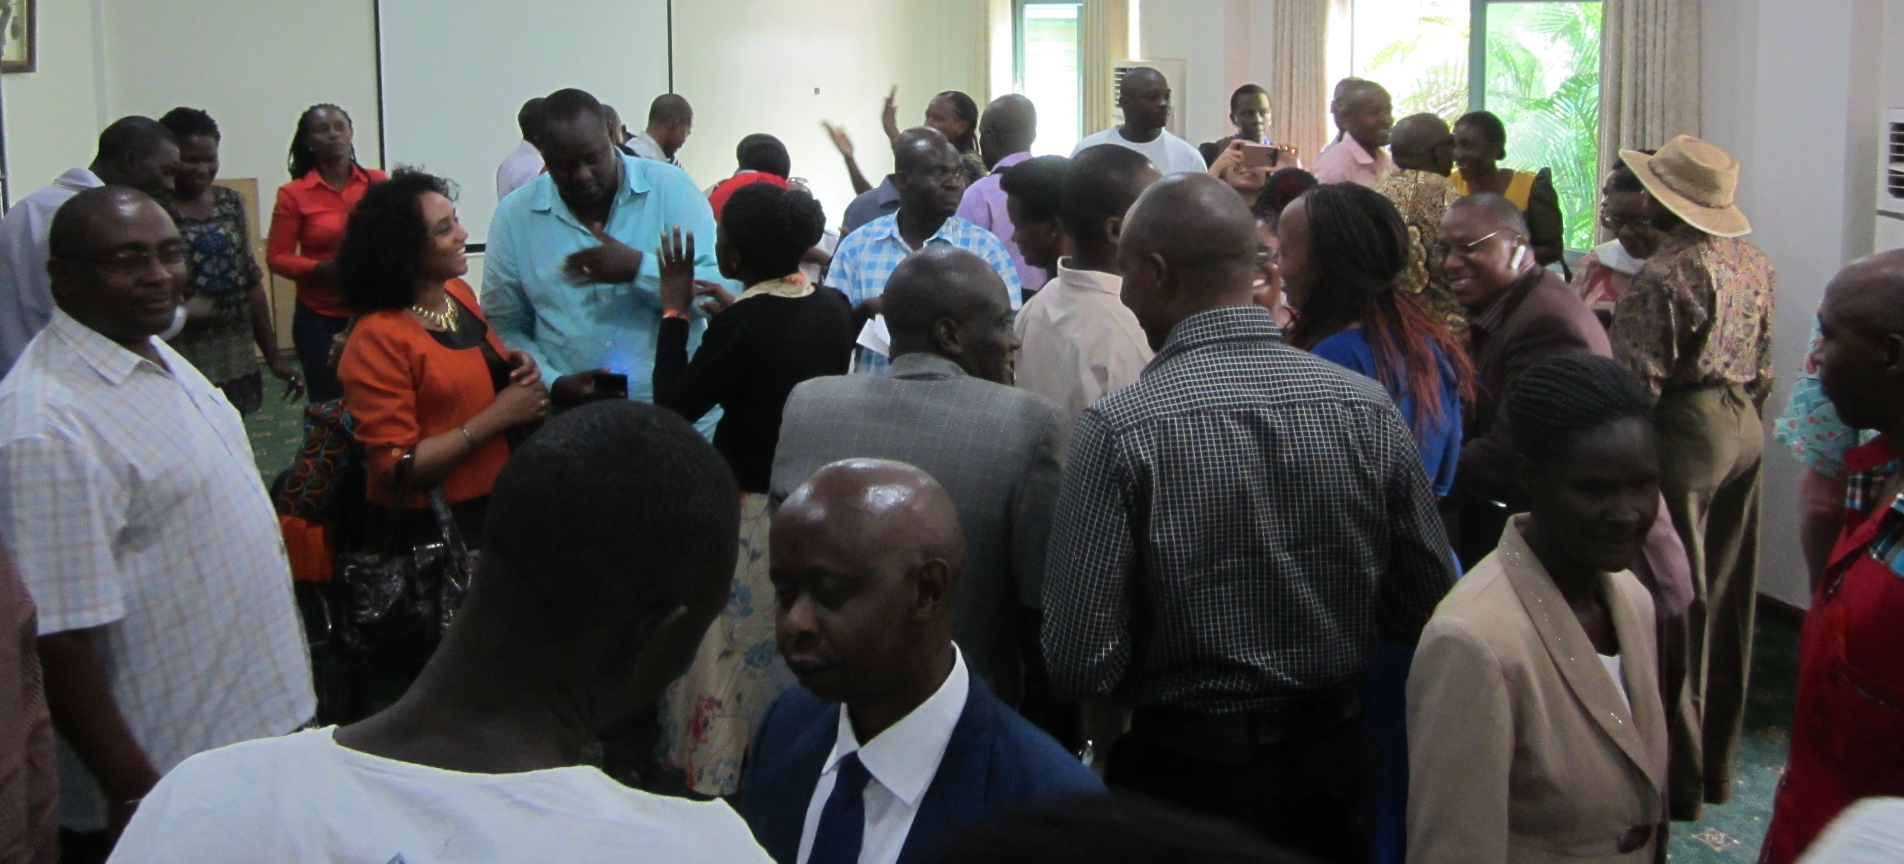
Caption: Picture of the Bridge CRPD-SDGs East West Africa –
Participants during Module 1, doing a ‘Speed dating’ activity. © Tchaurea Fleury
- rationale

Bridge CRPD-SDGs builds on IDA-IDDC analysis of lessons learned in their work which explicitly show the following, inter alia:

1. Disconnection between human rights and inclusive development
Advocating for ‘all human rights for all persons with disabilities’ is urgent yet also complex. The CRPD sets high standards and obligations to ensure the effective realisation of all human rights (i.e. covering all sectors and dimensions of life) for all persons with disabilities (acknowledging diversity of gender, age, culture, impairments, ethnic origin, etc.). However, its implications are rarely addressed equally for the diversity of groups that form the disability movement. The CRPD is also a fairly complex treaty (e.g. introducing notions such as reasonable accommodation, supported decision making), and translating its provisions in different contexts is equally complex.
This implies, among others:

- The need to take into consideration international cooperation without undermining the role and duties of the States (Articles 4 and 32);
- The need to address CRPD provisions and policy reform (including through inclusive development and the SDGs) concurrently to avoid a disconnect between human rights standards, and the mechanics required to translate them into local realities;
- The need to confront the practice of over-reliance on laws and/or even on INGOs and the lack of critical analysis about issues related to public policy implementation, especially public budget.

“Since this Training Initiative, the West African Federation of Organisations of Persons with Disabilities (WAFOD) has become one of the best organizations of people with disabilities in Africa. We have now become fundraisers of projects to reinforce DPO’s capacities, and no longer just recipients of funds. We now accompany DPOs and partners into inclusive disability development. We must remember what we were in 2011. This federation was completely on the ground.”
Siddo Oumarou, Niger

“Due to our advocacy after Bridge, Government has done the following:
Two out of the four counties where we are presently working are benefitting from the County Development Fund. Persons with disabilities are engaging duty bearers on issues and using the CRPD as a guide.”
Celio George, Liberia

2. Capacity gaps and the need for complementary efforts to address these gaps
Many DPO advocates have been left out of the system, for example, through denial of access to education. Hence, they may lack the skills to engage in actions challenging large scale systemic discrimination and unjust systems, including regarding budget allocation, and to hold governments to account. Significant efforts are therefore required to increase the numbers of skilled DPO advocates and leaders who can take action and challenge the status quo, especially in the Global South where the majority of persons with disabilities live. Observations also demonstrate:

- A disconnect between the obligations set by the CRPD and how DPOs perceive and experience the reality at national and local levels;
- Huge gaps in DPOs’ capacities to understand the complexity of the public policy reform and to influence its design, implementation, monitoring, evaluation and reforming;
- The importance of substantial training to ensure sufficient time and opportunity for people to challenge their own perceptions and biases and understand the implications of the CRPD for their own practice, in terms of promoting and realising all rights for all persons with disabilities;
- The need to build the capacity of DPOs to practice inclusive cross disability capacity development through practical participatory methods;
- Highly technical topics such as legal harmonisation, strategic litigation, budget advocacy should be further explored as a separate “specialisation” module;
- While ongoing training investment and capacity development of DPOs by IDA is essential, IDDC through its members has a stronger capacity to meaningfully involve DPOs in advocacy for inclusive development and policies.

“When we are called to the table, and we are not deep in knowledge, then that may not work for us. It's my prayer that more and more people see this dream. That more and more of us have power. Because I realise that it's empowered individuals who change societies.
It is about having an empowered movement and indeed important how the Alumni are called upon to commit to continue to build the movement after their participation in Bridge.
And, in this case, it's all about the paradigm shift. It's amazing!
We need to have more and more persons in key decision making positions to know Bridge, understand Bridge because then even at country levels it would help that more managers would then in their own ways prioritise capacity building of DPOs using Bridge and even if not Bridge, programs inspired by Bridge such as the two and half-days workshops.”
Elizabeth Ombati, Kenya

“The IFRC staff that participated in the Bridge session with stakeholders we did at IFRC was really impacted by the experiences from DPO representatives (Bridge participants), the information they gained, and most importantly by talking with persons with disabilities themselves.”
Mina Mojtahedi, Disability Inclusion Adviser International
Red Cross Red Crescent Movement
3. Inclusion of all persons with disabilities needs to be addressed
Despite great achievements to raise awareness about the rights of persons with disabilities through global advocacy, inclusive societies are still far from the reality experienced by persons with disabilities, especially those living in the Global South. Compelling evidence can be found in a number of reports and analyses, as well as from consultations with persons with disabilities themselves, such as those held to develop the SDGs. Also,

- Some groups of persons with disabilities and their voices are underrepresented in the disability and development arena, such as persons with intellectual disabilities, persons with psychosocial disabilities and people with deafblindness;
- Many DPOs have never experienced working with persons from underrepresented groups together as peers;
- The importance of inclusive methods in advocacy, training, awareness-raising so that persons with disabilities are equipped not only with the content but also the skills to convey their message in an efficient and inclusive way;
- The importance of building a training curriculum using practical examples from the diversity of low and middle income contexts (that is concrete and context-sensitive).

“Bridge has shown us that all CRPD articles are so crucial to all of us.
I had increased my knowledge. I had gained confidence. And I had realized that it is worth having the training to all persons with disabilities together. If I had not been trained by Bridge, I would not know how I can be an empowered leader to discuss with other INGOs, NGOs, CSOs, etc. plus at the international level. Thumbs up!!!”
Carolyne Dagani, Phillipines

“After the training, I was part of the team from the various Disabled People’s Organizations in Fiji who lobbied the government of Fiji to ratify the United Nations Convention on the Rights of Persons with Disabilities and also to passing the Fiji’s Rights of Persons with Disability Act 2018. I was also working with the Fiji Elections Office in ensuring that the 2018 general elections were accessible to all. After pushing for our issues, the government through the Fiji Elections Office approved that persons with disabilities in Fiji can take a person of their own choice to assist voters with disabilities to vote.”
Anaseini Vakaidia, Fiji

4. Building a critical mass of skilled DPO advocates representing the diversity of constituencies in all regions requires coordinated efforts
The scope of work of the Bridge CRPD-SDGs Initiative requires coordination of efforts drawing from different sources of expertise (e.g. in-depth understanding of the CRPD and its enforcement, inclusive facilitation skills, inclusive policies and governance, Agenda 2030). It requires drawing from the resources of diverse constituencies. It also needs a clear strategy for roll-out, replication across the regions, and coaching to build a critical mass of DPO advocates and trainers to accelerate changes at national and regional levels, building on the momentum created by the SDGs.

“The Bridge initiative links us all as Human Rights Defenders and advocates to the rights of persons with disabilities.”
Patrick Ramarson (Madagascar)

"I learned thanks to our colleagues in Bridge the notion that despite we are all different, we are equal, and that the intellectual disabilities do not limit the participation."
Participant from Bridge MENA 1(Feb 2019)

“Morgan Tjakrawinata now formed a new organisation (Yapesdi) that supports youth with intellectual disabilities to speak up about their rights. Bridge had changed him a lot. He feels not alone and asked his mother to support him to form a group of youths with intellectual disabilities to learn how to speak in public and speak up about issues that affected them. It was in Bridge training for the first time that Morgan gave a speech in front of people, and exposed to the diversity of disability community.”
Dwi Ariyani, regarding Bridge Indonesia

- Background

Bridge CRPD-SDGs is a direct response to the limited capacity of the disability movement, to truly implement the ‘Nothing About Us Without Us’ motto of the CRPD and the ‘leaving no one behind” from the Agenda 2030, particularly in countries from the Global South.
Bridge CRPD-SDGs significantly draws from two experiences, the Training of Trainers, Advocates and Leaders (ToTAL) developed by IDA and the Training of Trainers on Inclusive Facilitation (ToTIF) developed by IDDC.
ToTAL (Training of Trainers, Advocates and Leaders)
ToTAL was a training curriculum developed by IDA in response to the need to create a joint training curriculum to provide guidance to DPOs on advocacy for implementation of the CRPD in the Global South. This training was piloted in three regions:
- West Africa, in partnership with the West Africa Federation of DPOs (WAFOD) and Handicap International (in French),
- South Asia, covering Nepal, India and the Philippines, in partnership with Disabled Peoples’ Organisations Denmark (DPOD),
- The Pacific, in partnership with the Pacific Disability Forum (PDF) and with AusAID funding.

ToTAL was adapted to various contexts, and comprised at the minimum of two modules. Module 1 (10 days) focused on ensuring that participants developed a comprehensive and inclusive understanding of the CRPD, followed by an assignment. Module 2 (7 days) was organised six months later focusing on policy analysis and review. Pacific and West Africa undertook a Module 3 for consolidation and review of post-training assignments. Altogether 68 participants took part in ToTAL trainings over 3 years.

ToTIF (Training of Trainers on Inclusive Facilitation)
ToTIF was developed through dialogue amongst members of the IDDC Facilitators’ Forum over the course of a year in 2014. The rationale for ToTIF was the importance to ‘walk the talk’ and ensure training on inclusive development is being delivered in an inclusive manner, showing inclusion by example. ToTIF was led 100% by persons with disabilities for a participant group that was 100% composed of people with disabilities from Africa and Asia. This resulted in a 5-day curriculum aimed at building the capacity of trainers with a disability to gain confidence in inclusive training and facilitation skills, as a core foundation in promoting greater awareness on disability inclusive development. ToTIF was piloted for 8 participants from Thailand, the Philippines, Uganda, Kenya, Tanzania and Indonesia in November 2014 and integrated in a post-ToTAL training for French-speaking Africa in 2015.
Furthermore, it also built on IDA’s work to support DPOs to monitor the CRPD’s implementation both towards the Human Rights mechanisms, such as Treaty Bodies and the Universal Periodic Review, and the development mechanisms, such as the High-level Political Forum (HLPF).

“The Bridge Initiative supported me to actively contribute to preparation of reports for submission to different UN bodies such as the UN treaty bodies and as well as SDGs.”
Abner Manlapaz, Phillipines

“Bridge supported me to be involved in different tasks, including flagships such as the recent elaboration of the SDGs-CRPD regional report. I’m better equipped to provide technical support to OPDs in the elaboration of the alternative reports for the CRPD committee and other treaty bodies. All what I learned in Bridge was very useful to reflect and analyze the information collected to elaborate the SDGs-CRPD regional report for RIADIS.”
Rosario Galarza, Peru

“I have been selected as a technical expert to help the writing of a report for a federation of Vietnamese DPOs toward SDGs through the Bridge Alumni and facilitator network. It has been a great opportunity to learn about a different legal system and the way in which policies and programmes function, and in addition, as it is a country in which the Washington Group Set of Questions has been used, it has been a great learning experience to see the manner in which these questions have yielded data on the inclusion of persons with disabilities.
Amba Salelkar, India

- ObjectiveS
Bridge CRPD-SDGs is a training programme of 2 modules which is part of a broader training initiative.
General objective
To build a critical mass* of DPO activists and allies able to advocate for CRPD-compliant enforcement of the SDGs.
* By critical mass we refer to a relevant diversity of resourced disability activists in position to influence or motivate changes in public policies making them inclusive and more respectful of persons with disabilities.

Specific objectives
1. To expose DPO representatives and allies to in-depth discussions on concepts of the CRPD,
2. To strengthen their abilities to articulate CRPD and SDGs concepts as interconnected and to learn how to use them to influence public policies,
3. To promote a more inclusive and holistic disability movement, embracing underrepresented groups such as persons with intellectual disabilities, people with psychosocial disabilities, people with deafblindness, indigenous peoples with disabilities,
4. To be exposed and understand tools of inclusive facilitation,
5. To intensify relationship between umbrella (or more predominant) DPOs with informal (or early constituted) networks of underrepresented groups,
6. To strengthen opportunities between DPOs and IDDC members to jointly work at regional- and country-levels,
7. To create hubs of Alumni to provide technical support to partners, government, UN agencies, private actors and others, such as help-desks,
8. To strengthen technical capacities of persons with disabilities to become inclusive facilitators with strong knowledge on the CRPD, Agenda 2030, use of UN monitoring mechanisms, inclusive public policies, among others, to reverse the existing power dynamics.

Both general and specific objectives are implemented through promoting and ensuring technical and well-coordinated support for the effective and quality implementation of a Bridge cycle (including the modules, training of trainers, mentoring and coaching, assignments, inclusive and adapted material, the community of practice/Alumni).

To ensure the accomplishment of the Bridge Initiative, a Steering Committee was established to provide guidance, promote the Initiative and secure the means required for quality and sustainability, such as the creation of a pool of accredited Bridge CRPD-SDGs trainers, and a quality criteria guide to support the coordination of training programmes or defining modalities of engagement in the broad Bridge CRPD-SDGs Initiative.

A Coordination Team was also established and mandated by the Bridge CRPD-SDGs Steering Committee to provide coordination for the effective and quality implementation, development and monitoring of the Bridge CRPD-SDGs Initiative, in partnership with concerned stakeholders and allies, thought the Task Teams.
“As part of the knowledge I obtained in Bridge CRPD-SDGs, I led a group of people in drafting a bill to give representation of persons with albinism in addition to other interested groups in the Ugandan Parliament. Today the bill was passed and it will be assented to by the President next week. Thanks again for the mentorship and training, I send my humble appreciation to the Bridge funders and facilitators.”
Okwii Simon Peter, Uganda

Expected outcomes
Bridge CRPD-SDGs participants will be able to meaningfully:

- Engage and act in the promotion of an inclusive (all persons with disabilities) and comprehensive (all human rights) CRPD perspective on development, including in policy debates linking the CRPD and SDGs implementation, legal harmonisation, public budget, policy reforms;
- Engage with other civil society and state actors to ensure mainstreaming of rights of persons with disabilities;
- Engage in monitoring of CRPD and SDGs;
- Engage in further capacity development of DPOs - using inclusive methodology for cross disability movement building and joint advocacy.

“Thanks to tools provided by Bridge, our Federation was invited to train Senegalese government officials, OPDs representatives and members of the inter-ministerial committee on disability. It is a high-level training with 45 participants, including National Directors, which are disability focal points that will be deployed in all ministries of the country. We are grateful to influence transversal use of the CRPD in Senegal.
Rose Diakité, Mali

DEVELOPMENT OF THE TRAINING PROGRAMME

2010-2013 | The first training exchanges between IDA and IDDC were started through ToTAL, which was piloted in partnership with members of IDDC
2013-2014 | The experience of ToTAL was shared by IDA with IDDC’s DPO Partnership Task Group (Dec 2013), and the IDDC Facilitators’ Forum (April 2014)
Nov 2014 | ToTIF pilot training
April 2015 | A 2-day dialogue was organised between members of IDA and IDDC (including representatives of DPOs from different regions) to engage in the development of a joint curriculum. After reviewing existing training experiences, participants discussed the opportunity of a joint training initiative, agreed on an overall training strategy and programme (including modules, assignments, coaching) and developed a draft outline for Module 1
July 2015 | The curriculum outline was then further reviewed and enriched by several contributors, including IDA, IDDC and former ToTAL and/or ToTIF trainees. A first attempt to merge focus on CRPD and SDGs was attempted with a French speaking ToT for DPOs from Maghreb & West Africa that took place in Morocco for former ToTAL trainees
Aug 2015 | A preparatory meeting was convened to build on the draft curriculum and further develop the objectives and training plan for Module 1, in view of pilot Bridge modules 1 in South East Asia and Latin America
Oct 2015 | Pilot Bridge Module 1 in South East Asia (9 days, 10 countries, 30 participants)
 | Pilot Bridge Module 1 Latin America (7 days, 11 countries, 17 participants)
Nov 2015 | Pilot Bridge Module 1 in Indonesia (7 days, 2 countries, 28 participants)
Dec 2015 | Pilot Bridge Module 1 in Rwanda (6 days, 4 countries, 14 participants) facilitated by 3 WAFOD trainers
Jan 2016 | IDA and IDDC facilitators reviewed pilot Module 1 experiences, defined Module 2 and started sketching a roll-out strategy to ensure quality, promote the initiative and optimize the impact of the training
Feb-Mar 2016 | IDA and IDDC Boards agreed to set up a Bridge Steering Committee to take the Bridge initiative forward, including quality assurance, promotion and mobilisation of trainers
 | Training of Trainers in Geneva, Module A, (5 days, 15 participants) facilitated by IDA, and involvement of DPOD, SSI, CBM and DRF
 | Pilot Module 2 South East Asia (same participants, 7 days)
May 2016 | Pilot Bridge Module 1 in Pacific (7 days, 11 countries, 22 participants) facilitated by IDA, PDF, WFD, CBM and DRF trainers
June-July 2016 | Pilot Bridge Module 2 Latin America (6 days) and Indonesia (6 days)
June 2016 | Training of Trainers in Washington, Module B, (5 days, 10 participants)
Nov 2016 | Pilot Bridge Module 1 East & West Africa (7 days, 10 countries, 31 participants)
Nov 2016 | Pilot Bridge Module 2 in Rwanda (6 days, 4 countries and 15 participants)
Feb 2017 | Training of Trainers in Geneva, Module A (6 days, 13 countries, 14 participants), with members from II, WBU, WFD, IFSBH, IFHOH, PDF, RIADIS, CBM, HI, LFTW)
Mar-April 2017 | Pilot Bridge Module 2 in Pacific (7 days, 11 countries, 22 participants) facilitated by IDA, PDF, WFD, CBM and DRF trainers
May 2017 | Pilot Bridge Module 2 East & West Africa (7 days, 10 countries and 30 participants) Nairobi, Kenya
June 2017 | Technical meeting was convened in Geneva among IDA, IDDC Chair and CBM lead trainer at Pilot Bridge East & West Africa, with Bridge CRPD-SDGs team
Sept-Oct 2017 | Training of Trainers in Brighton, Module B (8 days, 11 countries, 16 participants), facilitated by IDA, and involvement of SSI, CBM and DRF
Oct 2017 | Bridge CRPD-SDGs Steering Committee meeting, Athens
Feb 2018 | Training of Trainers in Geneva, Module A (6 days, 9 countries, 10 participants)
Mar 2018 | Bridge Steering Committee, Beirut & Technical workshop Beirut on Art 11 and MENA cycles (4 days, 23 participants, 5 facilitators, 3 consultants)
April 2018 | Bridge Uganda Module 1, (7 days, 22 participants, 16 facilitators, 3 support to underrepresented groups), supported by IDA, ADF, CBM, ADD & BLF
May 2018 | Technical meeting convened in Brussels by CBM with consultants of Bridge M3 on Art 11
Oct 2018 | Training of Trainers Module B, in Dubai (10 days, 12 countries, 12 participants)
Nov 2018 | Bridge Uganda Module 2, (7 days, 22 participants, 10 facilitators, 3 support to underrepresented groups), supported by IDA, ADF, CBM & BLF
Dec 2018 | Bridge Middle East and North Africa (MENA) Module 1, (7 days, 9 countries, 30 participants, 6 facilitators)
Mar 2019 | Bridge CRPD-SDGs Steering Committee meeting, Madrid
March 2019 | Training of Trainers Module A, in Geneva (8 days, 9 countries, 16 participants, 4 facilitators), supported by IDA, II, WAFOD, DPOD, LFTW, DFAT, MOFA, DFID, DRAF and CAGI.
May 2019 | Technical meeting convened in Brussels by CBM with members of the facilitation team of Bridge M3 on Art 11
Jun 2019 | Bridge CRPD-SDGs Module 3 on Art 11, in Beirut (8 days, 30 countries, 28 participants, 7 facilitators and 4 inclusion support team members)
July 2019 | Bridge Tanzania Module 1, in Dar-es-Salaam, (in its native language Swahili, 7 days, 15 participants, 7 facilitators all from the African region), supported by IDA, ADF, CBM/ NLCF (previous BLF) and NAD
Oct 2019 | Bridge MENA 2, Cairo, (In Arabic and English, 7 days, 26 participants, 7 facilitators, 9 countries), supported by AOPD, IDA, DPOD, CBM, DFAT, the European Union Civil Protection and Humanitarian Aid and MOFA
Nov 2019 | Bridge Francophone West Africa Module 1, Niamey, (in French and Portuguese, 7 days, 31 participants, 6 facilitators, 2 in the ToT process and 1 support team member), supported by WAFOD, ADF, IDA, HI, EU, DPOD, CBM, LFTW, DFAT, MOFA and the Belgium Cooperation
Dec 2019 | 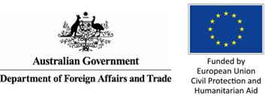  Bridge Asian multi-countries Module 1, Kathmandu, (in English, with simultaneous interpretation on Laos, Nepali and Tamil, 30 participants, 6 countries and PDF ToT, 10 facilitators, supported by IDA, DPOD, TCI-Asia Pacific, CBM, HI, MOFA Finland, DFID and the Open Society Foundations.

“DPOs in Uganda have engaged in budget analysis to help in overseeing the health expenditure at the district. DPO analyses budget allocations to different departments in the Kingdom to advocate for more funding to the Department of Disability so that it gets enough financial backing to effectively carry out its mandate.
We also analyzed annual budgets of Wakiso District in the capacity of the Hon. Council Member to determine financial strategy and allocating resources for disability programming via Council Budgetary Workplan.
We are also analyzing budget for advocacy on increasing of funds for public universities with focus on affirmative action.”
DPOs in Uganda

- TRAINING approach
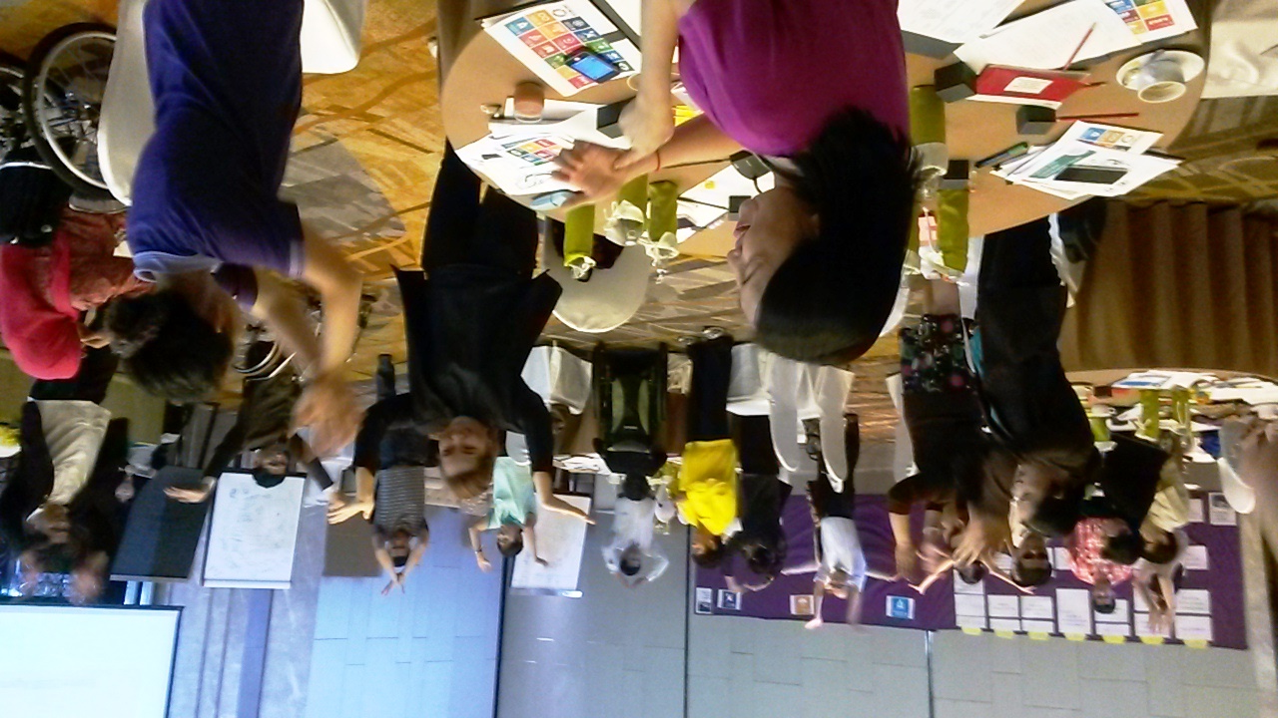
Caption: Picture of Bridge CRPD-SDGs South East Asia participants during Module 2, doing an energiser proposed by one of the participants. ©Priscille Geiser

Key working principles of Bridge CRPD-SDGs

Bridge CRPD-SDGs strives to enact the general principles of the CRPD throughout its training objectives, content, and facilitation methods. In addition, it enshrines the principles of:

- By, for and with persons with disabilities - targeting DPO advocates as the primary audience, it aims to equip self-advocates with the skills required to participate and influence decisions that affect their lives, in line with the motto of the disability movement ‘Nothing About Us Without Us’ and the ‘leaving no one behind” from the Agenda 2030, particularly in countries of the Global South. Therefore, the majority of Bridge CRPD-SDGs participants should be persons with disabilities (80%). This is equally true to co-facilitators and trainers.
- Ensuring and promoting diversity - Working cross-disability: attention is paid to ensure the optimum representation of the diversity of the disability movement among participants (and facilitators as possible), including a gender balance, representation of people with different types of impairments reflecting at least the disability groups included in article 1 of the CRPD, and persons with disabilities from ethnic minorities, as enshrined in the Bridge Basic Quality Criteria.

- Inclusiveness: Bridge CRPD-SDGs puts emphasis on inclusiveness and strives to ensure inclusive facilitation for all groups and participants. This requires significant attention to accessibility, reasonable accommodation requirements, different learning styles and rhythms, different ways of engaging and communicating. This should be ensured by mobilizing accredited Bridge CRPD-SDGs trainers and co-facilitators and applying the use of diverse tools and methods to get feedback from participants and optimise participation and learning.
- Participatory methods - Valuing participants’ expertise: in line with principles of adult learning, Bridge CRPD-SDGs is based on mobilization of participants’ knowledge and is meant to be very practical and participatory. Each participant is selected in relation to her/his experience, knowledge and active contribution to the promotion of rights of persons with disabilities and they are expected to actively contribute to the content of the training.

- Quality: Bridge CRPD-SDGs partners need to strive for optimum quality of the training, aiming high in terms of content, organization, facilitation methods and enacting of the Bridge CRPD-SDGs values and principles. Quality assurance mechanism include:
  - A process of accreditation of Bridge CRPD-SDGs trainers and co-facilitators;
  - Training material and resources, and set of quality standards;
  - 2 modules of 7 days each with assignments for participants in between;
  - Mentoring support of participants between Module 1 and 2 to complete assignments;
  - A process for certification of participants.

- Commitment to peer accountability and learning to promote CRPD compliance – Partners commit to contribute and engage with others to ensure mutual learning through a Bridge CRPD-SDGs Alumni network and to encourage continuous dialogue and to share among participants.

- Open source and acknowledgement: All material produced in the frame of Bridge CRPD-SDGs will be under creative common license. Partners should ensure credit of IDA/IDDC as initiators and authors of Bridge CRPD-SDGs contents (creative common license).

- Not for profit: Bridge CRPD-SDGs material and methods are meant to be open source and free to use by any organisation committing through the current working principles for non-profit purpose. It cannot be used by any participating organisation, participants or facilitators for commercial gain.

- Enabling environment: Guidance on the requirement for enabling environment is being prepared by the Bridge CRPD-SDGs team. The IDA secretariat is available to provide information in the meantime. Its modalities have to be discussed and validated by the Bridge CRPD-SDGs SC.

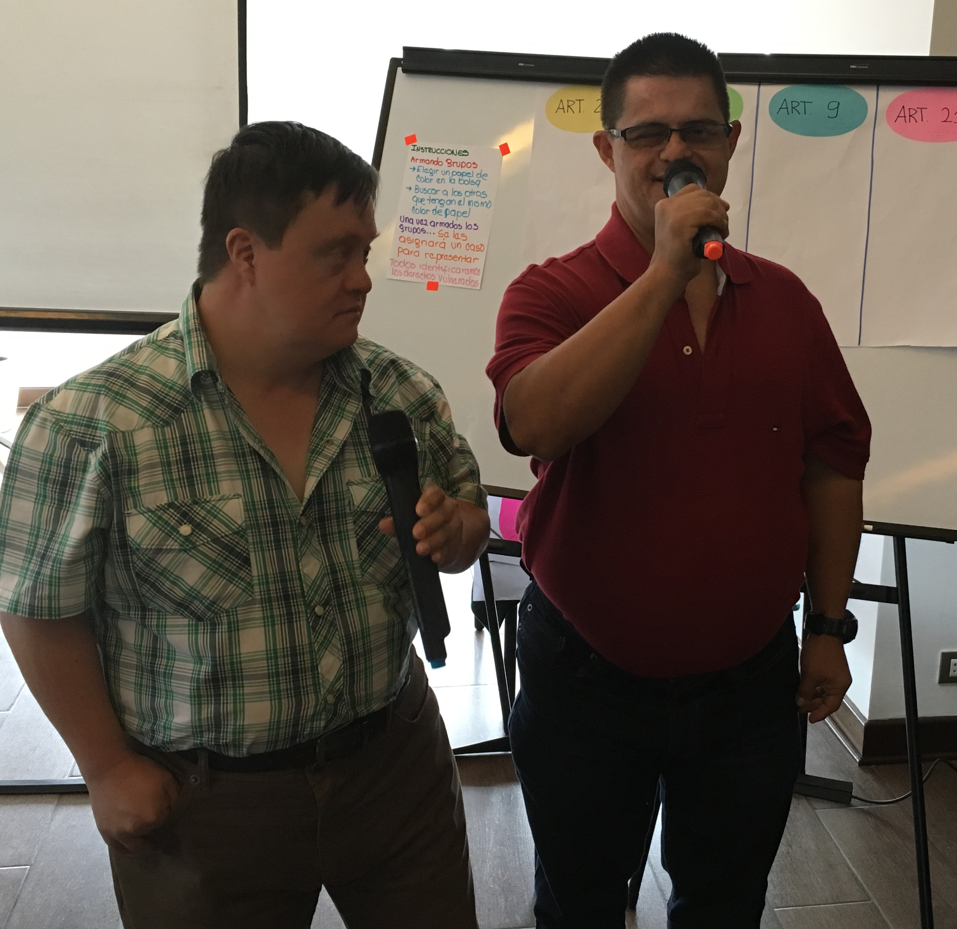
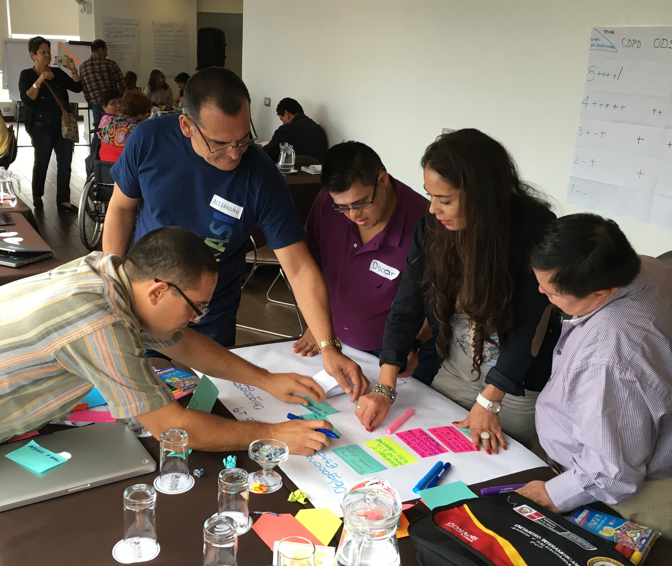

Caption: On the left, a group creating a presentation. On the right, two participants presenting a session on self-advocacy and their rights. Both moments were during Bridge CRPD-SDGs Latin America. @TFleury
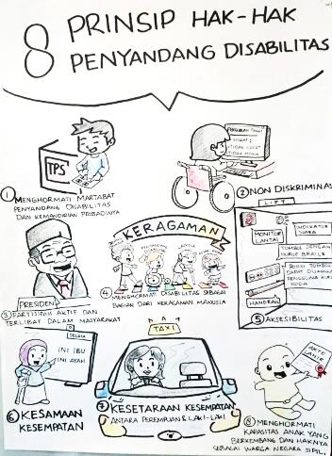
Caption: On the left, illustration of Article 29 drawn during South East Asia Module 1 training sessions by cartoonist Anan Prapaso. On the right, illustrations of CRPD principles drawn during Indonesia-East Timor Module 1 training session by Mr. Rotinsulu to support explanation of key messages to self-advocates.

“I am currently engaged in a very strategic role within the Disability Sector as I am providing CRPD alignment advice to the government’s Technical Working Group on the country’s draft Disability Authority Bill, which will soon be passed by parliament and I have played the initial advocacy key role in this development to achieve for my country to finally have a legislation on disability which the CRPD SDGs Bridge Training have greatly built my capacity to advocate and initiate this legislative process.”
Kevin Akike, Papua New Guinea

- CURRICULUM STRUCTURE

Overall training structure
The training is composed of two (02) core modules with a set of assignments to complement the learning and put the theory into practice:

Module 1 focuses on the development of knowledge and skills to UNDERSTAND the CRPD and start to ANALYSE development from a CRPD perspective;

Module 2 builds on this understanding and analysis to further develop knowledge and capacities to TAKE ACTION towards the full and effective participation of persons with disabilities, through different key advocacy routes (legal harmonisation, budgetary advocacy, inclusive programming, influencing for good disability data and evidence, etc.).

Module 2 also provides practical application of advocacy skills learned by engaging with government, donors or UN agencies.

Between Module 1 and Module 2 participants have to develop a policy brief on analysing a development issue in their own country from a CRPD perspective. The policy paper should be finalised after the Module 2 to receive the Bridge CRPD-SDGs certificate.

Additional optional modules are foreseen for participants who wish to go further. The Bridge Initiative proposes the trainer trajectory for participants to become facilitators and/or lead trainers:

- A Training of Trainers to support participants to disseminate the learning of the first two modules, with a focus on inclusive facilitation;
- Additional modules as co-facilitator in Bridge cycles on inclusive policy and governance including legal harmonisation, budget advocacy, inclusive programming or disability data;
- Training opportunities with IDA’s team at country-level to develop a more in-depth understanding of the CRPD (drawing from the CRPD advanced training developed by IDA);
- Practical exposure at state review processes before treaty bodies, the Universal Periodic Review or High-level Political Forum.
Further opportunities can be explored with IDDC partners nationally or regionally.

“After my Bridge training, I was involved in the shadow reporting of UPR and building capacities of DPOs on UPR. I also conduct trainings of SDGs for DPOs and VNR reporting.”
Ali Shabar (Pakistan)

“I conducted various trainings, discussions, seminars to disseminate CRPD-SDGs to the target groups. Provide input to the government in the preparation of the RAD SDGs, preparation of various regional regulations to village regulations.”
Nuning Suryatiningsih (Indonesia)

Structure of Bridge CRPD-SDGs training

As a work in progress, the Bridge CRPD-SDGs training is enriched with learning from each Bridge CRPD-SDGs cycle being delivered in different regions and countries. The overall process can be described in different steps as follows:

Step | What is expected from participants | Support IDDC and IDA can bring
Pre-requisite and selection of participants | To have a basic understanding of the CRPD and to have acquired basic skills, this may vary for different groups | Prior to the Bridge CRPD-SDGs training, IDA and IDDC members may provide preparatory training;  Support in identifying relevant potential participants to pass through the selection of participants (see the quality criteria).
Pre-training preparation | Ensure preparatory reading of the information shared in advance,  A preparatory day with underrepresented groups is also offered. | Share key preparation documents and guidance; webinars might be considered;  Support a day (or half day) preparation to all underrepresented groups.
Module 1 (7 days) | Engage actively in the training | Collaborative organisation; joint facilitation of sessions, mobilisation of trainers with disabilities from the region.
First assignment | In their respective country, participants should analyse CRPD compliance of one policy | Provide remote guidance/mentoring to support participants with their assignments.
Module 2 (7 days) | Engage actively in the training and the practical advocacy exercise  Account for their assignment | Collaborative organisation; joint facilitation of sessions, mobilisation of trainers with disabilities from the region;  Support with the reporting.
Completion of assignment | Finalise the policy paper | Provide remote guidance/mentoring to support participants with their assignments; certification.

Bridge Alumni have also reported on how the experiences in Bridge, the knowledge and skills, and the networking has been instrumental in supporting their organizational fundraising:

'After Bridge Module 1 in Uganda, we wrote a proposal, influenced by our learning on inclusive education, we will soon receive funding to implement a project on inclusive education,'
Christine Kirungi. Reports have been similar from Kenya, Nigeria.

Prerequisite
In preparation for Module 1, all participants need to carefully read:
- The Convention on the Rights of Persons with Disabilities (CRPD) from Preamble to Article 33,
- The Sustainable Development Goals (SDGs) and targets,
- General Comments from the CRPD Committee and thematic reports of the Special Rapporteur on the Rights of Persons with Disabilities.

Module 1
Learning objectives:
After the training, participants should:
- Be familiar with all CRPD articles,
- Have confidence in the CRPD principles,
- Be familiar with the SDGs and have confidence in recognising the linkages between the CRPD and the SDGs, applied to their development contexts / have an understanding of how the CRPD can support disability inclusion in the SDGs,
- Have been exposed to practice inclusive facilitation skills.

The Module 1 is focused on understanding the CRPD and its links to post-2015 development agenda and the SDGs.
During the pilot phases (2015 - 2017), the length of Module 1 varied from 6 days (Big Lakes Africa and Latin America) to 9 days (South East Asia). From 2017, the length of Module 1 is of 7 days, with a free afternoon on the 4th day, a team briefing before the training and a debriefing after, and a preparatory day with participants from underrepresented groups that require specific leaning support. Bridge MENA’s length was adapted to 8 days, due to the needed simultaneous translation considering the still limited number of co-facilitators equipped to deliver Bridge in Arabic.

Module 2
Learning objectives:
After the training, participants should:
- Be able to identify core CRPD articles and link them to specific SDGs,
- Familiar with the laws in their country and with their national development plan,
- Understand public policy and able to identify main blockages and issues in its implementation,
- Be aware of differences between cultural beliefs, social roles and responsibilities considering gender identities and equality,
- Develop skills on how to influence development actors nationally and regionally for inclusion of persons with disabilities.

Module 2 is focused on applying this understanding and analysis via the diverse advocacy routes (legal harmonisation, budgetary advocacy, litigation, awareness campaign and others). It also promotes a privileged space to bilateral meetings with development actors in different regions.

From 2017, the Module 2 also follows the length of the Module 1 with 7 days of training, two previous days (facilitation team briefing and preparation with underrepresented groups), and a debriefing day with the facilitation team. Again, Bridge MENA was adapted to 8 days.

- TRAINING OF TRAINERS
Bridge CRPD-SDGs trainers and facilitators
Bridge CRPD-SDGs was started by an initial group of trainers and co-facilitators from very diverse backgrounds (see the list of contributors in Appendix 6). Bridge CRPD-SDGs modules mobilised trainers with and without disabilities, from the Global South, but also the North.

Diversity has been strengthened through 2017 with a pool of trainers and facilitators from underrepresented groups, including people with psychosocial disabilities, deaf people, persons with autism, persons with albinism, indigenous people with disabilities, among others. Facilitators with intellectual disabilities and deafblindness are also in their training trajectory.

The experience from different regions where the Bridge CRPD-SDGs modules have been piloted is being regularly reviewed. Three ranges of core skills are required for a successful Bridge CRPD-SDGs facilitation, they cover advanced CRPD skills, inclusive governance and policies, and inclusive facilitation.

Fig. B – Core skills for Bridge CRPD-SDGs trainers and co-facilitators

Caption: The above slide represents 3 intersecting circles of CRPD, governance and policy, and inclusive facilitation.
Bridge CRPD-SDGs is a demanding experience which requires at least one lead trainer and three co-facilitators with complementary skills and expertise. Bridge CRPD-SDGs lead trainers are expected to have core expertise in one of the three areas as well as a confirmed level in the other two areas. The process of accrediting trainers is defined with support of the Bridge CRPD-SDGs Steering Committee and Coordinator.

Bridge CRPD-SDGs in the landscape of disability trainings
The curriculum of the Training of Trainers (ToT) was developed by IDA, with direct engagement from IDA and IDDC members as well as DRAF, in order to respond to the increased demand on highly qualified trainers on a diverse curriculum covering in-depth issues related to the Convention on the Rights of Persons with Disabilities’ (CRPD) and the Sustainable Development Goals (SDGs)’ implementation.

Bridge does not intend to replace the diversity of training modules of various lengths or focus that exist around CRPD and disability-inclusive development (e.g. Community Based Rehabilitation (CBR), Disability-Inclusive Development, Inclusive Disaster Risk Reduction (DRR), Disability Equality Training, Inclusive Education, etc). Rather, it aims to develop a common understanding of key messages and skills for experienced DPO advocates to engage more efficiently in CRPD promotion and monitoring.
Over the past four years, Bridge CRPD-SDGs has proved to be a most advanced example of inclusive training on the CRPD respecting diversity, through differentiated approaches to accommodate different learning styles. Adequate attention to everyone leads to successful learning outcomes. The expectation is that those participating in Bridge CRPD-SDGs are already active and empowered advocates within their own constituencies. Bridge CRPD-SDGs builds on this and helps to strengthen opportunity for greater cross disability advocacy, network and movement building.

The strengthening of capacity of these trainers will foster guidance to organisations of persons with disabilities (DPOs) on advocacy for inclusive implementation of the CRPD and the SDGs in the Global South, with meaningful inclusion of underrepresented groups of persons with disabilities.

IDA and IDDC members can support this process by facilitating additional trainings and exposure in processes that influence inclusive public policies at country level, and reinforcing the Training of Trainers trajectory proposed for those that want to become Bridge facilitators /lead trainers.

“After the ToT in Geneva, fellow ToT colleagues and myself conducted a training on CRPD and CEDAW for women with disabilities and women activists in Indonesia.
Bridge helps me a lot in providing support to DPOs/DRF grantees in Indonesia.”
Dwi Ariyani, Indonesia

Fig. C – Bridge CRPD-SDGs in the landscape of disability-related training initiatives
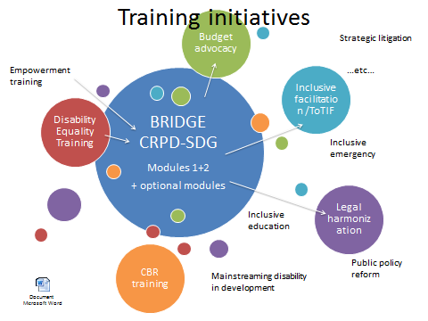

Caption: this slide shows bubbles of different sizes and colours to depict the variety of training initiatives that exist on the topics of disability rights and disability-inclusive development. It shows how the Bridge CRPD-SDGs bubble in the middle can be a way to develop common messages and a common cross-disability perspective to promote all human rights for all persons with disabilities. It is meant to complement other training initiatives such as inclusive facilitation training, budget advocacy training, CBR training, inclusive education training etc.

Core ToT modules
Bridge CRPD-SDGs Training of Trainers is composed of 2 core modules:
- Module A focuses on understanding the CRPD and inclusive development as well as analysing some key development issues from a CRPD perspective. It historically takes place in Geneva, late February or early March, concomitantly to the March session of the CRPD Committee, to allow great exposure of trainees to the Committee’s work, and meetings with relevant UN mechanisms, such as special rapporteurs, as well as UN agency and NGO officers who are Geneva-based;

- Module B focuses on public policy, CRPD and SDGs implementation in different country contexts; applying this understanding and analysis via the diverse advocacy routes (legal harmonisation, budgetary advocacy, litigation, data collection, among others). It takes place in October each year, wherever relevant to the curriculum, either in the Global South or in the North. For instance, ToT B 2018 took place concomitantly to the World Data Forum, in Dubai, in 2017, it was during the Financing for Development Conference, in Ethiopia. It can be in any place or during any relevant event decided by the responsible Task Team.
In addition, trainees also:
- Participate as co-facilitator in a full cycle of Bridge CRPD-SDGs (2X 7 days),
- Write a policy paper on a key CRPD-SDGs topic,
- Get active involvement in submission for treaty bodies, UPR or HLPF country review,
- Provide distance support on technical mentoring for 18 months.

The ToT process is tailored to ensure that by the end of the process each trainee is in a position to be a Bridge CRPD-SDGs co-facilitator. This is an intensive process needed to develop the comprehensiveness and depth required for delivering trainings like Bridge CRPD-SDGs. Any certified Bridge CRPD-SDGs facilitator will be in position to deliver multiple level of CRPD and SDGs related training of different lengths to different audiences.

Co-facilitators may also experience different trajectories to access the ToT process, which can be either:
- Successfully completing a full Bridge CRPD-SDGs cycle as participant, and completing at least one of the ToT modules, benefitting from mentoring as well as mentoring some participants,
- Successfully completing a full IDA ToTAL cycle (Training of Trainers, Advocates and Leaders), and participating as co-facilitator, observer or support person in at least one Bridge Module, mentoring and supporting some participants,
- Actively engaging in a UN monitoring mechanism review supporting national DPOs and participating as co-facilitator, observer or support person in at least one Bridge Module, mentoring and supporting some participants,
- Being a key resource person from an underrepresented group proposed by an IDA or IDDC member, who passed through both ToT modules while waiting for a Bridge cycle to act as a co-facilitator or resource person for underrepresented groups.

Inclusive facilitation
Bridge CRPD-SDGs is a fairly intensive program that puts emphasis on inclusiveness and will strive to ensure gender equality as well as full and effective participation and inclusion of all groups and participants reflecting the CRPD purpose and principles - all human rights for all persons with disabilities - and the agenda 2030 commitment to leave no one behind, which demands from the facilitation team to gather all the skills required to deliver the content of the curriculum with great inclusive facilitation ensuring optimal participation of all trainees.

The Bridge CRPD-SDGs Training of Trainers is based on mobilization of trainees’ knowledge and is meant to be very participative. Indeed, each trainee is valued in relation to her/his experience, knowledge and active contribution to the promotion of the rights of persons with disabilities and is expected to actively contribute to the content of the training.

This resulted in a 3-day curriculum aimed at building the capacity of trainers with disabilities and development actors to gain confidence in inclusive training and facilitation skills, as a core foundation in promoting greater awareness on disability inclusive development. This is imparted as part of Module B of the ToT course.
- HOW TO ENGAGE IN BRIDGE CRPD-SDGs?

The scope and ambition of Bridge CRPD-SDGs, as well as the way it was conceived requires a collaborative approach, and therefore contributions and further support are needed. Bridge CRPD-SDGs was started by a group of committed disability trainers, advocates and development workers, who all undertook this experience alongside their main occupation and commitments. To sustain the initiative, both coordination and institutional support is required. Bridge CRPD-SDGs is intended to be open for use by a wide range of stakeholders who agree and commit to the Bridge CRPD-SDGs objectives, values and principles.

Support is required at various levels, for example:
- Co-funding the Bridge CRPD-SDGs modules in different regions, including the ToT modules and engagement in post-Bridge training experiences,
- Involvement in the Task Teams of particular cycles,
- Facilitation of Bridge CRPD-SDGs training modules,
- Support the constant development of a pool of Bridge CRPD-SDGs trainers, through the Training of Trainers (ToTs) as well as their exposure to the UN monitoring mechanisms, such as Treaty Bodies, Universal Periodic Review and High-level Political Forum,
- Support pre-Bridge mechanisms and adaptation of materials to ensure wider reach and accessibility of the curriculum and material to all impairment groups,
- Encourage engagement of Bridge Alumni and trainees in diverse CRPD and SGDs monitoring and reporting processes.

Modalities of engaging as a Bridge CRPD-SDGs partner is defined in the Task Team Partnership Protocol.

Costs of Bridge CRPD-SDGs training
Average costs of the Bridge CRPD-SDGs training (1 cycle of 2 modules):

- Per person: 3,500 EUR (including travel, accommodation, food, reasonable accommodation), with variations depending on the region,

- A module with 60 people involved, including participants, facilitators, personal assistants, captioners, illustrators, sign language interpreters, among others: 110,000 EUR.

Co-funding of Bridge CRPD-SDGs modules till date:
Bridge CRPD-SDGs training | Co-facilitation | Co-funding
South East Asia (2015 & 2016) | IDA, WNUSP, CBM, HI, Inclusion International, Life Haven, Deaf Resources Philippines, Bapu Trust India | IDA Core (DFAT, MOFA, SIDA), ADD International, Atlas Alliance, CBM, DPOD, HI, LFTW, DRAF
Latin America (2015 & 2016) | IDA, HI, RIADIS, WNUSP, Inclusion International | IDA Core (MOFA), HI, RIADIS and CBM
Indonesia and East Timor (2015 & 2016) | IDA, DRF, Konas Difabel Indonesia | IDA Core (DFAT), DRAF & HI
Training of Trainers B 2016 Washington | IDA | IDA (MOFA, SIDA), DRAF
Big Lakes (2015 & 2016) | WAFOD, HI | HI
Consensus workshop 2016 | IDA and IDDC members & DRAF | IDA (DFAT, MOFA, SIDA), ADD, CBM, HI, LFTW, SSI
Pacific (2016 & 2017) | PDF, IDA, World Federation of the Deaf, DRF | IDA Core (DFID & DFAT), PDF (DFAT), DRAF & CBM
EWA (2016 & 2017) | IDA, CBM, ADF, SS, DPOD, II, WNUSP, HI | IDA (DFAT, SIDA, DFID, MOFA, UNFPA/Youth & OSF/co-leader salary), CBM, SSI, HI, DPOD, LFTW and DRAF (indigenous)
Training of Trainers A 2017 | IDA | IDA (DFAT, DFID, SIDA, OSF), CBM, HI
Training of Trainers B 2017 Brighton | IDA & CIP | IDA (DFAT, DFID), SSI, CBM, HI & DRAF
Uganda (2018) | IDA, ADF, NUDIPU, WNUSP, II, IFHOH, DSi, IFSBH, ADD, CBM, RIADIS, UNAD & WAFOD | IDA (DFID) and CBM (BLF)
Training of Trainers A 2018 | IDA, CBM | IDA (DFID, Ford Foundation), DRAF, Art 11 (IDA, CBM & HI)
Training of Trainers B 2018 Dubai | IDA, CIP & WBU | IDA (DFID, DFAT, MOFA, Bridging the Gap Project & TCI Asia), SSI, CBM, ADD International
MENA (2018 & 2019) | IDA, AOPD, II, WFD, ADD | IDA (MOFA), AOPD, DRAF & Art 11 (IDA, CBM & HI)
Training of Trainers A 2019 | IDA & WAFOD/ADF | IDA (DFID, MOFA & DFAT), DPOD, LFTW, and DRAF; with support from the Centre d'Accueil de la Genève Internationale (CAGI).
Module 3 on Art 11 2019 | IDA, WNUSP, Life Haven, CBM, Rescue International | IDA (DFAT, MOFA), CBM, DPOD, European Union Civil Protection and Humanitarian Aid, and the Bridging the Gap Project.
Tanzania 2019 | II, WNUSP, ADF, Bridge Fellow, IDSBH, Shivyawata | IDA (DFID), CBM (NLCF, previous BLF) and NAD

Annex 1 - Bridge CRPD-SDGs Module 1

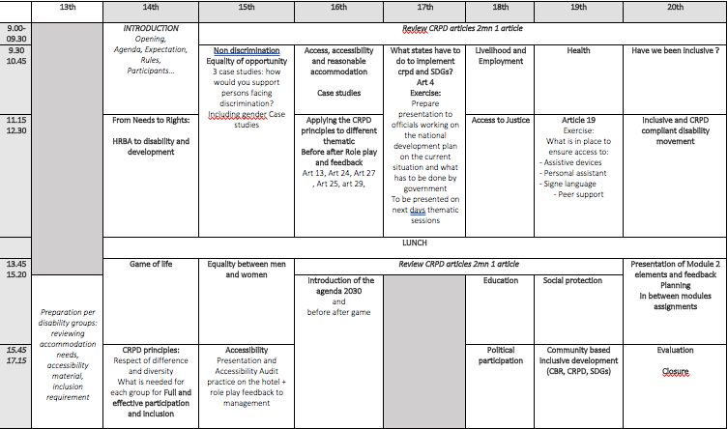

Annex 2 - Bridge assignment between Module 1 and 2

Post Module 1 assignments
After Module 1 all participants will have to complete an assignment which is a condition of their continued participation in Module 2:

A policy paper assignment: All participants have 5 months to develop a short policy paper (6 pages) on analysing a development issue from a CRPD perspective and the implementation of a key provision of the CRPD in her/his country, including
- Short description of the development issue (e.g. access to health, education, justice….) for the general population as well as in terms of the impact/restriction of social participation of persons with disabilities, preferably by using existing available statistical data and other type of evidence
- Identification of key issues with regards to the compliance (or not) of the legal framework with the CRPD
- Identification of bottlenecks in policy implementation (e.g. budget, human resources…).
- Formulation of recommendations

The policy paper should be sent to the Bridge co-facilitators one month before Module 2.

Note: Written assignments are not academic assignments but rather practitioner ones and will be assessed as such. Moreover, as English is not the mother tongue of most participants, assessment of assignments will focus on the content, in particular assessing the adequate understanding and use of the CRPD in analysis and quality of information and references provided. Assignments can also be submitted in sign language multimedia file and alternative format.

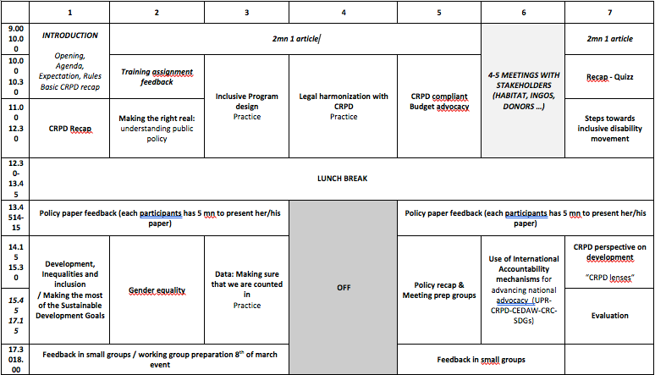
Annex 3 - Bridge CRPD-SDGs Module 2

Annex 4 – List of contributors to Pilot Bridge CRPD-SDGs

People listed below have contributed to the development of Bridge CRPD-SDGs training modules and/or facilitation of session(s) in different regions from 2015 to 2017.

Name | Organisation | Country | Role
Abner Manlapaz | Life Haven | Philippines | Participant
Alex Cote | International Disability Alliance (IDA) before 2017, Center for Inclusive Policy (CIP), from 2017 | France | Design Bridge & lead trainer
Alexandre Mapurunga | Latin American Network of NGOs of Persons with Disabilities and their Families (RIADIS) | Brazil | Co-facilitator
Anderson Henao | Handicap International | Colombia | Co-facilitator
Angeline Chand | Pacific Disability Forum (PDF) | Fiji | Co-trainer
Anna MacQuarrie | Inclusion International | Canada | Design Bridge & co-facilitator
Ansofie Leenknecht | European Disability Forum (EDF) | Belgium | Design Bridge - participant
Berhanu Tefera | African Disability Forum | Ethiopia | Design Bridge & co-lead trainer
Bhargavi Davar | Bapu Trust | India | Design Bridge & co-facilitator
Brianna Wilson | CBM Australia | Australia | Co-facilitator
Carolyn Dagani | National Federation of the Deaf | Philippines | Co-facilitator
Carlos Rios | Former member CRPD Committee | Mexico | Resource person
Christina Parasyn | Disability Rights Fund (DRF) | Australia | Co-facilitator
Daniel Mont | Center for Inclusive Policy (CIP) | USA | Design Bridge & co-facilitator
David Corner | Inclusion International | New Zealand | Resource person
Dwi Ariyani | Disability Rights Fund (DRF) | Indonesia | Co-lead trainer
Eeva Tupi | World Federation of the Deaf (WFD) | Finland | Design Bridge – participant
Elena Down | CBM | Australia | Design Bridge & co-facilitator
Fatma Wangari | Inclusion International | Kenya | Co-lead trainer
Gabor Gombos | World Network of Users and Survivors of Psychiatry (WNUSP) | Hungary | Design Bridge & co-facilitator
Getty Fefoame | Sightsavers | Ghana | Co-facilitator
Imed Ouertani | BRIDGE CRPD-SDG Fellow | Tunisia | Co-facilitator
Kathy Al Jubeh | CBM | Ireland | Design Bridge, lead trainer
Liza Martinez | Deaf Resources Philippines | Philippines | Design Bridge & co-facilitator
Louise Carroll | International Federation of Hard of Hearing (IFHOH) | New Zealand | Design Bridge – participant
Madezha Cepeda | CBM | Peru | Co-facilitator
Mamadou Sissoko | West Africa Federation of DPOs (WAFOD) | Mali | Co-facilitator
Meenakshi Balasubramanian | Equals | India | Design Bridge
Michael Njenga | World Network of Users and Survivors of Psychiatry | Kenya | Co-facilitator
Monica Cortes | Inclusion International | Ecuador | Resource to inclusion of underrepresented groups
Nagase Osamu | Inclusion International | Japan | Resource to inclusion of underrepresented groups
Priscille Geiser | Handicap International, International Disability and Development Consortium (IDDC) | France | Design Bridge & co-facilitator
 | Pacific Disability Forum Resource team | Pacific
Rebeca Alamo | Handicap International | Mexico | Design Bridge & co-lead trainer
Risna Utami | Konas Difabel | Indonesia | Co-lead trainer
Rose Diakite | WAFOD | Mali | Co-facilitator
Salam Gomez | Fundamental, WNUSP | Colombia | Co-facilitator
Shitaye Astawes | African Disability Forum | Ethiopia | Design Bridge – participant
Signe Højsteen | Disabled People’s Organisations Denmark | Denmark | Design Bridge & co-facilitation
Siddo Nouhou Oumarou | WAFOD | Niger | Co-lead trainer
Stefan Lorenzkowski | Handicap International | Germany | Co-facilitator
Sylvie Cordier | ADD International | France | Co-facilitator
Tamara Jolly | CBM Australia | Australia | Co-facilitator
Tchaurea Fleury | IDA | Brazil | Design Bridge, lead trainer
Ulrike Last | Handicap International | Germany | Co-facilitator
Ximena Serpa | RIADIS | Colombia | Co-lead trainer
Yetnerbesh Nigussie | Light for the World | Ethiopia | Reporting

ToT on how to improve facilitation on CRPD and public policies analysis (with participants from WAFOD and DPOs from Maghreb) 17 participants.
Participants included representatives of IDA and IDDC and some of their members, including: the World Network of Users and Survivors of Psychiatry (WNUSP), the Latin American Network of non-governmental Organizations of Persons with Disabilities and their Families (RIADIS), the International Federation of Hard of Hearing (IFHOH), the European Disability Forum (EDF), Inclusion International, the World Federation of the Deaf, the Pacific Disability Forum, Handicap International, ADD International.
Contributions vary from contribution to core budget, lack of accessible venues, sponsoring participants/ trainers, as well as national to regional cycles. Attention is also paid to enable participation of trainees with higher reasonable accommodation requests, which may also increase costs.

