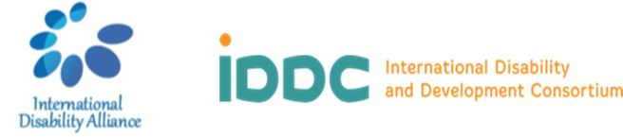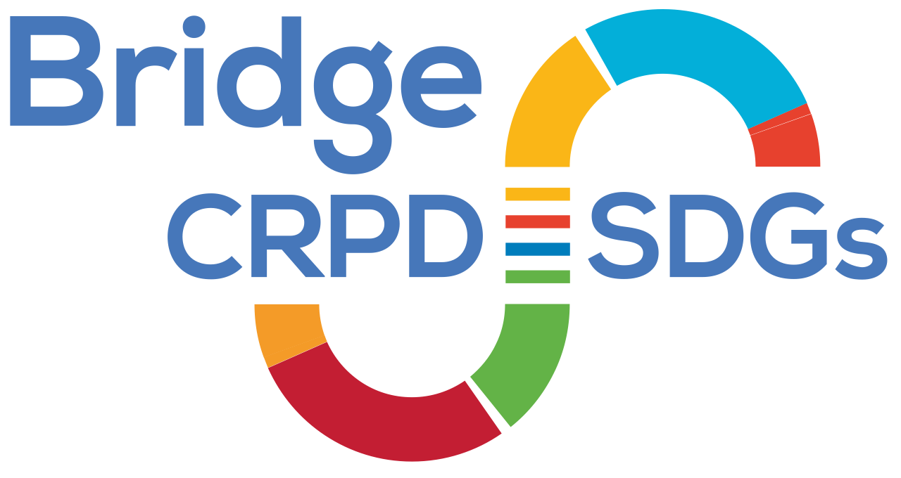

**Bridge CRPD - SDGs Tanzania Module 2**

**Arusha, 14-20 January 2020**

**Narrative Report**

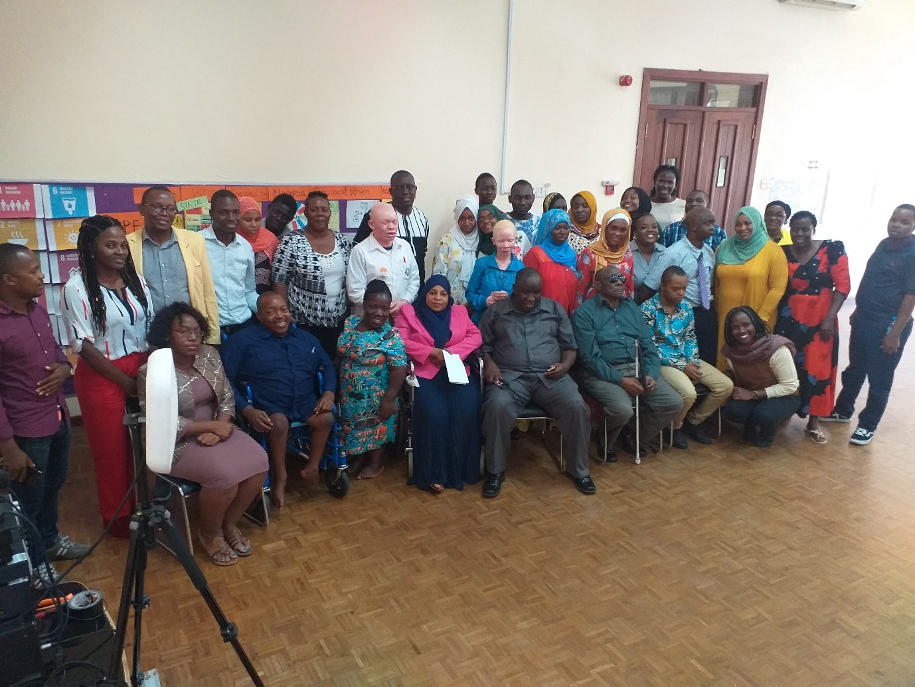

**Contents**

Executive Summary 2

Module 2 overall evaluation 3

Recommendations and next steps 3

Part 1: Bridge CRPD SDGs Tanzania Cycle process 3

Component 1: Training and Learning Coordinator 3

Component 2: Pre-Bridge preparations 4

Component 3: Participants 4

Component 4: Support personnel 4

Component 5: Facilitation Team 5

Component 6: Daily Summaries 5

Part 2: Bridge CRPD SDGs Module 2 Evaluation 20

Component 1: Participants self-evaluation 20

Component 2: Ranking chart 30

Component 3: Self-assessment forms 30

Self-assessment evaluation participants’ responses 32

Component 4: Next steps 34

# 

## **Executive Summary**

The Module 2 of Bridge CRPD-SDGs training Tanzania Cycle was held from 14th to 20th January 2020 in Arusha, Tanzania. This Module 2 was organised by the African Disability Forum (ADF) and the International Disability Alliance (IDA) with support from Inclusion International and World Network of Users and Survivors of Psychiatry.

The training brought together 15 participants drawn from diverse impairment groups and geographical locations within the United Republic of Tanzania. This is inclusive of persons with low vision and blindness, physical disabilities, persons who are deaf, those with deafblindness, intellectual disability, psychosocial disability, participants with albinism, and also with small stature.

The training was facilitated by 2 lead trainers and 5 co-facilitators, all from Africa, 6 being persons with disabilities themselves and 1 family member. Between participants and facilitators, the Bridge CRPD-SDGs Module 2 comprised a total of 52% of women and 76% from underrepresented groups of persons with disabilities.

The average rating for this Module was at 4.4 out of 5. The training was conducted in the regional lingua-franca, Kiswahili, with simultaneous interpretation to English and sign language. The efforts in making the training more accessible and inclusive in national Swahili language was a major milestone in Tanzania disability movement. Participants noted that the training had supported them greatly in their work on ensuring that no one is left behind in development.

## **Module 1**

Detailed information on the **Module 1** as well as its report can be found at [www.internationaldisabilityalliance.org/bridge-tanzania-module1](http://www.internationaldisabilityalliance.org/bridge-tanzania-module1), which provides deeper detail concerning the selection of participants and the facilitation team as well as the Bridge feedback mechanisms. Noteworthy, participants from Module 1 are the ones that completed the Module 2, hence, the depth of the selection processes is narrated in the Module 1 report. Additionally, the team of facilitators remained largely the same, while a few changes were made to service providers, as explained further on in this report. The Bridge CRPD-SDGs methodology remained the same and the key feedback mechanisms are discussed in detail in the Module 1 report.

## **Module 2 overall evaluation**

The average rating for this Module was at 4.4 out of 5. This is as regards the content of the training, its relevance, the clarity of presentation and the level of participation. The accessibility of the venue and preparations before the training and also logistical support before and during the training was rated at 4.0. out of 5. Both the ranking chart that participants filled on the first and last day of the training; as well as self-assessment forms that they filled before Module 1 and after Module 2, showed a largely positive feedback as to how the participants perceived the training and also how their levels of confidence had increased in various thematic areas relating to the training. These results are reflected in the second part under **Learning and Evaluation**.

## **Recommendations and next steps**

Participants made various recommendations including:

a) have a pool of trainers that use entirely the Swahili language;

b) opportunities for further training to be equipped as trainers of trainers;

c) to be certified, and

d) be exposed to various regional and global platforms to strengthen their knowledge on global advocacy.

This report details the Module 2 training and is sub-divided into two parts:

* **First part** highlights the training process and key elements regarding inclusive facilitation methodology and the preparation of a diverse team of co-facilitators,
* **Second part** details the learning and evaluation based on feedback from participants as well as key recommendations.

# **Part 1: Bridge CRPD-SDGs Tanzania Cycle process**

## **Component 1: Training and Learning Coordinator**

The contract for the ADF training and learning coordinator which ended in December 2019 was renewed to June 2020 to steer the running of Module 2 and related activities such as following up with Bridge Tanzania assignments. This was in addition to other corresponding activities including overseeing the implementation of the Inclusion Works project on behalf of IDA and ADF.

## **Component 2: Pre-Bridge preparations**

Right after Module 1, participants were working on their policy paper assignments, mentored by the facilitators, and coordinated by the ADF training and learning coordinator. Additionally, the translation into Swahili of the CRPD Committee General Comments was an ongoing process that was also supported by the Learning Coordinator and the Bridge Team.

Ahead of the Bridge CRPD-SDGs Module 2 training, the IDA logistics team together with ADF contacted each participant for logistics specifically on reasonable accommodation requirements. Correspondence on other areas such as the venue, ground transportation was also addressed.

A pre-training package was shared with all participants and their support persons to ensure meaningful preparation for the Module 2. This included the Bridge CRPD-SDGs Recap document, General Comments of the CRPD Committee and reports of the Special Rapporteur on the Rights of Persons with disabilities, among other documents. All the General Comments had already been translated into Swahili.

## **Component 3: Participants**

Bridge CRPD-SDGs Training consists of two Modules. To be certified, one has to go through both Modules. As such, the Module 2 was attended by all participants from Module 1. They were drawn from different regions of Tanzania and included persons from different disability constituencies. In total there were 15 participants (7 Male, 8 Female) with an overall presence of 50 people attending the Module 2, including the facilitation team, support to underrepresented groups, sign language interpreters, captioners, illustrators, personal assistants and logistics support.

## **Component 4: Support personnel**

During this Module, there were slight changes in support personnel for effective provision of support to all participants. There was a team of 22 support personnel to ensure that facilitators and participants got maximum support throughout the training week as follows:

**Caption:** *English to Swahili simultaneous interpreters (2), Illustrator (1), personal assistants (7), lip reading sign language interpreter (1), tactile sign language interpreters (1), sign language interpreters (5), others (4).*

It had not been possible to have an illustrator in the Module 1 due to some technical difficulties, but these were addressed, and an illustrator joined in Module 2 to support visual learning. He worked hand in hand with the lead trainer and member of Inclusion International and other self-advocates and support people. Other support for inclusion that joined this Module and who was not present in Module 1 was a co-facilitator with intellectual disabilities to specifically support participants from the same constituency.

## 

## **Component 5: Facilitation Team**

The training was led by Fatma Haji (Inclusion International) and Michael Njenga (World Network of Users and Survivors of Psychiatry, WNUSP), both representing the African Disability Forum (ADF).

It was also supported by a diverse co-facilitation team who are Bridge CRPD-SDGs Alumni including Betty Najjemba (ADF), Elizabeth Ombati (IDA Bridge CRPD-SDGs Fellow), Jane Akinyi (Inclusion International), David Shaba (Tanzania Association of the DeafBlind -TASODEB) and George Okudi (Down Syndrome International-DSI).

The facilitation team received remote support from Tchaurea Fleury (IDA). In this Module Rebecca Opetsi, Bridge Alumni and also representing International Federation for Spina Bifida and Hydrocephalus could not join as she was in session for her school semester.

The facilitation team held a preparatory meeting a day earlier to ensure readiness for the week. In the preparatory meeting, facilitators went through the week’s agenda, and held in depth discussions on ensuring that each session not only met its objectives, but also looking into the supports that each facilitator required to ensure a successful delivery of their session.

# 

# **Component 6: Daily Summaries**

**Day 1**

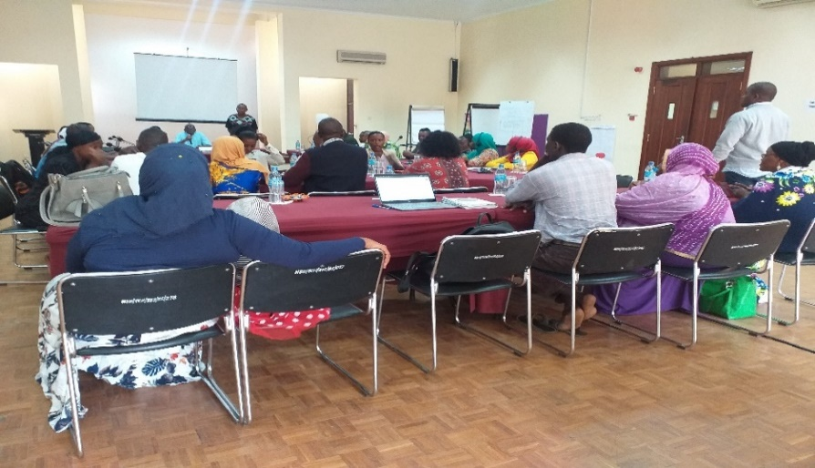The meeting began with introductory remarks from Mr. David Shaba representing the umbrella organization of persons with disabilities in Tanzania, (Shivyawata). Mr. Shaba expressed gratitude and shared the joy of the participants in the coming together to finalise the Bridge CRPD-SDGs Module 2 training program.

He noted that not only was the program key in strengthening the capacities of the participants, but also familiarity to use the CRPD and the SDGs for advocacy had been strengthened.

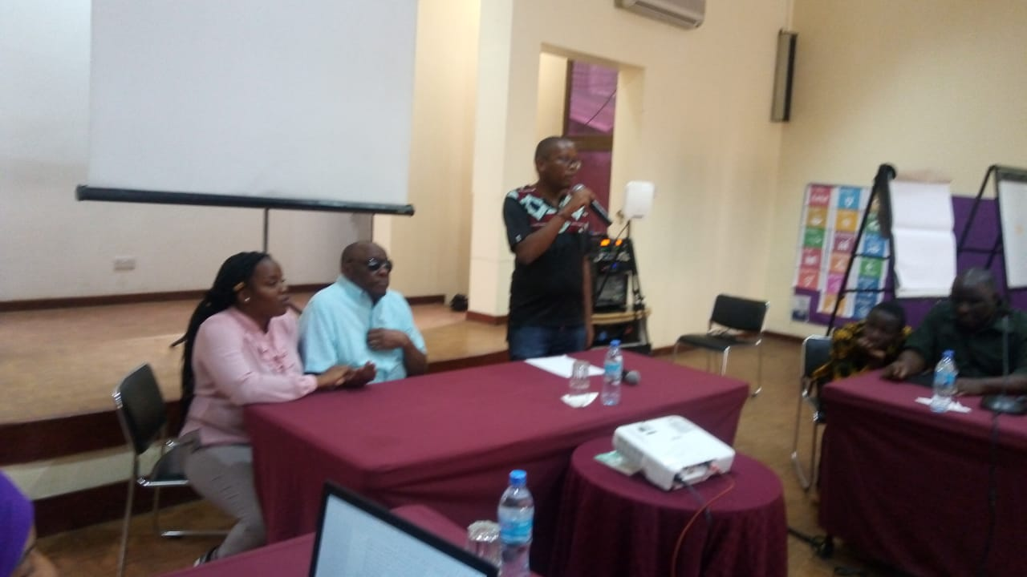This was evidenced when the participants in a session to reflect on the past six months since the Bridge CRPD-SDGs Module 1, enumerated a number of ways in which their advocacy had been impacted by the new knowledge on the CRPD and the SDGs.

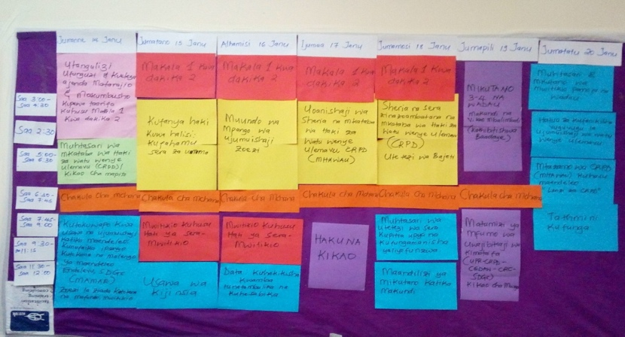

The lead trainers welcomed everyone to the second module, emphasizing on full commitment and concentration as the module was an introduction to critical ways of advocacy basing on the CRPD. These include legal harmonization, budget advocacy, inclusive program design, and data and understanding public policy.

**Bridge Philosophy**

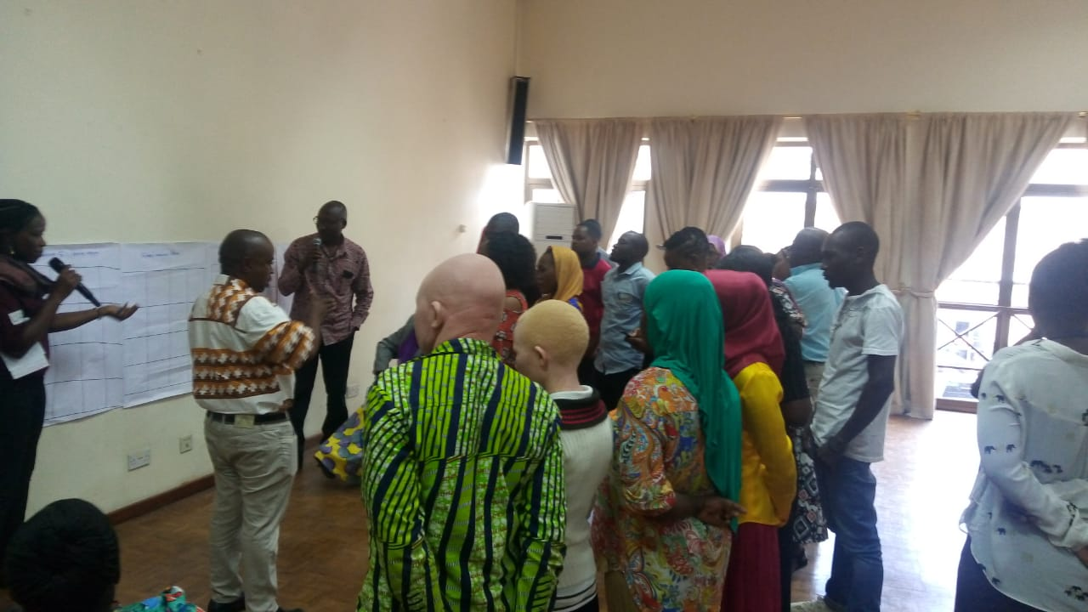In the introductory session, the facilitation team took time to reflect with the participants on the Bridge philosophy. From this, the participants were able to share on what it would take to ensure their full and effective participation during the week. Among what they mentioned was the importance of respecting each other’s opinions; creating a safe space to learn; ensuring the need to importantly be aware of each other’s requirements, all in the spirit to ensure no one was left behind in the training.

**Feedback Mechanisms**

Participants were taken through the feedback mechanisms to ensure optimum benefit for both the facilitators and the participants. They were also briefed on the tasks they would undertake such as presenting a summary of their assignments in plenary to receive feedback from the facilitation team and the 5-minutes 1 article sessions.

**CRPD Recap**

The second session of the day was dedicated to a recap of the CRPD using the ‘*hot ball activity’* that probed participants on their understanding of the CRPD. This was meant to support them in internalizing the CRPD concepts to build on how they do their advocacy.

**Interlinkages between the CRPD and SDGs**

This session looked at interlinkages between the CRPD and the SDGs. The “question and answer” methodology was used to explore the SDGs and their relevance in advocacy by persons with disabilities.

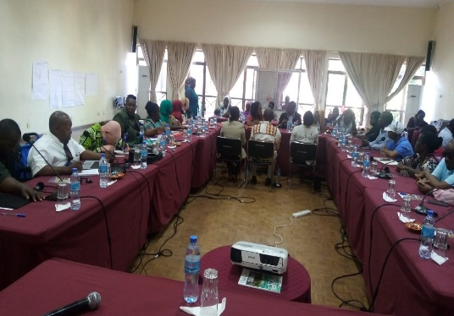Participants were then invited to elaborate their contextual realities with some goals of the SDGs and propose ways in which the goals could be implemented in line with the CRPD.

In plenary it was emphasized that policies for instance on education and employment cannot be implemented if budgets are not allocated to ensure their effective implementation. Thus, as long as the education system remains inaccessible for persons with disabilities, they will not effectively participate in work and employment.

Hence the need to address discrimination that persons with disabilities face in different sectors.

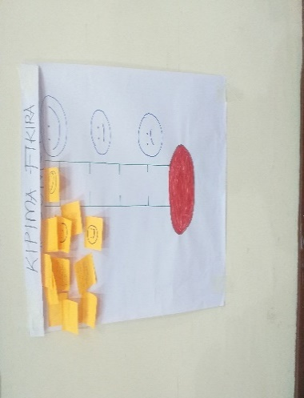

**Daily evaluation**

Most of first day sessions were meant to act as a connector between first and second module for Bridge CRPD-SDGs training. The day ended with a positive feedback on the *moodometer* and the daily review team where participants expressed their appreciation at the sessions of the day and how this had worked to set a good foundation for the rest of the training week

**Day 2**

**Recap**

The day’s sessions began with a report presentation from the previous day’s review team. This was followed by a recap session where participants reflected on the key messages from the previous day’s learning through question and answer.

**Public policy**

The session began with the facilitator recalling state obligations in connection to the realization of various human rights for persons with disabilities. Some of these rights may be realized immediately and others progressively. Emphasis was made that unless all persons with disabilities understand the different aspects of public policies, they will not be fully and effectively involved in the formulation and implementation of public policy which is critical towards inclusive participation and the enjoyment of the fundamental rights and freedoms on an equal basis with others.

For an interactive session, the participants were divided into three different groups to reflect on different components of public policies in their country.

They focused on education, health and work and employment.

They analysed these policies at national level, local level, and with the identification stakeholders involved in the implementation of the policy. They discussed the various ingredients of public policy as, budgets, training of staff, delivering of service, and information dissemination to persons with disabilities and their families and the monitoring aspects.

The session was concluded with a plenary presentation and feedback from colleagues and the facilitation team.

**Gender equality**

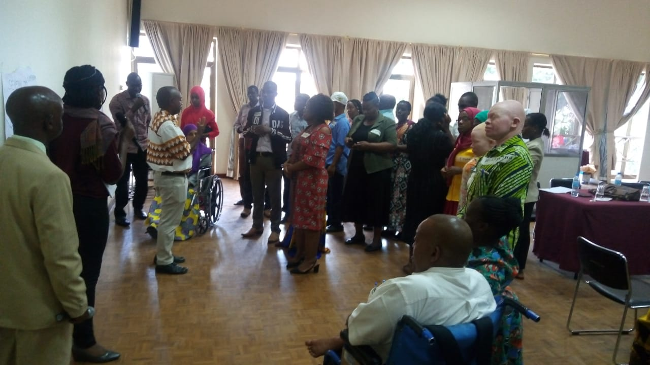The afternoon session was dedicated to gender equality, covering equality between men and women, intersection of gender and disability, discrimination and women empowerment within the context of disability.

Presented in an interactive manner, participants were invited to critically address pertinent issues in the society that result in discrimination, based not only on disability, but also other identities such as age and gender.

**Equality and non- discrimination**

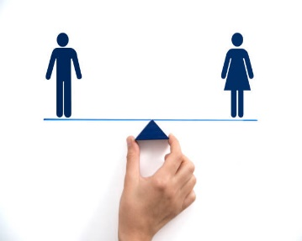The facilitator tackled the topic of equality and non-discrimination linking to the article 6 of the CRPD and highlighting the multiple and intersectional discrimination that women with disabilities face and emphasizing the need to eliminate all forms of discrimination in society faced by women with disabilities.

The participants were then divided into three groups to work on an activity where they were supposed to discuss and give propositions on some scenarios in society, answering questions such as, are boys treated differently from girls? What can you do to change the situation as DPO activists, as family members and also as government? In conclusion, they also spoke on the need to ensure there are policies that address discrimination on the basis of disability and gender.

**Daily evaluation**

The daily review team met with the facilitators to evaluate the day. Participants indicated that the training accelerated new knowledge and also gave the opinion to adapt some questions used in the gender session to help in contextualizing the session. The moodometer was positively reflected with a few participants expressing concern for clarification on some content in the last session. The facilitators invited those who had difficulties to continue engaging with the facilitation team throughout the week.

**Day 3**

**5 Minutes 1 Article**

The day’s program started with the 5-minutes 1 article presentations on article 23, the right to home and family and article 29, participation in political and public life in a creative way.

**Recap**

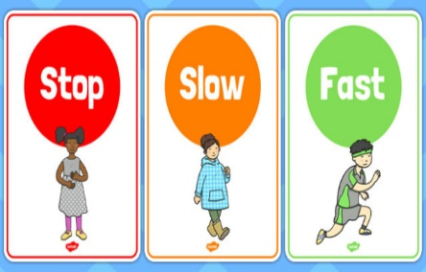The review team gave the feedback from the previous day’s discussions with the facilitation team. As the sessions began, the facilitation team encouraged the participants to use the traffic cards to ensure that they were following presentations and discussions in an inclusive way especially when there is reasonable accommodation required and clarifications.

**Policy paper assignment**

Three participants presented their policy paper assignments, received feedback from facilitators mentoring them for improvement, enhance their knowledge and finalise the assignments after Module 2. The articles presented were on article 11 on situations of risk and humanitarian emergencies, article 12 on equal recognition before the law and article 13 on access to justice.

**Inclusive program design**

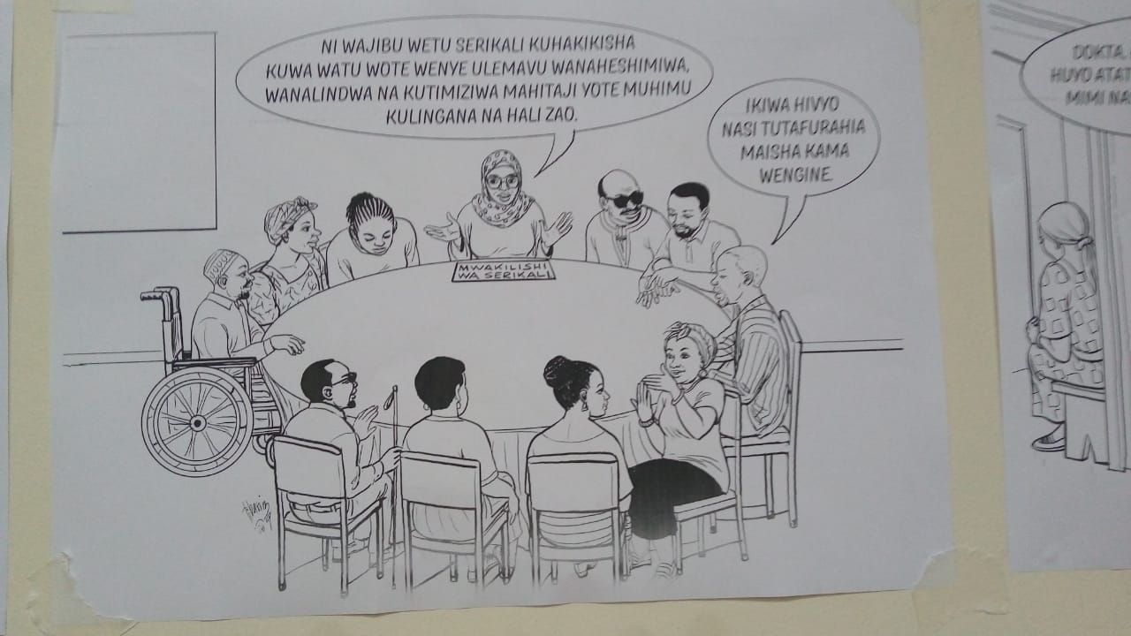The session on inclusive program design introduced to the participants key understanding on what that means to be an inclusive program, and the importance of ensuring that persons with disabilities are effectively part of programs, right from their design, implementation and monitoring. They were informed that there are both government and donors running programs and they should ensure persons with disabilities and their representative organisations participate in them on an equal basis with others.

Additionally, in the running of programs, it was noted that persons with disabilities should not be used in a tokenistic, symbolical, way. For instance, an allegation that they were consulted, however, when persons with disabilities and their representative organisations only received no accessible documents to review or being requested to make reviews within a short term without consideration for reasonable accommodation, such engagement cannot be said to be consultation that is effective and meaningful.

From the interactive dialogue, it was also noted that persons with disability are often not aware about planning as well as being involved and many issues arose pointing to lack of accessibility, inadequate budgeting to involve persons with disabilities, and also the lack of monitoring and accountability mechanisms to ensure that all persons with disabilities in society are involved in programs.

The general messaging from the participants was on the need for organizations of persons with disabilities to engage with both government and donors in their planning in a twin track approach. They reflected on organizations of persons with disabilities (OPDs) having limited capacity for this engagement; however, questioning on what the entry point could be. Participants indicated that through amplified voices, development of strategic collaborations and collective efforts from their OPDs, as themselves are the experts and must contribute in all process of inclusive program design.

**Data and statistics**

Participants shared their experiences citing challenges faced when collecting disability data, such as stigma that is attached to disability; the lack of knowledge on the CRPD and the lack of knowledge from state officiers regarding the State obligation to collect disability data, among others. Participants made recommendations on how to ensure changes, including the need to train all officers engaging in data collection in line with the obligations created under the CRPD and the SDGs for disability disaggregated data.

The participants also shared their experiences from their work and country’s endeavours on data collection and the processes used to capture data; to collect disability data both through a disability specific survey and also the census. There was general agreement that often times there is undercounting on the prevalence of disability, but also the acknowledgement that the use of the Washington short set of questions had ensured the collection of better-quality data on the prevalence of disability in most countries. Hence a mechanism in ensuring better inclusion of persons with disabilities in programming.

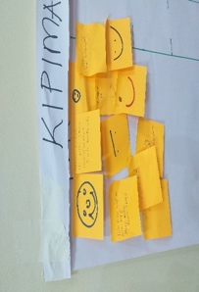**The moodometer**

The moodometer of the day reflected positivity with participants noting that they appreciated the knowledge received. It was also important as participants were reaching out to facilitators to further clarify information on some sessions.

**Day 4**

**Policy paper assignment presentation**

Participants presented their policy paper assignments in plenary. The policy paper assignments presented were on article 28 on adequate standard of living and social protection; article 5 on equality and non-discrimination and article 10 on the right to life. Key messages were based on various ways of data collection for the policy paper from various sources including government census and survey reports, UN agencies and interviews. The participants were encouraged to base their assignments on evidence-based approaches.

**Legal Harmonisation**

Participants familiarised themselves with domestic legal frameworks and were supported to be in a position to analyse national legislation to ensure compliance with the CRPD. The session also strengthened the capacity in understanding how to domesticate international human rights instruments which Tanzania has signed and ratified.

Participants were taken through the legal harmonization test with questions such as: Does the laws/specific articles of a given law respect the provision of the corresponding article of the CRPD, the rights of persons with disabilities and obligation of states? Does the laws/specific article consider the jurisprudence of the CRPD Committee in relation to the respective articles? Does the law include all persons with disabilities and lastly, do the different articles reflect article three of the CRPD on the general principles?

Various methodologies were used in the delivery of the session including a question and answer session, presentation by the facilitator at plenary, and also an activity where participants were tasked to analyse two laws in Tanzania and reflect on their compliance with the CRPD.

Among the questions that were posed included whether participants understood the legislative making process in their country, both at the national and local level and whether they had been fully and effectively included in any such process and what was the outcome of their participation in the law-making process.

Some reflections from some participants were that the technical capacities of organizations of persons with disabilities (OPDs) must be strengthened for them to understand and effectively contribute to the domestication of the CRPD hence Bridge CRPD-SDGs recognised as one of the instruments to push the notion forward. There was a reflection that a lot of time it is assumed that it is only the expertise of legal professionals that is required in the process of legal harmonization.

It was emphasized that the meaningful engagement of persons with disabilities through their representative organizations is critical in ensuring that domestic legislation at all levels reflects the spirit of the CRPD. It was also stated that it is important to focus on both disability specific and mainstream legislation frameworks to ensure the full and effective inclusion of persons with disabilities in compliance with the CRPD.

An example was given that as Tanzania shall hold its general elections in 2020, they are currently reviewing the enabling legal frameworks in relation to political participation. Also, that there is a need to ensure that those reforms are compliant with the CRPD and will ensure that electoral processes are inclusive and accessible to all persons with disabilities.

In their reflections, participants also stressed that lack of budgets, the lack of consultation of persons with disabilities through their organizations to participate in legal harmonization hinders their full and effective participation of domesticating international human rights instruments which Tanzania is a state party to. This is something which violates articles 4.3 and 33.3 of the CRPD.

The participants reiterated on the need to proactively engage with strategic partners to support them in lobbying for the domestication of the CRPD and its implementation. Linking with the inclusive program design, it was noted that in line with article 32 of the CRPD on international cooperation, international organizations should support OPDs not only with finances, but with the technical capacity in the process of legal harmonization.

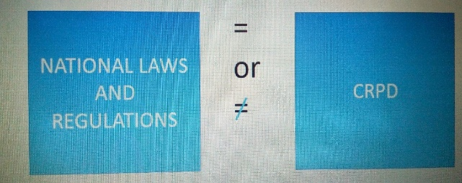The session was finalised with group assignment evaluating Tanzanian laws whether such laws were compliant with the CRPD or not and their proposal to ensure compliance.

These included the Tanzania Mental Health Act, 2008, and the Persons with Disabilities Act, 2010. Participants were able to pick out issues that were not CRPD compliant including denial of legal capacity; deprivation of liberty on the basis of disability, involuntary admission which violates article 25 on the right to health and also article 19 on the right to live independently and be included in the community and freedom from torture among others.

The participants had a free afternoon hence the daily review team did not meet the facilitation team.

**Day 5**

**Policy paper assignment**

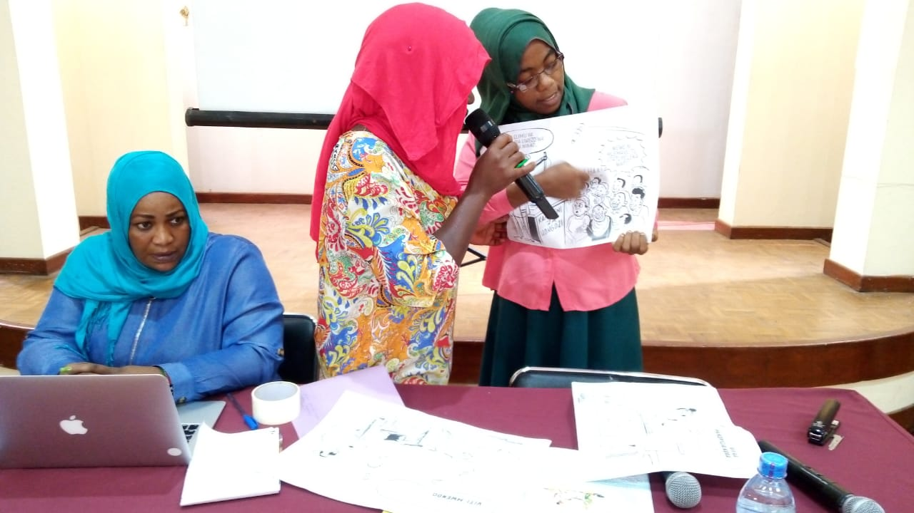The sessions started with the policy paper presentations on articles 25 on the right to Health, article 19 on the right to live independently and be included in the community and article 29 on the right to participation in political and public life.

**5 Minutes 1 Article**

Additionally, two groups presented their 5-minute 1 article on article 19 and article 12 on the right to equal recognition before the law. Each of the presentations was followed by feedback from the facilitation team. The emphasis was on participants to deeply reflect on what the CRPD states, its context and derive key information for various advocacy agendas.

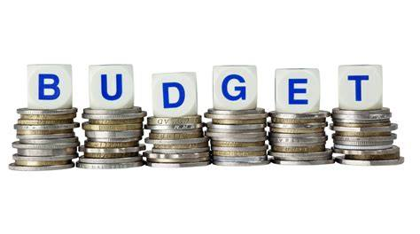

**Budget Advocacy**

In this session, facilitators reinforced the understanding of inclusive budget advocacy, based on compliance with the principles of the CRPD.

Various methodologies were used in presentation. One technique used was the family budget exercise where participants were provided with a case scenario of a family of five that has to plan on how to use their limited resources in the priority of one ill member, and also one child whose wheelchair is broken. It was an exercise that elicited a lot of interest from the participants, who were able to practically see how the process of budgeting can be complex both at the family level; and also, at other levels such as the state level.

The facilitators reinforced key messages from the exercise, including the importance of consulting diverse stakeholders who have a key stake on how resources are used. Linkages were made to the CRPD articles 4.3 and 33 on the importance and obligation to consult with ODPs in the budget making process.

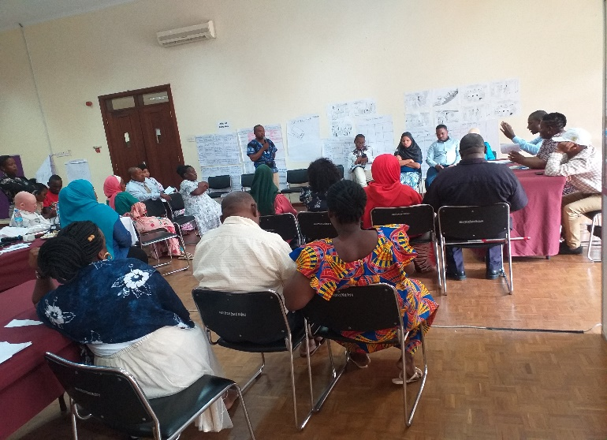The participants were then taken through a budget cycle to identify entry points in the process, and how to effectively participate.

Afterwards, in groups they made a role play where they were divided into various groups of OPDs and also government ministries. The exercise served to show the participants a real set up where there has to be concrete negotiations when it comes to ensuring that everyone in society is reached by programs which starts with budgeting.

Facilitators concluded the presentations highlighting how the OPDs had not settled on common issues to present before relevant ministries; how the OPDs had also not referred to laws including international conventions such as the CRPD in their advocacy with government ministries. It was stated the need to be aware that the budget process is more about laws and politics much more than just numbers.

Key messages from the session included that budget analysis can be complex and it is crucial that organizations of persons with disabilities (OPDs) strengthen partnership and collaborations with relevant organizations in their contexts to ensure that they are involved in the processes. It was acknowledged that many OPDs may not have the technical capacity hence the need for partnership. Participants were encouraged to have a structured way to do budget advocacy; for them to make justifications on programs and services that they wanted and must know exactly their issues and targets as OPDs.

Emphasis was put on the fact that Budget advocacy is important both at the national and local levels. It is a process that takes time and participants were encouraged to always be patient, with the addition that resources are never enough and all the time there are competing interests.

**Evaluation**

In the daily review team, the facilitators advised that when groups are presenting, they should try as much as possible to be inclusive of all in the room. This included not rushing through presentations, and asking for reasonable accommodation where necessary. The moodometer of the day was positive as the participants stated that the case scenarios presented made the sessions interactive and memorable hence easy to pass across key messages.

**Day 6**

**International accountability mechanisms**

The session looked at how persons with disabilities and their organisations can engage with the UN mechanisms, being active as monitoring actors of the CRPD implementation. This session meant to support the participants to understand how to engage in the different international accountability mechanisms.

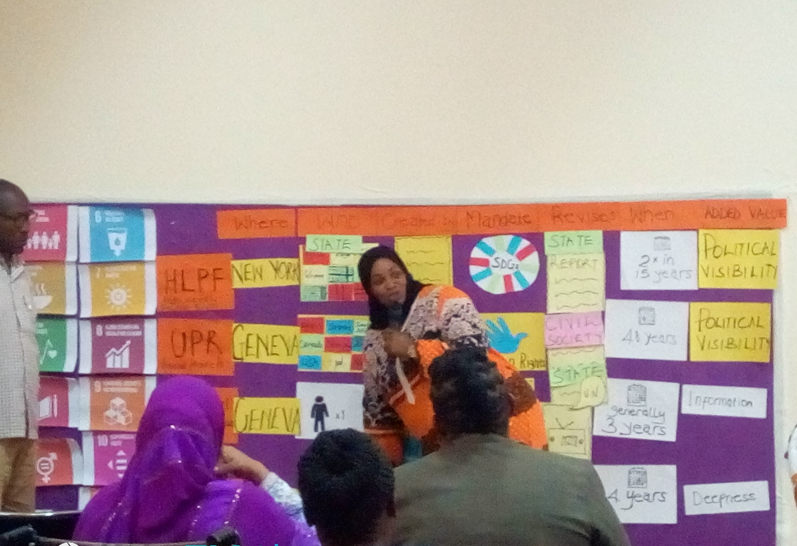The visual presentation showcased the processes of the Universal Periodic Review; the special procedures mechanisms; the CRPD Committee process and also the High-level Political Forum process. Most participants being new to the process, inquired on who is reviewed in the mechanism, how often the review happens; the importance of the whole review process, how to effectively and fully participate in the whole process. This was supplemented with the facilitators’ experiences having engaged with these processes and mechanisms in their countries.

Afterwards the participants took part in a mock CRPD review meeting. They were divided into three, the state party, the OPDs and the CRPD committee. They were given an article from a country that had already been reviewed to use in the group’s activity. The session in a way brought to reality what usually happens during the review process.

Tanzania has not presented a state report to the CRPD committee and the participants were encouraged to closely advocate with the government to ensure that the state prepares its report. This would support them to draft their alternative report and hence participate in the monitoring process of their country as far as the implementation of the CRPD is concerned something which was a positive impact got from bridge CRPD-SDGs training.

However, it was emphasized the need to closely work with all the international accountability mechanisms as they all complemented one another in ensuring that persons with disabilities realize all their human rights and enjoy their fundamental freedoms.

**Day 7**

**Meeting with stakeholders**

In every Bridge CRPD-SDGs training in Module 2, participants are accorded an opportunity to engage with stakeholders from the community, both state and non-state actors. This is to create networks but also to advocate with the various groups on the critical issues that persons with disability wish addressed in public policies.

Participants had an interactive session with two government officers and one from civil society. During the open dialogue, the participants seized an opportunity to understands clearly and explore the gaps in services provision from the stakeholders’ programs hence probing further on to how persons with disabilities should lobby for inclusion in these programs. Participants tabled proposals on what would be ideal in ensuring the full and effective participation of persons with disabilities in both state and non-state programs.

*“Budget implications limit our effective participation in different programs and policy issues affecting us”*

***Arusha region chairperson, SHIVYAWATA***

*“All policy makers should be part of future Bridge trainings due to their ignorance about the rights and needs of persons with disability”*

***Stakeholder from CSO***

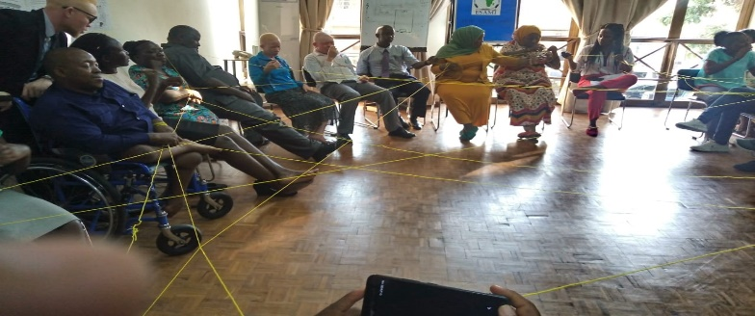**An inclusive disability movement**

This session focused on fostering an inclusive disability movement in Tanzania. The idea was to strengthen solidarity within the country level, which would positively affect the regional level.

The participants used a ball of string that they built around each other’s arms and made commitments to each other on what they will do afterwards to ensure they are proactive in their roles in advocating around concerns of persons with disabilities in the country.

The participants expressed satisfaction from the session citing that lessons had been drawn on how to build networks on commitments which are achievable and realistic. The facilitators encouraged them to stay true to these commitments. An example was given by the facilitators that even for them, having gone through Bridge and having made commitments; they were now seeing the commitments come to pass.

*“I committed to take on the Bridge training in all aspects, and from our side we hoped to hold a Bridge national Training, and soon it is going to happen. It all began from the commitment we made at the end of Bridge Module 2.”*

***Elizabeth Ombati***

Participants then filled their evaluation forms which was meant to be a reflection for them from the seven days of the workshop. The results of the evaluations will be used to make changes and improvements to the training methodology.

**Training closure**

Participants and facilitation team graced the conclusion of long week training with closing remarks. Participants, through their prospective representative thanked the facilitation team and organizers and expressed their immense gratitude having covered both module 1 and 2 with a pool of knowledge on advocacy strategies to fulfil rights of persons with disabilities in Tanzania.

The efforts in making the training more accessible and inclusive in national Swahili language was a major milestone in Tanzania disability movement. They noted that the training had supported them greatly in their work on ensuring that no one is left behind in development.

Representatives from the facilitation team, speaking on behalf of the African Disability Forum and the International Disability Alliance expressed gratitude to all participants for their enthusiasm and support through the workshop and committed to work with them, and support them in their advocacy. The facilitators urged the participants to seize the opportunity as a foundation to uplift the status of the disability movement in their country noting that Bridge CRPD-SDGs is an initiative that drives towards reinforcing the enjoyment of rights of persons with disabilities across the globe specifically towards the members of underrepresented groups.

# **Part 2: Bridge CRPD-SDGs Module 2 Evaluation**

## **Component 1: Participants self-evaluation**

Participants were invited to make self-evaluations of the training. They filled a 4-part questionnaire that consisted of

**a)** self-reflection questions on key messages from the training,

**b)** a post-Bridge understanding of some questions relating to disability,

**c)** relevance of the content of the week, and

**d)** feedback on the venue and logistics.

**Section 1: Self-Reflection Questions**

1. ***Key messages and learnings about the CRPD from the Bridge CRPD-SDGs Module 2:***

* DPOs should better understand and get involved in monitoring the implementation of the CRPD as well as other international and national laws and also policies that are directly or indirectly of concern to people with disabilities,
* DPOs should prioritise to provide a report on the implementation of the CRPD to the UN CRPD Committee,
* Importance to domesticate the CRPD,
* Advocating for inclusion of persons with disabilities at mainstream budgets is not easy,
* It is important that all rights in the CRPD are realised for all persons with disabilities,
* The advocacy of persons with disabilities should be inclusive of underrepresented groups,
* The CRPD is there to ensure the rights of persons with disabilities are realised, such as the right to inclusive education,
* The general principles of the CRPD are core and it is important to have a deep understanding on them as well as of various articles of the CRPD and to understand how practically appears in their context,
* Remaining inequalities in the inclusion of persons with disabilities in development,
* Importance of the inclusion of persons with disabilities in all services that are provided to the public.

1. ***Key messages and learnings about the SDGs from the Bridge CRPD-SDGs Module 2:***

* Importance of inclusion of all groups of persons with disabilities in the sustainable development goals,
* Importance of monitoring mechanisms to the implementation of laws in line with the CRPD as the SDGs,
* Strong linkages between the SDGs and the CRPD,
* The importance to leave no one behind as the slogan of the Agenda 2030 and the sustainable development goals which is a concept of non-discrimination,
* In the implementation of the SDGs, the CRPD must be the foundational framework so as not to leave out persons with disabilities in development,
* How articles in the CRPD link with sustainable development goals and how they are inclusive of persons with disabilities,
* How to monitor the implementation of SDGs at national, regional and global levels,
* There are barriers that persons with disabilities face that disproportionally affect their inclusion in development,
* Many countries do not have frameworks or know what steps to take to achieve inclusion of people with disabilities in achieving sustainable development goals for persons with disabilities,
* There is need to advocate within the public sector with the aim to bring changes in terms of inclusion of persons with disabilities,
* In development, for example, in accessing land, persons with disabilities should not be denied rights to land ownership.

1. ***Key learnings about inclusive facilitation from the Bridge CRPD-SDGs Module 2:***

* Facilitation should be done inclusively in a way that no one is left behind by considering human diversity,
* The importance of having sign language interpreters to ensure that Deaf participants are included in all discussions,
* The critical role of support persons and assistants to ensure the full inclusion and participation of persons with disabilities,
* To appreciate ideas of all and also ensure an equal opportunity for all in terms of contribution to a discussion, and also take into consideration reasonable accommodation,
* The importance of identifying barriers to participation and eliminating those to ensure full and effective participation,
* Reasonable accommodation to be requested beforehand.

1. ***Key messages and learnings while making its assignments:***

* The exercise helped in developing a deeper understanding and knowledge based on learning from the training,
* The assignment was helpful in ensuring that as trainees we become more critical, ask more questions from what we were exposed to in the training so as to know more,
* The importance of self-belief, to be included, and to give opinion and be listened to,
* Practical exercises provide insight and understanding and build confidence,
* The assignment was critical to address tension in the training and to inspire us to learn more,
* There is still a lot that needs to be done in ensuring that persons with disabilities realise all their rights, persons with disabilities still face more barriers to participate in different spheres in life.

1. ***What will you do differently in your advocacy work on rights as a result of the Bridge training?***

* To work with the local government in my locality to create committees that will address cases of human rights violations facing persons with disabilities,
* To create awareness among persons with disabilities not to remain silent whenever their rights are violated,
* To make advocacy in various offices including the one on social development, and endeavour to work with government bodies on law making, budget advocacy and all aspects where decision making is concerned,
* To deeply discuss with my peers about the training and what else we could do in our advocacy,
* To involve activists from DPOs in the fight for rights of persons with disabilities through training and workshops and meetings,
* To work with all disability types. Ensuring the participation of all persons with disabilities in advocacy,
* To ensure that people in decision making bodies are working hand in hand with DPOs in ensuring the implementation of the CRPD,
* In the module 2 we have been exposed to the importance of using disability data and statistics in advocacy, in planning, in monitoring of programs, laws, in development processes and in influencing and advocacy. These various ways of doing advocacy are important and will highly guide our work as DPOs.

1. ***What will you do differently in your cross-disability work as a result of the Bridge training?***

* To continue to raise awareness and emphasize the need to ensure persons with disabilities realise their rights,
* To build one strong voice that brings together all persons with disabilities which is effective to ensure social change for persons with disabilities and also to claim their rights,
* To take leadership and to advocate that the government plans and programs benefit persons with disabilities without discrimination,
* To continue to raise awareness with various government offices so as to ensure the inclusion of persons with disabilities in budget making and legal harmonisation among other advocacy routes,
* Advocate and lobby relevant authorities to provide appropriate trainings to persons with disabilities and other stakeholders on the CRPD.

1. ***What will you do differently in the way that you facilitate meetings and workshops as a result of the Bridge training?***

* I will use inclusive facilitation methods as was used during the Bridge CRPD-SDGs training. I will allow a space of cross-learning and a welcoming space where everyone would feel their contribution is valued,
* Places where a meeting is held have to be accessible for all, and also important the materials I share I will endeavour that they are accessible to all and also the way of presentation in meetings and workshops to be accessible for all,
* To use the CRPD and other relevant laws as a backbone of my meetings which will help in ensuring a greater awareness in my society on the rights of all persons with disabilities,
* Addressing issues of discrimination and trying to ensure the inclusion of persons with disabilities in development; with the main aim being that persons with disabilities realise their rights and are fully included and access services.

1. ***Please share any follow up actions or networking opportunities you have agreed with Bridge colleagues and facilitators.***

* Communication via email and whatsapp on progress after the training,
* Continue to do own personal learning and to work on good practices in the inclusion of persons with disabilities in my community,
* Reflect and work on advice given by my peers and facilitators in making follow up so as to ensure that concerns of persons with disabilities are successfully addressed,
* DPOs to work with other civil society organisations in advocacy,
* Work with the umbrella DPO Shivyawata as a platform to meet and connect with different groups.

**Section 2: Post Bridge understanding**

To help participants reflect on various concepts in the realm of advocacy for the rights of persons with disabilities, and as a way to encourage them to reflect more on what the CRPD says which in turn would help them to develop critical messages in their advocacy on human rights for all persons with disabilities, they were supposed to make reflections on the following questions:

* *What is your understanding of disability?*
* *How would you describe discrimination?*
* *What are the major issues your organisation and other people with disabilities face in your county currently?*
* *Do men and women with disabilities have the same opportunities in your country? If not, what are the differences?*

**Discussion**

On their **understanding of disability,** there was a mix of responses where some participants used a medical approach in how they understood disability as they indicated that disability is when people cannot carry out ordinary day to day duties because they have an impairment. For them, it is the impairment that stops them from carrying out such duties.

Other participants had their responses guided by the CRPD. They stated when barriers in the societies interact with people’s impairments, this hinders participation on an equal basis.

In a Bridge training, it will be critical that at the end of each day, participants reflect on what the CRPD says. It will be critical to also have other resources on the various models of disability as this will help participants have a broad understanding on the paradigm shift envisioned by the CRPD especially on the human rights-based approaches. This will be key in supporting the participants in their advocacy work.

On the topic of **discrimination,** it was a small percentage of participants who referred to the CRPD and how it defines discrimination on the basis of disability. The majority used the common understanding of discrimination. Which also calls upon the need to continually have all participants daily reflecting on the CRPD, because this will support them in having a firm foundation of an advocacy based on the CRPD.

On the **major issues their organisations and other people with disabilities face** in their country and also the question on **whether men and women with disabilities have the same opportunities**, responses showed similar challenges faced including concerns of discrimination in education, in schools; employment, and many other barriers faced in the communities including attitudinal barriers among others.

On men and women with disabilities, participants reflected that women did experience more discrimination and they offered similar responses including how first and foremost society discriminates against women in general which is then escalated when it comes to women with disabilities.

**Major issues your organisation and other people with disabilities face in your county currently**

* Corruption, unemployment, poverty, ICT inaccessibility,
* Few children with disabilities accessing quality inclusive education,
* Lack of spaces and avenues to participate and be included in political processes for persons with disabilities; processes that are not transparent,
* Persons with disabilities, even those with necessary qualifications facing discrimination in the field of work and employment, especially high paying work,
* Lack of inclusion, lack of access to quality services in buildings that serve the public,
* Inclusion that is not full and effective in terms of programs and planning and also decision making. The society largely not accommodating persons with disabilities due to stereotypes and negative pictures they have of persons with disabilities,
* Persons with psychosocial disabilities denied opportunities on the pretext that they do not have perception or understanding,
* Widespread discrimination, lack of opportunity based on disability,
* Discriminatory laws and policies, lack of inclusion in budgetary allocations, a lack of understanding by duty bearers on the CRPD which hampers programs and policies directed at persons with disabilities and also in terms of mainstreaming.

**Men and women with disabilities do not have the same opportunities at country context**

* Men with disabilities have more opportunities than women with disabilities. For instance, boys with disabilities will often be sent to school, while most girls with disabilities are hardly sent to school which starts from an early stage and negatively impacts on their outcomes in life going forward. Other examples were that most men with disabilities are more computer literate compared to women with disabilities; most men with disabilities are employed in tertiary institutions than women with disabilities,
* In terms of the realm of marriage and starting families, it was also stated that men with disabilities have it easier to start families which is not the case for women with disabilities,
* It was indicated that most women with disabilities hardly have opportunities to participate in decision making processes,
* Culturally women are seen as ‘gifts to men’ which is a way that women’s ideas and opinions are overlooked, and this was seen to doubly affect women with disabilities who from the first instance do not have such value accorded to them.

**New areas of advocacy that participants would prioritise, or whether they would use the CRPD and its monitoring mechanisms differently**

* The CRPD and SDGs are great advocacy tools which will go a long way to address the discrimination faced by persons with disabilities over the years. I will use both in addition to engaging in the monitoring processes in my advocacy,
* To use the new knowledge to strengthen my voice and voices of other persons with disabilities in our advocacy,
* To put an emphasis on addressing issues of discrimination that in addition to disability come also as a result of age and gender,
* Engagement in public policy, changing of laws, policies, budget advocacy ensuring that it is all in line with what the CRPD says,
* An increased work together between and among DPOs in CRPD advocacy,
* In the upcoming general election, advocacy to ensure the full and effective participation of persons with disabilities in the whole electoral processes mostly ensuring accessibility of communication, of the physical environment, of the whole electoral process among others.

**How participants are involved in discussions and work on the Sustainable Development Goals (SDGs)**

While many participants felt that their involvement was minimal, they shared some of the ways they have been engaged in the discussions.

* Participation in a few workshops and conferences organized by other civil society organizations,
* With the new knowledge it is imperative to be involved in the SDGs discussions as persons with disabilities,
* Engagement in preparation of strategic plans in the national party which are inclusive of how the SDGs are to be implemented,
* By virtue of being a citizen there is involvement though the priorities set by government such as poverty eradication programs.

**Section 3. Bridge CRPD-SDGs Evaluation Questions**

In this section, participants were to reflect on the content of the training and how relevant it was, the clarity of presentation, their level of participation, how they felt they were able to network in the week, what needs to be improved among others.

They were to rate each question from 1-5 and make comments. 1 denoted the lowest meaning not good at all, 2 not very good, 3, good, 4, very good while 5 was the highest at excellent. **The average rating was at 4.4.**

**Relevance of the content of the sessions presented and the materials shared**

The overall response was at **5 point** as regards the relevance of the content. Some of the comments shared included:

* The training has increased my understanding and knowledge on the CRPD and SDGs and how to use this in my advocacy,
* This has greatly helped to strengthen me as an advocate for rights of persons with disabilities basing on the CRPD,
* It was important to differentiate between myths and facts as regards the view of people especially when it comes to disability.

**Clarity of the presented content**

Overall response was 4.2 with 85% of the participants giving a 4 and a 5. Among the feedback shared was the following:

* To a really large extent the content was clearly presented and understood. For the most part, it will be using more additional resources outside the training room to further deepen understanding,
* The continued use of role plays, presenting the materials in an easy to understand manner and various ways of inclusive facilitation was helpful in the process of understanding the content.

**Ability to participate and contribute to the workshop**

Overall response was at 4.2. will all participants giving over 3. The participants’ confidence in the workshop was highly rated and also reflected in the comments shared:

* I participated in depth through giving feedback to questions raised by facilitators, or if a topic seemed to be challenging to my fellow participants, or even where I was able to bring in a new idea,
* There should be sufficient time given to explain in detail or even to give more insight into an argument,
* Through the active participation of fellow participants, I have a deeper understanding in the topic on budget advocacy, legal harmonisation and sustainable development goals.

**Opportunity to network and exchange learning**

The overall response was at 4.1 with a majority (92%) of the participants rating it over 3. The following were comments shared:

* We have built on the understanding of Bridge Module 1. We have strengthened our own individual and professional relationships with each other, and, in addition, we were introduced to leaders in government, civil society and from DPOs in Arusha,
* It has brought change as it has given us strength to advocate with the government to build inclusive education for people with disabilities,
* It is our hope that Bridge continues to link us with various other networks in the region and globally so that we join them,
* The whole week was critical and great for us to have this understanding and awareness on various institutions of government and what they do in relation to the principles of the CRPD.

**Support that participants received on the assignment task**

Participants indicated that they were happy with the support they were receiving in doing their assignments from the facilitation team. All responses were above 4 with the overall response at **4.6**. and the following comments shared:

* The support from my mentor facilitator is very important during the training itself and also when I am doing my assignment,
* The mentor facilitators are very helpful and willing to support.

Participants shared that **among the ways that the Bridge facilitation team can better support assignments in the future** is to keep up their willingness to support the participants and to always have the numerous communication lines open for continuous communication.

The evaluation had also sought to know from the participants **which session of the week was the most helpful and why** and also which one was the least helpful. This is meant to support the facilitation team to continuously improve the Bridge curriculum.

All the sessions were listed as being useful with the following comments:

* Introduction to and understanding public policy has given me ideas on how to do advocacy with relevant government institutions to ensure that public programs, polices are inclusive of persons with disabilities,
* Budget advocacy has given me understanding on the importance to ensure that in making their budgets, governments must ensure to budget for disability specific programs but also to ensure that in mainstream programming, budget is made available for the inclusion of persons with disabilities,
* The session on international accountability mechanisms has exposed us to various methods on ensuring the monitoring of the implementation of the CRPD and SDGs and how it is important that persons with disabilities are part of the monitoring processes globally,
* The session on gender equality was easy to understand for people with intellectual disabilities.

Participants indicated that all sessions were helpful as they helped them to increase their knowledge and understanding. Participants also shared on the **topics that were still not clear** for them and what they would want to learn more on. Topics mentioned included data, legal harmonisation, international accountability mechanisms, budget advocacy, public policy. A majority noted that they will need support to go through the topics once they are out of the training room to increase their knowledge on the various topics.

As Bridge CRPD-SDGs is based on learning from and building on each other’s knowledge, participants were asked to share the **most important learning** they got from one or more of their fellow participants during the training. Their comments were as follows:

* I saw many of my peers giving of themselves both during group presentations and also in the sessions which encouraged me as well to make my submissions,
* The way we all participated and worked together, for example, with participants with intellectual disabilities, and getting their ideas was a learning in itself, especially looking at the different supports provided to ensure full and meaningful participation in the training like the use of an illustrator.

**Suggestions on how to improve future exchange, learning and cooperation between Tanzania Bridge CRPD-SDGs participants with IDA and IDDC, and their members**

* Have a pool of trainers that use entirely the Swahili language and that the entire training be provided in Swahili. Using English and having translations makes the participant lose some of the information compared to if the participant would capture everything right from the facilitator,
* The possibility to have the participants going through further training of trainers so as to prepare them to be future trainers,
* To be provided with certificates of participation as it is a good thing that we have gone through the Bridge CRPD-SDGs training and have been strengthened as advocates who have deep understanding on the CRPD and SDGs and be able to use that to further our advocacy with other DPOs, NGOs and government,
* For there to be a common project between IDA, IDDC and Shivyawata with the aim to further build the strengths of participants in advocacy,
* To be afforded opportunities to participate in global meetings to widen our perspectives as disability advocates,
* If it is possible to make the training not to be as heavy to take into consideration our various levels of knowledge and understanding,
* The need to engage media in the future so as to relay information to the public on the training and also on the participants,
* The need to add some sessions on data sources and social media management,
* Participants also shared on the need to be supported to ensure that the upcoming Tanzania elections are accessible to all persons with disabilities,
* If participants can have a social evening where they interact and mingle also with the facilitation team.

**Feedback on the hotel and logistics**

The accessibility of the venue and preparations before the training and also logistical support during the training was rated at 4.0.

**Friendliness and accessibility of the hotel**

The overall rating was at 4. With 92% of the participants rating it over 3. Majority felt that the hotel was accessible to all groups of participants in the training, also indicating that the attendants were also welcoming and willing to be of help at all times. A small percentage, however, felt that some places were inaccessible such as the bathrooms.

**The quality and variety of the food**

The overall rate was at 3.4. A majority of the participants indicated that the food was of good quality and also being served at good times, however, other participants who indicated point 2 or 3 stated that there was not much in terms of food variety.

**The preparation and the quality of information about the meeting**

The overall rating was at 4.5. with majority of the participants happy with the preparation of the workshop and the quality of the information provided. They shared the following comments:

* All related information was shared on time and also in an accessible manner,
* Participants who felt that there had been some delays noted that some information came albeit quite late, while also another noted that materials in Braille had lacked and also some sessions did not yet have all materials in Swahili,
* The training has built our understanding on advocacy for our inclusion highly.

# Picture with ranking chart**Component 2: Ranking chart**

On the first and last days of the training participants filled a ranking chart which is a self-evaluation tool, that aims to have a quick and general idea of where participants believe they are in terms of understanding the general themes of Module 2. The four areas that they were to state their confidence levels was on: Public policy, Inclusive program design, Data, Legal harmonisation and Budget advocacy. They were to indicate whether they had: **A lot of confidence, confidence, some confidence or lack confidence.**

Notable is that at the beginning of the week, a large percentage of participants indicated being at **Some confidence**, while **on the last day,** majority of participants scored at **A lot of confidence** and **Confidence**.

However, it was also interesting to note that at the beginning of the training, no participant indicated **Lack of Confidence**, which was indicated at the end of the training week (with two participants indicating it). This could be explained by the possibly of participants realising the need to have a more in-depth understanding on the sessions listed which were data and legal harmonisation, which had also been indicated in the self-evaluation by a few participants as sessions they would want more resources and information on.

# 

# **Component 3: Self-assessment forms**

**Analysis**

The Self-assessment form by participants was filled pre and post Bridge CRPD-SDGs Module 1 and 2. It had four sections each with a descriptor. At the end of each descriptor, participants indicated their level of confidence choosing from the range of six which are:

* None/ not at all -0
* No confidence /A little - 1
* Some - 2
* Fairly confident/A lot -3
* Confident -4
* Fully confident / can support external agencies -5

They also shared comments, questions or requests next to the relevant descriptor and capacity development support requests that they had. The four sections included the following and had a total of 24 questions:

* ***Development and humanitarian experience***
* ***Rights, advocacy and accountability***
* ***DPO networks and engagement***
* ***Inclusive practice and facilitation***

This analysis considers both the responses pre-Bridge Module 1 and Post Bridge Module 2.

Overall and in all the four sections, there was a marked change with points increasing post Bridge Module 2. As the self-assessment is about experience in, for example, **supporting your community in a humanitarian crisis situation,** it is interesting to see the participants giving higher rates after Module 2, which could imply a number of things. Firstly, would be that the participant engaged in an additional advocacy area after Module 1 Bridge through to coming for the Module 2. Secondly, it could be that the participant has new awareness on the topic, even though they have not directly engaged in advocacy under the stated thematic area.

There is the overall confidence that comes about as a result of attending a Bridge CRPD-SDGs training, and participants being able to see the training as a way to give them tools which would also support them to engage as confident actors in the areas that were listed in the self-assessment form. This is also a plausible reason as to the increased levels of confidence after Module 2.

Under **development and humanitarian experience**, for example, in the first Module there was very low rating in terms of confidence by the participants in the humanitarian field, with a **1.2** from the overall rating of all the participants. Under the same thematic the knowledge of disaster risk frameworks was at 1.4., designing accessible humanitarian projects at 2.1 and engaging with humanitarian actors at 0.9. After the Module 2, the average was of **2.6**, (respectively as follows: 2.4, 2.4 and 2.7). It is clear that even though an increase in confidence is recorded, it is still not a lot of confidence, but the participants have a more increased awareness and some level of comfort in this field. It is an area where most of them requested for more support to fully and effectively engage within the humanitarian field.

This trend is replicated in other areas, for example, ***Rights, Advocacy and Accountability,*** pre-Bridge CRPD-SDGs Module 1, there was an overall point of **2.3**. This goes up to **4.3** post-Bridge Module 2.

There was a low of **1.1** under experience and familiarity using the CRPD Committee jurisprudence and also another low of **0.7** in experience in engaging with shadow/parallel reporting for CRPD, or other treaty bodies such as CRC & CEDAW, or engaging with the Universal Periodic Review (UPR) or High-Level Political Forum (HLPF). Post-Bridge Module 2, there is an increase to **3.7**. and **2.1**, respectively. Which would be attributed as well to sessions on accountability mechanisms among others. Also, even as these two areas recorded an increase post-Bridge, still participants expressed the desire to have more in practice.

Under **DPO networks and engagement,** participants recorded high levels of confidence which also increased further after the Post-Bridge Module 2.

Overall, participants expressed the desirefor continuous exposure in all areas to further strengthen their awareness and understanding including exposure to international and global platforms for them to not only create networks but have a further understanding of how advocacy can be moved from the local and national to regional and global platforms.

## 

## **Self-assessment evaluation participants’ responses**

|  |  |  |
| --- | --- | --- |
| **Descriptor** | **Pre-Bridge Module 1** | **Post-Bridge Module 2** |
| **Development and humanitarian experience** |  |  |
| Experience in supporting your community in development programmes (this could be CBR projects, livelihood programme, youth or women's group initiatives, environment, housing etc. as some examples) | 3.3 | 3.8 |
| Knowledge of current international and/or national development plans and frameworks | 1.9 | 3.3 |
| Experience of designing & monitoring development programmes that are fully accessible and inclusive of all persons with disabilities | 2.6 | 3.8 |
| Experience in supporting your community in a humanitarian crisis situation (this could be a Tsunami, flood, drought, earthquake, displacement or due to conflict/ unstable situation such as political conflicts/ election process/ refugee crisis etc.) | 1.2 | 2.4 |
| Knowledge of current international and/or national humanitarian / disaster risk reduction frameworks | 1.4 | 2.4 |
| Experience of designing humanitarian emergency projects that are fully accessible and inclusive of all persons with disabilities | 2.1 | 2.7 |
| Understanding of UN cluster system and experience of engaging with this and with humanitarian actors in general | 0.9 | 2.7 |
| **Rights, Advocacy and Accountability** |  |  |
| Knowledge and understanding of the Convention on the Rights of Persons with Disabilities (CRPD). Ability to explain its principles and articles. | 2.3 | 4.3 |
| Experience and familiarity using the CRPD Committee jurisprudence | 1.1 | 3.7 |
| Experience in engaging with shadow/parallel reporting for CRPD, or other treaty bodies such as CRC & CEDAW, or engaging with the Universal Periodic Review (UPR) or High-level Political Forum (HLPF). | 0.7 | 2.1 |
| Experience in advocating for change in laws and legislation or development of regulations, standards, directives or decrees. | 2.1 | 3.3 |
| Experience in advocating with government for change in budget allocations at national or municipal level, | 2.2 | 4.1 |
| Experience in engaging with national statistics commission and other key stakeholders in advocating disaggregated data on disability (such as promoting the Washington Group short set of questions in national census), | 0.8 | 3.1 |
| Experience in working with human rights bodies such as the National Human Rights Institution or Commission and other national or international human rights organisations, such as women's rights, indigenous rights, human rights mainstream organisations, | 1.6 | 3.4 |
| Experience in supporting specific empowerment programmes for women and girls with disability to access justice, legal aid, shelter and recovery, compensation, micro finance etc, | 2.4 | 3.7 |
| **DPO networks and engagement** |  |  |
| How confident are you in working with other impairment groups, including those who are less represented such as persons with psycho-social disability, deafblindness and intellectual disability, persons who have leprosy, albinism, etc.? | 4.3 | 4.7 |
| How confident are you in working with people with disability from different backgrounds such as indigenous peoples, rural / remote /isolated communities, displaced persons, communities living in inner city slums or other groups who are typically discriminated? | 4.2 | 4.6 |
| How confident are you in working with a wide range of mainstream national and community development organisations working in fields such as education, livelihoods, youth rights, election committees, service delivery etc.? | 3.9 | 3.8 |
| How confident are you in working with local and national government ministries, departments/ administration, public officers and parliamentarians etc.? | 3.5 | 4.5 |
| How confident are you working with international NGOs, donor agencies and UN agencies? | 4.2 | 4.3 |
| **Inclusive practice and facilitation** |  |  |
| Experience of creating accessible meetings, events and communications to ensure access of all different impairment groups, e.g.access audits of buildings, ensuring appropriate media and materials and logistics have been assessed for all impairment group requirements. | 2.8 | 4.1 |
| Experience of planning and delivering inclusive training to enable meaningful participation of all impairment groups in your training and capacity development efforts. E.g. using a diverse range of training methods and approaches to suit all different types of people who have different learning styles and communication preferences) | 2.6 | 4.1 |
| How confident are you assessing and supporting reasonable accommodation requests for a wide range of people with disability from different impairment groups/ backgrounds? | 3.3 | 4.6 |
| How confident are you in providing technical advice to mainstream agencies on how to ensure the full and effective participation of all people with disabilities? | 3.5 | 4.3 |

# **Component 4: Next steps**

The main steps ahead would be:

* The ADF Training and Learning Coordinator to draw a temporary matrix plan to guide and inform on next activities including deadlines on policy paper assignment review on both participants and facilitators side. The Coordinator also to do frequent follow ups on the same until the end of June 2020. After which the participants will be awarded certificates of completion for Bridge CRPD-SDGs Modules 1 and 2,
* The ADF Learning Coordinator together with other Bridge team will engage participants on further capacity development and advocacy opportunities across the globe,
* Continue to liaise with Bridge CRPD-SDGs Coordination team on possibilities of engaging the Bridge Alumni in different Bridge CRPD-SDGs cycles and other related tasks which may need the alumni’s engagement,
* Follow up with the respective organisations of persons with disabilities that proposed the Bridge participants to gather their assessment about the Bridge CRPD-SDGs training.