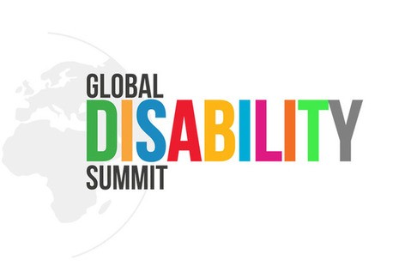

“
We must make an effort to encourage the key players within the Government to also attend t the GDS 2022.

The GDS 2022 is the first global platform in the pandemic era that is expected to give opportunities to stakeholders to share their experiences and learn the lessons to strengthen their dedication in realising inclusive development programmes for persons with disabilities.
“

Report on National Consultation
Pre-Global Disability Summit 2022
Nusa Dua, Bali, Indonesia, 19 – 22 March 2021

Between October 2020 and April 2021, the International Disability Alliance (IDA) and its members organized a number of national consultations and one regional consultation on the Global Disability Summit (GDS 2022).

The objective of the consultations was to assess progress made against national commitments adopted in 2018, as well as to encourage constructive dialogue between persons with disabilities and their representative organizations, together with national government representatives, as well as UN agencies, National Human Rights Institutions (NHRIs), International NGOs, private sector organizations, among others, in order to discuss thematic priorities, and brainstorm towards designing an engagement roadmap ahead of the main GDS event in Oslo.

The sessions initially explored the history of the GDS process, and through a rich interaction among participants reviewed the implementation of the 2018 commitments and identified priorities for GDS 2022. At the beginning of the consultations, participants were able to listen to the key messages from both co-hosts of the 2022 summit, the Norwegian Ministry of International Development and IDA. Through pre-recorded video, IDA stressed the importance of the national and regional consultations ahead of the GDS 2022. The Norwegian Minister of International Development underscored the importance of GDS 2022 and the role of persons with disabilities in shaping the agenda for GDS 2022.

This GDS consultations process promoted ownership of the GDS process among persons with disabilities and their representative organizations by taking into the account the multidimensional challenges and barriers that have historically left out key groups of persons with disabilities in decision making processes, particularly in the Global South. This is why national and regional consultations are crucial as they collect priorities, aspirations and concerns of persons with disabilities from different parts of the world.

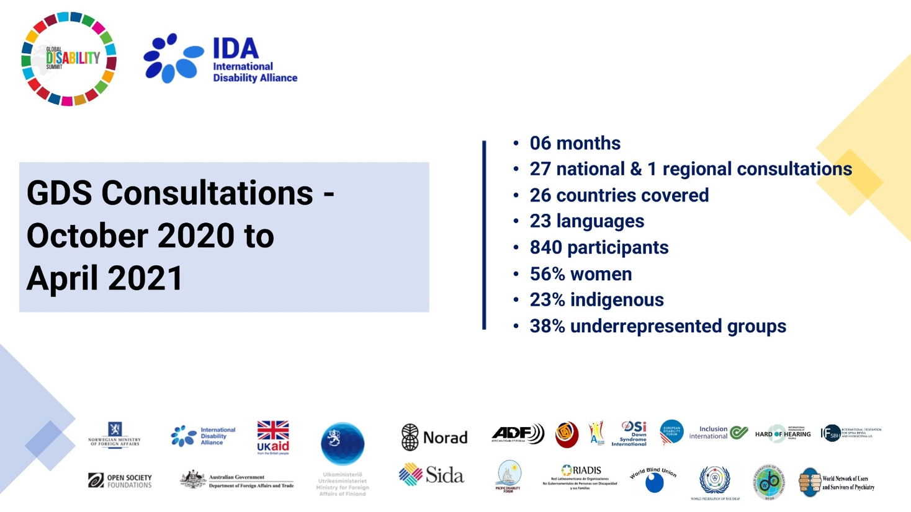

During these six months of consultations in preparation of the GDS 2022, we were able to organise 27 national & 1 regional consultations, in 26 countries, with 840 participants, and in 23 different spoken and sign languages. Of the participants, 56% were women, 23% were indigenous peoples and 38% were from underrepresented groups of persons with disabilities.

In countries such as Ecuador, Nepal and Indonesia, a strong presence of participants from indigenous groups with disabilities was recorded. In Uganda, Colombia, Kenya, Ecuador, Indonesia and Nepal, a strong presence of youth was observed. In Ecuador, Indonesia and Nicaragua we were able to welcome a large number of people from remote and rural areas. In Kenya, Uganda, Bangladesh, Indonesia, Ghana and Colombia we had a significant number of participants with intellectual disabilities. In Kenya, Zambia, Ghana, Uganda, Indonesia, Nepal, Bangladesh and Senegal, we had good participation from amongst people with psychosocial disabilities. Finally, in Nepal, Uganda, Bangladesh, Ghana, Indonesia, Colombia and Cape Verde, we witnessed a very important discussion of cross-disability groups bringing a good balance of gender and diversity among participants.
“

Within the communities or governing bodies of our indigenous peoples and nationalities, the participation of people with disabilities is often not allowed, many of us are relegated and our participation is not taken into account; and even more so when it comes to underrepresented groups such as deaf people who do not have an interpreter to support with communication (it should be noted that there are no sign language interpreters who know Kichwa) or people with intellectual disabilities, they are simply not considered.
“

Workshop with Indigenous communities
in Ecuador, Dec 2020

Emerging trends and issues from the consultations
During the consultations, persons with disabilities and their representative organizations reiterated the need to implement the existing 2018 commitments, and having evaluated national priorities, they proposed additional issues that need to be considered during GDS 2022. In addition to the seven key pillars of commitments made in 2018, the following were the key emerging issues and trends from the consultations held in different countries (in alphabetical order):

- Access to communication and information
- Access to justice
- Accessible transportation systems
- Active citizenship and political participation
- Deinstitutionalisation and access to community-based support
- Economic, social and cultural rights
- Inclusive budgeting
- Independent living and inclusion in society
- Involvement of local communities and access to community-based services
- Legal capacity
- Right to land and property
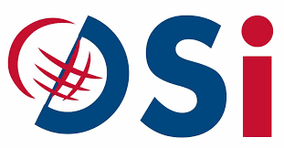
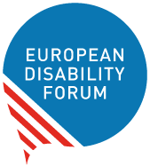
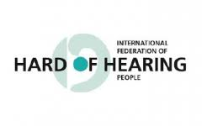
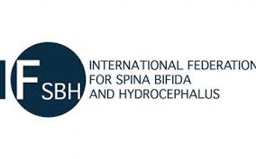
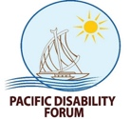
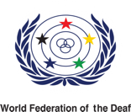
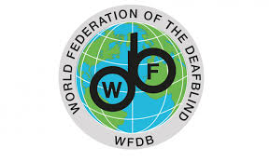
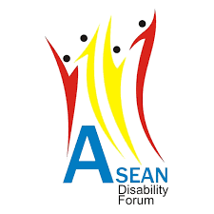
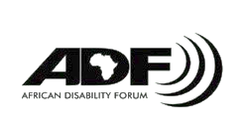
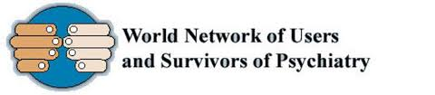
- Sport and cultural events

