Workshop report
High Level Workshop towards building Donor Investment in OPDs at the Country Level
16-17 March 2022 | Dhaka, Bangladesh

Figure 1. Participants brainstorming in groups on recommendations to donors

April 22

Contents
1. Introduction 1
2. Background 1
3. Objectives of the workshop 2
4. Participant’s details 3
5. Accessibility and reasonable accommodation 3
6. Resourced used 3
7. Workshop’s discussions 4

Introduction
A two-days’ workshop titled “High Level Workshop towards building Donor Investment in OPDs at the Country Level” was held on 16-17 March 2022 at the Radisson Blue Hotel in Dhaka, Bangladesh. The workshop was organized by the Global Action on Disability (GLAD) Network and the International Disability Alliance (IDA), with the support of the UK Foreign Commonwealth and Development Office (FCDO). The workshop was facilitated by the IDA Capacity Building Unit and the IDA Program Unit.
The workshop was attended by around 29 participants that included representatives of national and sub-national organizations of persons with disabilities (OPDs), disability organisations and members of the International Disability and Development Consortium (IDDC). Over two days, they exchanged experiences and ideas on OPD engagement in Bangladesh, learnt about existing or proposed coordination mechanisms between donors at the country level, and reflected upon current research on OPD engagement, including the OPD Engagement Paper launched at the Global Disability Summit 2022.

Background
In 2019, the GLAD Network identified the importance of investing in OPDs to ensure they can develop the skills, capacity, and influence to act as meaningful development counterparts. During a first meeting held on the margins of the COSP 2019, GLAD members reviewed existing initiatives and identified the need for the donor community to do more and better to build capacities of OPDs. The first IDA Global Survey on OPD participation identified that OPDs are increasingly consulted but do not yet participate meaningfully in development efforts. This further highlighted the lack of coordination of donor investments in capacity building efforts as an issue to address through country case studies.
Experiences from OPD engagement in international cooperation show that investments in OPDs do not always promote their leadership nor respect their priorities and do not always advance cohesion across different constituencies of the disability rights movement.
Financial support remains the biggest challenge for OPDs to exist as representative organizations. The lack of financial resources strongly undermines their independence, autonomy, and ability to develop their capacities and engage with others. As organizations representing discriminated groups, OPDs equally experience the consequences of prejudice and discrimination, resulting in lower levels of education, lower access to social capital and funding opportunities, and fewer invitations to participate compared to other civil society groups.
OPDs also report lacking the resources and technical and organizational capacity to engage. Because of the number, complexity, and lack of coordination between different processes and stakeholders soliciting OPDs’ inputs, OPDs face significant opportunity costs when choosing to engage with different agencies. This, combined with limited financial resources, is experienced more harshly by underrepresented groups, stretching OPDs’ capacities to the maximum. Moreover, the COVID-19 pandemic has brought uncertainty and budget cuts to Official Development Assistance (ODA) making it even more important that investments made in supporting OPD capacity development are optimised, strategic and impactful.

Objectives of the workshop
The Dhaka workshop focused on addressing the barriers faced by OPDs in accessing funding opportunities to make way for meaningful participation that respects, values, and considers the unique role and perspective of OPDs.
The objectives of the workshop were:
- For stakeholders (i.e. OPDs, government agencies, IDDC members) to exchange experiences and ideas on their work in Bangladesh and their experiences with OPD engagement.
- To learn about existing, formal, informal or proposed coordination mechanisms between donors as they exist at the country level.
- To reflect upon the existing research on OPD engagement, including the GDS 2022 OPD Engagement Paper.
- To identify case studies and recommendations towards promoting donor engagements with OPDs.
As an outcome, a workshop methodology was developed for replication in other countries, including Nepal and Kenya, to contribute to a series of country case studies and recommendations for coordinated donors’ investments, currently being produced by the GLAD Network.

Participant’s details
The workshop was attended by 29 participants from Bangladesh, including 13 women (52%); 17 persons from underrepresented groups (65%); and 18 persons from rural/remote areas (69%), and 8 young persons with disabilities (31%). OPD participants were invited from amongst alumni of the Bridge CRPD-SDGs training initiative in Bangladesh including from the recently concluded Module 1, as well as representatives of the major OPD networks in Bangladesh. GLAD network participants were invited to participate, however, only participants from the IDDC (which is a GLAD member) actually attended the event.

Accessibility and reasonable accommodation
All participants were provided with support and reasonable accommodation as required. The workshop had simultaneous English to Bangla interpretation, Bengali sign language interpreters for deaf participants and captions.

Resources used
- OPD Engagement Paper (GDS 2022)
- IDA Global Survey on DPO Participation in Development Programmes and Policies
- IDA Survey on the Experiences of Persons with Disabilities Adapting to the COVID-19 Global Pandemic
- General comment 7 on the participation of persons with disabilities, including children with disabilities, through their representative organizations, in the implementation and monitoring of the Convention

Figure 2 Dorodi Sharma, IDA Inclusive Development Officer, opening the event

Workshop’s discussions

On the first day, after setting the ground rules and going through a round of introductions, facilitators from IDA Secretariat gave an overview on inclusive development through the presentation of:

- The results and recommendations from the 1st IDA Global Survey on OPD participation, focused on the Asia Pacific region.
- the OPD Engagement Paper launched at GDS2022, including the need for a twin track approach, a particular attention to underrepresented groups of persons with disabilities; support to movement building, anticipation, and resourcing for participation across all stages of decision making and project management, feedback and meaningful dialogue, as well as flexibility.
- the four themes included in the GDS2022 Menu of Commitments namely: I. Advance the disability rights movement by building a stronger and more diverse collective voice, including diversity and intersectionality; II. Increase and monitor funding that goes to OPDs; III. Support OPD technical and organisational capacity development; IV. Create conducive legal and social environments for OPDs to exist and operate
- as well as key considerations from the UN Disability Inclusion Strategy (UNDIS) for meaningful consultations of OPDs and persons with disabilities.

After these presentations, participants had the opportunity to hear from IDDC members present in the room about their work in Bangladesh through a marketplace.

Figure 3. UNDIS key considerations on OPDs meaningful consultation
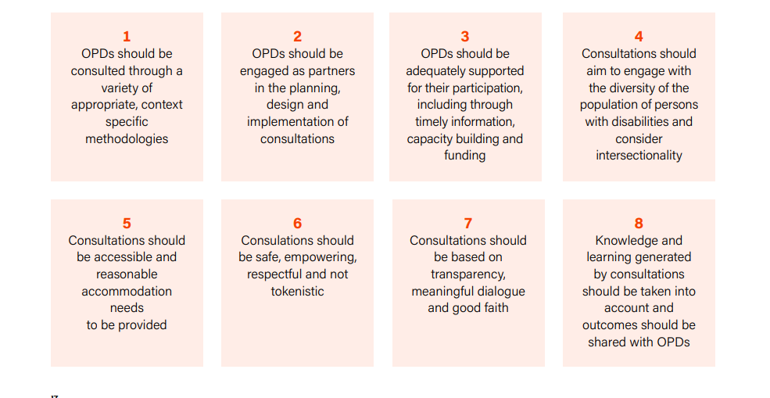
After lunch, participants were asked to work in groups on the below topics and expressed the following remarks:
- Funding and funding conditionalities
  - Often, OPDs cannot fulfil donors’ criteria in terms of due diligence and organizational capacity, including a certain number of staff. As a result, OPDs cannot access direct funding and cannot reinforce their capacity.
  - Most OPDs in Bangladesh receive funding through international NGOs.
    - In Bangladesh, even the process of formally registering an organization can be complicated and overwhelming for small organizations run by volunteers (which is the reality of most ODPs at the national/local level)
      - In Bangladesh, OPDs need a letter of commitment to from an INGO for submission to the NGO Affairs Bureau in order to access funding.
  - The fiscal sponsorship model can be a useful way to overcome this barrier, while reinforcing their operational and organizational capacities at the same time.
  - OPDs need funding to cover for: accessibility costs and reasonable accommodation; office costs; administrative costs, staff salaries; capacity building training costs.

Figure 4 Marketplace exercise with INGO representatives

- Types of projects and roles of OPDs in projects
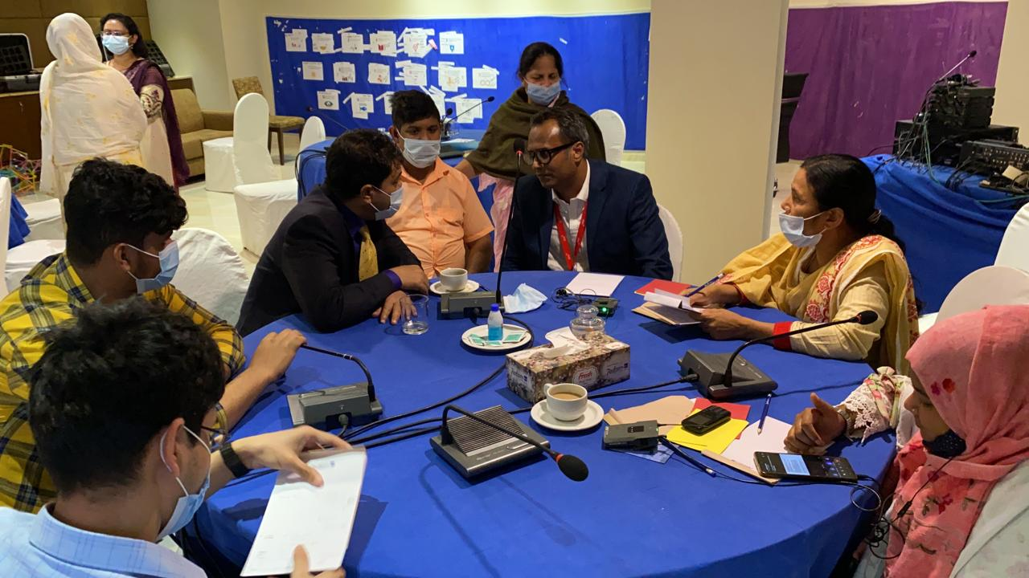
  - If OPDs have access to funding, they should have no restrictions in terms of project types to implement.
  - If OPDs can rely only on their resources, they would probably implement micro-credits projects, strengthening individuals’ skills on livelihoods and run small-scale advocacy for inclusion in education and health.
  - OPDs are normally asked by partners to play a consultative, technical partner role, including key informant in all sorts of project, from livelihood to advocacy and awareness raising, to receiving capacity building.
  - Normally, on issues not pertaining to disability, such as environment issues, OPDs are rarely invited to participate in consultations; moreover, OPDs feel like they are invited only when everything has already been decided, as a mere tick boxing exercise.

- Coordination of Initiatives on Donor Investments
  - Currently, there is no coordination mechanism for donors’ investments in Bangladesh: for instance, UN funded projects being implemented through government organizations are not coordinated with the donor.
  - In Bangladesh, the way the government works with UN agencies is exclusive, with no possibility for OPDs to interact with them.
  - OPDs are normally involved in smaller budget projects.
  - To improve coordination between OPDs and donors, a website collecting all data and information of OPDs working in the country could be useful.
  - All donors should have a strategy on how to include persons with disabilities and their representative organizations in their project and activities.
  - Recently, OPDs in Bangladesh have started receiving information on donors’ project, and have been consulted by FCDO on its Disability Inclusion Strategy

On the second day, building on the discussions of the previous day, participants formulated the following recommendations, tailored to the Bangladesh context:
- A twin-track approach
  - A legal system enabling a conducive environment for OPDs to operate is paramount.
  - Direct partnerships between key development stakeholders working in Bangladesh with OPDs need to be strengthened.
  - Costs to ensure meaningful participation of OPDs in projects must be budgeted (i.e. reasonable accommodation, accessibility, etc).
  - An umbrella federation of OPDs, representing all impairments groups, should be supported in strengthening their capacities.
  - OPDs should support the government of Bangladesh in understanding the nuances/distinction between OPDs, CSOs, CBOs, NGOs, etc.
  - Decision making spaces of law making, must be inclusive of OPDs otherwise we may not be able to address these barriers.
  - Grass-root level OPDs should be particularly involved and supported.

- Participation of underrepresented groups
  - Much effort is needed to include LGBTQI+ persons with disabilities within the movement is needed, as well as persons who have been affected by leprosy who are underrepresented in Bangladesh.
  - Data collection around underrepresented groups needs to be strengthened and advocacy carried towards governments officials.
  - In Bangladesh, inclusion of persons with intellectual and psychosocial disabilities is insufficient: their networks should be supported and awareness raising targeting their families is particularly needed.
  - Persons with intellectual and/or psychosocial disabilities should be supported to represent themselves, and not be represented by professionals or families.
- Support to movement building
  - To be more effective, OPDs should come together under an umbrella organization, particularly to strengthen collective advocacy around a specific theme and act as a united voice towards the government.
  - A coordination mechanism between OPDs, INGOs and the government is needed, and the role of OPDs should be made clear to the government.
  - More flexibility in the NGOs registration process is needed.
  - OPDs leaders should be supported in strengthening their leadership skills
- Anticipation and resourcing participation
  - Project design must consider the requirements of persons with disabilities and anticipate and budget for accessibility, adequate time and reasonable accommodation. Governments and INGOs in particular must consider multiple level of arrangements
    - In this regard, a non-exhaustive list of required services for persons with disabilities could be drafted.
  - Information about projects and decision-making process must come with adequate anticipation.
  - Information should also be provided in the local language and not just in English.
- Feedback and meaningful dialogue
  - Exchange of information between OPDs and partners should be continuous, and not on an ad hoc basis
  - After consulting with OPDs, partners should keep them informed and provide feedback
  - OPDs shall take responsibility and hold partners accountable to sharing information (i.e. follow up on meeting notes, etc).
- Flexibility
  - Donors, governments and INGOs partners should review their standards for granting fund to OPDs and allow flexibility and support them to comply to requirements.
  - All information is in English, including for application, they should be available in local language and also in a manner that is easy to understand.
  - Donors should consider providing letter of commitment to OPDs so that they can get NGO registration. For the local level, the process is easier: it can be done at the sub-district level, by tying up with other local organisations.
  - However, some argued that if OPDs are forced to register, this might have an adverse effect given the requirements around paperwork and regulatory requirements. Registration should not be mandatory, given the fact that the General Comment No. 7 is explicit that for the purpose of participation it is not necessary that OPDs are registered entities.
  - OPDs activists do not usually have the capacity to write proposals according to donor requirements, nor do they have the social capital or resources to identify consultants or hire staff to support these processes.
  - Participants expressed that the Government still appeared to work on a charity model, for instance, whenever OPDs asked for accessibility, all that is given is response is wheelchairs. They did however acknowledge the good that in the 2013 law it is mandated that they must recognise OPDs.
  - Another barrier was when donors ask OPDs for specific data that they may not have. OPDs need training on what requirements are there for donor funding.
  - Bangladesh has a lot of emphasis on digital inclusion, disability movement can raise demand for participation to be made easy, government should be taking concrete steps like make mobile sets accessible etc. data collection through mobile phone system that is easy for persons with disabilities to be trained on or how to use apps etc.

Conclusion and way forward
In conclusion, the participants were very appreciative of the manner in which the workshop was organized, that they were exposed to some of the discussions happening at the global level and were given the space to reflect on them in their national context.
Participants from INGOs and OPDs appreciated the space for mutual exchange and learning about their own work and challenges. Participants were especially appreciative that the major networks of OPDs were represented, as well as OPDs of underrepresented groups including persons with psychosocial disabilities, intellectual disabilities, persons affected by leprosy and the deafblind.
It was unfortunate that despite high interest from the GLAD network, organizations and several confirmations, representatives did not actually attend the proceedings in person, but given the rich outcomes of this workshop it seems possible to have a follow up discussion post the drafting of the report on the consultations.
Participants look forward to the cumulative report that will be generated at the end of the series of workshops in order to take the advocacy forward as well as to see actual change and engagement of OPDs by donor agencies.
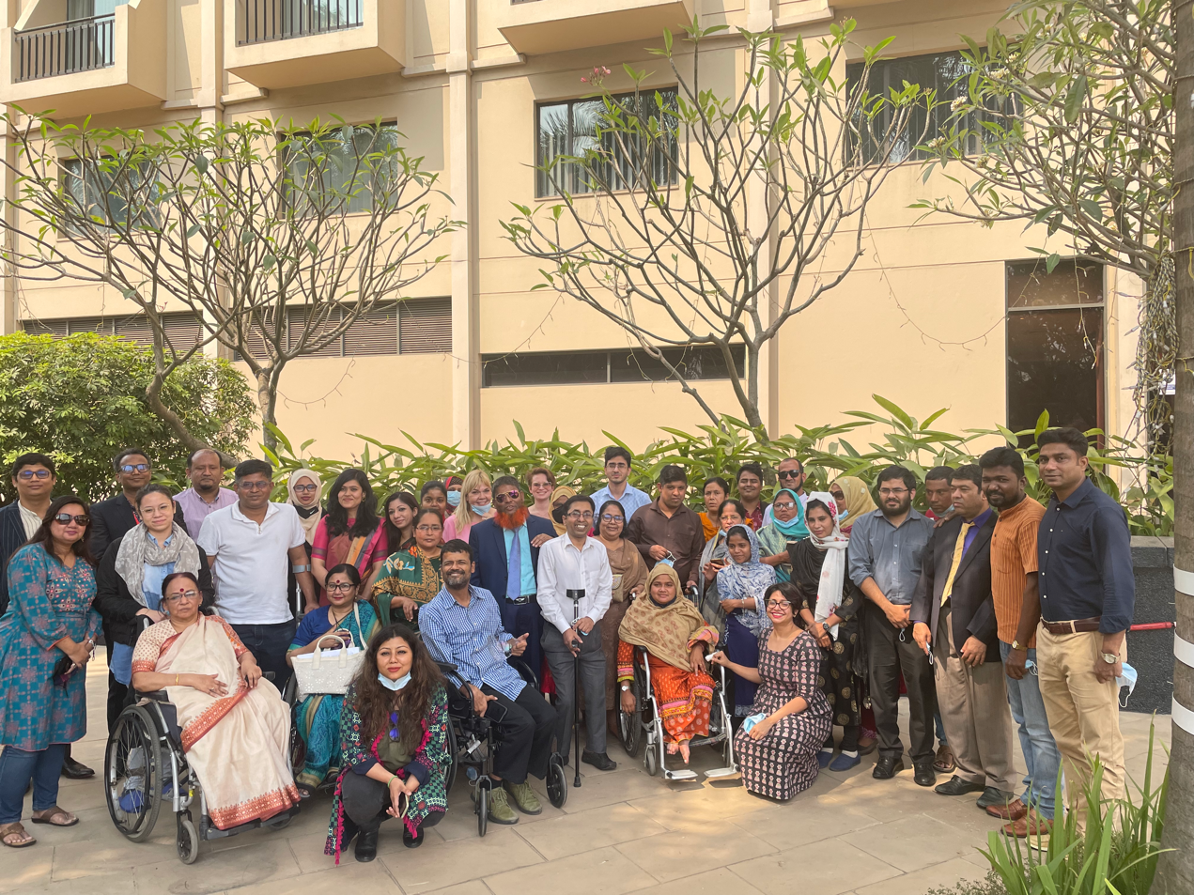

Figure 5 Group photo of the participants

