APRIL 2020
NEW
THE
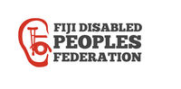
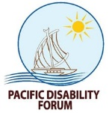
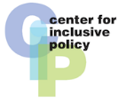
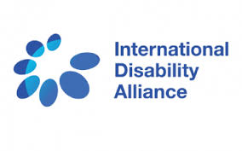
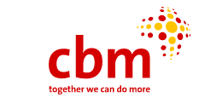
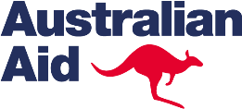
VOLUME 1
Learning from DPOs initial work on budget advocacy in the Asia-Pacific
Version 1.0
GETTING GOVERNMENTS TO SPEND [MORE & BETTER] FOR [INCLUSION] OF ALL PERSONS WITH DISABILITIES
NORMAL.
Published with the support of:

ACKNOWLEDGMENT AND DISCLAIMER

This document has been prepared by the Centre for Inclusive Policy (CIP) and CBM Australia in consultation with Equals-CPSJ (India), Life Haven-CIL and the Philippine Coalition on the UN Convention on the Rights of Persons with Disabilities, the Access Bangladesh Foundation, the Fiji Disabled Peoples Federation and the Pacific Disability Forum who have all been engaging in budget advocacy in recent years.

The authors would like to acknowledge early support from DPOD, CBM, Australian DFAT and the Open Society Foundation through the International Disability Alliance for national initiatives in India, the Philippines and Fiji.

This document was initiated to inform OXFAM in Timor-Leste Open the Books project’s efforts to support DPOs’ budget advocacy in Timor-Leste. Building on the initial work of the International Disability Alliance and previously published papers from CIP, its aim has been broadened to provide a general introduction for DPOs willing to engage in budget advocacy. It also benefitted from CIP’s exchange with the Westminster Foundation for Democracy in the development of an upcoming training package on inclusive budgeting for elected officials.

A volume 2 is being prepared by CIP and IDA in consultations with DPOs and based on their experiences, to provide further insight and guidance on technical issues related to budget analysis and advocacy.

Author(s): | Alexandre Cote and Meenakshi Balsubramanian
Contributors: | Benjamin Bernadino, Polly Meeks, Elizabeth Morgan, Laisa Vereti, Joshko Wakaniyasi, Lauro Purcil, Janice Cambri, Tom Tanhchareun
Published with the support of: | Center for Inclusive Policy, OXFAM in Timor-Leste and Oxfam Australia, CBM Australia and the Australian Government through the Australian NGO Cooperation Program (ANCP).

The information and views set out in this document are those of the authors’ alone and are not necessarily the views of the Australian Government, partners and sponsors.

FOREWORD
The COVID-19 crisis has magnified the significant barriers and inequalities faced by persons with disabilities all over the world. Everywhere the lack of accessibility of information and essential services, including health care, has put persons with disabilities at greater risk.
In high-income countries while extensive social protection mechanisms allow for mitigating the impact of the crisis, an over-reliance on residential care institutions has led to dramatic outcomes for many persons with disabilities, especially among older persons. In addition, in most Low and Middle Income Countries (LMICs) a lack of support services and the low coverage of social protection schemes have severely limited the capacity of central and local governments to support persons with disabilities.
Even before COVID-19, low levels of public resources were allocated to inclusion of persons with disabilities in most LMICs. Simply maintaining pre-crisis spending will thus be insufficient to prevent their impoverishment and further marginalization. For instance, while recent global estimates consider that a basic universal disability benefit would require an average 0.5% of GDP investment in LMICs, less than ten LMICs invest more than 0.3% of GDP on disability-related social protection compared with an average 1.4% of GDP for high-income countries (OECD).
An inclusive recovery will require both increasing public resources dedicated to social protection and support services as well as ensuring that all public funds across sectors are spent in an inclusive way.
However, as governments’ relief expenditure and loss of revenue due to lockdown increase public deficit and debts, there is a significant risk of fiscal consolidation and political decisions leading to austerity measures that would hit persons with disabilities as it did in high-income countries after the 2008 financial crisis
The recent UN Secretary General policy brief calls for COVID-19 response and recovery that “have a strong focus on building more equal, inclusive and sustainable economies and societies.” It also calls for “National and sub-national economic models and assumptions need to be critically reviewed to identify gaps that disproportionately impact persons with disabilities and take into account the cost of underinvestment in disability-inclusion”.
While this first manual, based on the experience of several DPOs of Asia-Pacific in budget advocacy, was developed before the crisis, its objective has never been more relevant. We hope that it will be a source of inspiration and will support leaders of the movement to engage further with governments and other civil society coalition to ensure that the COVID-19 recovery contributes to more inclusive, equitable and progressive mobilization and use of public resources.
TABLE OF CONTENTS

ACKNOWLEDGMENT AND DISCLAIMER 3
FOREWORD 4
1. THE CRITICAL IMPORTANCE OF PUBLIC BUDGET FOR AN INCLUSIVE RECOVERY AND THE REALISATION OF THE RIGHTS OF ALL PERSONS WITH DISABILITIES 6
2. WHAT IS CRPD COMPLIANT BUDGETING? 9
IN A NUTSHELL: BASIC RULES FOR CRPD COMPLIANT BUDGETING 11
3. WHY SHOULD DPOs ENGAGE IN BUDGET ADVOCACY? 13
PART 2: EXPERIENCE OF DPOs’ ENGAGEMENT IN BUDGET ADVOCACY 14
1. BUDGET ADVOCACY: ONE GOAL, DIFFERENT ACTIONS, ALL NECESSARY 15
2. INITIATING NATIONAL BUDGET ADVOCACY FOR INCLUSION OF PERSONS WITH DISABILITIES 18
OVERVIEW OF PROCESS IN INDIA, THE PHILIPPINES AND FIJI 18
CASE STUDY: INDIA (M.BALSUBRAMANIAN) 19
COMPARISON WITH THE PHILIPPINES AND FIJI PROCESSES 21
REVIEW OF THE LESSONS LEARNED IN THE INITIAL PHASE OF BUDGET ANALYSIS IN INDIA AND THE PHILIPPINES 23
3. LOCAL BUDGET ADVOCACY 25
INDIA 25
THE PHILIPPINES 25
4. OVERALL RESULTS TO DATE 27
5. RECOMMENDATIONS 28

THE CRITICAL IMPORTANCE OF PUBLIC BUDGET FOR AN INCLUSIVE RECOVERY AND THE REALISATION OF THE RIGHTS OF ALL PERSONS WITH DISABILITIES
The UN Convention on the Rights of Persons with Disabilities (CRPD) – which explicitly sets out States Parties’ obligation to ensure the realisation of the civil, political, cultural, social and economic rights of all persons with disabilities – was adopted in 2006 and has now been ratified by 181 countries worldwide. According to the 2011 World Report on Disability published by the World Health Organization and the World Bank, national implementation of the CRPD requires policy reforms, social innovation, pilot programs and scaling up of successful local practices for most
countries and in most policy areas. This in turn requires governments to increase, and improve the quality of, public spending on realisation of all rights for all persons with disabilities.
Disability generates costs for persons with disabilities, their families and countries and governments:
PERSONS WITH DISABILITIES AND THEIR FAMILIES | COUNTRIES AND GOVERNMENTS
Forgo income:  - discrimination in education and employment leads to no work or lower wage  - family members who provide support can’t work or children providing care drop out of school  - spending on disability implies reprioritisation of resources that could have funded better education or investment in livelihood.  Face specific costs such as:  - specific expenditures because of disability, for example assistive devices or personal assistance  - increase in general expenditures, for example, medical care, transportation, housing due to higher use or cost to overcome inaccessibility of existing services. | Economic cost due to exclusion of persons with disabilities:  - ILO estimated that the cost of exclusion of persons with disabilities from the labour market ranged from 1% to 7% of GDP in 10 low- and middle-income countries.  Have to spend public resources to:  - ensure access to support services such as assistive devices or personal assistance, as well as (re)habilitation  - make all mainstream services (education, justice, health…) and infrastructure, information and communication accessible and inclusive  - provide income security and cover extra cost of disability.
Require at least 40% of average income to have same standard of living as a household without persons with disabilities. | In high income countries, specific public spending for support of persons with disabilities is often above 1.4% of GDP, but below 0.3% in low- and middle-income countries.
Investing in inclusion of persons with disabilities yields benefits for society as a whole:
Lowering extra costs of disability faced by persons with disabilities and their families will allow them to use their resources more productively, which will have a positive impact on poverty eradication and reduction of inequalities;
Increase in education level and employability of persons with disabilities will lead to higher employment and better income;
Investing in support services and accessibility will benefit not only persons with disabilities but also older people and many others.
In line with CRPD obligations, countries irrespective of their level of income or economic development have to use maximum available resources to meet CRPD commitments. This implies that all ministries and all levels of government have to contribute.
In all contexts, significant efforts have to be made to ensure that all public spending actually fosters accessibility and non-discrimination. For instance, few countries have clear accessibility requirements in their public procurement policies, along with regulations which imply that most goods, services and works purchased by public money might actually create new barriers for persons with disabilities.
Resourcing specific support for persons with disabilities (in terms of services such as personal assistance, sign language interpreters or assistive devices and social protection schemes, among others) will vary according to context.
Higher income countries, such as European Union countries, already have substantial budget allocation on disability, spending at least 2.1% of GDP on average (albeit this is not always sufficient to meet their obligations in full). Former socialist countries such as Georgia and Uzbekistan also have significant public spending, ranging from 0.7% to above 1% of GDP. However, in those countries, some public spending finances programs and services that do not comply with the CRPD, such as residential institutions or segregated special education. This means that financing inclusion will require reallocation of those expenditures towards CRPD-compliant programs and policies, such as inclusive education, deinstitutionalisation and the development of community-based services.
In most low- and middle-income countries, few significant policies or programs aiming at the inclusion of persons with disabilities have been developed or adequately funded publicly. Data from India, Mauritius, Namibia, the Philippines, South Africa and Pacific Island countries indicate that allocations in many low- and middle-income countries are below 0.5% of GDP, and in some, such as India, are actually less than 0.1% of GDP.
Required interventions to implement the CRPD range from no to relatively high cost:
NO COST | a social clause for employment of persons with disabilities in public procurement
LOW COST | ensuring accessibility of all new infrastructures, transports, websites
HIGH COST | support services and social protection support for children and adults with significant support needs (2-3% of the population)
For most LMICs, where there are little or no formal support services and social protection, implementing the CRPD and inclusive SDGs will therefore imply significant increase of budget allocations across sectors. The Government of Samoa’s efforts to develop a costed CRPD implementation plan in 2015, following their CRPD ratification, provides an interesting illustration, even though the experience had many caveats due to data limitations. The plan covered only key actions prioritised by stakeholders as critical for starting CRPD implementation and estimated that resource allocation ranging from 0.2% to 0.7% of GDP over five years would be required, compared with the 0.1% then allocated.
However, in low- and middle-income contexts, just as in high-income contexts, it is critical to consider the increase of resource allocation within a CRPD-compliant framework. Investing more in residential care institutions or segregated schools can indeed result in an increased higher budget allocation while actually creating more barriers to inclusion.
DPOs, national and local governments and donors have to develop a common understanding of CRPD standards, make the most of the available data, and identify gaps and priorities to allocate existing resources effectively and equitably.

WHAT IS CRPD COMPLIANT BUDGETING?

In recent years, as many countries have adopted new legislation to implement the CRPD, interest has been growing in the role of public budgets in supporting the inclusion of persons with disabilities. The terms “inclusive budgeting”, “disability budgeting” and “disability responsive budgeting” are used somewhat interchangeably by stakeholders. While these offer an entry point for stakeholders to engage with budget processes and public financial management (PFM), they might not provide the comprehensive guidance required to ensure that maximum available resources are used to implement the CRPD.
Inclusive budgeting is the broadest concept. It implies that government revenue generation and expenditures will contribute to inclusive development, involving and benefitting all people in their diversity. This should include persons with disabilities among others and pay attention to the impact of revenue generation and expenditures on gender equality and the most marginalised groups. It should ensure also that all stakeholders are meaningfully consulted in budget processes. Important as an overarching concept, such an approach alone might miss the specific requirements of different groups, particularly the most marginalised among persons with disabilities.
Disability budgeting and disability responsive budgeting echo gender-responsive and child-responsive budgeting methodologies, with a focus on persons with disabilities. Such concepts provide a focus on disability and might be more inclusive of all groups, but they may not be specific enough to ensure compliance with CRPD. Indeed, governments in good faith might consider the following to be disability-responsive public expenditure:
1 | programs that are important but which do not promote inclusion of persons with disabilities per se, such as public health programs (immunisation, mine risk awareness, etc)
2 | programs that contravene the CRPD, such as spending on segregated special education or psychiatric hospitals practising forced treatment and coercion
3 | a focus on disability-specific programs only while failing to promote a whole-of-government inclusive approach.

CRPD compliant budgeting builds on the comprehensive standards of the CRPD to assess and plan public resource allocation. This covers all human rights of all persons with disabilities. While the CRPD Committee has not yet developed specific guidance on the subject, a few basic elements can be elaborated based on the CRPD Standards, including the CRPD Committee jurisprudence, as well as the experience of DPOs from the Philippines, India and the Pacific in budget analysis and advocacy. In CRPD-compliant budgeting:
- The planning process and execution of public budgets strictly comply with provisions of the CRPD.
- Persons with disabilities, including women and children, through their representative organisations, should be closely consulted in planning and execution of budgets at the national and local levels, with specific attention to the most marginalised groups.
- The overall public financial management system contributes efficiently and effectively to CRPD implementation, using all available instruments (transfers, public procurement, grants, contracts, tax credit, revenue generation, etc.).
- All national and local public spending and development assistance foster accessibility and non-discrimination across sectors and contribute to the inclusion of persons with disabilities.
- All policies, guidelines or administrative regulations allowing for and related to public expenditures, are consistent with the CRPD, including public procurement regulations.
- Public resources, domestic and international, do not finance programs and services that contravene the CRPD:
  - Reforms of such programs towards compliance are implemented or resources are reallocated from CRPD non-compliant to CRPD-compliant policies, services and programs. This may be realised incrementally but a deadline should be set. This applies also to services that are publicly funded and/or regulated but delivered by private entities.
- Public resources are used to:
  - sustain and ensure universal access to effective national policies, programs and services that are compliant with the CRPD
  - scale up effective local programs, services and initiatives that are compliant with the CRPD
  - allow for the development of new policies addressing gaps in services required for inclusion.
- Specific attention should be paid to ensuring that public spending supports gender equality and the inclusion of the most marginalised groups among persons with disabilities.
- Maximum available resources, both domestic and international, are mobilised across sectors and government levels. All ministries and public agencies allocate resources to ensure non-discrimination and to progressively make their services accessible and inclusive to all persons with disabilities. Such earmarking should be supported by implementation plans and technical assistance.
- Public resources follow responsibilities devolved from central to local governments within the frame of fiscal decentralisation to ensure that local authorities have the means to deliver the services and support they are mandated to deliver.
- Revenue generation, including taxation, takes into consideration the extra costs faced by persons with disabilities.
- The principle of non-retrogression is fully applied and prevents disproportionate and arbitrary cuts in resources allocated for the inclusion of persons with disabilities. Austerity measures that have weakened standards of support across Europe since the 2008 financial crisis are an illustration of such negative policies.
- Budgeting processes and reports are transparent, with agreed-upon indicators for monitoring the progress of CPRD-compliant budgeting, including not only budgetary allocation but actual expenditures as well.

IN A NUTSHELL: BASIC RULES FOR CRPD COMPLIANT BUDGETING
1 | DO NOT spend public funds on programs and services that are contrary to the CRPD such as segregated education or social care institutions.
2 | ENSURE that all public spending across ministries and levels of government contributes to inclusion, including development assistance:  - accessibility in all publicly funded new infrastructure, transport, information and communication systems  - accessibility requirement in public procurement regulations for services, works and goods  - non-discrimination and duty to provide reasonable accommodation in all public services  - social clause in procurements favouring employment of persons with disabilities.
3 | PROGRESSIVELY AND EQUITABLY increase spending to ensure national access to support services that promote inclusion: (re)habilitation, assistive devices, personal assistance, sign language interpreters, support for children and their families, disability allowance, etc.
4 | PROGRESSIVELY invest in making existing infrastructure and services accessible to all persons with disabilities.
5 | COLLECT AND DISSEMINATE data on budget and outcomes of publicly funded programs and services.
6 | CONSULT with DPOs in their diversity across the budget cycle.

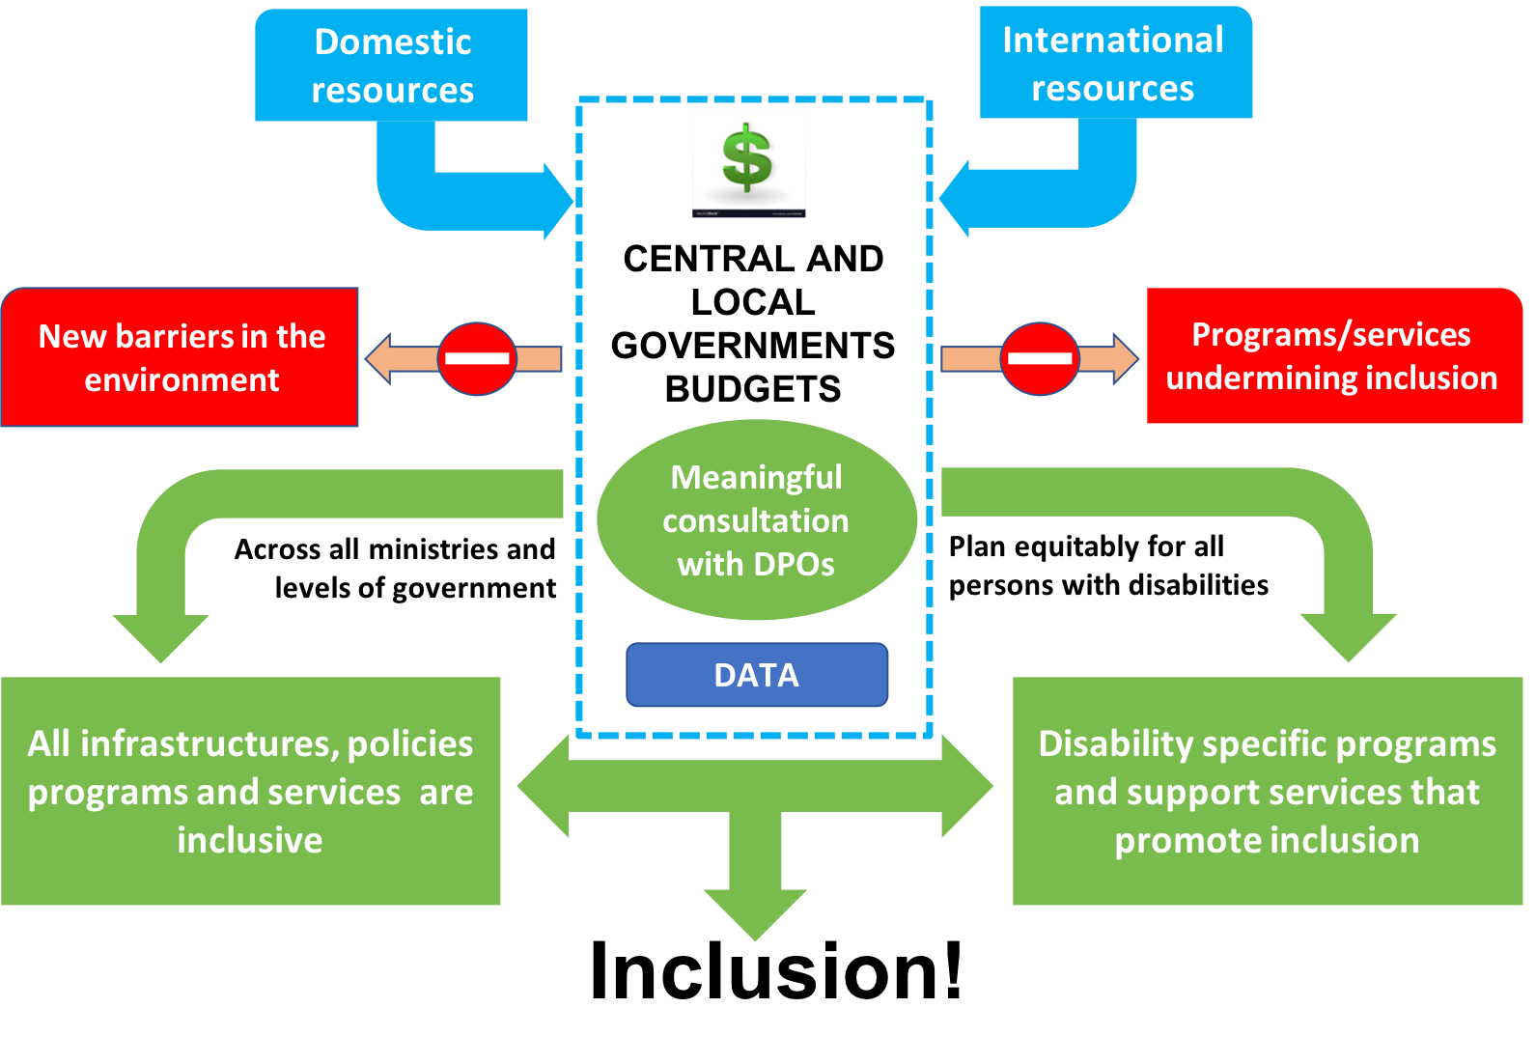
Figure 1 - Basic principles of budgeting for inclusion of persons with disabilities (CIP, 2019)

WHY SHOULD DPOs ENGAGE IN BUDGET ADVOCACY?
Engagement of DPOs in budget advocacy is critical for several reasons:
  - NOTHING ABOUT US WITHOUT US: It is the duty of government to consult with DPOs in any policy matters impacting persons with disabilities. DPOs need to be in a position to be an effective counterpart to make the most of this engagement. Engaging in budget advocacy helps build new skills and knowledge and gain credibility towards public authorities and elected officials.
  - SUSTAINED DEMAND: Ensuring that adequate public resources will be allocated and effectively used for inclusion of all persons with disabilities will take many years. DPOs are the only actors with the necessary long-term focus and interest in developing and sustaining demand for more and better public spending on inclusion.
  - ACCOUNTABILITY: Budget advocacy helps monitor the political will of government, the level of prioritisation given to inclusion of persons with disabilities and the effort to implement the CRPD.
  - FRAMING THE RESOURCE DEBATE: Limitation of resources is a recurrent argument put forward by governments for explaining their lack of progress to advance inclusion of persons with disabilities. Often measures required are deemed unaffordable. DPO analysis of existing public expenditures, gap analysis and costing of measures will allow them to negotiate and reframe the resource debate by proposing a realistic way forward.
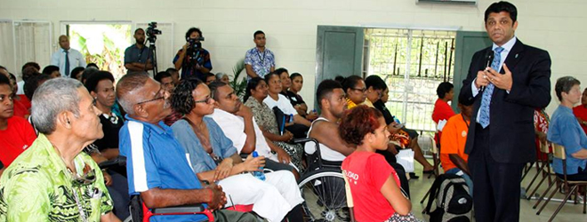
  - ENSURING EQUITY: Governments tend to prioritise increasing expenditure on existing services and programs which may not address needs of the most marginalised groups, and these groups may not have access to budget debates. By developing consensus among all constituencies on key budget demands, DPOs can contribute to greater equity in the use of resources between groups and gender equality over the years.
Figure 2
Fiji Minister of Economy Aiyaz Sayed Khaiyum during the 2017/2018 National Budget Consultations with members of the Fiji National Council for Disabled Persons

PART 2: EXPERIENCE OF DPOs’ ENGAGEMENT IN BUDGET ADVOCACY

This chapter will describe the key steps to be undertaken by DPOs willing to engage in budget advocacy based on lessons learned from DPOs experience in India, the Philippines and Fiji.
Before describing those steps, a review of the experience of DPOs in these countries shows there are important elements to consider:
BUDGET ADVOCACY IS NOT ONLY ABOUT MONEY - without a good knowledge of existing policies, regulations and decentralisation mechanisms, it is very challenging to understand the way public funds are planned, used and reported. For instance, DPOs may ask for reallocation of funds from one program to another, which is administratively difficult to do.
MORE MONEY IS NOT ALWAYS BETTER - while it is important to ask for more resources, the way those resources are used is as important. For instance, more public funds allocated to institutional care rather than community services undermine inclusion of persons with disabilities.
BUDGET ADVOCACY TAKES TIME - public budgets usually evolve slowly. The vast majority of budget items are recurrent costs of public services such as salaries of teachers, police, army personnel, and health care staff and maintenance of buildings. From one year to another those items do not change much and there is often limited space to create new budget lines for new services. So, achieving significant changes may take many years.
EVERYTHING IS POLITICS - the way government collects revenue and spends resources is framed by legislation and policy choices that are the outcome of political processes. While data and evidence play an important role, ultimately priorities are often decided based on power play between stakeholders. Politics also play a role within the disability movement where some groups have more strength and voice than others in shaping key demands or accessing decision-making processes.
CONTEXT MATTERS - political, social and economic environments have a big influence on budget process outcomes. At any given time, there can be a positive political momentum that will allow leapfrogging results. When there is little momentum, it will be significantly more difficult to make any gains. The issue is that one has to be ready because context can change quickly.
BEYOND DISABILITY - many issues related to mobilisation and use of public resources for inclusion of persons with disabilities are not disability-specific. This includes low social public spending overall, lack of transparency, corruption and issues with fiscal decentralisation. Only broad alliances with other civil society movements can contribute to tackle those issues.

BUDGET ADVOCACY: ONE GOAL, DIFFERENT ACTIONS, ALL NECESSARY
While the goal of budget advocacy is to influence the way in which public resources are allocated and used, budget advocacy covers many different complementary and often combined activities, such as:
ANALYTICAL WORK | for instance, review of evolution and/or impact of public spending in a certain sector or for particular groups and publication of findings
LOBBYING | engaging politically in budget process to demand creation, increase or reallocation of budget items or adoption of laws or regulations that will have a direct impact on spending (accessibility requirement in public procurement)
ACCOUNTABILITY WORK | monitoring the level of transparency of budget data or the use of public funds allocated for specific purposes via expenditures tracking and review of audited accounts.
Some groups will focus on the governance and transparency of budget process while others will focus on the optimum use of public resources to realise a certain goal such as gender equality or inclusion of persons with disabilities. The experience of DPOs shows that those different objectives and actions are mutually reinforcing. Marginalised groups will not be able to engage if budget process and information are not open and transparent, and engagement of many different groups creates a critical level of demand for more transparency and openness.
The main goal of DPOs’ engagement in budget advocacy is getting government to spend more and better for inclusion of persons with disabilities. This implies a subset of objectives that are aligned with the principles of CRPD-compliant budgeting presented in Part 1:
- That data on persons with disabilities, existing services and budget allocated for support to and inclusion of persons with disabilities is available
- That public funds do not contribute to programs and policies that undermine inclusion of persons with disabilities.
- That public funds do not create new barriers and that accessibility and non-discrimination requirements apply in procurement regulations
- That all public funds contribute to inclusion:
  - domestic and international development resources
  - central and local governments
  - across ministries and sectors (not only social affairs, health and education but also justice, transports, trade and industry)
- That progressive and equitable increase of resources to ensure development and access to all required support services for inclusion and accessibility is available.
Lessons from the experience of DPOs in India, the Philippines and Fiji and their partners in budget advocacy coalitions over the years shows that there are different levels of engagement in budget advocacy:
PHASE 1: GETTING STARTED
- Understanding the basics of budget cycle processes, the structure of budgets and the basic flow of public funds
- Initial data collection and analysis of budgets to identify spending for persons with disabilities
    - Regulations and spending on programs that are specifically designed for persons with disabilities
    - Regulations and spending on policies and programs including persons with disabilities as one of their target groups
    - Regulations on general policies and programs that are supposed to include persons with disabilities but do not specifically mention persons with disabilities.
  - Basic review of procurement and other regulations to assess the extent to which they foster accessibility and inclusion
  - Basic understanding of distribution of implementation and financing responsibilities between different ministries and between central and local government
  - Basic review of the level of actual spending of funds allocated for persons with disabilities (in countries where information such as audited accounts is available)
  - First engagement in budget cycle and demands to government
  - Basic engagement with broader civil society budget advocacy coalition.
PHASE 2: ENGAGEMENT
  - Recurrent review of national budget (allocation and level of use of funds) with analysis of equity of allocation and outcomes between groups as well as gender equality
  - Gap analysis level 1:
    - What are the provisions of the laws that are actually funded?
      - Are there any CRPD-compliant elements of legislation that are not adequately funded?
      - Are there any CRPD non-compliant programs funded that could lead to reallocation?
    - Are there programs (CRPD-compliant or not) funded that are not in the law?
    - To what extent are publicly mainstream programs and services inclusive of persons with disabilities?
  - Engagement in local budget advocacy
  - Repeated engagement with budget process
  - Lobbying for accessibility requirement in public procurement regulations
  - Consensus-building among DPOs to formulate key demands in policy change and budget demands with greater focus on equity between groups
  - In-depth engagement with broader civil society budget advocacy coalition.
DPOs in Fiji, the Philippines, India and Bangladesh are at this initial level, but not all cover all of the activities every year. Once this initial level is mastered there are different elements that can be improved further
PHASE 3: ADVANCED WORK
  - Combination of national and local budget advocacy with bottom up accountability:
    - Is the money allocated actually spent on what it is intended to do at the local level? This assumes that national DPOs will provide information on national policies and budget allocation that is supposed to reach local levels and that local DPOs will actually monitor if and how funds are used and report back.
  - Gap analysis
    - Assessing outcomes of current publicly funded policies, programs and services when compared to actual needs for all groups of persons with disabilities across the country in different sectors. DPOs would evaluate effectiveness and efficiency of spending
    - Costing of gaps in services and support identified based on best available data
    - Policy proposal to address and finance gaps identified
    - In depth consensus process among DPOs to identify possible reallocation and priorities for increasing public spending over a three to five-year period.
This first volume focuses on the initial level as it reflects the current experience of DPOs. A second volume is in preparation for 2020 which will provide guidance on each step of the different phases.

INITIATING NATIONAL BUDGET ADVOCACY FOR INCLUSION OF PERSONS WITH DISABILITIES
In India, the Philippines and Fiji, the work on budget advocacy started in connection with International Disability Alliance (IDA) support linked to CRPD monitoring. Budget advocacy was framed from the outset by CRPD principles and standards. Here, we will review the key lessons learned from the initial phase in India and the Philippines and see in detail how the initial analysis was carried out in India.

OVERVIEW OF PROCESS IN INDIA, THE PHILIPPINES AND FIJI

 | INDIA | PHILIPPINES | FIJI
Starting point | Work on the parallel report of the CRPD (2011) | Work on the parallel report of the CRPD (2011) | Started in 2014 and worked on the ratification of the CRPD (2017) and new disability rights act (2018)
Lead organisation | National Disability Network  (informal network) | Philippine Coalition on the U.N. CRPD (informal network) | Fiji Disabled Peoples Federation  (FDPF)
Initial steps | - DPOs’ workshop with Centre for Budget and Governance Accountability (CBGA) and IDA  - Three-months internship of two DPOs activists in Centre for Budget and Governance Advocacy to carry initial budget analysis | - DPOs’ workshop with Social Watch Philippines and IDA  - Initial budget analysis carried out by external consultants which led to good data but lack of ownership among DPOs  - Reboot the year after, with a team of DPO activists carrying out analysis  - Investment in training of local DPOs to engage in the Philippines bottom up budgeting | - Workshop with IDA and PDF supported by Equals-CPSJ  - Initial budget analysis carried out by FDPF team with IDA-PDF support
Engagement of the movement | While the initial team has developed very strong expertise, the set-up did not lead to strong DPO engagement. | The investment of a core team of members of the CRPD coalition in the second year contributed to greater involvement of DPOs, but this has remained limited | Being led by a team made up of different members of FDPF and supported by affiliates of FDPF with the leadership of the president, there has been sustained engagement of DPOs
Engagement with broader coalition | Collaboration with the People’s Budget Initiative led by CBGA | Collaboration with the Alternative Budget Initiative led by Social Watch Philippines | Work mostly focused on DPOs with low engagement with broader civil society

CASE STUDY: INDIA (M.BALSUBRAMANIAN)
India ratified the CRPD in 2007. The first country report was due in 2011 and the Government produced a draft report in 2011. However, the report was done without much consultation with the disability movement. Following this the National Disability Network (NDN), a loose network of individuals and organisations working in the disability movement, came together based on the initiative of the National Centre for Promotion of Employment for Disabled People (NCPEDP) to work on the first parallel report as a response to the draft country report. The process was facilitated by the International Disability Alliance (IDA).
As a process, the network focused on the UN reporting mechanism, review of the country report and response to the country report. The group took up various tasks as part of the reporting process, including:
- Legal analysis – to take stock of discriminatory provisions under various national laws. It was observed that many laws had discriminatory clauses against persons with disabilities on the grounds of unsoundness of mind
- Collection of case studies on discrimination experienced by persons with disabilities while accessing services and exercising their rights
- Gathering information on sub-national level implementation. In order to do this, members of the network filed applications under the Right to Information Act across ministries and departments.
As the network put together various pieces of information, they asked questions such as:
- Is there budget allocation for persons with disabilities?
- How much is allocated?
- What informs the budget allocation and is it compliant with CRPD?
- Where do you see allocations?
- Is it enough?
Responding to these questions was crucial in understanding the fulfilment of the state’s obligation as mandated in article 4 of the CRPD. Two representatives from the network were selected to undergo training with the Centre for Budget and Governance Accountability (CBGA), which is the coordinator of the People’s Budget Initiative.
The initial step was to understand the extent to which there was political will to invest in persons with disabilities. This was done through the analysis of the budget speeches of the finance minister for three years preceding the year of review, the plan documents and the outcome documents of the national Government. This was then followed by mapping the various schemes and programs across government ministries mandated by law or not. This mapping exercise sought to gain understanding of:
- different programs that were specifically designed for persons with disabilities (G1)
- schemes and programs that made specific mention of persons with disabilities, including as one of their target groups (G2)
- schemes that were general but with no specific mention of persons with disabilities (G3).
These schemes were further analysed to understand their compliance with the CRPD and their responsiveness to effectively include persons with disabilities at various levels of implementation. Subsequently, these were identified in the budget documents of the respective ministries to understand the budget allocation. The same exercise was followed in two sample states (sub-national units).

What was found in the first phase?
- The budget speeches over the years showed the lack of prioritisation of investing in inclusion of persons with disabilities, with limited references to tax exemptions and coverage through social assistance programs at the national level.
- Only eight out the fifty ministries had programs that had specific mention of persons with disabilities, and then only four ministries had some financial data disaggregated in the budget document.
- The total specific allocations (G1 and G2) to persons with disabilities represented only 0.009% of GDP.
- In spite of the Planning Commission mandating at least 3% earmarking across ministries, the disaggregated data revealed that the allocation had been less than 1% of the overall allocation to the ministry / department.
- There was huge variation between the two sample states in their allocation towards specific expenditure for persons with disabilities.
- The administrative bottlenecks in general in the system impacted effectiveness and efficiency in administering the programs for persons with disabilities.
- The programs and policies were not mandated to be in line with the CRPD.
These initial findings helped the group to follow up the budget in subsequent years and produce a response in collaboration with the CBGA. The group aligned with the People’s Budget Initiative platform in producing a charter of policy demands every year before the budget. The policy demands were primarily based on the budget analysis and included proposals for:
- the reframing of the existing programs so they were compliant with the CRPD
- the removal/transition of non-compliant programs such as spending on institutions
- new policies to effectively implement CRPD in addition to data disaggregation of all programs.
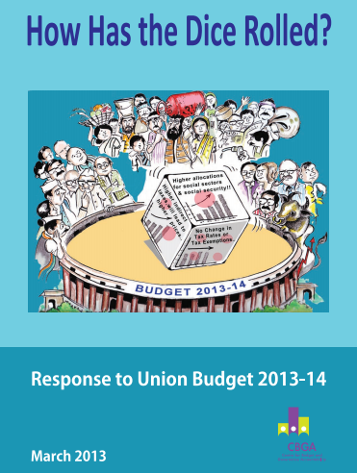
The experience has led to the expansion of the analysis to all the sub-national units using data available in the public domain. This was very important since in India, responsibilities for social spending are shared between the Union and state levels. Half of the social spending is actually made by states. Results of the analysis showed vast discrepancies among states in their priorities towards persons with disabilities. The per capita allocation ranged between INR5/person/per year and INR 3000/person/year.
The team has since created a DPO, Equals Center for Promotion of Social Justice (Equals-CPSJ), which has continued this work and has been carrying out budget and policy analysis for the broader disability movement and policy makers. They conducted a gender budget analysis through the lens of women and girls with disabilities for UN Women, undertook specific scheme analysis on, for example, education of children with disabilities, and made a study on inclusion of persons with disabilities in the Union flagship rural public works program.
They have continued their engagement with the People’s Budget Initiative, with the media being used as a key avenue to publicise issues of budgeting for inclusion. Five days after the 2018-19 general national budget was presented by the finance minister, a media article explained how the budget was leaving people with disabilities behind, using information and quoting a member of Equals-CPSJ.
Findings of the budget analysis work also informed the initial parallel report of 2012 as well as the DPO submission to the CRPD committee prior to the country review of 2019. They have contributed to strong engagement of DPOs and have led to comprehensive recommendations from the committee to Indian governments, including several recommendations related to increase and greater equity of public spending.

COMPARISON WITH THE PHILIPPINES AND FIJI PROCESSES
In the Philippines, there were similarities with India such as the link with CRPD monitoring and connection with the broader civil society budget advocacy coalition. However, the set-up was different. The initial data analysis was carried out by budget experts, who provided a wealth of information but did not frame their analysis within the CRPD. Also, since the work was done externally, there was low understanding and ownership within DPOs. The second year, a core team composed of different members of the Philippines CRPD coalition carried out the work, which improved overall understanding, ownership and engagement. The core team has continued to work within the Alternative Budget Initiative and coordinated inputs of other DPOs in the process. It has led them to meet with public auditors, and various other authorities, and to strengthen their advocacy towards elected officials. One of the challenges is that they did not secure to-date funding to maintain the high level of engagement.
In Fiji, the main difference was that the work was led and sustained by the Fiji Disabled People’s Federation (FDPF), with strong buy-in from the members and the leadership and adequate resourcing. This is critical as budget advocacy takes time and yields results only after certain investment. In sharing their experience with Pacific colleagues, Fiji DPOs acknowledged that it took four to five years to see the results of their work on the budget. The budget team was made up of representatives from the five DPOs, DPO leaders and young emerging leaders. This has been a key to succeeding as it allowed collective action - from members of FDPF, each recognising their own strengths and going as one voice. In addition, this work took place in connection with advocacy for CRPD ratification and adoption of a new disability rights act which generated a very positive momentum. The budget advocacy allowed DPOs to make the most of this momentum and they have managed to secure a significant increase of budget allocation for persons with disabilities in recent years.
It is important to note that the fact that both India and the Philippines are large decentralised countries with a lack of effective national cross-disability umbrella DPOs. This somehow undermines the potential of national budget advocacy and limits capacities to receive funding to carry out such work. In those contexts, there is a need to combine investment in more effective disability movement governance at the national level with significant support for local DPOs’ budget advocacy.
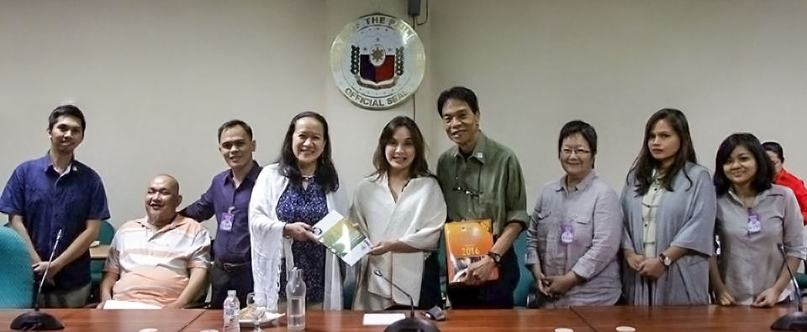

REVIEW OF THE LESSONS LEARNED IN THE INITIAL PHASE OF BUDGET ANALYSIS IN INDIA AND THE PHILIPPINES
Since the work on budget advocacy in these two countries was initiated in the same year, it is interesting to note that, while the context and legal framework of the Philippines and India are different, many of the findings from the initial data collection were similar:

- Stakeholders, including ministries, local authorities and civil society, need to develop a comprehensive and inclusive understanding of the CRPD. In particular, DPOs have to be able to critically assess existing schemes and programs and advocate for the phasing out of those that are not CRPD-compliant and the reallocation of resources to existing or new programs that contribute to the implementation of the CRPD
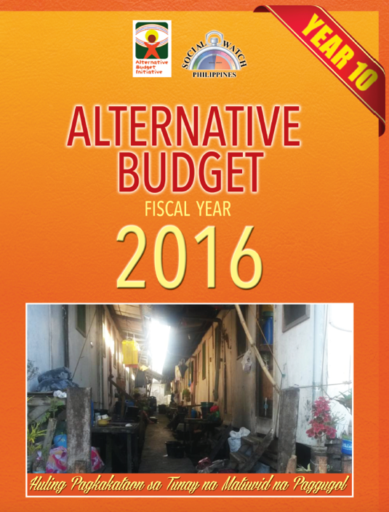
- Initial studies revealed that in India and the Philippines there were comparatively few resources directly allocated to programs aimed at the inclusion and equal participation of children and adults with disabilities. Few government ministries had specific spending for persons with disabilities. For instance, India’s federal government spent only 0.009 % of GDP annually in the four previous years on programs and policies targeting persons with disabilities. For the Philippines it was 0.02% of GDP. By comparison, OECD countries spent on average 1.3% of GDP, only taking into account disability-related benefits.
- In both countries, there was a lack of available disaggregated data to provide information about spending and outcomes of mainstream public schemes and programs for children and adults with disabilities. Moreover, the studies found that very few mainstream schemes had accessibility and non-discrimination requirements in their guidelines, which implies that very little or no spending was allocated to ensure inclusion of persons with disabilities in those schemes.
- One of the policy tools that could lead to an increase of those much-needed additional resources across ministries is compulsory earmarking, which had mixed results. Both India and the Philippines had budget earmarking provisions - under the 11th five-year plans, the Indian government imposed a 3% earmarking of the overall outlay of the concerned ministries and the Philippines had an earmarking of 1% of all public entities’ annual budgets for persons with disabilities and elderly people. This could contribute to adequately resourcing all policies and programs that support persons with disabilities and their families. However, both in India and the Philippines, the teams found that most ministries fell short of what was required over the past five years. While the earmarking created a first benchmark for accountability, it seems that the lack of monitoring as well as technical guidance and awareness within the concerned entities greatly limited the impact of earmarking.
- The first stage of analysis also revealed that bottlenecks in implementation leading to underutilisation of funds are not only related to disability rights issues but also to inadequate design of schemes, poor coordination between central and local levels, problems with expenditure tracking, late disbursement, lack of transparency and other common governance issues.
- While a significant part of public spending was conducted through public procurement (up to 20% of GDP in India and 16% in the Philippines), there was no accessibility requirement for goods and services purchased or contracted in procurement regulations.
- With regards to affirmative action favouring the employment of persons with disabilities in public procurement, there was potentially a strong element in the Philippines with presidential Executive Order 417, which allocated 10% of all goods-and-services public procurement contracts to cooperatives of persons with disabilities. But this was only partially enforced. No similar measures have been found in India.

These findings were echoed by findings in four Pacific Islands countries and by the experience of Access Bangladesh Foundation, which illustrate the challenge to translate legislative frameworks in budget commitments to implement the CRPD and ensure disability inclusion in the region.
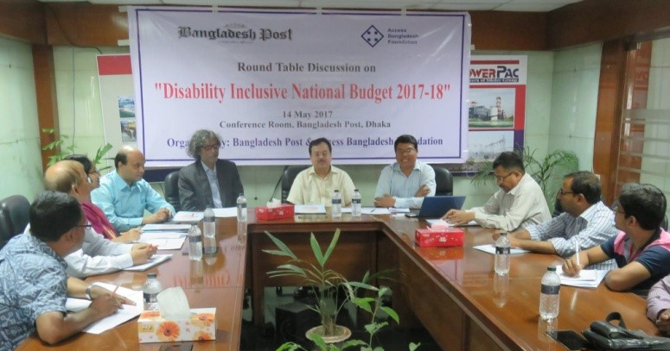

LOCAL BUDGET ADVOCACY
Local budget advocacy can be critical for two reasons:
- In many countries, there is a high level of decentralisation of service delivery responsibilities. Often local authorities do not have adequate resources to fulfil new responsibilities, which leads to a high level of competing priorities. This means that engagement of DPOs is critical to ensure that their issues will not be side-lined.
- Use of nationally allocated public resources should result in service delivery at a local level. If DPOs are not involved in monitoring the extent of implementation of programs and schemes or the quality of service delivered, it is ultimately very difficult to assess the effectiveness of the use of public resources.
In India and the Philippines, engagement at the local level took different forms related also to different local governance structures.

INDIA
Following the initial work at national level presented in the case study above, the team that had been trained went back home to Chennai, Tamil Nadu, and started work locally. Echoing the process they used for the Union budget, they carried out an in-depth analysis of the different schemes for persons with disabilities in Tamil Nadu. They ran focus groups in several local communities to assess:
- the effectiveness of the schemes in supporting persons with disabilities
- the level of information and preference for disabled people with regards to those schemes
- the level of involvement of local DPOs in the monitoring/implementation of those schemes.
One of the learnings from the study was that persons with disabilities had a very limited awareness of the type of support available to them. So, the team produced a series of leaflets and videos to give accessible and simpler information to people with disabilities about the existing schemes.
They also produced a response to the Tamil Nadu state budget. This was the first time that such an exercise had been carried out in the state and it was initiated by the project team, which also encouraged other social groups to do the same type of work. So, while at national level the DPOs joined the mainstream social coalition in Tamil Nadu, the disability activists of the team initiated such budget monitoring work at state level.

THE PHILIPPINES
Several years ago, the Philippines Government launched a so-called “bottom-up” budgeting process in which part of the local government unit (LGU) budget would be defined in consultation with civil society. This provides opportunities for DPOs to put forward their demands. So, in parallel with national budget advocacy, the coalition supported training and mentoring of DPOs to engage in local public budgeting processes. After a pilot undertaken with the technical support of Social Watch Philippines in 2013 in two Metro Manila cities (Valenzuela and Las Pinas) and one Laguna municipality, the coalition extended this support to five regions: Region III (Nueva Ecija), Region IV-A (Calamba City, Laguna), Region IX (Zamboanga City), Region XI (Davao City) and Region XVII (Dumaguete). These regions were chosen because of existing links with DPOs created during the CRPD monitoring activities, to reflect the diversity of the country and to have better distribution of budget advocacy activities.
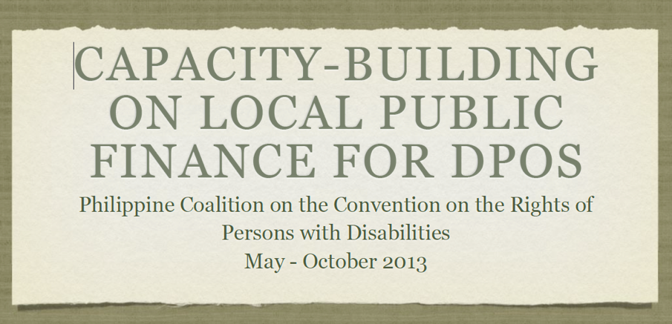
The support consisted of training mentors who then delivered training workshops in the five different regions, as well as follow-up with the DPOs’ activists in their work. In general, the knowledge gained from the training addressed the perennial complaint of DPOs that proposals submitted before they attended budget consultation would be declined by the LGU due to resource constraints. Knowing more about the budget cycle helped DPOs understand why they got such a response earlier in a given year, while they would hear in the last quarter of the same year that the LGU was actually asking for project proposals to spend the remaining budget. Learning about the way in which LGU budgets were built and the budget process and schedule of each stage gave them insight into what had previously appeared in many ways arbitrary or inconsistent, as well as ways to be more effective in their advocacy. From the feedback received by the mentors, the project improved DPO activists’ confidence and assertiveness in engaging with the LGU.
Today, Life Haven continues to provide distant support to local DPOs. They remind them about the budget cycle calendar. They also get calls for consultation from their network in the provinces when DPOs need additional information or encounter challenges and need suggestions on engaging with government officials: how to be assertive, how to be diplomatic or how to apply strategies of conflict management, from avoidance to compromise and collaboration.

OVERALL RESULTS TO DATE
The experience of DPOs in India, the Philippines and Fiji shows that budget advocacy can lead to different sets of results which contribute to strengthening the overall capacities of DPOs’ advocacy. However, it is clear that there is no straightforward path between initiating budget advocacy work and getting significant increase of resources. Influencing budget is long-term investment that can yield results that no NGO project can match such as creation and financing of a disability allowance or creation of a new set of support services nationally.
- Confidence and credibility of DPOs and better engagement with authorities.
  - In all countries, carrying out budget analysis and understanding better the national budget and related processes gave greater confidence to DPOs’ activists to engage with authorities.
  - Engagement with authorities has taken on a different dimension with acknowledgement that DPOs are getting “serious”, speak a realistic language and are becoming credible counterparts.
- Greater visibility of disability issues within civil society coalitions.
  - In both the Philippines and India, engagement in a broader budget advocacy coalition has led to greater understanding of disability rights issues within different constituencies, such as women, children and indigenous people.
  - Budget advocacy has created opportunities for collaboration with stakeholders who would not have engaged with DPOs otherwise.
- Influencing policy planning.
  - In India, the Strategy for New India @ 75 was informed by the budget and policy analysis provided by Equals-CPSJ to the National Foundation India which carried out the four-year review of the government policies. It proposes to “Reorient the [Department on Persons with Disabilities] to focus on data collection and policy evaluation, instead of focusing on the implementation of a large number of schemes with small budget allocations; bring programmes focused on improving specific issues related to persons with disabilities under the purview of the relevant line ministries; [and] earmark at least 5 per cent of the budget of social sector ministries for schemes for persons with disabilities”.
- Creating new schemes and budget allocations.
  - In Fiji, engagement in budget advocacy contributed to the creation of a new disability allowance, which in one year covered 1% of the adult population and represents an increase of nearly 100% of the budget allocated to support persons with disabilities.
  - In Tamil Nadu, budget advocacy led to the adoption of a new program that supplied Alternative and Augmentative Devices for persons using such communication methods.

RECOMMENDATIONS

The overall learning from DPOs about budget advocacy would be: It takes time, but it is worth it. Budget advocacy has led most of the DPOs involved into new territory. At first it is impressive, and overall it seems technical and challenging and in some ways it is. But once they made the initial investment to understand the budget-related mechanisms, it opened doors to understanding advocacy and policy-influencing differently, as more grounded on evidence and with a better sense of what is actually achievable.

A set of recommendations were identified by DPOs’ leaders involved in budget advocacy from India, the Philippines and Fiji when gathered in Manila for the 2019 exchange and learning workshop that took place during the Asia-Pacific Social Protection Week hosted by the Asian Development Bank. They were:
- Know the CRPD.
  - Whether the country has ratified the CRPD or not, DPOs need to have a sound understanding of its principles and standards and the meaning of CRPD compliance. This will contribute to having common ground to assess policies and build collective demands that support realisation of all rights for all persons with disabilities. It also helps to question current practices which may still be identified as positive but which ultimately undermine inclusion. Budget advocacy has to be framed by the CRPD and will contribute to effective CRPD monitoring and implementation.
- Connect with local experts.
  - In all countries there are experts on budget and public finance, working with Civil Societies Organisations, government or development agencies. According to DPO’s experience, many are open to deliver a small workshop to introduce DPOs to national budget processes. Those experts will not do the work but will be very useful in providing advice in accessing data or making sense of information.
- Connect with other CSOs.
  - In most countries there are CSOs who engage in budget advocacy. Some focus on governance and transparency; some, like DPOs, want to influence the way public spending affects their constituencies. In all cases, they have knowledge about budget structure and cycle. Sometimes they will be organised in a coalition that DPOs can join. This cooperation will help DPOs develop skills and engage, and will strengthen the coalition by adding one more group to build a critical mass for advocacy on big picture issues.
- Mobilise knowledge within the movement.
  - While no DPOs in the country might have done budget advocacy per se, some will be more familiar with service delivery mechanisms, others will understand the way the parliament works, others will have better connections to officials in ministries and may have easier access to data… Together, DPOs can gather a set of skills, knowledge and connections that goes far beyond what any of them individually has, and that will be very useful.
- A number on its own says little - build a story.
  - At first, one can get stuck with numbers. Once the data on the spending gathered, it may be difficult make sense of them. It is important to build a narrative based on the data collected. This is how DPOs can mobilise people and convey key messages supported by evidence. It is always important to compare numbers to build a story:
    - How has data evolved over the years? What is the trend?
    - How much was actually spent every year?
    - What is the actual effort that this number represents? What is this amount of money spent for persons with disabilities compared to the ministry budget? To the government budget? To the overall economy?
    - What is this amount in comparison to actual needs of people with disabilities? Is it significantly impacting persons with disabilities? Does it allow coverage of the whole country?
    - Is there anything else that could have better impact for the same amount of money?
  - This is probably what takes most of the time: moving from numbers to an analysis that will help collective elaboration of key demands. Achieving that requires a good knowledge of the system, the policies and the different alternatives that could be possible.
- Building consensus for stronger advocacy.
  - Building consensus among DPOs is not easy. Every group has different issues and is facing a lack of resources. The temptation of competition is real. As for cooperation with other movements, the only way to secure resources needed is to advocate with a unified voice and ask for a sustainable increase of overall resources.
  - Find common ground using SWOT analysis and needs assessment of different disability groups so that it is understood what the barriers and issues of all groups in all sectors are. Developing CRPD parallel reports helps a lot in achieving this.
  - Collecting and analysing the data together helps a lot to develop a shared understanding of the constraints and opportunities related to a public budget.
  - Make the most of individual and combined strengths of different DPOs.
  - It is important to secure funding to carry this work collectively. There is a need for possibly one full-time staff person to coordinate the work but also resources for several part-time persons in different DPOs. This will bring diverse skills and ensure broad ownership, which is essential for building consensus and successful advocacy.

NOBODY SAYS IT WILL BE EASY, BUT THIS IS THE NEXT LEVEL OF ADVOCACY FOR DPOS.
THIS IS THE ONLY WAY TO MAKE THE RIGHTS REAL!

ILO 2019. Calculations are based on the payment of a periodic disability benefit at 100 per cent of the full national poverty line, granted to persons with any severe disabilities.
Development pathways, 2019, Leave no one behind: building inclusive social protection systems for persons with disabilities
OECD, 2020, Public spending on incapacity (indicator). (Accessed on 10 February 2020). The figure has been calculated by subtracting OECD average expenditures related to sickness from the OECD average total public expenditures on incapacity
United Nations, Convention on the Rights of Persons with Disabilities, https://www.un.org/development/desa/disabilities/convention-on-the-rights-of-persons-with-disabilities.html
http://whqlibdoc.who.int/publications/2011/9789240685215_eng.pdf P.65.195.214.267.275
Banks, L. & Pollack, S. (n.d.). “The Economic Costs of Exclusion and Gains of Inclusion of People with Disabilities: Evidence from Low and Middle Income Countries”, CBM; and Mitra, S. et. al (2017), “Extra costs of living with a disability: A review and agenda for research.”, Disability and Health Journal, Volume 10, Issue 4, 475 – 484.
Banks, L. & Pollack, S. (n.d.). “The Economic Costs of Exclusion and Gains of Inclusion of People with Disabilities: Evidence from Low and Middle Income Countries”, CBM
UN Committee on Economic, Social and Cultural Rights (2012), General Comment No. 3, Center for Economic and Social Rights, 2012, The OPERA Framework.
ANED (2017). Adequate standard of living and social protection (Article 28 of UN CRPD) Statistical Indicators.
Analysis of Union Budget 2019-20 - http://www.cbgaindia.org/wp-content/uploads/2019/07/Promises-and-Priorities-An-Analysis-of-Union-Budget-2019-20-2.pdf, p. 42.
Kidd, S. et. Al (2019). “Leave No-one Behind: Building Inclusive Social Protection Systems for Persons with Disabilities”, Development pathaways, p.29.
Adapted from “Clarification Needed: Inclusive, Disability Responsive or CRPD compliant budgeting?” Center for Inclusive Policy, May 2019.
Article 4.3 of the CRPD. See CPRD general comment 7 for more details on obligations of states parties.
See here: https://thediplomat.com/2018/02/indias-budget-2018-those-left-behind/
Excluding inclusive education, rehabilitation, active labour policies related expenses. OECD (2010), “Sickness, Disability and Work: Breaking the Barriers.”
Draft Public Procurement Bill, 2011, India Ministry of Infrastructure. http://infrastructure.gov.in/pdf/public-procurment-bill.pdf
(2008). Plugging the Loopholes of the Philippine Procurement System, “Senate Economic Planning Office policy brief, p.11 http://www.senate.gov.ph/publications/PB%202008-05%20-%20Plugging%20the%20Loopholes.pdf
https://niti.gov.in/writereaddata/files/Strategy_for_New_India.pdf

