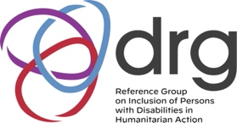
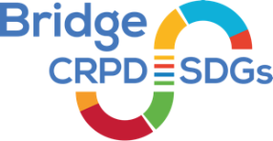
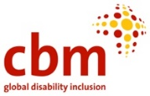
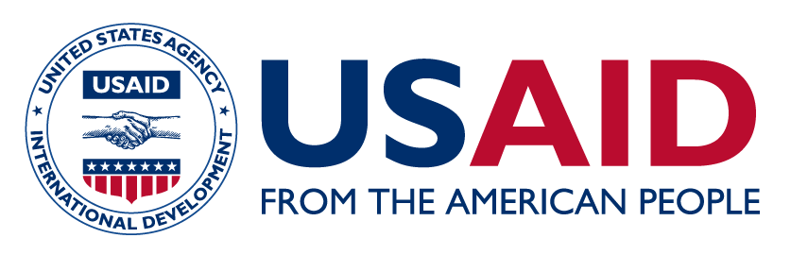
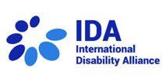
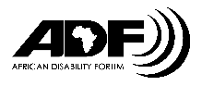

Call for Applications: Bridge CRPD-SDGs Module 3: Article 11 on Situations of Risk and Humanitarian Emergencies
Focused on complex emergencies, for participants from OPDs and humanitarian actors from Benin, Burkina Faso, Burundi, Cameroon, the Central African Republic, Chad, Comoros, Congo, the Democratic Republic of Congo, the Côte d'Ivoire, Guinea, Madagascar, Mali, Mauritania, Niger, Rwanda and Senegal

Background
The barriers and the discrimination faced by persons with disabilities in everyday life are greatly
amplified when communities are disrupted as a result of crises such as conflicts or disasters. The
obligation of States to ensure the protection and safety of persons with disabilities on an equal basis with others in such situations is enshrined in Article 11 of the United Nations Convention on the Rights of Persons with Disabilities (CRPD).
Following the adoption of the Sendai Framework in March 2015, and the launch of the Charter on Inclusion of Persons with Disabilities in Humanitarian Action at the World Humanitarian Summit in May 2016, there has been significant movement towards addressing the inclusion of persons with disabilities in situations of risk and humanitarian emergencies. In 2019, the UN Disability Inclusion Strategy (UNDIS) was launched, which applies across all pillars of work of the UN system, including in humanitarian contexts. Further, there is a growing body of standards and guidance including the Inter-Agency Standing Committee Guidelines on Inclusion of Persons with Disabilities in Humanitarian Action, and the Guidance on Strengthening Disability Inclusion in Humanitarian Response Plans.
Despite this substantial progress, challenges remain to implement these standards and guidance in practice. A key priority is therefore to strengthen leadership and participation of local organizations of persons with disabilities (OPDs) in humanitarian action, as part of a broader localization agenda. This training aims to address this priority.

Disability Reference Group
In 2020, the Reference Group on Inclusion of Persons with Disabilities in Humanitarian Action (the DRG) was established as a platform fostering cooperation between the UN, International Agencies, NGOs and Organizations of Persons with Disabilities (OPDs) in promoting disability-inclusive humanitarian response, including, implementation of key guidance materials, such as the IASC Guidelines on Inclusion of Persons with Disabilities in Humanitarian Action. The DRG currently has over 300 members and is an important network for learning and exchange. The DRG has three main pillars of work, including influencing global processes: operationalizing the IASC Guidelines through technical support to humanitarian actors, and supporting OPD leadership and participation in humanitarian action. These pillars of work are advanced by the three co-chairs- IDA, CBM Global and UNICEF and by a number of working groups led by various entities.
It is this collaborative partnership approach that this training will aim to further strengthen and reinforce, with a particular focus on supporting partnership between OPDs and humanitarian actors at country and local levels, including through implementation of a Bridge CRPD-SDGs Module 3 training, focusing on humanitarian action.

Bridge CRPD-SDGs Module 3 on Article 11 focusing on Complex Emergencies
The Bridge CRPD-SDGs training initiative was developed by IDA and IDDC in 2015 as an intensive training programme that aims to support OPDs to develop an inclusive (all persons with disabilities) and comprehensive (all human rights) CRPD perspective on development, including the post-2015 agenda and Sustainable Development Goals (SDGs), to reinforce their advocacy for inclusion and realisation of rights of persons with disabilities. The first Global Bridge CRPD-SDGs Module 3 on Article 11 was organized in Beirut, Lebanon, from 20 to 27 June 2019.

Call for Applications
This current call for applications is for OPDs and Humanitarian actors who are working in any of the countries Benin, Burkina Faso, Burundi, Cameroon, the Central African Republic, Chad, Comoros, Congo, the Democratic Republic of Congo, the Côte d'Ivoire, Madagascar, Mali, Mauritania, Niger, Rwanda and Senegal for the Bridge CRPD-SDGs Module 3 on Article 11 focused on complex emergencies.
The training will be an intensive fully residential training and will take place between the 14 to 20 October 2023 in Niger, West Africa. Participants will comprise representatives of organizations of persons with disabilities and of organizations working in the sphere of humanitarian action. All participants for the regional training should be working in/from the relevant region of focus, or at a global level with a specific focus on the relevant region.
There will be approximately 30 participants following a ratio of 2:1 OPDs to Humanitarian actors. This will be selected by a task team composed of OPDs/UN/INGOs, representing the diversity of the DRG.

Criteria and information for applications

Criteria for organizations of persons with disabilities
OPDs should be those who are Bridge CRPD-SDGs alumni or disability activists with equivalent experience in inclusive cross-disability activism/ advocating for the rights of persons with disabilities and with a knowledgeable background of the CRPD. The intake of OPDs will be guided by the Bridge CRPD-SDGs Quality Criteria.

Criteria for humanitarian actors
Humanitarian actors should be middle level and/or senior field practitioners with experience working in humanitarian action and knowledgeable on humanitarian principles/ infrastructure/ system and standards with a commitment to promoting the rights of persons with disabilities.

Important information and commitments for all applicants
This Module will be held in French, with simultaneous sign interpretation. Reasonable accommodations will be provided to participants upon request.

Applicants for Bridge CRPD-SDGs Module 3 should also have:
- Work or lived experience on situations of risk and/or humanitarian emergencies. An added value for humanitarian actors is a proven experience on inclusive humanitarian or DRR action.
- A commitment to learn, exchange, mentor and support other disability advocates or humanitarian actors within their own group and beyond: be this at local, national or regional level.
- Readiness to share and learn about the complexity and diversity of the lived experience of disability and humanitarian and DRR contexts.
- Demonstrated experience, interest and aptitude to engage in influencing humanitarian processes or public policy, be this at local, national or regional level.
- Commitment to attend all days of the training (a full missed day disqualifies a participant from being certified as having completed the Bridge CRPD-SDGs Article 11 training).
- Willingness to work with fellow participants to support an inclusive, respectful peer learning environment.
In addition to the above criteria every participant is required to commit to undertake follow up in at least one of the following areas- recognising that not all areas are relevant to both groups:
- Public policy influencing with local/national government to promote humanitarian action
- Monitoring human rights implementation of Article 11 of the CRPD.
- Building capacity of cross disability movement to engage with humanitarian action
- Building capacity of humanitarian actors to practice inclusive humanitarian action
Fees
There are no fees payable to the organizers either by participants or their organizations to attend the Bridge CRPD-SDGs Training. All the expenses related to this training will be covered by the training program.
All participants will be asked to sign a letter of commitment, that they will revert the knowledge they receive back to the organization that supported their application and that they commit to working inclusively on OPD engagement in inclusive humanitarian action in line with the IASC guidelines on inclusion of persons with disabilities in humanitarian action, to support wider advocacy and public policy influencing for inclusive humanitarian action, and to support cross disability networking and movement building of all people with disabilities of all backgrounds, diversity and characteristics to engage with humanitarian action.

How to apply
If you are interested in applying or are an organization that would like to propose a candidate, the following 3 materials are essential for the application process:
- An expression of interest and commitment to the training and its objectives, reflecting the criteria (above). This can either be written, one page maximum, or via recorded oral or video presentation, including in sign language, not longer than 3 minutes.
- An updated brief CV, not more than 2 pages long. Please include your gender, date of birth and if you are a person with a disability, your impairment group.
- For OPDs: your linkages with the OPD movement must be supported by a letter on the letterhead of an OPD that you are associated with, which could be a sub national, national, regional or international organization of persons with disabilities. Alternatively, if you are working with a collective/network of persons with disabilities that is supported by an IDDC member or a mainstream human rights or humanitarian organization, you can also provide a letter from those organizations.
For participants from the humanitarian sector: Your application must be supported by a letter of recommendation on letterhead from a humanitarian organization.
All 3 documents must be submitted by e-mail to the following email address: bridge_platform@ida-secretariat.org by the end of day July 23, 2023.

Adopted by IASC Principles in 2019. Available at https://interagencystandingcommittee.org/iasc-guidelines-on-inclusion-of-persons-with-disabilities-in-humanitarian-action-2019
Developed under an interagency initiative supported by DFID (2019). See www.unicef.org/disabilities/files/Guidance_on_strengthening_disability_inclusion_in_Humanitarian_Response_Plans_2019.pdf
www.internationaldisabilityalliance.org/content/bridge-crpd-sdgs-training-initiative
It was organised by the International Disability Alliance (IDA), the International Disability and Development Consortium (IDDC) and their members, in particular CBM; with support from the Arab Organisation of Persons with Disabilities (AOPD), and funded by Disabled People's Organisations Denmark (DPOD), CBM, HI, the Australian Department of Foreign Affairs and Trade, the European Union Civil Protection and Humanitarian Aid, the Ministry for Foreign Affairs of Finland and the Bridging the Gap Project. www.internationaldisabilityalliance.org/BridgeLebanonMod3
The understanding of organizations of persons with disabilities is guided by the CRPD Committee see www.ohchr.org/en/documents/general-comments-and-recommendations/general-comment-no7-article-43-and-333-participation
Bridge CRPD-SDGs is also committed to empowering all persons with disabilities and focuses on ensuring a gender balance between participants and inclusion of underrepresented groups through the Bridge CRPD-SDGs Quality Criteria www.internationaldisabilityalliance.org/sites/default/files/bridge_quality_criteria_principles_development_oct2018.pdf

