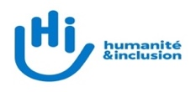
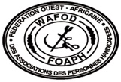
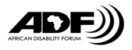
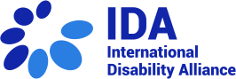
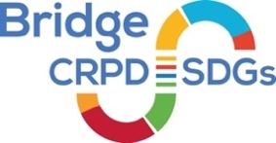
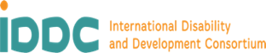

Bridge CRPD-SDGs Niger, Benin, Burkina Faso & Togo Module 1

22 August to 1 September 2022

What is the Bridge CRPD-SDGs Training?
The Bridge CRPD-SDGs is a training initiative developed in 2015 by the International Disability Alliance (IDA) and the International Disability and Development Consortium (IDDC).
This is a two part intensive training focused on an inclusive and comprehensive understanding of the Convention on the Rights of Persons with Disabilities (CRPD) as well as generating a human rights based perspective on development, in general, and the Sustainable Development Goals (SDGs), in particular.
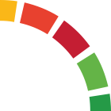
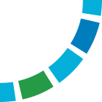
The training consists of two week long residential modules of 7 days each, with an intervening period of six months within which participants undertake to write a policy paper. Participants are expected to take their learnings forward with an organization of persons with disabilities (OPD) that they are linked to.
Module 1
7 days + 3
Module 2
7 days + 3
Assignments
6 months
Since 2015, the Bridge CRPD-SDGs has involved over 1000 people, from 104 countries, with 400 participants from 12 regional and national cycles, that are now part of a lively and active community of practice.

Bridge CRPD-SDGs Niger, Benin, Burkina Faso and Togo
The African Disability Forum, West Africa Federation of the Disabled (WAFOD), the International Disability Alliance (IDA), and Humanity and Inclusion (HI) have the pleasure to launch this open call for participation in the Bridge CRPD-SDGs Niger, Benin, Burkina Faso & Togo.
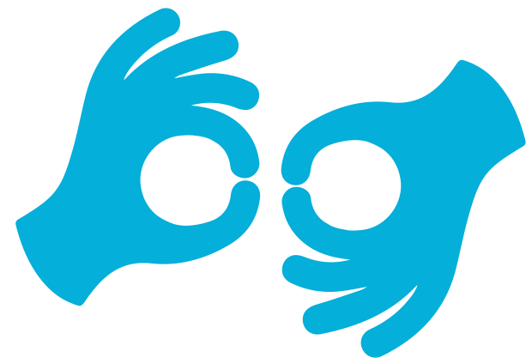
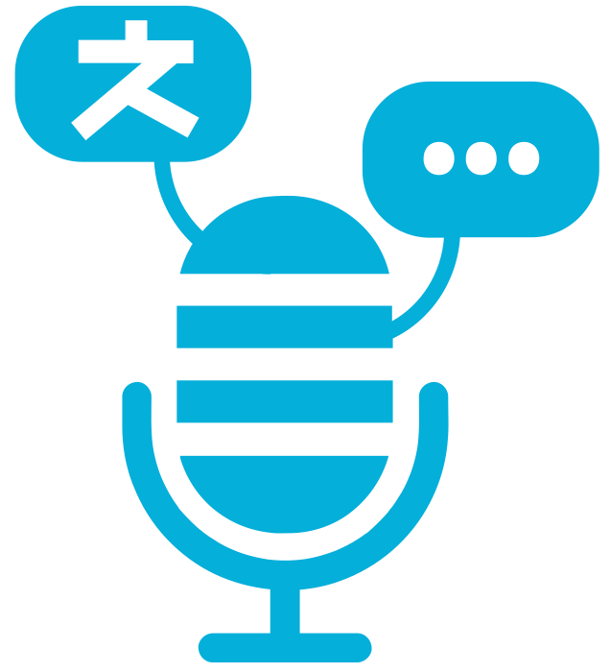
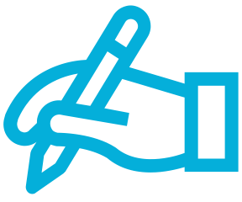
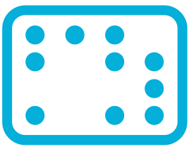
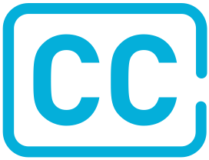
Language
The medium of the training will be French with simultaneous interpretation in the National Sign Languages. Where required, participants will be supported to have materials and access in Braille, alternative script, or augmentative and alternative modes, means and formats of communication that they may be using.
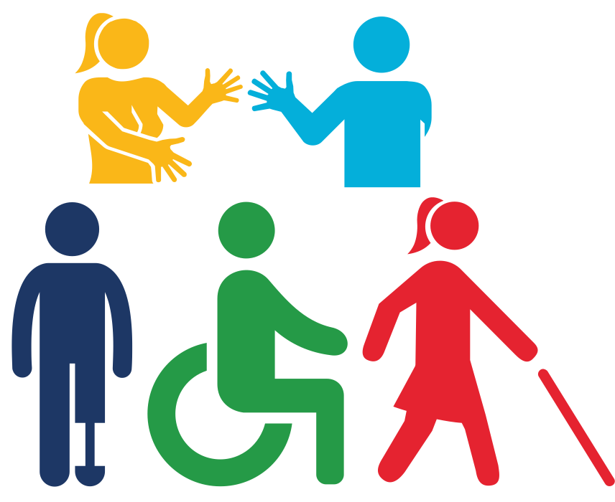
Participants and a focus on underrepresented groups of persons with disabilities
Persons with disabilities from underrepresented groups are strongly encouraged to apply. We welcome applications from all ages, levels of experience, all levels of literacy, and across the diversity of the disability movement, especially from those groups who face high restrictions in participation.
The open selection process for participants is guided by the Bridge CRPD-SDGs Quality Criteria that ensures a balanced group of participants in terms of impairments, gender, urban/rural location, and other identities that may be important to represent in the country or region of the cycle.
Underrepresented groups are those groups of persons with disabilities who remain underrepresented in the disability movement like persons with psychosocial disabilities, intellectual disabilities, deafblind persons, autistic persons as well as indigenous persons with disabilities, persons with disabilities from minority communities, refugee or internally displaced persons with disabilities etc.
Our logistics team works with all selected participants to understand what they need to fully and effectively participate in the training and to enable those reasonable accommodations.
The selection of participants is not negatively influenced by the level of support that they require.
Criteria for application
- The Bridge CRPD-SDGs Training is meant to strengthen the OPD movement, therefore, applicants must show linkages to the OPD movement, at any level.
- Candidates should be an active member, staff or volunteer of an OPD or OPD federation which works at the national, sub-regional or continental level.
- The OPD does not need to be a formally registered organization, especially if you are a person with disability from an underrepresented group. It can be a collective, or a network, but it must be led by persons with disabilities and working on rights-based advocacy on the rights of persons with disabilities.
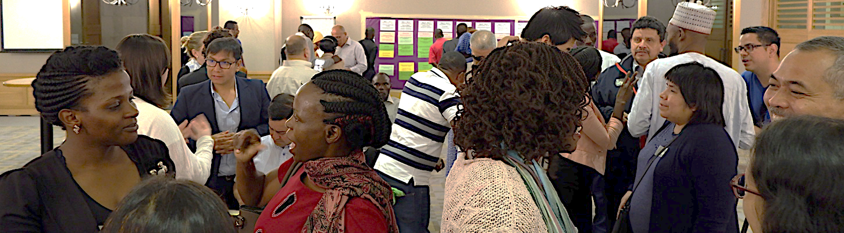
- All candidates must show a commitment to learning, exchange, mentor and support other disability activists within their own group and beyond: be this at a local, national or regional level.
- Even if you work with a single impairment group, you must have a genuine commitment to working inclusively to strengthen a cross-disability movement, being ready to share and learn about the complexity and diversity of the lived experience of disability.
- Preferably, candidates must have a working awareness of the CRPD and a commitment to learn more about how to apply human rights concepts approach, including using other human rights treaties, and the SDGs to advocate for disability inclusive public policy at national and local levels, however, this may be relaxed in the case of persons who have not had access to this exposure on account of the barriers they have faced.
- Candidates must demonstrate experience, interest and aptitude to engage in influencing development processes and public policy, be this at a local, national or regional level,
- Finally, candidates must be able to fully attend both modules and to undertake given assignments. A full missed day disqualifies the participant from completing the Bridge training.
- This will be a fully residential training, and candidates will also have to respect the COVID-19 related protocols that will be in place for the training.
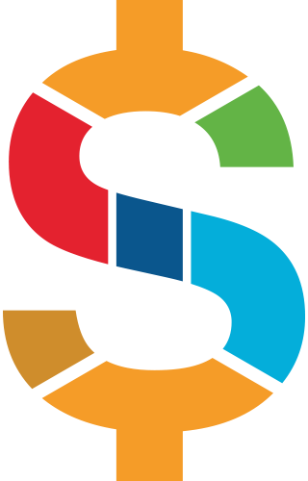
Fees
There are no fees payable to the organizers either by participants or their organizations to attend the Bridge CRPD-SDGs Training.
All participants will be asked to sign a letter of commitment, that they will revert the knowledge they receive back to the organization that supported their application.

Application
If you are interested in applying, or are an organization that would like to propose a candidate, the following 3 materials are essential for the application process:
- A statement regarding your interest and commitment to the training and its objectives, reflecting the criteria (above). This can either be written, one page maximum, or via recorded oral or video presentation, including in sign language, not longer than 3 minutes. This can be in French.
- An updated brief CV, preferably not more than 2 pages. Please include your gender, date of birth and if you are a person with a disability, your impairment group.
- Your linkages with the OPD movement must be supported by a letter on the letterhead of an OPD that you are associated with, which could be a sub national, national, regional or international organization of persons with disabilities. Alternatively, if you are working with a collective/network of persons with disabilities that is supported by an IDDC member or a mainstream human rights or humanitarian organization, you can also provide a letter from those organizations to demonstrate your linkages with an upcoming OPD that they are promoting.
All 3 documents must be submitted by e-mail to the following email address: bridge_platform@ida-secretariat.org by the end of day July 23 2022
