CDPF Side Meeting COSP 14-Show-casing Success of Commonwealth Disabled People's Forum Online Disability Equality Training
How do we build DPOs/OPD capacity and understanding of the paradigm shift from individual/medical model thinking to social/human rights model thinking?
With at least 1.3 billion disabled people/people with disabilities in the world how can we use modern media to improve their understanding of their rights?
The Commonwealth Disabled People's Forum has grown to 82 DPOs in 47 countries. During the Covid Pandemic CDPF gathered information, held online meetings providing guidelines on the best ways to support disabled people during and after the Pandemic. There was clearly a need to develop an accessible online course to capacity build disabled activists around the 54 Countries of the Commonwealth. Funded by Commonwealth Secretariat and Disability Rights Fund, the course ran over 15 weeks, February to May 2021. The 14 Modules were delivered by experienced disabled leaders across the Commonwealth. Each week a signed/ captioned presentation was put on the organisation's website. This consisted of films, powerpoint, lectures & Course Book with follow up activities. This was reinforced by 2 x 90 minute interactive online seminars. Participants in many countries really enjoyed and learned a great deal from the course. Now it is online for all, open access from 14th June 2021 www.commonwealthdpf.org/training Overleaf more details of aims & content.
Moderator- Sarah Kamau, CDPF Acting Chair, United Disabled Persons Kenya
Speakers Agreed
Layne Robinson-Head Policy Commonwealth Secretariat
Richard Rieser-General Secretary Commonwealth Disabled People's Forum
Dr Sruti Mohapatra-Vice Chair CDPF, Swabhiman, Odisha, India
A range of participants from the Course
Gemma White-Action on Disability and Development, Course Administrator
Amba Salelka-International Disability Alliance, Capacity Building Unit
Harriet Knowles-UK FCDO Disability Capacity Building programme
Diana Samarasan-CEO Disability Rights Fund

SPONSORS
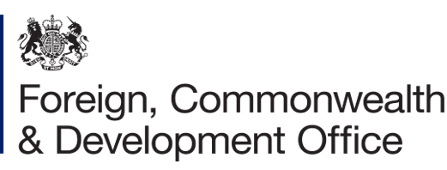

CO-SPONSORS
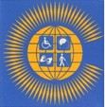
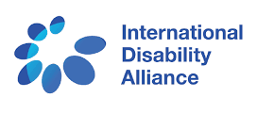
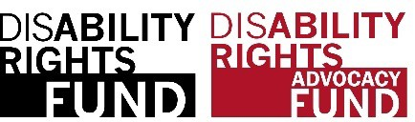
Commonwealth Disabled People’s Forum

Disabled activists, their organisations and leaders need to understand the oppression we face as disabled people, regardless of our impairment. We need to understand that the impact of old fashioned thinking of us as a problem to be fixed, as people without rights, has to change to a social model/human rights approach in line with the UNCRPD and SDGs, where disabled people are in control of what happens to us as powerful subjects in civil society. We are capable of bringing about real social and economic change for the 450 million disabled people of the Commonwealth.

The course targeted disabled women and young people and achieved this. Opening the course to all who met our criteria 428 were accepted. A core group of around 150 participants for the whole course, though many others accessed resources. For accreditation there were four levels based on attendance and the amount of follow up work completed.

CDPF plan to produce the materials on a computer stick, so it can be used where internet connectivity is poor. There will be an option to translate from English to main community languages with Country DPOs organising dissemination events.
Modules
1. Models and Thinking About Disability and Implications for Action.
2. The UN Convention on the Rights of People with Disabilities, the Sustainable Development Goals and their Impact on Disabled People’s Human Rights.
3. Health - focusing on Mental Health and Covid-19
4. Innovation - focusing on Improving Access and Assistive Devices.
5. Trade- focusing on Improving Livelihoods and Employment.
6. Environment - focusing on the Impact of Humanitarian Situations.
7. Respect for Law-focusing on Eliminating Stigma and Discrimination.
8. Youth and Disability Rights in collaboration with CCYDN.
9. Inclusive Education.
10. Women and Girls.
11. Anti-Racism, Equality and Respect for Ethnic Minorities.
12. Data of Disability.
13. Building DPOs, Campaigning and Increasing OUR voice.
14. Influencing Government.

Accreditation for each module will require accessing and viewing module presentation, reading chapter in Course Book, completing at least 3 of module follow-up activities and attending 1 of the weekly seminars.
The course was delivered by experienced Disability Equality Trainers who are members of the CDPF Training Sub-Committee led by Richard Rieser our General Secretary. The content of the course was focused on Commonwealth Heads of Government Meeting (CHOGM), Sustainable Development Goals (SDGs) and United Nations Convention on the Rights of Persons with Disabilities (UNCRPD) implementation and is aimed at activists in Disabled People’s Organisations (DPOs) throughout the Commonwealth. Each module was viewed with the Covid/Post Covid -19 Build Back Better perspective.
More information CDPF General Secretary email rlrieser@gmail.com
Course materials available open access from 14th June 2021 www.commonwealthdpf.org/training

