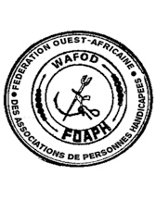
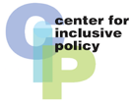
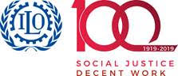
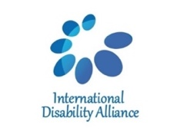
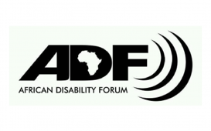

Regional Workshop in West Africa French speaking countries on Disability Inclusive Social Protection Response to Covid-19 Crisis: a new path towards inclusion

Organized by WAFOD, ADF and IDA
Supported by ILO and NORAD
Niamey, Niger
4 - 5 November 2020

Concept Note

It is estimated that about 15 per cent of the global population - one billion are persons with disabilities. Around 80 per cent of them live in developing countries (WHO and World Bank, 2011). They routinely face accessibility and attitudinal barriers, discrimination and lack of support that hinder their participation in social, economic and political life on equal bases with others. Those barriers and lack of support resulting in let persons with disabilities have less access to education, health and lower participation in the labour market than people without disabilities and, as a result, they are at considerable risk of poverty.

The COVID-19 pandemic and its related socioeconomic consequences has further exacerbated those barriers, marginalization and inequalities. Persons with disabilities are in many ways more exposed to the crisis due to lack of inclusive response. Moreover, they are more likely to lose jobs and to face difficulty to return to employment comparing with persons without disabilities. In addition, persons with disabilities face disruption “during crisis” in accessing support services which are precondition for them to participate and in some cases to save their lives such as sign language translation, rehabilitation services and assistive devices.

Social protection which, at any point in time, is critical for persons with disabilities as it play significant role in facilitating access to support services, education, income support and economic empowerment as well as to health services including rehabilitation and assistive devices, a cross the life cycle. Moreover, social protection could be a crucial vector of relief during COVID-19 pandemic and any such crisis.

Therefore, some countries, including African countries, have begun implementing interventions addressing the economic impacts of COVID-19, such as food assistance, emergency cash transfers, unemployment assistance or expansions to existing social protection programs (IMF, 2020). However, these measures should be inclusive of persons with disabilities and take into consideration the issues of non-discrimination and accessibility of those measures by persons with disabilities as well as adequate coverage of disability related cost and support services. Therefore, the disability movement has an opportunity to take advantage of the ongoing relief measures to influence/reform the design and delivery of social protection programmes which will truly support their empowerment, inclusion and access to services across the life cycle.

In light of this current situation, WAFOD, ADF and IDA are organizing two days’ workshop in Niamey, Niger, in November 2020. DPOs from 8 West African French-speaking countries
- Benin, Burkina, Ivory Coast, Guinea-Conakry, Mali, Niger, Senegal and Togo - will come together to share their knowledge, skills, and expertise as well as to enhance coordination, cooperation and commitment to support each other advocacy to ensure inclusion of persons with disabilities in social protection system response and recovery measures.

Workshop objectives
- Share experiences of social protection measures taken by different countries in the region in response to COVID-19,
- Assesses the extent to which existing social protection measures inclusive of persons with disabilities,
- Explore how social protection and other initiatives to mitigate the economic impacts of the pandemic should include persons with disabilities, with recommendations for disability-inclusive actions in the design and implementation of eligibility criteria and application procedures and adequacy of benefits,
- Explore advocacy messages and approach in regard to inclusion of persons with disabilities in COVID-19 relief and recovery measures that DPOs can use at different level: regional and national.

Provisional agenda
4 November
- Set common understanding around the right to social protection according to the CRPD,
- Share experiences on social protection measures taking to respond to the pandemic in the region,
- Analyze the inclusiveness of social protection systems in the region.

5 November
- Identify existing challenges in the current social protection systems in regard to inclusion and how they can be overcome,
- Develop rational for reforming the social protection systems to be inclusive of persons with disabilities,
- Discuss the meaningful participation of DPOs into reform/design/ delivery of social protection programs.

