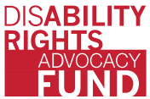
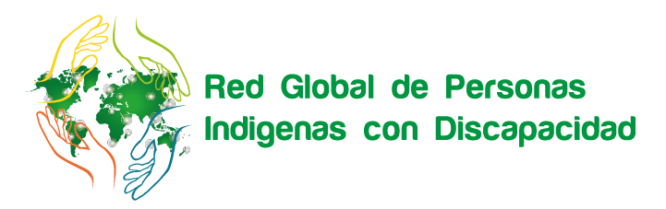
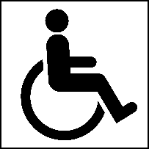
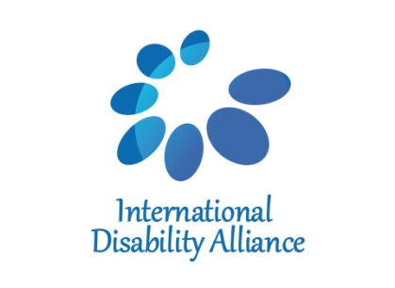
Indigenous Persons with Disabilities Global Network
NAROK SOUTH DISABILITY NETWORK

Concept Note
Technical Workshop on ensuring the rights of Indigenous Persons with Disabilities in line with UNCRPD, in connection with the UNDRIP and the Agenda 2030
Bomet, Kenya
20 – 23 August, 2018

Background
Since 2012, the Indigenous Persons with Disabilities Global Network (IPWDGN) has strengthened its advocacy towards United Nations (UN) mechanisms, through direct support from the International Disability Alliance (IDA) and the Disability Rights Advocacy Fund (DRAF).
Over the past years, the IPWDGN advanced the rights and concerns of indigenous persons with disabilities at the global and regional human rights and development agenda. The Network was particularly active in influencing relevant mechanisms, both indigenous and disability-related, such as the United Nations Permanent Forum on Indigenous Issues (UNPFII), the Expert Mechanism on the Rights of Indigenous Peoples (EMRIP), the UN Committee on the Rights of Persons with Disabilities (UN CRPD Cttee) and the Special Rapporteurs on the Rights of Persons with Disabilities, and on the Rights of Indigenous Peoples, as well as mainstream mechanisms such as the Human Rights Council (HRC), the Commission on the Status of Women (CSW) and the UN Women. Furthermore, members of the IPWDGN have been involved in regional meetings both related to persons with disabilities, indigenous peoples and indigenous persons with disabilities.
The current proposal is aimed to foster opportunities in order to strengthen the Indigenous Persons with Disabilities Global Network (IPWDGN) and empower indigenous persons with disabilities and their respective organizations, disability and indigenous advocates to develop an inclusive and comprehensive CRPD and UNDRIP human rights perspective on development, relating with the 2030 Agenda for Sustainable Development, to reinforce their advocacy and enhance their linkage at global, regional and national levels work further with concerned stakeholders.

Rationale
The Technical Workshop on ensuring the rights of Indigenous Persons with Disabilities in line with UNCRPD, in connection with the UNDRIP and the Agenda 2030, to be held in Bomet, Kenya, from the 20 to 23 August 2018, will combine experiences of indigenous peoples, persons with disabilities and indigenous persons with disabilities from Kenya, with the international experiences from the International Disabilities Alliance (IDA) and the Indigenous Persons with Disabilities Global Network (IPWDGN) and its national member, the Narok South Disability Network, on the Convention on the Rights of Persons with Disabilities (UNCRPD).

Also, the workshop will cover the 2030 Agenda and the SDGs and how these frameworks are implemented in line with the CRPD, with the aim to equip organizations of indigenous persons with disabilities to further work connecting with other likeminded organizations/network/alliance in Kenya to mainstream indigenous persons with disabilities issues effectively.

Objectives
To consolidate the indigenous peoples’ organisations in Kenya,
To provide initial or strengthen understanding on UNDRIP and CRPD to implement and ensure the rights of indigenous persons with disabilities at national level, and connect with SDG implementation, by strengthening the network of indigenous persons with disabilities, in Kenya, in an inclusive and comprehensive perspective,
To strengthen relationships between organisations of indigenous persons with disabilities with human rights and development actors.

Expected outcomes
Participants will be able to:
- Consolidate a national network of indigenous persons with disabilities,
- Better articulate linkages between the UNDRIP and CRPD and link with SDGs,
- Better articulate the issues of indigenous persons with disabilities and connect it with key actors at their country level to collectively strengthening the networks of indigenous persons with disabilities.

Participants
The workshop will bring together a diverse group of indigenous persons with disabilities from Kenya, in particular from the counties of Narok, Kajiado, Baringo, Samburu and Bomet.

The workshop will include 13 participants’ indigenous persons with disabilities, 4 experts from indigenous and disability background and observer - in approximately a total of 20 people, including support providers and interpreters. The workshop will be delivered in English, and will be simultaneously interpreted into Sign Language.

We expect participants to understand the core values of CRPD and UNDRIP and meaningfully engage in the UN monitoring processes as well as in national public policies, through sharing information, preparing report, coordinating and collaborating with other DPOs, IPOs and indigenous persons with disabilities networks.

To reflect the diversity of the disability community, particular consideration will be taken to involve leaders from the following constituencies:
- Youth indigenous peoples with disabilities,
- Women indigenous peoples with disabilities,
- Indigenous peoples with disabilities from different groups. A particular effort will be made to include people with disabilities from underrepresented groups,
- Indigenous peoples with disabilities from minority cultural or linguistic groups,
- Indigenous peoples from rural or remote areas, among others.

A final report will be produced and shared with IDA, IPWDGN members, DRAF and relevant partners.

Narok, 31 Mai 2018.

