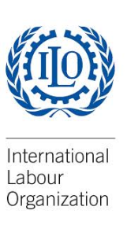
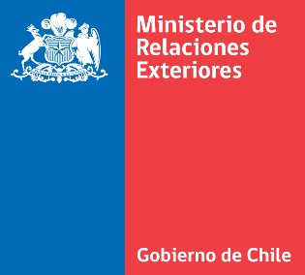
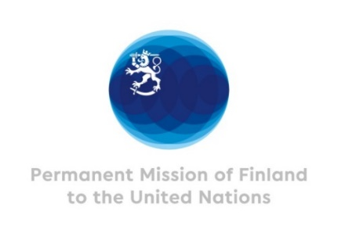

Virtual Side Event at the 14th Conference of the State Parties to CRPD

June 17 2021 8.30-9.45am EST / 15.30-16.45 EET

Promoting the inclusion of persons with disabilities in just transition towards a sustainable economy

Background

Estimates suggest that, overall, the transition to low-carbon economies worldwide will be a net generator of jobs, with as many as 18 million new jobs appearing by 2030, according to the ILO World Employment Social Outlook 2018.
How this transition will play out for persons with disabilities will be determined largely by the local and national policies of governments and social partners. If the principles of a just transition are applied, the world of work will move towards a more inclusive and empowering situation for persons with disabilities. Persons with disabilities would have equal opportunities at benefitting from new or upgraded green jobs and the economic empowerment those jobs can offer. For example, skills development initiatives in the renewable energy sector that are disability-inclusive could pave the way for an effective match of green jobs with applicants with disabilities.

Objectives

The event aims to explore rights and inclusion of persons with disabilities in building back better through a just transition towards a sustainable and low-carbon economy.
It will address the following questions:
- What measures need to be taken by public authorities and other stakeholders to ensure that persons with disabilities will have access to the jobs that will be generated by the transition to low-carbon economies as part of the building back better recovery plans?
- Are there examples of good practice both in developed and developing countries from which we can learn and which can be replicated?
- How can we promote the inclusion of persons with disabilities in the just transition discussions within COP26?

Outline of the session
Opening by Krista Mikkonen, Minister of the Environment and Climate Change, Finland
Moderation by Mina Mojtahedi, Senior Adviser on Non-discrimination, Ministry for Foreign Affairs of Finland
Panellists:
- Moustapha Kamal Gueye, Global Coordinator, ILO Green Jobs Programme
- Fernando Riaño, Institutional Relations and Social Responsibility Director, ONCE Social Group
- Maria Soledad Cisternas, Special Envoy of the Secretary-General on Disability and Accessibility, United Nations
Questions and comments from the audience
Closing words by representative from the International Labour Organization
Organizers:
Ministry for Foreign Affairs of Finland
International Labour Organization
Co-Sponsors:
Ministry for Foreign Affairs of Chile
International Disability Alliance
Registration link:
https://ilo-org.zoom.us/webinar/register/WN_t_o30zErScylXxb4WT-msQ
The link to join the live event will be sent to the participants by email after registration to the event.

The event is organized on Zoom and is accessible and open to all. International sign language and automatic captioning will be available.

