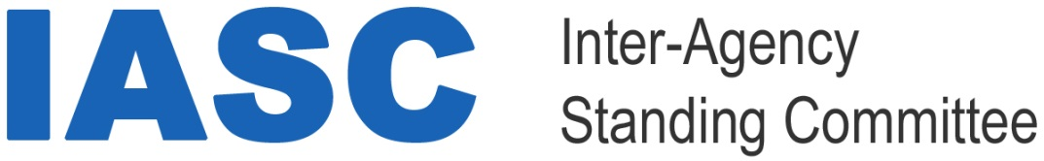

Some rules for making sure people with disabilities get the right support during Covid-19

Covid-19 is a new illness that many people in the world are getting. It is also called a coronavirus.

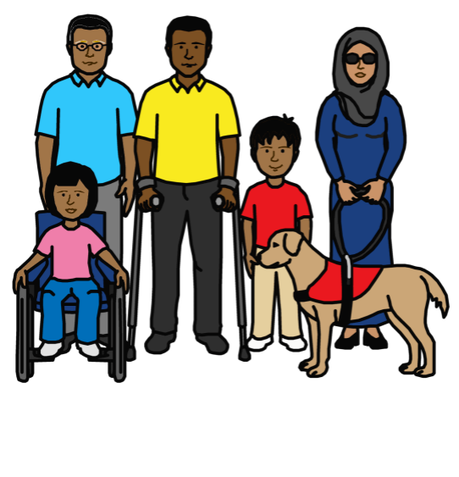

Covid-19 response: key messages on applying the IASC guidelines on inclusion of persons with disabilities in humanitarian action

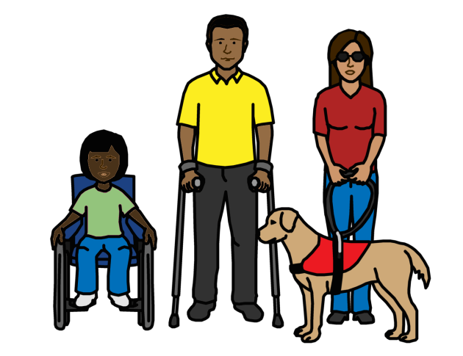
About this document
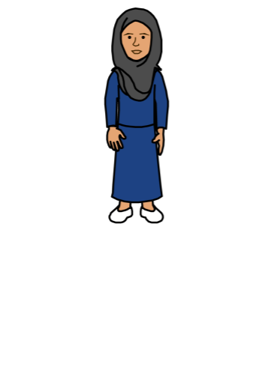

There are some rules about making sure people with disabilities get everything they need when big problems happen in the world.

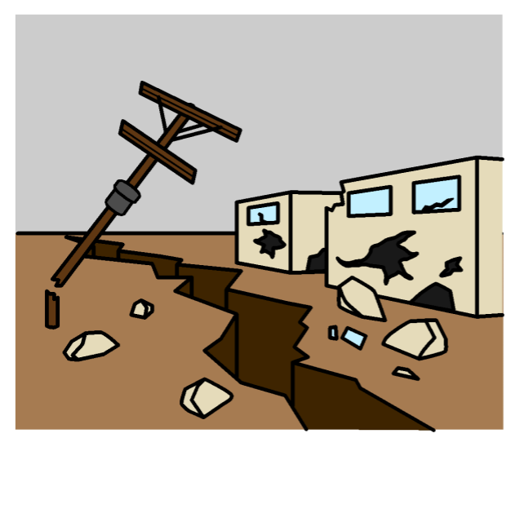
For example:
- War
- Violence
- Floods
- Earthquakes
- Not enough food and water for people

The rules are on this website:

https://interagencystandingcommittee.org/system/files/iasc_guidelines_draft_for_consultation-birmingham.pdf
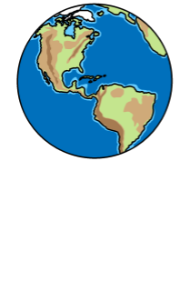

This document is about how to use the rules to support people with disabilities during Covid-19.
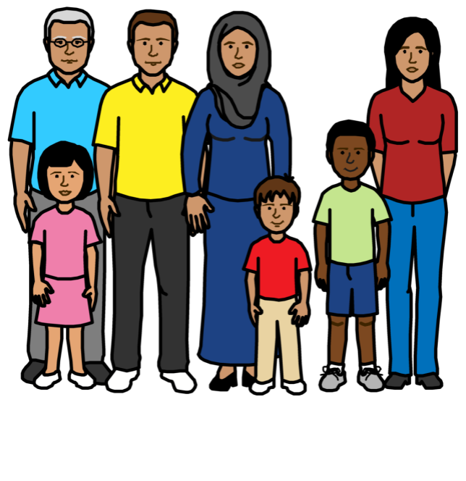

Covid-19 is a new illness that many people in the world are getting.

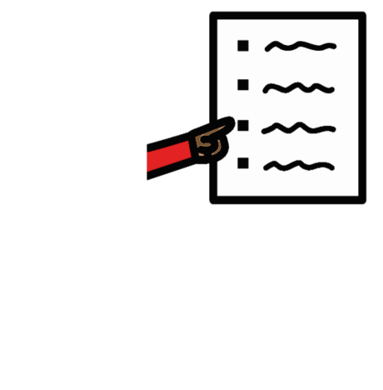
This document talks about:

- Extra problems that might happen to people with disabilities because of Covid-19

- What should be done to help stop the problems

Anyone can use this document.

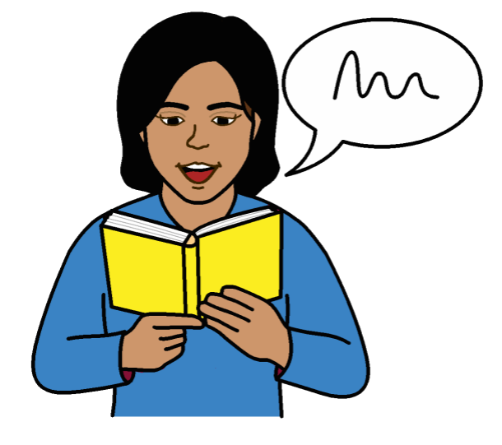
For example:

- People with disabilities and disability groups

- Parents and other people in the community

- Governments and people who support people with disabilities

Extra problems for people with disabilities because of Covid-19

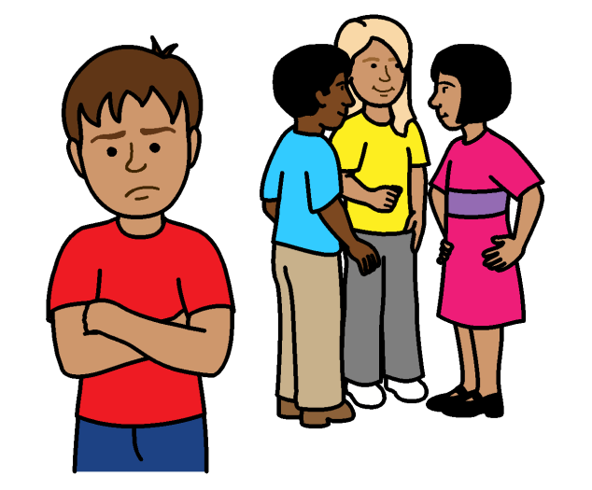

Many people with disabilities are already left out and treated unfairly.

But some problems might be worse for
people with disabilities during Covid-19.

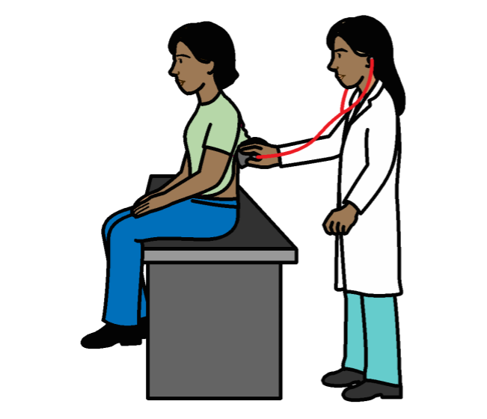

For example:

People with disabilities might find it hard to get the right medical care for Covid-19.

For example, some doctors might give care to people without disabilities first.

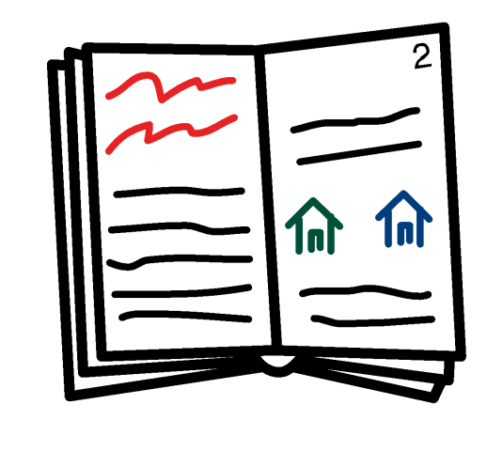
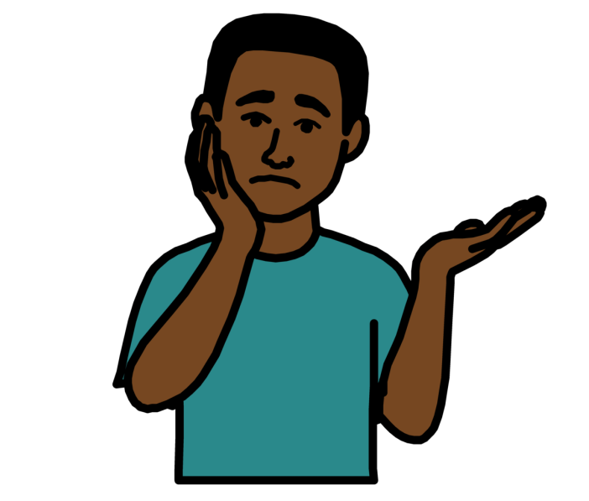

Information about Covid-19 might be hard for people with disabilities to get and understand.

This includes information about how to keep safe and other support they can get.

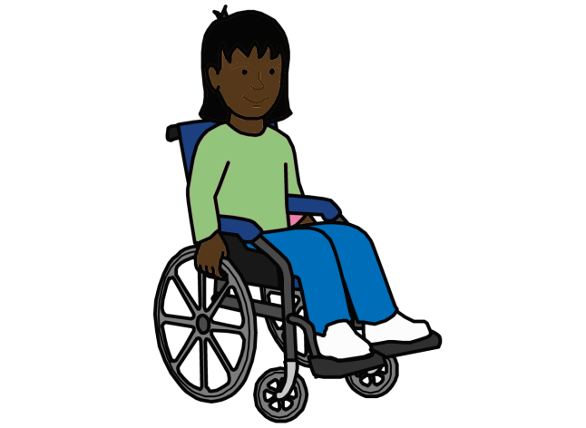
Everyone needs to wash their hands a lot to stop Covid-19 spreading.

But people with disabilities might find it hard to get to wash places and use them.
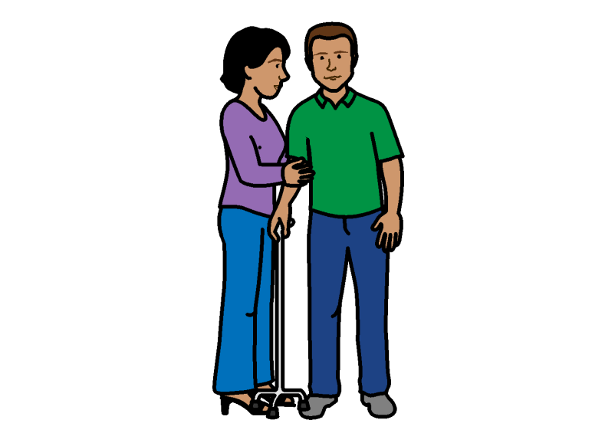

Some people with disabilities might have more chance of getting Covid-19.

For example, because they have to be close to other people to get support.
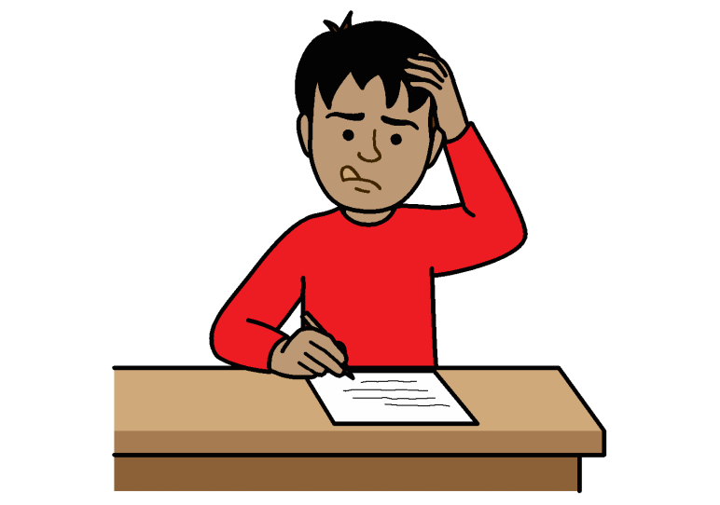

Children with disabilities might not get the right support to learn at home if schools close because of Covid-19.

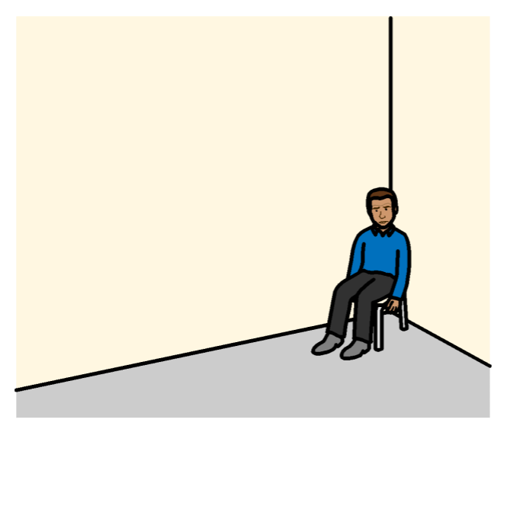

Some support for people with disabilities might stop during Covid-19.

For example, governments might spend money on Covid-19 problems instead.

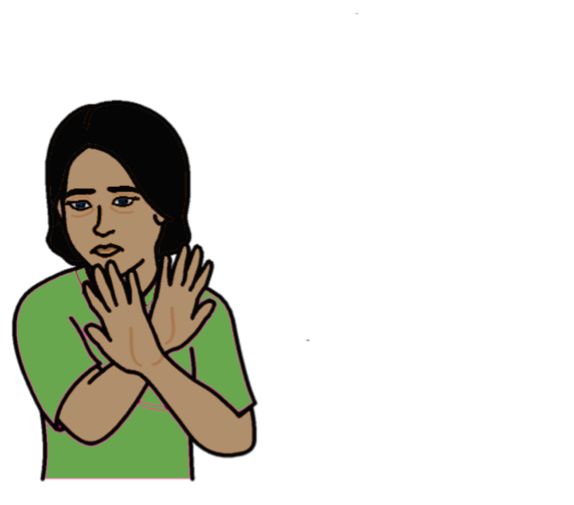
People with disabilities might be hurt or treated badly more during Covid-19.

For example, when families might have to spend more time at home together.

This can be worse for women and girls with disabilities.

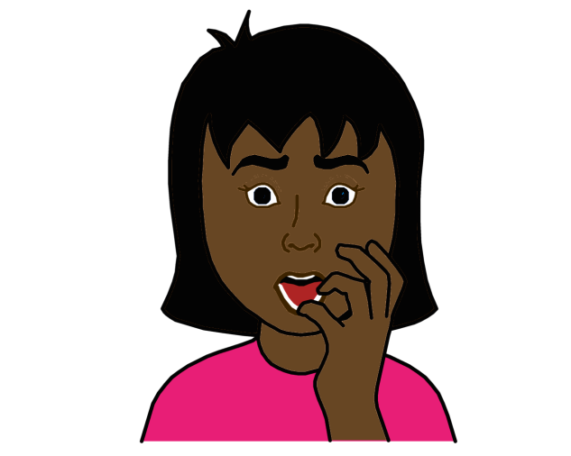

It might be hard for people with disabilities to get the right support if bad things happen to them.

For example, support on the phone or internet might be hard for them to use.

People with disabilities might find it hard to earn money and buy things they need during Covid-19.

For example, their work might stop because of Covid-19.

What should be done about the problems
People should follow the rules starting below:
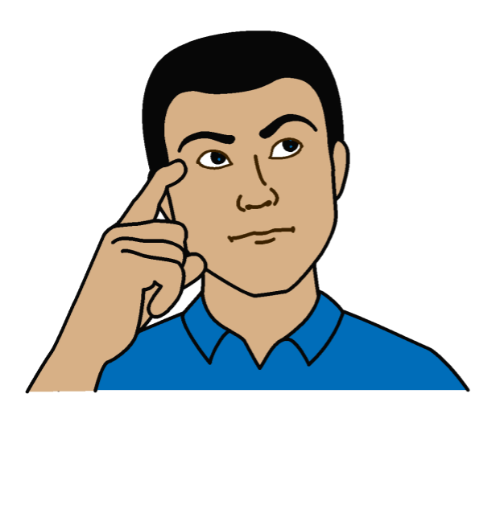

Find out what different people with disabilities need.

For example, women, men, children, older people and people with different disabilities.

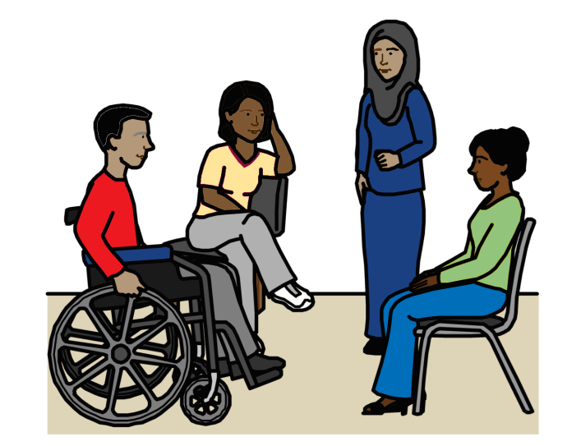

Make sure people with disabilities help make plans about Covid-19 and what should happen.

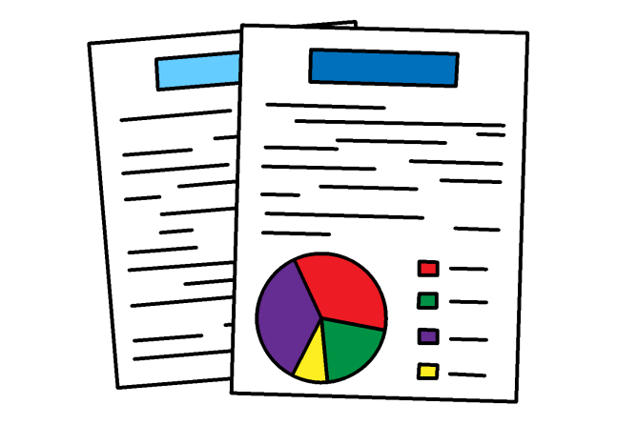

Make sure there is good information about what is happening to people with disabilities and what they need.

This will help everyone make good plans that work for people with disabilities.
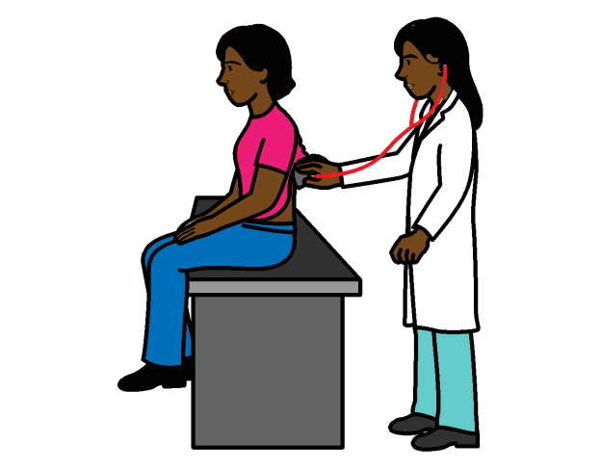
Make sure health services for Covid-19 work well for people with disabilities.

For example, services to find out if someone has Covid-19.
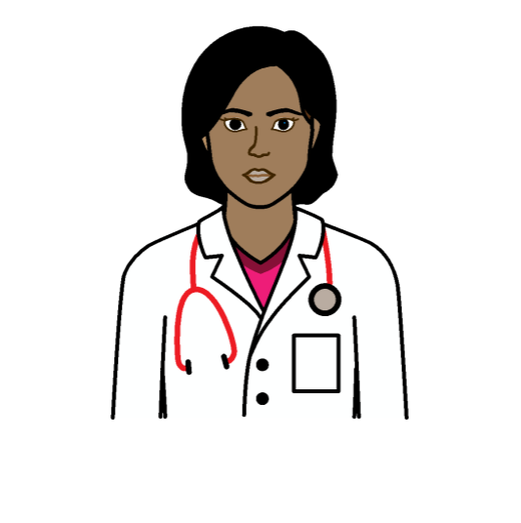

Make sure decisions about health care for Covid-19 are fair to people with disabilities.

People with disabilities should not get worse care than other people.

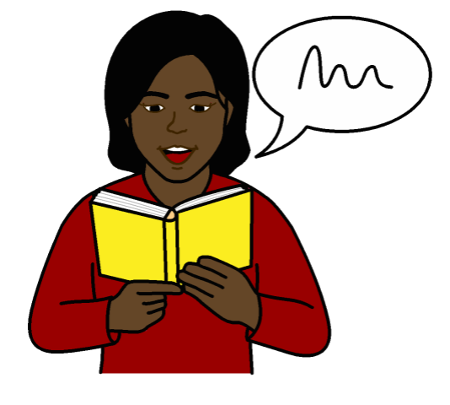
Make sure people with disabilities get information they can understand about:

- Covid-19 and how to keep safe

- Health care and medicines they could get

- Other support they can get

This will help people make the right choices for them.

Make sure all people with disabilities can do the right things to keep safe.
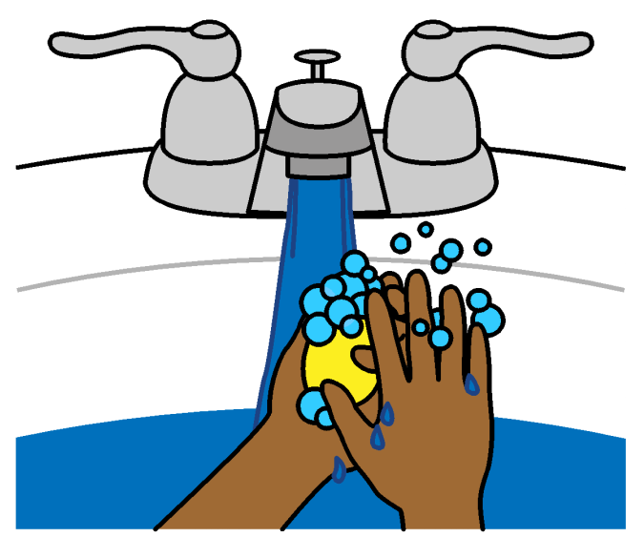

For example:

- Make sure all people with disabilities have the things they need to wash their hands and keep clean.
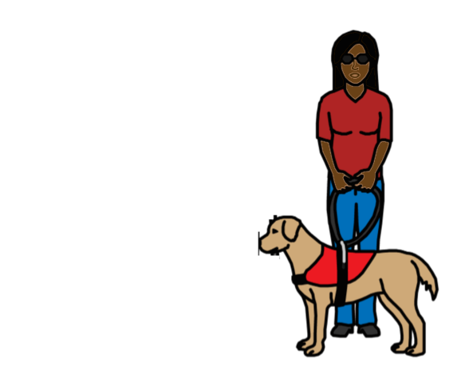

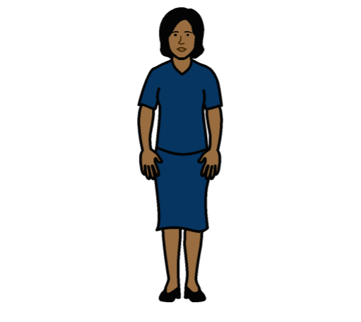

- Help people with disabilities stay a bit away from other people if they live with many other people.

Or make sure they have the right face masks to wear.

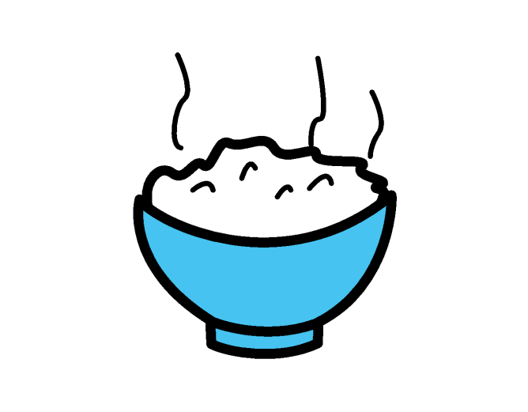

Find safer ways to give people with disabilities food and other things they need.

For example, by taking it to them so they do not have to travel a long way.

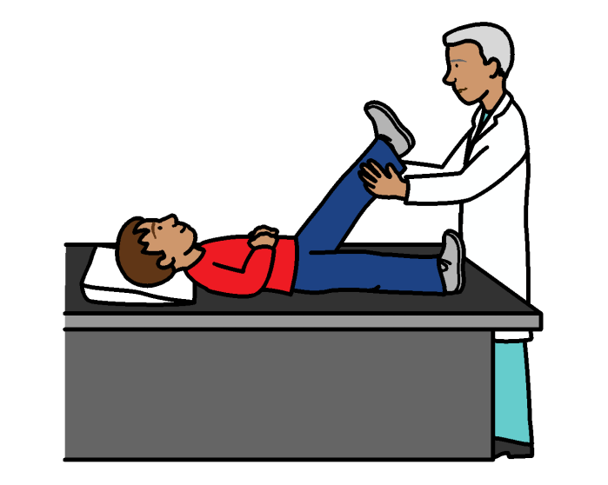
Make sure people with disabilities still get the support they need during Covid-19.

For example, if someone who supports them has to stop because they get ill.

Make sure people with disabilities get the right help if they need it.

For example, if someone is violent to them.

Or if they feel upset or scared.

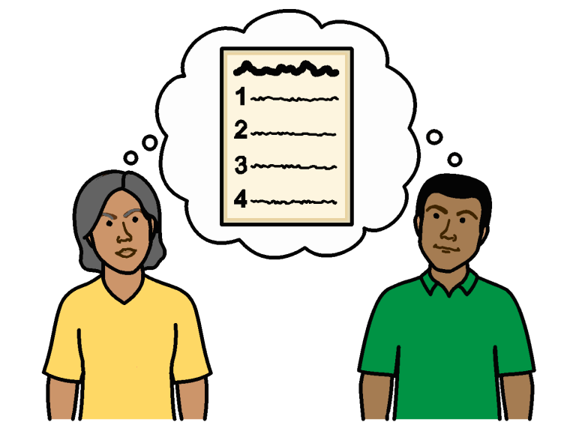
The help should be easy for them to get and use.

Look at other ways to give people with disabilities support if they cannot use the internet.
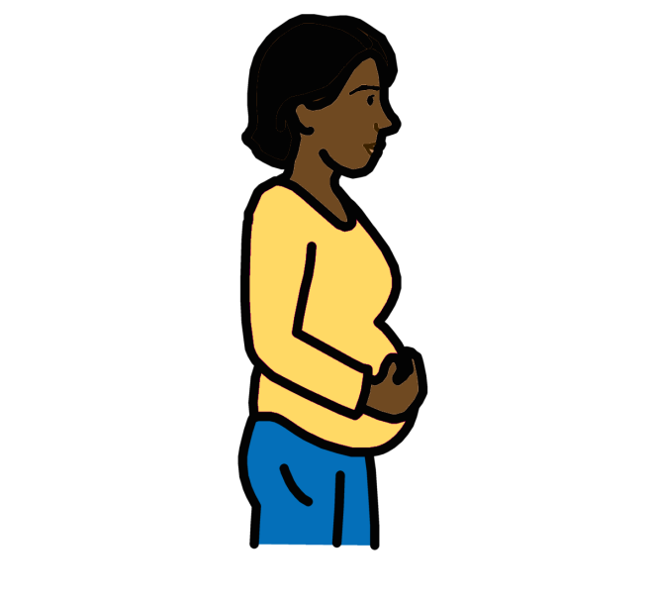

Make sure women and girls with disabilities still get the right support to do with their bodies, sex, relationships and having children.
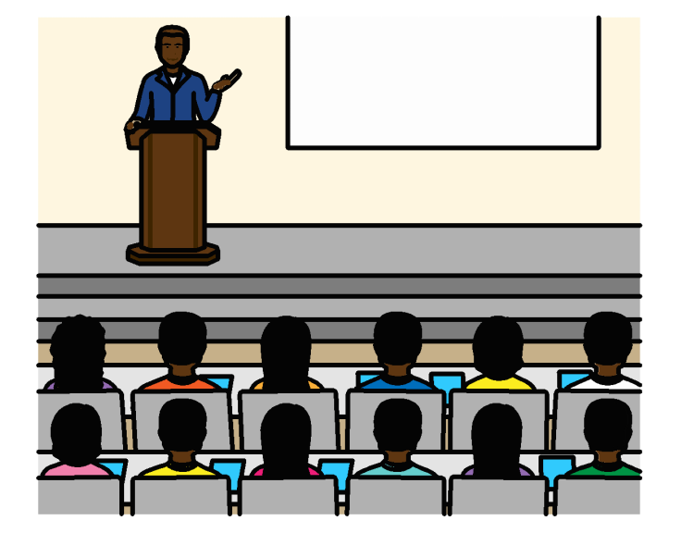
Make sure health and support workers have training about:

- How to keep everything clean and stop Covid-19 spreading.

- How to support people with disabilities in the right way.

- How to know if someone with a disability might be hurt or treated badly.

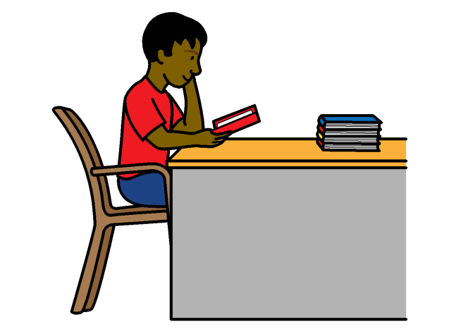

Make sure children and young people with disabilities can still learn at home if their schools close.

For example, lessons should be easy for them to take part in.
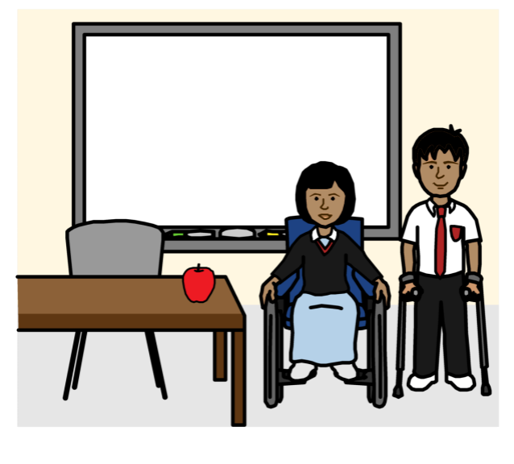

Children and young people with disabilities must get support to go back to school when it opens again.

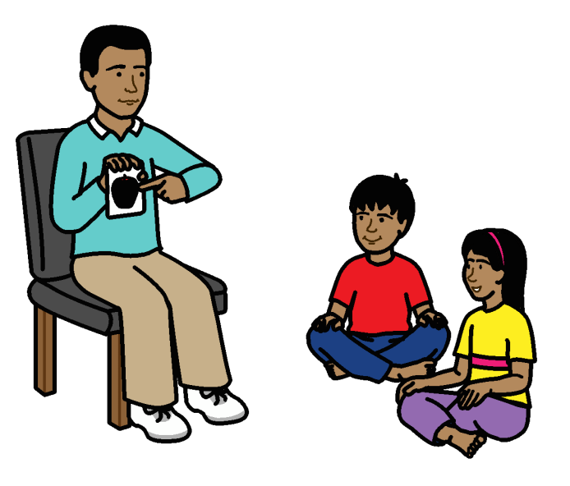
Make sure parents get the right support if they have to teach children with disabilities at home.

For example, a teacher could help them know what to do.

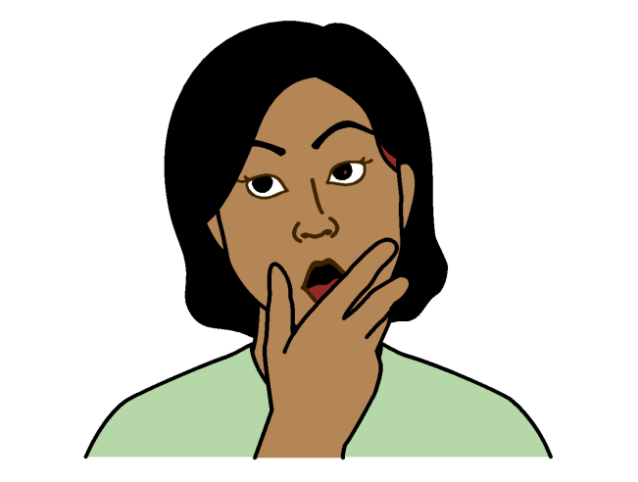

Make sure information about Covid-19 does not give people wrong ideas about people with disabilities.

For example, information should say that Covid-19 happens to everyone. Not just people with disabilities.

Some people with disabilities live in homes for people with disabilities.

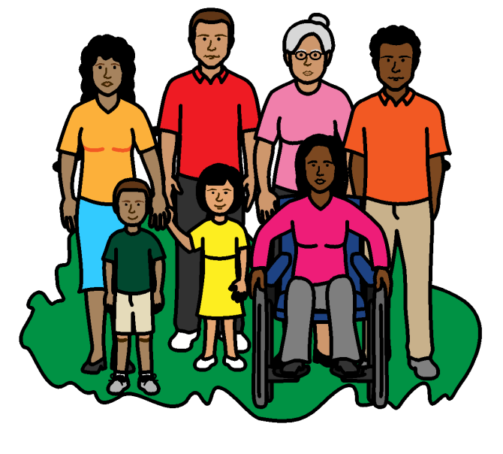

Make sure these people with disabilities can get support with their families or in the local community instead.

Make sure they can stay in touch with family and support workers.

Some notes about this document:

This document was not made by the Inter-Agency Standing Committee (IASC).

The Inter-Agency Standing Committee (IASC) is not responsible for what is in this document.

The document that this version was made from is called:

Covid-19 response: key messages on applying the IASC Guidelines on inclusion of persons with disabilities in humanitarian action

This is the version that the Inter-Agency Standing Committee (IASC) made.

Pictures by The Picture Communication Symbols ©1981–2016 by Mayer-Johnson LLC a Tobii Dynavox company. All Rights Reserved Worldwide. Thousands of resources available for free at www.boardmakeronline.com
Document checked by Hackney People First.
© European Easy-to-Read Logo: Inclusion Europe. More information
at www.easy-to-read.eu.

