Navigating the AT Ecosystem as Users:

Findings from IDA’s Assistive Technology Survey
March 2024

This publication has been developed by the International Disability Alliance in partnership with the Global Disability Innovation Hub. This project is part of AT2030, a program funded by UK Aid and led by the Global Disability Innovation Hub.
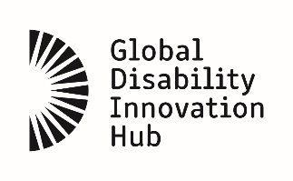 | 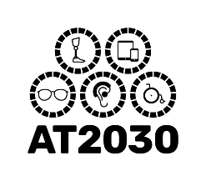

Accessibility Statement
The International Disability Alliance is committed to ensuring digital accessibility for persons with disabilities in its publications by applying relevant accessibility standards. This publication includes alternative texts on figures, a contrast checker, and an interactive table of contents. If you encounter any accessibility barriers on this document, please contact us at info@ida-secretariat.org.

© 2024 International Disability Alliance
www.internationaldisabilityalliance.org

This work is licensed under the Creative Commons Attribution 4.0 International license (CC BY 4.0). This license allows reuses to distribute, remix, adapt, and build upon the material in any medium or format for non-commercial purposes only, and only so long as attribution is given to the creator.

Graphics and Graphs: International Disability Alliance
Design: Invisible Assistant

Please cite this work as:
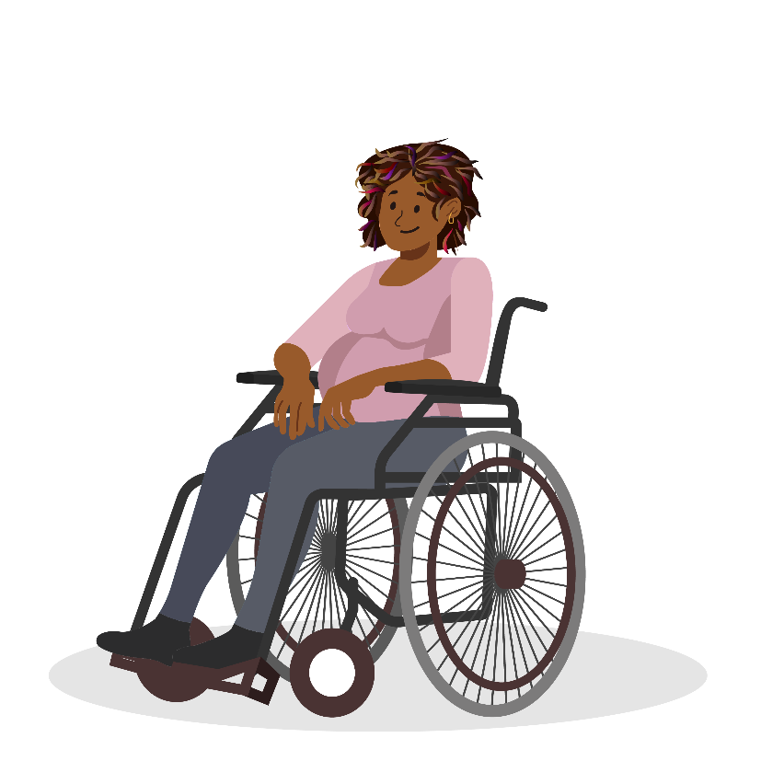
International Disability Alliance (IDA), Global Disability Innovation (GDI) Hub, Navigating the AT Ecosystem as Users: Findings from IDA’s Assistive Technology Survey, 2024.

Table of Contents
ACCESSIBILITY STATEMENT 2
TABLE OF FIGURES 5
ACKNOWLEDGEMENTS 6
EXECUTIVE SUMMARY 7
BACKGROUND 12
IDA’S AT USER SURVEY 15
Objectives 15
The AAAAQ framework 15
iData Survey Platform 16
Strategic Dissemination of the Survey 17
AT USER SURVEY RESPONDENTS 19
Study Groups and Data Analysis Methods 22
FINDINGS 24
Assessing access to AT using AAAAQ 24
Respondents who identified as persons with disabilities 24
Respondents who did not identify as persons with disabilities 27
Respondents who identified as AT users 30
Respondents who did not identify as AT Users 30

COMPARING RESPONSES AMONG STUDY GROUPS 32
Assessing access to AT using AAAAQ 32
Comparing access to AT among AT users and Non-users 34
Is access to AT similar for AT users with and without disabilities? 36
Who shares awareness about AT? 37
Barriers to AT: A Gender Perspective 39
Spotlight study: Funding for AT 40
OPD Consultations 42
Recommendations to improve AT access 43
LEARNINGS & NEXT STEPS 46
REFLECTIONS 47
ANNEX 1 TABLES 48
ANNEX 2 52

Table of Figures
Figure 1: Geographic distribution of respondents to the survey 20
Figure 2: Distribution of respondents by gender, age group, and self-identification as belonging to an ethnic minority 21
Figure 3: Percentage-wise distribution of the respondents by impairment group 22
Figure 4: Assessing AT using the AAAQ Framework among Persons with Disabilities 25
Figure 5: Rating accessibility to AT for persons with disabilities 26
Figure 6: Assessing access to AT using the AAAAQ framework among respondents without disabilities 28
Figure 7: Rating accessibility to AT for persons without disabilities 29
Figure 8: Assessing access to AT using the AAAQ framework among respondents who are AT users 30
Figure 9: Assessing access to AT using the AAAQ framework among respondents who are not AT users 31
Figure 10: Comparing access to AT using the AAAAQ framework between respondents with and without disabilities 33
Figure 11: Comparing access to AT using the AAAAQ framework between AT Users and Non-Users 34
Figure 12: Comparing access to AT using the AAAAQ framework between respondents who are AT Users with and without disabilities 36
Figure 13: Who spreads awareness about AT among the respondents? 38
Figure 14 Major barriers to AT among respondents with and without disabilities 39
Figure 15: Major barriers to AT by Gender 40
Figure 16 Sources of funding for the procurement of AT, respondents with disabilities 41
Figure 17 Sources of funding for the procurement of AT, respondents without disabilities 41
Figure 18 Distribution of ratings about OPD consultations from respondents who identified as persons with and without disabilities 43

Acknowledgements
This report is the collective work of the International Disability Alliance and GDI Hub.
The International Disability Alliance is an Alliance of global and regional organisations of persons with disabilities who advocate at the United Nations for a more inclusive global environment for everyone. IDA brings together over 1,100 organisations of persons with disabilities and their families from across eight global and six regional networks. IDA promotes the inclusion of persons with disabilities across global efforts to advance human rights and sustainable development and supports organisations of persons with disabilities to hold their governments to account and advocate for change locally, nationally and internationally.
This report was part of a project with the Global Disability Innovation Hub, as part of AT2030, a programme funded by UK Aid and led by the Global Disability Innovation Hub. AT2030 will test ‘what works’ to improve access to AT and will invest £20m to support solutions to scale. With a focus on innovative products, new service models, and global capacity support, the program will reach 9 million people directly and 6 million more indirectly to enable a lifetime of potential through life-changing assistive technology.
This work received additional support from ATscale, which supported webinars and in-person workshops which greatly increased the responses to this survey. This report, and its base survey, also benefitted greatly from the contributions of the IDA-GDI Hub AT User Fellows, namely Ahmed Abdallah, Banya Ojok, Elizabeth Campos, Nayem Molla, and Yusra Gilani. Several user testers from IDA’s community of practice supported the enhancement of this survey, with their contributions making the survey accessible to numerous respondents.
The views expressed in this report are those of the International Disability Alliance and GDI Hub and do not necessarily reflect the perspectives of the donor organizations. Any responsibility for any errors, interpretations, or omissions lies solely with the author(s).

Executive Summary
Assistive technology (AT) plays a pivotal role in transforming the lives of persons with disabilities, offering a pathway to increased independence, enhanced participation and inclusion, and improved overall quality of life. In settings where access to resources and services may be constrained, AT emerges as a critical enabler, bridging gaps in accessibility and fostering inclusive societies.
The potential of AT in everyday life extends far beyond overcoming physical and communication barriers. It has the potential to act as a catalyst for societal transformation, empowering persons with disabilities to advocate for their rights and inclusion across various aspects of life.
Despite the increased efforts to drive AT user participation and engagement, there is still a large gap in the amount, type and quality of data required to understand the scale and nature of the challenges experienced with several contributing factors. Moreover, there is a significant difference in the availability of assistive technology worldwide. Those with broader access to AT (mainly located in the Global North) face different challenges to those with less access to AT, who are largely located in Low- and Middle-Income Countries (LMICs). The former generally tend to have far greater global advocacy reach, power, and influence.

“First of all, let everyone with a disability have the right to choose.”

– A respondent from the Asian region

To bridge the stated gap in collecting data specific to LMICs, and assessing access to AT, IDA and GDI Hub developed an online survey with focused dissemination efforts across LMICs. The survey aimed to collect data on the general prevalence of assistive products and AT need among AT users and potential users, and identifying the barriers that limit the access to AT in LMICs.
Hosted on IDA’s iData platform, the survey was made available in several languages; including English, Spanish, French and Arabic, along with English easy read and international sign. The survey used the AAAAQ framework as a tool to assess access to AT. It also sought to identify major barriers to AT. There were a total of 1040 responses to the survey from over 100 countries; of which 49.3% identified as female, 49.2% as male, 1.0% preferred not to specify their gender, and 0.49% identified as "Other." The data from the survey was analyzed using the filters of respondents identifying as persons with disabilities and as AT users, both with and without disabilities. The results revealed significant differences between the experiences of respondents who did and did not self-identify as persons with disabilities in terms of access to AT.

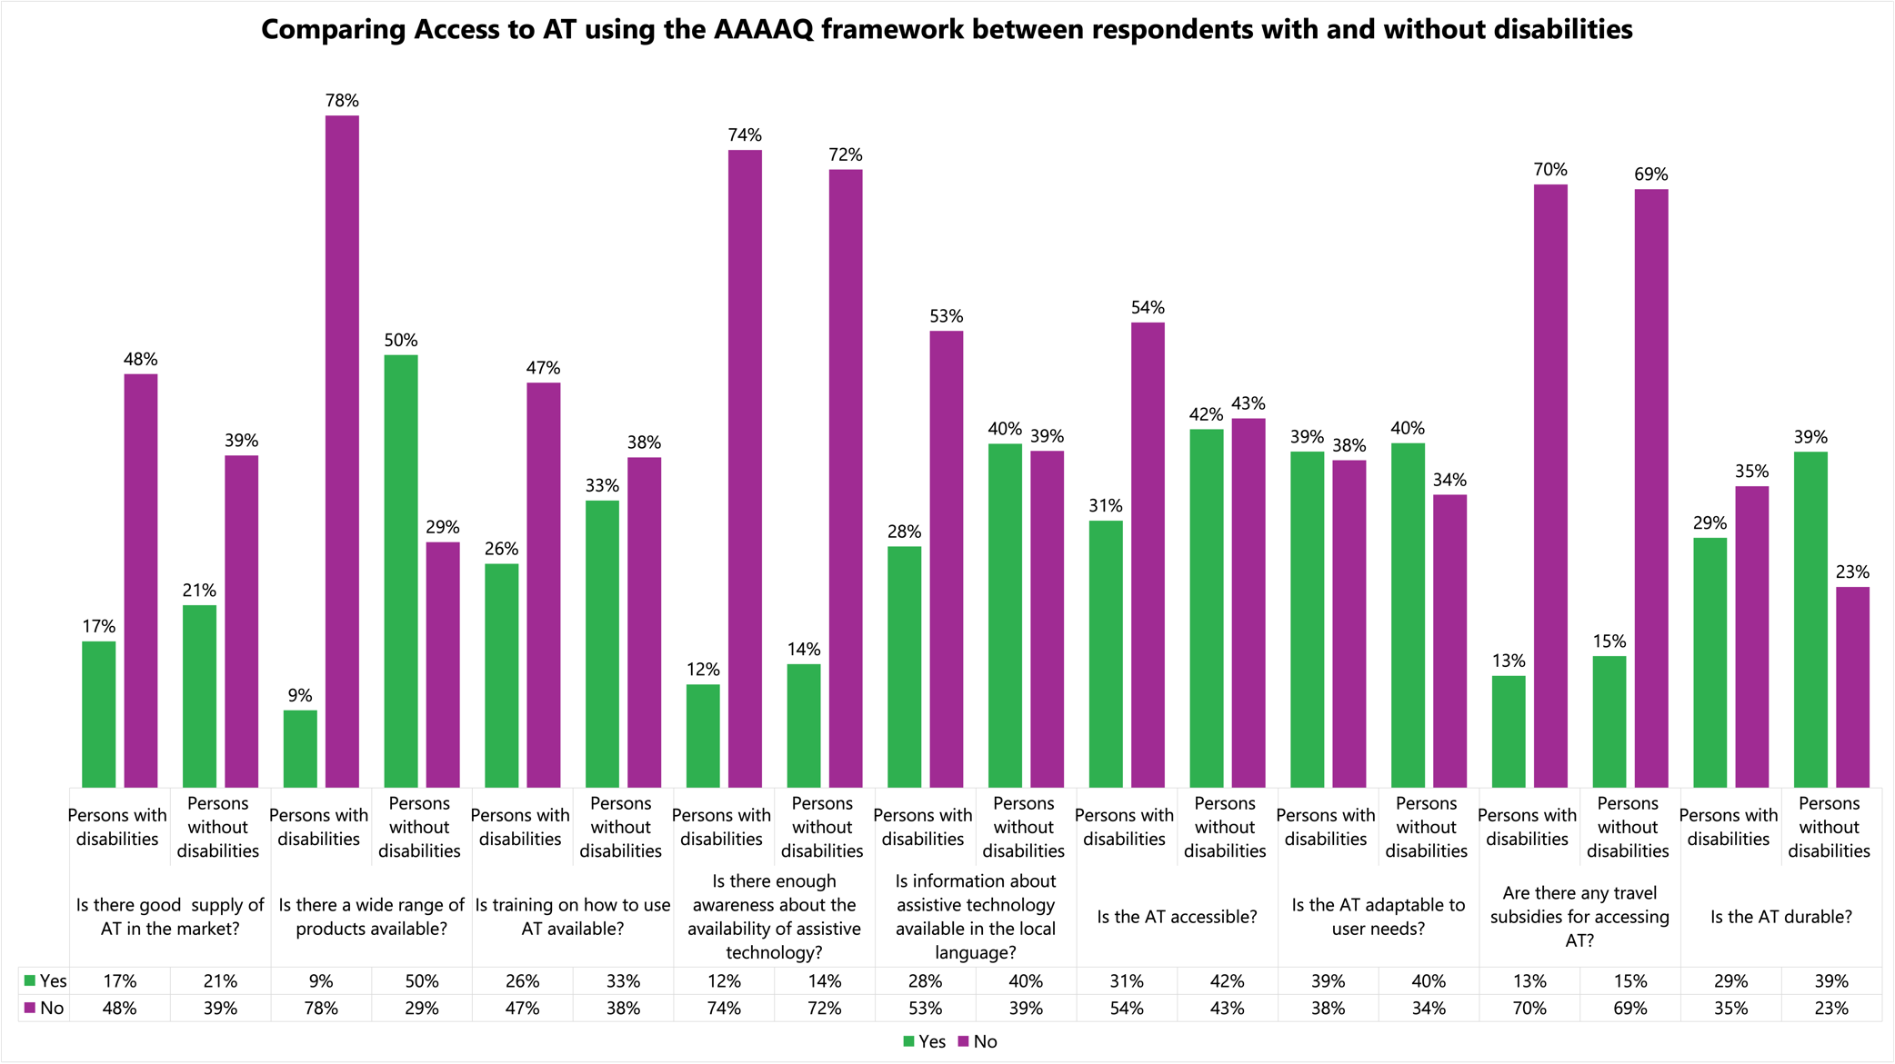

Among both groups, there was low opinion on crucial aspects of access to awareness about the availability of AT (an average of 73% across groups said there was no awareness), the supply of AT in the market (an average of 43% across groups said there was no supply), if assistive devices could be modified to suit specific needs (an average of 36% across groups said no).
Groups differed on the range of AT products available in the market: only 9% of respondents with disabilities believed that there was a range of AT products available in their market, against 50% of respondents without disabilities who had this view.
Similarly, respondents with disabilities also rated the aspect of accessibility of AT lower with 31% saying yes, and 54% saying no, while more respondents without disabilities agreed that AT was accessible (42% said yes, AT was accessible, and 43% said no, AT was not accessible).
Another key difference was in the aspect of the durability of AT, again rated lower by persons with disabilities.
An additional disaggregation of the data set into AT users and non-AT users, further disaggregated into respondents, namely into self-identified persons with and without disabilities, shed light on the overall understanding of the concept of disability and also related to specific impairment groups.

Both study groups (persons with and without disabilities) stated that the biggest barrier to accessing AT was the lack of laws that protected the right to access to AT. The second largest barrier indicated by both groups was the stigma associated with using AT. This provides unequivocal evidence for how the use of AT presents additional attitudinal barriers for persons with disabilities, making campaigns such as GDI Hub’s #Wethe15 and ATscale’s Unlock the Everyday increasingly important in the Global South and LMICs. Additionally, all groups presented the affordability of AT as a barrier.
The survey also gathered recommendations from respondents regarding the improvement of AT access. Over 800 recommendations were gathered, and they focused on a large range of AT-related areas, including policy, national and regional AT supply chains, subsidies for AT production and procurement, advocacy and capacity building efforts to strengthen Organizations of Persons with Disabilities (OPDs), and, above all, the need for coordinated efforts from multiple actors and urgent cross-sectoral collaboration. These findings evidenced that the respondents regard AT as an ecosystem, rather than as a product or service alone.

"Ma première recommendation: Avoir des leaders handicapés respectés par leurs gouvernements."

– A respondent from the African Region
Together with these findings was a major reflection on the inclusive approach to AT research that is required for the effective participation by persons with disabilities. IDA and GDI Hub’s research methodology focused on building a process that iteratively combined capacity building and research efforts, along with a lengthy period (3 months) of the survey being open for participation and language options for the survey. This inclusive and participatory model of consultation and research was a notable success, evidenced by the deep and nuanced feedback and recommendations from respondents.
Most importantly, the survey results reaffirmed what the disability movement has stated since its conception: that persons with disabilities are critical partners in conceiving and creating systems of inclusive development. AT is targeted at empowering persons in disabling environments. Persons with disabilities, with both a history of pioneering advocacy for AT, unparalleled user knowledge of AT products, and lived experience expertise have an inherent imperative to be a part of the team that builds AT.
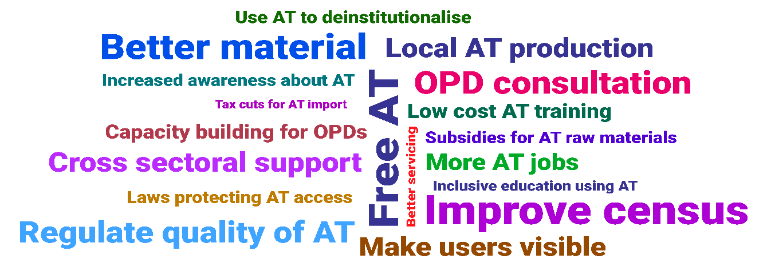

Background
Access to assistive technology (AT) is a human right. The UN Convention on the Rights of Persons with Disabilities (CRPD) makes explicit references to AT in several articles, including in its general obligations, as well as in specific articles related to personal mobility (Article 20), habilitation and rehabilitation (Article 26), adequate standard of living and social protection (Article 28) and participation in political and public life (Article 29). In addition, the provisions related to international cooperation under Article 32 oblige States Parties to undertake and promote research and development of new technologies, mobility aids, and devices. States are also to provide accessible information to persons with disabilities about AT. By guaranteeing access to AT, the CRPD seeks to eliminate barriers and establish an inclusive environment where persons with disabilities can equally partake in opportunities in all spheres of life.
The CRPD has also defined the obligations of States Parties to promote the use, research, development, production, and distribution of assistive technology, and make it affordable and widely available for persons with disabilities. Nevertheless, in several Lower- and Middle-income Countries (LMICs), access to AT stays restricted due to several interlinked barriers, including financial, physical, and attitudinal barriers. Consequently, systemic investment faces logistic obstructions. Enormous effort is essential to address this significantly underserved but pervasive issue. Additionally, there is a shortage of explicit attention to assistive technology concerns for all underrepresented groups. Data that drives the need for special attention to the concerns of underrepresented groups is still largely absent. Financial constraints pose a significant challenge as the high costs associated with acquiring and maintaining assistive products limits accessibility.
The WHO rATA survey report highlights the lack of adequate availability of assistive products, coupled with a lack of awareness about their benefits, which compounds the issue. Inadequate infrastructure, negative social attitudes, as well as stigma surrounding disabilities further hinders access. The absence of comprehensive policies, limited training, and gaps in healthcare systems further contribute to this system of barriers. Supply chain issues and the digital divide also play a role, emphasizing the need for a comprehensive, collaborative approach involving policymakers, healthcare providers, OPDs, and the broader community to overcome these barriers and ensure equitable access to assistive technology for AT users.
Studies have also shown that a critical lack of participation by AT users is part of the market and system failures that hinders AT access. The provision of AT services stands to improve greatly if it were better informed by the stories and experiences of diverse AT users. Many persons with disabilities face barriers to accessing higher education, and therefore have had less access to opportunities for developing research skills. They are often not viewed or included as researchers. This dilemma causes major detriment to AT initiatives, since involving persons with disabilities in research that impacts their lives is crucial for ensuring that data reflects the actual priorities of the disability movement and responds to users’ real needs. More research and direct consultations with organizations of persons with disabilities, including those from the Global South and underrepresented groups, are critical to the success of any AT initiative.
AT has been a focus area for OPDs in the recent past. For instance, at the Youth Global Disability Summit in 2022, OPDs of youth with disabilities released a call for action wherein Assistive Technology (AT) access was identified as a critical action, and AT was a significant element during the Global Disability Summit itself which came up in several thematic workshops and ran across all themes.
In this context, IDA, along with the GDI hub, undertook the initiative to design participatory research methods by leveraging our extensive knowledge of the disability rights movement and connections to OPDs to strengthen disability-informed academia and research.
To understand the experiences of current and potential AT users, IDA, in collaboration with the GDI Hub-IDA AT User Fellows, developed an online survey to assess access to AT. This survey was supported by the GDI Hub and translated into the languages of the different regions represented by forum members. The survey was prefaced by regional webinars, which shared more about the Global AT movement and provided a comprehensive background for the survey.

IDA’s AT User Survey
IDA’s AT User survey followed an exploratory methodology. It included a combination of open and closed-ended questions that aimed to elicit both quantitative and qualitative responses. The questions were designed to be aligned with a set of three distinct research objectives.

Objectives
To gather evidence on the overall prevalence of need and access to assistive devices among persons with disabilities.
To identify disability groups that have lesser access to assistive products and services.
To identify barriers experience by these underrepresented groups accessing assistive technology.
Additionally, the survey aimed to gather relevant input regarding sources of funding for AT, alongside evidence of successful social protection that covers AT costs. The primary objective of the survey was to assess access to AT among respondents using a neutral framework for assessing products and services. For this, the AAAAQ framework was selected as the tool of assessment.

The AAAAQ framework
In its General Comments nos. 13 and 14 on the right to education and the right to health, the Committee on Economic, Social and Cultural Rights put forth a set of 5 interrelated features that are essential for a system to fulfil the obligation of equal access to services. Also referenced by the Committee on the Rights of Persons with Disabilities in their General Comment No. 4 on the right to inclusive education, these features were defined as:

Availability: the guarantee of a broad supply of services at all levels in sufficient quantity and quality
Accessibility: the need for the accessibility of services and systems without discrimination, encompassing various types of accessibility such as physical, financial and information / awareness, with periodic regulatory and technical adjustments to suit the dynamic nature of accessibility
Acceptability: the need to design and implement products and services that respect the cultures of persons, be respectful of language needs, ethics, sensitive to gender and age-specific needs, allowing for confidentiality in the systems of data involved in the service, and ensuring pre-informed consent is obtained by service user.
Adaptability: the need to allow for modification and flexibility of products and services to promote their widened usage
Quality: the imperative for products and services to be scientifically appropriate, adhering to continuing standards or good quality, measured by national and international standards.

Today, AAAAQ or 4AQ is a well-recognized tool that can be used to measure access to most services. The IDA AT survey used the AAAAQ framework to assess access to AT among its respondents. Key questions that related to these aspects were incorporated into the survey. There were multiple questions offering opportunities to gauge distinct aspects of the AAAAQ framework.
Additionally, the survey included questions to gather insights into the major barriers that respondents face in accessing AT, and sources of funding for the procurement of AT. The survey concluded with a consultative question on recommendations to improve AT access.
A demo-version of the survey can be accessed by clicking here. In this demo link, users will be able to toggle accessibility and language options, as well as interact with the questions. The survey was hosted on IDA’s iData platform.

iData Survey Platform
Assistive Products (AP) are improved through engaging with users, but this understanding of user-centered design does not often extend to services and enabling environments. Several stakeholders seeking to consult or engage with AT users are unaware of whom to consult with (for example, OPDs versus service providers), or they are confronted with multiple entry points which creates confusion. Collecting large amounts of diverse data from a globally dispersed user group is complex and can be expensive, and often platforms for data collection are inaccessible. Aiming to address these gaps in the AT data ecosystem, IDA hosted the AT user survey on its iData platform.
Hosted on the Accessible Surveys platform, iData is a survey tool developed for the specific needs of IDA and its members. It offers options to build and access large-scale, multi-lingual surveys without limitations on survey questions or responses. Centralized and managed by IDA, the platform is completely safe, and data is anonymous, and offers provisions to add questions in International Sign and Easy to Read formats. Additionally, the platform offers IDA’s survey analysts access to survey responses as both qualitative and quantitative data, which eases the process of collating insights from the data and organizing it into accessible formats such as reports.
Additionally, before the launch, the survey was user-tested extensively by different AT users, both on web and mobile versions. Developers worked to incorporate all the feedback provided by testers on the length, accessibility, technological difficulties, AT compatibility, and other aspects to refine the experience of users taking the survey. Following the testing, the survey was launched for public access.

Strategic Dissemination of the Survey
A frequently observed hurdle to AT user engagement is the lack of awareness of data collection methods among AT users and persons with disabilities. Many times, data collection and user engagement mechanisms from AT actors are not built with specific users in mind. Part of AT user engagement is also building awareness among potential respondents, both about the AT ecosystem and about the specific goals of the data collection. Strategic efforts to build awareness and sensitivity to the need for reflection and constructive feedback on AT products and services are key in engendering optimal participation among persons with disabilities and other AT users from key geographic areas. Additionally, IDA’s 2nd IDA Global Survey on the Participation of Organizations of Persons with Disabilities (OPDs) has shown that while there have been improvements in Governments consulting OPDs on data collection, there was still much scope for improvement.
With these pointers, IDA worked to disseminate the survey and raise awareness using a series of well-coordinated strategic approaches:
Awareness webinars accessible to specific time zones that offered increased exposure to the AT system, with language interpretation and logistic support.
In-person OPD workshops that created groups of AT advocates across 3 different regions, namely Rwanda, Kenya, and Peru, that increased awareness about AT and encouraged participants to share the survey with their OPDs.
Partnerships with OPDs to ensure the inclusion of traditionally underrepresented disability groups, improving access to the survey. This included approaches such as the option to access the survey in international sign or in easy-to-read formats. Promotional material for the survey included a minute-long video in international sign language that was shared by organizations such as the World Federation of the Deaf and members’ as well as partners in their newsletters and other media.
Mobilization by AT User Fellows played a key role in engaging users from varied geographies and promoting deeper insights aided by peer support from the fellows.
Social media engagement included utilizing social media platforms, texting, and emails in all the languages of the survey.
IDA’s AT survey was open between the 20th of November 2023 and the 15th of February 2024. 1040 responses to the survey were registered during this period.

AT User Survey Respondents
The AT survey gathered responses from a variety of regions and countries across the world. The survey results showed that 31% of respondents were from African regions, 28% from European regions, 27% from Latin America and the Caribbean, 23% from Asian regions, 5% from Oceania, and 2% from North American regions. (See Table 1A in Annex 1). The distribution of survey respondents by country included Pakistan at 11.38%, Kenya at 6.36%, the United States of America at 4.44%, Peru at 7.71%, Bangladesh at 9.26%, Guatemala at 3.18%, Uganda at 5.98%, Argentina at 2.89%, the United Kingdom at 2.51%, Sudan at 2.51%, Bolivia at 2.31%, the United Arab Emirates at 2.22%, and 39.25% from other countries. The other countries included India, Panama, Colombia, Honduras, Tanzania, Mexico, Ireland, Egypt, Rwanda, Malawi, and 100 others (See Table 1B from Annex 1).
Figure 1 shows a distribution of the countries that respondents identified as their nationalities.

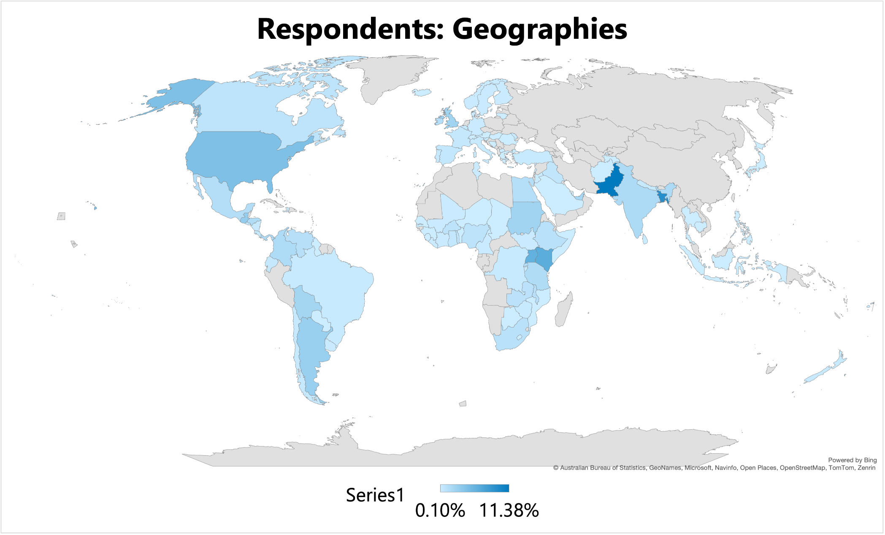
Figure 1: Geographic distribution of respondents to the survey

Among 1040 respondents, 49.3% identified as female, 49.2% as male, 1.0% preferred not to specify, and 0.49% identified as "Other."
Respondents were distributed across age groups as follows: 46% were in the 18-35 age range, 33% in the 36-50 range, 18% in the 50-65 range, 3.011% in the 66-75 range, and 0.21% were 76 years old and older. Survey respondents' identification as ethnic minorities varied, with 28% answering "Yes," 66% responding "No," and 7% preferring not to disclose this information.
Figure 2 shows a summary of the distribution of respondents by gender, age group, and self-identification as belonging to an ethnic minority.

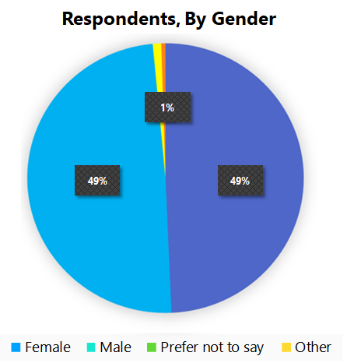 | 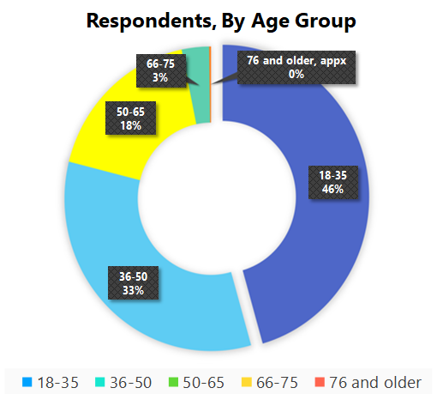 | 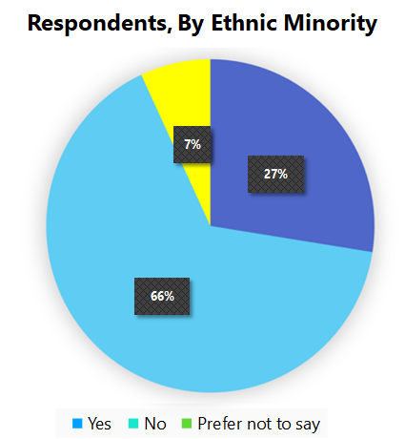
Figure 2: Distribution of respondents by gender, age group, and self-identification as belonging to an ethnic minority
The survey had a diverse representation of respondents based on various types of disabilities. The highest percentage, 24%, identified as persons with physical disabilities. The second highest was persons with visual disabilities at 10%, intellectual disabilities at 7%, Deaf persons (using sign language) at 6% and 16% identified as persons with multiple disabilities. A variety of other identifications such as those who are hard of hearing, autistic persons, persons with psychosocial disabilities, cerebral palsy, deafblindness, and albinism, were also represented, with their respective percentages ranging from 1% to 2%. 23% of respondents did not identify as persons with disabilities.
Figure 3 shows the percentage-wise distribution of the respondents by impairment group.

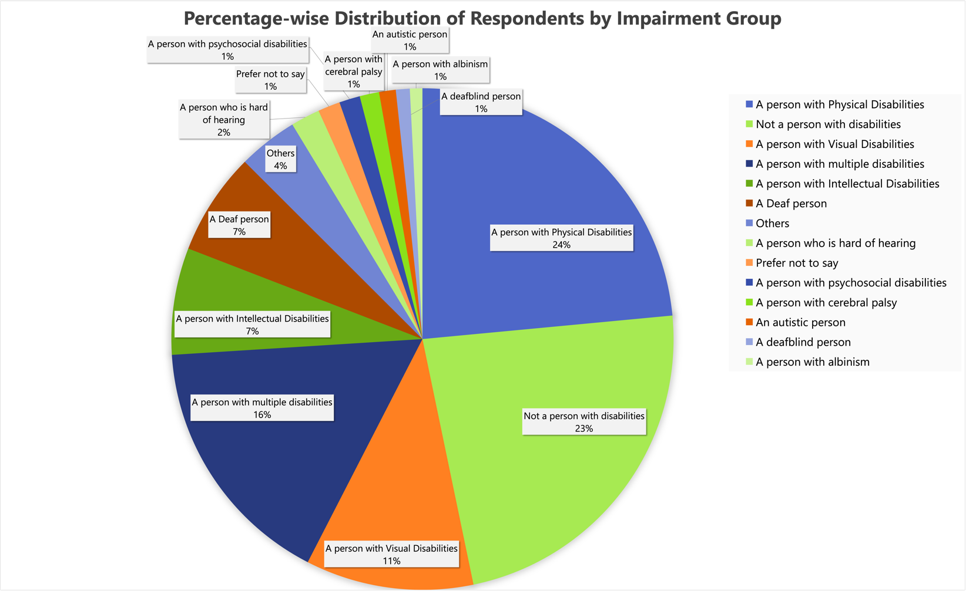
Figure 3: Percentage-wise distribution of the respondents by impairment group

Study Groups and Data Analysis Methods
To optimally utilize the prolific responses obtained from a vast and diverse set of respondents, two key differentiators were identified in order to categorize respondents into strategic study groups.
Key differentiator 1: self-identification as a person with a disability/disabilities
Key differentiator 2: self-identification as a permanent or intermittent user of assistive technology (products and/or services)

These differentiators were selected based on the primary objective of the study, to assess access to AT. Responses were grouped based on these differentiators, creating 3 groups:
Respondents who identified as persons with disabilities (see Annex 1, Tables 2A – 2F)
Respondents who did not identify as persons with disabilities (see Annex 1, Tables 3A – 3E)
Respondents who identified as AT users (see Annex 1, Tables 4A – 4F)

Responses from each study group were collated, and comparative analyses were performed across the study groups. The analyses focused on survey questions closely aligned with the AAAAQ frameworks, assessing the availability, accessibility, acceptability, adaptability, and quality of AT products and services at their regional and national level.
Furthermore, while analyzing major barriers to AT access, gender was used as a key differentiator, to gather qualitative inputs on factors that compound the barriers, and to consider if gender is one of them.

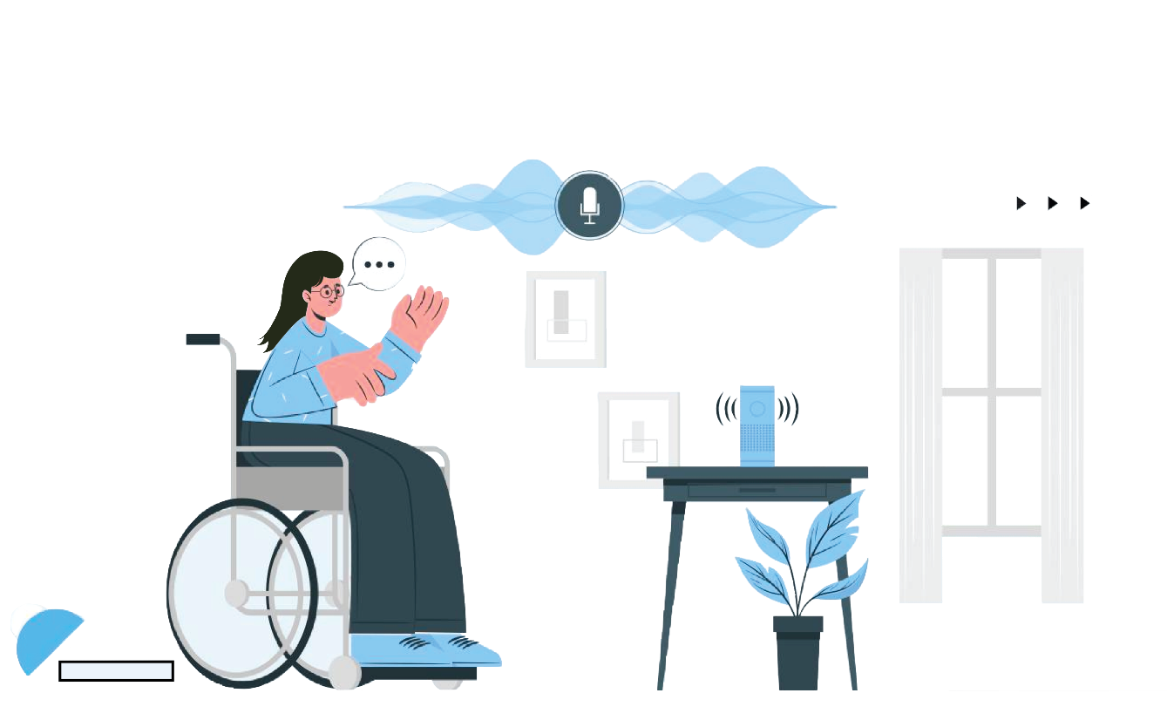

Findings

Assessing access to AT using AAAAQ
To assess access to AT, the survey asked several questions that were directly related to the AAAAQ framework, including whether there was a good supply of AT in the market, whether a wide range of AT was available, if retail stores and regions for procurement are accessible, and if the AT could be modified, among others.

Respondents who identified as persons with disabilities
A total of 570 respondents identified as persons with disabilities. This was 54% of the total number of respondents.
Figure 4 summarizes the responses to these questions. Only 17% of respondents affirmed the existence of a good supply of AT in the market, while a substantial 48% indicated its absence. Concerns about the diversity of available products were pronounced among persons with disabilities, with 78% asserting a limited range. Training sessions for the effectiveness of AT products seemed insufficient, as 47% claimed its unavailability. A lack of awareness about AT was highlighted by 74% of respondents, emphasizing a need for improved outreach. Additionally, the accessibility and adaptability of AT were areas of concern, with 54% and 38% expressing doubts, respectively.
Furthermore, the absence of travel subsidies (government payments) for AT access was indicated by 70% of respondents. The durability of AT was also met with uncertainty, as 35% were unsure about the longevity of their AT products.
To further inspect the aspect of accessibility, the survey asked respondents to rate the ease of access for different groups of persons. Figure 5 summarizes these findings. (See Annex 1, Table 2G for details)

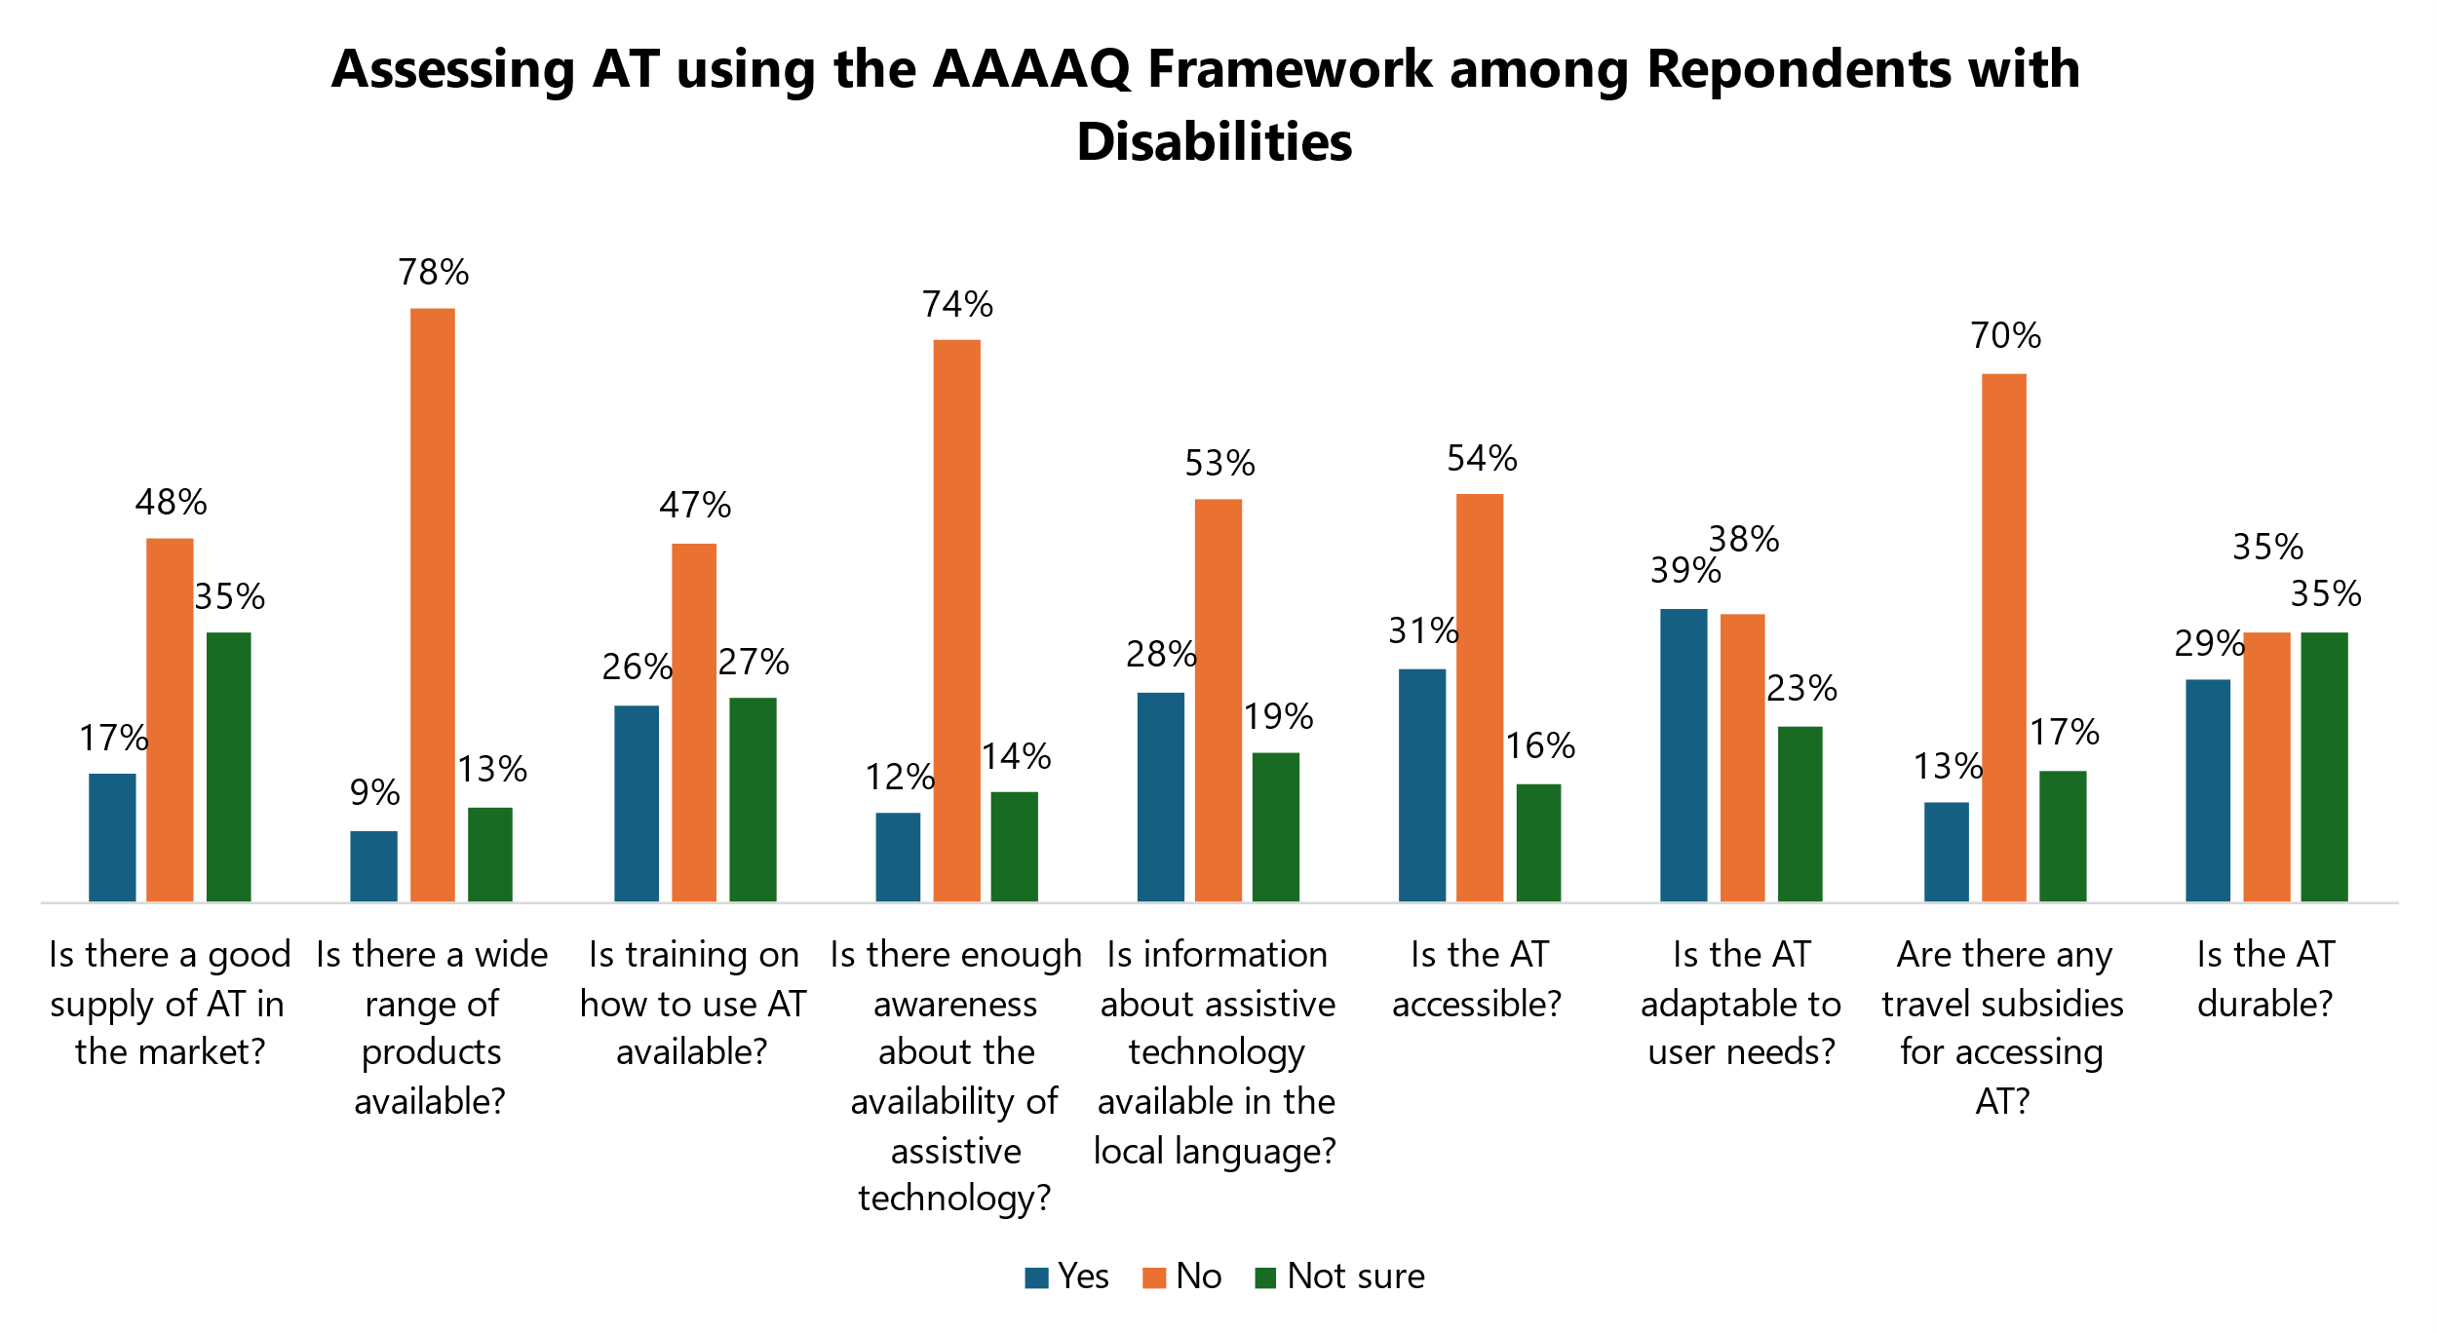
Figure 4: Assessing AT using the AAAQ Framework among Persons with Disabilities

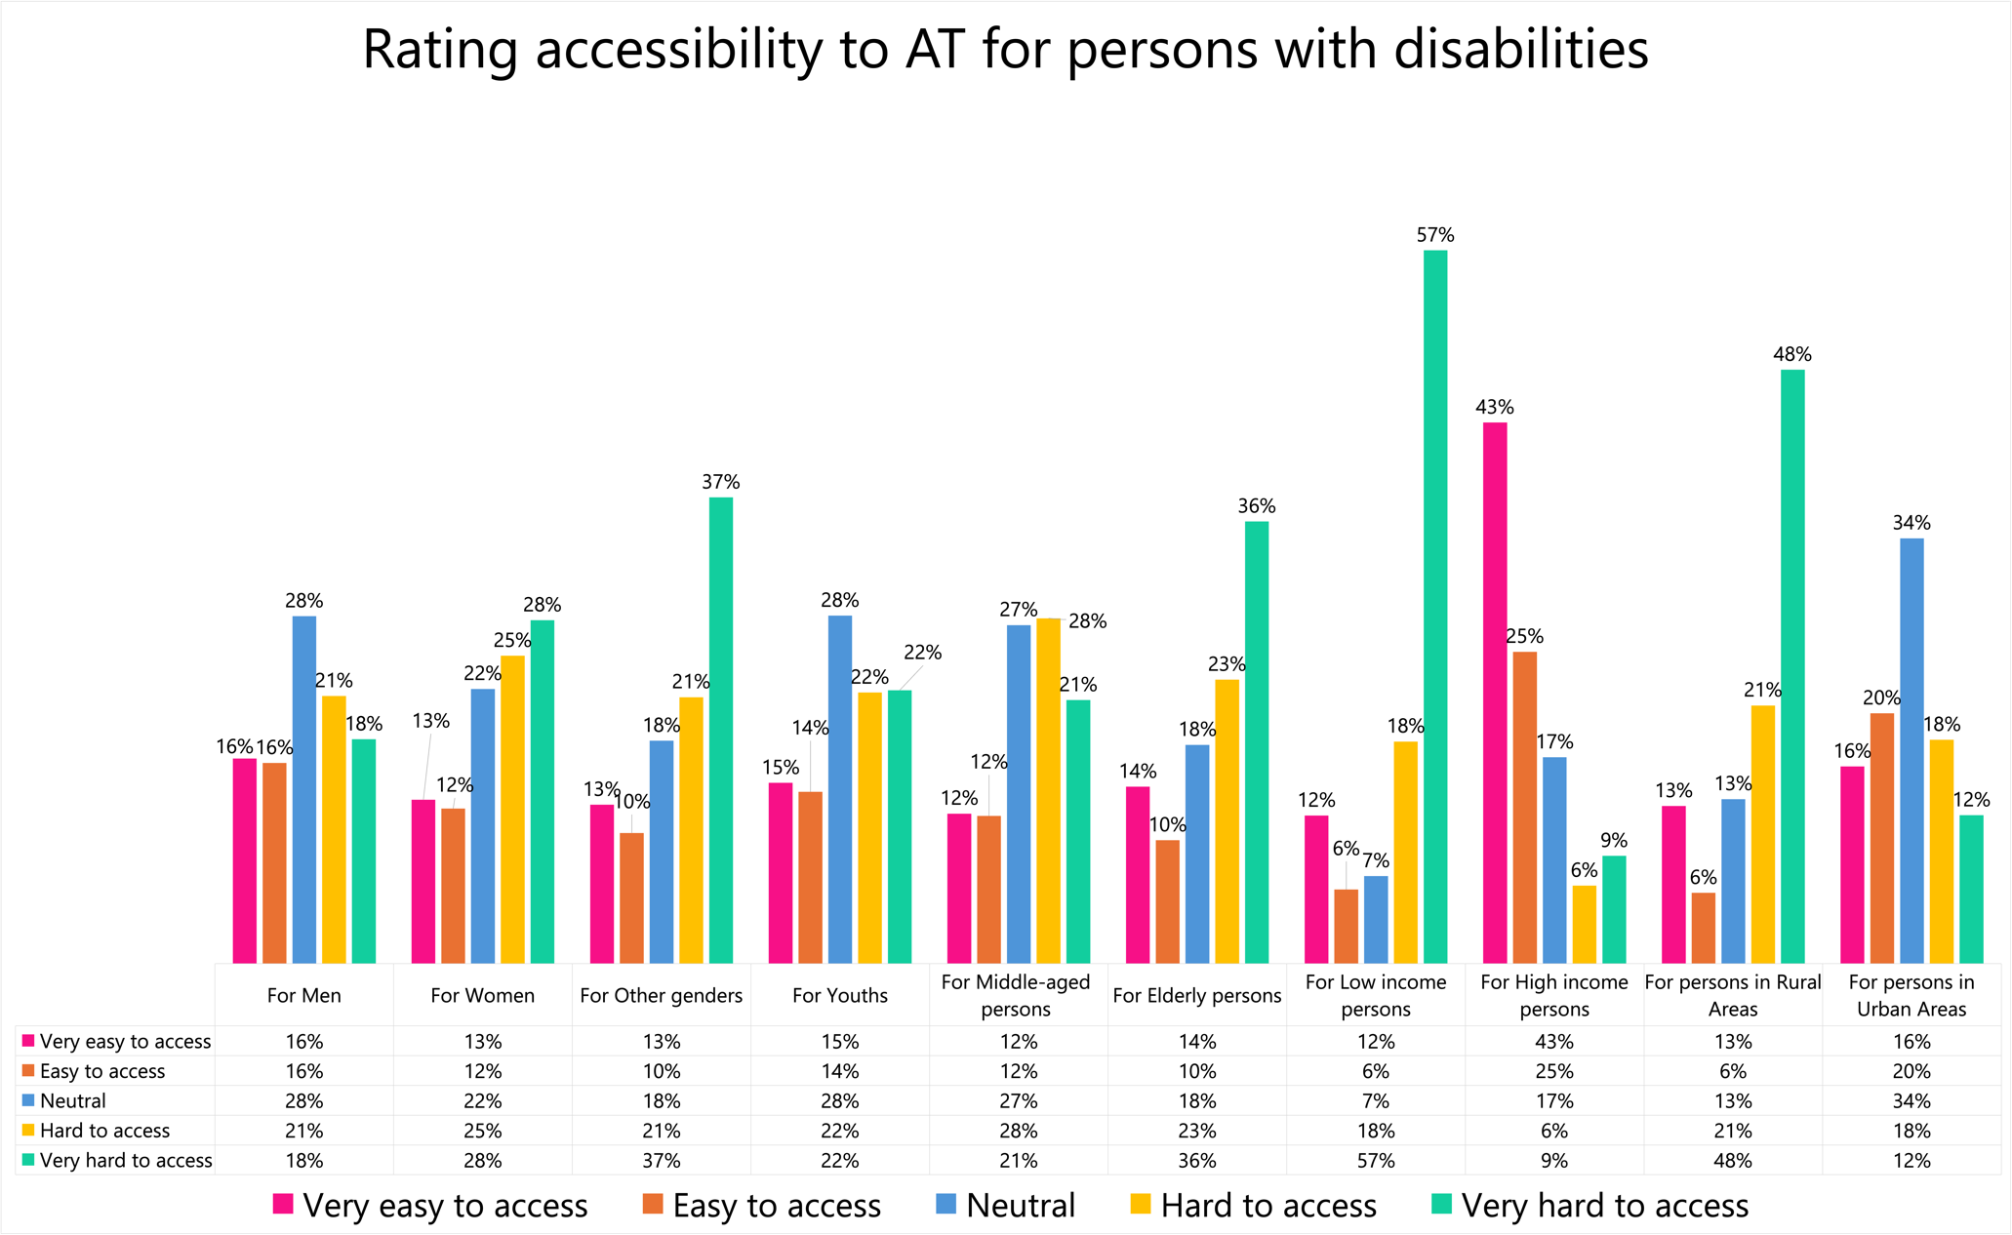
Figure 5: Rating accessibility to AT for persons with disabilities

43% of respondents responded that persons with disabilities who have a high income find access to AT very easy, while only 6% of persons with low income and 9% of persons living in rural areas find access very easy. Women and the elderly also face challenges, with 28% and 36%, respectively, finding access very challenging. Youth and middle-aged persons with disabilities are generally rated to have better access, with higher percentages in the "very easy" and "easy to access" categories. Urban areas tend to have higher ease of access ratings, with 34% neutral, 20% easy, and 12% very easy. These findings highlight the disparities in AT access based on income, age, and urbanization, showing a stark lack of accessibility.

Respondents who did not identify as persons with disabilities
Assistance is not a need that is specific to persons with disabilities. All persons need support, and the use of AT is not an exemption. A total of 257 persons identified as not being persons with disabilities. This was 25% of the total number of respondents.
40% of respondents affirmed the presence of a wide range of AT products. 42% of respondents indicated that AT is accessible with 40% indicating that AT is adaptable and 33% of respondents reporting that training on AT usage was available, but the availability of information about AT in the local language was relatively low at 14%. 39% of respondents indicated that their AT was durable, but the same number indicated that they were not sure.
Overall, the data showed that while there was some range of AT available in the market, the overall availability, awareness, accessibility, and financial accessibility was low.
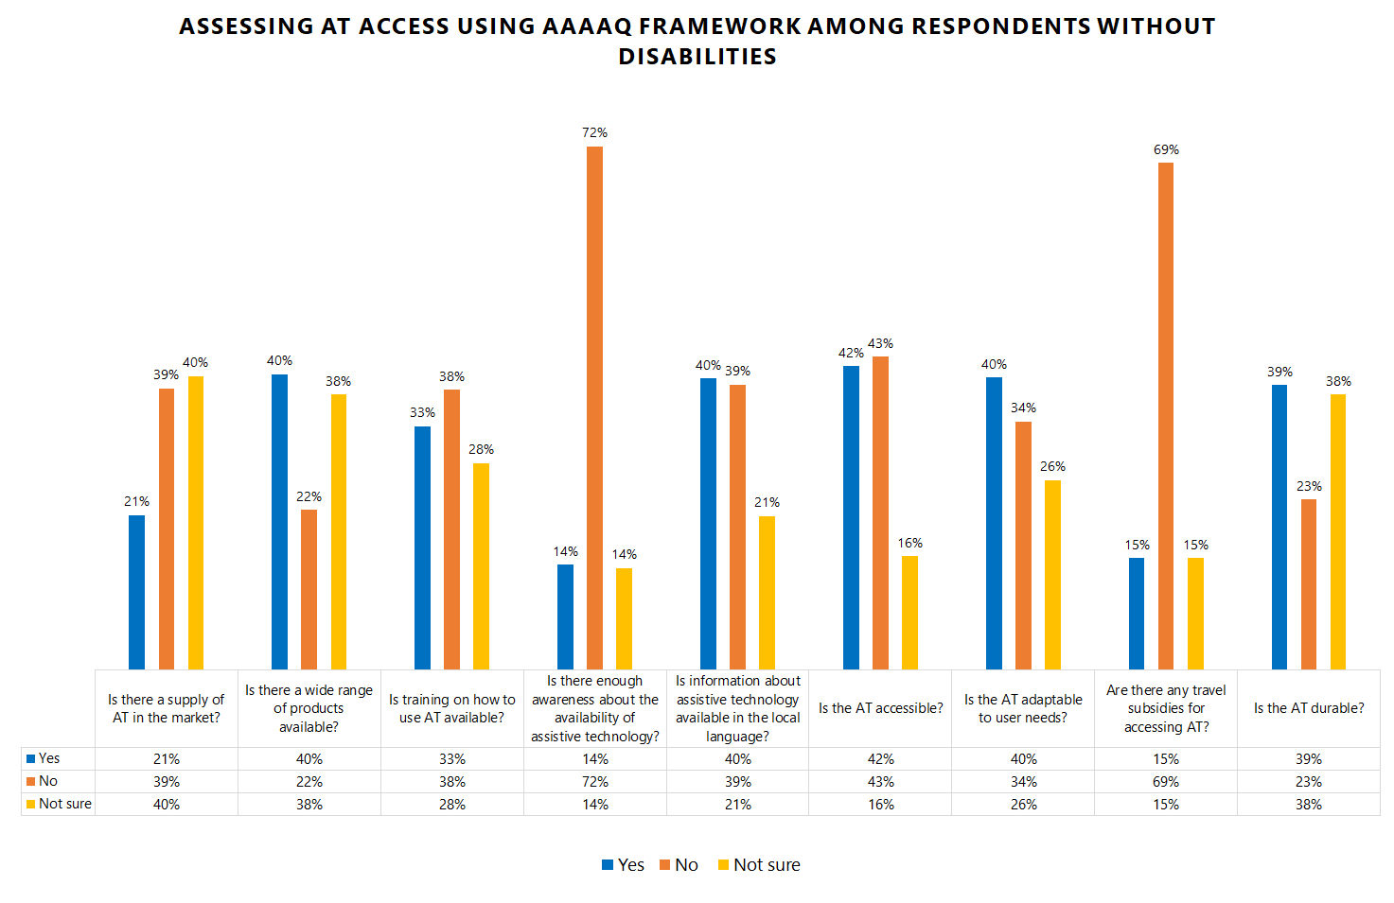
Figure 6: Assessing access to AT using the AAAAQ framework among respondents without disabilities

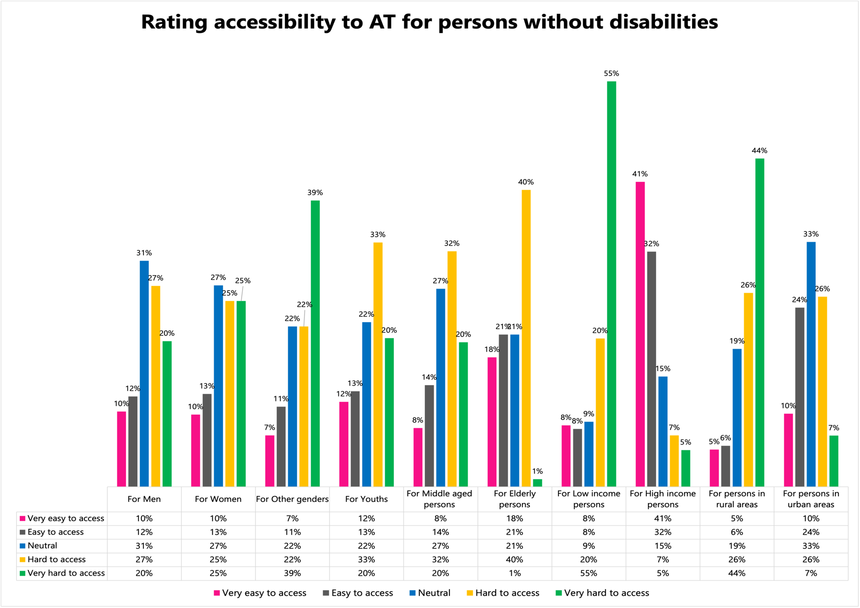
Figure 7: Rating accessibility to AT for persons without disabilities
55% of respondents who did not identify as persons with disabilities indicated that persons with low income had the least access to AT. 44% reported that persons in rural areas find it very hard to access AT. Another group identified by this study group with the hardest access was persons living in rural areas, followed by persons of genders other than male or female.

Respondents who identified as AT users
AT users are significant participants in the AT ecosystem but are often not regarded as such. 54% of respondents identified as either intermittent or permanent AT users. An analysis of their responses to questions related to the AAAAQ framework revealed negative responses on all aspects of the AAAAQ. 49% of AT users responded that there was not a good supply of AT in the market, 51% said that there was not a good range of products or services and 54% indicated that AT was not accessible. The highest number of responses, 74% reported that there was a lack of knowledge about AT. The responses are summarized in Figure 8.
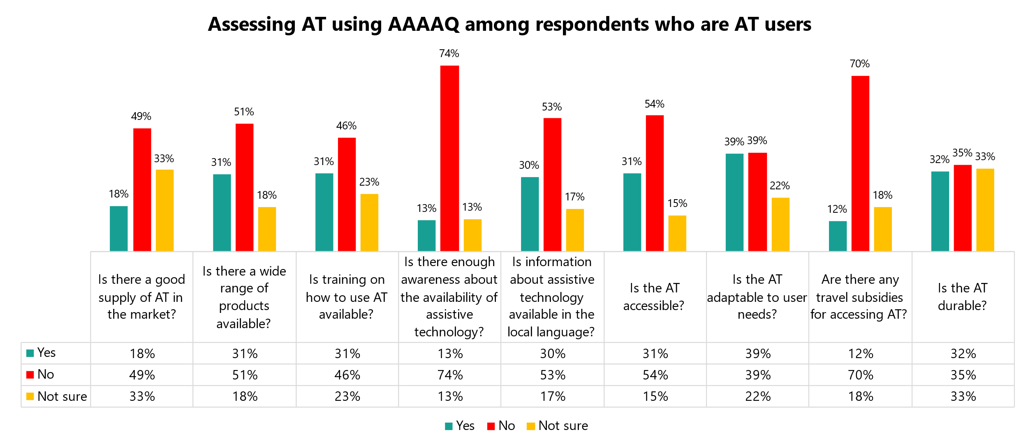
Figure 8: Assessing access to AT using the AAAQ framework among respondents who are AT users

Respondents who did not identify as AT Users
46% of respondents identified as persons who did not use AT. 42% also reported that they were not sure of the availability of AT, and 44%% indicated that they were not sure of whether information about AT was available in the local language. Additionally, 72% said that there is not enough awareness about the availability of AT. Their responses are summarized in Figure 9.

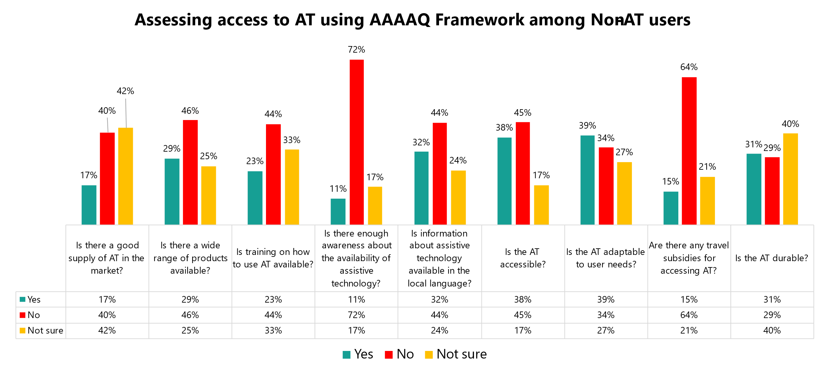
Figure 9: Assessing access to AT using the AAAQ framework among respondents who are not AT users

Comparing responses among study groups

Comparing access to AT among Respondents with and without disabilities
Analyzing responses to questions drawn from the AAAAQ framework revealed several key differences and similarities between the respondents with disabilities and those who did not identify as persons with disabilities.

Differences between study groups:
The largest difference between the two study groups concerned the availability of a wide range of AT. 78% of respondents who identified as persons with disabilities indicated that there was no wide range of AT available. On the other hand, only 29% of respondents who did not identify as persons with disabilities indicated that there was no wide range of AT available.
Responses to most questions drawn from the AAAAQ framework showed a similar pattern, but the extent to which this was the case varied by question among the study groups. To analyze this statistically, two Simple T-tests were performed on the data, one comparing the ‘Yes’ across the study groups, and the other comparing ‘No’ across study groups. Both tests yielded a statistically significant difference in the means between these groups. See Annex 2 for statistical analyses and interpretation.

Similarities between study groups:
Both study groups indicated that the awareness about the availability of AT was insufficient. Additionally, opinions on adaptability, durability, and travel subsidies for AT access were also similar between the two groups, with 39% of both respondents with and without disabilities stating that AT was adaptable, 31% and 32% of respondents with and without disabilities stating that AT was durable, and 70% and 64% of respondents with and without disabilities stating that there were travel subsidies available to access AT.

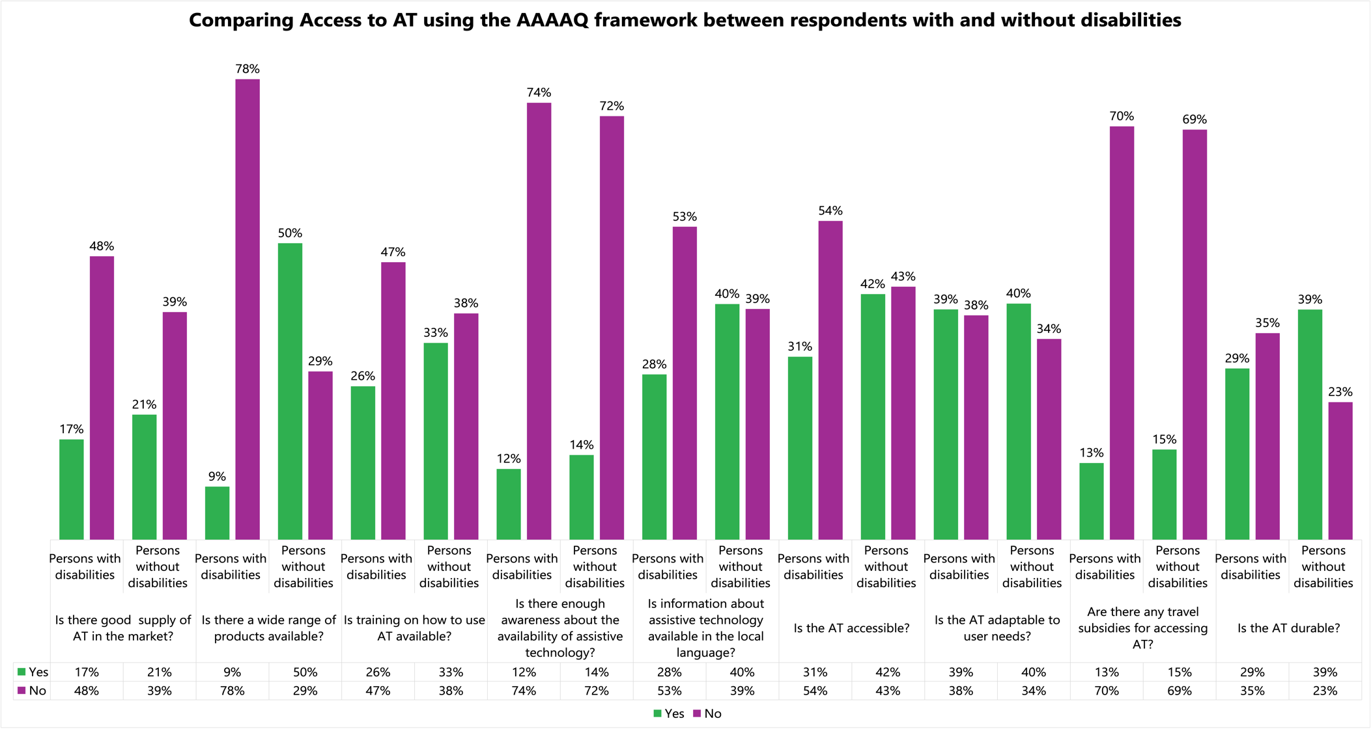
Figure 10: Comparing access to AT using the AAAAQ framework between respondents with and without disabilities

Comparing access to AT among AT users and Non-users
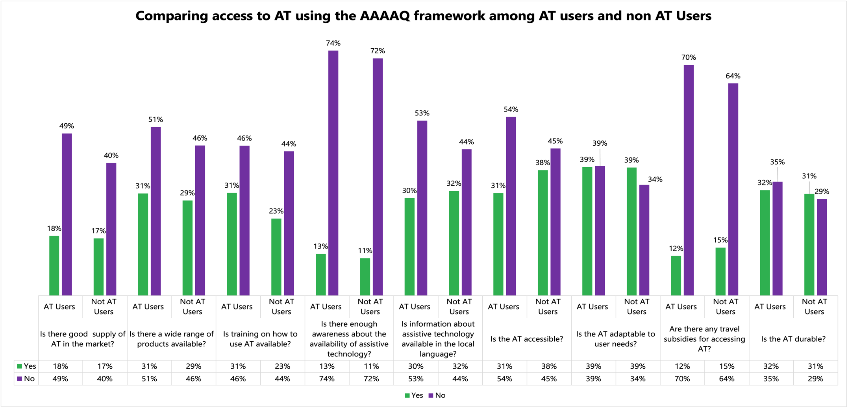
Figure 11: Comparing access to AT using the AAAAQ framework between AT Users and Non-Users
Comparing responses to questions drawn from the AAAAQ framework from AT users and non-AT users revealed two major findings:
Both study groups opined that there is not enough awareness about the availability of AT. Doubtfulness on the durability of AT and the lack of travel subsidies to access AT were also points of agreement.
There were significant differences in the way that the two groups evaluated:
  - The availability of AT
  - whether there is training on how to use AT
  - if information about it is available in the local language.

These findings indicate a significant collection of conclusions:
There is a prevalent need for AT
Access to AT is rated poorly both by current and potential users
Across study groups, the availability, accessibility, affordability, adaptability, and quality of AT are rated unsatisfactory, insufficient, and needing investment and course correction.
All study groups indicate a lack of awareness about the AT available in the market.

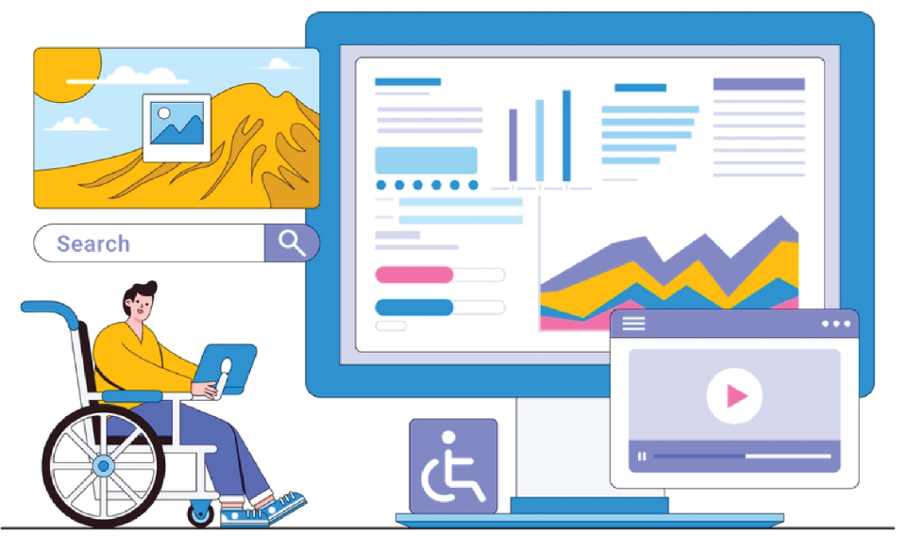

Is access to AT similar for AT users with and without disabilities?
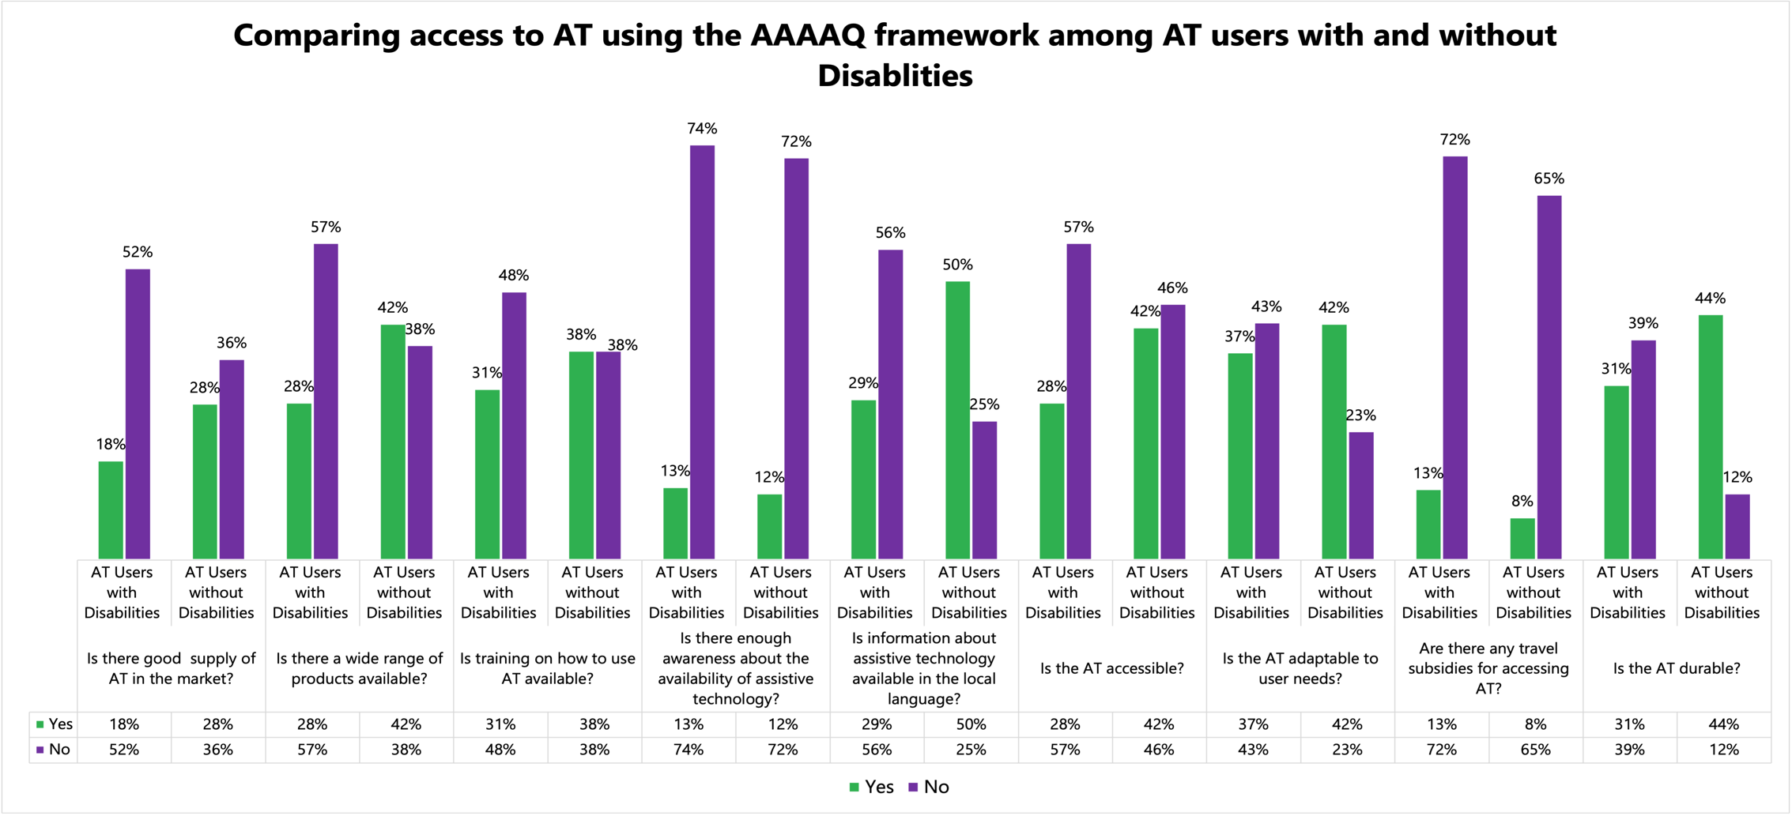
Figure 12: Comparing access to AT using the AAAAQ framework between respondents who are AT Users with and without disabilities
To gain a deeper understanding of the experience of respondents who were AT users, this group was further disaggregated into AT users who self-identified as persons with and without disabilities. An important consideration of this data analysis was that only 28 respondents (5%) within the AT user group identified as persons without disabilities. Examples of AT that are used by these respondents included: mobility aids such as wheelchairs, crutches, orthopedic devices; magnifying equipment; AAC; prostheses; and smart devices relying on cable and the internet. One interpretation of this data is that while these persons do not identify as having disabilities, a tool such as the Washington Group of Questions would capture them as having functional limitations. It is also a significant commentary on the self-identification of persons as being persons with disabilities, particularly those who acquire disabilities during their life cycle.
Of respondents who were AT users without disabilities, 11% reported being users of eyeglasses. This may explain the data that many AT users without disabilities reported that there was no training and that the AT was not durable. While AT users both with and without disabilities both broadly responded that there was not enough supply of AT in the market, the proportion of AT users with disabilities who believed that the supply was not enough was higher. Additionally, AT users without disabilities responded that information on AT was more widely available in local languages, which may be on account of the nature of the AT they were using being more popular or generally accepted.
In parallel, the discrepancy between experiencing functional difficulties and self-identifying as a person with disability/disabilities gives rise to an interesting question, whether persons without disabilities who use AT even identify as “AT users” and would find a survey such as this relevant to their lives.

Who spreads awareness about AT?
To assess the main actors in AT ecosystems across nations, the survey asked respondents to rate which organization or actor played the biggest role in raising awareness about AT. Both respondents who did and did not identify as persons with disabilities rated OPDs and NGOs as playing the chief role in spreading awareness about AT. This finding echoes the significant role that OPDs continue to play in the AT space. However, even this had key differences across the study groups. A larger proportion of respondents who did not identify as persons with disabilities (12%) shared the view that national governments helped spread awareness about AT, falling to 6% among those who identified as persons with disabilities. These proportions are summarized in two tree map charts in Figure 13.

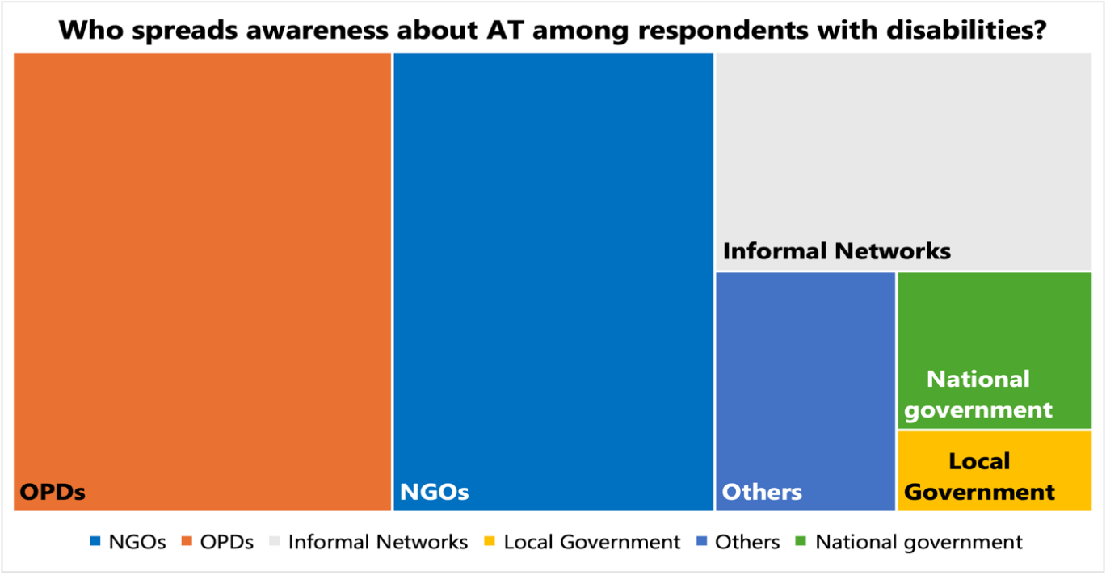
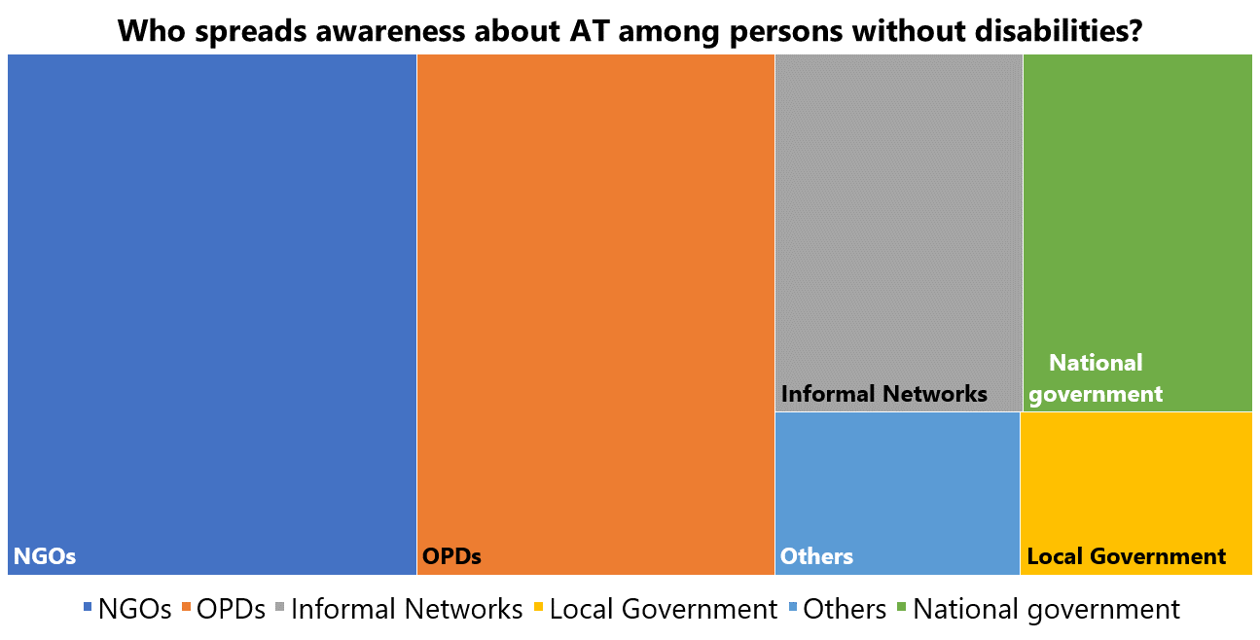
Figure 13: Who spreads awareness about AT among the respondents?
To investigate issues aside from awareness and availability, accessibility, adaptability, and quality, the survey asked respondents to select all major barriers to accessing AT.

What are the major barriers to accessing AT?
Both major study groups (respondents with and without disabilities) stated that the biggest barrier to accessing AT was a lack of local laws that protected access to AT. The second largest barrier indicated by both groups was the stigma associated with using AT. The third biggest challenge indicated by respondents in both study groups was that services that provide AT are not respectful of the cultures of minorities/peoples of all communities, indicative of a lack of acceptability. The groups also reported similarly that the fourth biggest barrier was that the available AT could not be modified, indicating that a lack of adaptability is a barrier. Figure 14 summarizes these findings.
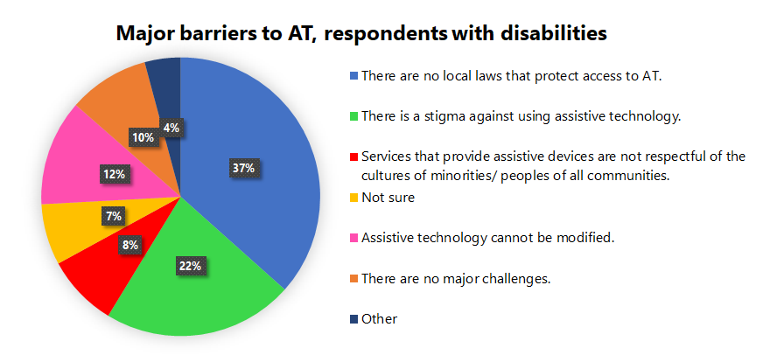
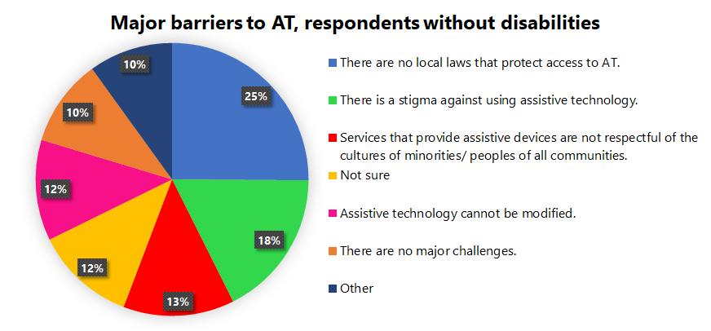
Figure 14 Major barriers to AT among respondents with and without disabilities

Barriers to AT: A Gender Perspective
A distinctive characteristic of the respondent set to this survey was an almost equal distribution of respondents who identified as male and female (see Figure 2a). To understand if barriers to AT varied greatly by gender we compared the responses from respondents who identified as male, female, and other.
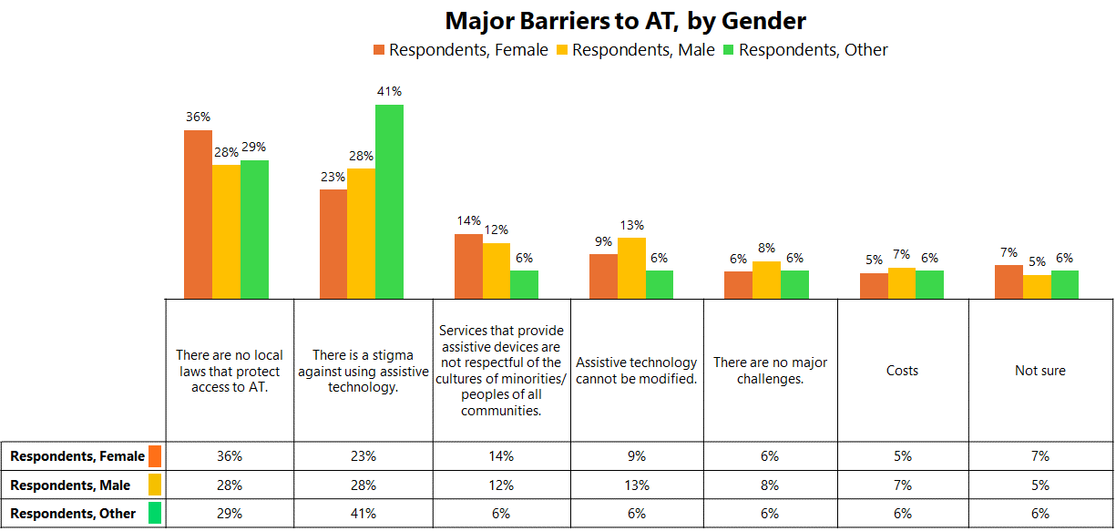
Figure 15: Major barriers to AT by Gender

The lack of local laws to protect AT access and the stigma associated with AT were rated as the highest barrier to AT by respondents of all genders, with a higher proportion of persons outside the gender binary reporting that stigma was a barrier. However, more female respondents (36%) than male (28%) indicated that the lack of local laws was a barrier. More female respondents (14%) also said that AT provision lacked respect for cultural and other needs, which is an indicator of acceptability, slightly higher than 12% of male respondents . The situation was reversed without any stark differences about the modification of AT as a barrier, i.e., a lack of adaptability, among other responses.
Those who responded 'Other' to the question on barriers were likely to detail that the high cost of AT was a barrier. This also did not vary among gender groups.

Spotlight study: Funding for AT
The financial barriers to AT was cited by many as an additional barrier to AT. This was additionally evidenced by the higher accessibility to AT indicated among persons with higher incomes, and the lower accessibility to AT indicated among persons with lower incomes.
To further explore the sources of funding for AT, an analysis was conducted of how both study groups, respondents who identified as persons with and without disabilities, perceived different sources of funding for AT.
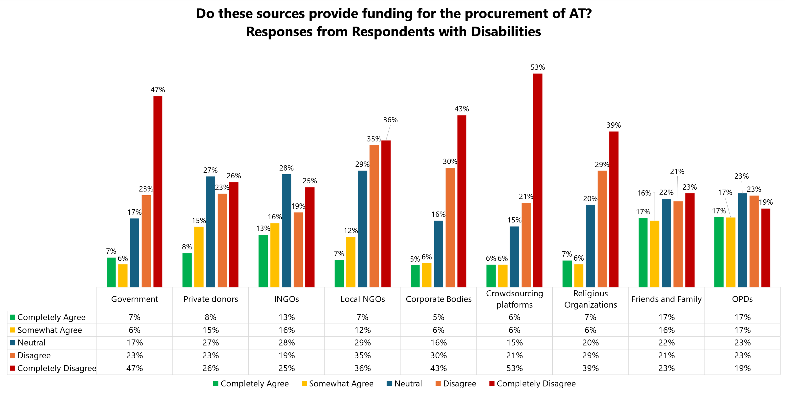
Figure 16 Sources of funding for the procurement of AT, respondents with disabilities
The sources of funding that respondents with disabilities felt most reliable were Organizations of Persons with Disabilities (OPDs) and their friends and families, with 17% of respondents completely agreeing with these as funding sources for AT. Respondents stated that the most unreliable sources of funding were crowdsourcing (53% of respondents indicating it was unreliable), the government (47% of respondents indicating it was unreliable) and corporate bodies (43% of respondents indicating it was unreliable).
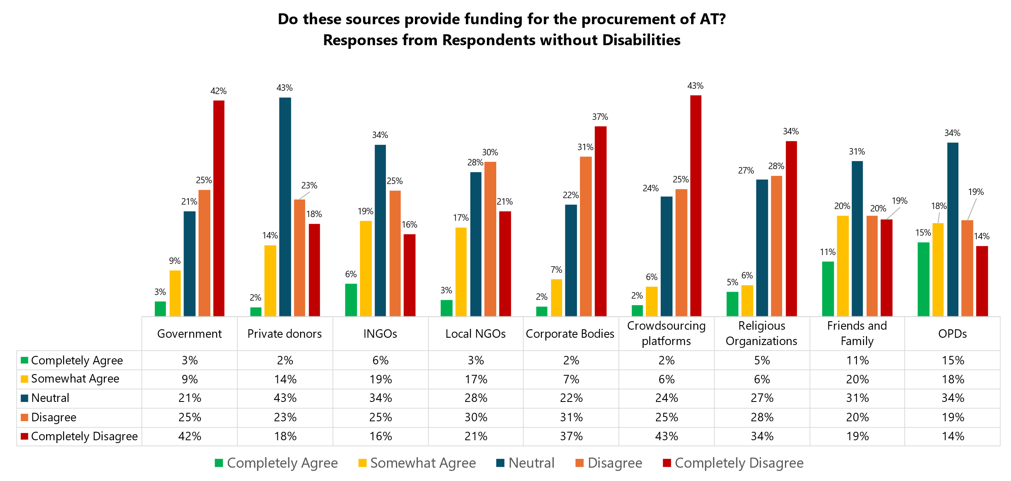
Figure 17 Sources of funding for the procurement of AT, respondents without disabilities

The results from respondents who did not identify as persons with disabilities were similar (2% marked ‘completely agree that they are reliable sources of AT’ for private donors, 3% for the government, 3% marked ‘completely agree that they are reliable sources of AT’ for local NGOs, 5% marked ‘completely agree that they are reliable sources of AT’ for religious organizations, 6% marked ‘completely agree that they are reliable sources of AT’ for INGOs), except with minor differences in the number of respondents who did not have strong feedback either way. Again, OPDs and friends and family were rated the best sources of funding, but the percentages of respondents who voted for these options were much lower (15% for OPDs and 11% for friends and family).
The survey questions asked respondents how much they agree with the potential of a few different sources of funding for the procurement of AT. The overall lower proportion of responses in the ‘completely agree’ category and the overall higher proportions of votes in the neutral and somewhat agree/disagree categories could be indicative of two aspects:
- a lack of general awareness about funding sources for AT among respondents without disabilities;
- a much lower trust in the overall sources for funding listed, evidenced by the low percentage of those who ‘completely agreed’ and the higher percentage of those who ‘completely disagreed.’
Additionally, both study groups spotlighted OPDs as the highest rated source of funding they ‘completely agree’ with (persons with disabilities: 17%, persons without disabilities 15%). This provided an insight into the financial role that OPDs play in the AT ecosystem, especially among AT users.

OPD Consultations
OPD consultations are an integral part of global and regional disability inclusion efforts, but in the context of AT, they must be treated as the foundation upon which good AT is built. Assistive technology is used by persons with and without disabilities of various ages, and OPD consultations during the process of AT development ensure that AT is accessible to diverse groups of current and potential users. OPDs are the representative voice of persons with disabilities and must be consulted in all matters concerning persons with disabilities (Article 4.3, CRPD), such as the development of policies around AT including those related to procurement, design and development of AT related services. In recent times, the CRPD Committee has also recommended States parties closely consult with OPDs on issues related to AT.In the 2nd IDA Global Survey on the participation of OPDs, despite 40% of OPDs reporting that they considered access to technology a priority area, only 35.5% of the OPDs were engaged on this issue with their Governments and only roughly 26% believed that their interventions had made any impact. To understand if and to what extent OPD consultations are a part of the AT ecosystem, the survey asked respondents if consultations with OPDs are done systematically and regularly, not just ad hoc. Respondents were asked to rate the frequency and quality of consultations out of 5. Figure 18 shows the distribution of ratings across respondents who identified as persons with and without disabilities.
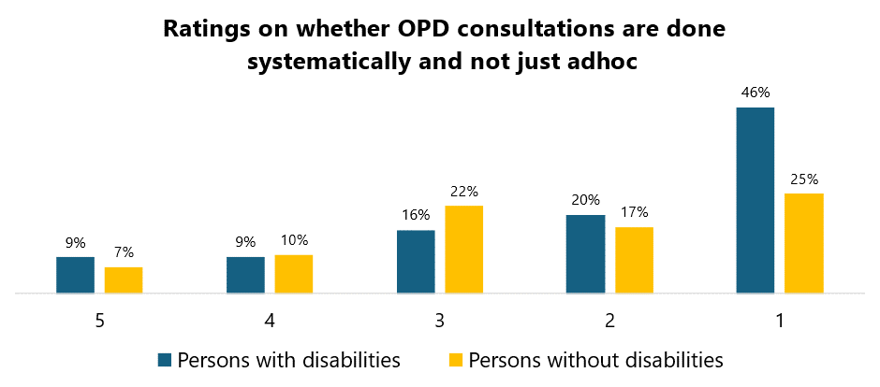
Figure 18 Distribution of ratings about OPD consultations from respondents who identified as persons with and without disabilities
Respondents with and without disabilities both rated the occurrence of systematic OPD consultations poorly (1 out of 5). However, the difference in the percentage of responses was the largest in that category, indicating a possible lack of awareness among respondents who were not persons with disabilities about how involved OPDs really are in AT processes.

Recommendations to improve AT access
Over 800 respondents shared recommendations for the improvement of AT access in their regional, national, and global contexts. Four major areas were highlighted, each offering several interventions: production and distribution, government actions, advocacy and capacity building, and coordinated actions across sectors.

 | Production & Distribution | - Improved raw material  - Local production of AT  - OPD consultations during design and production  - Increased innovation in AT, added variety based on user input  - Low-cost training for AT use  - Continuous support and assistance
 | Government Actions | - Subsidies for buying AT and for raw materials of AT  - Laws protecting access to AT  - Free or low-cost AT  - Government funding for localized AT production  - Increased visibility of persons with disabilities in the census to enable proper estimation of demand  - Increased language accessibility mandated and funded by government  - Increased inclusive education that includes AT use and education  - Removal of taxes on AT imports  - Localized information to improve access of AT for indigenous peoples  - Policy to regulate the quality of AT
 | Advocacy & Capacity Building Interventions | - Increased awareness about AT  - Capacity building in remote areas  - Capacity building among OPDs  - WHO interventions in reducing cost for AT
 | Coordinated efforts from all actors | - Inclusion and support from Private and Public Sectors  - Increase the number of jobs related to AT  - Use AT in capacity building efforts for persons currently under institutionalization to prepare them for community living

The list of recommendations presented is a consolidated list from over 800 responses generated in 4 different languages across the world. The congruous nature of these recommendations enabled them to be grouped into these focus areas despite the vast geographies and heterogenous population of respondents they represented, which was indicative of the converging needs of AT users across the globe, and especially in LMICs.

Learnings & Next Steps
The AT User Survey collected a diverse range of data that assessed AT using the AAAAQ, seeking to understand the most common and useful sources of funding for AT, and most importantly, aimed to collect data on which groups of persons with disabilities had the least access to AT and were underrepresented in the gamut of decision makers, as well as beneficiaries of AT policy and design. With the data collected, our next steps will be to analyze responses to collect this information.
Additionally, the survey focused on understanding the intersectional lived experiences of respondents, such as being in situations of humanitarian crises, or belonging to an indigenous or ethnic minority, among other considerations. Analyzing the dataset for these perspectives will also illumine intersectional perspectives on the prevalent and potential need for AT and its critical role.
While the AT survey garnered over a thousand responses that provided a rich, diverse, abundant source of data, and perspectives and acted as a basis for consultation with a set of wide-ranging respondents, there was one group that was not as represented. Elderly respondents were poorly represented (0.21% above the age of 76, see Figure 2). Next steps must involve ways to include persons of this age group in the survey methodology.
The way in which respondents interpreted the self-identification of persons with disabilities in this survey (see Is access to AT similar for AT users with and without disabilities) threw light on the understanding of the concept of disability and also specific impairment groups. AT Stakeholders could use tools such as the Washington Group Set of Questions to identify potential and current users of AT without having to consider this issue of self-identification.
Lastly, while the survey gathered a sizeable set of responses, it represents a minute portion of the total number of current and potential AT users. Only well-resourced studies by multiple actors will help build a stronger and more applicable database.

Reflections
The AT survey was created to build a body of evidence that would help focus AT advocacy action efforts. Often, persons with disabilities are not regarded as equal stakeholders in the AT ecosystem, due to various reasons including but not limited to the assumption that they have inadequate exposure and understanding of AT. IDA and GDI Hub’s research methodology focused on building a process that iteratively combined capacity building, and research efforts to better ensure informed and effective participation in the survey. This inclusive and participatory model of consultation and research was a significant success, evidenced by the deep and nuanced feedback and recommendations from respondents. Further, it provided undeniable evidence of the fact that with adequate investment and accessibility, persons with disabilities, and current and potential AT users could all participate meaningfully in exploratory, non-exclusionary research and play their parts in a bigger ecosystem. They have a nuanced, comprehensive outlook on AT in its many roles: as a human right, a consumer good, and a booming industry within the context of their national administrations and local economies.
Additionally, respondents recognize that AT plays a unique role in the need for multi-sectoral collaboration within both the national and international contexts. Their recommendations provide actions across sectors that address issues at all levels, from awareness and capacity building at the grassroots level to legal harmonization of protecting access to AT, from financing AT to systems of import, manufacture, and supply chain systems of AT: all interlinked components of an extensive, integrated AT strategy and ecosystem.
Lastly, the most striking reflection on these findings reaffirms the disability movement’s core truth: persons with disabilities can function as equitable stakeholders in decisions made for and about them when they are not denied access to the authority and capacity to do so, and assistive technology is no exception.

Annex 1 Tables
- Overall Respondents
  - Global Regional Distribution of respondents
Region | Percentage of Respondents
African Regions | 31%
European Regions | 28%
Latin America and Caribbean | 27%
Asian Regions | 23%
Oceania | 5%
North American regions | 2%
  - Countries represented in the survey by respondents
Afghanistan | Costa Rica | Iceland | Nepal | Somalia
Åland Islands | Côte d'Ivoire (Ivory Coast) | India | New Zealand | South Africa
American Samoa | Democratic Republic of the Congo | Indonesia | Nicaragua | South Sudan
Argentina | Denmark | Iraq | Niger | Spain
Australia | Ecuador | Ireland | Nigeria | Sri Lanka
Austria | Egypt | Italy | North Macedonia | Sweden
Bangladesh | El Salvador | Japan | Norway | Switzerland
Belgium | Ethiopia | Jordan | Pakistan | Tajikistan
Benin | Fiji | Kenya | Panama | Tanzania
Bosnia and Herzegovina | Finland | Lebanon | Paraguay | Thailand
Botswana | France | Lesotho | Peru | Togo
Botswana | Gambia | Liberia | Philippines | Trinidad and Tobago
Brazil | Germany | Lithuania | Portugal | Tunisia
Burkina Faso | Ghana | Luxembourg | Qatar | Turkey
Burundi | Greece | Malawi | Romania | Uganda
Cambodia | Guatemala | Mali | Rwanda | Uruguay
Cameroon | Guinea | Malta | Samoa | USA
Canada | Guyana | Mexico | Saudi Arabia | Venezuela
Chad | Haiti | Moldova | Senegal | Zambia
Chile | Honduras | Morocco | Sierra Leone | Zimbabwe
Colombia | Hungary | Mozambique | Slovenia
- Respondents who identified as persons with disabilities
  - By Gender
Male | 54%
Female | 44%
Prefer not to say | 1%
Other | 1%
  - By Age group
18 to 35 | 51%
36 to 50 | 32%
50 to 65 | 16%
66 to 75 | 1.93%
76 and older | 0.14%
  - Identifying as an ethnic minority
Yes | 30%
No | 63%
Maybe | 7%
  - Identifying as an Indigenous person
Yes | 29%
No | 64%
Maybe | 6%
  - Area
Urban area | 69%
Rural area | 18%
Suburban area | 13%
  - Types of Disabilities
A person with Physical Disabilities | 34%
A person with Visual Disabilities | 16%
A person with Intellectual Disabilities | 10%
A Deaf person | 10%
A person who is hard of hearing | 3%
A person with psychosocial disabilities | 2%
A person with cerebral palsy | 2%
An autistic person | 2%
A person with albinism | 1%
A deafblind person | 1%
A person with multiple disabilities | 12%
Prefer not to say | 2%
Other | 6%
  - Rating access to AT for different groups of persons with disabilities
Rating the ease of access to AT | For Men | For Women | For Other genders | For Youths | For Middle-aged persons | For Elderly persons | For Low-income persons | For High-income persons | For persons in rural areas | For persons in urban areas
Very easy to access | 16% | 13% | 13% | 15% | 12% | 14% | 12% | 43% | 13% | 16%
Easy to access | 16% | 12% | 10% | 14% | 12% | 10% | 6% | 25% | 6% | 20%
Neutral | 28% | 22% | 18% | 28% | 27% | 18% | 7% | 17% | 13% | 34%
Hard to access | 21% | 25% | 21% | 22% | 28% | 23% | 18% | 6% | 21% | 18%
Very hard to access | 18% | 28% | 37% | 22% | 21% | 36% | 57% | 9% | 48% | 12%
- Respondents who did not identify as persons with disabilities
  - By gender
Male | 34%
Female | 65%
Prefer not to say | 1%
  - By age group
18 to 35 | 30.4%
36 to 50 | 38.4%
50 to 65 | 24.5%
66 to 75 | 6.3%
76 and older | 0.4%
  - Identifying as an Indigenous person
Yes | 35%
No | 62%
Prefer not to say | 3%
  - Area
Urban area | 75%
Suburban area | 14%
Rural area | 11%

  - AT used
Glasses | 40%
Miscellaneous improvised devices | 11%
Walking stick | 8%
Large print | 6%
Wheelchair | 6%
Computer | 5%
Smartphone | 5%
Closed captioning | 5%
None | 5%
Braille software | 3%
Screen readers | 3%
Medicines | 2%
CPAP | 2%

Annex 2
Simple T-test results on AAAAQ framework, comparing means among respondents with and without disabilities who responded ‘Yes’ to questions.

t-Test: Two-Sample Assuming Unequal Variances
 | 121 | 50
Mean | 169.5 | 78.875
Variance | 6206.57143 | 806.125
Observations | 8 | 8
Hypothesized Mean Difference | 0
df | 9
t Stat | 3.06090953
P(T<=t) one-tail | 0.00677584
t Critical one-tail | 3.24983554
P(T<=t) two-tail | 0.01355168
t Critical two-tail | 3.68966239

Interpretation
Means:
The mean of the first group (with 8 observations) is 169.5.
The mean of the second group (also with 8 observations) is 78.875.
Variances:
The variance of the first group is 6206.571429.
The variance of the second group is 806.125.
Hypothesized Mean Difference:
The t-test assumes a hypothesized mean difference of 0.
Degrees of Freedom (df):
The degrees of freedom for the t-test are 9.
t Statistic:
The calculated t-statistic is 3.06090953.
One-Tail and Two-Tail p-values:
P(T<=t) one-tail (probability of getting a t-value as extreme as observed, assuming the null hypothesis) is 0.006775839.
P(T<=t) two-tail (probability of getting a t-value as extreme or more extreme than observed) is 0.013551678.
t Critical Values:
The t critical value for a one-tailed test at a 5% significance level (df=9) is 3.249835542.
The t critical value for a two-tailed test at a 5% significance level (df=9) is 3.689662392.
Interpretation:
The t-statistic (3.06090953) is greater than the critical value for both one-tailed and two-tailed tests.
The p-values are relatively small, indicating evidence against the null hypothesis.
Conclusion:
We reject the null hypothesis.
There is evidence to suggest that the means of the two groups are significantly different.
The direction of the difference (greater or smaller) can be inferred based on the sign of the t-statistic.
In summary, the t-test indicates a significant difference between the means of the two groups, and this difference is unlikely to have occurred by random chance alone.

Simple T-test results on AAAAQ framework, comparing means among respondents with and without disabilities who responded ‘No’ to questions.

t-Test: Two-Sample Assuming Unequal Variances
 | 343 | 91
Mean | 407.625 | 106.25
Variance | 13755.6964 | 1454.78571
Observations | 8 | 8
Hypothesized Mean Difference | 0
df | 8
t Stat | 6.91163391
P(T<=t) one-tail | 6.1538E-05
t Critical one-tail | 3.35538733
P(T<=t) two-tail | 0.00012308
t Critical two-tail | 3.83251869

Interpretation
Means:
The mean of the first group (with 8 observations) is 407.625.
The mean of the second group (also with 8 observations) is 106.25.
Variances:
The variance of the first group is 13,755.69643.
The variance of the second group is 1,454.785714.
Hypothesized Mean Difference:
The t-test assumes a hypothesized mean difference of 0.
Degrees of Freedom (df):
The degrees of freedom for the t-test are 8.
t Statistic:
The calculated t-statistic is 6.911633908.
One-Tail and Two-Tail p-values:
P(T<=t) one-tail (probability of getting a t-value as extreme as observed, assuming the null hypothesis) is very small: 6.15381E-05 (or 0.0000615381).
P(T<=t) two-tail (probability of getting a t-value as extreme or more extreme than observed) is also very small: 0.000123076 (or 0.000123076).
t Critical Values:
The t critical value for a one-tailed test at a 5% significance level (df=8) is 3.355387331.
The t critical value for a two-tailed test at a 5% significance level (df=8) is 3.832518685.
Interpretation:
The t-statistic (6.911633908) is much greater than the critical value for both one-tailed and two-tailed tests.
The p-values are very small, indicating strong evidence against the null hypothesis.
Conclusion:
We reject the null hypothesis.
There is strong evidence to suggest that the means of the two groups are significantly different.
The direction of the difference (greater or smaller) can be inferred based on the sign of the t-statistic.
In summary, the t-test indicates a highly significant difference between the means of the two groups, and this difference is unlikely to have occurred by random chance alone.

Availability, Accessibility, Acceptability, Adaptability, Quality
https://www.wethe15.org/
https://unlocktheeveryday.org/
a system or network of interconnecting and interacting parts
Original quote was in French, English translation: “My first recommendation is to have leaders of the movement of persons with disabilities respected by their governments”
Also see IDA’s Quarterly AT Digest Issue 1 https://www.internationaldisabilityalliance.org/sites/default/files/documents/at_digest_issue_1_final.pdf
Fernández-Batanero, J.M., Montenegro-Rueda, M., Fernández-Cerero, J. et al. Assistive technology for the inclusion of students with disabilities: a systematic review. Education Tech Research Dev 70, 1911–1930 (2022). https://doi.org/10.1007/s11423-022-10127-7; Sauer, A. L., Parks, A., & Heyn, P. C. (2010). Assistive technology effects on the employment outcomes for people with cognitive disabilities: A systematic review. Disability and Rehabilitation: Assistive Technology, 5, 377–391
IDA understands the term “underrepresented groups” to be those among persons with disabilities who enjoy less visibility in decision-making processes. The disability movement, like other social movements, is not homogenous. Some groups have traditionally been less included in participatory processes, harder to reach, or that face higher barriers to participation, such as persons who are deafblind, persons with intellectual disabilities, persons with psychosocial disabilities, autistic people, deaf people, and hard of hearing people. It can also include those who may be less engaged in decision-making, such as women, children, older people, and indigenous persons, as well as people from diverse faith, ethnicity, caste, class, sexual orientation or gender identity minorities. This understanding may differ in different countries, cultures and contexts.
https://tinyurl.com/GDS-IDA
https://www.ohchr.org/en/documents/general-comments-and-recommendations/general-comment-no-4-article-24-right-inclusive
https://www.ohchr.org/en/resources/educators/human-rights-education-training/e-general-comment-no-14-right-highest-attainable-standard-health-article-12-2000
https://www.internationaldisabilityalliance.org/sites/default/files/full_ida_global-survey-2022-final.pdf p. 55
The group other also included those who picked ‘preferred not to say’ against the question about gender.
https://www.un.org/development/desa/disabilities/convention-on-the-rights-of-persons-with-disabilities/article-4-general-obligations.html
Also see reference 6 about AT Digest on CRPD jurisprudence
https://www.internationaldisabilityalliance.org/sites/default/files/full_ida_global-survey-2022-final.pdf Page 47
https://hhot.cbm.org/en/card/washington-group-questions

