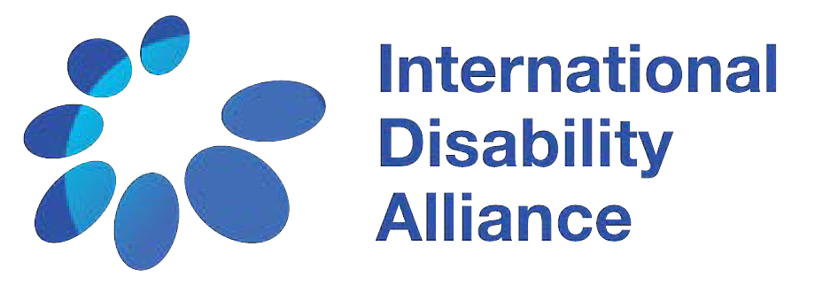

São Paulo, Brazil 22 - 24 October 2015
Advancement of the
UN
the
CRPD through
2030
Agenda
Towards Implementation in
Latin America

Conference Report

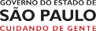supported by

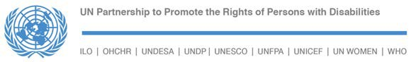

International Disability Alliance

150 route de Ferney, PO Box 2100 CH 1211 Geneva 2, Switzerland
Telephone: +41 (0)22 788 42 73

205 East 42nd Street New York, NY 10017
Telephone: +1.646.776.0822 info@ida-secretariat.org
www.internationaldisablityalliance.org

Contents
Summary 4
Welcome 5
Introduction 7
Panel One: From Needs to Rights: Implementing the UN CRPD
at the Regional Level, Particularly in Latin America 7
Panel Two: The 2030 Agenda for Sustainable Development and
the Rights of Persons with Disabilities 10
Workshops:
- Women and Girls with Disabilities 11
- Children and Youth with Disabilities 12
- Indigenous Persons with Disabilities 13
- Situations of Risk and Humanitarian Emergencies 15
- Employment and Social Protection 16
- Education 17
- Living Independently and being Included in the Community 18
Panel Three: Global Indicators, National Data and Statistics, Data Partnership 19
Panel Four: Regional and Global Coordination and the Role of
Stakeholders Towards Implementation 21
Looking Ahead: High-Level Political Forum, Global Reporting Mechanism, and Engagement of DPOs through Regional and Global Coordination 24
São Paulo Political Declaration 25
List of Participants 30

Summary

This report summarizes the first Regional Conference of Latin America and the Caribbean “Advancement of the UN CRPD through the 2030 Agenda: No-one left behind”, carried out by the International Disability Alliance (IDA) with the support of the United Nations Partnership for the Promotion of the Rights of Persons with Disabilities (UNPRPD), the São Paulo State Secretariat on the Rights of Persons with Disabilities and the United Nations Children’s Fund (UNICEF) in São Paulo, Brazil from the 22 to 24 October 2015.

The Conference brought together over 100 participants, from organisations of persons with disabilities(DPOs), government representatives, and recognized experts.

This first session consisted of two blocks: the first included welcoming speakers followed by an introduction to the Conference theme, and the second block consisted of two panel discussions.

Welcome
The welcoming session was chaired by Volmir Raimondi, President of the Latin American Blind Union. Participants included:

- Maryanne Diamond, Chair of the International Disability Alliance
- Rosangela Berman Bieler Chief, Disability Unit, UNICEF and Representative of the UN Partnership to Promote the Rights of Persons with Disabilities
- Ana Lucia Arellano, President of Latin American Network of Non-Governmental Organisations of Persons with Disabilities and their Families (RIADIS)
- Linamara Rizzo Battistella, São Paulo State Secretary for the Rights of Persons with Disabilities.
- Catalina Devandas, UN Special Rapporteur on the Rights of Persons with Disabilities
- Maria Soledad Cisternas Reyes, Chair, CRPD Committee shared their messages through video.

The participants thanked IDA for the organization of the Conference and for the several strategic gains IDA had helped in achieving with the movement since the adoption of the UN CRPD.
It was noted that it was a key moment to open up dialogue for strategic, coordinated and co-operated work.
Interventions highlighted the approaching ten year anniversary of the adoption of the UN CRPD, which would not have been possible without the active participation of DPOs.

In the discussion, reference was made to the 2030 Agenda, which was recently approved in New York, and to the importance of working across all aspects of the 2030 Agenda in order to improve implementation of the UN CRPD.

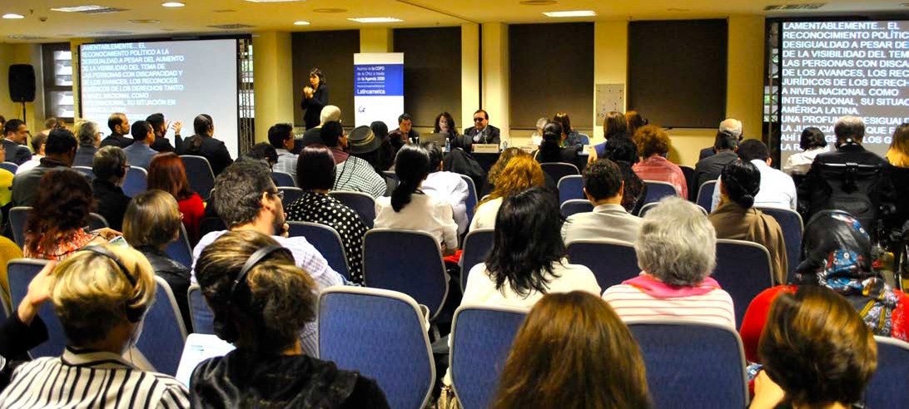
Participants during plenary session of the Sao Paulo Conference

Participants emphasized the fact that the Agenda has seven concrete references to persons with disabilities, and the importance of developing compliance indicators at global and national levels.

It was highlighted that, since the adoption of the UN CRPD, the world is witnessing a rapid change and greater commitment from the international community, reflected in actions such as the appointment of the Special Rapporteur on the Rights of Persons with Disabilities.

The Latin American region is characterized by sharp inequalities which call for the urgent equal and just participation in decision making processes. It is expected that the implementation of the 2030 Agenda enables an advance to justice.

The speakers encouraged the participation and action of different actors, across all levels in the region, and highlighted the need to move forward in the search for equal opportunities to participate.

The interveners underscored the importance of sharing experiences and networks, and mentioned the importance of producing data—highlighting examples of several
projects that had been developed to obtain reliable data.

Interveners also mentioned the importance of the UN CRPD, including related projects in 23 countries and their concrete impact on strengthening agendas for the rights of persons with disabilities.

Rosario, an 18-year-old woman from the “New Voices, New Challenges” programme was invited to represent the many young people who had demonstrated through action the importance of their involvement and participation. Lucas, also a member of the programme, shared a sign that the group created to express “we are all united, we are all included.”

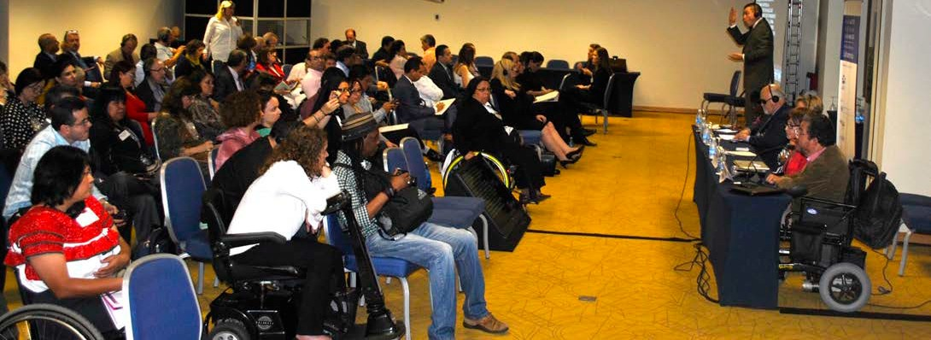
Plenary Session of the Sao Paulo Conference

Introduction to the Conference theme
The session continued with presentations from Vladimir Cuk, IDA’s Executive Director, and Tchaurea Fleury, a Senior Adviser with IDA.

In the session, the agenda and methodology of the Conference were explained:
The plenary conclusions of the workshops were to be presented by a spokesperson appointed by the participants, with the aim of illustrating how the Agenda could be used, in relation to the issues of each workshop, to promote the rights of persons with disabilities and improve the implementation of UN CRPD.

The importance of drafting a declaration as a final outcome, to be adopted on the morning of Saturday 24 October, was highlighted. The Nairobi Declaration was mentioned as a successful example to follow.

In relation to the Declaration it was said:
  - That the objective is that the declaration could be useful for the advocacy work with national and local governments in order to reach the objectives of the UN CRPD and the 2030 Agenda.
  - That the text of the Declaration should appeal to the participation and the responsibility of everyone.
  - That,forpracticalreasons,arepresentative drafting group of seven to nine people would be appointed to guarantee that no one is excluded, facilitated by Colin Allen as an IDA Board Member, and Tchaurea Fleury, and supported the decelaration writing process.
- Finally, that this draft document of the Declaration would be shared with everyone on Saturday 24 October during the morning. In that way, everyone would be able to formulate their observations and adopt by consensus a final document.

Panel One
From Needs to Rights:
Implementing the UN CRPD at the Regional Level, Particularly in Latin America
This panel was moderated by Liliana Peñaherrera, Sociedad Peruana de Síndrome de Down. The speakers were Carlos Rios Espinosa, ex Member of the UN CRPD Committee; Raquel Jelinek, Regional Representative for the Americas, Inclusion International; Yannis Vardakastanis, President, European Disability Forum and Rachel Kachaje, Former Minister of Disability and Elderly Affairs, Malawi.
All the panellists thanked IDA for the initiative and the invitation.
Carlos Rios Espinosa opened the panel, presenting a “Summary of Concluding Observations from the Nine Latin America Countries Reviewed Thus Far.” Ríos mentioned that the countries examined by the UN CRPD Committee were Argentina, Brazil, Costa Rica, Ecuador, El Salvador, Mexico, Paraguay, Peru and the Dominican Republic. He highlighted common issues

to all of them. Among others, the lack of integration of the UN CRPD in the national legal frameworks, situations of multiple discrimination, the lack of adequate anti- discrimination legislation, the insufficient promotion of awareness-raising about rights, deficient accessibility, the lack of attention to people in situations of risk and humanitarian emergencies, the barriers to access to justice, the absence of a model that bans substitutive decision-making and contributes to supported decision-making, the lack of protection of personal freedom, the prevalence of forced treatments without respecting personal autonomy, the inappropriate implementation of Article 19 of the UN CRPD, the absence of policies for supporting persons with disabilities in the family and the existence of practices that are incompatible with the realization of this right, the denial of participation, and the weakness of the national bodies in implementation and monitoring the UN CRPD.

To conclude, he reinforced the need to demand of governments that the slogan
¨Nothing About Us, Without Us¨ must become effective.
Raquel Jelinek presented the “Case Study: Lessons-Learned from the UN CRPD Committee Review of Peru.” The speaker explained the reasons why IDA chose Peru to analyse the implementation of the recommendations made by the UN CRPD Committee, highlighting that it was the first developing country reviewed by the Committee. She also pointed out that Peru immediately endeavoured to implement those recommendations.

The work done by civil society produced significant social changes in a short amount of time: this set a good example for other countries in the region. The goals of the mission were: a) to follow up on the recommendations made by the Committee to Peru, b) to assess the real impact of these actions in citizens’ lives, and c) to carry out the review in the framework of other United Nations mechanisms (such as other treaty bodies and the Universal Periodic Review).
She mentioned different actions, meetings withseveralimportantactors,theorganization of working groups, and the social impact of those actions. She emphasized two themes: legal capacity and inclusive education. She highlighted IDA’s support in the revision

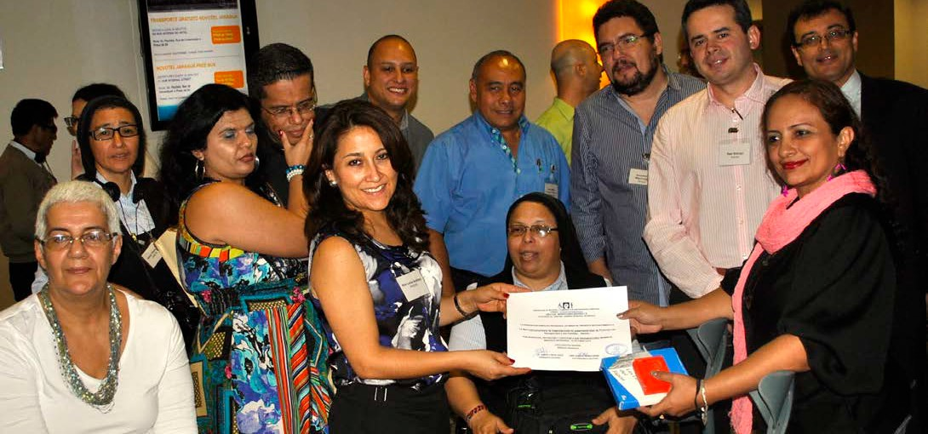
RIADIS and FEMUCADI Nicargua Members

of the civil code—one of the most urgent and complex changes needed—and commended IDA’s commitment, reflected in their country-level support, both in form and content, in submitting information to the United Nations, and to improve with other experiences that can serve as example.

She concluded by pointing out how IDA shared its experiences during the mission, underlining the need to seek justice and equal opportunities, the need to eradicate confinement of persons with disabilities, and to discourage the use of “they and us” narratives - since we are all part of the same humanity.

The third speaker was Yannis Vardkastanis, who addressed the issue of “Sharing Regional Experiences: European Disability Forum Advocacy in the European Union— Ratification and Monitoring.” He highlighted the importance of this meeting for the recent adoption of the 2030 Agenda, and he reminded the audience that nine years ago the adoption of the UN CRPD created similar challenges that forced the movement of persons with disabilities to develop new strategies at different levels to promote inclusion. He explained that the European Disability Forum is an umbrella organization, integrating more than 100 DPOs which function across every member state of the European Union, representing more than 8 million persons with disabilities. He also discussed how the European Union—an intergovernmental and regional organization for economic, political and social integration—ratified the UN CRPD in December 2010. The European Disability Forum had a very active role in this ratification process and has since been working intensely to integrate the UN CRPD in a cross-cutting manner into legislation, policies and European programmes. He mentioned the budgets and means of
implementation had been achieved not only in public finances but also in relation to private finances. He also discussed how the European Union had been examined for the first time by the UN CRPD Committee about progress on implementing the Convention.

The Committee issued its final observations last September, and gave recommendations to the European Union to adopt measures to improve their policies, legislation, and action about freedom of movement, non- discrimination, independent life, education, employment, legal capacity, access to justice, freedom, security and health. These recommendations are useful to establish priorities in the movement’s actions in the coming years regarding the European Union. To conclude, he said that the movement needs to build alliances to utilise available financing sources.

The fourth speaker was Rachel Kachaje who presented “Lessons-learned from the 2014 IDA-UN PRPD Africa Conference in Nairobi, Kenya.” The speaker made reference to the Nairobi Declaration and its importance as a tool in advocacy work in Africa. She also affirmed that the production of and access to information was a central theme in the Conference which was reflected in the Declaration. She remarked on the importance of dialogue between all stakeholders, with the necessary participation of NGOs and DPOs in the discussions of all governmental areas, and emphasized the need for disability to work in a cross-cutting way. She suggested that governments need to be principal allies and are essential to achieving change towards inclusion. She concluded her presentation by pointing out the need for implementation of the Sustainable Development Goals to ensure policies make real changes in the lives of persons with disabilities, as well as the inclusion of the Declaration goals.

Panel Two
The 2030 Agenda for Sustainable Development
and the Rights of Persons with Disabilities
Natalia Mattioli, UN Partnership to Promote the Rights of Persons with Disabilities, was the moderator of this panel, which included Vladimir Cuk, Executive Director, International Disability Alliance (IDA); Priscille Geiser, Chair, International Disability and Development Consortium (IDDC); and Catherine Townsend, Wellspring, as speakers.

This panel was opened by Vladimir Cuk, who spoke about “The Inclusion of Persons with Disabilities in Agenda 2030.” He started by discussing the present situation, and how IDA approached the process leading to the 2030 Agenda: when they found out that there would be a new process to develop the Sustainable Development Goals (SDGs), and given that the Millennium Development Goals (MDGs) had not mentioned persons with disabilities, IDA decided that this exclusion must not happen again, so the consultation, participation and negotiation process began with the aim of inclusion.

As a result of this participation, the process resulted in seven specific mentions of persons with disabilities in the 2030 Agenda, covering issues of education, employment, public spaces, inclusive cities, inequalities,
and data disaggregation. He remarked that the greater visibility persons with disabilities will receive with this inclusion, and suggested there will be a change of narrative, so that persons with disabilities would no longer be excluded from development programmes. This change implies new responsibilities for the movement and for governments. He also mentioned the need to create indicators to measure progress of the implementation of the Goals and targets, starting with today’s current situation as a baseline. He emphasised that disability has never been an official part of any previous development commitment. Now that this opportunity exists, it requires the movement to use the 2030 Agenda to reinforce implementation of the UN CRPD.

Priscile Geiser discussed “The role of disability and development organisations in the implementation of the 2030 Agenda.” She explained how IDDC is composed of 28 non-governmental organizations that promote inclusive development, with particular focus on the fulfilment of the rights and full participation of persons with disabilities. Both IDDC and IDA Members had a very important role in all the ‘Post- 2015’ process that led to the 2030 Agenda. Beyond celebrating the accomplishment, what will follow is the need to transform all of these commitments into action. In this regard, there are risks and challenges in this move to an ‘action phase’, such as overcoming the lack of knowledge at national and local level on implementation, and the limited collaboration between government and civil society. It is important that civil society continues to have an active advocacy role in implementing the 2030.

Geiser suggested that every organization now adjust their practices to incorporate this new framework, and that there is a need to collectively strengthen and share

information, network, coordinate abilities, keep high standards, gather and optimize the use of data to monitor, reinforce and advocate for implementing both the UN CRPD and the Sustainable Development Goals, and include all persons with disability in every level.

Catherine Townsend addressed “The role of donors in the implementation of Agenda 2030.” She discussed how the UN CRPD is a binding instrument and, as with the 2030 Agenda, donors have a very specific role. Persons with disabilities need to be active and monitor what happens at national levels. Donors need to build capacity, know what needs to be modified, and get to know situations better. Strong advocacy is needed, and it will only happen with civil society’s action, and with everyone’s commitment.

She emphasised that it is important to be aware of situations on the ground, and monitor the situation of children with disabilities, for example, concerning quality inclusive education. DPOs can make sure that this happens: their role is very important.
She suggested that it was possible to increase influence and gather more funding, while explaining how it should be used. For this, more data and evidence would be needed to show whether persons with disabilities are included in the programmes or not. DPOs need to be involved in programmes at national and local levels, and donors need the support of DPOs to get to know the issues bette.

Seven thematic parallel workshops took place in the afternoon and the following morning. They provided the opportunity to share ideas and specific initiatives of the different member states, UN agencies, and national teams relevant for the issues dealt by each each workshop.

Workshop 1
Women and Girls with Disabilities
Facilitator: Natalia Santos Estrada, Colectivo Chuchan A.C.
Speakers: Maryanne Diamond, Chair, International Disability Alliance (IDA), Advocating for women and girls with
disabilities in the international arena; Cristina
Francisco, Women with Disabilities Circle, Inc., CIMUDIS Advocating for women and girls with disabilities at national and sub- regional levels.; Antonia Irazabal and Fatma Wangere Experiences of indigenous women and girls in Latin America.; Maria Camila Lozano Inter-American Institute on Disability and Inclusive Development (iiDi)

Plenary
- Sexual and reproductive rights for girls and women with disabilities are far from being fulfilled. It was highlighted that when a woman wants to practice her right to maternity, she is questioned and mistreated.
- This was linked with the lack of access to health services, health information and to different regular examinations, such as mammographies or gynaecological tests.

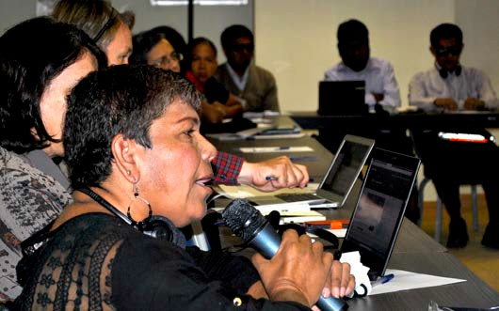
Workshop participants

- Violence is prevalent in the different domestic spheres, in interaction with caregivers and in institutional settings. The lack of data on the issue was emphasized. Regarding programmes that aim to eradicate violence, it was highlighted that they are not designed from a diversity perspective. None of them are offered in an accessible way.
- Discrimination in the labour market was particularly emphasised. It was said that this has its root in the lack of access to education and that it is more evident in rural areas.
- Legal capacity was discussed, with focus on how to strengthen and support organizations of women with disabilities.
- Outcome: there was an agreement about a) the need to take these issues to women’s organizations that have not yet incorporated a disability perspective;
b) involve men so they can also visualize the barriers; and c) carry the voices of women with disabilities to every possible public space. It was proposed to include the theme in the Economic Commission for Latin America and the Caribbean (ECLAC) meeting in Uruguay and reinforce the communication between Africa and Latin America, with the goal of
getting feedback on good practices.
Workshop 2
Children and Youth with Disabilities

Facilitator: the workshop was moderated by the iiDi team: Natalia Farías, Hailey Fox and Sergio Meresman with support of Mario Volpi, Unicef Brasil and the Viraçao group, Civil Society Organization of Brazil, supported by UNICEF.

Speakers: Maria Camila Ramirez, Inter- American Institute on Disability and Inclusive Development (iiDi) ; Lola Martin Villalba, Spanish Cooperation on Youth and Disability, United Nations Population Fund (UNFPA)
Presentation of the UNFPA Spanish Cooperation on Youth and Disability: “Policies of social inclusion, gender equality, non discrimination and prevention of sexual violence;” Antonella Cellucci, National Council on Disability Equality (CONADIS) Dominican Republic
Plenary
- It was suggested to adopt common

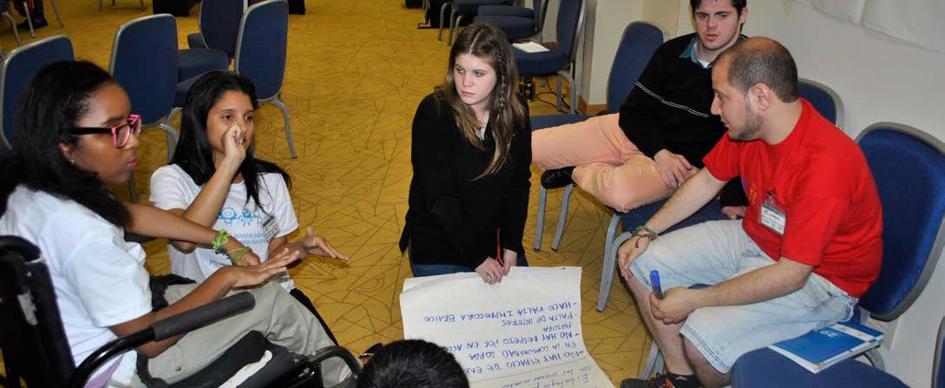
12 iiDi, UNICEF and IDA side event, New Voices, New Challenges

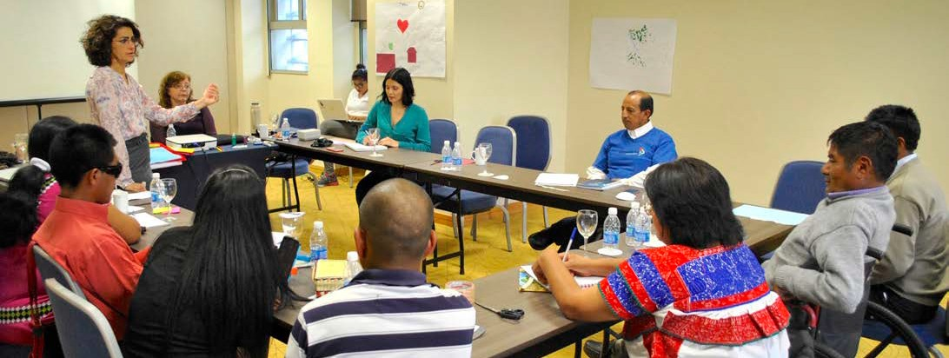
Indigenous Persons with Disabilities Global Network workshop

collaboration schemes between three fundamental actors that have defined roles in rights advocacy: 1) national governments,
2) civil society, 3) UN cooperation agencies.
- It was pointed out that national governments have the duty to harmonize national legislation with the UN CRPD, incorporating active consultation with civil society.
- It was mentioned that DPOs have to advance their training and promotion of actions towards every sector of society, including families, to raise awareness.
- It was stressed that international cooperation (plans and programmes which allow dealing with the different realities from different groups) needs to be linked with national policies and civil society.
- It was said that Inclusive Development is fundamentally about the recognition of individual autonomy in decision-making.
- Two key issues were highlighted: education and health (without setting aside other areas related to the realization of rights). Inclusive education requires solid work to put an end to the parallel system of special education, while, in health, particular attention should be placed on sexual and reproductive health.
- It was pointed out that public policies
must promote the 2030 Agenda.
Workshop 3
Indigenous Persons with Disabilities
Facilitator: Indigenous Persons with Disabilities Global Network
Speakers: Carlos Rios Espinosa Jurisprudence of the UN CRPD Committee in relation to indigenous persons with disabilities; Olga Montufar Case Study: Expert Mechanism on the Rights of Indigenous Peoples (EMRIP) and United Nations Permanent Forum on Indigenous Issues (UNPFII), advocating for the rights of indigenous persons with disabilities in the international arena.

Plenary
- The workshop laid out the background and evolution of international advocacy regarding the rights of indigenous persons with disabilities. The outcome document of the 2014 high-level plenary meeting of the World Conference on Indigenous Peoples includes three references to indigenous persons with disabilities. The most important is in

Paragraph 9: “We commit ourselves to promoting and protecting the rights of indigenous persons with disabilities and to continuing to improve their social and economic conditions, including by developing targeted measures for the aforementioned action plans, strategies or measures, in collaboration with indigenous persons with disabilities. We also commit ourselves to ensuring that national legislative, policy and institutional structures relating to indigenous peoples are inclusive of indigenous persons with disabilities and contribute to the advancement of their rights.”
- It was highlighted that one of the biggest achievements has been the inclusion of the indigenous perspective in the recommendations issued by the UN CRPD Committee, because it requests governments to include the issue in their agenda.
- Suggestions were made to develop advocacy activities that could have an impact on general national policies about disability and also general policies towards indigenous peoples. It was outlined that it is necessary to read domestic laws in line with the UN CRPD, so that international standards are respected.
- Regarding the right of indigenous peoples to consultation, it was highlighted that it is a right established in the International Labour Organization (ILO) Convention 169, and that it is reinforced by the UN CRPD, especially Articles 3, 4 and 29, and the Preamble.
- There was an agreement about the importance of indigenous persons with disabilities to be empowered and receive information so they can promote a culture of human rights from inside their communities. This would be key to accepting the language of human rights, which is sometimes still regarded as
colonialist, and to encourage ownership of the project by the indigenous communities through their members with disabilities. The project should see the inclusion of persons with disabilities as an opportunity to advance the human rights of all the members of the community, in harmony with the customary laws and traditions of each community.
  - Issues prioritized included lack of access to education (which is ineffective because it is not taught by indigenous teachers, and generally not bilingual). A Brazilian case was mentioned as an example of this situation: deaf persons do not receive education in their native language, and they have to learn the Brazilian Sign Language. In Mexico, a case was mentioned about a young boy that could never attend regular school because his community forbade it.
  - It was concluded that including the issue in national legislation and policies is still a challenge but there are good prospects.

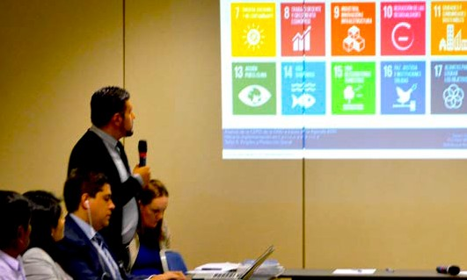
Sao Paulo Conference workshop discussion

Workshop 4
Situations of Risks and Humanitarian Emergencies
Facilitator: Venus Ilagan, Rehabilitation International
Speakers: Gustavo Giler, Ecuador Secretariat on the Rights of Persons with Disabilities Case Study: The Ecuadorian Inclusive Disaster Risk Management Strategy; Latoa Halatau, Pacific Disability Forum, Regional and global advocacy in relation to UN CRPD Article 11; Sonnia Margarita Vilacres, World Federation of the Deafblind DPO experience at the Third World Conference on Disaster Risk Reduction in Sendai, Japan; Monica Cortes, Inclusion International Displaced Persons with Disabilities

Plenary
    - Global, regional, national and individual experiences of persons with disabilities in situations of risk and humanitarian emergencies were shared by participants.
    - The public speakers assessed the progress of the inclusion of persons with disabilities in the Sendai Framework for Disaster Risk Reduction and the upcoming challenge of inclusion in the next World Humanitarian Summit.
    - A case study about the Inclusive Disaster Risk Management in Ecuador 2005- 2015 was presented, remarking how that country has progressed and that it has developed an emergency plan for persons with disabilities.
    - Regarding the ‘Pacific Plan’, it was said that advocacy towards public authorities was done to achieve attitudinal changes in the islands in case of natural disasters.
  - The case of Chile was highlighted. Here, due to the ratification of the UN CRPD— with particular reference to Articles 9 and 11—advocacy was focused on the government’s need to comply with the commitments stemming from that instrument. An example of this advocacy was a public awareness campaign called “Earthquakes”, transmitted in Sign Language.
  - There were calls to reflect about the relocation of indigenous communities, taking in account the characteristics that should be considered in that situation, from the perspective of indigenous communities.
  - There were also mentions about the type of weaknesses to consider, and agreements for directions to be taken, considering the need to:
- educate for changes to take into account accessibility for all persons, with emphasis on persons with mental and psychosocial disabilities;
- work on the prevention and training of persons with disabilities, their families and the entire community; and
- improve the coordination of actions between civil society and governments and, if possible, implementing actions that have already proved to be successful in other places. It was agreed that the answer should come from the governments, but if this is not the case, civil society must strengthen its advocacy, relying on Articles 9 and 11 of the UN CRPD.

Workshop 5
Employment and Social Protection
Facilitator: Ruth Warick, President of World Federation of Hard of Hearing People Speakers: Javier Guemes Pedrasa,
Technical Director, General Council ONCE,
Un A comparison of regional perspectives on social protection schemes: Europe and Latin America; Madai Linkimer, United Nations Development Programme Costa Rica Lessons-learned through the UN PRPD project on the national plan for labour inclusion in Costa Rica; Salam Gomez, Strategies for the labour inclusion of persons with psychosocial disabilities: the Experience Productivity Deal

Plenary
- Experiences from Colombia (www. fundamentalcolombia.org), Costa Rica (UNDP) and Spain (security and social protection) were shared.
- With a view to contribute to the Final Declaration, the following issues were stressed:
- The need to reinforce employment and social security.
- Employment needs to be highlighted as a key issue, linked to poverty in the Sustainable Development Goals. Implementation remains a major challenge, which will contribute to the reduction of the poverty.
- The importance of the role of persons with disabilities in this process. Everyone agreed that it is necessary to define the role of persons with disabilities in the areas of employment and social security.
- Work is not only a right, but also an instrument to reach specific Sustainable

Development Goals. There is a need to articulate the interdependence of work (Art. 27), women and girls (Art. 12), education (Art. 24) independent life (Art.
- and social protection (Art. 28) of the UN CRPD. Particular attention was drawn to the right to work of indigenous persons with disabilities.
- Awareness should be raised on the need to discuss whether persons with disabilities should be a part of contributory systems or non-contributory systems.
- The need to endorse a human rights- based approach on employment, since there is still a reductionist view of the employment as a simple source of income. It is necessary to consider other dimensions, among them: dignity, autonomy, accessibility, and the involvement of other stakeholders. It is necessary to begin strengthening this view behind closed doors, and to look for relevant stakeholders to implement what is in fact included in the legal frameworks of our countries and in the 2030 Agenda’s goals. The importance of discussing the costs associated with labour inclusion, reasonable accommodation and supports was stressed.
- Participants discussed the example of a Colombian project called “Relay Center” that minimizes barriers experienced by deaf persons, where they work with online interpreters. It was explained that in public centres there are computers available which allow the connection with an interpreter, and this is considered to be very useful for employment.

Workshop 6
Education
Facilitator: Colin Allen, President, World Federation of the Deaf
Speakers: Klaus Lachwitz, President, Inclusion International Overview of the International Disability Alliance joint position paper on Inclusive Education; Mª del Carmen Peral, Official Technician, ONCE Fundation for Latin America Perspective of a donor on the challenges and opportunities to assure inclusive education in Latin America; Natalia Farrigas y Matias Ferriera, META, Youth perspective on inclusive education and social participation
Plenary
  - The panel started with the question of how are we going to reach 2030.
  - It was pointed out that Article 24 of the UN CRPD is one of the most complex to implement, so people need to understand this from the start.
  - It was highlighted that it is key for implementation that governments understandwhatuniversaldesignentails—
both in architecture and teaching— and the use and implementation of reasonable accommodation.
- Panellists agreed on the autonomy of each country to plan the implementation of Article 24, and mentioned the importance of designing ways to implement inclusive education.
- It was pointed out that the realization of Article 24 is a process and special schools are part of that process, with an important role in providing support for inclusive education.
- There was a mention about the need to work with adequate financial means to improve education, and for governments to prioritize inclusive education. This would facilitate obtaining funding for projects.
- The META Young Activists Group discussed their inclusive education project in the region, which covers several issues, such as the accessibility of buildings, materials and knowledge, among others. They also shared personal experiences.
- It was agreed that there is a lack of training of teachers regarding inclusive teaching,

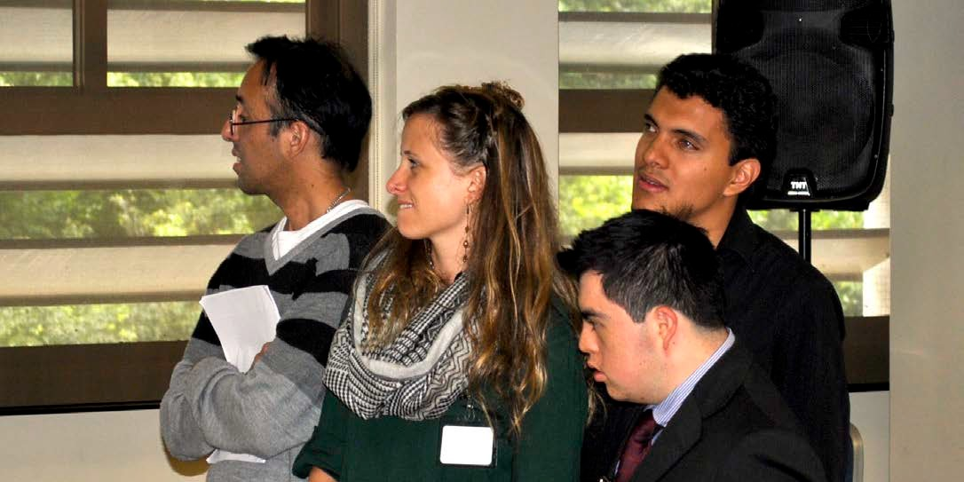
iiDi, UNICEF and IDA side event youth participants 17

and a lack of knowledge about disability from the UN CRPD perspective.
- It was stressed that persons with disabilities in rural areas often lack access to any kind of education.
- The issues of the rate of students per class—including the rate of students with disabilities—and lack of structural and individual support were also discussed.
- It was remarked that sign languages require consideration from governments, given the failure to implement bilingual schools. Participants mentioned issues faced by indigenous persons with disabilities, including the fact that indigenous children with disabilities are often expelled from schools. This is common for indigenous persons in general.
- It was pointed out that the lack of data makes planning harder. The group made recommendations to improve statistics.
- Participants suggested the need to work with persons with disabilities, families and organizations, and to give voice of children and young persons.
- The need to provide technical knowledge and to promote consultancies within the government sphere was highlighted.
- Participants mentioned the importance of expanding strategies that go beyond schooling, such as vocational orientation
- Participants discussed how, and agreed that, education is the key that opens the doors to rights, and they stressed that ensuring inclusive education, including for children with disabilities, will lead to inclusive communities, and this would also be reflected in inclusive employment.

Workshop 7
Independent Life
Facilitator: Ines de Escallion, Inclusion International
Speakers: Vanessa Maya, UN Country Team, Mexico UNPRPD México Support Project for Children with Disabilities and their families; Latoa Halatau and Tewai Halatau Case Study, Gabor Gombos, World Network of Users and Survivors of Psychiatry Case Study; Ferro Facundo Personal experience regarding how to live independently in the community.

Four experiences were presented.
- In Mexico, the “Children with Disabilities and their Families Program” is supported by several UN Agencies, in collaboration with other institutions, and helps enable children with disabilities to benefit from children’s institutions and services. It is a three-month programme, and it has support 9,000 projects in different parts of Mexico. The programme also supports single parents.
- In New Zealand there are numerous challenges, including access to public transportation, and obstacles faced by indigenous communities, which are still victims of institutionalization.
- A model to provide support to persons with disabilities, including peer support so that they can find a job, is being implemented. Participants pointed out that “being independent does not mean to live alone, but to contribute in a significant way to the community and take their own choices.” The programme is being implemented in New Zealand and managed by persons with disabilities.
- Participantsexplainedwhat“psychosocial disability” means, mentioning that the

term had been accepted shortly after the adoption of the UN CRPD. It was pointed out that bad practices still exist nowadays: for example, persons with psychosocial disabilities are forced to take medication as a condition to access adequate housing. Regarding good practices, the example of the “Fundamental Colombia” organization was mentioned, highlighting their programmes on access to justice. Participants pointed out that people themselves need to have control about their own lives to be included. It was also said that there are some good examples in Asia, and the example of restorative justice for Maori indigenous communities was also brought.
  - There was a personal testimony of a Chilean participant, that first became part of a protected workshop, but then participated with his girlfriend and family in the church. That opened several doors for him, including the possibility to participate in a labour workshop and in sports activities. He said that he wants to start a family and that he needs a stable job for that.
  - International Inclusion remarked that they work in 150 countries on issues such as the right to make one’s own decisions and the need for support, pointing out that a new concept of community is required. Institutionalization was criticized, and the importance of working towards deinstitutionalisation was highlighted.

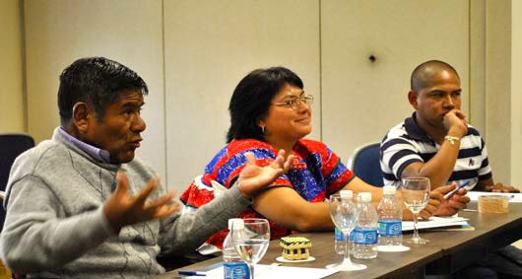
Indigenous Persons with Disabilities Global Network workshop participants
Panel Three
Global Indicators, National Data and Statistics, Data Partnership
This panel was moderated by Nawaf Kavara Speakers included Rosangela Berman Bieler, Chief, Disability Unit, UNICEF Presentation
of the UNPRPD One Data Project; Malcolm
Maclachlan, KnowUNPRPD and GATE and Belén Zamora, Programme Analyst, Resident Coordinator Office, Bolivia Strengthening the capacity to use disability data to develop evidence-based inclusive policies
All the panellists thanked IDA for the initiative and the invitation.

Nawaf Kavara recalled that 2016 marks the 10th anniversary of the adoption of the UN CRPD. He also mentioned the 2030 Agenda, and that IDA and other partners have worked very hard so that persons with disabilities were represented in the best possible way in the agenda. He highlighted the importance of indicators and emphasized the need to work seriously on their development. He pointed out that we know what we want and we have to work together, we know what is done and where, and how to push to create a better world for us. He concluded saying that we can only make concrete advocacy with data.

Rosangela Berman Bieler delivered a “Presentation of the UNPRPD One Data Project.” She outlined that her role is not just to talk about UNICEF’s work on data, but to highlight the UN PRPD alliance programme. She explained that the initiative

19

tries to bring all the UN Agencies involved to work together in a complementary manner on disability issues. Each agency has its own mandate, and thus we should strive to harmonize their work on disability, and to reinforce each other’s contribution. She also said that “disability issues are still invisible and, for this to change, it is necessary that we all collaborate through our own roles.” She explained that it is common to work with shared indicators in order to use the same language and compare data. In this way we can help governments and avoid confusion. UNICEF works with the Washington Group and has developed a module on ‘Children with Disabilities.’ It is a great tool for data collecting, allowing data cross-matching. UNICEF has also been working on a module to measure the environment of schools and, for that, families were asked about existing barriers. She explained that in Latin America many children cannot attend school because they face several barriers: families are often hopeless, afraid of mistreatment, and suffer lack of access to transportation. None of these obstacles are linked with children’s functioning. She clarified that UNICEF is using the WHO’s International Classification of Functioning, Disability and Health (ICF) in their modules, as it is a conceptual framework that factors in barriers, so that public policymakers can work on them. She shared that they have been working on the development of guides to measure the prevalence of disability in children. To conclude, she said that they are also working on sexual and reproductive rights, trying to show existing barriers, but also how to empower people to achieve access to maternal health care, prevention, sexual education and the eradication of harmful practices, such as forced sterilization.

Malcolm Maclachlan made a presentation about the UN PRPD. In his opinion, the community needs to get more involved with
statistics. He proposed contacting National Statistics Offices and educating them about the disability perspective. He shared that disability is an experience, not an attribute, and although this is a simple message, it is neither well understood by society, nor by National Statistics Offices. He mentioned a project that aims to harmonize the criteria of National Statistics Offices in several countries, along with the United Nations and civil society, to advance the creation of inclusive policies. He encouraged civil society to strengthen its participation. He also made reference to a survey about disability that involved the Washington Group and its great potential to offer comparable data. He said that in order to be successful, there is a need to create comparative indicators between countries and, over time, have more countries involved. He said that we are dealing with complex issues, with multiple stakeholders, so we require civil society’s participation. He mentioned GATE (Global Cooperation on Assistive Technology) and he remarked the importance of listing assistance priorities, and that it is expected that there will be more competition in the assistance market. In a second stage, there will be a global survey in 50 languages, available online and in paper, to encourage participation and partnership work.

Belén Zamora, from the Resident Coordinator Office of the UN in Bolivia, talked about Strengthening the capacity to use disability data to develop evidence-based inclusive policies. She explained that, since December 2014, the programme has been headed by UNICEF and it has received the support of many other agencies. Once the UN CRPD was adopted, special attention was paid to Articles 13, 24, 31 and 33. Drawing on Article 33, the government established an entity to be one of the partners of the programme, the other entity being the Bolivian Confederation of Persons with Disabilities. The programme

goals are:
  - strengthening programmes on access to justice, health and education. She clarified women’s and children’s access are strengthened in different programmes of several ministries; and
  - encouraging the development of mechanisms to comply with the international commitments. The expected impact is that access to justice, health and education are improved. She added that the ICF is being used, and that there has been work done in the elaboration of a campaign for December 3, in order to create awareness about the rights of persons with disabilities and promote the harmonization of national law with the UN CRPD.
Panel Four
Regional and Global Coordination
and the Role of Stakeholders Towards Implementation
This panel was moderated by Ana Regina Campello World Federation of the Deaf and FENEIS. Speakers included Mª Jesús Varela, General Director of Fundación ONCE para América Latina (FOAL); Ruth Fernandez UNDP, UN Country Team; Luis Fernando Astorga, Political Advisor of REDODICEC; Priscille Geiser International Disability and Development Consortium and Ana Lucia Arellano, RIADIS.
The first speaker was Ma. Jesus Varela, who addressed the issue of ‘’Best Practices: the added value/benefit of involving DPOs in planning and implementation of projects.” She explained that ONCE is self-

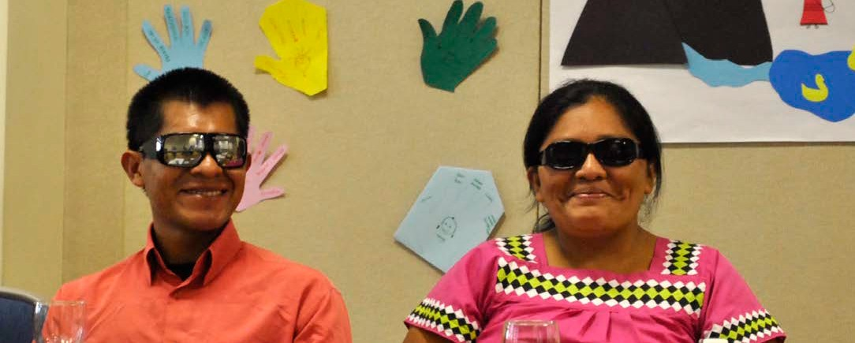
Indigenous Persons with Disabilities Global Network workshop participants 21

managed by blind people, and that FOAL is working for the inclusion of persons with visual impairments in Latin America. She highlighted that achieving autonomy and access to employment is possible for persons with visual impairments, and she emphasized the need for inclusive education. She mentioned that the resource centre for inclusive education (which works for the adaptation of materials, text books, embossed illustrations, braille, staff training—so they can transmit that knowledge to the rest of the teachers—etc.) She pointed out the importance of working with governments and promoting inclusive quality education for persons with disabilities in each of their countries. She also mentioned the Agora Project, related to employment. She concluded her presentation by making it clear that their projects are all based on sustainability and cooperation.

AGORA. Employment management workshops in the Latin American Region
The AGORA Project aims to incorporate persons with visual impairments from Latin America into the production system. In that regard, a project was developed to establish units to advise, offer training and facilitate access to employment, so that blind people or persons with severe visual impairments can access the labour market in Latin America.

Ruth Fernández, talked about “Agenda 2030 in the context of the Dominican Republic.” She explained the round of national consultations for the 2030 Agenda in that country; two conferences took place in two different places in July 2015 with the goal of achieving national coverage. The conferences focused on the content of the Millennium Development Goals: each goal was examined with the participation of persons with disabilities. The conclusions were presented to the government—not only
22

to the National Council on Disability Equality (CONADIS) but also to the President of the Dominican Republic—and they were taken as inputs for the General Assembly. Fernandez mentioned the creation of national indicators, and the need to take advantage of inter- sectorial spaces to strengthen the value of inter-sectorial labour. She also highlighted the importance of establishing alliances between governments, civil society and international agencies, and being in line with the development goals. She concluded by mentioning the importance of disseminating and promoting ownership of the outcome Declaration of the Conference.

Luis Fernando Astorga addressed the issue of “Establishing a regional coordination mechanism for implementing the SDGs, including planning, accountability and monitoring.” He emphasized that there is an important failure in implementing the UN CRPD, reflected in the reports that the countries have submitted to the UN CRPD Committee. He suggested that it is essential to focus on poverty and inequality affecting persons with disabilities. He stated that, with these premises, it is necessary to understand the Goals and targets of the 2030 Agenda as an opportunity to enhance the implementation of the UN CRPD. Otherwise, it might seem that if States are unable to fulfil the obligations stemming from the UN CRPD, they are even less likely to fulfil the SDGs. Accordingly, the first thing to do is to plan the national

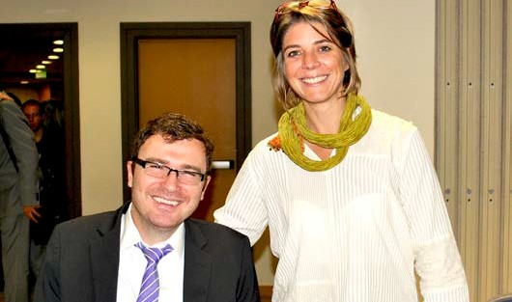
Vladimir Cuk, IDA Executive Director, and Priscille Geiser, IDDC Chair

implementation of the SDGs, which should direct the national coordination mechanism for implementing the UN CRPD (Article 33, section 1). He emphasised that DPOs need to be properly consulted. He described concrete impact indicators, allowing the assessment of progress through linkages between the compliance of the SGDs with the rights of persons with disabilities. He also tackled the issue of accountability, pointing out that DPOs and human rights organizations in charge of monitoring need to develop intense activities to assess how the rights of persons with disabilities are being implemented. However, he pointed out that they are not the only stakeholders with monitoring responsibilities: he proposed to use every accountability mechanism in order to avoid reaching 2030 without having made any real achievements. He concluded his presentation by remarking that an in- depth, deep knowledge of the Goals and their contextualization in each country is necessary as well as alliances with other sectors of society. Since the disability movement has been isolated, hidden in its advocacy, unlike many other movements— such as the Women’s movement—it still not recognized widely as a social movement. He said it is necessary to work on this issue, because it is key for taking an active role. In the words of the speaker: “active surveillance, concrete accountability and monitoring.”

Priscille Geiser and Ana Lucía Arellano made a “Joint Presentation of BRIDGE.” They discussed how the BRIDGE initiative is promising and has demonstrated the importance of building capacities in civil society to promote involvement. The SDGs should be important to all participants, to promote inclusive perspectives. BRIDGE is a training programme, inclusive-oriented, carried out to be relevant to everyone and to include human rights and sustainable
development, including the UN CRPD and 2030 Agenda. BRIDGE’s work is directed to reinforce the understanding of the UN CRPD, and it was formulated to answer the increasing demands of civil society. The idea is to create a ‘bridge’ to overcome existing biases and develop capacities, perspectives and expectations to bring the 2030 Agenda in line with the disability movement and closing these existing gaps.

BRIDGE’s structure is formed by two modules. The first focusing on what is non- negotiable in the UN CRPD, the second including examples of analysis, litigation and advocacy, etc. One important aspect of BRIDGE is in identifying what people already know and plan how to promote that knowledge.

The intention of the programme was to increase the participation levels in the public debate and relate this participation with civil society. One of the objectives of BRIDGE in Latin America was to bring the international experience to the national level.

Outcomes
- Common capacity building for all persons with disabilities:
- Conecting networks RIADIS – ULAC - REDODICEC
- CRPD-Inclusive development - SGDs
- Global-Regional-National-Local
- Strengthen the capacities of members
- Capacity-building for effective advocacy
- RIADIS-REDODICEC Project 2016- 2020- Impact indicator observatories - SDGs 1 & 4
- Constructive dialogue with key stakeholders
- Implementation and Monitoring of the CRPD and SDGs

Looking Ahead:
High-Level Political Forum, Global Reporting Mechanism, and Engagement of DPOs through Regional
and Global Coordination
Speaker: Vladimir Cuk, Executive Director, International Disability Alliance.

The last speaker of the day thanked participants and remarked that it had been a hard-working day. Mr Cuk began by mentioning the The United Nations High-Level Political Forum on sustainable development (HLPF), the UN CRPD and the 2030 Agenda. He explained that the Conference’s workshops aimed to create bridges between the Sustainable Development Goals and the UN CRPD.
He continued to affirm that we all know what the UN CRPD is, and that the SDGs indicate how to use the funding obtained by Members States. The Goals have specific indicators, and these must be used with government ministries to guarantee that different programmes include persons with disabilities. He said that we have to pressure governments to implement the SDGs and, through them, promote the UN CRPD. Countries will be able to request financial assistance to fulfil the Goals, and showing that they are achieving the Goals will allow them to receive additional funding.
The UN’s consultative mechanisms, and governments’ experience of assessment, have been based on how the MDGs are implemented, which were not inclusive of persons with disabilities. Thus is why it is so important for us to prepare governments and the UN for the 2030 Agenda’s inclusion of persons with disabilities.
We need to come together: from these meetings the Declaration will be the outcome of our dialogues. Cuk pointed out that we have to consider, on the one hand, the importance of the funding to promote the achievement of the Goals and, on the other hand, the need to make the adequate connections at the national level. This can be confusing and complex: we need to ask ourselves how can we ensure governments fulfil the SDGs and at the same time continue to receive financial assistance from them.

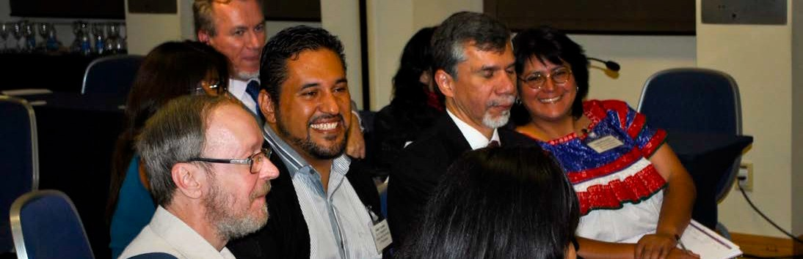
Declaration Drafting Working Group

São Paulo Political Declaration
The following Declaration has been adopted by persons with disabilities and their representative organisations from national, sub-regional and regional levels of Latin America and the Caribbean on 24 October 2015 during the São Paulo conference ‘Advancement of the UN CRPD through the 2030 Agenda: No-one left behind: Towards implementation in Latin America and the Caribbean’, organized by the International Disability Alliance with support from the United Nations Partnership to Promote the Rights of Persons with Disabilities, UNICEF and the São Paulo State Secretariat on the Rights of Persons with Disabilities.

SÃO PAULO POLITICAL DECLARATION
ADVANCEMENT OF THE UN CRPD THROUGH THE 2030 AGENDA - NO ONE LEFT BEHIND: TOWARDS IMPLEMENTATION IN LATIN AMERICA AND THE CARIBBEAN

Preamble
WE, persons with disabilities from 16 countries in Latin America and the Caribbean, representative organisations of persons with disabilities and multi-stakeholder from Governments, United Nations (UN) agencies, donors and civil society organisations, gathered by the International Disability Alliance in São Paulo, Brazil, from 22 to 24 October 2015, at the conference ‘Advancement of the UNCRPD through the 2030 Agenda: No-one left behind: Towards implementation in Latin America and the Caribbean’:
- Determined to advance the rights of all persons with disabilities in Latin America and the Caribbean in the interest of all humanity, and to implement the 2030 Agenda for Sustainable Development (hereinafter 2030 Agenda),
- Guided by the UN Universal Declaration of Human Rights, the UN Convention on the Rights of Persons with Disabilities (hereinafter CRPD), the 2030 Agenda, the UN Declaration on the Rights of Indigenous Peoples, the Sendai Framework for Disaster Risk Reduction, the Beijing Declaration and Platform of Action and the Addis Ababa Action Agenda,

RECOGNISE
- The 2030 Agenda, its Goals and targets are universal, indivisible and interlinked, and aim to promote equality of opportunity for all,
- That full human potential and sustainable development cannot be achieved in the region when persons with disabilities are still denied full enjoyment of their human rights, and that grave situations of social, economic and environmental inequality persist,
- With appreciation, the explicit references to persons with disabilities enshrined in the 2030 Agenda and strong recall that more than 80% of persons with disabilities live in poverty,
- That the 2030 Agenda resolve to combat inequalities and to increase significantly the availability of data disaggregated by disability,
- That the follow-up and review processes of the 2030 Agenda’s implementation must be guided by the principles of open, inclusive, participatory and transparent reporting for all people,

ENCOURAGED BY
- The work of the Special Envoy of the UN Secretary-General for Disability and Accessibility, the Committee on the Rights of Persons with Disabilities as well as other relevant Treaty Bodies, and the work of the UN Human Rights Council, its Universal Periodic Review and Special Procedures, in particular the Special Rapporteur on the Rights of Persons with Disabilities,

- The Inter-American Commission and Court of Human Rights, and relevant regional Conventions, including on the Elimination of All Forms of Discrimination Against Persons with Disabilities,

CONSIDERING THAT
- Of the 33 member States in the Latin American and Caribbean, 31 have ratified the CRPD; of which 24 have ratified both the CRPD and its Optional Protocol,
- In Latin America and the Caribbean there are more than 90 million persons with disabilities,

EXPRESS DEEP CONCERNS THAT
- In the region, persons with disabilities still experience different forms of poverty, including extreme poverty, and face enormous disparities of opportunity in participating and effectively being included in society,
- Persons with disabilities were absent from the Millennium Declaration and consequently remained absent in processes related to the Millennium Development Goals, resulting in pervasive exclusion,
- Despite considerable legislation present in several States of the region affirming the rights of persons with disabilities, the population continues to face multiple barriers regarding adequate participation in decision-making processes, access to inclusive quality education, health, rehabilitation, employment and justice, among other areas and rights,
- Persons with disabilities belonging to specific constituencies face multiple and intersectional discrimination, in particular: women and girls; youth and older; indigenous peoples, African descent or belonging to other ethnic groups; persons with intellectual or psychosocial disabilities, persons who are deafblind, hard of hearing, deaf, blind or partially sighted, autistic persons; persons of short stature, persons with albinism, persons with physical disabilities; lesbian, gay, bisexual, transgender, and intersex people (LGBTIs); and people in specific situations, such as those who require more intensive support, persons living with HIV/AIDS, leprosy or epilepsy, persons living in rural, remote, disaster-prone or conflict-affected areas, persons who are refugees, displaced or migrants, persons deprived of liberty, among others,
- Families – which play an active role in the structure of societies in the region – are often disproportionately disadvantaged due to the lack of services and support they should receive to contribute towards the full and equal enjoyment of the rights of their family members with disabilities,

CONVINCED THAT
- The transformative nature of the 2030 Agenda, implemented in line with the CRPD, will enhance the promotion of the human rights and development of all persons with disabilities in the region,
- Regional challenges are interrelated and thus demand joint and inclusive measures - comprising legal, administrative and judicial measures - to promote a real paradigm shift in individual and social attitudes,
- A substantial change on social expectations regarding new and future generations of persons with disabilities is needed. This change in expectations and attitudes should be reflected in a culture of inclusion, meaningful participation and respect for diversity,

THEREFORE and in order to see the full implementation of the 2030 Agenda in line with the CRPD and ensure that indeed no one will be left behind and that the motto ‘Nothing about us without us’ is adhered to,

WE URGE Latin American and Caribbean States, including national, state, provincial and municipal governments, to take all necessary measures including mobilising adequate financial and human resources - with the involvement of regional integration organizations and UN agencies, persons with disabilities and their representative organisations, civil society organisations, donors, human rights institutions, trade unions and private actors, to:

  - ENSURE EQUALITY OF OPPORTUNITY AND ELIMINATE DISCRIMINATORY LAWS, CONSIDERING THAT
    - Legal and administrative barriers to social and political empowerment of all persons with disabilities should be removed, as a matter of priority, and aligned with the CRPD to ensure equality of opportunity,
    - Latin American and Caribbean States should take effective measures to recognise the right of all persons with disabilities to exercise their legal capacity on an equal basis with others, to abolish substitute decision-making processes and create regional exchange mechanisms of good practices of supported decision-making in line with the CRPD,
    - Legal frameworks should ensure the participation of all persons with disabilities, in particular children, youth, adolescents, women, indigenous persons and African descents, in the design and implementation of public policies that may affect their lives,
    - States of the region should ratify and implement the Marrakesh Treaty to Facilitate Access to Published Works for Persons Who Are Blind, Visually Impaired, or Otherwise Print Disabled,

  - ERADICATE POVERTY AND REDUCE INEQUALITY, CONSIDERING THAT
- Persons with disabilities are over represented among the poorest in the Latin American and Caribbean region,
- States should promote their economic, social and political empowerment and ensure that they have equitable access to economic resources such as ownership and control over land and other forms of property, inheritance and financial services, including microfinance, as well as access to basic services, including disability-specific services,
- As matter of priority, States should create or strengthen comprehensive and inclusive social protection schemes to support the economic empowerment, social participation and inclusion of persons with disabilities,
- While the region benefits from significant mobilization of resources from international cooperation, both donors and States should ensure that poverty reduction and development strategies are inclusive of persons with disabilities, in line with the CRPD,

  - PROMOTE PEACEFUL AND INCLUSIVE SOCIETIES THROUGH
- Support of economic, political and social empowerment of persons with disabilities and their representative organisations, to ensure their participation and sustainability as qualified national and regional allies for the Global Partnership of the 2030 Agenda,
- The establishment of urgent measures, including economic, informational and personal assistance, to ensure that persons with disabilities enjoy their right to live independently and be included in the community to prevent their segregation, as enshrined in the CRPD,
- Effective inclusion and consideration of persons with disabilities and their representative organisations in the design, implementation and monitoring of all programmes and policies that may impact their lives, in order to effectively implement the 2030 Agenda in line with the CRPD,
- Establishment and implementation of national plans for inclusion and accessibility of all persons with disabilities in the region, with established timeframes and adequate human and

material resources , and that assistive devices and other services required are available and affordable for all persons with disabilities,
- Accessible and effective access to justice for all persons with disabilities, including the provision of procedural and age-appropriate accommodations and effective legal remedies,
- Effective measures that prevent, eliminate and respond to violence, abuse, exploitation and torture of persons with disabilities, with particular attention to people most subject to multiple discrimination,
- The provision of legal identity for all persons with disabilities in the region, including birth registration, especially to children, youth, people living in rural and remote areas and indigenous persons, African descent or belonging to other ethnic groups,
- The strengthening of national statistical institutes to increase collection and availability of timely, reliable and high-quality disaggregated data on persons with disabilities, the barriers they face for full and effective participation and inclusion in society as well as their specific requirements,

  - ENSURE ACCESS TO INCLUSIVE AND QUALITY EDUCATION AND EMPLOYMENT
- For all persons with disabilities in the region through inclusive, equitable and quality education at all levels, and access to life-long learning opportunities, including in rural and remote areas as well as with support measures and reasonable accommodation, in line with the CRPD,
- By promoting, encouraging and investing in the employment of persons with disabilities, including through financial incentives, quotas and public procurement among other, both in public and private sectors as well as promoting self-employment through microcredit programs,

  - RECOGNISE SEXUAL AND REPRODUCTIVE RIGHTS AND PROHIBIT GENDER-BASED VIOLENCE , BY:
- Guaranteeing family planning and fertility retention of all persons with disabilities on an equal basis, in particular of women and girls and ensure inclusiveness and accessibility to public and private services and programmes, as well as to all means of accessible and age-appropriate communication and information,
- Taking effective measures - including child-focused, gender-, and disability-specific measures, when appropriate - to effectively prohibit gender-based violence against persons with disabilities, in particular against women, girls, boys and LGBTI people,
- Protecting persons with disabilities from gender-based violence, including financially or through accessible communication and information, and ensure that instances are documented and investigated and, where appropriate, prosecuted to combat impunity,

  - CELEBRATE, GUARANTEE AND PROMOTE HUMAN DIVERSITY BY:
- Celebrating and promoting the diversity of all persons with disabilities, their inherent dignity and individual autonomy - including the freedom to make one’s own choices - by making every effort in line with the CRPD,
- Developing strategies to raise awareness in mass media to foster a positive image of persons with disabilities and eliminate discrimination,
- Promoting inclusive spaces for persons with and without disabilities, in particular children and young people, to learn to live together in equality and fully participate in society,
- Implementing mechanisms that guarantee, respect and promote youth, deaf, deafblind and indigenous community cultures consistent with human rights, and recognise sign languages and native indigenous languages as part of linguistic diversity,
- Recognising, promoting and facilitating the use of sign languages, Braille, augmentative

and alternative communication and all other accessible means, modes and formats of communication of their choice by persons with disabilities and in line with the CRPD,

  - TAKE APPROPRIATE MEASURES IN SITUATIONS OF RISK AND HUMANITARIAN EMERGENCIES
- To reduce disproportionate exposure of persons with disabilities to disaster situations, including through the implementation of the Sendai Framework for Disaster Risk Reduction,
- By calling on States from the region to ensure that the World Humanitarian Summit results in strong political commitments to develop and endorse global guidelines that include and recognise persons with disabilities as assets in humanitarian response,

  - ESTABLISH EFFECTIVE, ACCOUNTABLE AND TRANSPARENT INSTITUTIONS, INCLUDING
- National frameworks and advisory commissions charged with implementation of the CRPD should have high institutional rank, with adequate human and financial resources to effectively coordinate the implementation of the rights of persons with disabilities at all levels and in all sectors of government. Considering their role in the execution of public policies, in no case, should these commissions develop independent monitoring tasks,
- The establishment or strengthening of focal points on disability in all relevant ministries and within government, in different sectors and at different levels, for matters relating to the implementation of the 2030 Agenda and the CRPD, and guarantee close consultation and adequate involvement of organisations of persons with disabilities to this end, in line with the CRPD,

  - ESTABLISH STRATEGIC PARTNERSHIPS FOR INCLUSIVE DEVELOPMENT BY
- Strengthening interlinkages in implementation, monitoring and evaluation mechanisms between the 2030 Agenda and the CRPD in the region to ensure that national plans, development strategies and mechanisms are inclusive and respectful of persons with disabilities,
- Urging States in the region to include the persons with disabilities in the implementation of the 2030 Agenda, including safeguarding their participation in the High Level Political Forum for Sustainable Development,
- Promoting a participatory process though the UN Partnership to Promote the Rights of Persons with Disabilities through the design of actions and programmes, trainings,
implementation, monitoring and evaluation, driven by civil society, governments and UN agencies working together as partners at all stages,
- Taking advantage of this São Paulo conference, organisations of persons with disabilities from national, sub-regional, regional levels as well as the networks of self advocates, indigenous persons and youth with disabilities commit to join and coordinate actions to assist states and UN agencies to achieve the Goals and targets of the 2030 Agenda in line with the CRPD,
- Taking advantage of international leadership of Latin American and Caribbean States to ensure that all development programmes and international cooperation, including regional and sub-regional, are inclusive of and closely involve persons with disabilities and their representative organisations, to make sure that the Goals and targets of the 2030 Agenda fully transform our world for the better by 2030 and that no single person with disabilities is left behind.

São Paulo, Brazil, 24 October 2015

Full annexes, references, translations and other conference materials are available here:

www.internationaldisabilityalliance.org/en/node/2149

List of Participants

Colin Allen, WFD
Ana Lucia Arellano, RIADIS
Maryanne Diamond, IDA / World Blind Union (WBU)
Vanessa Dos Santos, Down Syndrome International (DSI)
Gabor Gombos, World Network of Users and Survivors of Psychiatry (WNUSP)
Latoa Halatau, Pacific Disability Forum (PDF)
Geir Jensen, World Federation of the Deafblind (WFDB)
Nawaf Kabbara, Arab Orgnisation of Persons with Disabilities (AODP)
Klaus Lachwitz, Inclusion International (II) Volmir Raimondi, WBU
Yannis Vardakastanis, European Disability Forum (EDF)
Ruth Warick, Internatioan Federation of Hard of Hearing People (IFHoH)

Carolina Aguilar, REDODICEC
Luis Fernando Astorga, REDODICEC Regina Atalla, RIADIS
Victor Baute, RIADIS Ines Buraglia Gomez, II
Ana Regina Campello, FENEIS, WFD Anna Maria Canales, REDODICEC
Antonella Cellucci, CONADIS Dominican Republic Monica Cortes, II
Sandra Darce Mendoza, FEMUCADI NICARAGUA Fabiola Espinosa, ASHICO, IFHOH
Alexis Estibil, Federación Mundial de Sordos, WFD Ana Fisher, RIADIS
Cristina Francisco Segura, CIMUDIS Rosario Patricia Galarza Meza, CODIP German Garcia, ASHICO
Salam Gomez, WNUSP
Javier Guemes, EDF Joaquin Herbas, IFHOH
Antonia Irazabal, IIDI
Raquel Jelinek, CONFE Inclusion Interamericana
Rachel Kachaje, Disabled Peoples’ International (DPI)
Gibson Kachaje, DPI
Hugo Edvilar Leon Ibanez, Handicap International (HI)
Dean Lermen, CONALIVI Alexandre Mapurrunga, ABRACA
Henry Mejia, Federacion nacional de Sordos de Colombia
Alejandra Monge Arias, WNUSP and Fundamental Costa Rica
Ever Navarro, RIADIS Patricia Ospina, RIADIS
Liliana Penaherrera, DSI Sociedad Peruana de Sindrome Down
Carlota Perreno, RIADIS
Maria Camilia Ramirez, Interamerican Institute on Disability and Inclusive Development (iiDi)
Carlos Rios Espinosa, Self-Advocate
Priscilla Rodriguez, Disability Rights International
Natalia Santos Estrada, Colectivo Chuhcan, WNUSP
Teofilo Urbieta Gonzalez, HI Sandra Vasquez, RIADIS Sandra Vasquez, FEPAPDEM Jose Maria Viera, RIADIS Sonia Villacres Mejia, WFDB Fatma Wangare, ADF

Juan Arena, IPWDGN
Ulises Cardenas Hidalgo, IPWDGN
Martha Downs Anibal, FENOCORI / IPWDGN Felipe Santiago Flores Ponce, IPWDGN Rosario Jimenez, IPWDGN
Olga Montufar, IPWDGN
Camilo Andres Ramirez Tapasco, IPWDGN Jose Ramon Quesada, IPWDGN
Cecilio Ignacio Ticona Vilga, IPWDGN
Gustavo Giler Alarcon, Vice Presidency Ecuador

Rosana Alasino, CONADIS
Hernan Bascunan, Cosul General Chile Silvia Bersanelli, CONADIS
Darling Mejia, MOFA El Salvador Bridget Trazoff, USAID Sao Paulo

Kimberly O’Haver, Open Society Foundations Catherine Townsend, Wellspring
Vladimir Cuk, IDA Secretariat Priscile Geiser, IDDC Yolanda Munoz, DRAF Eliana Almorin, NHS Brazil
Maria Faget, Family Care International Martine Levesque, HI
Irene Materola, HI
Raul Montiel, Saraki Foundation Maria del Carmen Peral, ONCE Maria Jesus Varela, ONCE
Malcolm Machlaughlin, KnowUNPRPD-GATE Venus Illagan, Rehabilitation International UNFPA Martin Villalba, UNFPA
Natalia Mattioli, UNPRPD
Andrea Ribeiro Bosi, UNDP Brazil Gary Stahl, UNICEF Regional Office Rosangela Bieler, UNICEF
Ruth Fernandez, UNDP Dominican Republic Madai Linkimer, UNDP Costa Rica
Vanessa Maya, UNCT Mexico Maria Belen Zamora, UNCT Bolivia
Javier Salguero, Director Disability, Government of Bolivia
Israel Villa Joaquín Serrano Marco Castilho Marisa Shirasuna Mauro Lando Aldo Vidor
Glenda de la Fuente Mauricio Noguiera Roberto Sebok
Lucía Rodriguez Linda Bredal, WFDB
Pers Grimstadt, WFDB
Mariela Alexandra Hidalgo Cherres , WFDB Lisbet Moskaug, WFDB
Jaime Rosendo Villacres Mejia, WFDB Jahda Abu Khalil, AOPD
Mariela Rosana Alancay
Johndra Josefa Azartas Alvarado, FENOCORI / IPWDGN
Madeline Matarrita Castrillo, REDODICEC
Ana Karina Darce Mendoza, FEMUCADI NICARAGUA
Ricardo Estigarribia, RIADIS
Heyler Alejandra Gamboa Ramirez, IPWDGN Tewai Halatau, PDF
Maria Laura Herrera, FEDERACION NACIONAL DE SORDOS DE COLOMBIA
Rune Jensen, WFDB
Gabriela Elisabeth Kraemer Beyer, Self-Advocate Dalyla Montufar, IPWDGN
Judith Varsavsky, WBU Nelva Vilamonte, RIADIS
Alejandra Volpe, Interamerican Institute on Disability and Inclusive Development (iiDi)
Diego Barbosa, ISL
Jonas Carlsson, WFD / SLI Mariana Farias Lima, ISL Liz Gibson, WFD / SLI Rodrigo Machado, ISL Marianne Stumpf, ISL

Nicolas Bach, IDA Secretariat Georgia Dominik, IDA Secretariat Tchaurea Fleury, IDA Secretariat Jaimie Grant, IDA Secretariat Magdalena Orlando, IDA Secretariat
Mariana Sanchez Torres, IDA Secretariat Jacob Smith, IDA Secretariat

supported by

