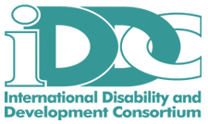
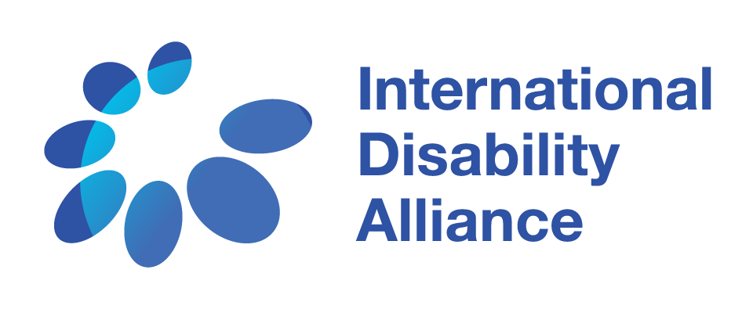

IDA & IDDC joint press release- Results of the 2016 CRPD Committee elections

New York, 15 June 2016

On the opening day of the Conference of States Parties, elections were held for nine of the eighteen seats of the CRPD Committee and the following candidates were elected:*

Mr Martin Babu MWESIGWA (Uganda)
Mr Monthian BUNTAN (Thailand)
Mr Laszlo Gabor LOVASZY (Hungary)
Mr Ahmad ALSAIF (Saudi Arabia)
Mr Imed Eddine CHAKER (Tunisia)
Mr Jun ISHIKAWA (Japan)
Mr Samuel Njuguna KABUE (Kenya)
Mr Robert George MARTIN (New Zealand)
Mr Valery Nikitich RUKHLEDEV (Russian Federation)

The International Disability Alliance (IDA) and the International Disability and Development Consortium (IDDC) congratulate those re-elected and newly elected members of the CRPD Committee. With this election, the CRPD Committee will count for the first time ever within its membership: a person with intellectual disabilities, self-advocate Robert Martin from New Zealand; and a deaf sign language user, Valery Nikitich Rukhledev from the Russian Federation. This marks the beginning of a new era for the Committee, and the UN system generally, calling for more inclusive and accessible processes, acknowledging the diversity of persons with disabilities.

While we applaud these historic developments and look forward to greater innovation for enhanced participation within and with respect to the Committee, we also lament the disquieting drop in numbers of women members of the Committee which will fall from the current six women members, to the 2017 composition of only one woman member.

The CRPD Committee now stands as the treaty body with the fewest number of women members – one woman (out of 18 members) in 2017- a significant departure from its previous compositions of six women (out of 18 members) in 2014-2016; seven women (out of 18 members) in 2012-2014; eight women (out of eighteen members) in 2010-2012; and five women (out of 12 members) in 2008-2010.

At the conclusion of the elections, IDA Chair, Maryanne Diamond remarked: “It is alarming that the new composition of the Committee counts but one woman, which begs the questions how we, women with disabilities, will be legitimately represented, and how the Committee can serve as a model for others? This signals a serious disconnect between the Convention’s principles of non-discrimination and gender equality within the nominations and elections procedures, as well as an objectionable disengagement on the part of States to ensure and promote gender parity.**
It is the responsibility of us all- States, the disability movement, the women’s movement- everyone, to be proactive in ensuring the inclusion of women and girls with disabilities across all agendas. We can only get there together, leaving no one behind.”

IDDC Chair, Priscille Geiser added: “Little attention is given to the situation of more than a half billion women and girls with disabilities who face multiple and intersecting forms of discrimination, this despite evidence indicating that they are more likely to experience violence than their peers. It is essential that gender and disability stakeholders acknowledge the intersection and engage to address this situation.”

On a more positive note, IDA & IDDC welcome the announcement made yesterday by New Zealand to present a resolution in the fall on women and girls with disabilities at the General Assembly as a concrete effort to leave no one, including no woman with disability, behind as reaffirmed in Agenda 2030 and Goal 5 specifically.

For further information, please contact Jaimie Grant, IDA Communications Officer: jgrant@ida-secretariat.org or Sarah Hull, IDDC Secretariat Coordinator: coordinator@iddcconsortium.net

*The elected members begin their term in January 2017 and their mandates will expire in December 2020.

Three candidates, whose terms as members of the CRPD Committee were coming to an end on 31 December 2016, Mr Martin Babu Mwesigwa, Mr Monthian Buntan & Mr Laszlo Lovaszy, were re-elected.

The newly elected and re-elected members will join the continuing members of the Committee:
Ms Theresia Degener (Germany), Mr Danlami Basharu (Nigeria), Mr Carlos Parra Dussan (Colombia), Mr Jonas Ruskus (Lithuania), Mr Damjan Tatic (Serbia), Mr Hyung Shik Kim (Korea), Mr Stig Langvad (Denmark), Mr Coomaravel Pyaneandee (Mauritius) & Mr Liang Young (China).

The geographical composition of the Committee from 2017 will be as folllows:
1 expert from Latin America and the Caribbean, 5 from Africa, 4 from Eastern Europe, from 5 Asia-Pacific and 3 from Western Europe and other States.

** Article 34(4) of the CRPD sets out the requirement that States Parties elect members of the Committee with consideration being given to: equitable geographical distribution, representation of different legal systems, balanced gender representation and participation of experts with disabilities.

