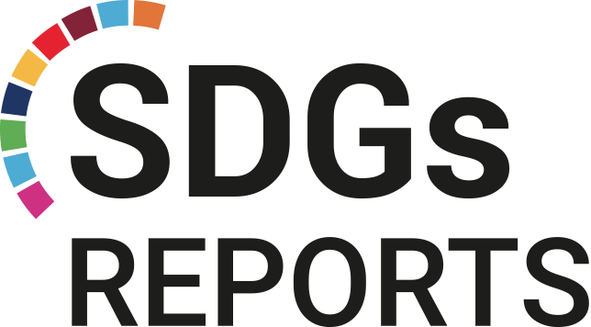

2023

THE PARALLEL REPORT ON THE IMPLEMENTATION OF THE 2030 AGENDA (SDG 4, 5, 17) IN LINE WITH THE CRPD, THE PHILIPPINES

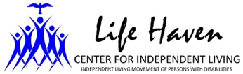
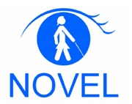
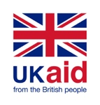
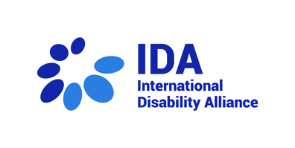
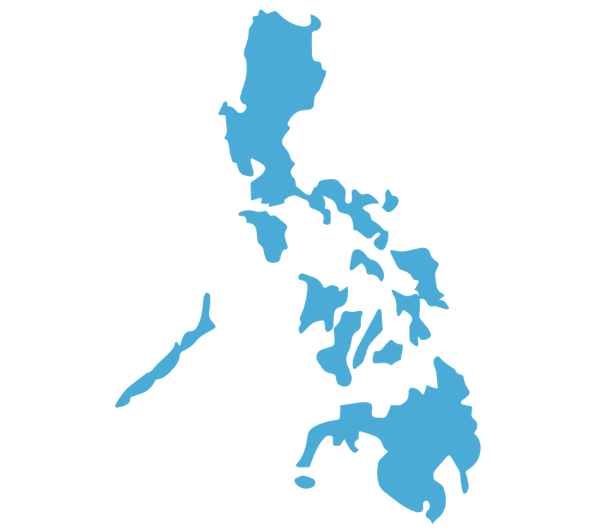
Table of Contents

PHILIPPINES

This publication
was supported by:

List of Tables iii
List of Figures iv
List of Abbreviations and Acronyms v
Acknowledgements viii
Executive Summary ix
Introduction/Background ix
Methodology ix
Highlights ix
Conclusion and Recommendation xii
Introduction 1
Background 3
Geolocation and socio-economic status 6
Persons with Disabilities population 7
Education structure 8
Overall situation of learners 13
Specific situation and concerns of learners with disabilities 13
Drafting process 14
Methodology 17
Aims and Objectives 17
Legal frameworks and stakeholders 18
Global/Regional 18
National ……………………………………………………………………………………….…19
SDG Desk Research 23
SDG 4 Quality Education and CRPD Article 24 Education 23
SDG 5 Gender Equality and CRPD Article 6 Women with Disabilities 26
SDG 17 Partnerships for the Goals and CRPD Article 32 International Cooperation……………………………………………………………………………………..28
Education Budget 29

Findings 33
SDG 4 (Quality Education) and CRPD Article 24 (Right to Inclusive Education) 33
Target 4.1: Universal primary and secondary education 33
Target 4.2: Early childhood development and universal pre-primary education 44
Target 4.3: Equal access to technical/ vocational and higher education 47
Target 4.4: Relevant skills for decent work 51
Target 4.5: Gender equality and inclusion 52
Target 4.6: Universal literacy and numeracy 56
Target 4.7: Education for sustainable development and global citizenship 57
Target 4.a: Effective learning environments 58
Target 4.b: Expand higher education scholarships for developing countries 62
Target 4.c: Increase the supply of qualified teacher in developing countries 62
SDG 5 Gender Equality and CRPD Article 6 (Women with Disabilities) 66
Target 5.1: End all forms of discrimination against all women and girls everywhere 66
Target 5.2: Eliminate all forms of violence against all women and girls in the public and private spheres, including trafficking and sexual and other types of exploitation 66
Target 5.4: Recognize and value unpaid care and domestic work through the provision of public services, infrastructure and social protection policies and the promotion of shared responsibility within the household and the family as nationally appropriate 68
SDG 17 Partnership for the Goals and CRPD Article 32 (International Cooperation)…………………………………………………………………………………….69
Target 17.9: Foreign funded projects 69
Conclusion 70
Recommendations 74
References 77
Appendices 83
Appendix 1: Methodology 83
Demography of Respondents 83

List of Tables

Table Name | Page
Table 1: Philippine Education System, the Relevant Stakeholders and Mandates | 9
Table 2: Report Activities and their Corresponding Timeframe | 15
Table 3: Breakdown of Participants from the 5-Day Workshop According to their Disability and Sex | 16
Table 4: Global and Regional Disability-Focused Policies and Laws | 18
Table 5: National Disability-Focused Policies and Laws | 20
Table 6: SPED Budget from 2010 to 2023 | 30
Table 7: Total Respondents: FGDs and KII | 83
Table 8: FGDs respondents: sex breakdown | 83
Table 9: FGDs respondents: geographic breakdown | 84
Table 10: KII respondents: Agency, Designation, Sex, and Disability Breakdown | 84

List of Figures

Figure Name | Page
Figure 1: Visualization of the Process and Purpose of the Parallel Report | 2
Figure 2: Overall Overview of Progress of SDG Watch in the Philippines | 4
Figure 3: SDG 4 Quality Education Progress - SDG Watch in the Philippines | 5
Figure 4: SDG 5 Gender Equality Progress - SDG Watch in the Philippines | 5
Figure 5: Number of SPED teachers from SY 2012-2020 | 12
Figure 6: Children and Learners with Disabilities in Special Education Programmes SY 2019-2020 | 24
Figure 7: Gender Ratios in Secondary Education SY 2019-2020 | 27
Figure 8: Budget Gains Infographic for 2022 | 31
Figure 9: Letter Response from Atty. Ariz Delson Acay D. Cawilan (Attorney IV) | 32
Figure 10: Pie Chart of Age Brackets of Respondents from FGDs | 86
Figure 11: Pie Chart of Respondents with and without Disabilities from FGDs | 86
Figure 12: Bar Chart Showing Count of FGDs Respondents by Disability Type | 87

List of Abbreviations and Acronyms

A&E Accreditation and Equivalency
ADF ASEAN Disability Forum
ADHD Attention Deficit Hyperactivity Disorder
AICS Assistance to Individuals in Crisis Situations
ALS Alternative Learning System
ASEAN Association of Southeast Asian Nations
ATRIEV Adaptive Technology for Rehabilitation, Integration and
Empowerment of the Visually Impaired
BAE Bureau of Alternative Education
BARMM Bangsamoro Autonomous Region in Muslim Mindanao
BLD Bureau of Learning Delivery
BLP Basic Literacy Program
BLR Bureau of Learning Resources
CARAGA Caraga Administrative Region
CEDAW International Convention on the Elimination of All Forms of
Discrimination Against Women
CHED Commission on Higher Education
CHR Commission on Human Rights
CLC Community Learning Center
COA Commission on Audit
CRC Convention on the Rights of the Child
CRCWD Costs of Raising Children with Disabilities in the Philippines
CRPD Convention on the Rights of Persons with Disabilities
CSO Civil Society Organization
CTU Cebu Technological University
CWC Council for the Welfare of Children
DAP Development Academy of the Philippines
DBM Department of Budget and Management
DepEd Department of Education
DFAT Department of Foreign Affairs and Trade (Australia)
DILG Department of the Interior and Local Government
DOH Department of Health
DSWD Department of Social Welfare and Development
ECCD Early Childhood Care and Development
ESD Education for Sustainable Development
FGD Focus Group Discussion
FOI Freedom of Information

FSL Filipino Sign Language
GAD Gender and Development
GDI Gross Domestic Income
GEC Girls Education Center
GII Global Innovation Index
GNI Gross National Income
HDI Human Development Index
ICT Information and Communications Technology
IDA International Disability Alliance
IDHI Inequality-adjusted Human Development Index
ILO International Labor Organization
ILRC Inclusive Learning Resource Centers of Learners with
Disabilities
IRR Implementing Rules and Regulations
KASALI Kabataang – Aralin Sa Lahat Ay Ibahagi
KII Key Informant Interview
LGU Local Government Unit
LIS Learner Information System
LSB Local School Board
LSWDO Local Social Welfare and Development Office
MOOE Maintenance and Other Operating Expenses
MSWDO Municipal Social Welfare and Development Office
NCDA National Council on Disability Affairs
NCDC National Child Development Center
NCR National Capital Region
NDPR National Disability Prevention and Rehabilitation
NEDA National Economic and Development Authority
NEP National Expenditure Program
NGO Non-Government Organization
NOVEL Nationwide Organization of Visually-Impaired Empowered
Ladies
OPD Organization of Persons with Disabilities
OSYA Out-of-School Youth and Adult
PASP Philippine Association of Speech Pathologists
PCW Philippine Commission on Women
PDAO Persons with Disabilities Affairs Office
PDP Philippine Development Plan
PEPT Philippine Educational Placement Test
PERIDDDEC Prevention, Early Identification, Referral, and Intervention of
Delays, Disorders, and Disabilities in Early Childhood
PESFA Private Education Student Financial Assistance
PH Gov Philippine Government
PhilHealth Philippine Health Insurance Corp.
PMB Program Management Bureau
PQF Philippine Qualifications Framework
PRPWD Philippine Registry for Persons with Disability
PSA Philippine Statistics Authority
R.A. Republic Act
RBI Resources for the Blind, Inc.
RHU Rural Health Units
SCP Save the Children Philippines
SDG Sustainable Development Goals
SEF Special Education Fund
SERG Sustaining Education Reform Gains
SLI Sign Language Interpreter
SPED Special Education
STEP Special Training for Employment Program
SY School Year
TESDA Technical Education and Skills Development Authority
TVET Technical and Vocational Education and Training
UHF Unang Hakbang Foundation
UNDESA United Nations Department of Economic and Social Affairs
UNDP United Nations Development Programme
UNESCO The United Nations Educational, Scientific and Cultural
Organization
UNICEF United Nations Children's Fund
USAID United States Agency for International Development
VAWC Violence Against Women and Children
VNR Voluntary National Review
WASH Water, Sanitation and Hygiene
WEAVE Weaving Women’s Voices in Southeast Asia
WLB Women’s Legal and Human Rights Bureau

Acknowledgements

We are truly grateful to all those who contributed to the success of this SDG Parallel Report Writing Project.
First, we would like to express our gratitude to our mentors, Mr. Abner Manlapaz and Dr. Benjamin Bernandino. Your guidance, expertise, and encouragement shaped the direction of our report and put our ideas in the right perspective.
We would also like to thank the members of our team - Ericzon Dy, Mary Ann Dao, Benjamin John Thatcher, Raisa Angela dela Cruz, and Sierra Mae Paraan; who provided valuable insights and assistance throughout the entire process. Your hard work and dedication were critical in the success of our project.
We would also like to thank the International Disability Alliance for providing funding and technical support for this project. Without your generous contribution, this project could not have been possible.

We would also like to thank all the support service providers who were crucial in ensuring the meaningful participation of persons with disabilities involved in this project. This includes:

- Filipino Sign Language Interpreters - Ember Parpa and Aimee Adiwang;
- Close Captioners - Charles Cubar and Jason Dichoso of TerpCap Inc.;
- And all the Personal Assistants of the project team and participants.
We would also like to thank the individuals and organizations who provided their services for the production of this report in accessible formats.
Finally, we would like to express our utmost gratitude to the participants of this project - learners with disabilities, disability inclusion advocates, parents of persons with disabilities, Special Education teachers, representatives from different government agencies, and representatives of civil society organizations and non-government organizations; who generously shared your time, experiences, and insights. Your participation and contribution are the driving force of this project.

Truly, we are grateful!

Aggarao, Shiela May – Researcher and Writer (NOVEL)
Henson, Karla Maria – Researcher and Writer (Life Haven CIL)

Executive Summary

Introduction/Background
The Philippines is a State party to the United Nations Convention on the Rights of Persons with Disabilities (CRPD). This provided the legal foundation to provide a more inclusive society. This ratification was supplemented with the implementation of the Sustainable Development Goals (SDG) that serves as a platform for the realization of the articles found in the CRPD.
This national report aims to supplement the third Voluntary National Review (VNR), conducted by the Philippines which was published in 2022. Collated by Life Haven Center for Independent Living (Life Haven CIL) and the Nationwide Organization of Visually-Impaired Empowered Ladies (NOVEL) with support from the International Disability Alliance (IDA), the report concentrates on the interaction of the SDG implementation and its compliance with the CRPD and the relationship of this report in line with the VNR. Specifically, it explores the degree to which the Philippine government achieved the SDG 4 (quality education) and elements of both SDG 5 (gender equality) and SDG 17 (Partnerships for the Goals), whilst being centered around the experiences of persons with disabilities.

Methodology
The study deployed qualitative methods of collecting primary data through Focus Group Discussions (FGDs) and Key Informant Interviews (KIIs). This was supplemented by secondary information acquired by reviewing open access documents, including but not limited to government policies, government reports, reports from CSOs, and the United Nations, and other development partners. Diversity, inclusivity, and representation was ensured by securing the participation of women with different disabilities, persons with psychosocial and intellectual disabilities as well as those from different geographic locations.

Highlights

- SDG 4 (Quality Education) and CRPD Article 24 (Right to Inclusive Education)
Various reports indicate low and declining participation of learners with disabilities. There is also a pressing concern on the invisibility of learners with disabilities in data and monitoring systems. The number of Special Education (SPED) centers also remain deficient. Meanwhile, not all Department of Education (DepEd) divisions provide an Alternative Learning System (ALS) program that is accessible to and inclusive of learners with disabilities.
There is a shortage of service providers including the lack of suppliers for accessible tools and equipment (e.g., talking weighing scales). In relation to this, there were references to purchasing and procurement issues that hamper access to accessibility tools and equipment.
Concerns on teachers, meanwhile, revolved on lack of teachers knowledgeable in teaching and supporting learners with diverse disabilities. General education teachers mentioned that training on how to effectively teach learners with disabilities is not readily available and if it was, the slots were limited. Furthermore, there is still an inadequate number of Professional Sign Language Interpreters (SLIs) in schools and colleges. Some of the SLIs are even unable to advance their skills and are also experiencing challenges due to the complexity and variation of signs per locality.
Accessibility is one of the main issues which includes the unavailability of accessible transportation; the problem is compounded with the need for additional expenses in reaching schools and other services. Facilities and infrastructures also remain inaccessible for teachers and learners with disabilities despite the existence of Accessibility Law. Most of the learning materials in Math and Science are still in inaccessible formats; whilst DepEd has Embossers and Large Print Printing Facility, the prerequisite medical certificates are difficult for families to avail due to the high cost and unavailability of service providers in the area.
Among the salient issues raised was bullying which is commonly experienced by learners with disabilities and is a reason for dropouts. Notably, none of the learners interviewed in the study reported getting any counseling or mental health support from the school or the community.
Whilst some parents were active in participating in community activities that facilitate the empowerment of their children with disabilities, there were reported issues on the attitude of parents and families towards children with disabilities which sometimes hinder their learning and community participation.
Technical Education and Skills Development Authority (TESDA) has made efforts to mainstream disability and gender. However, in some instances, persons with disabilities are placed in one batch/class and only ‘performing’ persons with disabilities are placed alongside persons without disabilities in a mixed class. Currently, there are Gender and Development (GAD) trainings and multiple courses with accessibility features for people with visual and hearing impairments.
Despite having policies on inclusive education, there is still low funding for DepEd’s inclusive education program. The R.A. 11650 or the ‘Instituting a Policy of Inclusion and Services for Learners with Disabilities in Support of Inclusive Education Act,’ was enacted. The DepEd is responsible for ensuring and leading the implementation to guarantee access of learners with disabilities to free public early and basic education services. However, the Implementing Rules and Regulation of this law has not been finalized as of the writing of this report.
Whilst there is an existing policy that promotes the system for the prevention, early identification, referral, and intervention of delays, disorders, and disabilities in early childhood across the country, those situated in the rural areas face more challenges in setting-up their system compared to urban or more developed areas. Moreover, LGUs currently do not prioritize the budget allocation for the implementation of the system.
Other units/institutions have been instrumental in the equitable delivery of education and attainment of the SDGs. In the peak of the pandemic, a new initiative was set up by Persons with Disability Affairs Office (PDAO) heads who created the League of PDAO (The League). The League monitored the education needs of learners with disabilities and advocated for it in their respective LGUs.
- SDG 5 (Gender Equality) and CRPD Article 6 (Women with Disabilities)
When it comes to eliminating disparities in gender and disability, multiple agencies have taken different actions and initiatives, often working with or under the Gender and Development (GAD) components and guidelines.
However, gender-based violence remains a major barrier for women’s access to education. This is likely exacerbated for women with disabilities who are more likely to experience physical and sexual violence than women without disability. In fact, carers and parents raised concerns of female learners reaching puberty as they worry about the capacity of female learners to handle themselves in school and in high-risk sexual situations. Female learners had experienced bullying at a higher rate compared to males.
Among junior and senior high school, females are proportionally more likely to stay in the system as males are likely to drop out which was attributed to male-specific pressures once they become teenagers. Males are struggling to keep up with their female peers in appropriate grade level progression.
The curriculum and other learning materials still perpetuate stereotypical views on women, young women, and persons with disabilities. The teachers, in certain circumstances, communicate gender stereotyping and victim-blaming as teachers’ education is not designed to unpack these kinds of societal problems. This is supported by reports suggesting that teachers make more allowances for unruly males with disabilities than females with disabilities. Moreover, this is justified by behavioral stereotypes that females must be prim and proper, and males must be rowdy.
- SDG 17 Partnerships for the Goals and CRPD Article 32 (International Cooperation)
Currently, the Philippines has multiple programs aimed at enhancing the conditions for persons with disabilities in education. As a civil society network pointed out, issues on partnership include the lack of involvement of youth with disabilities, accessibility requirements are not always enacted, and there is a lack of membership of organizations of persons with disabilities (OPD) in various groups, networks, and other monitoring and policy making bodies.

Conclusion and Recommendation

The scope and scale of the legal frameworks in the Philippines in principle are suitable to provide access to good quality education without discrimination or exclusion of learners with disabilities. However, if the policies are not implemented or budgeted for adequately, there will be challenges in the realization of rights of learners with disabilities which was proven to be the case in multiple aspects. For the realization of SDG and CRPD principles, the education system needs to adjust to persons with disabilities so that learning is possible for everyone.
- Finalize the Implementing Rules and Regulations (IRR) of R.A. 11650 - Instituting a Policy of Inclusion and Services for Learners with Disabilities in Support of Inclusive Education Act.
- Improve or establish, as needed, the integrated registry for learners with disabilities which includes proper disaggregated data to better understand the current conditions of learners with disabilities and develop appropriate programs for them.
- Improve the system for effective finding, recording, and monitoring of learners with disabilities. The government with support from the private sector, CSOs, academia, and the local community should undertake massive enrollment and tagging campaigns to mobilize learners with disabilities through the Child Find system of DepEd and sustain tracking and monitoring to identify and prevent school dropout.
- Intensify campaigns on school retention and anti-bullying with focus on disability and gender-based bullying activities. Require disability sensitivity training for students, teachers, school administration, parents and government agencies.
- The implementation of the ALS Act (R.A. 11510), includes OPD representation (e.g., including those learners with disabilities with experience in the ALS) in the monitoring & evaluation of programs.
- Ensure accessibility of schools, materials, and communication.
- Streamline and overhaul the budgeting and procurement process so that learners with disabilities have the tools (e.g., assistive devices and reasonable accommodation) required. Officials need to be able to spend the budget where it is most needed, with the removal of red tape in procurement for items needed for learners with disabilities. Further the budget needs to be protected and make sure adequate funding is used appropriately.
- Implement appropriate teacher-learner ratio in classrooms. Provide incentives, scholarships, and opportunities for further studies among SPED teachers studying in college and General Education teachers.
- Review the indicators that the Philippines use (e.g., Philippine SDG Indicators for Initial Monitoring in the Philippines) to integrate disability and gender perspectives.
- Improve representation of persons with disabilities in SDG monitoring bodies whilst ensuring their meaningful participation in related activities.
- Clarify the roles of the private sector, CSOs, academia, among others in achieving the SDG for persons with disabilities of all ages and genders.
- LGUs and national agencies for public-private or integrated multi-sectoral partnerships to create programs that will result in low cost/ free medical checkups/ diagnosis for learners with disabilities. This should take into account the extra costs of transportation.
- Increase support and empowerment of the parent teacher associations, OPDs including organizations of and for youth and children with disabilities and facilitate support for their meaningful participation in both local and national bodies such as local school board and the Advisory Council on the Education of Learners with Disabilities. This should be done by consulting them in relevant programs and providing capacity building activities (e.g., in human rights, Inclusive Education, gender, parenting and disability) and other topics relevant to their situation.
- The Department of the Interior and Local Government (DILG) should create a policy directing all LGUs to adopt the Prevention, Early Identification, Referral, and Intervention of Delays, Disorders, and Disabilities in Early Childhood (PERIDDDEC) system and appropriate budget for effective implementation.
- DepEd, Commission on Higher Education (CHED), and TESDA should adopt a policy directing all public and private schools, educational institutions, and training centers to adopt policies aligned with Safe Spaces Act (R.A. 11313) with adequate budget appropriations that accounts for disability inclusive services.
- The establishment of PDAO in every province, city and municipality (PDAO or Focal person whichever is applicable) with adequate CRPD training. The PDAO function needs to gather data and hold duty bearers accountable for the implementation of the CRPD. Whilst mainstreaming the rights of learners with disabilities into the fabric of policy making in both public and private schools. It must remain the mission that persons with disabilities do not require separate facilities but to integrate the support system into mainstream schools, this should be cross sectional and include the private sector, CSO, academia, local communities, among others.

Introduction

The Philippines is a State party to the United Nations Convention on the Rights of Persons with Disabilities (CRPD). This provided the legal foundation to provide a more inclusive society. This ratification was supplemented with the implementation of the Sustainable Development Goals (SDG) that serves as a platform for the realization of the articles found in the CRPD. Access to quality education remains a human right, which States have the responsibility to secure and guarantee (CHR, 2017). This is reflected under Article XIV, Section 1 of the 1987 Philippine Constitution which states that "the State shall protect and promote the right of all citizens to quality education at all levels, and shall take appropriate steps to make such education accessible to all” (PH Gov, 1987).
This national report acts in parallel to supplement the third Voluntary National Review (VNR), conducted by the Philippines which was published in 2022. The VNR had a special focus on SDG 4, 5, 14 and 15 with progress divided into four clusters: Health and Resiliency, Economic, Social, and Environment (NEDA, 2022). The VNR report stated that the “Philippine Congress, composed of the Senate and the House of Representatives, created their respective committees to ensure responsiveness of legislation to national programs, priorities, and financial plans on sustainable development” (NEDA, 2022:10). The main message from the VNR is that “No Filipino is poor, no one is hungry. Filipino families live together; there is work-life balance. Everyone feels secure over their entire lifetime” (NEDA, 2022:5). This message was extracted from the ‘AmBisyon Natin 2040’, a strategic vision that guides the Philippine Development Plan (PDP) in 6-year increments (NEDA, 2022). The VNR report outlined that the Coronavirus Disease (COVID-19) severely impacted and reversed some of the Philippines’ achievements on the SDG (NEDA, 2022). Hence, it is paramount to understand the current empirical conditions and lived experiences of persons with disabilities to supplement the VNR, as persons with disabilities in the Philippines face significant barriers in accessing education, health care, employment and community participation (Beyond Education, 2021).
This report was collated by Life Haven Center for Independent Living (Life Haven CIL) and the Nationwide Organization of Visually-Impaired Empowered Ladies (NOVEL) with support from the International Disability Alliance (IDA). The report concentrates on the interaction of the SDG implementation and its compliance with the CRPD and the relationship of this report in line with the VNR is shown in Figure 1. Expanding on the VNR, this report explores the degree to which the Philippines activities aimed at achieving SDG 4 (quality education) and elements of both SDG 5 (gender equality) and SDG 17 (Partnerships for the Goals) with their corresponding targets managed to engage and include persons with disabilities. This will benefit the monitoring of the SDG commitments set out by the CRPD and for persons with disabilities to meaningfully participate in the national development agenda. Whilst this report was directed by organizations of persons with disabilities (OPDs), the report had two mandates. Firstly, to have a cross-disability perspective and secondly, to include a section on women and girls with disabilities. The overlap between the CRPD and SDG has been well established in the literature, in particular in other countries’ parallel reviews (ADF, 2020; IDA, 2022).

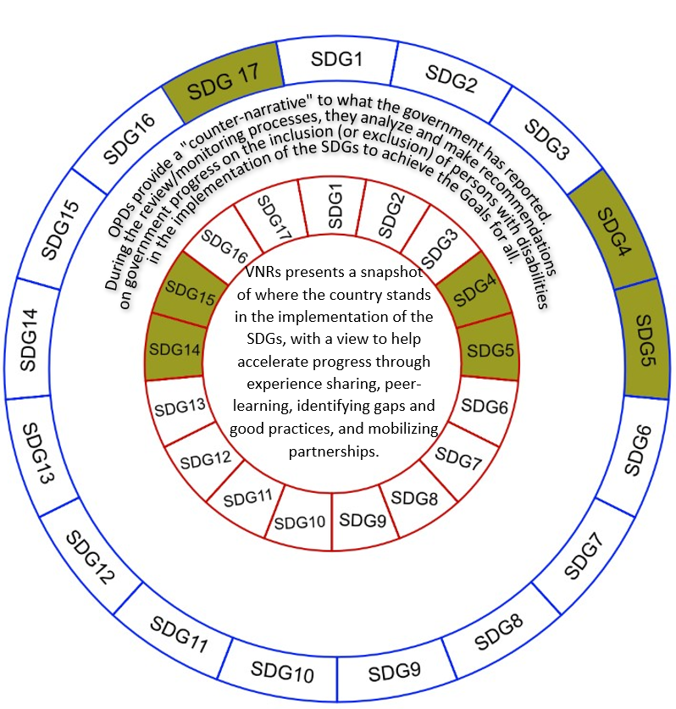
Figure 1: Visualization of the Process and Purpose of the Parallel Report
SDG 4, 5 and 17 provide a gateway for persons with disabilities to be included into Filipino society in a gender sensitive manner. Firstly, SDG 4 ensures inclusive and equitable quality education and promotes lifelong learning opportunities for all. This is supplemented by eliminating gender disparities in education and ensuring equal access to all levels of education and vocational training for the vulnerable, including persons with disabilities, and calls for building and upgrading education facilities that are child, disability and gender sensitive and also provide safe, non-violent, inclusive and effective learning environments for all (UNDESA, 2022a). The CRPD Article 24 on education also ingrains the right to education without discrimination on the basis of equal opportunity; States Parties shall ensure an inclusive education system at all levels and lifelong learning (UNDESA, 2022b). Secondly, SDG 5 aims for gender equality and to empower all women and girls. This can be achieved by ending all forms of discrimination everywhere, eliminating all forms of violence and any harmful practices against women and girls in the public and private spheres (UNDESA, 2022a).

This is entrenched in the CRPD Article 6 which recognizes that women and girls with disabilities are subject to multiple forms of discrimination (UNDESA, 2022b). Finally, SDG 17 aligns with foreign funded projects, in particular Target 17.9 to enhance international support for implementing effective and targeted capacity-building in developing countries to support national plans (UNDESA, 2022a), which aligns with CRPD Article 32 international cooperation requiring that international aid and humanitarian assistance is fully inclusive of and accessible to persons with disabilities (UNDESA, 2022b).

Background

The Philippine government's restrictive pandemic response led to economic contractions that disrupted the country’s development trajectory (NEDA, 2022). Education was heavily impacted and as of March 2020 classes were suspended due to the lockdown and only began to re-open in Aug 2022, ending one of the world's longest education lockdowns (E-Net Philippines, 2022a). Being out of school has serious consequences, with the World Bank examination of 35 studies from 20 countries finding that the longer schools remain closed, the more ground students lose (Patrinos, Vegas, & Carter-Rau, 2022). Even pre-pandemic, the Philippines had among the world’s largest education gaps (Gutierrez, 2022) which is also shown by the findings of a report produced by the World Bank (2022a) where the Philippines had a 90.4 percent learning deprivation rate and a 90.9 percent learning poverty rate.
The lockdown produced many negative consequences for Filipinos due to multidimensional factors. For instance, the Philippines had a lack of Information and Communications Technology (ICT) infrastructure which is costly for families; there was initially a lack of digital literacy for both students and teachers; and the pandemic led to family members playing a key role in educating their children (NEDA, 2022). Further, the pandemic severely impacted the Philippines economically and pushed 4 million more Filipinos into poverty in the first half of 2021 and was particularly potent in rural areas (E-Net Philippines, 2022a). Persons with disabilities were disproportionately impacted by COVID-19 as they face additional barriers such as marginalization or exclusion from full participation (United Nations, 2020). By early 2022, the Philippines did shift from a crisis mitigation position to one of sustained recovery and resilience and in the process aligned all economic recovery programs, for example, the Philippines put into action ‘Executive Order 166 (EO 166) which sets a Ten-Point Policy Agenda on Economic Recovery’ (NEDA, 2022).

SDG Watch in the Philippines (PSA, 2022a) reports on the pace of progress of the SDG, with zan overview provided in Figure 2. This overview shows that 37 out of the 97 targets have a measurable ‘pace of progress’, whilst 60 out of 155 indicators do. Out of these 60 indicators 11 (18.3 percent) are on track, 32 (53.3 percent) are in need of acceleration and 17 (28.3 percent) are in regression. The infographic shows that SDG 4 is making progress since 2000 levels, however SDG 5 available indicators show they are in regression.
Figure 3 and Figure 4 zoom into SDG 4 and SDG 5 specifically and show that SDG 4 is making progress on multiple indicators but is regressing in target 4.5 - access to equal education. SDG 5 there is regression in both violence against women and girls and early marriages. Whereas SDG 17 only has objectives for Target 17.8.1 exposure to the internet which is seeing progress.
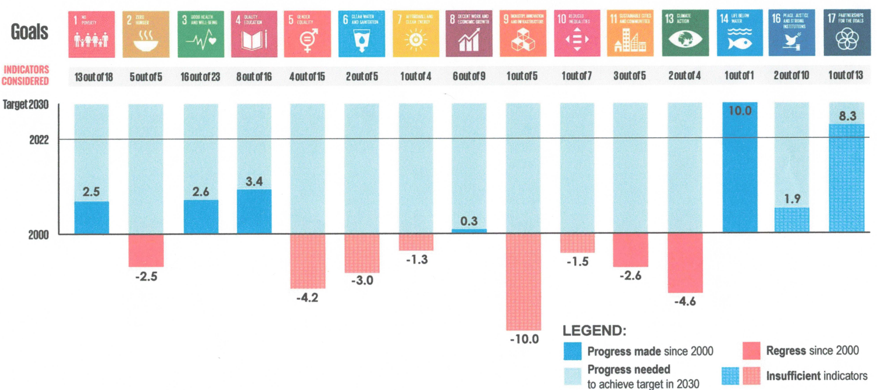

Figure 2: Overall Overview of Progress of SDG Watch in the Philippines (PSA, 2022a)

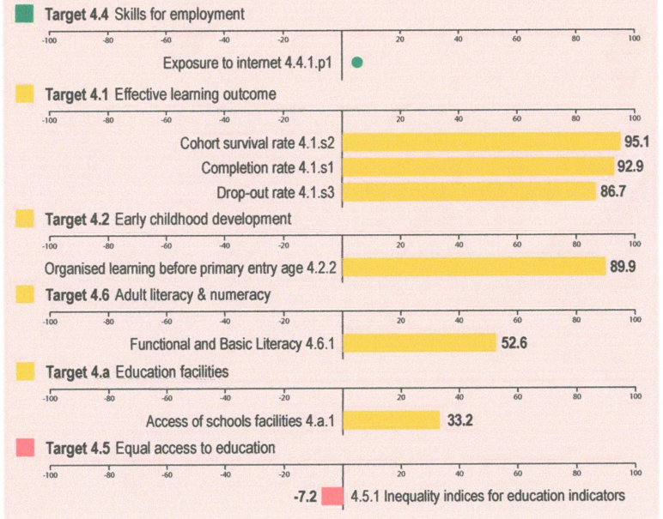

Figure 3: SDG 4 Quality Education Progress - SDG Watch in the Philippines (PSA, 2022a)
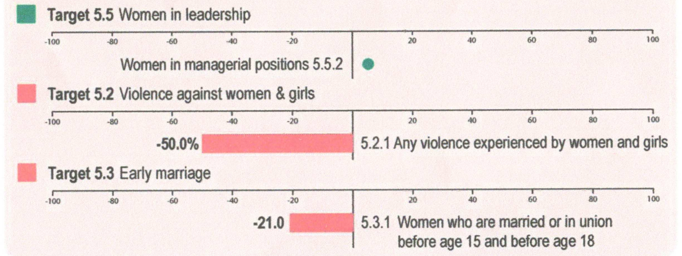

Figure 4: SDG 5 Gender Equality Progress - SDG Watch in the Philippines (PSA, 2022a)

Geolocation and socio-economic status

The Philippines is located in Southeast Asia consisting of 7,641 islands with a total land area of 300,000km. This milieu creates many logistical challenges when it comes to access to education. It is located between the South China Sea and the Pacific Ocean. Further, the Philippines often experiences natural hazards such as typhoons, volcanic eruptions, floods, and earthquakes (DepEd, 2022a). Modern culture has been influenced by periods of occupation by the Spanish, Japanese and Americans. This had led to the Philippines being a predominantly Catholic nation standing at 81.04 percent, other religions are Islam (5.06 percent), Evangelicals (2.82 percent) and the remaining 11.08 percent were either Aglipayan, Iglesia ni Cristo, and others (PSA, 2003).
The Philippine Statistics Authority (PSA) (2022b) estimates that according to the 2020 Census of Population and Housing the Philippines had a total population of 109 million. Split by sex, there are 55.02 million (50.6 percent) males and 53.65 million (49.4 percent) females. Meaning there is a sex ratio of 103 males per 100 females. However, though not officially documented extrapolating from the United Nations (2015) factsheet there could be between 0.05 to 1.7 percent intersex persons. Furthermore, Filipino and English represent the official languages but there are more than 170 indigenous languages (DepEd, 2022a). Estimates suggest 14 to 17 million indigenous peoples that belong to 110 ethno-linguistic groups (DepEd, 2022a).
The Philippines governance is structured into three co-equal branches of government, namely, the Executive, Legislative and Judiciary and is a unitary presidential constitutional republic as the President acts as both the head of state and the head of government (DepEd, 2022a). The structure consists of local government units (LGUs) that exercise jurisdiction over certain territory mandated under the devolution process of 1991 (the Republic Act (R.A.) No. 7160). LGUs have close coordination with centralized governance in areas such as education (DepEd, 2022a). As of 2015, the Philippines has 17 regions, 81 provinces, 146 cities, 1,488 municipalities, and 42,036 barangays, of which 7,437 are classified as urban barangays and 34,599 as rural barangays (DepEd, 2022a).
Economically, the Philippines is a lower middle-income country (World Bank, 2022b). The Human Development Index (HDI) for 2021, ranked the Philippines 116th out of 189 countries with a rating of 0.699; categorized in the bracket of medium human development (UNDP, 2022a). Whereas the Inequality-adjusted Human Development Index (IDHI) for the Philippines was 0.574 in 2021 (UNDP, 2022b), the Philippines's overall loss due to inequality is 17.9 percent, which lowers its overall HDI.

The 2021 female HDI value for Philippines is 0.695 in contrast with 0.702 for males, resulting in a GDI value of 0.990 (UNDP, 2022a). The GII measures gender inequalities in the Philippines had a value of 0.419, ranking it 101 out of 170 countries in 2021 (UNDP, 2022a). Finally, the Gini Index for the Philippines was 42.3 percent in 2018 (World Bank, 2022c). Overall, the Philippines still struggles to close one of the widest wealth gaps in East Asia Ranking 15th out of 65 countries in terms of inequality (Luna, 2022). Luna’s (2022) article summarizes the World Bank report that the top one percent of earners together capture 17 percent of national income, with only 14 percent being shared by the bottom 50 percent. This inequality can have big impacts on human potential and slow down innovation.

Persons with Disabilities population

Results of the 2020 Census of Population and Housing (PSA, 2022c) suggest that 8.7 percent had at least one domain of functional difficulty, this is 8,469,426 persons who are five years and older. Females accounted for 55.6 percent and male’s 44.4 percent. A further breakdown shows 86.0 percent were reported to have mild cases, 9.9 percent had moderate cases and 4.1 percent had severe cases. Out of the severe cases the highest domain of difficulty was in self-caring (150,643 cases), followed by those with difficulty in walking or climbing steps (135,814 cases) and difficulty in communicating (122,027 cases). Data from the (PSA, 2016) survey which aimed to provide information about how people conduct their lives and the difficulties they encounter regardless of any underlying health condition or impairment and to support the attainment of SDG, the implementation of the CRPD and to bring persons with disabilities into the mainstream development in achieving AmBisyon Natin 2040. The report provided data (that only includes persons with disabilities over the age 15 years) on a diverse range of themes. For instance, the prevalence of severe disability among those surveyed is 12 percent and disaggregated by sex, women experienced a higher rate of severe disability than men, 60-40 percent respectively. Furthermore, the Philippine Health Insurance Corp. (PhilHealth) estimated that 1 out of 7, or 5.1 million Filipino children are living with disabilities (UNICEF, 2018), whilst the findings of the Development Academy of the Philippines (DAP) in 2018 found that 1 out of 5 persons with disabilities in the Philippines are children aged 0-14 and that 26.56 percent of children living with disabilities are poor (DAP, 2018). UNICEF (2022) study on the ‘Costs of Raising Children with Disabilities in the Philippines (CRCWD) suggested that only 1 in 5 children with disabilities has a disability ID card.

Education structure

School systems
The Philippines education system is organized into four levels (DepEd, 2022a), which include:
- Early Childhood Care and Development (ECCD); under the Early Childhood Care and Development Council, entails leading government programmes for children aged 0–4 years in areas on health, nutrition, early education, and social services. Under the leadership of ECCD, LGUs provide services, such as pre-school education (DepEd, 2022a).
- The Basic Education under the Department of Education (DepEd); includes both public and private schools. Formal education is compulsory and free and is structured into one year in kindergarten which learners can start at age 5, then 12 grades of formal education that typically consists of six years of elementary education, four years of junior high school and two years of senior high school. Currently, in the public school system there are a total of 47,421 schools with 37,496 being elementary schools, 1,506 being junior high schools and 231 senior high schools. In addition, there are 13,256 schools that are privately run, 247 operated by state universities and colleges or local universities and colleges. There are also 25,291 Community Learning Centers (CLC) (DepEd, 2022a). Additional DepEd's responsibilities include “technical-vocational high schools run by DepEd, as well as the Alternative Learning System (ALS)” (DepEd, 2022a:22). Furthermore, out of the 965,660 DepEd regular employees, 847,465 are teaching personnel (including ALS) with 67,291 senior high school teachers, 276,778 junior high school teachers and 503,396 elementary school teachers, supplemented by 51,868 teaching-related personnel (4,747 at senior high school, 16,680 at junior high school and 30,441 at elementary school) (DepEd, 2022a). In the private sector during the school year 2019–2020 there were 72,141 teachers in elementary, 55,512 in junior high school and 45,558 in senior high school (DepEd, 2022a).
- The Technical and Vocational Education and Training (TVET); under the Technical Education and Skills Development Authority (TESDA); Technical-vocational schools (outside of DepEd) are certified and governed by TESDA. Under the R.A. No. 7796 TESDA “formulates human resources and skills plans, sets appropriate skills standards and tests, and coordinates and monitors human resources policies and programs” (DepEd, 2022a:22).
- The Higher Education under the Commission on Higher Education (CHED); operates at tertiary level and under CHED that works to ensure access to “quality higher education, guaranteeing and protecting academic freedom for continuing intellectual growth, the advancement of learning and research, the development of responsible and effective leadership, and the education of high-level professionals” (DepEd, 2022a:22).

Department leads and mandates
In addition to the ECCD, DepEd, TESDA and CHED there are multiple stakeholders in the Philippines’ education systems with the most relevant stakeholders and their mandates outlined in Table 1 below.
Table 1: Philippine Education System, the Relevant Stakeholders and Mandates
Stakeholders | Mandate
Early Childhood Care and Development (ECCD) council | Mandated by R.A. 10410, or the Early Years Act of 2013, to act as the primary agency supporting the government’s ECCD programs that covers health, nutrition, early education, and social services for children ages 0-4 years. It is responsible for developing policies and programs, providing technical assistance and support to ECCD service providers, and monitoring ECCD service benefits and outcomes (ECCD Council, 2022).
Department of Education (DepEd) | Mandated through R.A. 9155, otherwise known as the Governance of Basic Education act of 2001. DepEd formulates, implements, and coordinates policies, plans, programs and projects in the areas of formal and non-formal basic education. It supervises all elementary and secondary education institutions, including ALS, both public and private; and provides for the establishment and maintenance of a complete, adequate, and integrated system of basic education relevant to the goals of national development (DepEd, 2022b).
Technical Education and Skills Development Authority (TESDA) | Sets the direction, promulgates relevant standards, and implements programs geared towards quality assured and inclusive technical education and skills development and certification system (TESDA, 2022).
The Higher Education under the Commission on Higher Education (CHED) | In line with R.A. No. 7722, the CHED is mandated to set minimum standards for programs and institutions of higher learning recommended by panels of experts in the field subject to public hearing, and to enforce the same (PQF, 2022).
Department of Health (DOH) | Mandated to be the overall technical authority on health. DOH provides national policy direction and develops national plans, technical standards and guidelines on health. It is also a regulator of all health services and products; and provider of special or tertiary health care services and of technical assistance to other health providers specially to LGU (DOH, n.d.).
Philippine Commission on Women (PCW) | Policymaking and coordinating body on gender equality and women’s empowerment, commits to sustain the promotion of women’s socio-cultural, economic, civil, and political rights through the provision of: 1.) relevant and responsive policy development, advocacy, monitoring and evaluation, 2.) appropriate and strategic technical assistance (PCW, 2022).
Persons with Disabilities Affairs Office (PDAO) | Under the RA No.10070, formulate and implement policies, plans and programs for the promotion of the welfare of persons with disabilities in coordination with concerned national and local government agencies. For instance, coordinate and implement the provision of the Accessibility Law, and other relevant laws at the local level (NCDA, 2016).
Department of Social Welfare and Development (DSWD) | Mandated to develop, implement and coordinate social protection and poverty-reduction solutions for and with the poor, vulnerable and disadvantaged (DSWD, 2019a).
Local Government Units (LGU) | Under Article X Section 13 of the Constitution the LGU group themselves, consolidate or coordinate their efforts and resources for the purpose commonly beneficial to them in accordance with the law (DOH, 2022).
Local School Board (LSB) | Under the R.A. No. 7160, popularly known as the Local Government Code of 1991 (LGC 91). Its main duty is to allocate the Special Education Fund (SEF) to meet the supplementary needs of the local public school system (Robredo, n.d.).
Council for the Welfare of Children (CWC) | Coordinate the implementation and enforcement of all laws; formulate, monitor and evaluate policies, programs and measures for children. Providing dynamic leadership in ensuring a child-friendly and child-sensitive society where every child fully enjoys his/her rights (CWC, 2022).
National Council on Disability Affairs (NCDA) | Mandated to be the policymaking, planning, monitoring and advocacy body of the government for the prevention of the causes of disability, rehabilitation and equalization of opportunities in the context of a rights-based society for persons with disabilities (NCDA, 1987).
Civil Society Network for Education Reforms or E-Net Philippines (90 members from CSOs, NGOs, and People's Organization, nationwide) | Committed to expand and strengthen civil society participation in reforming the Philippine education system and in developing ALS with special concern for the marginalized, excluded and vulnerable sectors. “Education for All” has been its banner call then, and now as we endeavor to continue the Education for All movement in the light of the new SDG 4 – Ensure Inclusive and Equitable Quality Education and Promote Lifelong Learning Opportunities for All (E-Net Philippines, 2022b).
Unang Hakbang Foundation | An organization providing services for children with remedial classes in reading, writing, and Math. The objective is for children not to drop out from school and Targets Kindergarten to Grade 3. They develop peer tutors and deploy them in their communities; monitor the progress of peer tutors and their peers that they are teaching.
Women’s Legal and Human Rights Bureau (WLB) | A feminist non-government organization promoting the rights of women and girls. They provide training, research, advocacies including legislative advocacies and partner with government agencies to promote the rights of women and girls.

Other main stakeholders include Philippine colleges and universities, parent-teacher community associations, teacher education institutes and the development community; multinational organizations (e.g., World Bank, Asian Development Bank, etc.), think tanks, non-governmental organizations (NGO) and Civil Society Organizations (CSO) (DepEd, 2022a).

Systems
In the Philippines, a thirteen-year education is mandatory by law running from kindergarten up to grade 12, this is referred to as the K-12 programme. DepEd provides different educational programmes for learners with disabilities (Beyond Education, 2021:35). These full under the banner of Special Education (SPED) programs (DepEd,1997) which “aims to provide access to basic education among children with special needs, namely, the gifted/talented, the mentally retarded, the visually impaired, the hearing impaired, the orthopedically handicapped, the learning disabled, the speech defectives, the children with behavior problems, the autistic children and those with health problems through the formal system and other alternative delivery services in education”. These 3 main programmes are outlined below:
- Segregated classes (self-contained): available for learners with moderate to severe disabilities, the SPED program was initiated in 1997 as DepEd’s implemented the Magna Carta for Disabled Persons. SPED centers are required in all districts (Beyond Education, 2021). The total number of SPED Centers and mainstream schools offering SPED Programs (as of February 2017) was 648, with 471 being elementary and 177 for high school (DepEd, n.d). Figure 5 below provides data into the number of SPED teachers from academic year 2012-13 to 2020-21, which has increased from 2,089 teachers in 2012-13 to 4,882 teachers in 2020-21. Additionally, the DepEd (n.d:5-8) document provides a list of 15 DepEd Order No. programs of the Department that implement inclusive education for learners with disabilities from 1997 to 2017.
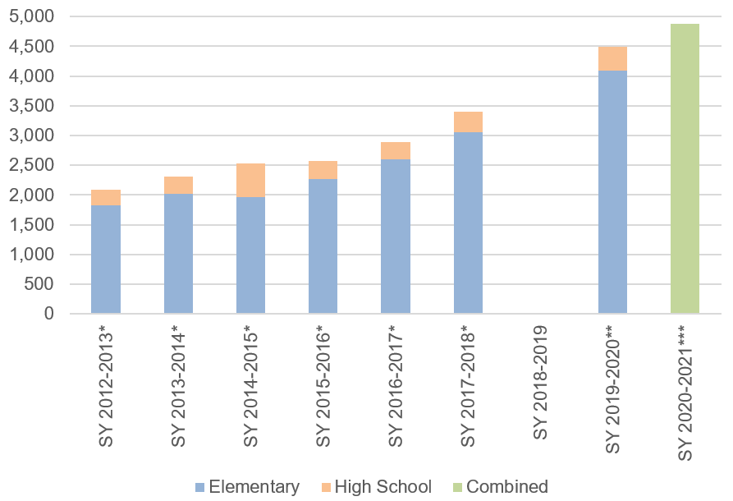
Figure 5: Number of SPED teachers from SY 2012-2020 (*DepEd, n.d; **de la Fuente, 2021; ***DepEd, 2022e)
- Integrated class (inclusion of children with disabilities in the mainstream class): entails enrollment into mainstream classrooms and are provided with support services. This can take the form of partial or full integration. Partial integration is when learners with disabilities are enrolled in a SPED class but integrated with learners without disabilities in non-academic activities, whereas full integration occurs when learners with disabilities are enrolled in a mainstream class for academic and non-academic activities (Beyond Education, 2021).
- A resource room program: this refers to when a learner with disability is partially pulled out of a mainstream class and is taught by a SPED teacher (Beyond Education, 2021).
Additionally, there is the possibility of Inclusive Class: UNICEF (2017:3) defines this as an education system that will “accommodate all students whatever their abilities or requirements, and at all levels”. Whereas the DepEd’s (2009:1) ‘Department of Education Order No. 72’ defines inclusive education as “the philosophy of accepting all children regardless of race, size, shape, color, ability or disability with support from school staff, students, parents and the community”. UNICEF (2017: 3) states this means that education environments will “adapt the design and physical structures, teaching methods, and curriculum as well as the culture, policy and practice of education environments” to be accessible for all students without discrimination, including those without disabilities.

However, Beyond Education (2021) concludes that there is a lack of data on the total number of schools implementing inclusive education in the Philippines. Though there are some select case studies in Baybay City, Cagayan de Oro City and Mandaluyong City.

Overall situation of learners

DepEd (2022a) compiles information from a range of sources that state that in 2019 there was a mean of 9.4 years of completed schooling. Further, an additional report showed that in 2018 the average school life expectancy was 6.13 years in elementary education (6.01 for females, 6.25 for males) and 5.06 years in secondary education (5.33 females, 4.80 males). E-Net Philippines (2022a) provides insight to the Philippines education context during the pandemic, with pilot testing of face-to-face classes starting in November 2021 after the initial face to face suspension in March 2020. The official enrollment data produced by DepEd under the Learner Information System (LIS) shows that as of November 2021 formal basic education enrollment reached 27,232,095 as of 15 November 2021 which was 3.83 percent higher than the previous school year. However, it was noted that more than 2 million learners were left out of the school year despite the schools’ extensive enrollment. Furthermore, this shift to distance learning accompanied by continued COVID-19 uncertainty led to a decline in total basic education enrollment. As for the ALS enrollment displayed a 60 percent decrease compared with the previous year. When considering the gender dimensions, a survey noted that nearly 71 percent of Filipina respondents categorized education as one of the main aspects of their lives that was most impacted by COVID-19 (E-Net Philippines, 2022a). The Philippine Magna Carta of Women gender-related modules have been developed and implemented in the basic education curriculum, this is done to avoid proliferating gender stereotypes through images and language (UNESCO, 2021a).

Specific situation and concerns of learners with disabilities

The DepEd programme for learners with disabilities represents 1.34 percent of the total enrollment (E-Net Philippines, 2022a), which is much lower than the estimated 1 out of 7 Filipino children who are living with disabilities suggested by UNICEF (2018). Supplementing this is the ALS enrollment rate, which dropped by 60 percent. This is an issue for learners with disabilities as the ALS Act aims to “design specialized programs for learners with disabilities, taking into consideration their different levels of learning needs and other functional difficulties in the development of instructional materials and learning resources in accessible formats” (E-Net Philippines, 2022a:3). E-Net Philippines (2022a) report mentions several other concerns, for instance, the CHED suspended the scholarship for the academic year 2022-2023, because of ‘budget inadequacy’ even though this programme was supposedly intended for the underprivileged, such as learners with disabilities. E-Net Philippines (2022a) points out that the Special Education Fund (SEF) of the LGU were supplementing the needs of learners and teachers during the pandemic but this varied significantly among LGUs.

Furthermore, basic Education Facilities Programme funding decreased by 46.5 percent and other budgets that support marginalized learners decreased by 8.4 percent namely the Flexible Learning Options, which covers the ALS, Alternative Delivery Mode, and Education in Emergencies. The NCDA (2017) report provides a ‘directory of disability inclusive schools’ throughout the Philippines, though many of these schools only accept learners with certain types of disabilities.
ABS-CBN (2022) reported in a September 2022 news article that the DepEd had to deny claims that it deliberately excluded funding for programs catering to learners with disabilities under its proposed 2023 budget. The DepEd stated that "Unfortunately, despite our earnest efforts to advocate for our learners with special needs, it was not considered in the National Expenditure Program (NEP). This is true for two other programs that were excluded from the NEP. This is a recurring circumstance every year, and DepEd is not at a loss because we always work with members of Congress to find other ways to fund DepEd programs. In the past years, DepEd has likewise made efforts within the organization to ensure that programs are supported".
Drafting process
Though the emphasis is the interconnectedness of the SDG, this report focuses on SDG 4, 5 and 17. Table 2 below is a list of activities and their corresponding timeframe. The webinars targeted a diverse group of persons with disabilities including under-represented groups such as deaf-blind and psychosocial and women and girls with disabilities. Also, parents groups, CSOs, and government agencies attended. Table 3 shows the representation by sex and disability at the workshop activities.

Table 2: Report Activities and their Corresponding Timeframe
Activities | Dates
Initial concept and design | August, 2022
Workshop series: | Blank
Workshop 1: Introduction to Agenda 2030 and the SDG | August 4, 2022
Workshop 2: Process of SDG parallel report writing, other monitoring tools, VNR process | August 5, 2022
Workshop 3: SDG and the CRPD | August 8, 2022
Workshop 4: Focusing on SDG | August 10, 2022
Workshop 5: Sharing of the Tools | August 11, 2022
Focus Group Discussions (FGD):  - Disability experts  - Learners with Disabilities  - Teachers  - Parents | 18 August 2022 to 27 August 2022
Key Informant Interviews (KII):  Interview with government agencies and CSOs | 17 November 2022 to 25 November 2022

Table 3: Breakdown of Participants from the 5-Day Workshop According to their Disability and Sex
 | Total participants with disabilities/ total number of participants | Participants with disabilities by Sex |  | Type of Disability
 |  |  |  | Physical |  | Visual |  | Hearing |  | Psychosocial |  | Intellectual |  | Deafblind |  | Speech
 |  | M | F | M | F | M | F | M | F | M | F | M | F | M | F | M | F
Day 1 | 21/ 28 | 10 | 11 | 5 | 2 | 3 | 3 | 1 | 2 | 0 | 1 | 0 | 1 | 1 | 1 | 0 | 1
Day 2 | 18/ 27 | 11 | 7 | 6 | 2 | 2 | 2 | 2 | 0 | 0 | 1 | 0 | 1 | 1 | 1 | 0 | 0
Day 3 | 15/ 23 | 9 | 6 | 4 | 1 | 3 | 2 | 1 | 0 | 0 | 0 | 0 | 1 | 1 | 1 | 0 | 1
Day 4 | 16/ 23 | 10 | 6 | 4 | 2 | 3 | 2 | 2 | 1 | 0 | 0 | 0 | 0 | 1 | 1 | 0 | 0
Day 5 | 16/ 24 | 10 | 6 | 4 | 1 | 3 | 2 | 2 | 1 | 0 | 0 | 0 | 0 | 1 | 1 | 0 | 1

Methodology
The study deployed qualitative methods of collecting primary data through Focus Group Discussions (FGD) and Key Informant Interviews (KIIs). This was supplemented by secondary information acquired by reviewing open access documents, including but not limited to government policies, government reports, CSO reports and those from the United Nations and other development partners. To ensure ownership of the SDG at the national and local level interviews were conducted to ensure the most marginalized disabilities could participate. Purposive sampling was used to determine FGDs which made it possible to reach women with different disabilities and persons with psychosocial and intellectual disabilities, and persons from different geographic locations. The KIIs were conducted with relevant government agencies. The questions proposed were based on SDG 4, 5 and 17 that were of relevance to this study and outcomes from the 5-day workshop. The characteristics of participants from the FGDs and KIIs are disaggregated and outlined in Appendix 1.

Aims and Objectives
This report aims to examine the extent to which the Philippines activities aimed at achieving the realization of SDG 4 include and consider persons with disabilities and if these activities comply with its commitments under the CRPD. The main focus is on the current status of Education in relation to SDG 4 (all Targets) applying the lens of gender equality under SDG 5 (Target: 5.1, 5.2 and 5.4) and considering the contribution of efforts towards achieving it under SDG 17 (Target: 17.9).
The specific objectives were to:
- Reflect on the implementation of the State’s activities, policies, and directions of the Government’s 2030 Agenda in relation to persons with disabilities, regarding Goal 4 (Ensure Inclusive and Equitable quality education) then also elements of both Goal 5 (Gender Equality) and Goal 17 (Partnership of the Goals).
- Discuss the Development Agenda 2030 compliance with the CRPD principles.
- Provide insight into the current situation of persons with disabilities, individuals and organizations from their perspective towards linking the CRPD and the SDG.
- Provide recommendations for future actions.

Legal frameworks and stakeholders

Global/Regional
Internationally and regionally, the Philippines has assented and/or ratified several instruments that were designed to protect the Filipino right to education and the specific rights of persons with disabilities. The State has a responsibility to secure and guarantee these rights stated in treaties, charters and strategies seen in Table 4 below. These instruments are supplementary to the CRPD and the SDG. Briefly, these instruments are 1) the Universal Declaration of Human Rights (1948) Article 26 that gives everyone the right to education; the Convention on the Rights of the Child (CRC) (1989) Article 23 that requires State Parties to provide for a child with a disability to enjoy a full and decent life; and the International Convention on the Elimination of All Forms of Discrimination Against Women (CEDAW) (1979) Article 10 “Parties shall take all appropriate measures to eliminate discrimination against women in order to ensure them equal rights with men in the field of education”.
Table 4: Global and Regional Disability-Focused Policies and Laws
Instrument | Relevant articles
Universal Declaration of Human Rights (1948) | Article 26: “everyone has the right to education”.
International Covenant on Economic, Social and Cultural Rights (1966) | Article 3: requires States to ensure that men and women enjoy equal rights in their entire economic, social and cultural rights.  Article 13: right to education.
Convention on the Rights of the Child (1989) | Article 23: requires State Parties to provide for a child with a disability to enjoy a full and decent life.  Article 28: “every child has a right to education” without discrimination.
International Convention on the Elimination of All Forms of Discrimination Against Women (1979) | Article 10: “Parties shall take all appropriate measures to eliminate discrimination against women in order to ensure equal rights with men in the field of education”.
United Nations Declaration on the Rights of Indigenous Peoples (2007) | Article 14: indigenous individuals, especially children, have the right to all levels and forms of education of the State, without discrimination ... where possible ... in their own culture and provided in their own language.
Salamanca Statement | Provides guiding principles on the inclusion framework: “school should accommodate children regardless of their physical, intellectual, social, emotional, linguistic or other conditions”.
Incheon strategy | Goal 5: Expand early intervention and education of children with disabilities.
CRPD General comment No. 2 (2014) Article 9: Accessibility | “Without accessible transport to schools, accessible school buildings, and accessible information and communication, persons with disabilities would not have the opportunity to exercise their right to education (art. 24 of the Convention)”.  “In order to foster accessibility, education as well as the content of school curricula should promote and be conducted in sign language, Braille, alternative script, and augmentative and alternative modes, means and formats of communication and orientation (art. 24, para. 3 (a)), with special attention to the appropriate languages and modes and means of communication used by blind, deaf and deaf-blind students”.

National
Nationally, the State is duty bound to protect and promote the right of all citizens to quality education at all levels and shall take appropriate steps to make such education accessible to all. The Philippines has legislated for this right through the creation of multiple Acts designed to protect the rights of persons with disabilities and persons without disabilities. These can be seen in Table 5 below. The R.A. No. 7277 declares it is unlawful for any educational institution to refuse a person’s admission to the institution because of disability. There are specific accommodations that are rights for persons with disabilities, such as R.A. No. 9442 provide educational assistance using different mechanisms; the anti-Bullying Act of 2013 has zero tolerance against all forms of abuse, violence, exploitation, neglect, discrimination, and maltreatment against learners; the Filipino Sign Language Law requires official communication accessible for the deaf; and the Batas Pambansa 344 which requires building to be accessible. Furthermore, the Alternative Learning System (ALS) Act establishes Inclusive Learning Resource Centers of Learners with Disabilities in all School Districts, Municipalities and Cities. DepEd has specific gender related policies, such as the DO 32, S. 2017 allow the Department to integrate the principles of gender equality, gender equity, gender sensitivity, and non-discrimination. Thus, for the DepEd, CHED and TESDA to fulfill their primary obligation to provide education and training to all learners they must provide support services. For instance, “assistive devices and technology, sign language interpretation, specialized materials and equipment, augmentative and alternative modes of communications, and other support services to facilitate the effective education and training of all learners with special needs” (CHR, 2019:7).

As of March 11, 2022, there was progress in legislating for learners with disability with the approval by the 18th Congress of the R.A. 11650, “Instituting a Policy of Inclusion and Services for Learners with Disabilities in Support of Inclusive Education Act”. This law mandates that learners with disabilities have access to free, appropriate, quality inclusive education.

As of December 2022, the law has yet to be fully rolled out and the implementation rules and regulations (IRR) yet to be formulated, but there has been a one-week stakeholder consultation workshop for the IRR ran by DepEd, with CSOs (e.g., E-Net Philippines), OPDs (e.g., Life Haven CIL) and INGO (e.g., CBM Global Philippines). The highlights of this Law consist of free and appropriate public early and basic education and support and related services based on their needs in preparation for independent living and community life, Inclusive Learning Resource Centers of Learners with Disabilities (ILRCs) (At least 1 in all cities and municipalities, in every School district), Child Find System and an Individualized Education Plan. Thus, no learner shall be denied admission on the basis of disability, the IRR will include minimum services and conditions to be included in the admissions systems and policies of the school.
Table 5: National Disability-Focused Policies and Laws
Instrument | Relevant articles
Republic Act No. 7277: Magna Carta for Disabled Persons. Then there is the R.A. 9155, and R.A. 10070 - Acts Amending Republic Act No. 7277 | R.A. No. 7277  Section 12: mandates equal access to education for all by declaring it unlawful for any educational institution to refuse a person’s admission to the institution because of disability (Beyond Education, 2021). Further, appropriate steps will be enacted to make sure education is accessible to all persons with disabilities.  Section 13: the State shall provide financial assistance to economically marginalized but deserving ‘disabled students’ pursuing post-secondary or tertiary education with at least five percent of the allocation for the Private Education Student Financial Assistance Program created by virtue of R.A. 6725 shall be set aside for disabled students pursuing vocational or technical and degree courses.  Sec. 14: the State shall establish, maintain and support a complete, adequate and integrated system of special education in all regions of the country. The National Government shall allocate funds necessary for the effective implementation of the special education program nationwide. Local government units may likewise appropriate counterpart funds to supplement national funds.  Sec. 15: the State shall provide disabled persons with training in civics, vocational efficiency, sports and physical fitness, and other skills. The Department of Education, Culture and Sports shall establish in at least one government-owned vocational and technical school in every province a special vocational and technical training program for disabled persons. It shall develop and implement sports and physical fitness programs specifically designed for disabled persons taking into consideration the nature of their handicap.  Sec. 16: the State shall develop non-formal education programs intended for the total human development of disabled persons. It shall provide adequate resources for non-formal education programs and projects that cater to the special needs of disabled persons.  Sec. 27: the Department of Social Welfare and Development shall develop a program to assist marginalized disabled persons gain access in the use of public transport facilities. Such assistance may be in the form of subsidized transportation fare.  R.A. 9155  Educational assistance to persons with disability, for them to pursue primary, secondary, tertiary, post tertiary, as well as vocational or technical education, in both public and private schools, through the provision of scholarships, grants, financial aids, subsidies and other incentives to qualified persons with disability, including support for books, learning material, and uniform allowance to the extent feasible.
Republic Act No. 9442: The Magna Carta for Disabled Persons - an Act Amending Republic Act No. 7277 | Provide educational assistance to persons with disability, for them to pursue primary, secondary, tertiary, post tertiary, as well as vocational or technical education in both public and private schools through the provision of scholarships, grants, financial aids, subsidies and other incentives to qualified persons with disability, including support for books, learning materials, and uniform allowance, to the extent feasible (NCDA, 2008).
Republic Act No. 10627 or the Anti-Bullying Act of 2013 | Requires all elementary and secondary schools to adopt policies to prevent and address the acts of bullying in their institutions. ‘DepEd Child Protection Policy’, created to enact a zero tolerance against all forms of abuse, violence, exploitation, neglect, discrimination, and all other forms of maltreatment against learners (DepEd, 2022a).
Republic Act 11106: Filipino Sign Language Law | Recognizes, promotes and supports the medium of official communication in all transactions involving the deaf, and as the language of instruction of deaf education, without prejudice to the use of other forms of communication depending on individual choice or preference (NCDA, 2018).
Republic Act 11510: Alternative Learning System Act | Supports the design of specialized programs for learners with disabilities, taking into consideration their different levels of learning needs and other functional difficulties in the development of instructional materials and learning resources in accessible formats (DepEd, 2022a).
Republic Act 11650, the Instituting a Policy of Inclusion and Services for Learners with Disabilities in Support of Inclusive Education Act | Mandates the Inclusion and Services for Learners with Disabilities in Support in Inclusive Education, Establishing Inclusive Learning Resource Centers of Learners with Disabilities in all School Districts, Municipalities and Cities (PASP, 2022).
Batas Pambansa 344 (B.P. 344) | Enhances the Mobility of Disabled Persons by Requiring Certain Buildings, Institutions, Establishments and Public Utilities to install Facilities and Other Devices (NCDA, 1983).
DO 32, S. 2017 – Gender-responsive basic education policy | Gender-Responsive Basic Education that shall allow the Department to integrate the principles of gender equality, gender equity, gender sensitivity, non-discrimination, and human rights in the provision and governance of basic education (DepEd, 2017).
DepEd Child Protection Policy, Order No. 40, s. 2012 | Promotes zero-tolerance policy for any act of child abuse, exploitation, violence, discrimination, bullying and other related offenses.
Gender equality is enshrined in the 1987 Constitution (Art. 14, Section 14). | Establishes a non-discriminatory and pro-gender equality and equity framework for policy formulation and implementation. In relation to education, it reaffirms the right of equal access and elimination of discrimination in education, scholarships and training. In addition, it declares unlawful the discrimination in education of women due pregnancy out of marriage in the form of expulsion, non-readmission or enrollment prohibition (UNESCO, 2021a).

SDG Desk Research

Below are the secondary findings on the current situation of learners with disabilities, relating to the relevant objectives outlined in SDG 4, 5, and 17.

SDG 4 Quality Education and CRPD Article 24 Education
Securing the rights of children attaining quality education remains one of the prime objectives of the government (NEDA, 2022). The VNR 2022 outlines that from 2016-2020, the net enrollment rate for elementary school recorded a decline of 7.1 percent, with Secondary Junior High School and Secondary Senior High School increasing respectively (NEDA, 2022). According to DepEd (2022a), the ALS programs in 2019 had 760,000 learners, with two-thirds of ALS learners being male, in which 75 percent were part of the accreditation and equivalency (A&E). There was a major decline during COVID-19 to almost 480,000 ALS learners in 2020. The reasons given were that learners prioritized income activities instead of education and training. For ALS learners who are parents, they would prioritize younger learners remote learning instead of their own. There was a fear from ALS learners that they would not be able to get certified through the program due to COVID-19. DepEd (2021a) reported that there were 4 million enrollees from 2016 to 2021 in the ALS program, but there was no available disaggregated data that shows how many learners have disabilities.
Focusing on disability, the DSWD (2019b) ‘Listahanan 2’ report found that 2 in every 3 poor learners with disabilities (aged 6 to 14 years old) are out-of-school in all regions, whilst 6 out of 10 were male. The report goes on to provide the findings that 51.0 percent of poor learners with disabilities identified (aged 15 years old and above) had attended or completed elementary education, 20.3 percent for high school, 3.0 percent for college level, 0.02 percent had obtained a post-baccalaureate degree, whilst 23.8 percent of the poor learners with disabilities did not finish any grade level. Additionally, there were a total of 360,879 learners with disabilities in the school year 2019–2020 outlined in Figure 6 (DepEd, 2022a). Males represented 57.76 percent of SPED enrollment, creating a 15.53 per person advantage over females (de la Fuente, 2020). Though there is lower access of girls to SPED centers, it was suggested there is no statistical reason for this, and the gender gap was due to different factors. Furthermore, de la Fuente (2020) calls attention to the deficient number of SPED centers despite the DepEd Order No. 72 series of 2009 on inclusive education. 84 percent of municipalities do not have SPED centers. Citing that this is due to “the inaccessible infrastructure, the lack of trained teachers and specialists, the lack of adequate screening systems, and comprehensive support to learners with disabilities” (de la Fuente, 2020).
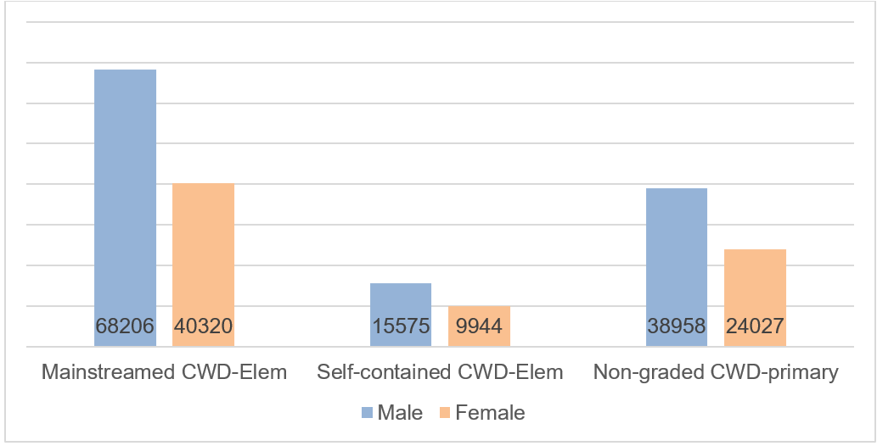
Figure 6: Children and Learners with Disabilities in Special Education Programmes SY 2019-2020 (DepEd, 2022a)
The pandemic impacted heavily on learners with disabilities in multidimensional ways, which is shown in the UNICEF et al. (2022) collaborative research on the impact COVID-19 had on the provision of both mainstream and disability-specific services for children with disabilities. The research collected quantitative and qualitative data from 6,561 respondents, with most data provided by parents representing their children with disabilities. The report outlines concerns accessing services: with 52 percent of respondents stating their inability to access education services and learning resources; 51 percent had troubles accessing child development services; with 49 and 43 percent struggling to access habilitation and rehabilitation services and general health services respectively. This restriction in access to services was mainly attributed to financial constraints (46 percent) and lack of transportation (43 percent). This decline in access was exacerbated with 14 percent of respondents reporting a decline in mental health, a 1.4 percent increase in the frequency of domestic violence and child abuse (59 percent males and 41 percent females), with sexual abuse being reported by 13 percent of child respondents (93 respondents). The key recommendations were to uphold the Rights of Children with Disabilities in areas of Right to Survival (e.g., disability-targeted materials and provisions), Right to Development (e.g., accommodations for different learning needs), Right to Protection (e.g., adaption of case management protocols and processes), and Right to Participation (e.g., bring relevant partners in different thematic areas together).
Recently, the legislative commitment for learners with disabilities was boosted by the signed R.A. 11650 or the ‘Instituting a Policy of Inclusion and Services for Learners with Disabilities in Support of Inclusive Education Act’, with the DepEd ensuring and leading in the implementation to guarantee learners with disabilities to access to free public early and basic education services (Yang, 2022). This is much needed, as Romero (2021) news article (using data extrapolated from the DepEd) showed that out of the estimated 444,294 children with disabilities, only 112,810 are enrolled in 2021, slightly up from the 111,521 enrolled in 2020 (from estimated 437,598).
However, this is a rapid decrease from the 360,879 enrolled in 2019, with an estimated population of 431,004. This data of learners with disabilities indicates that enrollment in basic education remains far from that found pre-pandemic levels (Romero, 2021). Sevillano (2022) article found that 152,420 female learners enrolled in the school year 2019-2020, which decreased to 38,914 enrollees in the school year 2021-2022. The rationale given by Annalyn Aquino (DepEd Senior Education Program Specialist of Student Inclusion Division-Bureau of Learning delivery) is that learners with disabilities were not being properly tagged in the LIS, particularly learners entering mainstream classes.
There are numerous different barriers that limit the provision of inclusive quality education as articulated in the CRPD Article 24, that requires State Parties to ensure an inclusive education system at all levels as well as lifelong learning. Firstly, there appears to be different interpretations in understanding between inclusive education and special education (Connie, 2021) with Muega (2016) research conducted in private education in Quezon City finding that teachers, school administrators, and parents of learners with disabilities that though participants accepted the practice of inclusion, though they believed they were practicing inclusive education, there was limited understanding of what inclusive education entailed. Secondly, UNESCO (2021b: 22) report (referred to Kenneth and Sales, 2019) writes that “challenges faced by the teachers in inclusive education are lack of special education teachers, lack of facilities for special care, lack of special education classes, lack of appropriate resources and inappropriate allocation of learning materials”. Thirdly, a study found that bullying was reported to be experienced in schools, particularly among children with disabilities and was a reason for dropouts (DepEd, 2022a). None of the learners interviewed in this study reported getting any counseling or mental health support from the school or the community (DepEd, 2022a). Furthermore, participating countries in the Program for International Student Assessment found the Philippines has the highest incidence of bullying (DepEd, 2022a). With 65 percent of learners reporting that they were bullied at least a few times a month, which is a high contrast to the 23 percent average across OECD countries (DepEd, 2022a). Fourthly, according to some respondents from Beyond Education (2021) it was found that the majority of schools are still not compliant with the Accessibility Law. Fifthly, there is a lack of sensitivity towards learners with disabilities as there is a one-size-fits-all inclusive education curriculum (de la Fuente, 2020). Finally, the UNICEF (2022) study on the CRCWD suggest that families with children with a disability (with disability identification) and children with functional limitations (without disability identification) situation was ‘systematic disadvantage’ across multiple dimensions (which includes education). The report found that “children without a disability ID card completed higher levels of education compared with children with a disability card. A higher proportion of children completed primary education (44 percent compared with 33 percent); lower secondary education (32 percent compared with 16 percent); and upper secondary education (5 percent compared with 2 percent)” (UNICEF, 2022b:41). The interviews found that there were common costs for learners with and without disabilities such as school uniforms, books and school fees. However, this cost was supplemented for learners with disabilities in the higher fees in SPED schools when a shadow or support teacher is required and transportation costs. Furthermore, learners with disabilities, particularly behavioral difficulties, due to having less school options to choose from led to them having to travel longer. It was reported that some learners with disabilities were denied access to school and at a later date the school had requested their parents to withdraw their child.

SDG 5 Gender Equality and CRPD Article 6 Women with Disabilities
The VNR report (NEDA, 2022) outlined that the Philippines remains a progressive country in terms of gender equality, steadily making considerable strides compared to other countries in Southeast Asia. In 2022, the Philippines recorded a gender gap of 21.7 percent, similar to the previous year (World Economic Forum, 2022). The number of reported violence against women and children decreased from 60,755 in 2016 to 25,654 in 2021. However, according to Baron (2021), the COVID-19 pandemic worsened violence against women and girls as sexual, physical, and psychological violence rose by 63 percent during the pandemic. Gender-based violence remains a major barrier for women’s access to education. This is likely exacerbated for women with disabilities who are more likely to experience physical and sexual violence than women without disability (Vaughan, 2015). This is outlined by DepEd (2022a) that found carers and parents raised concerns of female learners reaching puberty. They worry about the capacity of female learners to handle themselves in school and in high-risk sexual situations. Furthermore, Plan International (2022) survey on girls and young women’s experience during the pandemic found a profound impact on health and well-being, education, and safety and protection. Plan International found that the pandemic “significantly reduced the number of hours that girls and young women devote to learning” (Plan International, 2022:03). This was prescribed to be down to two main causes, poor internet connectivity and the need to help with domestic activities, which was disproportionately more compared to the male members of their families (Plan International, 2022).
When it comes to school enrollment DepEd (2022a) provides insight into the gender gap; when learners move towards junior and senior high school, females are proportionally more likely to stay in the system as males are likely to drop out which was attributed to male-specific pressures once they become teenagers. However, the gap narrowed during the pandemic when there was remote learning. Nevertheless, there is evidence that males are struggling to keep up with their female peers in appropriate grade level progression. This is outlined in Figure 7 displaying the gender ratios in secondary education. However, as mentioned in the previous section males are more represented in the ALS program.

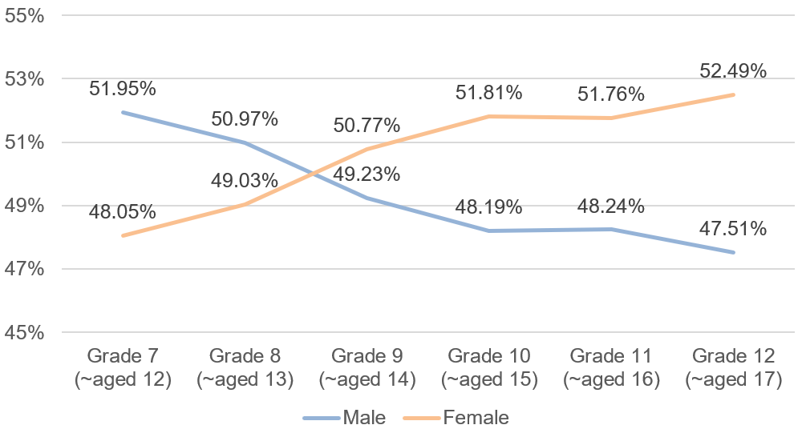
Figure 7: Gender Ratios in Secondary Education SY 2019-2020 (de la Fuente, 2020)
DepEd (2022a) report outlines the gender dimensions of bullying that occur in school. Female learners had experienced bullying at a high rate and accounted for 70.5 percent and 59.8 percent of male’s had experienced bullying. However, with the pandemic moving learners online, Cyberbullying was reported by 43.8 percent of young people between 13 and 18 years of age. Males accounted for 45.3 percent and female’s 42.2 percent. It was further reported that 14.3 percent of the respondents experienced physical violence, though socio-economic class had no significance, some violence based on gender was reported. The report stated that “2 out of 3 children experienced physical violence, 1 out of 4 experienced sexual violence, 2 out of 5 experienced psychological violence, and 2 out of 3 experienced violence from their peers” (DepEd, 2022a:64). This is compounded by finding that 1 in 20 females aged between 15 to 49 would have experienced sexual violence in their lifetime, with the LGBTQIA+ community particularly at risk.

SDG 17 Partnerships for the Goals and CRPD Article 32 International Cooperation
Strengthening inclusive education and sustainable development for learners with disabilities benefit from the mobilization of a multi-stakeholder global partnership. Currently, the Philippines has multiple programs aimed at enhancing the conditions for persons with disabilities in education. In addition to the programmes outlined in the VNR (NEDA, 2022:26-27, 50-52) other programmes that have been conducted in partnership with DepEd and other Filipino education actors are outlined below.
The US Peace Corps developed and tested new assessment tools for learners with disabilities in Albay province (Disability Insider, 2022), with the aim to “ensure that all learners, including learners with disabilities, receive a quality education” said U.S. Peace Corps Philippines Country Director Jenner Edelman (USAID, 2022a). The initiative is reported to involve 40 teachers and 200 students to ensure schools and their curricula are as inclusive as possible (Disability Insider, 2022).
DepEd, in relation with SDG 4, launched the Gabay Project in collaboration with the Resources for the Blind, Inc. (RBI) and the United States Agency for International Development (USAID) (DepEd, 2019; U.S. Embassy Manila, 2020). The project aimed to “increase access to quality education of children with sensory impairment for the attainment of improved education and literacy outcomes through early detection, instruction, and support for the blind, deaf, and deaf-blind children”. The project will also strengthen Inclusive Education Community Resource Centers (USAID, 2022b). The three-year project will be implemented in Batangas City, Batangas province, Sorsogon City, Sorsogon province, Maasin City, and Southern Leyte.
UNESCO (2021b) report outlined a program run by Save the Children; KASALI or Kabataang – Aralin Sa Lahat Ay Ibahagi (Education for All Children). This programme aimed to provide learners with disabilities (aged 12 years and below) access to inclusive basic education programmes and services. In particular, interventions were designed to improve the ECCD centers in the community and elementary schools. Targeting 50 barangays and 89 learning sites in the Paranaque, Taguig, and Pateros. The program was run in collaboration with DepEd, DSWD, NCDA, the Department of the Interior and Local Government (DILG), and partners from the civil society to private institutions.
In 2017, a South Korea-funded project (the Philippine Star, 2021; DepEd, 2021b) was initiated and was implemented by UNESCO and DepEd. It aimed to increase the passing rate among out-of-school girls in A&E tests. Further, it set out to improve ALS girl-learners and ALS mobile teacher’s skills, as well as develop new teaching and learning materials. The project constructed a Girls Education Center (GEC) in Tacloban.
Finally, the Australian government has development assistance for the Philippines (DFAT, 2022a; DFAT, 2022b). Australia's Department of Foreign Affairs and Trade (DFAT) Pillar 2 ‘Stability in the Philippines’ aims to foster inclusive, cohesive communities and help mitigate threats to regional security, predominantly targeting the Mindanao region. This is being realized with investments in education to avoid an increase in school dropout rates.

This has been conducted through the assistance of distance learning and teachers training to deliver classes remotely, including tailored support for learners with disabilities (DFAT, 2022a).
DepEd in partnership with DFAT launched the Sustaining Education Reform Gains (SERG), which aimed to improve teacher professional development through the provision of technical assistance among key DepEd personnel (DFAT, 2021; SCP, 2021a; SCP, 2021b). According to Save the Children Philippines (SCP) (2021a), this project conducted a situational analysis of learners with disabilities and teacher capacity and found that the main challenges are:
- learners’ risk for further marginalization with alternative learning modalities;
- critical gaps in inclusive education program delivery by receiving teachers;
- parental role shift for distance learning; and
- lack of community awareness on learners with disabilities, and their right to education, needs and potentials”.
Where learners with disabilities reported difficulties in “1) moving around (88.4%); 2) going to school (87.7%); 3) consulting the doctor (85.1%); 4) accessing food supply (77.9%); 5) buying medications (76.6%); and 7) accessing therapy services (65.6%) which may have long-term and detrimental effects to their learning and development”. This is exacerbated due to the fact that the enrollment data even prior to the pandemic showed that 30 percent of the pilot schools having no learner with disabilities enrolled for the previous and current schoolyears (SCP, 2021b:1).

Education Budget
Despite having policies on inclusive education, according to E-Net Philippines (2022c), there is still low funding for DepEd’s inclusive education program. For instance, E-Net Philippines (2022c) states that for 2022, the inclusive education program decreased by 8.8 percent or a budget of P15.9 billion as compared with P17.4 billion in 2021, whilst the SPED budget from 2010 to 2023 within DepEd is outlined in Table 6. There are proposed increases from previous years with SPED once again having a specific budget (as it had been distributed within other operating expenses). E-Net Philippines (2022c) stated that the disability-specific appropriation for learners with disabilities is estimated to be only 0.44 percent of DepEd budget with less than 2 percent allocated for inclusive education programs, with several programs under it. Figure 8 illustrates 7 education programs (and a WASH programme) that E-Net Philippines successfully lobbied for. Furthermore, DepEd's response to a Freedom of Information (FOI) inquiry (2015-2019) is outlined in Figure 9. This inquiry is in regard to the utilization of the Php100M budget for the instructional materials for learners with disabilities. The money was not spent by the Bureau of Learning Resources (BLR) in this period as there were failures in procurement and in the bidding process
Table 6: SPED Budget from 2010 to 2023 (E-Net Philippines, 2022c)
YEAR | AMOUNT IN PHILIPPINE PESO
2010 | 178,500,000.00
2011 | 168,065,000.00
2012 | 44,440,000.00
2013 | 227,250,000.00
2014 | 277,350,000.00
2015 | 270,299,000.00
2016 | 0 (budget was distributed to maintenance and other operating expenses)
2017 | 0 (budget was distributed to maintenance and other operating expenses)
2018 | 0 (budget was distributed to maintenance and other operating expenses)
2019 | 0 (budget was distributed to maintenance and other operating expenses)
2020 | 107 M – Adjusted to 0 (Zero) due to the Bayanihan Law,  Was reassigned for COVID the response.
2021 | 329.2 M
2022 | 560 M (Figure 8 has elements outside of this budgets scope)
2023 | Proposed: 531.625 M  MOOE (Maintenance and Other Operating Expenses): 435.625 M; CO: 96 M  Approved at NEP Level:  MOOE: 0 M; CO: 0

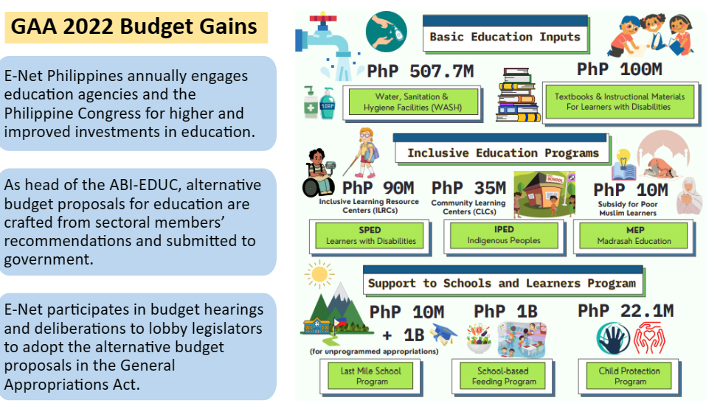
Figure 8: Budget Gains Infographic for 2022 (E-Net Philippines, 2022c)

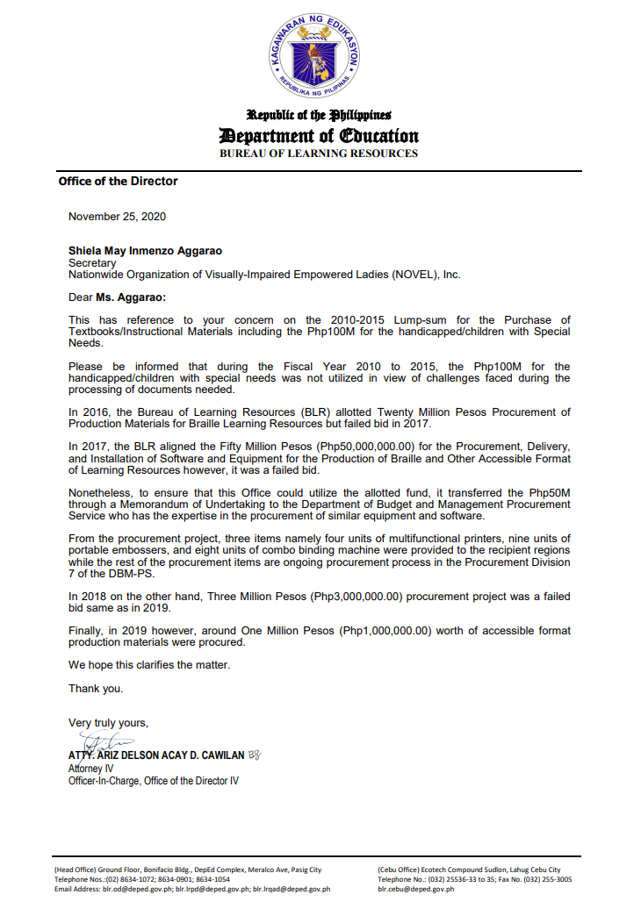
Figure 9: Letter Response from Atty. Ariz Delson Acay D. Cawilan (Attorney IV)

Findings

This section presents the primary findings from the KIIs and the FGDs. The findings were categorized into the most relevant SDG objective and when appropriate the findings from each KII and FGD were grouped into themes.

SDG 4 (Quality Education) and CRPD Article 24 (Right to Inclusive Education)

Target 4.1: Universal primary and secondary education
\Ensures that all girls and boys complete free, equitable and quality primary and secondary education leading to relevant and effective learning outcomes. The provision of 12 years of free, publicly-funded, inclusive, equitable, quality primary and secondary education – of which at least nine years are compulsory, leading to relevant learning outcomes – should be ensured for all, without discrimination.

Programmes and Initiatives
The DepEd is the primary body and the chief duty-bearer for ensuring persons with/ without disabilities can complete free, equitable, and quality primary and secondary education without discrimination.

Formal Education - PDAO’s Engagement
In regards to formal education systems, the SDG implementation is a cross governance operation and in addition to the DepEd there are other departments and bureaus that can influence the equitable delivery of the SDG. For instance, the Persons with Disability Affairs Office (PDAO). During the pandemic, a new initiative was set up by PDAO heads who created the League of PDAO (the League). The League President mentioned that the League was formed and organized on October 8 2020, during the height of the pandemic as PDAO witnessed that persons with disabilities were being left behind during the initial COVID response despite the assurances released directing the LGUs to prioritize the sector. The League was organized based on the premise that persons with disabilities were one of the groups who were restricted from leaving home (during the height of the pandemic as they were considered a vulnerable group) which also restricted the PDAO Heads who are often persons with disabilities themselves in performing their core functions. However, there were PDAO Heads who were able to survey their respective regions and they reported that one of the leading problems for persons with disabilities being left behind was the lack of a PDAO (in a particular region) and the fact that no persons will take up the role of PDAO Head.
One of the missions of the League is to advocate the full implementation of R.A. 10070 (an amendment of the Magna Carta for Persons with Disabilities) so that all LGUs regardless of income bracket will establish and have a functional PDAO that will focus on the issues of persons with disabilities on the ground. A PDAO representative mentioned that,
“Municipal Social Welfare and Development Offices are not mandatory but all LGUs have this department. Why is it that not all LGUs have PDAO? Although the law says that 4th, 5th, and 6th class municipalities are not required to have a PDAO, the current condition should be considered for it to be established even in the said LGUs”.
The League monitors the compliance of the CRPD and works to make the pandemic response inclusive and equitable. The League monitored multiple aspects of education, for instance, the League monitored if the government schools received assistive devices from DepEd. Alongside this they were lobbying their respective LGUs to provide the assistive devices that were needed by learners with disabilities.
When asked if the League had received complaints from learners with disabilities about LGU violations of B.P. 344 (the Accessibility Law) particularly from those who were struggling to access or cannot go to school at all because of inaccessible school facilities, the League President stated:
“Actually, hindi naman yun direct na sinasabi na non-compliant yung establishment sa B.P. 344 kaya hindi sila nakapag-aral. Ah, tinatry talaga nila na mag-aral and umabot naman sila ng Grade 6, yung iba nga umabot pa ng high school. Pero tama yung sinabi mo, meron talagang factor ang environment, na nandiyan pa rin yung naiiwanan sila, nabubully sila, saka yung personal nilang experience na hindi talaga accessible ang paaralan kaya sila na mismo ang tumigil; kahit noon binubuhat sila ng mga kaklase, sinisikap nilang makapunta sa second floor pero nahihiya na rin sila dahil binata o dalaga kaya sila na mismo ang nagsabi na magtigil na ako. Pero hindi nila directly sinabi na dahil sa accessibility. Parang sarili nila ang bini-blame nila dahil napagod na sila at saka hindi naman sigurado na makatrabaho sila after graduation, kaya tumigil na sila. Parang lack of opportunity, lack of hope yung parang hindi pa talaga open ang Pilipinas sa employment ng persons with disabilities”.
“Actually, they don’t directly say that the non-compliance of the establishments to B.P. 344 is the reason why they are unable to go to school. They really tried hard to study, some finished Grade 6, some of them even made it to high school. But you are right, the environment is really one of the factors. They are left behind, being bullied, and they personally experienced the inaccessibility of the school facilities. Even though their classmates helped to carry them and they really tried hard to go up to the second floor, eventually they felt embarrassed as they were already becoming young men and women. So, they just decided to stop going to school. But they don’t directly say that it’s the inaccessibility, they actually blame themselves because they grew tired of the situation and they were uncertain that there’s work waiting for them after graduation. It feels like there’s lack of opportunity, lack of hope, and the Philippines is not yet open for the employment of persons with disabilities”.
After travel restrictions were lifted, the League has started to travel around the country, and some members have been assigned regions to visit and to listen to the issues and sentiments of smaller PDAOs from the provinces and municipalities. They have organized a national convention and regional conventions are being planned. At this moment, the League is just using their office funds to do the visit to other PDAOs and advocate for the sector. There have been changes after the League establishment since now designated PDAOs are able to voice their concerns to their local chief executive unlike before when they felt contained and scared to speak up. This is especially true of those whose status is Job Order as they just did what their Local Social Welfare and Development Office (LSWDO) asked them to do even though they were against it. Regional representatives of PDAOs support the local PDAO Heads in raising their concerns to the LGUs. The regional representatives support by explaining the importance and benefits of establishing a functional PDAO versus just having a focal person and a table for compliance-sake. The League of PDAO formulated an action plan to challenge further and ensure that learners with disabilities will be provided with their required educational support from the government and are encouraging other PDAOs to include in their budget the support for learners with disabilities which includes a transportation allowance.
The Municipal PDAO provided a case study on education and gender programs when they collaborated with the Cordova District School to gather data on learners with disabilities from Kindergarten, Elementary, High Schools, SPED, and the ALS. They conducted orientations and sensitivity training for teachers and students which are usually conducted during National Disability Prevention and Rehabilitation (NDPR) week and also provided for the assessment of learners with disabilities funded by the Municipal Social Welfare and Development Office (MSWDO), which was conducted through an outreach program of developmental practitioners.
After the success of this activity, the District Supervisor committed to include the assessment as part of the Maintenance and Other Operating Expenses (MOOE) budget. The data collected has enabled them to identify the support needed and the issues of the learners. However, it was not clearly indicated if the identified needs and issues are addressed.
When Cordova PDAO office gathers data, it is then uploaded to the Philippine Registry for Persons with Disability (PRPWD) and this data provides information about whether the learner with a disability is schooled or unschooled, and it becomes the basis for their referral to programs like the ALS. In 2015 the number of learners with disabilities in Cordova SPED class was at 47. As of November 2022, the total count of learners with disabilities enrolled in different barangay schools is 120. The total number of children with disabilities (of different impairment types) in Cordova is 321. Some of the accumulated budget for the activities that were not conducted during the height of the pandemic were realigned for this survey and helped with the data collection on the situation of learners with disabilities. There is a regular monitoring of parents through house visits to know the condition of learners. The Municipal PDAO mentioned that,
“We (Municipal PDAO) work closely with our Cordova District School in getting data on learners with disabilities. From kindergarten to elementary Grade 1- 6, high school, and college, even ALS and SPED. From regular school and public school. From the data we gather, we are able to identify the needs of the learners, so we provide, we assist and facilitate them to enroll in high school. For example, kung naka-graduate na ng ALS o high school and college. Because here in Cordova we have free public college. We also help them with school supplies pag nagkaproblema sila through AICS, Assistance to Individuals in Crisis Situations through MSWDO. Pag na identify na namin o nakuha na namin yung data from the different schools, we provide the Philippine Registry for Persons with Disabilities and issue them an ID. And by doing that, we increase the registration, and we are able to help them avail the privileges. Kasi Nakita naming ang daming estudyante specially sa high school but then wala pa silang registration sa Philippine Registry”.
“We (Municipal PDAO) work closely with our Cordova District School in getting data on learners with disabilities. From kindergarten to elementary Grade 1- 6, high school, and college, even ALS and SPED. From regular school and public school. From the data we gather, we are able to identify the needs of the learners, so we provide, we assist and facilitate them to enroll in high school. For example, after graduating from ALS, high school or college; because here in Cordova we have free public college. We also help them with school supplies through AICS, Assistance to Individuals in Crisis Situations through MSWDO. Once we get the data from the different schools, we upload them to the Philippine Registry for Persons with Disabilities and issue them an ID. And by doing that, we increase the registration and we are able to help them avail the privileges. We found out that a lot of students, particularly from high school, are not yet registered in the Philippine Registry”.
The data (collected) is the basis for the issuance of person with disability IDs and encoded in the PRPWD. The PDAO assists and facilitates their enrollment and helps them with their school supplies through the Assistance to Individuals in Crisis Situations (AICS). Due to the visibility of school activities, Cordova now has two schools catering to learners with disabilities with one doing an integrated approach (ladderized program, if the learners with disability are prepared to be enrolled in general education classes, then they will be integrated). Out of school youth with disabilities and graduates of the ALS who do not want to pursue college education are encouraged to enroll in the Area Vocational Rehabilitation Center in Cebu.
Cordova District School has been able to roll-out training on Inclusive Education to Kindergarten, Grade 2, and Grade 3 teachers. Municipal PDAO provided an example of their response to the concerns of a learner with a disability. A parent went to the house of the PDAO Head of the Municipality of Cordova to inform them that the school is not accessible to her child who is a wheelchair-user. This PDAO Head went to the school and talked to the principal and provided information on how to implement a cemented pathway so the learner using the wheelchair could have access. This interaction also led to the principal requesting sensitivity training provided by PDAO and this was scheduled for their teachers. This was mentioned to be one of the few cases which ended with a positive result. Additionally, an advocate in partnership with their School Division in Cebu spearheaded an assessment for 72 learners with disabilities with assistance from medical and allied professionals who conducted the assessment. The Division Superintendent committed to include in their succeeding annual budget the cost of the assessment. The PDAO Officer and self-advocate with a physical impairment will be sitting on the Local School Board (LSB). They had persuaded the body to pass a resolution to strengthen their campaign to find and enroll more learners with disabilities.

Formal Education - Inclusive Education and experiences regarding school
The DepEd’s Bureau of Learning Delivery (BLD) student inclusion division commented on the future state of Inclusive Education, all though the Law R.A. 11650 is in place it seems that Inclusive Education will not be fully implemented as the main mechanism for learners with disabilities as segregated education will still be adopted. It was said that,

“Sa ngayon ang pinu-push ni DepEd ay Inclusive Education, pero hindi ibig sabihin nun ay mawawala na ang ating SPED programs kasi may mga bata talaga tayo na hindi kaya ilagay sa mainstream o Inclusive Ed so sila naman ang mapupunta sa Special Education classes”.
“Presently, the DepEd is pushing for Inclusive Education, but it doesn’t mean that SPED programs will be totally abolished because we have learners with disabilities that cannot be really placed in mainstream or Inclusive Education so they will be the ones to be under the Special Education classes”.
According to one disability inclusion advocate, OPDs are not always involved in the budget process; so for every opportunity that they have, they put forward recommendations about mainstream budgets for Inclusive Education.
However, it was mentioned that even when learners with disabilities are included in the budget, the reality is it’s not properly utilized to provide the actual accessibility and support requirements of the learners. Another advocate brought up that their Federation is part of the Local Development Council but they are not aware of involvement in terms of budgeting for Inclusive Education. Further, it was shared that even though there is a no rejection policy for learners with disabilities, this is not necessarily optimal currently as the teachers are not ready for learners with disabilities since there is a lack of training of receiving teachers on how to teach and support them. Thus, although Inclusive Education had been pushed in certain areas, according to FGD findings one advocate mentioned that some learners with disabilities prefer attending in SPED Resource Center than going to classes in mainstream school due to the fear of being discriminated against and bullied.
According to Article 24 (Right to Inclusive Education) of the CRPD State Parties need to recognize the right of persons with disabilities to education on the basis of equal opportunity. This means learners with disabilities should not be automatically segregated and placed into SPED Schools. An advocate for learners with disabilities mentioned they regularly look at the enrollment of learners with disabilities and campaign barangays to inform the families to enroll their children with disabilities in school. They also promoted awareness-raising activities to ensure that learners with disabilities in school, particularly mainstream schools, are not automatically placed in SPED. It was mentioned that this can be the case as SPED learners with disabilities from various grade levels are put into one SPED classroom despite differences in educational requirements. This can have consequences if not aligned correctly to learners' circumstances, as an advocate shared that he was placed in a separate room and time slot away from his classmates without disabilities during activities and exams which prevented him doing other things and socializing with other students.
Learners with disabilities experienced school differently and there were several reported issues. For instance,
- Participation: during class drills, a learner with a disability was asked not to participate but instead asked to just stay in the SPED classroom. A learner with a disability requested extra time to accomplish tasks, the teacher granted this extension, however the learner received a grade deduction. There were reported cases of teachers not believing learners and a learner with a psychosocial disability reported that when she had been absent due to mental health concerns, the teacher did not believe her. Again, there was a participant with a visual impairment who was questioned by the teacher if she really needed accommodation like a reader and so on.
- Awareness: there were instances where a learner with a psychosocial disability and someone hard-of-hearing chose not to inform their school of their disabilities because of concerns of how they would be perceived. However, even when the teacher knew about a learner's disability there were still awareness issues. For instance, a participant with psychosocial disability who went to a Catholic school was discouraged from taking her medicine by the nuns as the school did not believe in taking medicine and instead asked her to pray.
Also, during a basketball game a deaf participant reported that he was being shouted at by the referee (calling him several times) but was unaware and did not respond, the participant was embarrassed for being shouted at in front of his peers.
- Bullying: Sharing from learners, advocates, and parents. One learner with a psychosocial disability reported being embarrassed when a teacher began mimicking her during her manic episodes. A learner with a disability got turned into a meme in class as they posted a photo of her online and she had to leave her group. There was a case where classmates would flatten the braille dots of a learner with visual impairments and hide things from them. These examples are supplemented by the personal experiences of parents, and one pulled out their child from the school because they felt that the child was discriminated against and was not getting a quality education. They mentioned that,
"Sa panganay ko, nung nilagay ko na sa high school, yung teacher dini-discriminate siya. Kasi hindi siya pinapasok sa face-to-face".
“When I enrolled my eldest child in high school, they faced discrimination. The teacher didn’t want them to attend face-to-face classes”.
Other parents cited some of the barriers and discrimination faced by their children with disabilities in school. A parent mentioned that their child is unable to make friends because the people around her do not understand their behavior, her child was thought and said to be “baliw” (crazy). Further, it was mentioned there are limited activities being done for learners with disabilities in school. For instance, one parent said their child who has a visual impairment was prevented from doing a sports activity that may worsen her vision but there was no information if the sport was adapted based on her condition or an alternative was offered. It was mentioned that,
"Gusto niya sumali sa isang sport activity kaya lang medyo strenuous siya. In-explain ko na lang sa kanya. Kako kailangan na alagaan natin yung mata mo. Baka mamaya mabangga ka or whatsoever, baka maging cause ng detachment".
"She wanted to join a sports activity but it was strenuous for her. I just explained to her that we need to take care of her eyes. She might bump or whatever and it may cause her retinal detachment”.
There were many other examples of bullying not going on record. For instance, an advocate shared an anecdote that a parent came to them because their deaf child was being bullied in their community. They advised the parent to talk to the parents of those bullying the deaf child and to resolve the problem so it would not escalate to formal complaints. Furthermore, it was mentioned that there is no proper assessment for learners, and without being properly assessed, this led to some students being verbally abused by teachers calling them “bobo” (dumb), instead of there being modifications put in place that could have improved the situation.
There are many cases that are not reported for many reasons, one of them being that learners with disabilities feel that they must adjust to the education system and not the system that will adjust to them. So, if they feel a lack of dignity, they blame themselves.

Out of school and home-taught learners access to mainstream school
The responsibility to provide access to inclusive, equitable, quality primary and secondary education for learners who attend mainstream school later in life falls under the DepEd’s Bureau of Education Assessment Division. This Bureau administers the Philippine Educational Placement Test (PEPT), which they stated to be an accessible facility. The registration form of this test already has a field to indicate if the examinee has a disability or not. The test can be taken in Braille for learners with visual impairment, a recorded/ video presentation for Kinder and Grade 1 level learners, and a computer-based test is also available. There are some reasonable accommodations provided for examinees with disabilities taking the PEPT. They can book separate rooms to better cater for their needs. The Bureau of Education Assessment specialist for SPED interprets the instructions/ directions of the test in support for the deaf examinees. Learners with disabilities are given extra time (double the original allotted time) and learners with dyslexia can have support to have the questions read allowed to them. These provisions follow the D.O. 55 Series of 2016 (DepEd, 2016). However, this test is generic and learners with disabilities are taking the same test as learners without disabilities.
There have been no reported cases of bullying but when managing the behavior of learners with disabilities, it is required to have assistance from learner’s parents (though they cannot support in the assessment) to manage behavior as interviews are conducted with parents and the test-takers to better understand what their level and needs are.

Non-Formal and the Alternative Learning System (ALS)
When it comes to non-formal education programs the DepEd’s Bureau of Alternative Education (BAE), specifically the Program Management and Systems Development Division outlined that they are in control of the implementation of the ALS program and under the ALS there are 4 other major programs, namely; the Basic Literacy Program (BLP), Accreditation and Equivalency (A&E), Inclusive Education, and the Functional Education and Literacy Program.
These 4 major programs are opportunities for learners with disabilities to continue their education/. It was mentioned by the BAE that COVID only had a minor impact on the ALS operation since the modality being used was already distance education but what was limited were the face-to-face sessions which are 1 or 2 days a week (pre-pandemic).
In regard to the scope of the ALS in relation to disability a representative from the BAE mentioned that,
“Right now, since po nag start yung school year, collecting data pa lang po kami. To be honest with you, collecting data pa kami ng mga enrolled learners namin sa ALS in special cases, yung mga may disability. Hindi din naman lahat ng divisions nag cater ng ALS para sa may disability. But then if there are chances na may OSY (out-of-school youth) na may disability na nag enroll samin, nire-refer namin sila sa mga near SPED center school na meron sa community. Ito po yung nagiging paraan namin para lang ma cater namin sila at para mabigyan sila ng service at intervention”.
“Right now, since the start of the school year, we are still collecting data. To be honest with you, we are still collecting data of enrolled learners in ALS with special cases like those with disability. Not all divisions cater ALS for those with disabilities. But then if there are chances where there are OSY (out-of-school youth) with disabilities who wish to enroll with us, we refer them to a nearby SPED center school in the community. This is our way to cater for them and to provide them service and intervention”.
Not having access to ALS limits learners with disabilities access to inclusive, equitable, and quality education as not all divisions provide ALS that are accessible to and inclusive of those with disabilities and instead learners with disabilities are referred to a SPED center. The importance of opportunities like these was emphasized by a parent who mentioned that the opportunity for learners with disabilities to socialize with other parents and children without disabilities makes the latter more aware and accepting of the former.

Civil Societies closing gaps
Support for inclusive, equitable and quality primary and secondary education often occurs from CSO, who operate where there are gaps in government programmes. For instance, E-Net Philippines has initiated the Persons with Disabilities Cluster as part of their National Advocacy Council which gives advice on how to promote and mainstream issues and opportunities for persons with disabilities in terms of education. One of the objectives of the cluster is to develop a country plan.
E-Net Philippines supports the conduct of Disability Inclusive Education Training to their 90 members nationwide, which has representation for persons with disabilities in activities and programs. Further, E-Net Philippines attempts to consult and provide accessibility and support requirements for persons with disabilities when participating in meetings, activities, and events. However, there are still challenges, for instance, a lack of involvement of youth with disabilities (no organizational body yet), accessibility requirements are not always enacted (e.g., accessible venue) and there is a lack of membership of organizations of persons with disabilities in various groups and networks outside E-Net Philippines (e.g., Stakeholders’ Chamber for SDG, Literacy Coordinating Council, Education Forum). E-Net Philippines remains an advocate for disability-specific programs, such as the policy advocacy on R.A. 11510 (ALS Act), which highlights the quality and access of learners with disabilities in ALS. In regard to the policy advocacy on the R.A. 11650, E-Net Philippines have included groups of persons with disabilities in the development of the draft IRR. They are also supporting the running of ‘InkluNasyon’ an online program discussing the rights and issues of persons with disabilities in the Filipino language.
The Unang Hakbang Foundation (UHF) has systems and processes for identifying children so that they do not drop out from school. UHF calls this program the Bayanihan Magtulungan sa Pag-aaral. They go out to the communities to advertise the services they offer and seek assistance from the local schools in identifying children that may need such services. They have supported an average of 500-600 children a year for 20 years often providing remedial classes in reading, writing, and math. They have five centers located within communities (one urban center in Mandaluyong City, NCR; and four rural centers in the province of Pampanga). Learners take the test to determine whether their reading and writing skills are at par with their grade level. The UHF allows itself three years to bring the children up to speed. Fortunately, in most cases, children improve and catch up within five to six months. At this point, the children are unrestricted should they choose to go but in most cases, they stay to take other classes and activities like art classes, child rights sessions, and community reading activities. Additionally, these children may now transition to become peer tutors.
Those children who take the test but are identified as having sufficient reading and writing skills relative to their grade level, are encouraged to participate as peer tutors. However, currently there are very few learners with disabilities as they either have to refer them elsewhere or cannot accept them, as they do not have the capacity to support them. Currently, the UHF has yet to have a program for learners with disabilities and has yet to mainstream disability in their programs.
In addition, the UHF has other projects aside from the Bayanihan Magtulungan sa Pag-aaral. One project UHF had was a partnership with SPED teachers. They provided nutritious meals and helped the children with their reading and writing. This project was rolled out to both their rural and urban centers. For their Pampanga site (rural center), they opted to create the materials in the mother tongue of the province, Kapampangan. It was mentioned that this could have been very helpful for the children. However, it brought challenges since a lot of the children were internal migrants and are not Kapampangan speakers.

They also organized support groups for mothers where they attend sessions to share their problems and learn about health, family planning, and proper nutrition. Lastly, the UHF is in the process of finalizing their adult basic literacy program in partnership with the ALS program in several schools in Mandaluyong.

City of Valenzuela Local School Board (LSB) case study
The LSB mentioned the Education 360 program, which offers Inclusive Education for learners and is available for all learners in Valenzuela City. The Valenzuela SPED Center is part of the ‘360 degrees Education Investment Program’. Further, summer reading camps are made available for learners who have some difficulties and may fall short of requirements to advance to the next grade level. The interviewee did not mention if the reading program is solely for persons with disabilities but they did say the reading difficulty is due to inaccessible format of the reading materials. The reading tutors are students of Pamantasan ng Lungsod ng Valenzuela (Valenzuela City College). The holistic nature of the programme also addresses students who are malnourished. There Is a feeding program in partnership with parents through the General Parents and Teachers Association. This includes parents of learners with disabilities. However, accessible infrastructure is a major concern despite the fact that the city engineers, staff from various departments, and selected persons with disabilities received training from the OPD Life Haven CIL in 2018 to enhance the participants’ knowledge and skill on how to properly assess the accessibility of structures and buildings. There is still a need to practice the assessment and to supervise its implementation. The City of Valenzuela had a partnership with Imagine Law, a public interest law group working for people’s health and welfare, to include the accessibility programs introduced by Life Haven CIL and to make sure that structures and buildings of schools are properly constructed and safe for both learners with and without disabilities. Other policies, programs, and activities the City government have to safeguard persons with disabilities including children and youth with disabilities inside and outside of the school are:
      - The Anti-bullying ordinance;
      - The Anti-discrimination ordinance; and
      - The Intensified training for guidance counselors.
At the time of the interview, there’s no clear representation of persons with disabilities in the LSB, with only one Councilor as action officer representing the sector. The other programme mentioned is the “Thrive Together” employment program in partnership with Humanity & Inclusion. At the time of interview, there are 200 open slots for employment of youth with disabilities. This entails pre-employment skills training from creation of a resume to preparation for an interview, job coaching on how to handle themselves at work, and for coworkers to learn how to properly engage with co-workers with disabilities. Many registered for this but once they know that they have to train first, many do not pursue the opportunity further.
In addition to this case study, findings from the FGDs identified 8 out of 10 interviewees did not sit on the LSB and are not aware of any initiatives of the local special body to better include learners with disabilities.

Experience of Emilio, a child with Down syndrome
Emilio studies at Community of Learners, a private school located in San Juan City. It’s thirty minutes away from his house in Quezon City. He goes to school and back to his house by school bus. According to Emilio he has no classmates with disabilities. The number of students per class is around 10 with two teachers per class. Their class is a mixture of boys and girls and Emilio has many friends. Emilio belongs to Group 6 to 9. Based on his description, their school has a lot of facilities: classrooms, playground, gym, swimming pool, etc. They also have a lot of activities aside from classroom work such as art classes, cooking, dancing, music class, etc. Emilio plays the drums. At the height of the pandemic, they switched to online classes. Emilio learned to use his laptop and other gadgets and navigate through Zoom or Google Meet and their online learning platform.

Target 4.2: Early childhood development and universal pre-primary education
Ensures that all girls and boys have access to quality early childhood development, care and pre-primary education so that they are ready for primary education.
The ECCD Council is the primarily responsible entity for the implementation of this SDG Target. The Council Secretariat with the Early Learning Component ensures that the ECCD services are integrated in the Early Learning programs of the government and they also include families, offering family support programs and family education programs. The ECCD has established a National Child Development Center (NCDC) in every LGU, which serves as a resource center and a model center for child development workers. Simultaneously, the NCDC pilots new programs where teachers of NCDC are being utilized by the new programs, launches innovations and updates on Early Childhood Education with 50-55,000 child development teachers and workers. The ECCD Act of 2000 (R.A. 8980) and Early Years Act of 2013 (R.A. 10410) mandates the training of child development workers, but there are already LGUs that have been very active in building the capacity of their child development workers prior to the enactment of the said laws. Some of the activities of the ECCD programs are charged to GAD funds. Despite the above, there’s an issue which appears that the staff feel overworked in managing and supporting children with disabilities.
In mainstreaming disability, the R.A. 10410 (the Early Years Act), provides the legal basis and specific objectives for learners with disabilities. Through the technical support of UNICEF, a system was developed for the prevention, early identification, referral, and intervention of delays, disorders, and disabilities in early childhood. The referral system started in child development centers. It expanded to health centers where children were suspected to have delays or identified to have disabilities. Then LGUs map available resources and services near them. There is a full inclusion process as both children with and without disabilities are included in sessions in the child development centers.
The ECCD has developed a guidebook for parents and child development workers on Managing Child with Delays, Disorders, and Disabilities in Early Childhood, known as the ‘Guidebook for ECCD Service Providers and Parents Managing Zero (0-) to Four (4-) Year-Old Children with Developmental Delays and Disabilities in Early Learning Programs’. This guidebook was a response to the pandemic because they acknowledged that many children with disabilities stopped receiving services, for example therapy and rehabilitation sessions, because of the quarantines and lockdowns.
Consultation and validation workshops were conducted together with organizations supporting persons with disabilities, namely, Norfil, Humanity & Inclusion, and Resources for the Blind. Parents of children with disabilities were also participants in the development of the handbook, sharing what is feasible for them. Unfortunately, there was no participation by representatives from OPDs in these consultations and validation workshops.
The guidebook includes how to teach, how to make individualized activities for the children based on their needs and how teachers can prepare individualized activities for children with delays amongst other needs. The ECCD council is trying to convince the teachers that the work of individualized development plans and activities are not additional work for them. As stipulated in R.A. 10410, the national system for ECCD shall promote the inclusion of children with special needs, provide for reasonable accommodation and accessible environments, and establish an efficient system for early identification, prevention, referral and intervention for children with special needs from age 0 to 4 years. In keeping with this mandate, this Guidebook focuses on providing appropriate accommodation for children with disabilities and addressing the challenges of access to early childhood education. This Guidebook further envisions to aid the ECCD service providers and parents in delivering quality inclusive ECCD programs and services for children with disabilities.
Additionally, the guidebook was designed to accommodate children with disabilities across center-based, home-based, and other alternative early learning modalities. The Guidebook may be modified for applicability in geographically isolated and disadvantaged areas and emergency situational contexts such as but not limited to natural disasters, armed conflict, and health epidemic. The Early Education Curriculum is play-based, developmentally appropriate, and not specific to a certain subject adapted to the child whether with or without disability.
In terms of budget, the program can only be a start-up and cannot train everyone because the budget is with the LGUs, and the services are still being developed. The LGU is expected to continue the training and upskill their child development workers. The LGUs have started to request training on the system for the prevention, early identification, referral, and intervention of delays, disorders, and disabilities in early childhood. The target is that by 2030 all child development centers and workers are prepared to handle children with disabilities.
Unfortunately, there is a difference between urban and rural settings as rural settings face more challenges in setting up their system compared to urban or more developed areas. For instance, Northern Samar had difficulty in setting up this system because of their limited access to health services. The nearest health facility capable of providing the necessary service is in Tacloban City which is a 6-hour drive from Northern Samar. They need more resources to sustain the system. When they mapped out the specialists, the nearest are all in Tacloban City in the province of Leyte which will entail higher cost and investment once children are referred to them. Leyte on the other hand has Tacloban City, in terms of resource mapping and budget allocation, because of the Internal Revenue Allotment (IRA) process, the system was already established.
Furthermore, LGUs currently do not prioritize the budget allocation for the implementation of the system and the process stops after administering the ECCD checklist to a child in the child development centers. This results in a lack of early intervention both in health and education aspects. One of the ECCD representatives stated that,
“Ang pinakamalaking challenge talaga ay prioritization ng Local Government Units. Kasi binigyan mo na sila ng gabay. Ito na yung system na pwede nilang sundan. Kapag pumasok sa center yung bata, nag administer ng ECCD checklist yung Child Development Worker tapos nakitaan ng delays. Madalas hanggang dun na lang yon. Parang wala ng gagawin after.Wala ng nangyayari after. Kasi hindi na alam pano pag irerefer. Saan ire-refer. Yun yung goal sana ng ECCD Council na magkaroon sila ng gabay kung pano irerefer yung bata. Pero dahil sa prioritization ng Local Government Units, madalas, sad to say ECCD is the least prioritized programs of Local Government Units. Actually, hindi lang Local Government Units, kahit sa national level. Often, neglected ang mga bata below five years old. Kasi madalas education and learning ng mga bata nagsisimula from five years old pataas. Often neglected talaga. Isa yon sa pinakamalaking challenge, ang prioritization sa children with disabilities. Kasi yung lahat ng mga bata below 5 mas mababa na yung priority tapos mas nakikita natin na mas hindi na pa-prioritize yung pag identify, pagtulong, pag provide ng early intervention”.
“The biggest challenge is the prioritization of Local Government Units. Guidance is already provided. Here’s a system that they just need to follow. When a child enters the center, the Child Development worker administers the ECCD checklist, then delays are identified. Most often it stops there. They don’t do anything after that. Nothing happens after. They have no idea how to refer. Where to refer. That’s supposed to be the goal of the ECCD Council, for them to have guidance on how to refer the children. But because of the prioritization of the Local Government Units, most often, it’s sad to say that the ECCD is the least prioritized program of Local Government Units. Actually, not just the Local Government Units, even on the national level. Often, children below five years old are neglected. Mostly, children’s education and learning starts from five years old and above. They are often neglected. It is one of the biggest challenges, the prioritization of children with disabilities. Collectively, there is a very low prioritization for children below five, then we see a lesser priority on identifying, helping, and providing early intervention”.

The ECCD Council recognizes that there is less prioritization of children under five and not all child development workers are already trained to teach and support children with disabilities and that any activities are mostly general in approach.
Apparently the ECCD was not included by the NEDA as part of the indicators of SDG as well as in the implementation of the PDP. It was highlighted that the PSA are looking into additional indicators on the number of children that are developmentally on-track (in terms of their holistic development: physical, cognitive, socio-emotional domains) and this will be included in the household surveyed for ECCD. Meantime, it was mentioned by parents that sometimes they need different kinds of support. One parent shared her perspective regarding the development of her child who has an intellectual disability, what’s important for her is that her child knows self-help skills such as taking a bath, eating, brushing his teeth, and writing his name. The parent stated that,
"Emil is non-graded. Sa kinder lang siya lagi."
“Emil is non-graded. He remains in kindergarten.”
"Self-help lang ang mahalaga sa akin. Yung kaya niyang maligo, kumain, mag toothbrush".
“What’s important to me is he can do self-help skills; he can take a bath, eat, and brush his teeth”.

Target 4.3: Equal access to technical/ vocational and higher education
Ensures equal access for all women and men to affordable and quality technical, vocational and tertiary education, including university.

TESDA is the governance body in charge of the majority of technical and vocational training. These are not just for persons considered to be in the lower economic strata but for everyone who wants skills development training. Unlike DepEd and CHED, TESDA offers short courses that aim to provide a livelihood after the training or assessment for employment. TESDA has made efforts to mainstream disability and gender by offering scholarship programs for persons with disabilities. The courses usually enrolled in by persons with disabilities are:
- Massage therapy
- Electrical installation and maintenance
- Electronic products assembly and servicing
- Food and Beverages services
- Wellness Massage (Hilot)
- Housekeeping
- Organic Agriculture Production
- Computer System Services
- Contact Center Services
- Food Processing
- Bread and Pastry Production
- Beauty Care
- Cookery
- Barista
- Web Development 3
TESDA requires that training centers, including private training centers, are to be accessible and the trainers in-charge of the class to be equipped to communicate with persons with disabilities i.e., sign language. However, persons with disabilities are placed in one batch/class and according to the TESDA Region III Director Balmyrson Valdez, only persons with disabilities that they identified as able to perform alongside persons without disabilities are placed in a mixed class. TESDA Region III Director mentioned that,
“Yes, kasi magkakaiba rin naman yung kapansanan nila. Yung nakikita naming kayang makisabay jinojoin namin. But for those na hindi makakasabay, na kailangan ng additional curriculum o mode of sharing information, ayun hinihiwalay namin sila”.
“Yes, since they have different disabilities. Those who we see can keep up, we allow them to join. But for those who can’t and need additional curriculum or other modes of sharing information; we separate them”.
Those who need additional curriculum support, or a different mode of sharing information are put into separate classes. They conduct community-based training and these tend to be short courses of 3-5 days. There’s no distinction in terms of requirements to avail scholarships but the challenge is the availability of trainers who can train persons with disabilities.

When asked if they make the accessibility of training centers a requirement for TESDA accreditation, the answer was unclear but it was mentioned that TESDA makes sure that facilities are “friendly” and violations are a “no-no”. TESDA intends to ensure their training regulations, which are responsive to industry requirements, will be inclusive of persons with disabilities. They are planning to initiate development of a training program on emerging skills that will be inclusive of persons with disabilities and coordinate with an agency (government or non-government) whom TESDA Region III can coordinate with to address concerns of persons with disabilities. TESDA will also advocate programs for persons with disabilities and develop the trainers to be knowledgeable about inclusive facilitation and to cater for persons with disabilities.
Region III TESDA, which has the highest number of enrollees, offers flexible learning delivery modes and in addition to scholarships, offers an allowance of Php160 daily, a book allowance for some courses, health allowances, and internet allowances. The TESDA in this region go to the mountains to conduct training to indigenous people and emergency skills training after calamities to aid in rehabilitation. For instance, after Siargao was hit by a typhoon recently, they trained the people in basic carpentry to help rebuild their houses, basic installation of solar lights, and how to cook their food safely. There is constant coordination with LGUs and referrals to industries (apprenticeship program). The regional director met with persons with disabilities who are taking up welding courses and it was mentioned that welders are not only in demand abroad but also in Region III where a lot of construction projects are going on. In Region III it is estimated that there are 50-70,000 TESDA trainees and around 5,000 or less than 10 percent are persons with disabilities. According to the regional director, at present they have no training about inclusive facilitation. The private training institutions have more skills in inclusive facilitation.
Currently, there are 2 online Gender and Development (GAD) trainings and multiple courses under the TOP Courses with Accessibility Features. According to TESDA online, there are currently 2 courses with accessibility features for people with visual and hearing impairments. Because of the work of Adaptive Technology for Rehabilitation, Integration and Empowerment of the Visually Impaired (ATRIEV), the site is also accessible for screen readers at least, but low vision users have to enable accessibility settings to activate the options for different font size and color contrast. Meanwhile, the DSWD-supported technical/vocational training via the National Vocational Rehabilitation Center in the NCR, Regions 1, 7, 9, and 12 (Rehabilitation Center for the Handicapped) will be adopted by the Bangsamoro Autonomous Region in Muslim Mindanao (BARMM). The vocational rehabilitation and training programs for persons with disabilities and vulnerable groups include basic skills training like massage, reflexology, cosmetology, computer operation, agriculture, canteen and food management, carpentry, arts and crafts, basic English, communication, basic Arithmetic, and reading and writing. DSWD provides daily financial assistance throughout the training which could be for 3 months, 6 months, or one year. Rehabilitation center sheltered workshop - for those with severe disabilities, they also add services, such as social services, formulation of case management, social and physical activities, counseling, group dynamics sessions, psychological, home life and dietary services.

When it comes to accessing higher education, it was stated by the Municipal PDAO Head of Cordova, Cebu that,
“May mga Deaf na gusto nila mag finish ng college. But then the problem is sa college wala masyadong interpreter. Isang paaralan lang ang nagtanggap ng Deaf, ang CTU, basta school sa Cebu. And then they wanted gusto sana nila sa ibang school, private. Gusto sana nila kumuha ng Engineering, kasi yung kurso lang nila, kung ano lang ang available sa kanila. Yun bang hindi pinaplano, na hindi talaga na mainstream na pwede sila sa kahit anong mga choices ng courses ang gusto nila”.
“There are Deaf who want to finish college. But the problem is in college there are only a few interpreters. There is only one that accepts the Deaf, CTU (Cebu Technological University) in Cebu. They also want to go to other schools like private schools. They want to take up Engineering but they are limited by the course available to them. It’s not really planned; they are not mainstreamed like to have choices on the courses that they can take up”.
Teachers were asked about the prospect of learners with disabilities accessing general tertiary education. It was mentioned even when learners were assimilated in their current school, when making the move to college, students were often surprised that colleges were not as accommodating and did not modify the lessons. Further a teacher mentioned that to encourage more learners with disabilities to go to college, they need to change the mindset of parents to see that a university diploma is needed. Learners with disabilities who were interviewed whilst studying at higher education establishments did have some good experiences, for instance a woman with autism mentioned that,
“But what’s interesting about Ateneo is that it also prides itself on being inclusive to people, various genders, and various abilities. There currently is an organization dedicated to understanding people with disabilities in society which is the Ateneo Special Education Society and in our school government the Sanggunian ng mga Mag-aaral ng Paaralan ng Ateneo or we call the Sanggu, there is a commission under the Office of the President in school government dedicated to disability inclusion among Atenean students. And we're essentially part of a sector. As an autistic woman I am part of the disability sector in Ateneo as well. So there are efforts that are being made to ensure inclusion in our campus and it's doing pretty well. Professors have been considerate about people with disabilities and ah it's very accommodating and if ever we would feel uncomfortable we would have to inform our prof and be transparent about what would our needs be accommodated so there's that to consider”.
Another example from a student studying BSc Psychology course at Our Lady of Fatima University Pampanga, they stated that,
"Kasi kilala as oriented sa visually-impaired and persons with disabilities. Marami na po akong kilalang graduate dun with visual impairment and successful din naman po sila lahat sila may work. That's one thing good yung quality ng education dun”.
“Because it’s well-known for being oriented towards visually-impaired and persons with disabilities. I already know a lot of graduates from there who have visual impairment and they are also successful, all of them have found work. That’s one good thing, the quality of education there”.

Target 4.4: Relevant skills for decent work
Ensures substantially increase the number of youth and adults who have relevant skills, including technical and vocational skills, for employment, decent jobs and entrepreneurship.
TESDA Policy Research and Evaluation Division is the office in-charge of the development of training programs. They also provide financial assistance such as:
- Training-for-Work Scholarship Program
- Private Education Student Financial Assistance (PESFA)
- Special Training for Employment Program (STEP)
- Other scholarships in partnership with other government agencies
The entry requirements and training regulations are determined by the industry. Most of the training is open to all regardless of educational background but some training regulations may require higher levels of education. It was mentioned that the majority of those certified stay in their provinces for work. TESDA confirmed they are able to provide the accessibility and support requirements of their trainees with disabilities and they have a policy about ensuring the provision of accessibility and support requirements on items like disability-inclusive facilitation.
TESDA Policy Research and Evaluation Division, in the interest of Gender Equality and Social Inclusion, have conducted a few different initiatives. Three of them being:
- A project with the International Labor Organization (ILO) under the ‘Skills for Prosperity program’, where one of the outcomes is social inclusion.
- A study on persons with disabilities in partnership with Project Inclusion Network.
- A program in celebration of Women with Disabilities was conducted in March 2022 to increase awareness among GAD Focal Points.
They said that there is no specific program for persons with disabilities as they practice inclusion in all of their program design and their training delivery is evaluated about where they are accessible to persons with disabilities.
When it comes to community organization, parents have played a pivotal role giving access to learners with disabilities to community and education. One parent shared that they continuously engage their child in leadership and development training conducted by different organizations and groups.

For him it is important that his daughter is able to continuously interact with others even if it’s online. Whereas another parent who belongs to a parents’ group mentioned they had developed modules on understanding persons with disabilities and how to handle socialization and employment. They are now lobbying the LGUs to conduct these training sessions again. This parent speaking on behalf of the other parents in the organization stated that,
"Kailangan maturuan ang mga nanay. May modules kami gaya ng "pagkilala sa mga taong may kapansanan", "How to handle", "socialization or employment". Tapping kami ngayon sa mga LGU na sana maibalik ulit ang mga training para sa mga magulang".
“Mothers should be educated. Presently, we have a module “Pagkilala sa Taong May Kapansanan” (Knowing Persons with Disabilities), “How to Handle Socialization or Employment”. We are tapping the local government units (LGU) so they will conduct these trainings for the parents again”.

Target 4.5: Gender equality and inclusion
Eliminates gender disparities in education and ensures equal access to all levels of education and vocational training for the vulnerable, including persons with disabilities, indigenous peoples and children in vulnerable situations.
When it comes to eliminating disparities in gender and disability, multiple agencies have taken different actions and initiatives, often working with or under the GAD components and guidelines. For instance, these guidelines are being implemented in the ECCD by child development workers putting them into practice in child development centers. The training of child development workers (formerly known as daycare workers) aims to eliminate misconceptions about gender and gender stereotypes and then apply their learning to their daily encounter with learners i.e., gendering in terms of color. An ECCD representative commented that,
“In terms of gender, sa lahat ng programa - sa human resource development program na ini-implement namin, talagang nakapaloob ang konsepto ng gender. Dahil ang tini-train namin ay ang mga Child Development Workers, formerly known as Daycare Workers, isa ito sa mga gusto naming tanggalin: mga misconceptions regarding the concept of gender, gender stereotypes na nagsisimula sa murang edad ng bata. Kaya ang konsepto ng gender ay ini-ensure namin. Meron kaming committee within the agency; That would be the GAD committee, na nag e-ensure na yung mga progarmang ini-implement namin ay nakaayon sa GAD component and guidelines ng gobyerno. At the same time, nata-translate ito ng mga Child Development Workers into practices sa Child Development Centers or Daycare Centers”.
“In terms of gender, in all our programs - in the human resource development program that we implement, we really incorporate the concept of gender. Because we train Child Development Workers, formerly known as Daycare Workers, this is one of the things we want to eliminate: the misconceptions regarding the concept of gender; gender stereotypes which start at the early ages of children. This is the reason why we make sure that the concept of gender is present. We have a committee within the agency; That would be the GAD committee, ensuring that the programs we implement are in accordance with the GAD components and guidelines of the government. At the same time, this is translated by the Child Development Workers into practices in the Child Development Centers or Daycare Centers”.
The different DepEd bureaus such as the Student Inclusion Division have different initiatives on gender and take official data from the LIS. The BAE offers a program on gender, under the Functional Education and Literacy Program to Understanding Oneself and Society whereby Gender and Sexuality is integrated. Whereas the GAD Focal Point System which is required to provide technical assistance to program implementers and managers, they do regular assessments using a tool from the Philippine Commission on Women Gender and Development Harmonized tool to check if the programs and services are gender-responsive. This is via Executive Order 100 issued in 2019, providing for the creation of Diversity and Inclusion Program as well as establishment of Inter-Agency Committee on Diversity and Inclusion.
The Cordova Municipal PDAO conducts continuous awareness-raising on various policies such as Violence Against Women and Children (VAWC), Solo Parent Act, Gender Equality focusing on women with disabilities, LGBTQIA+ and youth. They make sure that all MSWDO activities will include solo parents with disabilities. There are regular meetings with women with disabilities on proper healthcare and also appointments for medical checkups in health centers as well as the monitoring of pregnant and lactating mothers with disabilities in Rural Health Units (RHUs). In the Cordova PDAO they have successfully lobbied for a Persons with Disability Help Desk in their RHU. This was launched during the Women with Disabilities Celebration in 2021 and in collaboration with the Municipal Health Office to give awareness on HIV-AIDS to the Cordova community, which was conducted by an independent HIV advocate. Further, the informant stated findings from a study conducted in a different area during the pandemic discovered that many persons were exchanging sexual partners, particularly those who identify as members of LGBTQIA+ community. After this session Cordova PDAO encouraged the deaf who identify as LGBTQIA+ members to have checkups. Furthermore, Cordova PDAO was given a seat as member of the Municipal Council on the Protection of Children and is a partner of the Children's Legal Bureau for which it was given recognition.
E-Net Philippines has a priority strategy and thematic advocacy for Inclusive and Accessible Education. They abide by the principles of gender equality and gender equity in all programs.
As part of E-Net Philippines involvement with the Alternative Budget Initiative, they draw up alternative budget proposals addressing gender-based violence and gender inequality, as well as supporting gender equality. For the evaluation of DepEd curriculum and textbooks using gender lens, E-Net Philippines proposed an allocation of PHP 1 million. Furthermore, their mid-term plan is to raise gender awareness and address gender-based violence via the Gender-Based Violence Country Plan Implementation, mainstream Gender Awareness in Education, Gender Awareness in the Rights to Education Advocacy and by improving access to education and Health of Mangyans in Mindoro with a Gender and Health component.
The WLB initiatives in relation to gender and education typically involves working either with mainstream schools and informal education. They provide trainings on R.A. 9262, R.A. 7877, R.A. 11313, gender sensitivity and feminism. These trainings are commonly requested by schools in March (Women’s Month) and November (International Day on the Elimination of Violence Against Women). A WLB member spoke of her experiences when she was still in the teacher movement and she said that sexual violence was not talked about much then. She also stated that “it is the curriculum that has the problem in our education system”.
The WLB outlined some of their current concerns when it comes to mainstreaming gender and disability in education, the main challenges they outlined were mainly surrounding the curriculum. It was said that persons with disabilities are not embedded in the curriculum, which they believed is a reason why learners with disabilities are still getting bullied in school. The curriculum is not designed to fix this, but still promulgates stereotypical views on women, young women and persons with disabilities. Further teachers are not trained on how to handle students with disabilities and policy is restrictive of this situation. The teachers, in certain circumstances are the ones who are victim-blaming, they are the ones who are perpetuating gender stereotyping, as teachers’ education is not designed to unpack these kinds of societal problems. An example of this is school policies where students are embarrassed and cannot express themselves because their preferred school attire or uniform do not adhere to the school standards. It was mentioned that it is really discriminatory, especially for those with disabilities and those who have different gender preferences.
The WLB outlined some challenges that occurred during their training sessions, it was mentioned that they have found it difficult to accommodate everyone, due to both budget and different needs. For instance, their presentation language, where the Deaf want it in English but this means other marginalized groups who only speak Tagalog would have an issue, e.g., groups of marginalized women, farmers, fishermen and indigenous groups. The WLB mentioned having materials in Tagalog is something they do prioritize but even the DepEd will comment on why the PowerPoints are not in English.

The solutions they use are to have different handouts in the different required languages, they also give advanced copies of the material to persons who may need it, this has been beneficial.
The WLB gave an anecdote into some of the realities they found during their training in rural areas. They conducted a shadow report in Western Samar which is particularly inaccessible for persons with disabilities. This training was conducted in 2016 and they had a participant who was a woman with a disability and she lived in the mountains, they commented on the barriers these women had to overcome due to the inaccessibility of the roads, they said,
“Tapos para syang merong sariling inuupuan na may gulong. So dahil hindi maganda yung kalsada, kinakamay nya yung pababa ng bundok papunta dun sa venue. So kunyari ang activity 9 o'clock sisimulan nya siguro alas-5 kasi walang way para bumaba eh. Mano-manong lakad pero kinakamay nya nga kasi hindi ko matandaan, nagka-polio ata sya kung di ako nagkakamali. Merong good ano yun kasi nag-iisip ka, after nun medyo madalas pumunta si WLB dun, parang minsan nangyari dun sa gawain na yun parang diniscuss nila with some government officials na napaka-ano yung accessibility issue. So pano nga naman pag ganon. So parang, sorry for the word awa... siguro na-realize din ng mga taga-dun na ay kawawa naman to, baka yun yung naisip ng mga politiko dun. May pina-sementadong parte ng kalsada dun na kung san sya dumadaan para medyo mas madali yung pagbaba nya sa area. Pero na-realize lang yun kasi nga lagi syang bumbaba dahil sa activity. Dahil before hindi nya kailangang bumaba kasi inii-schedule nya eh, dadalhan sya ng whatever dun. Eh dahil may pa-training at yung training namin hindi naman sa bundok, nasa kapatagan”.
“Then she had her own chair with wheels. So, since the roads were bad, she would use her hands going down the mountain to the venue. So, let’s say the activity was at 9 o’clock, she would start traveling at 5am because there’s no other way to go down. She had to maneuver manually since, I can’t recall but I think she had polio if I’m not mistaken. It had a good [side effect] since it made us think. After that, because WLB frequented that place, one time what happened during the activity was they discussed with government officials that the accessibility issue was [dire]. So, what if it’s like that? So, sorry for the word pity… but maybe the people there realized that she was pitiful, maybe that’s what the politicians there thought. They had a part of the road cemented, that’s the way she would go to be able to go down from that area easier. But that was only realized since she had to go down more often due to the activity. Because before, she didn’t have to go down as often because she would schedule that- how things would be delivered to her there. So, she was forced to go down then that was when the hardship was exposed”.

Target 4.6: Universal literacy and numeracy
Ensures that all youth and a substantial proportion of adults, both men and women, achieve literacy and numeracy.
DepEd’s Student Inclusion Division stated that in terms of reading and mathematics in general, Filipino learners rank low. It is not surprising for learners with disabilities to have low performance levels in these subjects due to the inaccessibility of the learning materials, for example, it was mentioned that for learners with visual impairment, most of the learning materials in math and science are still not available in accessible formats. However, in an interview with the BLR the representative mentioned that they can provide braille and large print formats upon request. The problem is that, at least for those with low vision requiring large print, the students need to provide a "medical certificate" enumerating visual acuity and also large print requirements/specs (font size etc.). This requirement cannot be provided by the students because check-ups are either expensive or low vision specialists are not available which leads people to opt out of making a request at all. This problem was identified by two of the parents who shared finding ways to support their children in terms of reading was difficult. One looked for a service-provider that could convert her child’s books to large print, whereas the other parent had to give extra time teaching her high school child to read. According to her the child has undiagnosed dyslexia. Additionally, a parent mentioned the importance of SPED teachers for learning to read, as their child was able to stay in their school’s SPED Center and got the support that she needs for reading from the teacher. It was said that,
"Yung SPED teacher naman yun ang support na ibinigay sa kanya. Kapag kailangan ng taga-basa, yung SPED teacher ang gumagawa non. Nag se-spend ng at least 2 hours doon sa SPED center para maibigay yung supporta na kailangan".
“The SPED teacher supports her by reading to her if needed. She stayed for two hours in the SPED Center so the support she needed could be provided”.
Filipino learners are still using abacus and NEMETH codes for math compared to learners from other countries who are using computers and LaTeX. The BLR is responsible for purchasing math and science tools and equipment. It was mentioned that the lack of suppliers selling accessible tools and equipment (like talking weighing scales etc.) was an issue as there was money available but nowhere to purchase it. There were other references to purchasing and procurement issues. The BLR stated there are efforts to procure laptops, but there’s a bottleneck in the procurement process. There is no provision to expedite these purchases and since they are not commonly used like the braille display as well as encountering problems acquiring them this has meant that the Php100 million allotted for instructional materials for learners with disabilities has not been well-utilized. The BLR was also encountering problems acquiring assistive devices and equipment such as laptops.
The acquisition is challenging because the procurement process limit for MOOE is Php 50,000.00, when most of the assistive devices or equipment cost more than this amount, for example a laptop with complete software. The availability of suppliers of assistive devices in the Philippines is also an issue. Furthermore, the Department of Budget and Management (DBM) and the Commission on Audit (COA) will not allow procurements from only 2 bidders and, additionally, bidders abroad are not allowed unless there’s a joint venture in the Philippines. If there is a joint venture, it should be made sure that there is a history as a qualified bidder, otherwise without this history they may be disqualified, and one failed procurement means years of lack of access for learners with disabilities. The interviewee explained that the rigid bidding regulations themselves are one of the reasons why bids always fail thereby preventing BLR from procuring learning resources particularly for learners with disabilities. DBM and COA are two of the government agencies involved in the bidding policies and process. Further it was outlined that, as of Dec 2022, only a few division schools have braille embossers, but most rely on donations. There is ongoing conversion of print materials to E-Pub. There are many items currently still in the procurement stage, in 2020 Funds were part of the MOOE, bidding for tablets which failed, in 2021 part of MOOE, extended up to 2022, the BLR hopes that before the end of the project the items will be procured. Access to assistive technology is paramount for learners to stay in school and this was the case for one learner with a disability, whose parent mentioned that,
"Nitong college niya, malaking bagay yung technology. Madami siyang naa-access na information. At yung mga kailangan niya, nakukuha naman niya sa internet".
“Now that she’s in college, technology helps her a lot. She is able to access a lot of information that she needs”.

Target 4.7: Education for sustainable development and global citizenship
Ensures that all learners acquire the knowledge and skills needed to promote sustainable development, including, among others, through education for sustainable development and sustainable lifestyles, human rights, gender equality, promotion of a culture of peace and nonviolence, global citizenship and appreciation of cultural diversity and of culture’s contribution to sustainable development.
E-Net Philippines has reviewed the ALS curriculum and modules integrating issues on food security, environmental protection, climate change, and gender dimensions and supports teachers’ orientation on Education for Sustainable Development (ESD) to help address the challenges of ESD; climate change, human rights, biodiversity, gender inequality, gender-based violence.

Target 4.a: Effective learning environments
Build and upgrade education facilities that are child, disability and gender sensitive and provide safe, non-violent, inclusive and effective learning environments for all.
When asked about how the ALS program mainstreamed disability, the DepEd’s BAE outlined a variety of ways to create inclusive learning environments. For instance, when a learner with disability enrolls in the ALS, the teachers are assessed on their capacity to teach and support the learner. If the teacher has no capacity, the learners with disability will be referred to other schools that can accommodate them (referral to SPED). Conversely, a PDAO officer mentioned that teachers do not know how to handle learners with disabilities. It was pointed out that not all Division Schools cater their ALS program to include learners with disabilities. Technically, the BAE has just been established, so the Bureau is just starting the capacity-building of teachers to handle and support learners with disabilities, for example, converting modules into braille for learners with visual impairment has just started in 2022. In 2022, the orientation of the ALS teachers on Inclusive Education began, to provide them with procedures on how to handle learners with disabilities and how to refer if they do not have the capacity. The BAE has a program on learning resources, but the BLR is still the ‘clearing house’ (working out where they are), and the bureau is approving the learning resources used by DepEd. Since the BAE is just starting, they have limited resources to transcribe modules into braille, so they ask for assistance from BLR. In the school environment, a teacher mentioned the difficulty of finding the equipment available, they stated.
"To be honest, when it comes to facilities, especially when it comes to learning materials, they’re very scarce. Although there are ramps, I think they put them everywhere. But when it comes to making learning easier for our students with disabilities, especially those who are blind. It’s scarce. It’s really scarce”.
The PDAO Municipal identified additional challenges in regard to the lack of comprehensive accessibility since some learners with disabilities cannot access the ALS facilities. For instance, in barangay halls which also function as ALS learning centers, there are no ramps going to the 2nd floor where classes are held.
Other issues emerged in formal education, there were issues with attitude of parents and families towards children with disabilities, inadequate number of professional Sign Language Interpreter (SLI) in senior high school and colleges, the lack of interest of the learner to enroll, short supply of service providers, as well as the challenge of retaining Filipino Sign Language (FSL) as they are down from four (4) FSL interpreters to two (2) as they seek better opportunities abroad. Furthermore, some of the sign language interpreters are unable to advance their skills and are also experiencing challenges due to the complexity and variation of signs per locality i.e., in the provinces. Additionally, the FGDs outlined an assortment of common barriers by the advocates for learners with disabilities. These were the following, namely, the unavailability of accessible transportation, the additional cost of transportation, the inaccessibility of facilities infrastructures, and the fact that ramps are only located in the ground.
Not all have accessible toilets and even if they have, they are not always open and sanitary. Roads leading to the school are not accessible and usually sidewalks are blocked, and old buildings are more difficult to retrofit to meet the accessibility standards.
A parent mentioned that the school is too far away from their residence hence their child will be far away as well. The school environment is very competitive and a parent feels that the behavior of her child is still too immature to study in such a premier school. The same parent also thought it was better to bring along her child to activities for persons with disabilities and she saw that her child’s behavior improved. However, another parent shared that their child who is bed-ridden is not going to school, and she was jealous of those parents whose children are studying and can speak. It was said that,
“Naiinggit ako sa iba kasi yung anak nila nakakapag-aral at nakakapag-salita. Yung sakin totally zero.”
“I am jealous of others because their children are going to school and can speak whilst mine is totally zero.”
Parents mentioned these barriers can be offset when they are located in close proximity to the schools. One parent also highlighted the community support that they receive, for him, knowing the people around like the tricycle drivers, barangay peacekeeping and safety officers helps a lot.
Learners with disabilities had different experiences with accessibility barriers at school. What was brought up was the support received when navigating around the school. A male learner mentioned that he had had no bad experience of being guided without consent. However, a female with a disability mentioned that there are times when she is not comfortable with the man (guiding her) and there are times that she gets scared even if it is in a public place.
“Actually kung sino lang po mag-volunteer kung wala po yung talagang friend ko. Mas gusto ko po talaga yung friend ko po talaga na mas gamay po kasi nila kung paano yung speed yung pagbabasa yung may mga pause”.
“Actually whoever volunteers is ok if an actual friend is not around. I would really prefer it if it was a friend of mine because they are more versed in how to do it, the speed, how to read with the pause”.
"Wala. Wala po akong maalala naman na ano po na scene na ganon po. Pero parang ano lang din po parang may pagka-same lang po ako kay ate, kay ate na parang nakakatakot natatakot din ako kapag ano kapag may group ng kalalakihan parang nakakatakot din mag-navigate. Specially dun yung sa mga ano yung mga guards parang di ako tiwala sa kanila ganun. Yun po".
“None. I don’t remember a scene like that. But it’s almost the same as with Ate (term to address an older woman or elder sister) where I’m a little fearful. I'm also afraid when there are groups of men, I’m scared to navigate. Especially with the guards, I’m a bit wary, I don’t trust them”.
"Ano po dun sa school na ano na nung dati hinahanap ko talaga si yung may kilala na po kasi ako nung isang girl na guard so parang agad yung hinahanap ko pag aged may lumapit na isang guard na lalaki tas nasan pa si ano si ate si ate ganito yung yun. Tas saka tatawagin nandun lang naman din sya. Tapos ano yun po yun po yung lagi nang nagga-guide sakin. And then ano po parang ganon”.
“In my last school I would look for, I already know one of the girl guards so I would immediately look for her when a male guard approaches. I would ask where the lady guard was. And then they would call her, she is just around anyway. So she is the one who always guides me around”.
Another common concern for learners with disabilities was the barriers in accessibility when arriving at school. When one learner with a visual impairment went to college, they had to hire a guide, food was paid for by the parents, though the guide had to regularly get replaced as they too became parents with children. The guide would copy the notes from the blackboard, read the handouts or encode on the laptop. However, when the guide became unavailable, this caused the learner to miss school and stay at home as they did not have the confidence to navigate independently at the time. It was said that,
"Tas biglang magsasabi na hindi sa ano na lang ako pupunta jan kasi may biglang emergency ganyan. Hindi talaga ko nakakapasok pag ganon... actually. Meron may mga naging subject ako before na ano inulit ko dahil ayun nga nawalan ako ng ano nun... sabi ko nga dati ano... hindi ko na ano tutuloy to parang gusto ko nang tumigil ganyan kasi nagkakaron na rin ako ng ano dati medyo nagiging emotional na medyo parang ano na lang wala naman akong mga kasama ganyan alis naman sila ng alis. Yun di ko na yata itutuloy to ganyan ganyan”.
“Then they would suddenly tell me that they couldn’t come, or I will just come on this day because there’s an emergency and such. I really couldn’t go to school at those times actually. I had subjects before that I had to re-take because of that, because I lost my guide. I said to myself I wouldn’t continue anymore, I felt like I wanted to stop and things like that. I was starting to get, in the past I was becoming emotional about not having companions, because they kept leaving”.
This took a financial toll also, as they had to pay double for transport.
“Opo. Doble. Doble talaga sya. Kasi hindi ka naman pwedeng kumain, hindi mo pakakainin yung kasama mo. So everytime na kakain ka for example, kasi katapat lang ng mall yung ah college namin dati kung san ako nag-aral so ah for example nagutom o kakain ako. Pakakainin ko rin siya so lahat ng gagawin ko doble talaga kasi kasama sya, may kasama akong sighted guide. Bukod pa dun sa kumbaga dun sa fee nya or dun sa sinasahod ng mga naging sighted guide ko yun kasama talaga sila sa kumbaga yung baon na para sana sa akin lang, dalawa pa kami ganun. Pamasahe, food, lahat”.
“Yes. Double. It really is double. Because you can’t really eat and not include your companion too. So every time you eat for example, since there’s a mall right in front of the college I studied in previously, for example I got hungry or I would eat, I would also feed her (companion) so everything I do would really be double (the expense) since she is included, I have a sighted guide with me. Aside from their fee, or the salary received by my sighted guides, they are actually also included in the “baon” (pocket money) that is supposed to be just for me, but it has to cover the two of us instead. Travel fare, food, everything”.
When it comes to illustrations and large print in DepEd’s Learning Resources Production Division there’s a multi-functional printer (2 in Central Office, 1 in region 7 for Visayas, and 1 for region 11 in Mindanao) for large print, but this needs to be requested by the school, however, if there is no information on visual acuity provided by a medical doctor the large print resources will not be reproduced. There had been a pilot where a module was converted to large print, and it took less than a week, but this is only the printout, and it excludes the illustrations. The illustrations still must undergo evaluation to determine if it will still be included in the large print format. If yes, the next step is to determine whether it will be described or modified. This is aligned to a new stage of their production that is being institutionalized. It started in 2019, at this point they already have 40 print materials that have been described but still they cannot release it because they are waiting for the revision of their curriculum guide. If the curriculum guide is still the same, they will release them but if it will be different then they will have to change them. They have been receiving requests for large print but most if not, all are informal, meaning no medical certificate is attached. However, they cannot cater for learning materials that are used by learners on a day-to-day basis like book reports, and test papers because of the long process/protocol.
An advocate mentioned that the PDAO Cordova, Cebu are regularly conducting school accessibility audits during Brigada Eskwela apart from during the pandemic. They were able to return before the 2022 elections. It gave them the chance to inform the school heads of their findings such as the presence of stone paths, as well as clarify the proper usage of ramps. They are hopeful that there will be a resolution to support the regular conduct of accessibility audits. It was raised that accessibility features installed in facilities are usually for physical accessibility and catering to one or few impairment groups only.

However, one advocate shared that their Federation does not want to meddle in accessibility audits and pursue violators in fear of being “red tagged”. A teacher mentioned that they had to work within their limits with accessibility, and move classes if needed. However, sometimes they found it impossible, a teacher said,
“It’s not accessible and you cannot just request right away because public school funding is not easily available. No matter how often you request, if they are not providing it, then it’s useless. For example, the toilet in my office has three steps; until now I have never entered it. When I need to clean up, my assistant does it”.
The pandemic impacted learners in different ways, a learner mentioned that the quality of the internet was a major barrier, which meant they had to study more after class had finished. Another learner mentioned that “the impact of covid is tremendous. Everything changed. Before I only did lip-reading and now I learned how to use notes”.

Target 4.b: Expand higher education scholarships for developing countries
Substantially expand globally the number of scholarships available to developing countries, in particular least developed countries, small island developing States and African countries, for enrollment in higher education, including vocational training and information and communications technology, technical, engineering and scientific programmes, in developed countries and other developing countries.
TESDA Policy Research and Evaluation Division stated that there are scholarships with a specific provision that persons with disabilities are among those who should be catered for. Omnibus Guidelines for TESDA Scholarship Programs under the New Normal (TESDA Circular No. 018-2022) states that persons with disabilities are classified as special clients; those who are prioritized to benefit from the scholarship. One parent mentioned there are private universities that accommodate learners with disabilities and provide scholarships to them and her daughter had received a 100 percent scholarship. Additionally, an advocate outlined that in theory scholarships are available to all learners but no learners with disabilities are applying in Hindang, Leyte because either they are not aware or their accessibility and support requirements to access them are not provided.

Target 4.c: Increase the supply of qualified teacher in developing countries
Substantially increase the supply of qualified teachers, including through international cooperation for teacher training in developing countries, especially least developed countries and small island developing States.
DepEd’s Bureau of Learning Delivery stated when it comes to examinations, there has been slow progress in terms of making them accessible. Teacher applicants with disabilities, particularly with visual impairment experienced barriers in taking the exam because they are not available in accessible formats. A teacher with a disability commented on their struggles becoming a teacher and were too scared to request reasonable accommodation as they did not want to be discriminated against. The teacher stated that,
“I did not request for reasonable accommodation. I was scared of what the people from the division would think - I was applying to be a teacher and couldn’t even climb the stairs. Instead, I asked help from my assistant, friend, or whoever was available to accompany me to climb the stairs of that building. Honestly, until now I am still a bit hesitant to ask for reasonable accommodation especially in public places. But in our school, where everyone is aware, it is easier for me”.
The supply and retention of qualified teachers is fundamental for learners with disabilities, as parents from FGDs shared that the support coming from the school particularly from the SPED teachers and the open-mindedness of the general education teachers make a lot of difference in the inclusion of their children. It was mentioned by a parent that in the mainstream setup, there is a shadow teacher to support the behavioral aspect of the learner with disability. One parent mentioned that,
"Actually yung presence ng faculty. Yung open mindedness nila. At yung support ng SPED teachers".
“Actually the presence of the faculty, their open-mindedness, and the support of the SPED teachers”.
Whereas a learner with visual impairment, showed the value of quality teachers and mentioned that,
“In high school I remember…I’ll never forget this one favorite math teacher I had that out of all the math teachers I’ve had I’ll never forget. Because they really found a way to — for example she would cut out cardboard for (lessons) that involved shapes. But what’s nice about it is that it wasn’t just because of me. It’s like it wasn’t just because I was blind that I was receiving special treatment, because that’s how it was for everyone. I mean they really had variations in teaching so I was really impressed with that math teacher. They were not the typical math teacher who would discuss now then later give a problem to solve, then a quiz, then an assignment. They had other (approaches to) activities besides the normal quiz and seatwork etc. like singing and things like that”.
When teachers are not qualified then parents have more reservations about sending their children to school. Parents mentioned their concerns were, teachers not knowing how to teach and support learners with diverse disabilities, there not being enough teachers handling one class and the fact SPED teachers move abroad.

Further, a parent reported that the ratio of SPED teachers to learners with disabilities is disproportionate (4 SPED teachers for up to 99 students).
"Sa SPED kasi napaka daming estudyante. Like last year they had 99 students pero yung SPED teacher nila 4 lang"
“There are so many students in SPED. Like last year, there were 99 students but there were only four teachers”.
Whilst another stated,
"There are too many students in a class. Si Emil kasi is hyper, hindi talaga siya ma handle ng isang teacher. Mixed ang students in a class. May high functioning, average, may hyper. Hindi sila classified kaya I said "It's no good for Emil. From there, we decided to put up our own school”.
“There were too many students in one class. Emil is very hyper and he cannot be handled by just one teacher. Students were mixed in a class, there are those who are high-functioning, average, hyper; they were not classified. So I said it’s no good for Emil. From there, we decided to put up our own school”.
Whereas learners with disabilities had difficult experiences also, for instance one learner mentioned that,
"And then yung ano pa pala naalala ko yung worst pala yun yung kumbaga hindi ka na pag bibigyan ng mga or hindi ka na pagagawin nung mga projects or mga activities sa nagrerequire ng paningin. Tas parang magbigay ka na lang ng ano magbigay ka na lang ng walis at floor wax ganyan bibigyan naman kami ng seventy-five yung mga ganyan. Hindi wails sila nagtatanong or di sila nagbibigay ng alternative kumbaga instead na drawing di ba na using pencil and paper meron namang pwedeng ibang way para maipakita mo pa rin yung art mo or something ganon. Pero ah hindi sige wag ka nang mag-ano mag-bigay ka na lang ng ganito ganyan bigyan na kita seventy-five. Yung mga ganyan na teachers dati may mga may mga ganun".
“And I remember, the worst is when they don’t bother giving you–they don’t bother letting you do the projects or activities that require eyesight. They just require you to give a broom and floor wax and such and they would give us a seventy-five (passing grade) and things like that. They don’t ask or they don’t give an alternative. I mean, instead of drawing using pencil and paper, there are other ways to show your art or something like that. But they go ‘No, don’t bother to do this and just give this or that item and I’ll give you a seventy-five’. There used to be teachers like that, who did that”.
Teachers mentioned that training on how to work with learners with disabilities is not readily available, and that is why they preferred having SPED teachers.

Whilst another teacher mentioned that there was training available, but it was limited who got spaces and they were struggling to get on them, they stated that,
"Marami po, joint po sa in service training namin, mga capacitated training na nangyayari or pino-provide ng school mismo namin. meron ding mga training na pang-regional, by district tapos nag-iinvite din sa region 2 kaso nga lang hindi lahat. Pinipili lang kung sino bang talagang mas nangangailangan. Like yung sa training sana ng Filipino sign language kasi yun ang kailangan sa curriculum ng mga deaf, na dapat nilang gamitin kasi we are all Filipino hindi dapat yung American sign language. Napakasaklap kasi limited lang daw yung slot. Ako talaga kasi mismo yung sa supervisor ko sinabi ko talaga na sir kailangan ko po talaga yun. Kasi for sure hindi na tama yung naituro kong sign doon sa mga deaf ko. Wala akong training. Ever since wala akong training ng FSL. Pano naman po ako maging ano effective teacher nyan. For sure mali-mali talaga yung naituro kong sign sa kanila kasi wala akong training ng FSL training. So sabi nya sige mam kakausapin ko dun yung ano daw, yung head nila sa region kasi sa region daw yun. Sana din po mabigyan naman. Di naman yun para sa akin kundi para din sa mga bata. Yun po".
"There’s a lot. It’s part of our in service training - capacitated training. This is provided by our school. There is also regional training and by district. Region II also sends invites but not for everyone. They only pick those who really need it. For example, the training on Filipino Sign Language. That is essential for the curriculum of the Deaf. That is what they need to use since we are all Filipinos, and not the American Sign Language. It’s terrible since they only had limited slots. I told my supervisor that I really needed that. I’m pretty sure I’m committing mistakes when teaching signs to my Deaf students. I have no training. Ever since, I have had no training on FSL. How can I be an effective teacher? For sure, I’m teaching them incorrect signs since I have no FSL training. My supervisor said that he’d talk to their regional head. Hopefully I get accepted. It’s not for me, it’s for the children".

SDG 5 Gender Equality and CRPD Article 6 (Women with Disabilities)

Target 5.1: End all forms of discrimination against all women and girls everywhere
DSWD’s Program Management Bureau announced that there is a home for girls that provides care and rehabilitation services to abused and exploited girls below 18 years old, who are victims of sexual, verbal, physical and other forms of abuse by families, neighbors, and community and other are victims of trafficking in regions 1, 3, 4A, 5, 6, 7, 8, 9, 10, 11, 12, and CARAGA. However, it was reported that there is still work to be done in school when it comes to gender norms, as males with disabilities are given more leniency by teachers than females are. A teacher said that,
"Pag ADHD, parang na e-excuse yung lalaki pag magulo. Dahil parang expected. Nasi-stereotype. Sa mga babae naman dahil mas nababantayan sila, mas behave. Parang yan lang yung difference in terms of gender. Yung mga lalaki mas naloloko sila. hindi nabu-bully ha. Mas relaxed yung mga kaklase. Very few lang naman kasi, when you talk about disabilities, yung babae".
"For those with ADHD, boys get a free pass. Being rowdy is somewhat expected. They are stereotyped. For girls on the other hand, they are more tended for, making them more behaved. I think that’s the only difference in terms of gender. Boys can be teased, not bullied. The classmates are more relaxed. There are very few, though, when you talk about disability”.

Target 5.2: Eliminate all forms of violence against all women and girls in the public and private spheres, including trafficking and sexual and other types of exploitation
DSWD’s Program Management Bureau mentioned the prospect of residential/ halfway homes for women training in the center and for victims of abuse who are provided with support going to school and back to the center, and they undergo social preparation given by social workers as many clients do not want to go out because of the trauma experienced.
The DSWD has a bureau-wide policy on Gender Mainstreaming, first approved in 2012 which was amended in 2019 to address specific gaps. The database is disaggregated by gender, sex, age, location but they are still working on disability disaggregation.
The system is being developed in cases that they accommodate and serve for gender-based violence; to know if the victim-survivors belong in sectoral categories (i.e., LGBTQIA+, persons with disabilities), and use the data for strategic planning, and budgeting. Cases of gender-based violence towards children with disabilities have been reported by field offices.
The WLB supports the legal cases of victim-survivors of violence against women and girls and they are a co-convener of Weaving Women’s Voices in Southeast Asia (WEAVE), which is a regional network of organizations of women and girls in Southeast Asia. WEAVE is the only regional network composed of marginalized women engaging with the Association of Southeast Asian Nations (ASEAN). Most of their engagement is with ASEAN Economic Community so the ASEAN Economic Blueprint where they apply a gender lens. Overall WLB have 3 thematic priorities related to:
- Sexual violence - Combatting sexual violence against women and girls,
- Promotion of feminist economic justice agenda,
- Combating the culture of impunity.
An initiative they do is implemented directly with communities and concentrates on “Pagbakbak” (not just removing but dismantling) gender stereotyping and internalization of disempowerment trainings. This is done to build upon community capacities on how to assist women who are victims of violence. This included, training on related laws, paralegal training and support on how to access livelihood programs and services in the government and how to talk/ engage with the government to access these livelihood programs and services.
They have found community work to be more effective than lobbying for policy related change in formal education, paraphrasing their answer, they suggested that if their intervention is on policy, they will need to talk to the policy-makers to influence different parts of the system e.g., books and curriculum. After this, the next concern is if they will even listen to them and if they will implement the policy that has been formulated. Whereas, in the community they can see a clear change on how women are now more aware and are able to raise the awareness of their family including her spouse and children and then after how she can influence the community.
In regard to disability, they actively seek women and girls with disabilities “but unless there’s self-identification of their disability, we do not label them”. The WLB currently has two women leaders with physical disabilities from Marikina City but a main problem is that women deny that they have a disability or the parents deny that their child has a disability. In regard to their training, they stated that,
“Ang katotohanan lang naman, ang edukasyon ay nagsisimula sa tahanan. Kaya yung pagsisimula naman ng gawain sa mga kabataang babae at batang babae ay magkadugtong yun sa mga magulang, mga nanay, hanggang sa mga naak. Kaya nagkakaroon kami ng mga pag-aaral kasama ang mga kabataang babae at batang babae ganun din ang kanilang mga magulang. Kaya ngayon ang aming mga training kasama ang mga magulang, at kababaihang magulang ay naka-frame sa pagtulong na ang kanilang mga kaalaman ay malipat din sa kanilang mga anak. Kumbaga, ang kanilang namulatan ay malilipat sa kanilang mga anak at kanilang buong pamilya ng sa gayun ay ang mga batang babae ay alam nilang pangalagaan ang mga sarili nila laban sa anumang anyo ng karahasan saan man sila naroroon”.
“Education starts at home. Our current work with young women and girls starts by training both them and their parents, and mothers. Our training is framed to support parents and female parents to pass on their learning to their children and their families so young women and girls will be able to take care of themselves against any form of violence wherever they may be”.

The Republic Act 11313 or the Safe Spaces Act was covered during the KII. Though WLB were not involved in the crafting of the law but they were involved with the crafting of the IRR and are part of the Inter-agency Oversight Committee on the Safe Spaces Act who are monitoring the implementation of the law. They mentioned they have had issues engaging and creating partnerships with schools in Metro Manila to draft or revise school policy and have had more engagement with schools in the provinces. Though broader, this policy also targets sexual exploitation of women and girls, as teachers and male students are involved in the mining of nude photos and are being saved in a Google Drive and circulated in Metro Manila, people can get access to these as long as they pay a fee. An issue here was the digital divide between the parents and the children, as parents do not understand technology enough to protect their children.

Target 5.4: Recognize and value unpaid care and domestic work through the provision of public services, infrastructure and social protection policies and the promotion of shared responsibility within the household and the family as nationally appropriate
One mother, whose child was a person with a disability mentioned about the unequal sharing of responsibilities in the house and she stated that,
“Most of the time even though husbands are there, they will just support you financially. Mostly it’s you who will really take care and support your family members with disabilities”.

SDG 17 Partnership for the Goals and CRPD Article 32 (International Cooperation)

Target 17.9: Foreign funded projects
Enhances international support for implementing effective and targeted capacity-building in developing countries to support national plans to implement all the Sustainable Development Goals, including through North-South, South-South and triangular cooperation.
There were numerous targeted international mechanisms that engaged in capacity-building activities for inclusive education mentioned during the KIIs. Firstly, according to Con. Nina of Valenzuela Local School Board, in 2022, Valenzuela City became a beneficiary of the project Thrive Together. Two hundred slots for employment are available for youth with disabilities from Valenzuela City to participate in the project. This is sponsored by FWD Insurance and Humanity & Inclusion. The project provides personalized support to youth with disabilities so they can have better access to employment and livelihood. Secondly, the ECCD with technical support from UNICEF developed a system for the Prevention, Early Identification, Referral, and Intervention of Delays, Disorders, and Disabilities in Early Childhood (PERIDDDEC). Initially, these referral systems started in the Child Development Centers where learners were identified having delays, disorders, or disabilities. Later, this expanded to children brought to health centers and who are suspected to have delays or are identified to have disabilities. It was mentioned that with the availability of this system, it will be helpful for the LGUs to map out the resources and services near them and subsequently provide an efficient referral pathway for the children and their families. Thirdly, the PDAO Head of the Municipality of Cordova, Cebu, mentioned that Cordova has an ongoing project with Paglaong Center, managed by the Philippine Miral Foundation, a counterpart of the Korean Miral Foundation. The project provides training on pastry-making and coffee-making for children with mental disabilities. It also provides scholarships to children with down syndrome, children with autism, and children with ADHD. Finally, TESDA partnered with the ILO under the Skills for Prosperity program. This aims to contribute to increasing national capacity to achieve sustained and inclusive growth through the enhancement of skills development and technical and vocational education and a training system.

Conclusion

The scope and scale of the legal frameworks in the Philippines in principle are suitable to ensure access to good quality education without discrimination or exclusion for learners with disabilities. The Philippine Constitution provides the foundation as "the State shall protect and promote the right of all citizens to quality education at all levels and shall take appropriate steps to make such education accessible to all”. There are multiple supporting laws reinforcing this foundation offering greater support and protection to the right to education. However, if this is not implemented or budgeted for adequately, then learners with disabilities will have major challenges obtaining their rights and this was found to be the case in multiple areas.
The SDG Watch in the Philippines reported there has been regression in target 4.5 for access to equal education. This was compounded by the fact the Philippines had one of the world's longest education lockdowns during the pandemic. Though most data is not disaggregated by disability, it is conceivable that the lockdown has disproportionately affected the 5.1 million Filipino children with disabilities estimated by PhilHealth, as 26.56 percent of children living with disabilities being poor according to DAP. It was estimated that only 112,810 learners with disabilities were enrolled out of the 444,294 in 2021 a rapid decrease from the 360,879 enrolled in 2019, suggesting that the pandemic has had a major impact on learners with disabilities entering school. A potential major issue found was that learners with disabilities were not being properly tagged in the LIS, particularly learners entering mainstream classes. Thus, the successful implementation of the Act No. 11650, namely the Instituting a Policy of Inclusion and Services for Learners with Disabilities in Support of Inclusive Education Act will be paramount to provide inclusive education for learners with disabilities. It remains unclear how Duty Bearers (e.g., DepEd) will place learners with disabilities, in regards to mainstream education, so that it is compliant with the CRPD Article 24. The need for finding learners, monitoring systems, adequate facilities, inclusive programmes, appropriate equipment, reasonable accommodation, and the funding for all of this is essential in both mainstream classroom and SPED facilities. The main areas of note are as follows,
The R.A. No. 7277 and the amending Acts: the Magna Carta for Disabled Persons mandates equal access to education for all by declaring it unlawful for any educational institution to refuse a person’s admission to the institution because of disability. For this to be effective, learners with disabilities will need the correct environment in order to have a quality education, with multiple sources commenting that this is not currently the case even if they are accepted into school. Overall, there is a failure to capture the essence and principles of inclusive education within the implementation of policy systems as there seems to be a one-size-fits-all predominantly in mainstream education. This has led to learners with disabilities feeling they need to adjust to the education system and not the system that will adjust to them.
The strengthening of the provisions of the R.A. No. 10627 or the Anti-Bullying Act of 2013 with school and teachers having obligations to learners with disabilities. The DepEd study stated that bullying was reported to be experienced often in schools, particularly among children with disabilities and was a reason for dropouts.
Further, discrimination was found to come from teachers themselves. With learners being called “baliw” (crazy) or “bobo” (dumb).
The R.A. 11106: Filipino Sign Language Law, which supports inclusion of learners who are deaf or hard of hearing. Teachers reported that access to this training was challenging and led to teachers teaching incorrect signs. It was identified that there was a lack of SLI in senior high school and colleges, retention issues of FSL as staff seek better opportunities abroad, issues with SLT being unable to advance their skills and also experiencing challenges due to the complexity and variation of signs per locality i.e., in the provinces.
Strengthening of PDAO staff and initiatives as over 50 percent of LGUs in the Philippines have no PDAO. The divisions are fundamental for the monitoring, lobbying and protection of rights for learners with disabilities. Further, it would be beneficial if the CRPD was better integrated and used as a tool by PDAO.
Creating a conducive and accessible environment, as the Batas Pambansa 344 (B.P. 344) provides the foundation to enhance the mobility of learners with disabilities. Studies found that the majority of schools are still not compliant with the Accessibility Law. The lack of accessibility eventually leads to learners with disabilities being left behind, being bullied, and many FGD participants personally experienced the inaccessibility of school facilities. This is fundamental to their dignity as when they start becoming young men and women, they are embarrassed that they are getting carried to classes, which leads to dropouts and self-blaming. Common barriers identified included unavailability of accessible transportation, inaccessibility of facilities infrastructures, that ramps are only located on the ground, that not all have accessible toilets and even if they have, they are not always open and sanitary, that roads leading to the school are not accessible and usually sidewalks are blocked and, finally, that old buildings are more difficult to retrofit to meet the accessibility standards. This is not just in school but other facilities that indirectly facilitate education access. For instance, lack of comprehensive accessibility as some learners with disabilities cannot access the ALS facilities when a barangay hall functions as ALS learning centers. Without accessible infrastructure and services learners with disabilities will not have the opportunity to exercise their right to education.
The additional cost of transportation, as learners with disabilities not only had limited access to transport but the cost of transportation is double for them as they also need to pay for assistance (transportation fees, food fees, etc.). This was normally self-funded by the family or included in the “baon” (pocket money) set aside for the learner with a disability. Under Section 27 of the Magna Carta the DSWD should provide avenues for persons with disabilities to use transport, such assistance may be in the form of subsidized transportation fare. Current levels do not take into account support staff.
The enactment of early identification, assessments and enrolments of children with disabilities into school systems can stop the misplacement and miss accommodation of learners, which may have contributed to the low enrolment figures of persons with disabilities. There was a rapid decrease of enrolled learners with disabilities from 2019 levels. There is a limited ability to find learners with disabilities and to enroll them in coordination with LGUs and barangays.
Though there has been a construction of a new guidebook for the prevention, early identification, referral, and intervention of delays, disorders, and disabilities in early childhood. These referral systems will need to be funded for it to be rolled out throughout LGU for training of child development workers.
The mandate is that all schools shall ensure equitable access to quality education for every learner with disability, with the government having the responsibility to promote and protect the rights of learners with disabilities. When it comes to SPED education, which still dominates access for learners with disabilities, 84 percent of municipalities do not have SPED teachers and out of the 13,408 schools in the Philippines that have SPED programs, only 648 are SPED centers. Males represented 57.76 percent of SPED enrolment, but there is no conclusive evidence on why this is the case. A major challenge for the lack of inclusive education is lack of special education teachers, lack of facilities for special care, lack of special education classes, lack of appropriate resources and inappropriate allocation of learning materials. Furthermore, learners with disabilities should not automatically be placed in SPED and pathways for mainstream schools should be in place. Training is required to develop mainstream and SPED teachers to handle learners with disabilities in mainstream school context.
The State ought to provide persons with disabilities with training in civics, vocational efficiency, sports and physical fitness, and other skills. With the DepEd and the Culture and Sports establishing in at least one government-owned vocational and technical school in every province a special vocational and technical training program. However, the enactment of school activities had prevented learners with disabilities participating, and often teachers had few ideas and little will to adapt sessions to be inclusive. For instance, in sports teachers were over protective of learners with disabilities and led to learners having to miss out.
In regard to ALS, there was an assumption that COVID only had a little impact. However, this contradicts the desk research, as the ALS enrollment rate dropped by 60 percent. Further, it was reported that not all Schools Division cater the ALS for learners with disabilities and instead refer them to SPED centers. The R.A. 11510: ALS Act, is in place to support the design of specialized programs for learners with disabilities, taking into consideration their different levels of learning needs and other functional difficulties in the development of instructional materials and learning resources in accessible formats. However, there are still requests for more flexibility in the curriculum by learners in ALS to deliver different activities related to the project that support their particular needs. This is an issue because the ALS should be designed to be inclusive for learners with disabilities, but instead of being accepted they are being pushed away to SPED instead (which is a formal set up in primary and secondary education). This defeats the purpose of them wanting to attend the ALS program in the first place and having access to a program they desire.
Girls and women with disabilities still face precarious situations, and greater gender sensitivity is needed, and as reported by the SDG Watch in the Philippines, there has seen regression in SDG 5 in both violence against women and girls and in early marriage. Further adaptations in schools for learners, as it can be scary for girl learners with disabilities when they are surrounded by male guards/ guides and don’t have a female option. There is also, additional need for solutions surrounding the mining of nude photos.

Finally, there are major concerns regarding budgets and procurement, with the inclusive education program seeing their budget decreased by 8.8 percent or for example with a SPED budget regularly getting incorporated into other budget lines. The budget concerns happened in several areas, with CHED suspending the scholarship for the academic year 2022-2023, and the Education Facilities Programme funding decreased by 46.5 percent. There is also extra budget needed to fund programs rollout, for instance, to train child development workers. Currently, the budget is in the LGUs which can lead to a skewed implementation across LGUs, that could lead to learners not being identified and captured in systems like the LIS. There were also major challenges in departments spending the budget to support learners with disabilities due to policies mandating unattainable requirements, for instance the utilization of the Php100M budget for instructional materials for learners with disabilities. There is the lack of bidders selling accessible tools, two bidders are required, and bidders abroad are not allowed unless there’s a joint venture in the Philippines, further, laptops and accessible software are above the threshold and procurement rules create a bottleneck during the purchasing process. Furthermore, there was a requirement for people to have medical certificates or checkups which could be expensive. Added to this for low vision people often the specialists were not available and this altogether too often put students off from requesting support, this is hindering learners with disabilities in classes like math and science which are still inaccessible.

Recommendations

This report notes several issues to consider to improve the implementation of SDG in the Philippines and for the SDG and CRPD principles to become a reality, these issues will need to be addressed. This is underlined with the condition that the education system needs to adjust to persons with disabilities and not the other way round as schools must be designed so that learning is possible for everyone.
- There is an urgent call to finalize the Implementing Rules and Regulations (IRR) of R.A. 11650. This Act will also need to clarify how and where learners with disabilities will be placed, in regards to mainstream education so that it is compliant with the CRPD Article 24.
- We have major concerns on the lack of a registry for learners with disabilities and lack of disaggregated data pertaining to them. There needs to be integrated disability data in more programs and departments, to better understand the current conditions of learners with disabilities. This is outlined by UNICEF (2022) study suggesting that only 1 in 5 children with disabilities has a disability ID card.
- The effective finding, recording, and monitoring of learners with disabilities remains inadequate. This is a major obstacle in fulfilling and protecting the rights of learners with disabilities. Learners with disabilities are still out of school, particularly after the pandemic. To achieve inclusive education for all, the government with support from the private sector, CSOs, academia, the local community among others, need to undertake massive enrolment and tagging campaigns to mobilize learners with disabilities through the Child Find system of DepEd. To improve retention rates, the academic progression of the learner with disability should then be tracked and monitored to make sure that it is sustained and to find out the probable reasons why, in the event where the child’s education is not maintained after enrolment.
- Drop-out rates of learners and trainees with disabilities needs to be addressed as does the need for effective anti-bullying campaigns with stress on disability and gender-based bullying and the requirement for disability sensitivity training for students, teachers, school administration, parents and government agencies.
- The implementation of the ALS Act (R.A. 11510) must include OPD representation (e.g., including those learners with disabilities with experience in the ALS) in the monitoring & evaluation of programs.
- On accessibility of schools, materials, and communication, there needs to be a mobilization of resources to ensure all schools and ALS facilities are accessible, inclusive, and teachers and other relevant staff to be trained and equipped in how to teach, interact with and support learners with disabilities, with emphasis on the corresponding responsibility that they have towards these students, classrooms having the resources needed, and the curriculum being flexible to enable the support required for all learners with disabilities, whilst simultaneously being gender and disability sensitive. There appears to be no adequate mechanism within the justice sector to ensure learners with disabilities get access to justice so that access is provided in accordance with the CRPD including WASH facilities, roads, transportation, learning materials and curriculum. DepEd, CHED and TESDA need to adapt to fulfill their primary obligation to provide education and training for all. For instance, the provision of assistive devices and technology and SLI.
- The overhauling and streamlining of the budgeting and procurement process so that learners with disabilities have the tools (e.g., assistive devices and reasonable accommodation) required. Officials need to be able to spend the budget where it is most needed, with the removal of red tape in procurement for items needed for learners with disabilities. Further the budget needs to be protected and make sure adequate funding is used appropriately.
- The teacher-learner ratio needs to be appropriate to students, DepEd’s aim is 1:15 teacher-learner ratio (it was mentioned there were 4 SPED teachers for up to 99 students). Improve enrolment of SPED teachers studying in college by giving scholarships, providing opportunities for General Education teachers to take further studies to switch to SPED track, and incentivized pay for SPED teachers.
- Review the indicators that the Philippines use (e.g., Philippine SDG Indicators for Initial Monitoring in the Philippines) to have disability and gender perspectives. For instance, Goal “4.a: Build and upgrade education facilities that are child, disability and gender sensitive and provide safe, non-violent, inclusive and effective learning environments for all” does not contain any indicator regarding disability.
- Persons with disabilities need increased representation in regards to SDG monitoring bodies whilst ensuring their meaningful participation by providing accessibility and support requirements.
- Clarify the roles of the private sector, CSOs, academia, among others in achieving the SDG for all people with disabilities of all ages and genders.
- LGUs and national agencies for public-private or integrated multi-sectoral partnerships to create programs that will result in low cost/ free medical checkups/ diagnosis for learners with disabilities. This should take into account the extra costs of transportation.
- Increase support and empowerment of the parent teacher associations, OPDs including organizations of and for youth and children with disabilities and facilitate support for their meaningful participation in both local and national bodies such as local school board and the Advisory Council on the Education of Learners with Disabilities. This should be done by consulting them in relevant programs and providing capacity-building activities (e.g., in human rights, Inclusive Education, gender, parenting and disability) and other topics relevant to their situation.
- In regards to the PERIDDDEC, the DILG should create a policy directing all LGUs to adopt the PERIDDDEC system and appropriate budget for effective implementation.
- Safe Spaces Act (R.A. 11313) DepEd, CHED, and TESDA should adopt a policy directing all public and private schools, educational institutions, and training centers to adopt policies aligned with R.A. 11313 with adequate budget appropriations. These new policies and the existing ones of schools, educational institutions, and training centers must explicitly state that all information, communication channels, processes relevant to the promotion, implementation, monitoring, and evaluation of Safe Spaces Act including access to grievance mechanisms, conduct of investigations, proceedings, appeals, and support i.e., psychosocial support and medical services are inclusive and accessible to persons with disabilities which includes the learners, teachers, and parents. Regular conduct of training and orientations to the entire school system which includes the Committee on Decorum and the Investigation and the officer-in-charge of receiving complaints must include topics such as CRPD, proper interaction to persons with disabilities, how to ensure and provide accessibility, support requirements, and reasonable accommodation among others. The consultation for the development of the Code of Conduct must have the representation of learners with disabilities and organization of persons with disabilities as well.
- There should be establishment of PDAO in every province, city and municipality (PDAO or Focal person whichever is applicable) with adequate CRPD training. The PDAO function needs to gather data and hold duty-bearers accountable for the implementation of the CRPD. Whilst mainstreaming the rights of learners with disabilities into the fabric of policy making in both public and private schools, it must remain the mission that persons with disabilities do not require separate facilities but to integrate the support system into mainstream schools, this should be cross sectional and include the private sector, CSO, academia, local communities, among others.

References

- ABS-CBN. (2022, 12 19). DepEd explains zero budget for special education, defends confidential funds. From ABS-CBN News.
- ADF. (2020). Report on the Implementation of the 2030 Agenda in Line with the CRPD Indonesia. Jakarta: ASEAN Disability Forum. From IDA
- ARTIEV. (2022). About Us. From ATRIEV
- Baron, G. (2021, 11 19). COVID-19 pandemic worsens violence against women, girls — GABRIELA. From MB
- Beyond Education. (2021). Philippine Disability Sector Research: An Initial Analysis of Access to Social and Public Services, Education, Work and Employment, and Civic Participation and Governance. Mandaluyong City: The Asia Foundation. From Asia foundation
- Commission on Audit (COA). (2017). CIVIL SERVICE - 3. From COA
- Commission on Human Rights (CHR). (2017). Human Rights Advisory on the Right to Education of persons with disabilities. CHR A2017-003. Quezon City: CHR. From CHR GOV
- Commission on Human Rights (CHR). (2019). Human Rights Advisory on the Accessibility as a Matter of Right of Persons with Disabilities A2019-005. From CHR
- Connie, G. (2021, 01 01). A Look into Inclusion and Special Education (SPED) Policies in the Philippines. From LinkedIn
- CWC. (2022). Council for the Welfare of Children. From CWC
- DAP. (2018, 09 06). Dap Presents Findings of Study on Children With Disabilities. From DAP
- De la Fuente. (2020). The Education Situation of Vulnerable Groups in the Philippines. TEACHERPH.
- De la Fuente. (2021). Total Number of DepEd Teachers by Position Title and Level of Education. From teacherph
- DepEd. (1997). MARCH 7, 1997 – DO 26, S. 1997 – INSTITUTIONALIZATION OF SPED PROGRAMS IN ALL SCHOOLS. From DepEd
- DepEd. (2009, 07 06). Inclusive Education as strategy for increasing participation rate for children. From DepEd
- DepEd. (2016, 06 30). DO 55, S. 2016 – Policy guidelines on the national assessment of student learning for the k to 12 basic education program. From DepEd
- DepEd. (2017, 06 29). DO 32, S. 2017 – Gender-responsive basic education policy. From DepEd
- DepEd. (2019). DepEd partners launch Gabay Project for children with special needs. From DepEd
- DepEd. (2021a). DepEd reports 4-million enrollment in ALS from 2016-2021. From DepEd
- DepEd. (2021b, 04 14). UNESCO, KOICA and DepEd Lead Ceremonial Groundbreaking to Kick Off Construction of Girls Education Center. From DepEd
- DepEd. (2022a). Basic Education Development Plan 2030. Philippines. Manila: DepEd
- DepEd. (2022b). The DepEd Vision. From DepEd
- DepEd. (2022c). ALS – Frequently Asked Questions. From DepEd
- DepEd. (2022d). ALS programs. From DepEd
- DepEd. (2022e). DepEd Data Bits: Public School Teachers SY 2020-2021. From DepEd
- DepEd. (n.d). From DepEd
- DFAT. (2021). End-of-Program Evaluation Study Basic Education Sector Transformation (BEST) Program. From DFAT
- DFAT. (2022a). Australia's development partnership with the Philippines. From DFAT
- DFAT. (2022b). Pillar 2 – Stability in the Philippines. From DFAT
- Disability Insider. (2022, 06 16). U.S. Peace Corps, DepEd partner to strengthen inclusive education. From U.S. Peace Corps, DepEd partner to strengthen inclusive education
- DOE. (2019). Learner Information System (LIS). From DepEd
- DOH. (2022). What Is The Legal Basis of The Inter-LGU Cooperation? From DOH
- DOH. (n.d.). Republic of the Philippines Department of Health Office of The Secretary. From DOH
- DSWD. (2019a). Department Of Social Welfare and Development: Citizen’s Charter. DSWD.

- DSWD. (2019b). National Results of Listahanan 2. DSWD.
- ECCD Council. (2022). Investing in Early Childhood Care and Development is investing in the future. From ECCD Council
- E-Net Philippines. (2022a). Civil Society Spotlight Report on SDG 4 or HLPF 2022. Manila: E-Net Philippines.
- E-Net Philippines. (2022b). Education for all. From E-Net Philippines
- E-Net Philippines. (2022c). Disability-Inclusive Education ASPBAE Online Workshop. From Google Drive
- Galing Pook. (2022). Education 360° Investment Program. From GALINGPOOK
- Gutierrez. (2022, 05 16). COVID-19 school closures fueled big learning losses, especially for the disadvantaged. From New York Times
- Happyhomeschool. (2022). Guide to the Philippine Educational Placement Test (PEPT). From happyhomeschool
- IDA. (2022). Sustainable Development Goals (SDG) Reports. From IDA
- Luna, F. (2022, 11 24). World Bank: Philippines has one of the widest wealth gaps in East Asia. From PHILSTAR
- MBHTE. (2023). Education in the Bangsamoro Organic Law. From MBHTE
- Muega, M. A. (2016). Inclusive Education in the Philippines: Through the Eyes of Teachers, Administrators, and Parents of Children with Special Needs. SOCIAL SCIENCE DILIMAN.
- NCDA. (1983, 02 25). Batas Pambansa Blg. 344 – An Act to Enhance the Mobility of Disabled Persons by Requiring Certain Buildings, Institutions, Establishments and Public Utilities to install Facilities and Other Devices. From NCDA
- NCDA. (1987). National Council on Disability Affairs Code Of Conduct. From NCDA
- NCDA. (2008). IRR OF REPUBLIC ACT NO. 9442. From NCDA
- NCDA. (2016). IRR of Republic Act no. 10070. From NCDA
- NCDA. (2017). Disability Inclusive Schools: Basic Education Schools Providing Services to Students with Disabilities. Quezon City
- NCDA. (2018). RA 11106 – An Act Declaring the Filipino Sign Language as The National Sign Language of The Filipino Deaf and The Official Sign Language of Government in All Transactions Involving the Deaf, and Mandating its Use in Schools, Broadcast Media, And Workplace. From NCDA

- NEDA. (2022). 2022 Voluntary National Review of the Philippines. Pasig City: NEDA. From NEDA
- PASP. (2022, 04 29). About Us. From PASP
- Patrinos, H. A., Vegas, E., & Carter-Rau, R. (2022, 05 16). COVID-19 school closures fueled big learning losses, especially for the disadvantaged. From World Bank
- Philippine Commission on Women (PCW). (1995). Republic Act 7877: The Anti-Sexual Harassment Act of 1995
- Philippine Commission on Women (PCW). (2021). Republic Act No. 11313: Safe Spaces Act (Bawal Bastos Law). From PCW
- Philippine Commission on Women (PCW). (2022). Quality Policy Statement. From PCW
- Philippine Commission on Women (PCW). (n.d.). RA 9262: the Anti-Violence Against Women and their Children Act of 2004. From PCW
- PH Gov. (1987). 1987 Constitution of The Republic Of The Philippines - Chan Robles Virtual Law Library. From CHANROBLES
- Philippines Congress. (2000, 12 05). REPUBLIC ACT NO. 8980. From LAWPHIL
- Philippines Congress. (2013, 03 26). Republic Act No. 10410 - Official Gazette. From OFFICIALGAZETTE
- Plan International (2022) Through her Lens: The Impact of COVID-19 on Filipino Girls and Young Women Executive summary. From Plan
- PQF. (2022). National Authorities Issuing the Qualifications. From PQF
- PSA. (2003, 02 18). Philippines: Additional Three Persons per Minute. From PSA
- PSA. (2016). National Disability Prevalence Survey (Model Functioning Survey) 2016. Quezon City: PSA.
- PSA. (2022a). 2022 Sustainable Development Goals (SDG) Pace of Progress Results Infographics. From PSA
- PSA. (2022b, 08 12). Age and Sex Distribution in the Philippine Population (2020 Census of Population and Housing). From PSA
- PSA. (2022c, 10 26). Functional Difficulty in the Philippines: For Household Population Five Years Old and Over (2020 Census of Population and Housing). From PSA
- Robredo, J. M. (n.d.). Reinventing Local School Boards in the Philippines. From SYNERGEIA
- Rocamora, J. A. (2021, 12 21). Over 50% of LGUs in PH have no PWD office: NCDA. From PNA
- Romero, P. (2021, 12 6). Enrollment Of Learners With Disabilities Still Low This Year – Gatchalian. From ONENEWS
- Save the Children Philippines (SCP). (2021a). Save the Children Philippines calls for the enactment of Inclusive Education Bill. From SCP
- Save the Children Philippines (SCP). (2021b). Situational analysis of learners with disabilities and teacher capacity in the time of COVID-19. Save the Children Philippines and Australian Aid. Manila.
- Sevillano, S. (2022, 03 28). DepEd targets to hike enrollment of learners with disability. From PNA
- TESDA. (2022). VISION. From TESDA
- Philippine Star. (2021, 04 14). UNESCO, KOICA and DepEd Lead Ceremonial Groundbreaking to Kick Off Construction of Girls Education Center. From DepEd
- U.S. EMBASSY MANILA. (2020, 02 21). USAID LAUNCHES RESOURCE CENTERS FOR CHILDREN WITH DISABILITIES. From U.S. EMBASSY MANILA
- UNDESA. (2022a). THE 17 GOALS. From United Nations
- UNDESA. (2022b, 05 06). Convention on the Rights of Persons with Disabilities (CRPD). From United Nations
- UNDP. (2022a, 09 08). Human Development Reports. From UNDP
- UNDP. (2022b). Inequality-Adjusted Human Development Index (IHDI). From UNDP
- UNESCO. (2021a). PH Inclusion. From UNESCO
- UNESCO. (2021b). Sub-education policy review report: inclusive education. Jakarta: UNESCO.
- UNICEF. (2017). Inclusive Education: Understanding Article 24 of the Convention on the Rights of Persons with Disabilities. Geneva: From UNICEF
- UNICEF. (2018, 07 24). No Child Left Behind: Study calls for better care of children with disabilities. From UNICEF
- UNICEF. (2022). Cost of Raising Children with Disabilities in the Philippines. UNICEF
- UNICEF, Council for the Welfare of Children, NORFIL and Physicians for Peace. (2022). Situation of Children with Disabilities in the Context of COVID-19. From UNICEF
- United Nations. (2015). FACT SHEET: Intersex. From United Nations
- United Nations. (2020). Policy Brief: A Disability-Inclusive Response to COVID-19. United Nations.
- USAID. (2022a, 06 14). U.S. Peace Corps, DepEd Partner to Strengthen Inclusive Education. From USAID
- USAID. (2022b). Education. From USAID
- Vaughan, C. (2015). W-DARE: a three-year program of participatory action research to improve the sexual and reproductive health of women with disabilities in the Philippines. BMC Public Health.
- WLB. (2022). About. From Women’s Legal and Human Rights Bureau
- World Bank. (2022a). The State of Global Learning Poverty: 2022 Update. World Bank
- World Bank. (2022b). Overview. From World Bank
- World Bank. (2022c). Gini Index. From World Bank
- World Economic Forum. (2022). Global Gender Gap Report 2022. World Economic Forum
- Yang, A. Y. (2022, 03 16). Philippines guarantees learners with disabilities with free basic education. From PHILSTAR

Appendices

Appendix 1: Methodology

Demography of Respondents
Table 7 outlines that there is a total of 51 respondents participating in FGDs and KIIs. In 18 different Zoom interviews, 30 persons undertook FGDs, with 46.7 percent males and 53.3 females. Whereas in the 17 KIIs, there were 20 participants (with one interview having 3 participants and another having 2 participants) and there was also 1 additional questionnaire undertaken with the DSWD (Program Management Bureau (PMB) Persons with Disability Division). Thus, out of the combined 18 (including the 1 questionnaire) KIIs participants, they were represented by 28.6 percent males and 71.4 females. Table 8 shows that in the FGDs, respondents interviewed 3 teachers, 5 parents, 12 learners with disabilities and 10 disability experts. Table 9 outlines the geographic split of participants, with the majority of persons living in the National Capital Region (NCR). Table 10 presents the KII respondent breakdown by agency, position, sex and disability, overall, there were 3 participants who identified as having a disability.
Table 7: Total Respondents: FGDs (18 interviews) and KII (17 Interviews plus 1 questionnaire)
Group | Male | Female | Total
FGDs (Zoom) | 14 | 16 | 30
KII (Zoom) | 6 | 14 | 20
KII (questionnaire) | 0 | 1 | 1
Total | 20 | 31 | 51

Table 8: FGDs respondents: sex breakdown
Group | Teachers |  | Learners with disabilities |  | Parents |  | Disability experts
 | Male | Female | Male | Female | Male | Female | Male | Female
FGDs | 0 | 3 | 5 | 7 | 2 | 3 | 7 | 3

Table 9: FGDs respondents: geographic breakdown
Area | Males | Females | Total
Luzon (8 regions; I, II, III, IV-A, and V, and CAR, and MIMAROPA), excluding NCR. | 3 | 5 | 8
NCR (in the region of Luzon) | 8 | 5 | 13
Visayas (3 regions; VI, VII, and VIII) | 3 | 2 | 5
Mindanao (6 regions; IX, X, XI, XII, XIII, and BARMM) | 0 | 4 | 4
Total | 14 | 16 | 30
Table 10: KII respondents: Agency, Designation, Sex, and Disability Breakdown
Agency | Designation | Sex | Disability
Early Childhood Care and Development | Planning Officer | Female | N/A
Unang Hakbang Foundation | President | Female | N/A
Valenzuela Local School Boards | City Councilor / LSB Council Member | Female | N/A
National Council on Disability Affairs | Deputy Director | Male | N/A
PDAO (Local) | PDAO Head | Female | Paraplegic
DepEd (Bureau of Learning Resources | Senior Education Program Specialist | Female | N/A
TESDA (Central) | Chief of Policy Research and Evaluation Division | Female | N/A
E-Net Philippines | National Coordinator | Female | N/A
DSWD (GAD) | Social Welfare Officer III  Gender Specialist and Focal for Peace & Development Programs | Female | N/A
TESDA (Region III) | Regional Director | Male | N/A
DSWD (Crisis Intervention Division) | Social Welfare Officer IV | Female | N/A
PDAO (National) | President | Female | Speech Impairment
DSWD (Community-Based Program Div.) | Social Welfare Officer III | Male | N/A
DepEd (Bureau of Education Assessment) | Education Program Specialist II | Female | N/A
DepEd (Bureau of Learning Delivery) | Senior Education Program Specialist | Male | Blind
DepEd (Bureau of Alternative Education) (3 Attendees) | Chief Educ. Prog Specialist  Supervising Education Program Specialist  Senior Prog Education Specialist | 2 Males  1 Female | N/A
Women’s Legal and Human Rights Bureau (2 Attendees) | Executive Director  Senior Program Officer | 2 Female | N/A
DSWD (PMB Persons with Disability Division)  Written response | Social Welfare Officer III | Female | N/A

According to Figure 10, among those who participated in the FGDs, the majority 34 percent were between the ages of 25-34 years, whilst 15-24 and 35-44 age groups were 20 percent each, there was no one interviewed over the age of 65 (the people aged 65+ who agreed to join, failed to attend). Figure 11 outlines that 87 percent (26 persons) of the FGD respondents were persons with disabilities and those without disabilities made up the remaining 13 percent (4 persons). As per Figure 12 the breakdown by disability types out of the 26 persons with a disability interviewed in FGDs, those with physical impairment and blind/ low vision disabilities were the majority 6 person each (23 percent each) followed by those with psychosocial numbering 4 persons (15 percent) and then 3 deaf/ hard of hearing and autism (12 percent each). The remaining participants included 2 persons who were deafblind, 1 person with down syndrome and 1 person with ADHD.
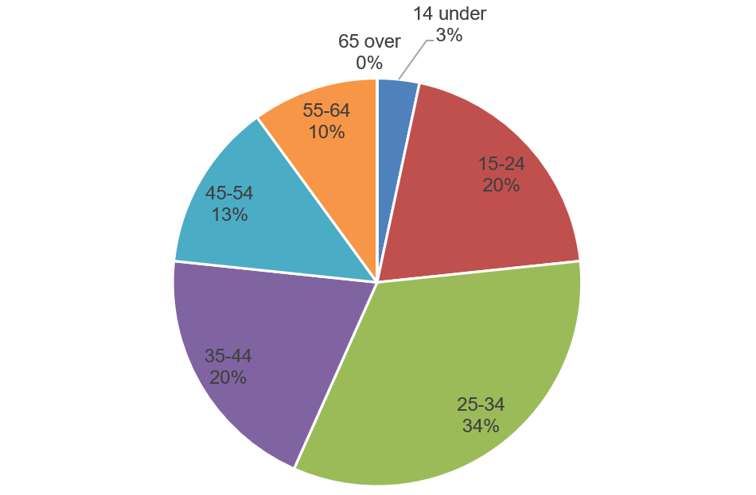
Figure 10: Pie Chart of Age Brackets of Respondents from FGDs
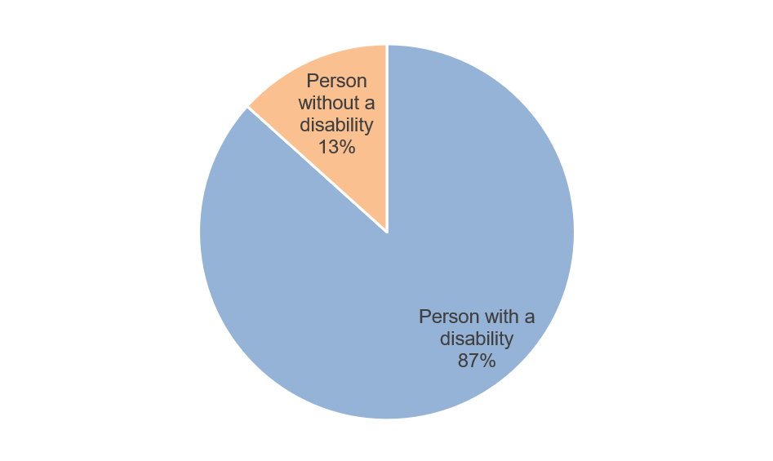
Figure 11: Pie Chart of Respondents with and without Disabilities from FGDs
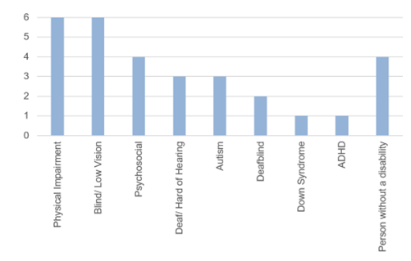
Figure 12: Bar Chart Showing Count of FGDs Respondents by Disability Type

Sampling, Response Rate, Data Analysis and Interpretation
The study employed a purposive sampling approach. For the FGDs, people from all 3 major islands were invited. The aim of using purposive sampling was to ensure that variables such as gender and disability were included. For KII, relevant agencies were identified, and the agencies provided representative/s to be interviewed. For both FGDs and KII Qualitative data was analyzed and categorized in thematic areas that matched SDG objectives from the data collected.

Ethical Considerations
The data collection was set in line with the ethical principles of voluntary participation, informed consent, anonymity, confidentiality, potential for harm, and results of communication. All interviews included information on child safeguarding, use of rights-based language and were conducted in a safe and non-violent environment. Furthermore, those who required reasonable accommodations were provided such. Due to the pandemic, it was decided that all interviews would be conducted online.

Limitations of the Study
For those in the rural areas whose access to internet services was limited and who were not always able to participate, we provided an internet allowance to mitigate these challenges. Furthermore, where appropriate, parents/guardians responded to the interview questions on behalf of the child participants. Also, all interviews (FGDs and KII) were conducted online via Zoom and not in person, due to potential risks from COVID.
Most interviewees from the FGDs were conducted in the Luzon region and specifically in the NCR, so there were limitations due to geographic representation. whilst in the KII, not all targeted agencies were represented such as Commission on Higher Education (CHED) and the Philippine Commission on Women (PCW). Furthermore, other intersecting identities such as indigenous, migrants, refugees, were not included.

The percent of children below the minimum proficiency threshold at the end of primary.
Measures the share of children who cannot read a simple text with comprehension by age 10.
The infographic states there are insufficient indicators available for SDG 5.
The HDI is a proxy measure for assessing long-term progress, it uses three basic dimensions of human development: a long and healthy life, access to knowledge and a decent standard of living.
Between 1990 and 2021, the Philippines's HDI value increased from 0.598 to 0.699, a change of 16.9 percent. This change led to the Philippines's life expectancy at birth increasing by 3.4 years, the mean years of schooling rose by 1.8 years and expected years of schooling by 2.3 years. Whilst the Philippines's GNI per capita changed by about 115.5 percent between 1990 and 2021.
The IHDI considers inequalities in all three dimensions of the HDI by ‘discounting’ each dimension’s average value according to its level of inequality in the distribution. The ‘loss’ in human development due to inequality is given by the difference between the HDI and the IHDI. The assumption here is, as the inequality in a country increase, the loss in human development also increases.
The GDI measures gender gaps in achievements in three basic dimensions of human development: between females and males: health (measured by life expectancy at birth), knowledge (measured by expected years of schooling for children and mean years of schooling for adults aged 25 years and older) and living standards (measured by estimated GNI per capita).
The GII measures gender inequalities (the loss in human development due to inequality between female and male achievements) in three key dimensions – reproductive health, empowerment, and labor market. Reproductive health is measured by maternal mortality ratio and adolescent birth rates; empowerment is measured by the shares of parliamentary seats held and population with at least some secondary education by each gender; and labor market participation is measured by the labor force participation rates for women and men.
The Gini coefficient is a measure of statistical dispersion intended to represent the income inequality or the wealth inequality within a nation or a social group.
The BARMM (Bangsamoro Autonomous Region in Muslim Mindanao) has a parallel subsystem, compared to the national education system (MBHTE, 2023), these systems and institutions are not covered within this report. This subsystem entails the Bangsamoro Government developing an educational framework that is contextually relevant to the Bangsamoro people. However, it shall conform to the minimum standards set by the National Government, under the Education in the Bangsamoro Organic Law (MBHTE, 2023).
The LIS is “an online facility that provides for the. registration of learners enrolled in schools. run or licensed by the Department of. Education (DepEd) in the Philippines” (DOE, 2019).
The ALS is a “parallel learning system in the Philippines that provides opportunities for out-of-school youth and adult (OSYA) learners to develop basic and functional literacy skills, and to access equivalent pathways to complete basic education” (DepEd, 2022c).
verbal abuse over the internet or cell phone or sexual messages.
data from 60 pilot schools in Regions V, VI, VIII and X.
Over 50 percent of LGUs in the Philippines have no PDAO (Rocamora, 2021).
“Refers to the hiring of a worker for piece work or intermittent job of short duration not exceeding six months and pay is on a daily or hourly basis. It is to be understood that the piece work or job to be performed requires special or technical skills not available in the agency and the same is to be accomplished under the worker's own responsibility and with minimum supervision by the hiring agency” (COA, 2017). In this particular case, the service provider is beholden to their superiors and did not want to go against them, as there was no security to their position.
A test to see what level homeschooled or out-of-school learners can enter formal education (Happyhomeschool, 2022).
Refer to Section 9 for information on the accommodation given to Learners with Disabilities in the Policy Guidelines on the National Assessment of Student Learning for the K to 12 Basic Education Program (DepEd, 2016).
The BLP is a program component of the ALS aimed at eradicating illiteracy among out-of-school youth and adults (OSYA), and in extreme cases, school-aged children, by developing the basic literacy skills of reading, writing, and numeracy (DepEd, 2022d).
The A&E Program is a program component of the ALS aimed at providing an alternative pathway of learning for OSYA who have the basic literacy skills but have not completed the K to 12 basic education mandated by the Philippine Constitution. Through this program, school dropouts are able to complete elementary and high school education outside the formal school system (DepEd, 2022d).
Learners are taught about oneself, Society, and Gender and Sexuality.
An additional program mentioned in a DepEd (2022d) website is the ‘Life Skills for Work Readiness and Civic Engagement Program’ which is aimed to address the mismatch between skills taught in school and skills demanded in the workplace that have left young people unable to find jobs, start their own businesses, or otherwise contribute to their communities.
All programs from the ALS except for the BLP have Learning Strand 5 which includes Gender and Sexuality (DepEd, 2022d).
For more information, visit the official Facebook Page of InkluNasyon
Click here to read more about Valenzuela City's best practices
The Nanay Teacher Program teaches parents how to properly introduce the learning modules and process in schools to avoid confusion. 97 percent of the parents are actively involved in the Nanay- Teacher program (Galing Pook, 2022).
For more information click here to view the Facebook Post from FWD Life Philippines
Click here to view more about National Child Development Center
An act promulgating a comprehensive policy and a national system for ECCD, providing funds therefore and for other purposes (Philippines Congress, 2000).
An act recognizing the age from zero (0) to eight (8) years as the first crucial stage of educational development and strengthening the ECCD system, appropriating funds therefore and for other purposes (Philippines Congress, 2013).
For more information about the Guidebook in Managing Children with Delays and Disabilities, click here
but it is not clear if these are just for identified persons with disabilities or for all community members and persons with disabilities are included.
For more information about the Gender and Development (GAD) Courses from TOP, click here
For more information about the TOP Courses with Accessibility Features, click here.
institutionalizing the diversity and inclusion program, creating an inter-agency committee on diversity and inclusion, and for other purposes.
R.A. 9262 seeks to address the prevalence of violence against women and their children, it “covers several acts of violence, which are: Physical Violence – acts that include bodily or physical harm (battery) causing/threatening/attempting to cause physical harm to the woman or her child; placing the woman or her child in fear of imminent physical harm” (PCW, n.d.).
R.A. 7877 is the Anti-Sexual Harassment Act, covering various elements on Sexual Harassment (PCW, 1995).
R.A. 11313 Safe Spaces Act and covers and defines “gender-based sexual harassment in streets, public spaces, online, workplaces, and educational or training institutions, provides protective measures and prescribes penalties therefor” (PCW, 2021).
Nemeth Code is a special type of braille used for math and science notations.
A software system for document preparation.
For more information about the Omnibus Guidelines for TESDA Scholarship Programs, click here.
Click here to know more about DSWD Home for Girls
ASEAN is an intergovernmental organization composed of ten countries; Brunei, Cambodia, Indonesia, Laos, Malaysia, Myanmar, Philippines, Singapore, Thailand and Vietnam.
For more information about ASEAN Economic Community Blueprint, click here.
To know more about Skills for Prosperity Programme in the Philippines, click here
“The DepEd said the “ideal student—teacher ratio for SPED is 15:1, however, Gatchalian stressed that there are only 4,000 SPED teachers. This indicates that with 126,598 learners with disabilities, the present student-teacher ratio is 31:1” (Dela Peña, 2023).

