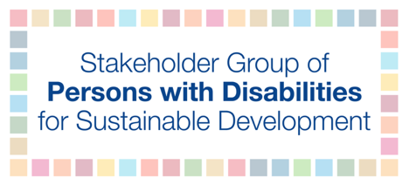
The ECOSOC Partnership Forum - 2 February, 9am to 6pm EST
“Building back better from the coronavirus disease (COVID-19) while advancing the full implementation of the 2030 Agenda for Sustainable Development”
Talking points for Dr. Mohammed Ali Loutfy

The COVID-19 pandemic and subsequent policies have affected persons with disabilities in grave ways. In response to the pandemic, the Stakeholder Group of Persons with Disabilities carried out qualitative research to gather information on the experiences of persons with disabilities at global and national levels.

The findings indicate that the most significant barriers, and thus priority areas for recommended policy change for the inclusion of persons with disabilities include: (1) lack of employment and social protection, (2) inaccessible healthcare facilities, (3) lack of access to and accessible COVID-19 information and data, and (4) lack of accessibility in terms of infrastructure, transportation, communication, digital, and more, (5) an increasing digital divide, (6) increased lack of security and safety, (7) and lack of prioritization of vaccines for persons with disabilities.

The findings also shed light on the key role of organizations of persons with disabilities during the pandemic. OPDs filled in and addressed the many gaps in government services. Many OPDs shared vital information, otherwise inaccessible, raised awareness with their members, and provided accessible materials in different formats.

To address this critical situation for persons with disabilities, in no particular order, we recommend that governments and other stakeholders:
- Address the growing digital divide that disproportionately affects persons with disabilities;
- Collect data on persons with disabilities to identify policy gaps and barriers faced by persons with disabilities to support policymakers to amend existing policies, regulations, and programs;
- Involve persons with disabilities and their representative organizations in the rebuilding process on all levels;
- Provide financing for development strategies and funding resources to support persons with disabilities’ involvement through systematic multilateral corporation among all stakeholders;
- Recognize standards of accessibility throughout the whole rebuilding process as a key strategic principle;
- Ensure that community-driven data be utilized by policymakers, UN Agencies, multilateral development banks, and international organizations.

