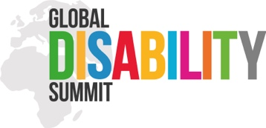
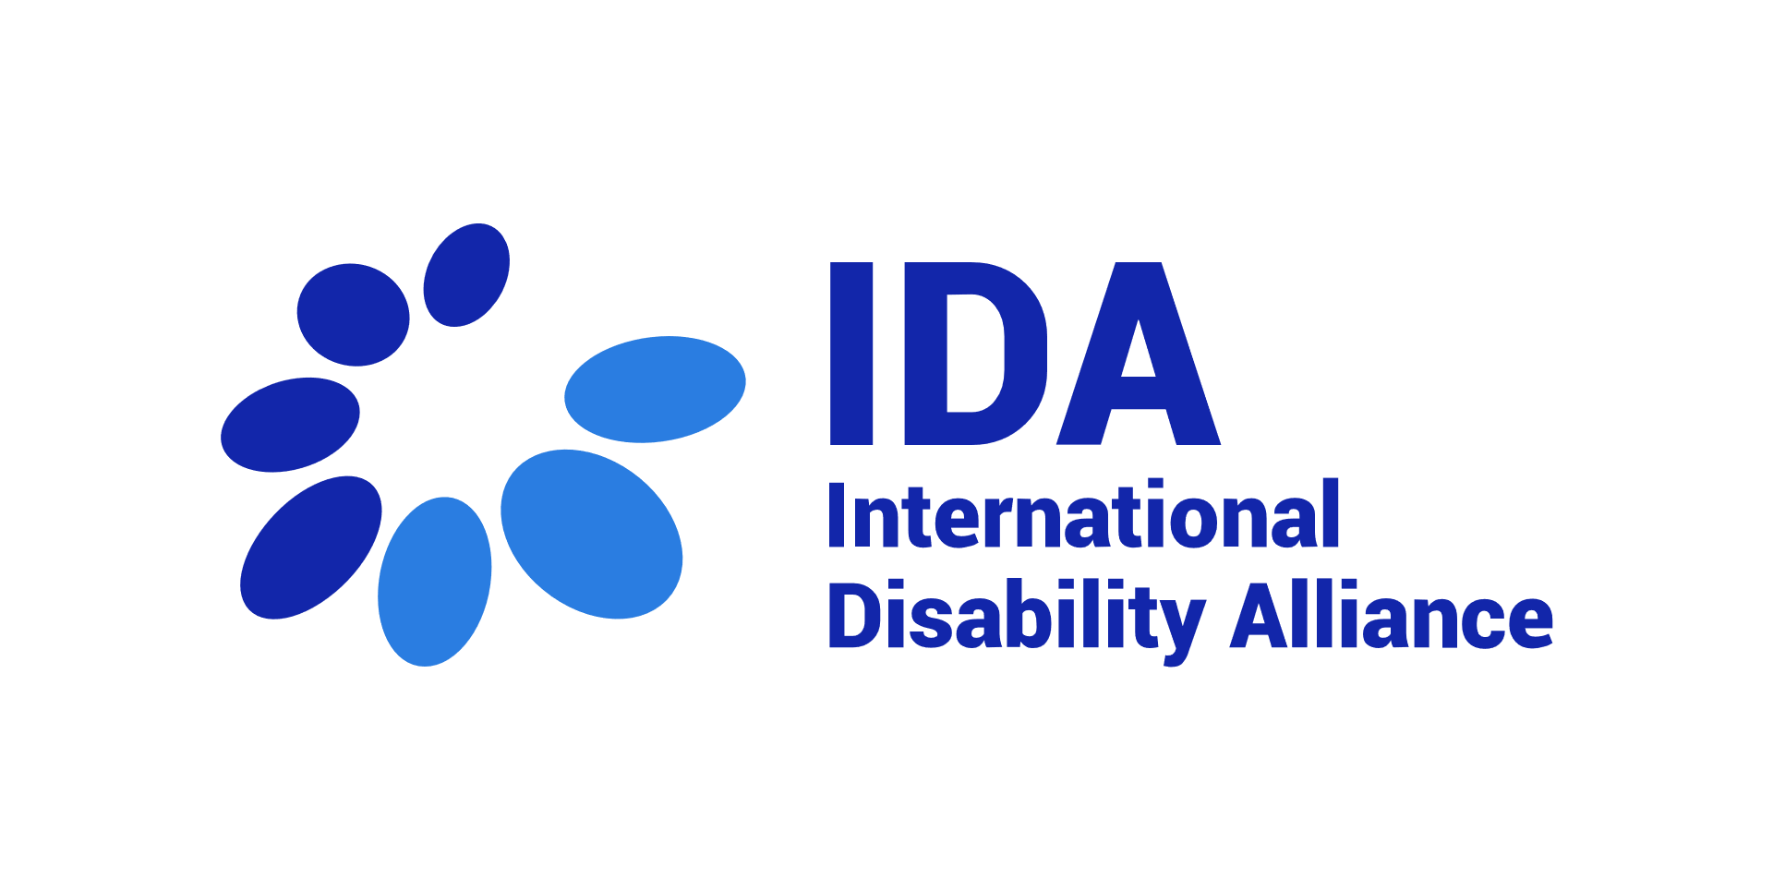
Building the case to accelerate meaningful OPD engagement: Framing a Discussion Paper for the Global Disability Summit 2022
Call for Good Practices/ Case studies

Background: The disproportionate impact of the Covid-19 pandemic on persons with disabilities, and the critical role that organisations of persons with disabilities (OPDs) played in advocating for inclusive responses showed us that if we want to build back better and inclusively, we cannot repeat the mistakes of the past. Persons with disabilities and their representative organisations should be part of shaping tomorrow’s policies and programs.
The Convention on the Rights of Persons with Disabilities (CRPD) created a general obligation to ‘closely consult with and actively involve persons with disabilities, including children with disabilities, through their representative organisations’, and significant commitments to consult with persons with disabilities have been made, such as through various international cooperation policies or the UN Disability Inclusion Strategy (indicator 5), and national level consultations with OPDs, by Governments, such as in the ratification of the CRPD.
However, as evidenced from the 1st IDA Global Survey on OPD participation (2019), while OPDs are more consulted than before, their participation is not yet meaningful, often restricted to specific topics, uneven across different constituencies and constrained by accessibility barriers, strong opportunity costs or lack of funding. While good practices exist, a stronger rationale on how to ensure meaningful OPD engagement is required to take these to more ambitious scale.
The Global Disability Summit 2022 provides a unique global opportunity to generate commitments to advance inclusion of persons with disabilities. Commitments can be generated at various levels - at national, regional or global level as well as at institutional levels. Under NORAD leadership, OPD participation has been identified as a cross-cutting theme and an important area of focus that should underpin GDS discussions and commitments. As a co-host of the GDS and global OPD network, IDA has been mandated to lead on the development of a Discussion Paper on OPD engagement.

Process: Following an initial webinar held on the 30th June 2021, IDA, NORAD, partners and allies formed 2 advisory groups to guide this process: a group advising the drafting of the Discussion Paper (group of 5 or G5) and a group supporting the review and selection of Good Practices/ Case Studies that will feed into the paper (group of 3 or G3).
Both groups met on the 30th of July 2021 to review a draft call for Good Practices/ Case Studies to be included in the Discussion Paper and set the initial parameters/ criteria that will be used for selecting a practice.
This Call for Good practices/ Case Studies is launched on 2nd August 2021.
The deadline for applying is: 8th September 2021.
All good practices/ case studies received will be screened first by a consultant to preselect those meeting initial requirements. The G3 will then screen and propose a selection based on the criteria described below. Pre-selected applicants may be contacted directly for further information and/or to validate how their work is being included in the final text of the GDS Discussion Paper.
The consultant will be selected by the International Disability Alliance, with support from the GDS Secretariat.

Objectives of the Call for good practices/ case studies
The objective of the Call is to collect existing good practices / case studies as evidence to inform ‘what has worked’ to promote meaningful OPD engagement, across different areas covered in the outline of the Discussion Paper.
- Who can submit? Good practices/ case studies can be from civil society organisations, consortia, networks or partnerships of organisations, private sector entities, media, donor agencies, or OPDs themselves from all countries and regions of the world; the report will aim to reflect a diversity of sources. Individual members of the G3 will not review the practices submitted by their own organisation or of organizations that are in financial relationship with the G3 members.
- What are the possible topics of good practices? Good practices/ case studies should relate to one or several areas of the draft report outline (see more below)
- How many good practices can be sent? An organisation can submit up to three good practices/ case studies.

Types of Good Practices/ Case Studies
In line with draft outline of the Paper as introduced during the initial webinar (see annex below, this be subject to changes), we invite interested organisations to submit good practices/ case studies in the 6 areas below:
Creating the preconditions at OPD level
- Organisational capacity building: What works to build the capacities of OPDs to engage in development and humanitarian projects? What strategies work to ensure that requirements (such as due diligence, safeguarding) do not exclude OPDs from engaging as partners? What works to ensure that investments and partnerships with OPDs do not effect investments of other groups?
- Movement building: What works to support greater coordination across different constituencies of the disability rights movement? What works to promote a greater participation and voice of underrepresented / marginalised groups of persons with disabilities? What works to build cohesion and solidarity across local, national, regional and global disability rights movements?
- Technical capacity building: What works to equip OPD activists with the technical skills, knowledge and capacities that they need to meaningfully engage as development/ humanitarian partners and/or policy entrepreneurs shaping more inclusive societies?
Participation as a coproduction: working together
- Inclusive programming: What works to ensure leadership and participation of OPDs across the project/ program/ policy cycle? What are examples that have proven impactful and transformative in the areas of inclusive project design, inclusive project governance, participatory project management, monitoring and evaluation?
- Inclusive policy making and advisory work: What works to ensure that the perspectives of OPDs are effectively included in policy making? What works to mobilize the expertise of OPDs’ activists for advisory work, in ways that reward individual expertise without disrupting the collective voice? What works to ensure balanced roles between OPDs and other experts?
- Creating new partnerships and transforming practices: What works to build or create new platforms, coalitions and consortiums involving or motivating new stakeholders to engage in the promotion of rights of persons with disabilities? What works to transform organisational practices (including at institutional level, such as Government entities) towards greater engagement with OPDs and accountability?

Initial parameters to select good practices/ case studies
Good practices/ case studies should clearly reflect the following principles:
- Demonstrate meaningful engagement of organisations of persons with disabilities (OPDs)
- Promote active participation of underrepresented / marginalised groups of persons with disabilities, including women with disabilities, children with disabilities, youths with disabilities, indigenous persons with disabilities, persons with intellectual disabilities, persons with psychosocial disabilities, persons with deafblindness, LGBTQI+ with disabilities, or any other group particularly at risk of exclusion in a given context
- Clearly explain the change process: what was the situation before, and how the practice led to progress
- Support building and cohesion of the diversity of the disability rights movement
- Provide a good rationale and motivation for others to replicate, in view of inspiring strong commitments at the GDS
- Create new partnerships, create new bridges, involve nonstandard partners – those organizations that are not traditionally involved in the promotion of rights of persons with disabilities
Good practices/ case studies should not:
- Discriminate against any group of persons with disabilities
- Contravene the CRPD
- Promote engagement of individual persons with disabilities without considering the existence and role of representative organisations
- Cause division within the disability rights movement
- Sustain power dynamics that prevent or de facto exclude OPDs from engaging as partners or meaningful contributors to development / humanitarian programs and projects

Overall, the Selection Committee (G3) will pay attention and recommend a selection that:
- Respects the above criteria
- Illustrates a diversity of practices (if several relevant submissions illustrate the same learning or recommendation, the G3 may suggest clustering them together)
- Covers engagement of the diversity of OPDs, including underrepresented / marginalised groups of persons with disabilities
- Balances across different sections of the Discussion Paper, across different regions/ countries, and across different types of organisations

How to submit a Good Practice/ Case study?
Please fill in the format in Annex B and send it by email to summit@ida-secretariat.org by the 8th September 2021.
Please feel free to contact Emma Pham at epham@ida-secretariat.org if you face any difficulty or would like to share your good practice in an alternative format.

Annex A – Provisional outline for the GDS discussion paper on OPD engagement

- Part 1 – Rationale and Framing (Why and What)
  - Reminder on the legal and policy framework calling for OPD participation
  - What this covers/ unpack what this means in practice: all issues, all stages of the program/ policy cycle, representing the diversity of persons with disabilities, different roles of OPDs, diverse ways of engaging
  - Setting initial parameters of meaningful participation

- Part 2 - Stock-taking (What is the current situation)
  - OPDs’ perceptions of their participation in decision-making with government and international cooperation stakeholders, including the impact of COVID-19 on OPDs
  - An example of self-assessment by the UN of their engagement with OPDs
  - A focus on ‘underrepresented / marginalized groups of persons with disabilities’

- Part 3 – Good practices and evidence from experience
  - Preconditions: OPDs capacity building
  - Preconditions: Smart investments in OPDs
  - Inclusive programming
  - Inclusive policy making

- Part 4 – Towards the GDS as a catalyst for meaningful OPD engagement: recommendations to generate strong GDS commitments to improve OPD engagement

Annex B – Template to submit a Good Practice / Case Study

Title of the practice:
Name of organisation(s) submitting the practice:
Contact person: name and email
Type of organisation (please select):
☐ Organisation of Person with Disabilities
☐ Donor agency
☐ INGO
☐ Other, please specify:
Geographical scope concerned by the practice (please select):
☐ Country, please specify:
☐ Multiple countries, please specify:
☐ Region, please specify:
☐ Global
Summary of the practice (please explain in 3 sentences how the practice actively contributes to OPD engagement)
Category of the Call that this practice relates to (please select one or more)
☐ 1. Organisational capacity building of OPDs
☐ 2. Movement building
☐ 3. Technical capacity building
☐ 4. Inclusive programming
☐ 5. Inclusive policy making and advisory work
☐ 6. Creating new partnerships and transforming practices
What was the problem your practice addressed? (please explain the initial problem and the context of your practice) 500 words max
What is the result/ outcome of your practice in improving OPD participation and how was it achieved? (please describe what changed and how the change occurred including resources mobilized, which groups of persons with disabilities are concerned and how the practice contributed to strengthen cohesion of the disability rights movement) 500 words max
What are your recommendations to multiply the results of this practice? (who is concerned? Any advice?) 500 words max
Please share any additional recommendation on OPD engagement you want to be considered to guide organisations to make ambitious commitments at the next GDS: 500 words max

Thanks for your contribution to the GDS Discussion Paper!
Please return this document to summit@ida-secretariat.org by the 8th September 2021.

Including: persons with intellectual disabilities, autistic persons, persons with deafblindness, persons with psychosocial disabilities, indigenous persons with disabilities, women with disabilities.

