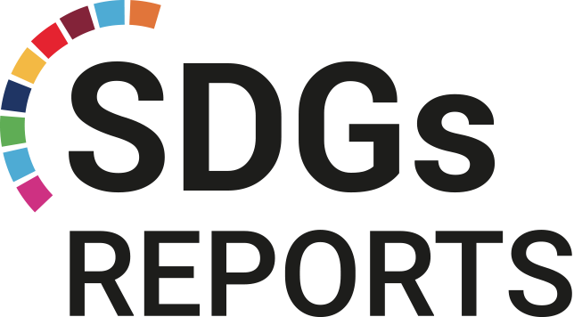

2021

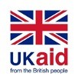
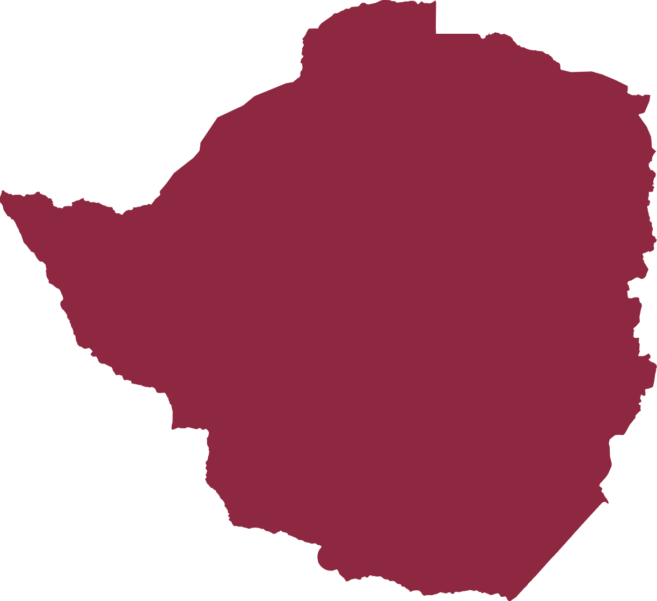
Shadow Report SDG 13 Climate Action -

COUNTRY
ZIMBABWE
Taking urgent action to combat climate change and its impacts on persons with disabilities
This publication was supported by:

DISCLAIMER

This report was funded by UK aid from the UK government and the Norwegian Agency for Development Cooperation (Norad) with the substantive and technical support of the World Blind Union (WBU) and the International Disability Alliance (IDA). The views expressed in this report do not necessarily reflect the perspectives of these organizations.

TABLE OF CONTENTS

DISCLAIMER 1
Acknowledgments 1
GLOSSARY 2
INTRODUCTION 3
Introduction 3
Context of the Report 3
Research Problem 5
Research Questions 6
ANALYSIS 7
Literature Review 7
Research Methodology 9
Research design 9
Population and Sample 9
Demographic Analysis 10
Measuring instruments 10
Research Findings 11
Knowledge on SDG13 11
Effects of Climate Change related disasters on persons with disabilities 11
Access to food 11
Accessibility 11
Access to support during crisis 12
Impact on persons with albinism 12
Knowledge of disaster management services 12
Accessibility of services on disaster response to persons with disabilities 12
Accessibility of Government Initiatives that deal with climate change 13
Accessibility of Civil Society Initiatives that deal with climate change 13
Access to information 14
Recommendations 15
Participation and Inclusion in Decision Making 15
Funding 15
Economic Empowerment 16
Capacity Building 16
Conclusion 17
References 18
Appendix 19
Survey on Zimbabwe's progress towards SDG13 - Taking urgent action to combat climate change and its impacts 19
Section A - Biographical Data 19
Section B - Knowledge and Experience with SDG 13 20
Section C - Knowledge and Experience with Initiatives Combating Climate Change 20
Section D - Experience with Climate Change 21

Acknowledgments

We are thankful to the Zimbabwe National League of the Blind for the opportunity to work on this research and write this report. Our immense gratitude as well to the World Blind Union and the International Disability Alliance for not just facilitating the research but for also providing with helpful insights and professional guidance in writing this report. We also thank Sheryl Chigwedere who was a co-researcher in the process.
Finally, we acknowledge with thanks the contributions and engagement of persons with disabilities and their organizations who contributed with their experiences in this report.
Although the WBU and the IDA have provided us with insights and guidance, the views represented here are not necessarily of either of the two organizations. Any errors, misrepresentations, or omissions are either due to consultants’ oversight or are a result of the data gathered from the survey.

Thando Gwinji

GLOSSARY

CRPD Convention on the Rights of Persons with Disabilities
EMA Environmental Management Agency
IDA International Disability Alliance
MDGs Millenium Development Goals
NAP National Adaptation Plan
NDC Nationally Determined Contribution
OPDs Organizations of Persons with Disabilities
SDG Sustainable Development Goals
UNDP United Nations Development Program
UNFCCC United Nations Framework Convention on Climate Change
WBU World Blind Union
VNR Voluntary National Review
ZimASSET Zimbabwe Agenda for Sustainable Socio-Economic Transformation

INTRODUCTION

Introduction
According to the 2013 National Survey on Living Conditions among Persons with Disabilities in Zimbabwe, the prevalence of disability in the country is estimated to be 7%, amounting to approximately 914,287 persons based on the total Zimbabwe population of 13,061,239.
Regardless of these figures, persons with disabilities often face challenges in their daily lives that lead to exclusion from opportunities to participate fully in their communities. Among these challenges are humanitarian emergencies that are a result of climate change.
Zimbabwe ratified the United Nations Convention on the Rights of Persons with Disabilities (CRPD) in 2013. The ratification of the CRPD reinforced the protection and promotion of the rights of persons with disabilities as provided for in the Constitution of the country protects the rights of persons with disabilities.
In 2015, Zimbabwe joined the world in adopting the Agenda 2030 and committed to leave no one behind including persons with disabilities.
This report will, assesses Zimbabwe’s commitment to implementing Goal 13 of the Agenda 2030 (SDG13) on climate change from a disability perspective, the gains, opportunities, challenges and gaps towards achieving disability-inclusive development.

Context of the Report
Adopted in 2015, SDG 13 requires States to take several measures to combat climate change and its impact. These measures include having national and local disaster risk reduction strategies, integration of climate change in national policies, strategies and planning, and improving of education, awareness-raising and human and institutional capacity on climate change. Similarly, article 11 of the CRPD obligates states to take measures to “ensure the protection and safety of persons with disabilities in situations of risk, including situations of armed conflict, humanitarian emergencies and the occurrence of natural disasters.”
This report comes at a time when there is an urgent need to take action against climate change and its impacts, as identified in SDG 13. No country is spared experiencing the drastic effects of climate change. The human impact of geophysical disasters, which are 91 per cent climate-related, has killed 1.3 million people between 1998 and 2017and left 4.4 billion injured.
Zimbabwe has faced natural disasters mainly in the form of droughts and floods. Some of the natural disasters that Zimbabwe has faced include the tropical cyclone Dineo, which hit Tsholotsho district in Zimbabwe in February 2017, caused flooding and left a trail of destruction in various villages. Hundreds of people were left homeless, livelihoods were destroyed, and one life was lost. Most recently, in 2019, the intense Tropical Cyclone Idai was amongst the worst tropical cyclones on record to affect Africa and the Southern Hemisphere.
The long-lived storm caused catastrophic damage, and a humanitarian crisis in Mozambique, Zimbabwe, and Malawi, leaving more than 1,300 people dead and many more missing. Zimbabwe has experienced a warming trend towards the end of the twentieth century compared to the beginning, with the annual mean temperature increasing by about 0.40C since 1900. Climate change adaptation and mitigation are of great importance to Zimbabwe and other countries that are experiencing the effects of climate change.
The global nature of climate change calls for solutions to be coordinated at the international level and requires international cooperation to help the developing countries to move towards resilience. The United Nations Framework Convention on Climate Change (UNFCCC) is the primary international, intergovernmental forum for negotiating the global response to climate change. The integrated nature of the 2030 Agenda for Sustainable Development poses special challenges for policymakers worldwide. Responses to climate change in the form of adaptation and mitigation measures can interact with other Goals and targets.
These responses can be planned in such a way as to maximize the synergies and limit the trade-offs. SDG 13 is among the ten focus goals selected by Zimbabwe as a priority for the implementation of the SDGs. The rationale for selecting it was that the economy of Zimbabwe is agro-based and relies heavily on the climate system hence there is a need to combat climate change and its negative impacts on livelihoods and the environment.
Reducing inequalities and ensuring no one is left behind is integral to achieving the SDGs. However, COVID-19 has deepened existing inequalities, hitting the poorest and most vulnerable communities the hardest. These inequalities include the lack of equal opportunities and representation in key decision-making processes. COVID19 has put a spotlight on economic inequalities and fragile social safety nets that leave vulnerable communities to bear the brunt of the crisis.
At the same time, social, political and economic inequalities have amplified the impacts of the pandemic on persons with disabilities. Much remains to be done to ensure that we truly become an inclusive society for persons with disabilities in all aspects of development.
In the education system, agricultural colleges exclude persons with disabilities in several ways that include accessibility to schools and availability of disability-friendly learning equipment.
In Zimbabwe, like everywhere else, the COVID-19 pandemic has disproportionately affected persons with disabilities and has had an impact on their socio-economic, health and general well-being in both urban and rural areas. Persons with disabilities have been severely exposed and affected because of their specific conditions and needs.
In addition, persons with disabilities have lost their livelihoods or have limited ability to undertake informal livelihoods activities, access health and education services, food & nutrition, COVID-19 information and are vulnerable to gender-based violence.
Addressing these challenges and barriers faced by persons with disabilities requires commitment and creativity. Addressing climate-related stocks, such as droughts, has wider benefits such as nutrition and livelihood skills for persons with disabilities, thereby supporting the achievement of SDG 1.
These actions must also go hand in hand with efforts to integrate disaster risk measures, sustainable natural resource management, and human security into national development strategies. National development strategies draw from international documents such as The United Nations, through the UN Convention on the Rights of Persons with Disabilities recognizes that the rights of persons with disabilities are central to the promise of the 2030 Agenda for Sustainable Development. They embody the pledge to leave no one behind, through transformative and lasting change, particularly, during times of crisis.

Research Problem
There are a number of challenges that Zimbabwe is facing concerning reaching SDG13’s targets. This report assesses Zimbabwe’s progress toward reaching SDG13 targets with a specific focus on persons with disabilities. Persons with disabilities constitute 13% of Zimbabwe’s population but are easily forgotten in decision-making on policy formulation and implementation.
Despite 2021 being the 6th year since the Agenda 2030 was rolled out, awareness of SGDs remains low, let alone their implementation. Information about how persons with disabilities have been affected by climate change and how they have been included in efforts towards disaster preparedness, adaptation and reduction is not readily available.
Climate Change is still a topic of little interest to the people, this means disaster preparedness and post-disaster management are poor and persons with disabilities are affected the most due to existing discrimination and marginalization. This automatically translates to minimal informed and meaningful participation of persons with disabilities in Climate Action.
The politicization of programs and threats that come from the political space, especially regarding land allocation limits the participation of persons with disabilities in specific country-level programs, especially those meant to target remote areas. These programs are provided by the National Adaptation Plan, the Green Climate Fund for the resuscitation of irrigation.
In policy formulation and implementation there are very few people involved, posing a problem in the spirit of leaving no one behind.

Research Questions

- What is Zimbabwe’s progress towards the attainment of SDG13’s targets, specifically looking at the inclusion of persons with disabilities?

- How can Zimbabwe ensure disability inclusive implementation framework for SDG 13 in the Decade of Action?

ANALYSIS

Literature Review
This section of the report will focus on reviewing evidence on Zimbabwe’s progress towards SDG13 with a specific focus on the inclusion of persons with disabilities.
Zimbabwe committed itself to implement all 17 SDGs. The country has, however, prioritized the following 10 SDGs: 2, 3, 4, 5, 6, 7, 8, 9, 13 and 17. The prioritization exercise was guided by the country’s vision, the need to focus on enabling Goals, resource availability and unfinished business in the MDGs. SDG13 became part of the priority SDGs because the economy (including the anchor sector of agriculture) depends on the environment and, therefore, it calls for an urgent need to combat climate change and its negative impact on the environment. The prioritization of SDGs was guided by Zimbabwe’s vision, which called for the need to focus on enabling goals and resource availability.
Climate change adaptation is of great importance to Zimbabwe and other countries that are experiencing the effects of climate change. Zimbabwe has suffered the brunt of climate change in recent years through the increased frequency of droughts, floods and epidemics. These make climate change adaptation a necessity for Zimbabweans. The goals were aligned to clusters of the country’s economic blueprint, Zimbabwe Agenda for Sustainable Socio-Economic Transformation (ZimASSET) for ease of implementation.
Zimbabwe was among the first countries to sign and ratify the UNFCCC in 1992. The country also ratified the Kyoto Protocol and its Doha Amendment. The Government of Zimbabwe ratified the Paris Agreement and pledged to lower its energy-related emissions by 33% per capita by 2030 below the projected business-as-usual through interventions such as promoting the adoption of renewable energy technologies, energy efficiency improvement and climate-smart agriculture, among others.
This was reflected in the Nationally Determined Contribution (NDC) which the country communicated to the UNFCCC Secretariat. In 2013, the Government established the Department of Climate Change Management with the mandate of promoting best practices in climate change adaptation and mitigation strategies to enhance response and capacity to manage the impacts of climate change.
The Department is implementing a number of projects and programs in trying to climate-proof all socioeconomic sectors of the country. The Department is under the Ministry of Water Resources Development and Climate.
The Government developed the National Climate Policy to guide climate change work in the country. The Policy is being supported by the National Climate Change Response Strategy, National Environmental Policy and Strategies. Renewable Energy Policy and the Forest Policy and other strategies aimed at achieving sustainable development.
While the country’s focus is mainly on adaptation to climate change, this does not make mitigation irrelevant. Various activities are being implemented to reduce the amounts of GHGs emitted and to promote a green economy. Whereas the definition of ‘green economy’ is widely contested, it generally implies an economy that results in “improved human wellbeing and social equity, while significantly reducing environmental risks and ecological scarcities.”
With support from United Nations Development Program (UNDP), through a project called Scaling-up Climate Change Adaptation in Zimbabwe through Strengthening Integrated Planning Systems, the National Adaptation Plan process was initiated. The objective is to reduce vulnerability to climate change impacts by building adaptive capacity and resilience and to facilitate the integration of climate change adaptation into relevant new and existing policies, programs and activities, in particular development planning processes and strategies, within all relevant sectors and at different levels, as appropriate.
The Government launched its National Climate Change Response Strategy that includes REDD+ as one of the mitigation options for reducing greenhouse gases in the forestry sector. The National Climate Change Response Strategy provides a framework for a comprehensive and strategic approach to aspects of adaptation, mitigation, technology, financing, public education and awareness. It will help to inform the Government on how to strengthen the climate and disaster management policies. Zimbabwe was admitted as a partner country to the UN-REDD program in 2013 and has introduced several pilot projects. In addition, several national stakeholders have participated in a number of REDD+ related capacity building activities at various levels. The country is in the process of developing several forestry-related projects on climate change adaptation and mitigation.
Zimbabwe is also in the process of developing several climate change-related policies including the Climate, Renewable Energy and Bio-fuels Policies. The government has embarked on the process of developing a National Adaptation Plan (NAP) which seeks to develop medium to long term approaches for reducing vulnerability to climate change impacts and facilitating the integration of climate adaptation into ongoing planning processes at national and sub-national levels. The NAP development process is championed under the Scaling up Adaptation in Zimbabwe through Strengthening Integrated Planning Systems Project, an initiative led by the Government of Zimbabwe supported by the UNDP and implemented by the Environmental Management Agency (EMA).
Zimbabwe has faced difficulties in implementing the SDGs. A policy action towards the service of SDG13 opened up the possibility of synergistic benefits across several others. However, the limited inclusion of persons with disabilities has had detrimental impacts on their efforts to achieve other Goals. The evidence from the Voluntary National Review (VNR) presented to date indicates that the government recognizes at the level of principle at least the implications of an integrated agenda.
They have been emphasizing their commitment to the policy coherence required across all organs of decision-making if the 2030 Agenda is to be implemented successfully.
The VNRs provide little detail on specific mechanisms that may have been created within the government to ensure that this dimension receives systematic attention within the machinery of everyday decision-making. In particular, there is limited evidence of concrete institutional arrangements being put in place to enable the governments to identify opportunities for synergies or to anticipate and manage trade-offs in the implementation of the SDGs.

Research Methodology

Research design
This research utilized a mix of quantitative and qualitative data collection methods. The mixed research method allowed for ensuring representative data from different groups of persons with disabilities and also allowed for a distinctive method of measuring the information gathered.
The mixed methods allowed for the collection of both descriptive and statistical data for the attainment of SDG13 targets considering its inclusiveness.

Population and Sample
The research gathered perceptions from persons with disabilities in all the 10 provinces of the country.
The research utilized purposive sampling by selecting persons with disabilities who have had experiences with climate change.
Through purposive sampling, it considered inclusion by considering gender representation, geographical location and type of impairment. A total of 22 people were interviewed as follows.

25-35
36-63
AGE
68%
32%
SEX
FEMALE
MALE
46%
54%
GEOGRAPHIC LOCATION
RURAL PROVINCES
URBAN PROVINCES
46%
54%
PHYSCHOSOCIAL
0%
VISUAL
4%
HEARING
2%
PHYSICAL
15%
OTHER (Albinism)
1%
TYPES OF DISABILITY

Demographic Analysis
The research managed to reach out to persons with disabilities from all the 10 provinces of Zimbabwe, however, more urban-based people were readily available to respond to the questionnaire than rural-based ones.
This was because of the lack of access to the network as most of their phones were off for calls and they were not online to fill in the online questionnaire. The population reached was mostly youth with disabilities.
The research managed to ensure that persons with different impairments were included, however, persons with physical disabilities were the majority. The questionnaire was disseminated to persons with intellectual and psychosocial disabilities, but there was no response. Effort was made to ensure that there was a combination of both audio and visual questionnaires. It is also key to note that most of the persons who were interviewed are members of Organizations of Persons with Disabilities (OPDs).
The following organizations were represented:
- Zimbabwe National League of the Blind
- Centre for Children and Youth with Disabilities
- ThisAbility Hub Zimbabwe
- Young Voices
- Kundai Rutendo Trust
- Impairments International Trust
- Bulillima People with Disabilities
- Bulawayo Disabled People Association

Measuring instruments
The research utilized a combination of an online questionnaire and telephone interviews (guided by the questionnaire to gather information from the respondents). Social media (WhatsApp) was used to share the online questionnaire. The online questionnaire was administered through a google form. The information gathered was recorded in text format.
Survey for Persons with Disabilities
See Annex 1 – attached.

Research
Findings

Knowledge on SDG13
The research showed that there is a general understanding of SDGs among young men and women with disabilities especially those in urban centers. Through their experiences, they were able to understand the correlation between climate change and other issues such as loss of property and income due to cyclones, droughts, and effects on small scale farmers and peasants.
Most of the knowledge that the respondents had about SDGs was derived mostly from workshops held by civil society organizations and from social and mainstream media. This explains why mostly young people with disabilities from urban centers are more knowledgeable than the elderly in rural settings because they have easier access to gadgets and mobile or Wi-Fi networks to access information and the media.

Effects of Climate Change related disasters on persons with disabilities

Access to food
47% of the respondents expressed that they have been affected by climate change related disasters that include severe droughts, floods, hailstorms and strong winds. The biggest impact of climate change on persons with disabilities has been that of food insecurity as most plunged into hunger and poverty as the change in rain patterns affected agricultural produce and increased reliance on imports. There was also a spike in the shortage of food and fresh water, leading to extreme hunger.

Accessibility
In areas that were affected mostly by floods, it became difficult for persons with physical disabilities to move around and get access to basic needs. Cyclones have led to the washing away of bridges, this limits the ability for persons with disabilities in rural areas to move to urban centers where they can access socioeconomic services because of accessibility issues with public transport that is available at that time.
Stampedes that happen during disasters when people are rushing for shelter on higher grounds have also affected persons with disabilities. For example, one of the respondents expressed that it was because of the stampede during the Cyclone Idai in Chimanimani that caused their disability. The economic effects were also seen when one of the respondents expressed that their property was damaged by the strong winds. The floods also damaged property in homes that were affected.

Access to support during crisis
There is also systematic discrimination where persons with disabilities are less likely to get help. This means that readily available systems do not take into consideration the disability-related support needs in a crisis. During climate response and assistance, the help that is issued is not inclusive. for example, there were very few wheelchairs available in the Cyclone Idai response. However, 47% of the respondents (mostly based in urban spaces) said that they had not been affected by climate change-related disasters. 4% of the respondents were not sure whether the disasters they faced were climate change-related or not.

Impact on persons with albinism
The fluctuations between the heat and very cold winters also affected those who have been operated on and affect their mobility. The heatwave that swept across the country in 2019 led to extreme headaches, skin burns among persons with albinism and increased heart problems.

Knowledge of disaster management services
52% of the respondents, mostly based in rural settings, showed a general understanding of disaster management. Most recalled instances where they responded to disasters that they experienced as highlighted above. It is, however, still concerning that 32% of the respondents (mostly youth) expressed that they do not know what to do if ever they are faced with disaster. This lack of knowledge exposes a gap in information dissemination when dealing with climate-related emergencies.
52% who have knowledge about disaster management, said that it entails reducing the impact and severity of disasters through disaster mitigation and preparedness. They highlighted the basics, such as finding a safe shelter, stocking up on food, alternative energy sources, keeping a charged-up phone for emergencies, emergency health supplies like first aid kits as well as staying with one or two other people or a group so that they are never alone in such circumstances.
They also mentioned the need to be evacuated from the affected area, move to higher ground and be up to date about what is going on and what is next and contact relevant authorities (Civic Protection Unit). Some of the respondents emphasized the need to be alerted and informed about disasters before they hit.

Accessibility of services on disaster response to persons with disabilities
50% of the respondents, based in urban areas, expressed that they are not aware of where to go in an event where they are faced with natural disasters, because information about the areas of rescue would not have been clearly stated.
Those who are aware of these areas and are mostly in rural settings expressed concern over the distance to these spaces and one recalled that in their experience they were treated the same way as persons without disabilities and no reasonable accommodation or support was provided to those in wheelchairs or walking with crutches. It was difficult to evacuate flooded areas since they use crutches. Many times, they sink into the ground when the area has sandy or loamy soils.

Accessibility of Government Initiatives that deal with climate change
68% of the respondents of all ages and from both urban and rural settings expressed that they are not aware of any of the government initiatives in line with climate change. This includes information on policies and relevant authorities as well. The other 23% know about the Civil Protection Unit which usually sends people messages on their phones alerting them about natural disasters. 23% are also aware of the national tree planting day in December as an initiative towards climate action. The remaining 9% were not sure whether or not they knew of any government initiatives, probably because they are not aware of the person organizing different initiatives in their communities.
Though 23% of the respondents had little knowledge of government initiatives on climate action, all of them expressed that they have not directly benefited from any government initiatives that deal with climate change. None have also been involved in the planning and implementation of government initiatives though they are interested in doing so.
This revealed that it is very difficult for persons with disabilities to access government initiatives because of gaps in information dissemination.

Accessibility of Civil Society Initiatives that deal with climate change
Most of the respondents (50%) confirmed that they were aware of civil society initiatives that deal with climate change including efforts toward the inclusion of young people in implementing climate actions.
Some of the civil society organizations that have directly been in contact with persons with disabilities for climate action include the Red Cross, Zimbabwe Agricultural Society, MINARA and others.
These organizations are working mostly on disaster response, environmental management, raising awareness about climate change, protecting wetlands and tree planting. Most persons with disabilities have benefited from these initiatives as participants in the process though one young person said that they are involved in the planning and implementation of the initiatives because they are actively participating in the advocacy and campaigns as youth leaders.
This revealed that information is accessible to those who have access to different spaces through the active roles that they play in society. It provides a gap for building the leadership capacities of young persons with disabilities.

Access to information
The study revealed that access to information is one of the major obstacles to improving awareness of climate change and its impacts. The information is hardly shared and when it is shared it is not in accessible formats such as braille, audio or sign language.
None of the information leaflets that persons with disabilities have come across on climate change is written in Braille. Information found on the internet is also not accessible to most young persons with disabilities and those in rural settings because data and gadgets are expensive.
Deaf people also do not gain much from meetings because some do not have sign language interpretation.

Recommendations

Participation and Inclusion in Decision Making
- Persons with disabilities should be included in decision making around climate issues in order to have inclusive policies that they will also be able to take part in implementing.
- Need for disability inclusion in all efforts. Ensuring that persons with disabilities are included in planning processes and the need for specific efforts for information sharing is necessary to mold policies and systems that are inclusive.
- Disability mainstreaming is necessary if we are to continue pursuing the leave no one behind agenda of the SDGs. This starts with employing persons with disabilities as field workers who are on the ground when consultations on programs and policies are being done.

Funding
- There is a need for multi-stakeholder approaches towards inclusion in climate action. This will allow for a combination of efforts from the government and civil society, especially in resource allocation. It will also enable the proper regulation of the private sector, especially those who operate in areas that are struck by climate-related disasters.
- Access to enough funding for information and disaster mitigation is very important, especially at a local level.
- While the rest of the world is going green, Zimbabwe still relies on firewood in rural areas. The fluctuations in weather patterns call for more reliable sources of energy to cater for the health of persons with physical disabilities. Therefore, there is a need for investment in renewable energy resources.
- All stakeholders need to come together to finance efforts towards climate action as is called for by the different international and national blueprints outlined above.

Economic Empowerment
- Private sector work on climate action should stop treating persons with disabilities as charity cases and meaningfully engage persons with disabilities in all the processes, including employing persons with disabilities and making employment accessible. Employment of persons with disabilities in these companies will ensure that the private sector plays its part in contributing to inclusive approaches to climate change.
- Agriculture is the major source of income for persons with disabilities in rural Zimbabwe, therefore, if their products are supported there will be an improvement in their livelihoods and socioeconomic status.

Capacity Building
- There is a need for awareness campaigns and intensified efforts in educating the public about climate change. This will cover the information gap and improve the informed participation of persons with disabilities in climate action.
- There is a need for new systems that include persons with disabilities that will be sustainable in the long run. These include a transformative education system, skills-building and training in diverse livelihoods such as apiculture, fisheries etc.
- Young persons with disabilities need to be given the capacity to position themselves in leading Climate Action. That way, they will also contribute immensely to filling information gaps that exist in terms of climate action.

Conclusion

Climate Action should be treated with urgency by all stakeholders, not just as a means of ensuring that the country benefits from it through income brought by agriculture but to avoid loss of lives, property and livelihoods of people as well.
This research’s recommendations do not only serve as a resource for ensuring inclusiveness in Zimbabwe’s progress towards SDG13 but also contribute to progress on the goal globally.
The Decade of Action calls for a need to draw on the continued support of local, national and global partners to secure and strengthen existing efforts. The urgency of this decade demands that all sectors of society galvanize to secure greater participation and leadership, more resources and improved, game-changing solutions to address increasing inequality and the escalating climate emergency.
There is a need for a drastic shift in the way in which efforts toward climate action are structured and implemented. Policy becomes ineffective if it does not translate to the daily lives of people at the grassroots as is currently on the ground.
Lastly, we cannot run away from the fact that all SDGs are interlinked and to achieve SDG13 we need to pay attention to others as well. There has to be deliberate action to pull out all stops, leaving no one behind.

References

Climate Change Management Department - Zimbabwe. (2017) Unpacking Sustainable Development Goal 13. www.climatechange.org.zw/sites/default/files/Article%203_SDG%2013.pdf
Markman, A. (2018). Why People Aren’t Motivated to Address Climate Change. https://hbr.org/2018/10/why-people-arent-motivated-to-address-climate-change
Mhlanga, C. Mpambela, M & Muzigili, T. (2019). Natural disasters in Zimbabwe: the primer for social work intervention. www.researchgate.net/publication/332750297_Natural_disasters_in_Zimbabwe_the_primer_for_social_work_intervention
Riberio, M. (2020). International Day of Persons with Disabilities| An inclusive, accessible and sustainable post COVID-19 Zimbabwe. https://zimbabwe.un.org/en/103539-international-day-persons-disabilities-inclusive-accessible-and-sustainable-post-covid-19
Sida’s Help Desk for environment and climate change. (2016). Environmental and Climate Change Policy Brief Zimbabwe. https://sidaenvironmenthelpdesk.se/digitalAssets/1725/1725303_zimbabwe_environment-cc_policybrief-2016-04-13.pdf
UNDP. (2020. UN-Zimbabwe-COVID19-Socio-economic-Framework. www.undp.org/content/dam/rba/docs/COVID-19-CO-Response/UN-Zimbabwe-COVID19-Socio-economic-Framework-Final.pdf
UNDP Zimbabwe. 2021. Goal13 – Climate Action. www.zw.undp.org/content/zimbabwe/en/home/sustainable-development-goals/goal-13-climate-action.html
UNDP Zimbabwe. 2021. Sustainable Development Goals. www.zw.undp.org/content/zimbabwe/en/home/sustainable-development-goals.html
Zimbabwe Legal Information Institute. (2019). Inclusive Education, Rights of Persons with Disabilities and Policy: Mainstreaming persons with disabilities at Africa University in Zimbabwe. https://zimlii.org/content/inclusive-education-rights-persons-disabilities-and-policy-mainstreaming-pwds-africa
Zimbabwe Voluntary National Review (VNR) of SDGs For the High-Level Political Forum. (2017). https://sustainabledevelopment.un.org/content/documents/15866Zimbabwe.pdf

Appendix

Survey on Zimbabwe's progress towards SDG13 - Taking urgent action to combat climate change and its impacts.
Survey on Zimbabwe's progress towards SDG13 - Taking urgent action to combat climate change and its impacts. Thank you for taking the time to complete this brief survey by the Zimbabwe National League of the Blind. The purpose of this survey is to gather data on Zimbabwe’s progress towards the attainment of Sustainable Development Goal (SDG) 13, specifically looking at the inclusion of persons with disabilities. Data from this survey will be used to draft a shadow report that will be presented to policymakers at different levels of engagement on the SDGs.

Section A - Biographical Data
- Full Name
- Email Address
- Sex
- Male
- Female
- Prefer not to say.
- Age
- Province
- Organization of Institution
- Disability
- Visual Disability
- Hearing disability
- Psychological Disability
- Other (Please Specify)

Section B - Knowledge and Experience with SDG 13
1 (a) Do you have any knowledge on SDG13?
  - Yes
  - No
  - Maybe
(b) If yes, what do you know?
(c) Where did you get the information from?
2. (a) Have you been affected by a natural disaster before?
- Yes
- No
- Maybe

(b) If yes, was it the cause of your disability?
(c) Kindly share what you know about disaster management.
(d) Is there a place where you can go and find shelter in the event of a disaster?
(e) How easy or difficult for you to get there?
Very Easy 1 - 2 - 3 - 4 - 5 Very Difficult
(f). Why is it easy or difficult?

Section C - Knowledge and Experience with Initiatives Combating Climate Change
3 (a) Are you aware of any government initiatives in line with climate change?
- Yes
- No
- Maybe
(b) Can you name these initiatives and where they are found?
(c) Have you or other people with disabilities benefited from these initiatives.
(d) Were you involved in the designing and implementation of these initiatives and how?
(e) How easy or difficult is it to access these government initiatives.
Very Easy 1 - 2 - 3 - 4 - 5 Very Difficult
4. Are you aware of any CSO initiatives in line with climate change?
- Yes
- No
- Maybe

(a) Can you name these CSO initiatives and where they are found?
(b) Have you or other people with disabilities benefited from these initiatives.
(c) Were you involved in the designing and implementation of these initiatives and how.
(d) How easy or difficult is it to access these CSO initiatives.
5. (a) Do you think enough is being done to enable you to access information about climate change?
- Yes
- No
- Maybe

(b) Explain

Section D - Experience with Climate Change
6. (a) Have you been affected by the effects of climate change? (Change in weather patterns, natural disasters etc.
- Yes
- No
- Maybe

(b) How were you affected?
(c) How could they have been avoided?
(d) What do other stakeholders do to help the government to mitigate the effects of climate change?
7. Any other Information.

The disability terms used throughout this report are derived from the Zimbabwe National Disability Policy Amended in June 2021. Accessible on the following link www.veritaszim.net/sites/veritas_d/files/National%20Disability%20Policy%20V4%28White%20Background%29.pdf www.zw.undp.org/content/zimbabwe/en/home/sustainable-development-goals/goal-13-climate-action.html
www.researchgate.net/publication/332750297_Natural_disasters_in_Zimbabwe_the_primer_for_social_work_intervention
www.researchgate.net/publication/332750297_Natural_disasters_in_Zimbabwe_the_primer_for_social_work_intervention
www.odi.org/sites/odi.org.uk/files/resource-documents/12771.pdf
https://sustainabledevelopment.un.org/content/documents/15866Zimbabwe.pdf
https://zimlii.org/content/inclusive-education-rights-persons-disabilities-and-policy-mainstreaming-pwds-africa
https://zimbabwe.un.org/en/103539-international-day-persons-disabilities-inclusive-accessible-and-sustainable-post-covid-19
UN-Zimbabwe-COVID19-Socio-economic-Framework
https://hbr.org/2018/10/why-people-arent-motivated-to-address-climate-change
www.zw.undp.org/content/zimbabwe/en/home/sustainable-development-goals.html
www.zw.undp.org/content/zimbabwe/en/home/sustainable-development-goals.html
www.climatechange.org.zw/sites/default/files/Article%203_SDG%2013.pdf
www.zw.undp.org/content/zimbabwe/en/home/sustainable-development-goals.html
https://sustainabledevelopment.un.org/content/documents/15866Zimbabwe.pdf
https://sidaenvironmenthelpdesk.se/digitalAssets/1725/1725303_zimbabwe_environment-cc_policybrief-2016-04-13.pdf
https://sidaenvironmenthelpdesk.se/digitalAssets/1725/1725303_zimbabwe_environment-cc_policybrief-2016-04-13.pdf

