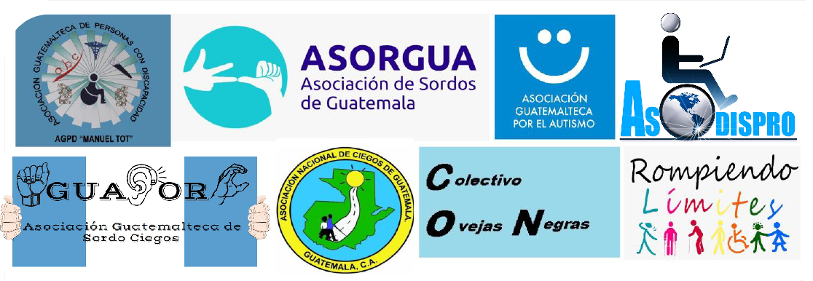

Executive Summary of the Alternative Report about the compliance of the SDGs by the State of Guatemala

April 2021

The present report was prepared by the coalition of organisations of persons with disabilities of Colombia, with the support of the International Disability Alliance (IDA) and the Latin American Network of non-governmental organisations of persons with disabilities and their families (RIADIS).

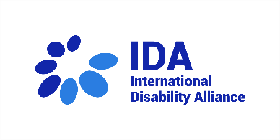
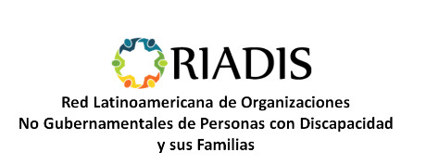

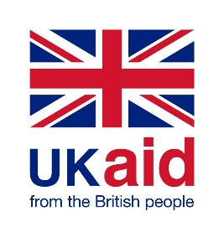
This material has been funded by UK aid from the UK government; however, the views expressed do not necessarily reflect the UK government’s official policies.

Guatemala ratified the Convention on the Rights of Persons with Disabilities (CRPD) in 2008 and adopted the Sustainable Development Goals (SDGs) in 2016.
To determine the progress of these commitments, from the perspective of civil society, a Coalition of Organizations of Persons with Disabilities was formed, with the support of the Latin American Network of Organizations of Persons with Disabilities and their Families (RIADIS. April 2021). This coalition produced an Alternative Report about the Compliance of the Sustainable Development Goals in Guatemala, evaluating SDG 3 and 16.
SDG 3: Guarantee a healthy life and promote well-being for all at all ages, goals 6, 7 and 8. In this evaluation, we identified that women and girls with disabilities do not have access to sexual and reproductive health, there’s a lack of suitable medical equipment, in addition, there is a lack of staff in health centers, and there is with very little accessibility, especially in rural areas. People with disabilities that require specialized services arrive by their own
Regarding the rehabilitation of victims of transit accidents, the organizations found that the Ministry of Public Health and Social Assistance (MSPAS for its acronym in Spanish) has a weak action in the rehabilitation of victims of transit events. The few rehabilitation services are located in urban centers and out of reach of rural areas.
SDG 16: Promote peaceful and inclusive societies for sustainable development, facilitate access to justice for all and create effective, accountable and inclusive institutions at all levels. Goals 3.7 Point B,
According to the information collected by the Coalition of Organizations of Persons with Disabilities, they point out that the Ministry of the Interior has not updated the regulations governing road safety education. While it is true, it has carried out education campaigns, but not in a sustainable way. Being, traffic accidents a predominant cause of physical, sensory, intellectual and mental deficiencies in the country.
The organizations indicate that they carried out the analysis of the justice entities, in this regard, they state that people with disabilities have promoted administrative and legal procedures to guarantee the access of people with disabilities to justice. But there is a lack of knowledge about its content and application by the target group, as well as an obvious lack of support from the disability coordinating body.
En lo que concierne, al ámbito legislativo, se ha aprobado el Decreto 03-2020, Ley de Lengua de Señas de Guatemala, quedando pendiente la aprobación del reglamento, el cual limita la aplicación de la presente Ley. Así mismo, señalan que constataron la marginación de grupos de mayor vulnerabilidad, tal es el caso de las personas con discapacidades múltiples, entre ellas, las personas sordociegas, quienes no cuentan con mayores programas de apoyo. Por tal razón la organizaciones de sociedad civil que promueven los derechos de las personas con discapacidad, impulsan acciones para atender las necesidades de la población con discapacidad desde los órganos de justicia, considera que dicho órgano no está bien asesorado.
Regarding the legislative field, the 03-2020 Decree has been approved about the Law of Sign Language of Guatemala, pending the approval of the regulation, which limits the application of this Law. At the same time, they indicate that they verified the marginalization of more vulnerable groups, such is the case of people with multiple disabilities, including deafblind people, who do not have access to support programs. For this reason, civil society organizations that promote the rights of people with disabilities, promote actions to comply the needs of the population with disabilities from the justice bodies, considering that this body is not well advised.
On the other hand, in regards to effective, responsible and transparent institutions, according to goal 12, National Development Priority: Institutional Strengthening Security and Justice, they report that there is a fragile capacity of public institutions, with emphasis on the processes planning and budget allocation. The Coalition considers that Guatemala has formulated the “Plan Nuestra Guatemala K'atún 2032”, whose objectives and goals are in accordance with the SDGs, but the actions they want for its application are not inclusive, rather, they exacerbate the historical exclusion towards people with disabilities.

