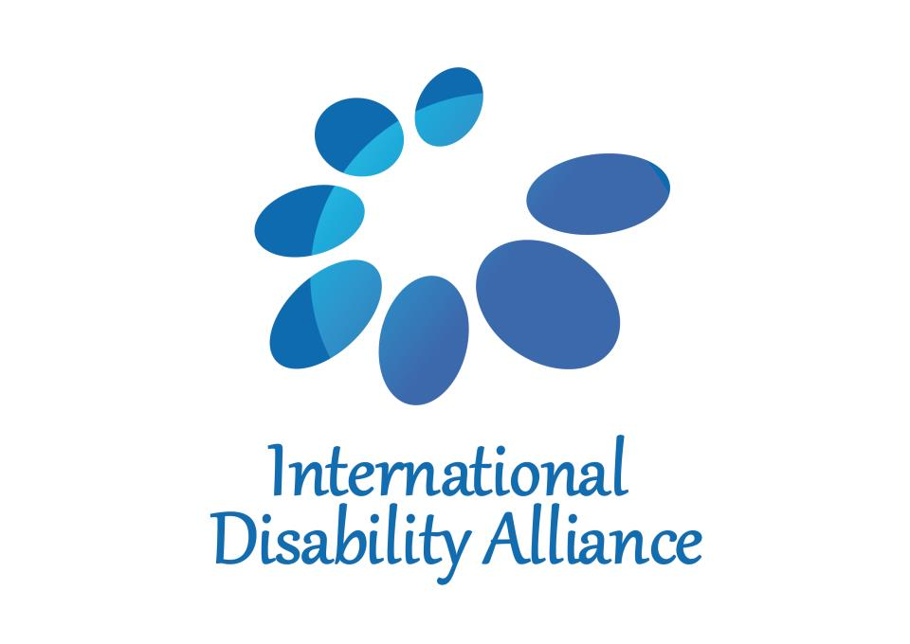
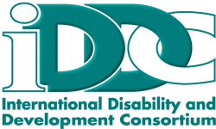

International Disability Alliance and International Disability and Development Consortium
Position Paper for 2018 Financing for Development Forum

I. Background
There are one billion persons with disabilities worldwide – 15 percent of the world’s population. Persons with disabilities experience compounding social, economic and political inequality, which is exacerbated when disability intersects with other forms of discrimination, including on the basis of gender. Such inequality and disempowerment means that, in any context where power imbalances distort the distribution of resources within society, one of the most extreme impacts will probably be on resources for the rights of persons with disabilities. We see this pattern clearly in situations of austerity, where persons with disabilities are often hit particularly hard.
II. UN and other international commitments
The Addis Ababa Action Agenda (AAAA) contains six explicit references to persons with disabilities and disability, one to “inclusive education,” one to “inclusive learning environment” and two to “accessible” technologies and infrastructures. What is more, unless the rights of persons with disabilities are addressed in the financing for development agenda, it will be impossible to fulfil a wide range of other international commitments, including the United Nations Convention on the Rights of Persons with Disabilities (CRPD); the 2030 Agenda for Sustainable Development – particularly its commitment to leave no one behind; and the Beijing Platform for Action.
III. Recommendations and Key Asks
Reflecting our mandate and expertise, these recommendations focus on persons with disabilities. However, many of our recommendations are also likely to apply to other populations experiencing identity-based discrimination.

- Economic justice for all
Many of the barriers that prevent persons with disabilities from enjoying their rights are the extreme manifestation of wider economic and political injustices. We join our voice and representation with the Civil Society FFD Group and Women’s Working Group on FFD, in calling for:
- Equal inclusion of all countries in decision making on international tax cooperation;
- Pro-poor taxation systems;
- Full transparency over all actual or proposed public-private partnerships, including compliance with the Open Contracting Global Principles;
- Fulfilment of commitments on Official Development Assistance and effective development cooperation;
- Alignment of decisions on trade and debt with human rights obligations, and the creation of a transparent, accountable and independent debt workout institution; and
- Reform of the governance of the international financial and monetary system, to uphold the rights of the poorest.

- Putting the furthest behind first in resource allocation
Dedicated resources are needed to tackle the economic and social inequalities that leave persons with disabilities behind. This includes not only disability-specific expenditures (e.g. tax exemptions or other policies to ensure affordable access to assistive devices), but also allocations to fulfil the rights of persons with disabilities within “mainstream” budget areas (e.g. an allocation for sign language interpretation within the education budget, to help deaf children attend school). Non-discrimination against persons with disabilities should be a key criterion in the assessment of proposed economic reform policies, and should be reflected in clear guidelines for the International Monetary Fund and for Regional Financing Arrangements.
We call for a progressive increase in dedicated domestic resource allocation and international development cooperation to support the full inclusion of persons with disabilities and their families in sustainable development. “Innovative” financing tools such as blended finance risk diverting resources from activities that would best fulfill the rights of persons with disabilities and other marginalized groups, and we urge that blended finance should not be used without a full, participatory, human rights impact assessment.
3. Policies to prioritize rights and accessibility
Effective regulation is essential to ensure that all development finance – public and private – complies with relevant obligations in the CRPD, as well as commitments in the AAAA paragraphs 12, 14, 16, 78 and 114. We call for regulations in all areas of government spending to be aligned with the CRPD. We call particularly for the full adherence of private investments to human rights standards, with effective redress for any transgressions.

Accessibility is a precondition for persons with disabilities to enjoy other rights and to benefit from infrastructure, ICT and financial services on an equal basis with others. We call for Member States to live up to the commitments on accessibility in the AAAA by making accessibility a key criterion in the mobilization of finance, including by building accessibility requirements into all public procurement procedures.

4. Transparency, accountability and participation in financial decision-making
A sustainable solution to the inequalities that persons with disabilities face in development finance will require a redistribution of power. As a starting point, we call for the following steps to make financial decision-making accountable to persons with disabilities:

- Transparent reporting of domestic and international resource allocations for the realization of disability rights, including through the agreement and implementation of the proposed disability policy marker on the OECD DAC Creditor Reporting System, as well as through disability disaggregated data on development outcomes (AAAA, para 126). Key information should be made available in easy-to-read language to enhance accessibility. We also call for the Inter-Agency Task Force, in its 2019 report, to examine best practices in transparency over the distributional impact of development finance, including the impact on persons with disabilities.
- The full participation of persons with disabilities and their families as experts in inclusive and accessible citizen-led social accountability mechanisms engaged at all stages of the process to design, implement and monitor budget and fiscal policies.

World Bank/World Health Organisation, 2011, World Report on Disability
See for example The Report of the Independent Expert on the Effects of Foreign Debt and Other Related International Financial Obligations on the Full Enjoyment of All Human Rights, particularly Economic, Social and Cultural Rights: Developing Guiding Principles for Assessing the Human Rights Impact of Economic Reform Policies, A/HRC/37/54
UN Convention on the Rights of Persons with Disabilities
2030 Agenda for Sustainable Development
Beijing Platform for Action
For more detail on these issues, please refer to the CSO Declaration from the Addis Ababa Civil Society Forum on Financing for Development, Eurodad’s 2018 FFD Forum position paper, and J Griffiths (forthcoming), “Financing for Development and the SDGs: an analysis of financial flows, systemic issues and interlinkages”.
Such technology includes, but is not limited to, the technologies covered by the Marrakech Treaty to facilitate access to published works for persons who are blind, visually impaired or otherwise print disabled; by the World Health Organisation’s Essential Medicine List, Priority Assistive Products List and the forthcoming World Health Assembly resolution on assistive devices; and by International Telecommunications Union standards and guidance on accessibility; as well as basic sun protection technologies highlighted in the Regional Action Plan on Albinism in Africa (A/HRC/37/57/Add.3)
As recommended in the recent report by the UN Independent Expert on the effects of foreign debt, as above.
Eurodad, 2017, Mixed messages: the rhetoric and reality of using blended finance to ‘leave no-one behind’

