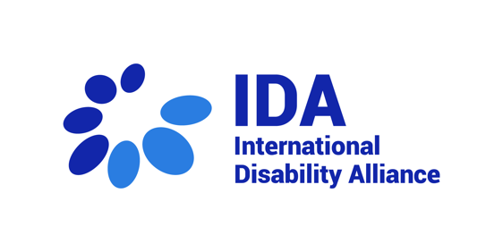
International Disability Alliance, closing statement 28th session

Thank you very much Madame Chair,

Dear members of the CRPD Committee

It is my great pleasure to join you today to deliver this brief statement on behalf of the International Disability Alliance.

Let me start by warmly congratulating and thanking you CRPD Committee members, CRPD Committee Secretariat and the UNOG Conference services, for making possible and effective this busy four-week long 29th session, including eight States reviews together with two Follow up sessions to Inquiry Procedures.

The International Disability Alliance (IDA), in coordination with its members the European Disability Forum, the Latin American Network of Organizations of Persons with Disabilities and their Families, and other partners such as the Disability Rights Fund and Women Enabled International, continued to provide support to the national organizations of persons with disabilities engaging with seven of the eight State review processes. Let me share that the International Disability Alliance and national OPDs representatives are always thankful for the opportunities given, and the availability of Committee members and the support of its Secretariat to listen to their concerns regarding CRPD implementation -or lack of it- in their countries.

Some challenges remain, as we learnt from the experience with colleagues from Mauritania. For our IDA side, and thanks to the tentative forecast of reviews produced and published by the CRPD Committee Secretariat, IDA expects to prevent and overcome the barriers of delays and challenges in visa procedures to allow for travel to participate in the CRPD sessions. On the other side, the relevance of interpretation for remote participation by the UNOG remains a critical element. IDA is aware of the complexities in technical terms (connectivity, quality of sound, etc.), budgetary terms and probably other factors. Still, while always thanking and acknowledging that the CRPD Committee’s practice for civil society engagement, which is outstanding compared to others -with private briefings within official time and accessibility features-, IDA hopes that solutions can be found soon on this specific issue of interpretation for remote participation to continue creating and ensuring opportunities for civil society engagement with UN Treaty Bodies in the years to come.

Moving to other elements, next year, CRPD Committee’s elections will take place in June and nine seats will be at stake. IDA will undertake its efforts to ensure the visibility of the electoral process and calling States Parties nominate candidates through transparent and open processes at the national level and to vote based on the relevant criteria established by Article 34 paragraphs 3 and 4 of the Convention, including both individual qualifications of candidates and the outcome of the Committee’s composition reflecting gender balance, geographical representation and disability diversity.

Moving to substantive developments, IDA is glad that the process towards general comments no. 9 and 10 is advancing steadily under the leadership and supervision of the Working Group on Article 11 CRPD, with the support of the Secretariat and of relevant stakeholders with technical expertise to contribute to as appropriate. IDA looks forward to further information and to contribute to this process in the appropriate ways and opportunities, given its role as the unique alliance of global and regional representative organizations of persons with disabilities.

From the States reviews of this session, IDA notes with concern Germany’s blunt opposition to the full scope of article 12 of the CRPD, prioritizing the views of national jurists and academics over the views of this CRPD Committee, international monitoring body mandated to monitor and interpretate the Convention. While IDA believes the Committee holds its dialogues respectfully and constructively, this kind of messages from States force all of us to reflect on what can be done or communicated better for States to gain in understanding and ownership over CRPD human rights standards to conduct CRPD compliant reforms.

On Monday 9th, October, the World Health Organization and the Office of the High Commissioner for Human Rights will launch their joint publication entitled “Mental health, human rights and legislation: guidance and practice.” While there might always be points of criticism, it is important to acknowledge that this publication, whose main audience are existing health systems, at this point of time, incorporates key elements emanating from the CRPD and the courageous and groundbreaking work of this Committee. For what may remain pending to tackle, IDA believes the Committee may decide to go further in detailed during States’ reviews on how to de-medicalize psychosocial disability and concrete recommendations on how States parties should provide options for services and support outside the health-care system, that fully respect the individual’s self-knowledge, will and preferences .

As always, IDA remains fully committed to support the work of the Committee and its Secretariat. We thank you, members of the Committee, personal assistants, and colleagues of the Secretariat, for your work, as well as interpreters and staff of conference management, for facilitating the meetings.

I thank you for your attention.

