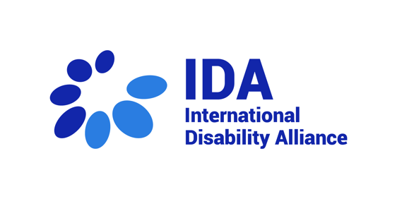
International Disability Alliance, closing statement 28th session

Delivered by Juan Ignacio Pérez Bello, Senior Advisor on Human Rights

Thank you very much Madame Chair,

Dear members of the CRPD Committee

I deliver this statement on behalf of the International Disability Alliance.

Let me start by warmly thanking you CRPD Committee members, CRPD Committee Secretariat and the UNOG Conference services, for your tireless work during this 30th session, ensuring international human rights monitoring in these difficult times for Universal Human Rights System due to the liquidity crisis of the United Nations and when international human rights law and humanitarian law can seem powerless in the context of ongoing armed conflicts.

We, together with national organizations of persons with disabilities, are looking forward to reading the seven Concluding Observations adopted during this session and the outcomes of the follow up sessions on Inquiry Procedures.

The International Disability Alliance (IDA), in coordination with its members the European Disability Forum, the Latin American Network of Organizations of Persons with Disabilities and their Families, and other partners such as the International Commission of Jurists and Norwegian Association for the Disabled, provided support to the national organizations of persons with disabilities engaging with five State reviews processes. IDA, its partners and national OPDs cannot be more thankful for the opportunities given, and the availability of Committee members, with the support of its Secretariat, to listen to their concerns related to the rights of persons with disabilities at the national level.

IDA appreciates the methodology piloted with the States of Kazakhstan, Zambia and Sweden. We know it was also foreseen for Costa Rica but could not be followed due to the minimal State delegation for the dialogue. While some adjustments would be useful, e.g. on time management and technical issues, this methodology seems very fit for the purpose of seeking that States officials realise, on the spot of each question and related back and forth, of their shortcomings in the understanding of the concepts of the Convention and of their implementation at the national level. States delegations should get used to it appreciating the value of making the dialogue more concrete and to the points, and thus more constructive. We also believe this methodology would also allow for a more straightforward connection with the content of the Concluding Observations. IDA encourages the Committee to keep improving in this direction.

The IDA, as many others in the human rights community, is highly concerned by the ongoing situation of the United Nations and the OHCHR, in terms of lack of sufficient resources for its basic operations. We also regretted at the opening the sudden end of remote participation in official meetings. We understand there would be plans -still not fully confirmed- in the very short term for ensuring the realisation of the next 31st session in August, but the situation remains precarious. For the case of the CRPD Committee, it also further reduces the possibility of catching up with the backlog of 68 pending initial States reviews, mentioned by the CRPD Secretariat at the opening session. This should be of serious concern to us all.

On its side, IDA will keep advocating for increased resources within the United Nations for timely human rights monitoring, and also for accessibility and reasonable accommodation for persons with disabilities in al procedures, in particular in the context of the work of all human rights treaty bodies, in line with the 2023 Conclusions of the Meeting of Chairpersons of Human Rights Treaty Bodies, which we highly appreciated. The General Assembly will adopt its resolution on human rights and the treaty body system in December 2024. IDA will seek to join efforts with other partner human rights organizations and other stakeholders to increase advocacy for a well-resourced treaty body system to ensure human rights monitoring and to allow for increased engagement by national organizations of persons with disabilities.”

Moving to other issue, in less than three months, the CRPD Committee’s elections will take place at the Conference of States Parties. For now, OHCHR's website shows 10 nominated candidates, including three current members and one former member. IDA will contact the ten candidates to seek their collaboration to increase visibility and transparency of the elections, by replying to a written questionnaire and producing a short video to share their motivations to continue as or to become a CRPD Committee member highlighting their future contributions to the work Committee. The information will be publicly available and will reach States Permanent missions to the UN connected to the election’s procedures.

Moving to substantive developments, IDA is glad that the process towards general comment no. 9 continues to advance, despite the difficult times in terms of funding,
under the leadership and supervision of the Working Group on Article 11 CRPD, with the support of the Secretariat and of relevant stakeholders with technical expertise to contribute to as appropriate. IDA looks forward to contributing to this process in the appropriate ways and moments, given its role as the unique alliance of global and regional representative organizations of persons with disabilities.

As always, IDA remains fully committed to support the work of the Committee and its Secretariat. We thank you, members of the Committee, personal assistants, and colleagues of the Secretariat, for your work, as well as interpreters and staff of conference management, for facilitating the meetings.

I thank you for your attention.

