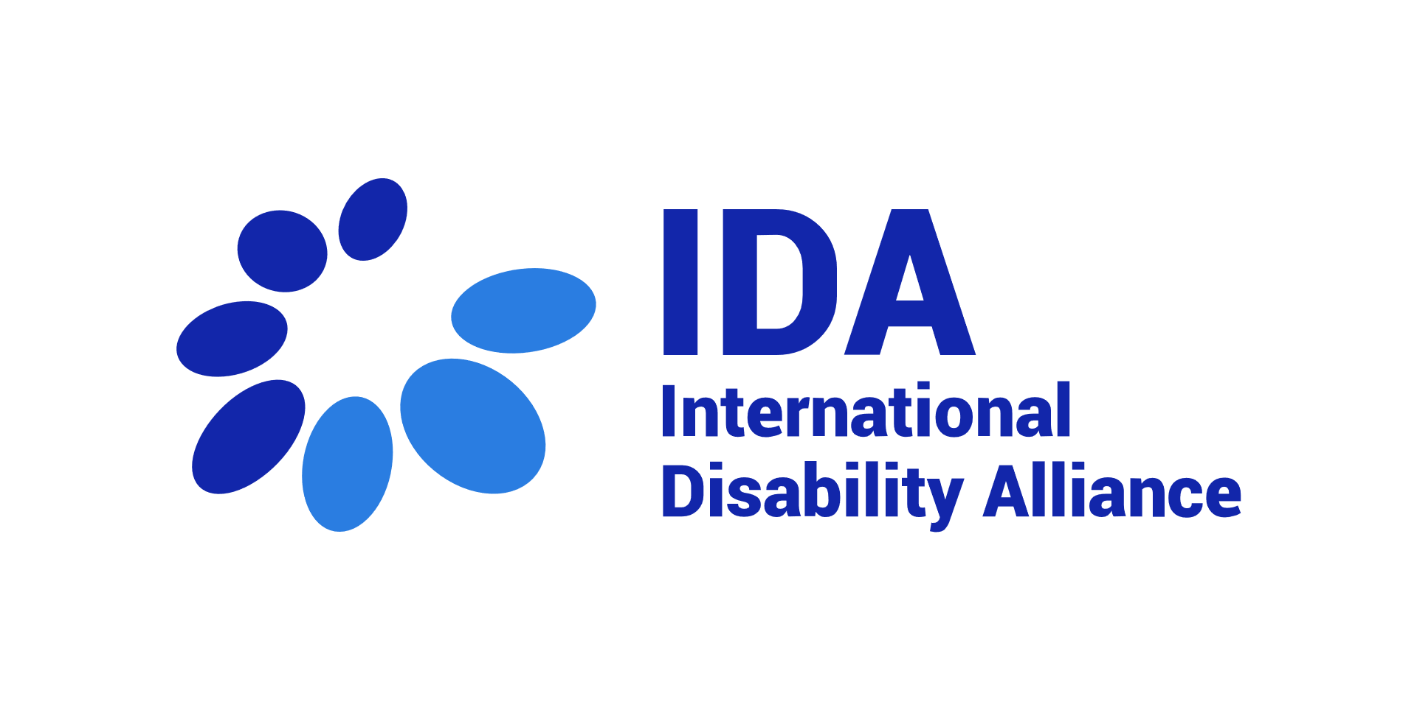

Safeguarding and Management of Malpractice and Misconduct - Complaint Reporting Form

Version | Prepared by (name, title, date) | Validated by (name, title, date) | Signed by
V1 | Priscille Geiser, Programme  Manager, 2020 | Vladimir Cuk, Executive Director,  2020

This form is to be filled by anybody from IDA staff or Board member reporting a complaint for a behaviour considered negative and prohibited under the scope of IDA Policy on Safeguarding and Management of Malpractice and Misconduct. The person reporting the complaint may be directly affected or reporting an incident affecting another person.
Please refer to the complete Policy document for more information on the scope of the Policy and procedure to follow.

Name of the person reporting:
Link with IDA:
☐IDA employee, please specify your position:
☐ IDA board member
☐ Member of IDA member
☐ IDA partner
☐ Other, please specify:
☐ I am not sure
Contact email:
Date of reporting:
Date/ time of the incident reported:
Name of the person who you believe is responsible of the negative/ prohibited behavior:
If the negative/prohibited behavior was towards another person, please identify this person:
Please identify any witness:

Describe the incident(s) as clearly as possible (“who, what, when, where, why”).
Include a full description of the event(s), verbal statements (threats, requests, demands, etc.), the location, and what, if any, physical contact was involved:

How did you or the person concerned (if not you) react (or not)?

What contact did you or the person concerned (if not you) have with the person responsible for the negative/ prohibited behaviour before the first incident?

This complaint is based upon my honest belief that (NAME OF THE RESPONSIBLE PERSON) is responsible for a behaviour that is prohibited as per IDA Policy on Safeguarding and Management of Malpractice and Misconduct affecting me / or (NAME OF THE PERSON).
I hereby certify that the information I have provided in this complaint is true, correct and complete to the best of my knowledge.

Date
Signature

