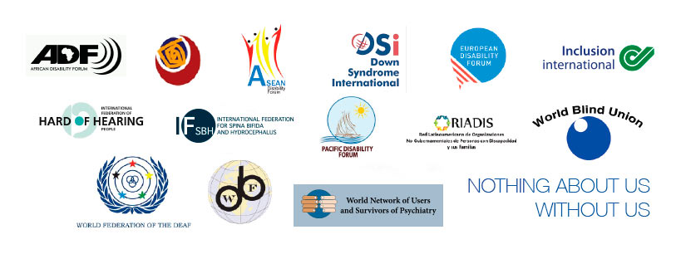

Reach the furthest behind first:

Persons with disabilities must be prioritized in accessing COVID-19 vaccinations

Summary
Persons with disabilities are experiencing exclusion, discrimination and neglect during the response to the pandemic. We don’t want this to be the case in dissemination of COVID-19 vaccinations. As the International Disability Alliance - representing more than a billion persons with disabilities worldwide, we call all policy-makers and health-care planners in every region and in every country to include persons with disabilities and support networks of their choice in priority groups to receive vaccinations, and to make sure that all persons with disabilities can access vaccinations on the basis of accessible and understandable information, through informed consent. We call on the United Nations, including the World Health Organization to issue clear and strong recommendations in this regard, and to take all necessary measures to ensure that governments comply with their obligations to persons with disabilities with regard to priority access to COVID-19 vaccinations and related information and processes.

Rationale
According to World Health Organization, persons with disabilities are categorized as vulnerable populations during public health emergency situations. Institutional, environmental and attitudinal existing barriers exacerbate, and new ones appear in the times of public health emergencies, restricting further the exercise of basic rights for persons with disabilities, including the right to life, the right to access to health care, and the right to independent living. This has been extensively documented during the global COVID-19 pandemic.
- Persons with disabilities face enhanced risk of contracting COVID-19
Persons with disabilities face increased risk of contracting COVID-19 due to existing health conditions and inequities in underlying and social determinants of health and contact with support service providers. Many persons with disabilities cannot observe physical distancing because they require personal assistance or guide to carry out their daily activities or rely on physical contact to explore and navigate their environment. Others are exposed because they do not have access to timely and understandable information on how to protect themselves against COVID-19 in accessible formats. For some persons with intellectual or persons with psychosocial disabilities or autistic persons, observing physical distancing or extended use of masks or face coverage and other hygienic requirements is not feasible. This is particularly the case for persons with disabilities who are living in congregate settings where infection rates are very high, such as refugee camps and nursing facilities, as well as psychiatric institutions and other segregated settings contrary to article 19 of the United Nations Convention on the Rights of Persons with Disabilities (CRPD).
- When infected by the virus, persons with disabilities are more likely to develop more severe symptoms risking death
In case of contracting COVID-19, those groups of persons with disabilities with pre-existing conditions such as respiratory challenges, are at higher risk of developing critical conditions or losing their lives. Others may not access timely and equal medical attention due to lack of adequate information about symptoms and primary steps in case of exposure to infection, inaccessible health systems, inaccessible transportation, lack of required financial resources or lack of adequate personal assistance or support. When reaching to critical stage, persons with disabilities are very likely to be deprioritized due to formal discriminatory triage protocols or informal de-prioritization by health care team based on judgement about quality and value of their lives.
- Observing physical distancing disproportionately impedes persons with disabilities access to livelihoods, independent living and health care and rehabilitation
Due to restrictions caused by COVID-19, many persons with disabilities who worked in informal sectors or could not adopt the new working conditions such as remote working or physical distancing at the work place lost their livelihood and face disproportionate financial challenges. This particularly affected women with disabilities who are more represented in those areas. Other persons with disabilities who require personal assistance experience serious difficulties in carrying out daily activities or, due to lack of governmental support, have to rely on family members which may undermine their dignity and independence. Some groups such as persons with deafblindness are simply cut off from the world to a large extent because in-person interpretation is not possible due to physical distancing. Persons with intellectual disabilities, persons with psychosocial disabilities and autistic persons may experience even more profound mental health challenges, double isolation, and anxiety due to a combination of all of the different impacts of the Pandemic.
- Unless specifically prioritized, persons with disabilities in practice will be among the last groups accessing vaccination
Due to attitudinal and environmental barriers, persons with disabilities are often among the last groups who can access highly demanded public services, in particular in situations of risk and emergency. Because vaccine demand would exceed supply in the first years, without prioritization, persons with disabilities will be disproportionately excluded. Inaccessible information on registration systems or processes, inaccessible medical centers, and stigmatizing attitudes among family members, health care professionals and others who view life and health of a person with disability of less value than others, are only some of the barriers that persons with disabilities may face accessing vaccinations on equal basis with others.
- Prioritize support networks of choice when prioritizing access to vaccines, or persons with disabilities will remain excluded
Support networks include personal assistants, family care-givers, interpreters, and guides for persons with disabilities of their choices. Adequate and consistent support by this network is of key role for the life, health and dignity of many persons with disabilities. Therefore, support networks of persons with disabilities need to be prioritized in accessing vaccines.
- Ensure that vaccination is performed only after receiving the informed consent of the persons

Vaccination should only be performed after receiving the full and informed consent of the person. Persons with disabilities, could have a mistrust in the health system due previous negative experiences, discrimination or forced treatment. Persons with disabilities should not be treated differently to the rest of the population if they refuse vaccination.

Conclusion and Recommendations
It is clear that a global vaccination roll-out is being developed to ensure that vaccination against COVID-19 will be distributed equitably. No person, no country should be left behind.
At first, targeted strategies will be developed to ensure vaccination of priority target groups- for example healthcare workers and older people. This paper argues that persons with disabilities, by reason of their increased exposure to COVID-19 and all its consequences, should be prioritized in vaccination strategies. Otherwise, they will be left further behind, experiencing disproportionate loss of lives and livelihoods, inaccessible health care services, and undignified lives and aggravated disconnection from the society.
On behalf of persons with disabilities and their organizations as well as support networks all over the world, we call on all governments, United Nations agencies and the private sector to immediately take all measures to ensure that:
- COVID-19 vaccinations are available in free or low-cost targeted programs to all people including persons with disabilities and support networks of their choice;
- Persons with disabilities, and support networks of their choice have priority access to vaccinations; including personal assistants, family care-givers, and persons working in disability-related services;
- Sites where vaccinations are delivered are physically accessible and live guidance and assistance is provided for those who need it. Free or low-cost targeted programs for accessible transportation must be provided where necessary;
- Specific outreach is conducted to ensure that persons with disabilities know of the availability of vaccinations, and all information campaigns are inclusive and accessible to persons with disabilities, including gender and age appropriate;
- All information systems related to vaccinations must collect data disaggregated by age, gender and disability, and web-based services should also be fully accessible, while ensuring respect for private life and the confidentiality of health-related information;
- Receiving a COVID-19 vaccination must be based on free and informed consent of persons with disabilities. Autonomy and legal capacity of all persons with disabilities including persons with intellectual disabilities, persons with psychosocial disabilities and autistic persons must not be undermined with justifications such as public good or best interest of the person;
- International organizations and government must ensure that persons with disabilities and their representative organizations meaningfully participate in policy-making and planning on distribution of COVID-19 vaccinations and related processes;
- Organizations of persons with disabilities must be properly resourced to become partners in the roll-out of information campaigns, for instance by reaching out to the most marginalized people and ensure their messages are clear, inclusive and accessible.

