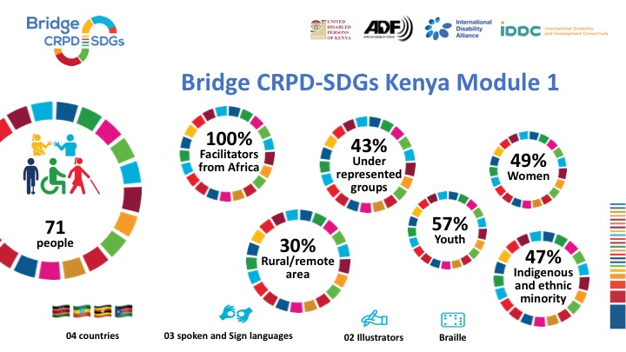
This picture represents the infographic for the Kenyan Bridge CRPD SDGs participants for module 1.On the top of the picture we have logos for Bridge CRPD SDGs, UDPK, ADF, IDA and IDDC. Below the logos there are 7 circles and 4 symbols below the circles.
The first circle shows that we had 71 people involved in this Bridge. The other circle shows that 100% facilitators were from Africa. Third circle shows that 30% of them were from rural/remote area. The fourth circle shows that 43% were underrepresented groups. The fifth circle shows that 57% were youth. The sixth circle shows that 49% were women. The last circle shows that 47% were indigenous and ethnic minority.
Below the circles we have 4 flags representing countries of origin from the participants and those are South Sudan, Uganda, Kenya, and Ethiopia. The next symbol shows that we had 3 sign language interpreters. Next to that is symbol that shows that we had 2 illustrators to support the workshop. Last symbol shows braille.

