Submission for the CEDAW Committee on the rights of indigenous women and girls
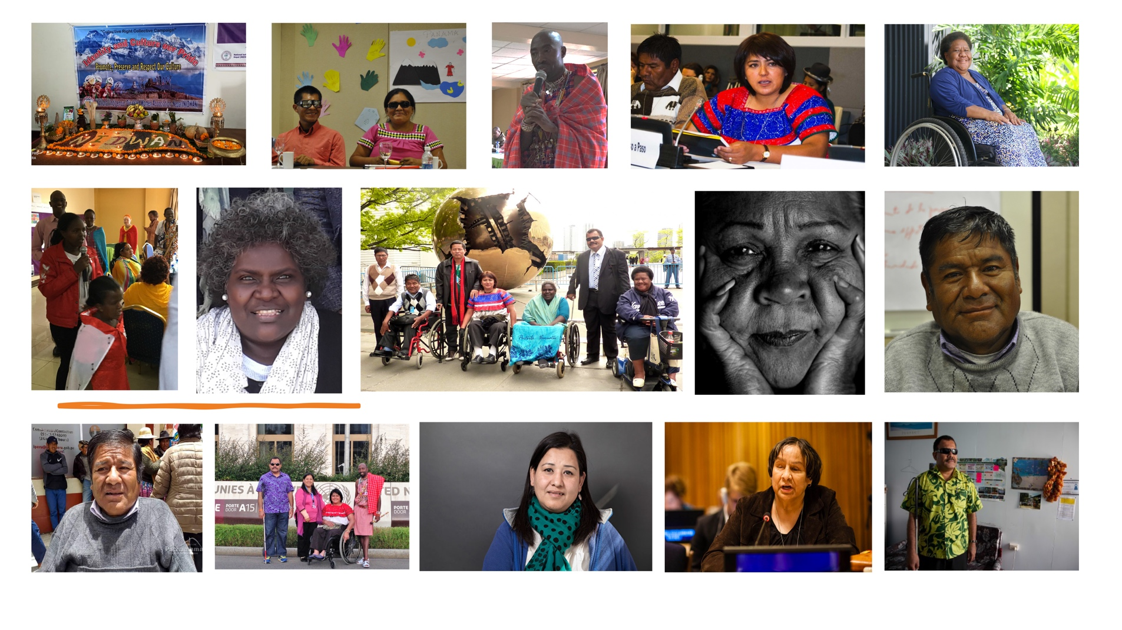
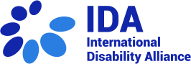
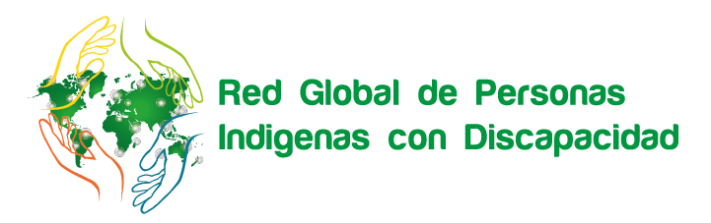
Indigenous Persons with Disabilities Global Network

June 2021

The Indigenous Person with Disabilities Global Network (IPWDGN) is a is a global alliance comprised by organisations and networks of indigenous peoples with disabilities, from all around of the world, including at local, national and regional levels. The Network was founded in May 2013 during the twelfth session of the United Nations Permanent Forum on Indigenous Issues (UNPFII). The IPWDGN has the aim to encourage, strengthen and support organisations of indigenous persons with disabilities, to promote global, regional and national exchanges of experiences, knowledge, good practices, and lessons learnt on issues relevant to the rights of indigenous persons with disabilities, as well as to engage with multiple human rights and development mechanisms, and strengthen presence and participation of indigenous persons with disabilities in both disability and indigenous peoples’ movements.

The International Disability Alliance (IDA) is a network of global and regional organisations of persons with disabilities (DPOs) comprising eight global and six regional DPOs. Established in 1999, each IDA member represents a large number of national organizations of persons with disabilities (OPDs) from around the globe, covering the whole range of disability constituencies. IDA thus represents the collective global voice of persons with disabilities counting among the more than 1 billion persons with disabilities worldwide, the world’s largest – and most frequently overlooked – minority group. IDA’s mission is to advance the human rights of persons with disabilities as a united voice of organisations of persons with disabilities utilising the Convention on the Rights of Persons with Disabilities and other human rights instruments.
INTRODUCTION
The IPWDGN and IDA welcome the initiative of the Committee on the Elimination of All Forms of Discrimination against Women (hereinafter ‘CEDAW’) to hold a Day of General Discussion in the lead up to a General Recommendation on the rights of Indigenous women and girls. This submission focuses on indigenous women and girls with disabilities and the barriers they face in the enjoyment of their rights, and provides with recommendations to ensure their perspective is considered explicitly.
This submission reflects a consultation with members of the Indigenous Person with Disabilities Global Network and their members, particularly the Indigenous Person with Disabilities Latin-American Network, Group of Indigenous Peoples supported by RIADIS, Paso a Paso Foundation, Indigenous Person with Disabilities Asia Network, Indigenous Person with Disabilities African Network, Indigenous Person with Disabilities Pacific Network, National Indigenous Disabled Women Association- Nepal (NIDWAN), Narok South Disability Network and Pacific Disability Forum.

BACKGROUND
Indigenous women with disabilities, estimated in 28 million across the globe, and indigenous girls with disabilities face discrimination, including multiple and intersectional discrimination based on gender, disability and indigenous background, among others. Both persons with disabilities and indigenous persons are over-represented amongst those in poverty. Often living in rural areas, indigenous women and girls with disabilities have limited access to employment, education and healthcare. All this places indigenous women and girls with disabilities as one of the most marginalised groups in society, rendered vulnerable by the lack of their political voice and of consideration of their needs and rights, reinforcing disadvantages.
Indigenous women and girls with disabilities are subjected to historical, structural, direct, indirect and others forms of discrimination that are distinct from others and vary among indigenous women with disabilities. Stigma, stereotyping and lack of awareness raising measures account for their perpetuation. In addition, documenting and reporting discrimination including proper figures and findings can be very challenging. Furthermore, these groups might often be unaware that their intersectional identities might attract negative impacts to their lives by others. As a consequence of these previous factors, women and girls with disabilities have remained invisible within the disability and indigenous movements.
Indigenous women and girls with disabilities face barriers common to other indigenous women such as “lack of representation in government, including in indigenous parliaments, lack of good hospital networks, lack of consultation, multiple forms of discrimination, poor access to education, health care and ancestral lands, high rates of poverty, increased risk of violence and sexual abuse, including trafficking.” In addition, they are subject to violent and harmful practices also suffered by women and girls with disabilities, e.g., sexual abuse, domestic violence, forced sterilisation and neglect, perpetrated in the home and within their own communities, in institutional settings, schools and the wider community.
The broader structural context of colonisation, imperialism, dominant non-indigenous groups’ power exercise over indigenous peoples historically creates a unique history and identity which continues to be a burden upon the struggle for equality. States’ policies and practices for the assimilation or extermination of indigenous groups, such as forced removal of indigenous children from their families and forced sterilisation, impacted women and girls with disabilities. Such impact is part of a intergenerational and historical trauma. Indigenous girls with disabilities taken from their families and placed into residential schools or into foster families have been at high risk of abuse and neglect, also resulting in post-traumatic stress disorder, anxiety grief and psychosocial disabilities. Practices of forced sterilisation often targeted indigenous women with disabilities as an instrument of indigenous population control. When two or more factors converge, as in the case of multiple and/or intersectional forms of discrimination faced by indigenous women and girls with disabilities, the sum of a greater number of identities, greater poverty, in particular in rural areas, and less exercise of human rights, makes them more likely to remain hidden at home by their own families, limiting access to education and social life, reinforcing exclusion.
The Convention on the Rights of Persons with Disabilities (CRPD, 2006) and the UN Declaration on the Rights of Indigenous Peoples (UNDRIP, 2007) came to protect and promote the rights of both persons with disabilities and indigenous persons, thus of indigenous persons with disabilities, including a specific focus on women and girls. Mainstreaming the rights of indigenous women and girls with disabilities within CEDAW Committee general recommendations can make a great contribution for their inclusion in society.

LIMITED ACCESS TO SERVICES AND DISCRIMINATION BASED ON DISABILITY AND/OR INDIGENOUS BACKGROUND

Indigenous women and girls with disabilities have face more barriers in accessing services in terms of their availability and their quality, compared to other persons and other persons with disabilities. There is a pervasive “lack of prioritization of their needs, unique capabilities and potential contributions to the development of their communities”. In addition, general lack of accessibility (in its diverse dimensions) of services, as well as lack of access to alternate and accessible formats, sign language interpretation, plain language, support services and assistive technology, come to restrict access to services based on disability.

Indigenous women with disabilities face both multiple and intersectional discrimination at different levels of education. Racism, stigmas, ableism, sexism, either alone or concurring, prevent indigenous individuals from participating fully and effectively in the education process. For instance, indigenous girls “may be unable to attend school if the facilities are not accessible and also if instruction is not available in his or her indigenous language” (multiple discrimination based on disability -lack of accessibility of facilities- and on indigenous background -lack of indigenous language-) or if not in inclusive intercultural settings.
Furthermore, according to a study requested by the Permanent Forum on Indigenous Peoples, “lack of support and services for families with indigenous girls with disabilities has led to the displacement of families from their communities and often even to the separation of children from their families and communities,” In the same vein, indigenous children with disabilities remain at risk of family separation and institutionalization (see below).
“On my point of view, the violence is cross cutting on gender and disability. Women indigenous and indigenous girls with disabilities are particularly vulnerable in humanitarian contexts and risk of sexual vulnerable in violence, some of them are engaging in survival sex with community members.
It’s is very important to design and adapt mainstream humanitarian programs and intervention to ensure they are inclusive and accessible to all women and girls. Secondly, establish focal point agency or task force to respond women and girls with disabilities issues in humanitarian coordination mechanisms or working groups.”
Kenyan personal experience shared to IDA
PARTICIPATION OF AND CONSULTATION WITH INDIGENOUS WOMEN AND GIRLS WITH DISABILITIES
For indigenous peoples, political participation is part of their self-determination, understood as the right to “determine their political status and freely pursue their economic, social and cultural development”. Further, equality, cultural integrity, free, prior and informed consent and property underpin the right to participation of indigenous peoples. This reflects the collective dimension of this human right for indigenous peoples. As recognised in Articles 5 and 18 of the UNDRIP, States must recognise the right of indigenous peoples to maintain and strengthen their distinct political, legal, economic, social and cultural institutions as well as their right to participate in the ones of the State.
Nevertheless, gender inequalities in the exercise of these rights remain pervasive in practice. For example, in Baringo, Africa, the community is led by men, so the women, including women with disabilities, do not have right to ownership of occupied land, even if generally women account for 70% of Africa’s food production. In a similar way, in many indigenous communities, including those receiving influence of western, colonized and patriarchal mindset, the preference for boy child applies. Consequently, it is only men who make the decisions, leading to discrimination of women and girls. Typical examples are indigenous girls not being sent to school by their parents because they consider it unnecessary, preferring that boys have access to education and have better opportunities and performance in community positions.
In this area, indigenous women with disabilities must have equal opportunities to participate in both indigenous decision-making institutions and state institutions. For this purpose, reasonable accommodation and specific measures to promote their involvement must be provided. In the exercise of their political rights, Indigenous women with disabilities must be considered individually and as members of their communities, giving rise to responsibilities in the “community” which must be recognised by States.
In particular, In designing and implementing of public policies, States must acknowledge their situation, involve and consult with indigenous peoples with disabilities, ensuring measures in line with the CRPD, the UNDRIP and the CEDAW. Participation should be the contrary to merely tokenistic: “Currently, the exercise of power for indigenous women takes the form of opportunities to “attend”, to be present, speak and decide for themselves. For them participation means visibility within the community and the ability to express their desires, ideals, position and struggle.”

VIOLENCE AND HARMFUL PRACTICES AGAINST INDIGENOUS WOMEN AND GIRLS WITH DISABILITIES
Violence against indigenous women and girls is multifaceted in nature and cannot it be separated from the violence that “stems from the ongoing impact of colonisation including the breakdown of community structures and cultural authority which is a correlate of alcohol, and drug-associated violence against indigenous women and girls”. When it comes to indigenous women and girls with disabilities, disability-inherent aspects of the violence exercised upon them can also concur. In other contexts, women and girls with disabilities are rendered more vulnerable to violence: almost 80 percent of women with disabilities are victims of violence and they are four times more likely than other women to suffer sexual violence.
Targeted research is scarce limiting assessments including on whether the underlying discrimination is intersectional or just multiple. Yet, research in Canada shows that “[i]ndigenous women with disabilities (74%) and women without disabilities (46%) were more likely to have experienced intimate partner violence in their lifetime than their non-Indigenous counterparts (54% and 37%, respectively),” indicating the worst rate for indigenous women with disabilities followed by non-indigenous women with disabilities.
Both the indigenous background and the disability would lead to a higher risk of being subjected to violence and harmful practices. Prevailing stereotypes (e.g. incapable, not credible) and structural factors (e.g. invisibility) contribute to perpetuate violent practices which often go unreported.
Indigenous women with disabilities, like many indigenous women, may wish to avoid “bringing shame” upon their communities often resulting in not reporting violence and its tacit acceptance. The lack of victim support services, particularly in isolated indigenous communities, and the lack of services in general which are culturally and disability sensitive and accessible, do not help in breaking these cycles of violence.
According to regional organizations of persons with disabilities, in Kenya, women with intellectual disabilities face extreme discrimination and are subjected to harmful practices. Family members can forcibly sterilize them. Most of them faced sexual harassment and violence since most of them are being used for sex by close family relatives/members. Women with disabilities cannot get married, so if they get children are left on their own to raise them.

FAMILY LIFE AND SEXUAL AND REPRODUCTIVE HEALTH: FORCED STERILISATION AND FAMILY SEPARATION
Both women and girls with disabilities and indigenous women have been subject to practices which aim at controlling their bodies, restricting their reproduction, and preventing or removing their role as mothers. These two groups have been targeted by laws, policies and practices aiming at their forced sterilisation and the forcible removal of their children, resulting in the disintegration of families and communities, causing irreparable and intergenerational harm.

Among others, Articles 23 and 25 of the CRPD are relevant to protect indigenous women and girls with disabilities of their right to family, including deciding freely and responsibly on the number and spacing of their children, retaining their fertility on an equal basis with others, as well as their right to health on the basis of free and informed consent.

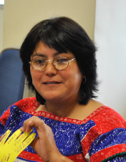
“It is well known that indigenous women with disabilities in Africa are forced sterilized by their relatives, although in Latin America they face a similar situation as indigenous women with disabilities are not seen as sexual partners, or that they are able to have a family, said so, they do not know their sexual and reproductive rights. The States must understand the full scope of this problem if we are to initiate effective and meaningful solutions.”
Olga Montúfar, Co-Chair from the IPWDGN

ADEQUATE STANDARD OF LIVING FOR INDIGENOUS WOMEN AND GIRLS WITH DISABILITIES, INCLUDING IN THE CONTEXT OF CLIMATE CHANGE
Under Article 28 of the CRPD and the Article 14(2)(h) of the CEDAW, indigenous women and girls with disabilities are entitled to enjoy adequate living conditions, particularly in relation to housing, sanitation, water supply, electricity, transport and communications. Nevertheless, in many contexts access to fresh and clean water is not ensured to all indigenous women and girls with disabilities. Furthermore, according to our consultation with indigenous persons with disabilities, their claims for ensuring the water supply are rarely considered by authorities.

For instance, most of the Maasai people in Kenya and Tanzania live in semi-arid or arid areas, these areas are commonly hot dry and dusty. Lack of sufficient water supplies becomes a serious problem, as both people and animals are competing for water. People most often get drinking water from polluted and muddied ponds or dams. Women and girls spend long hours looking for water. Woman and girls with disabilities are left at home waiting for the members of the family to come back home and bring them some water. Similarly, in Kenya, there is frequently water shortage in some of the indigenous communities, requiring their members to walk long distances looking for water, which is very hard for indigenous women and girls with disabilities who end up having to rely on support by other persons.
In addition, indigenous women face the consequences of climate change due to their dependence and their relation to the environment and its resources. In case of women and girls with disabilities the impacts of climate change might be more adverse, such as the extreme weather events and its effects on agriculture, forest and water availabilities largely affect them and their families. The primary care givers of disabled child have to spend additional time and energy in managing water, farm, food and energy resources. And the hardening of soil due to long spells of dry weather requires more labor to dig and prepare the farms; the increase of new and aggressive pests both in farms and in storage not only takes their time and energy but also causes loss of food and income. Further, they do not receive related information and resources.

INDEPENDENT LIVING AND INCLUSION IN THE COMMUNITY
Living independently and included in the community (Article 19 of the CRPD) for indigenous women and girls with disabilities requires both living independently and being included in wider society and in their own indigenous communities, as well as being able to choose to live by their customs and traditions. Assimilation policies often targeted indigenous children by displacing them from their families and communities and placing them in residential school settings or into foster families.
Moreover, living in the community for indigenous women and girls with disabilities requires that they can access services responsive to their needs within their communities. More often than not, the necessary supports do not exist within their own communities, and they are subsequently left without a choice but to leave to access services available in institutional and group home settings, where the physical divide with their community is reinforced by lack of support to participate in their community events, and due to the lack of staff with “culturally competent skills” to ensure their continued participation in their community.
Indigenous women and girls with disabilities have faced more and diverse barriers during the Covid-19 pandemic, and mostly their right to living and being included on the community. In Latin America and Africa, they lacked access to key information on the danger of the virus and on-going related events. Many have been only kept in isolation and without support services.

RECOMMENDATIONS

In view of the above considerations, we call the CEDAW Committee to recommend States the following:
1) To address multiple and intersectional discrimination in their legislation, including based on gender, disability, indigenous background and age, and to recognise the specificities and the aggravating circumstances in the determination of liability and in effective remedies, as well as the duty to contemplate the gender, disability and indigenous perspective in the adoption of relevant public policies.
2) Closely consult and actively involved indigenous women and girls with disabilities, including through indigenous institutions, in decision making, implementation, evaluation and monitoring of legislation and policies related to their rights under the CEDAW convention. To do so, interpretation in different languages, reasonable accommodation and disability and age-appropriate assistance should be provided.
3) Promote and support the participation of indigenous women and girls with disabilities within civil society organizations, including organizations of persons with disabilities and women rights organizations, as well as in indigenous institutional mechanisms.
4) Adopt awareness raising measures for the promotion of the rights of indigenous women and girls with disabilities and to combat stigma, stereotyping, invisibility, and discrimination.
5) Adopt measures to increase access to quality services for indigenous women and girls with disabilities, including through ensuring general accessibility (in its diverse dimensions), as well as access to alternate and accessible formats, sign language interpretation, plain language, support services and assistive technology, as required.
6) Undertake and promote the collection of statistical data and research focusing on indigenous women and girls with disabilities, including through official statistical efforts disaggregating by disability and indigenous background, and through the promotion of quantitative and qualitative research, including to inform the recovery efforts related to the current pandemic.
7) Adopt urgent measures inclusive of indigenous women and girls with disabilities to ensure an adequate standard of living, including food, water and medicines are provided to them. This is especially urgent during these times of COVID-19 to avoid malnutrition, diseases and deaths.
8) Adopt urgent measures access to inclusive education free from stigma and discrimination to indigenous girls with disabilities, including through in distance learning due to the COVID19 pandemic, as well as ensuring the preparation of teachers who carry out their work in indigenous communities.
9) Adopt measures to protect the right of women and girls with disabilities to family life and sexual and reproductive health care, including prevention of family separation and prohibition of forced sterilization.
10) Adopt measures to ensure that indigenous women and girls with disabilities can exercise their right to live independently and be included in the community, vis-à-vis their indigenous community and the general population, including by the availability and provision of support services.
11) Facilitate access to justice for indigenous women and girls with disabilities victims of violence and harmful practices, including through restorative justice and reconciliation for violence and harm perpetrated against communities, including disability awareness training, with rights based and intercultural and gender sensitive approaches, the staff of the administration of justice of the State and within indigenous communities, provided in consultation with indigenous women and girls with disabilities.

For further information, please contact:
Rosario GALARZA, rgalarza@ida-secretariat.org
Juan Ignacio PEREZ BELLO, jiperezbello@ida-secretariat.org

International Disability Alliance
Geneva
www.internationaldisabilityalliance.org

UN Women Fact Sheet on Indigenous Women with Disabilities, 2020, available in www.unwomen.org/-/media/headquarters/attachments/sections/library/publications/2020/fact-sheet-on-indigenous-women-with-disabilities-en.pdf?la=en&vs=5640,
See e.g., Banks, L. M., H. Kuper, and S. Polack. 2017. “Poverty and Disability in Low-and Middle-Income Countries: A Systematic Review.” PLOS ONE 12 (12): 1–19, pp. 9- 10; Canedo, A. P. (2018). Analyzing Multidimensional Poverty Estimates in Mexico From an Ethnic Perspective: A Policy Tool for Bridging the Indigenous Gap. Poverty & Public Policy, 10(4), 543-563, p. 550,
Permanent Forum on Indigenous Issues, Study on the situation of indigenous persons with disabilities, with a particular focus on challenges faced with regard to the full enjoyment of human rights and inclusion in development, E/C.19/2013/6, February 2013, para 40. See also Presentation shared in the 20th session of the UNPFII Side event entitled “WFP and Indigenous Peoples: generating evidence for action” 27 April 2021, based on A Study on Access to Food of Indigenous Peoples with Disabilities in Nepal, (Draft report), WFP, Nepal 2021, indicating that “nearly 45 percent of both indigenous women and men with a disabilities monthly income is under 5000 Nepali rupees (USD 42.00) or none”,
NIDWAN et.al (2018) The Rights of Indigenous Persons with Disabilities in Nepal, submitted to The Committee on the Rights of Persons with Disabilities 19th Session of CRPD find in www.indigenouspeoples-sdg.org/index.php/ english/all- resources/resource-materials2/reportsand-publications/75-indigenous-people,
A Study on Access to Food of Indigenous Peoples with Disabilities in Nepal, (Draft report), WFP, Nepal 2021,
Pratima Gurung, COVID 19 in Nepal: The Impact on Indigenous Peoples and Persons with Disabilities, 2021, Disability and the Global South, 2021, Vol.8, No. 1, 1910-1922,
Permanent Forum on Indigenous Issues, Study on the situation of indigenous persons with disabilities, with a particular focus on challenges faced with regard to the full enjoyment of human rights and inclusion in development, E/C.19/2013/6, February 2013, para 40,
Id page 11,
Id para 51,
Rural indigenous women are the poorest subgroup within the overall group of persons with disabilities in Peru with a poverty incidence of 88.1%. (Clausen, J., & Barrantes, N. (2020). Implementing a Group-Specific Multidimensional Poverty Measure: The Case of Persons with Disabilities in Peru. Journal of Human Development and Capabilities, 21(4), 355-388.) See also, CRPD/C/GAB/CO/1, para. 14,
The CRPD’s preamble (para p) refers to the difficult conditions faced by persons with disabilities who are subject to multiple or aggravated forms of discrimination including on the basis of indigenous origin, and Article 6 is dedicated specifically to women with disabilities; and Articles 21 and 22 of the Declaration on the Rights of Indigenous Peoples refer to the need for particular attention to marginalised indigenous groups such as women and persons with disabilities,
E/C.19/2013/6, Study on the situation of indigenous persons with disabilities, with a particular focus on challenges faced with regard to the full enjoyment of human rights and inclusion in development, EMRIP, 2013, para 30,
Ibid.,
Ibid.,
Ibid, para 46.
Ibid, para 46.
Article 3, Declaration on the Rights of Indigenous Peoples,
Permanent Forum on Indigenous Issues, Study on Indigenous women’s political participation at the international, national and local levels, E/C.19.2013.10, February 2013, para 14; Special Rapporteur on the situation of human rights and fundamental freedoms of indigenous people, Interim report, A/65/264, 2010, para 39,
Articles 5 and 18. Declaration on the Rights of Indigenous Peoples,
See Women struggle to secure land rights, Hard fight for access and decision-making power, United Nations,
Devandas-Aguilar.C Report of the Special Rapporteur of the Human Rights Council on the rights of PWDs, 2016,71st session, UN General Assembly, A/71/314. www.un.org/ga/search/view_doc.asp?symbol=A/71/31/english/&Lang=E,
Eileen Mariena, “El empoderamiento para garantizar la plena, activa y propositiva participacion de las mujeres indigenas y el fortalecimiento del liderazgo”. First Summit of Indigenous Women of the Americas Oaxaca, Mexico 2002, cited in Permanent Forum on Indigenous Issues, Study on Indigenous women’s political participation at the international, national and local levels, E/C.19.2013.10, February 2013, para 8,
Permanent Forum on Indigenous Issues, Study on the extent of violence against indigenous women and girls in terms of article 22(2) of the UNDRIP, E/C.19/2013/9, 12 February 2013, para 6 (a),
European Parliament, Report on the situation of minority women in the European Union (2003/2109(INI)), p 13, cited in OHCHR Thematic study on the issue of violence against women and girls and disability, A/HRC/20/5, 30 March 2012, para 21,
Savage, L. (2021). Intimate partner violence: Experiences of women with disabilities in Canada: 2018. Juristat: Canadian Centre for Justice Statistics, 1-23, p.9,
Fadwa Al-Yaan, Mieke Van Doeland and Michelle Wallis, Family Violence Among Aboriginal and Torres Strait Islander Peoples, Australian Institute of Health and Welfare, Canberra 2006, p 27, cited in Permanent Forum on Indigenous Issues, Study on the situation of indigenous persons with disabilities, with a particular focus on challenges faced with regard to the full enjoyment of human rights and inclusion in development, E/C.19/2013/6, February 2013, para 11. See also Special Rapporteur on violence against women, Report on violence against women with disabilities, A/67/227, 3 August 2012,
Paul Memmot and others, Violence in Indigenous Communities, Crime Prevention Branch of the Commonwealth Attorney-General’s Department, 2001, both cited in Permanent Forum on Indigenous Issues, Study on the situation of indigenous persons with disabilities, with a particular focus on challenges faced with regard to the full enjoyment of human rights and inclusion in development, E/C.19/2013/6, February 2013, para 31,
Information gathered by Regional OPDs,
NIDWAN, 2021. Impacts of Climate Change on Indigenous Women with Disabilities: A Rapid Assessment in Nepal, supported by PAWANKA,
Permanent Forum on Indigenous Issues, Study on the situation of indigenous persons with disabilities, with a particular focus on challenges faced with regard to the full enjoyment of human rights and inclusion in development, E/C.19/2013/6, February 2013, paras 43, 44,

