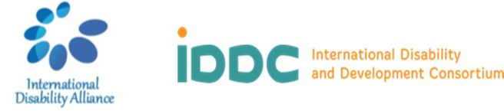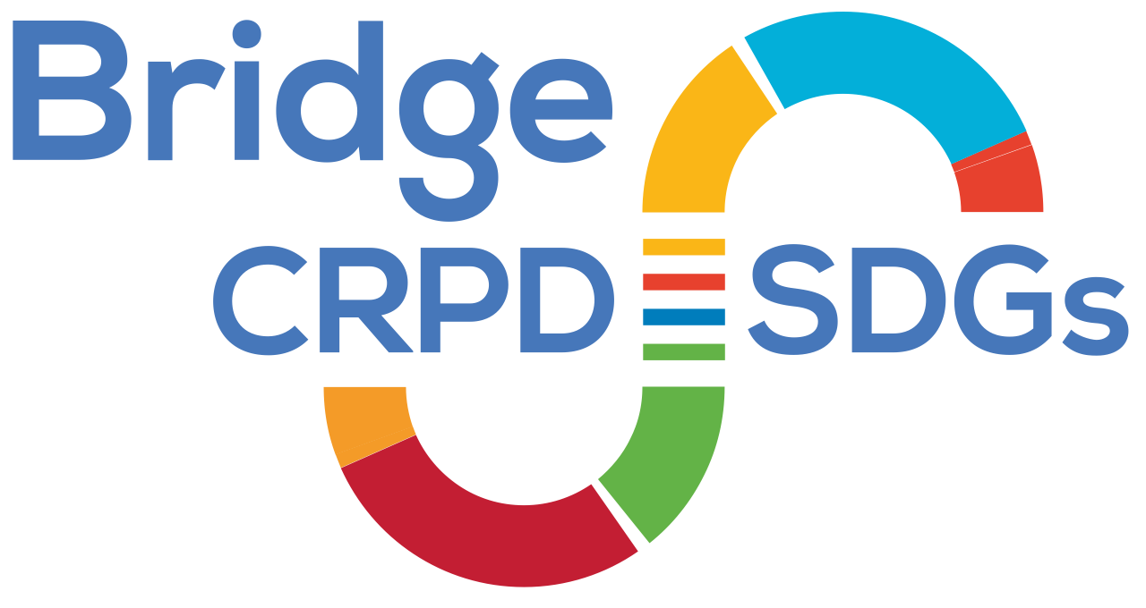

**Bridge CRPD-SDGs Tanzania – Module 2**

**List of Participants**

14th to 20th January 2020

Arusha, Tanzania

**Participants**

1. Mr Abdalla Ally Simba, Deafblind, Tanzania Association of the Deafblind (Tasodeb),
2. Ms Abdalla Mwanaasha, Deafblind, Tanzania Association of the Deafblind (Tasodeb),
3. Ms Agripina Kasiga, Albinism, Tanzania Albinism Society,
4. Ms Asha Ali Humud, Intellectual, ZAPDD Zanzibar Association for People with Developmental Disabilities,
5. Mr Celestine Karuhawe, blind, Tanzania League of the Blind,
6. Ms Elimina Shayo, psychosocial, Tanzania Users and Survivors of Psychiatry Organization (TUSPO)/WNUSP,
7. Mr Fredrick Msigallah Wanging'ombe, physical, Tanzania Association of the Disabled,
8. Mr Genarius Ernest Gabriel, physical, Tanzania Association of the Disabled,
9. Ms Habibu Mashukura, blind, Tanzania League of the Blind,
10. Ms Mary Ndimbwa, short stature, community leadership,
11. Mr Netto Mhadisa, Deaf, CHAVITA (Chama cha Viziwi Tanzania),
12. Mr William Simwali Mbeya, Albinism, SHIVYAWATA,
13. Mr Samwel Edward Mwanyika, Intellectual, Pearl of People with Down Syndrome - Down Syndrome International,
14. Ms Tungi Kenneth, Deaf, CHAVITA (Chama cha Viziwi Tanzania),
15. Ms Zeyana Kassim, physical, Zanzibar Federation of Disabled People Organizations,

**Facilitators**

1. Ms Fatma Wangari HAJI, Parent of child with intellectual disability, Inclusion International
2. Mr Michael Migayo NJENGA, WNUSP,
3. Mr. David Shaba, Tanzania Association of the Deafblind,
4. Ms Betty NAJJEMBA, African Disability Forum,
5. Ms Elizabeth Ombati NYABIAGE, WNUSP, Bridge CRPD-SDGs Fellow,
6. Mr. George Okudi, Down Syndrome International,
7. Ms. Jenipher Akinyi, Inclusion Africa,

Ms Tchaurea FLEURY, IDA-IDDC Bridge CRPD-SDGs Coordinator (distant support)

**Documentation**

1. Mr. Victor MBUGUA, Note taker

**Support persons, interpreters, captioners and illustrators**

1. Ms. Kassim KHAMIS, Personal Assistant
2. Mr. Daimu NAMPUPANGA, Support person/ Personal Assistant
3. Ms Edna James, Sign Language Interpreter
4. Ms Fatuma Rajabu, Personal Assistant (Parent for Mwanaasha)
5. Ms Fayel Achieng Odeny, Support Person
6. Ms. Peace Kalugendo, Tactile Interpreter
7. Ms. Hope Florence Agwang, Sign Language Interpreter
8. Ms Shaba Happy, Tactile Interpreter
9. Mr Marko Tibissima, Illustrator
10. Mr. Oscar Michael, translation equipment/ public address system support
11. Mr Joseph Migila, Swahili- English translator
12. Ms. Khadija Matimba, Personal Assistant
13. Mr Msigallah Petro, Personal Assistant
14. Ms Mtumwa Iddifikirini, Sign Language Interpreter
15. Mr. Roberts Majiga, Swahili- English translator
16. Mr. John Buyinza, Sign Language Interpreter
17. Ms Vestina Mutagulwa, Lip Reading-Sign language Interpreter
18. Ms. Ibrahim Aziza, Personal Assistant
19. Mr. Remigiius Chizanye Karuhawe, Guide
20. Mr. Milishidi Kabiriga, Personal Assistant
21. Mr. Kudra Munis, Sign Language Interpreter
22. Mr. Claudia Mwakatobe, Personal Assistant

**Logistics**

1. Ms Dragana Jocic, International Disability Alliance
2. Ms Djina Milic, International Disability Alliance