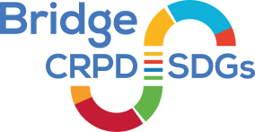
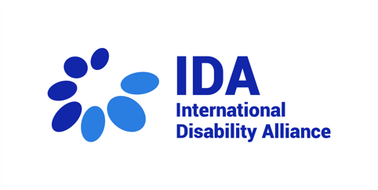
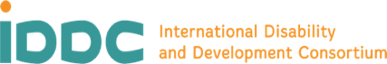
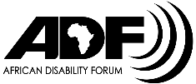
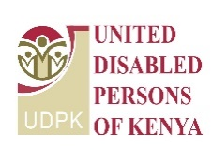

Meet our Bridge CRPD-SDGs youth in Kenya, module 1

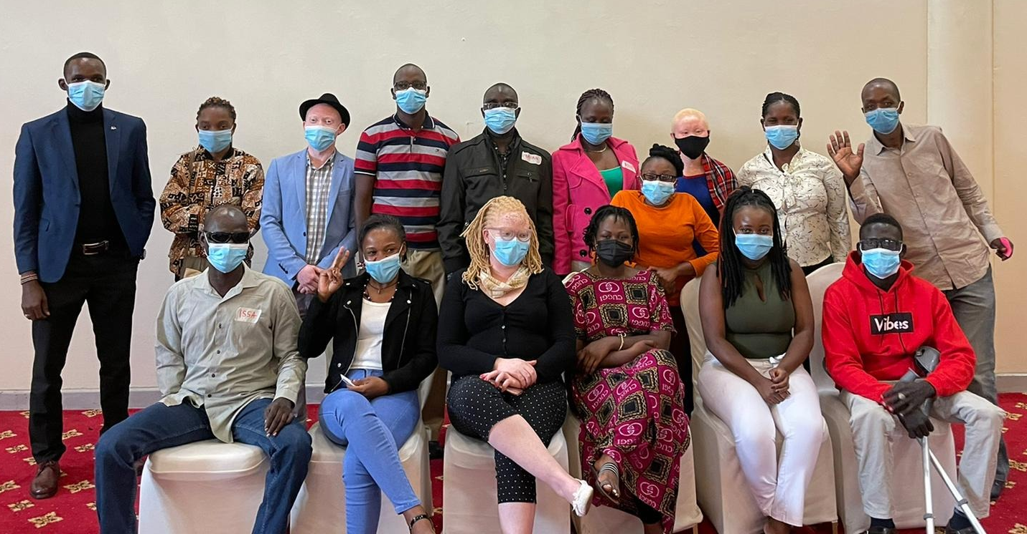

- There are 16 youth participants attending the Bridge training module 1 in Kenya, from 24th until 30th of June 2021. They all come from different counties in Kenya, Uganda and South Sudan.
- They all have similar expectations and want to learn more about CRPD and how to implement their learning in order to better advocate for human rights.

