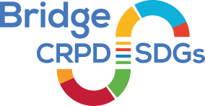
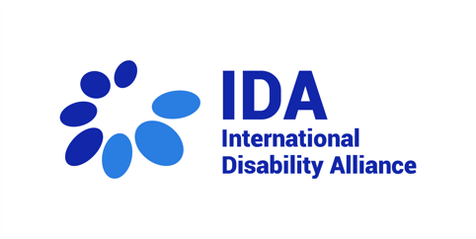
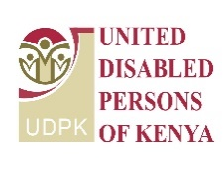
Expectations of the youth participants:
- Ashura Michael: “Want to develop my own policy paper, also to understand how to organize perfect Bridge in Kenya.”
- Joy Rema: “Learn more about my rights and CRPD and to be able to transfer knowledge to other people who have disabilities.”
- Teopista Nannyanzi: “To equip myself with skills and how to become a trainer in the future. I want to extend my support and share knowledge with others.”

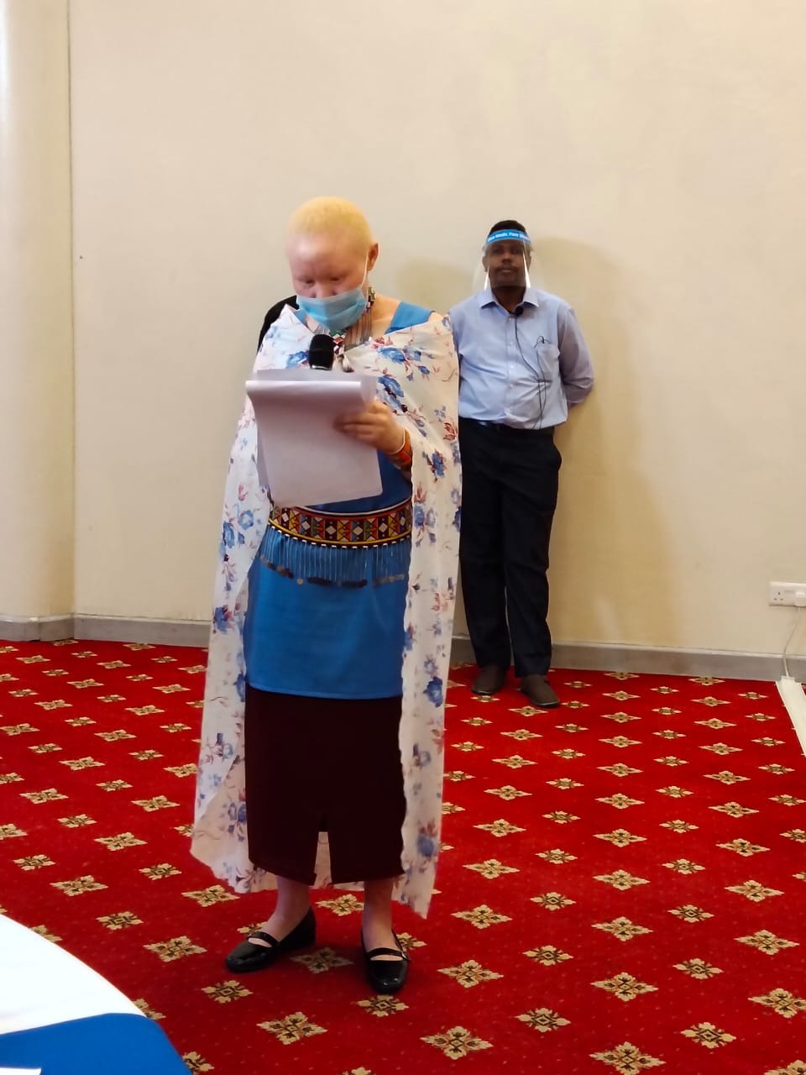
Issa Khamis Murshal Jada Teopista Nannyanzi Zipporah Ntininie

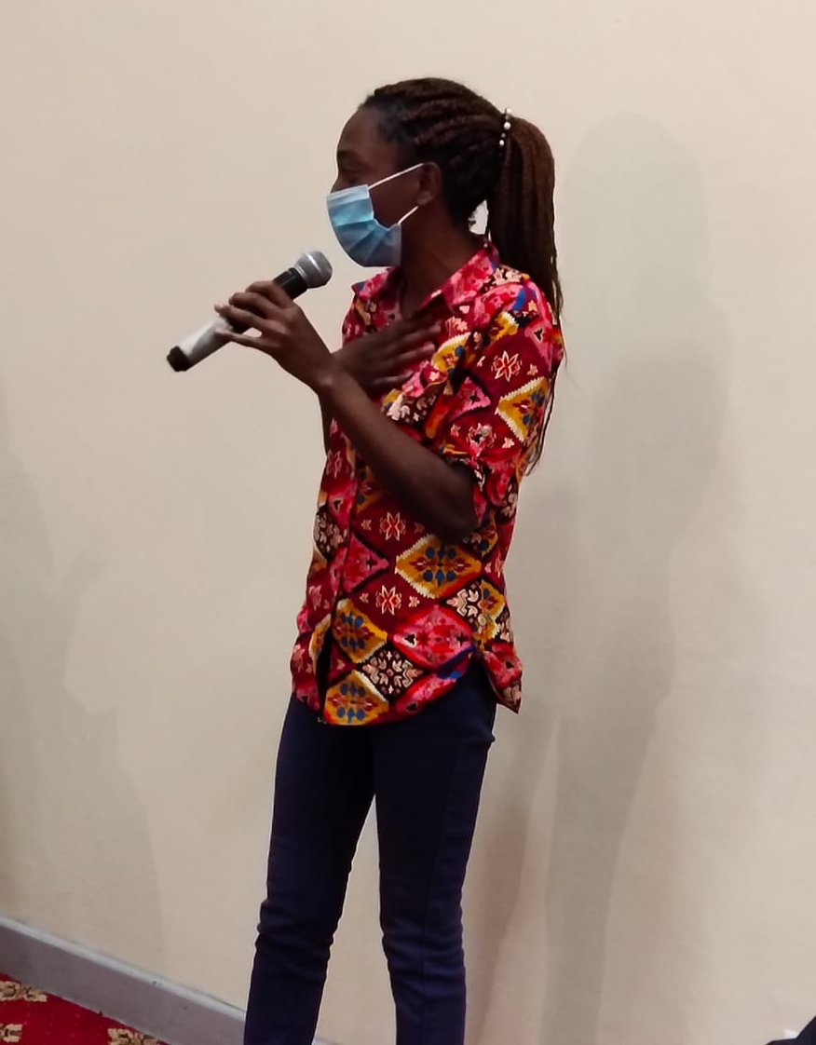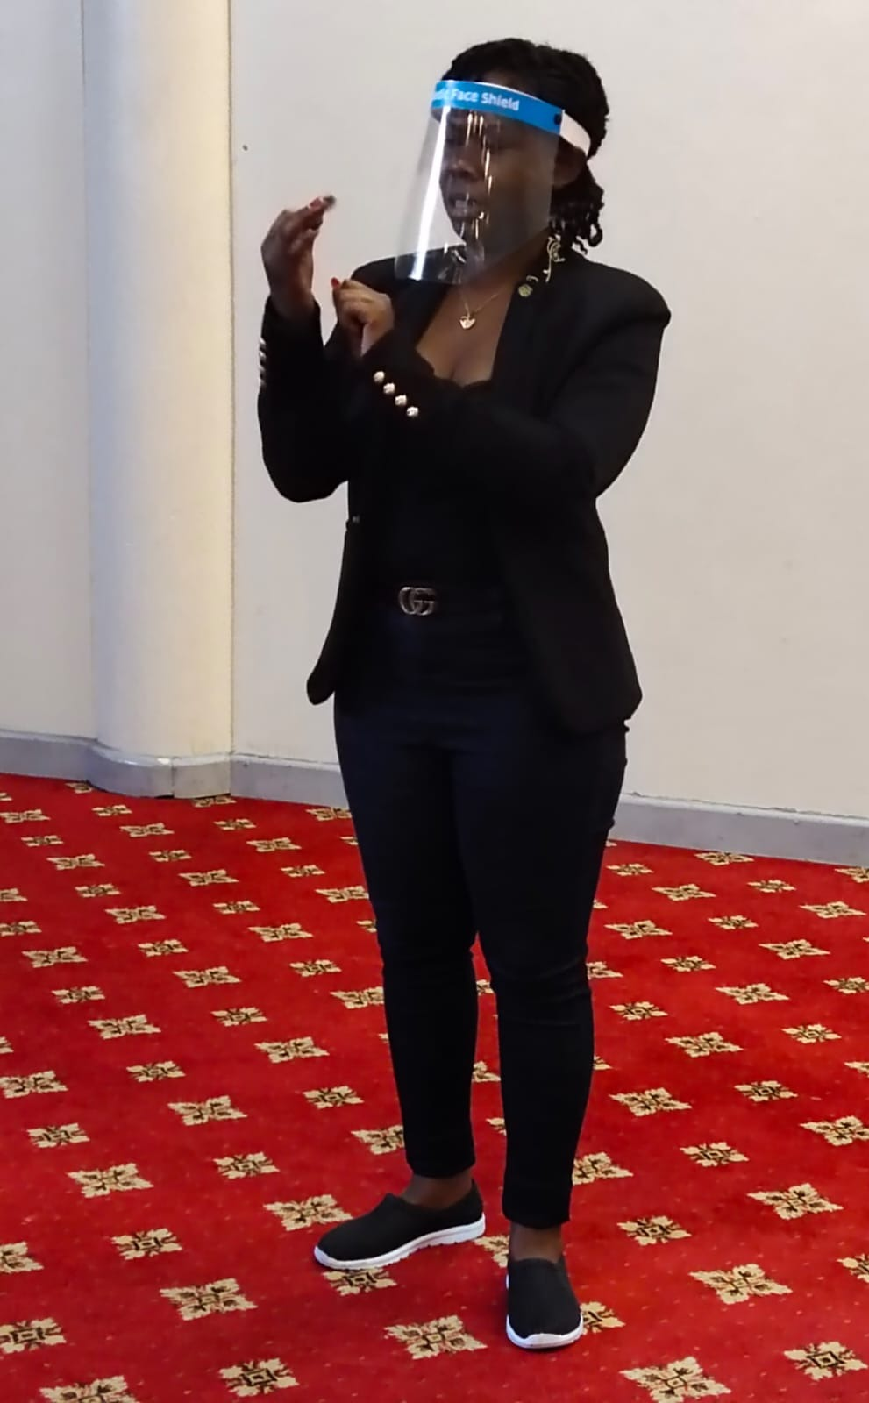
Joy Rema Ashura Michael Erick Sande

