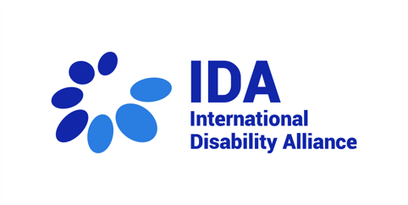
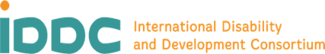
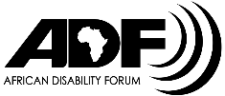
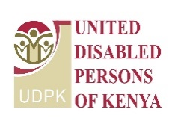
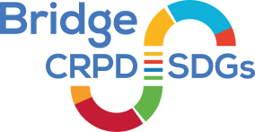
Meet our Bridge CRPD-SDGs youth in Kenya, module 1

- Louise Waringa, Spina Bifida and Hydrocephalus Association of Kenya
“I am expecting to understand more about CRPD. I am doing a lot of advocacy work, but I did not have as much as understanding as needed. Now, I can understand more about accessibility and reasonable accommodation, what is right and what is needed. After this training, I will know when I can push and what to do, to better advocate for rights.”

- Paul Butito, Black Albinism organization
“To gain skills that will help my fellows initiative members and groups with albinism and other disabilities in advocating for their rights and increasing advocacy for societies to know how to advocate for rights more than before.”

