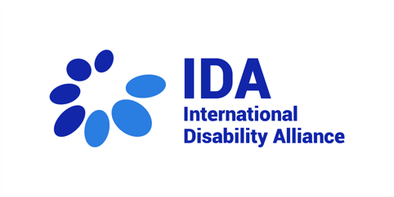
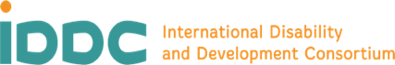
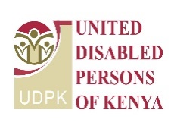
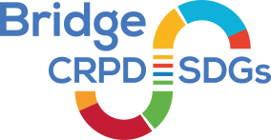
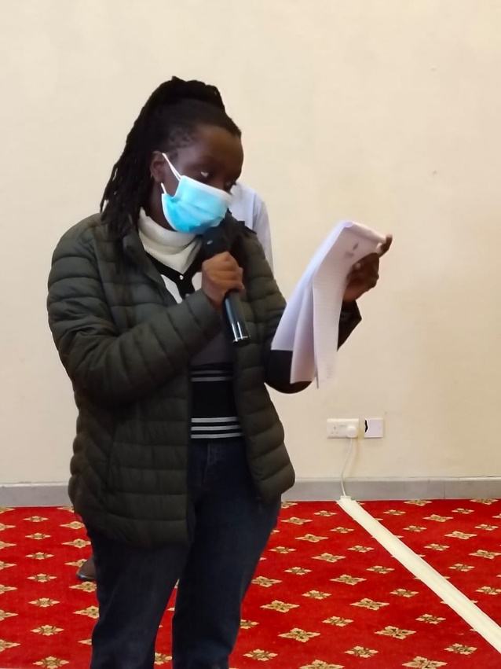
Meet our participants!
Karen Rose Muriuki
Founder of Kenyans Living with Autism
“My journey was very long but I am happy to be here with you all today. Autism is not understood and embraced by others. That is why when I did not speak until 6 years old, no one understood what I was going through. On my journey, I faced with violence, bullying, psychological anxiety, and emotional challenges that are still very hard for me to speak about. I do not have an opportunity to be independent and even today I am facing a lot of discrimination, social and family rejection”.
Her expectation from this Bridge CRPD SDGs is to learn more and then share her knowledge with other autistics persons in her community!
We are very proud of having you with us, Karen, visible and meaningfully participating!!!

