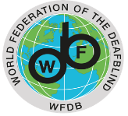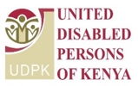

Technical Workshop Towards the
2nd WFDB Global Report on the Situation and Rights of Persons with Deafblindness

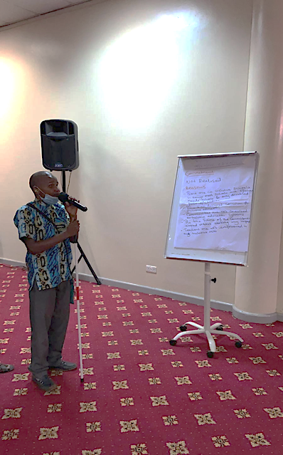
Rydone Shitambasi - indigenous youth with deafblindness
“I learnt things about the CRPD that I did not know before. I will transmit this knowledge to my peers once back home.”

Christabel Kageha - indigenous youth with deafblindness
“ I enjoyed the group exercises, finding the discussions meaningful and helpful to advance my advocacy.”

