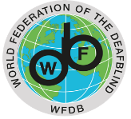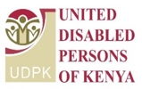

Technical Workshop Towards the
2nd WFDB Global Report on the Situation and Rights of Persons with Deafblindness

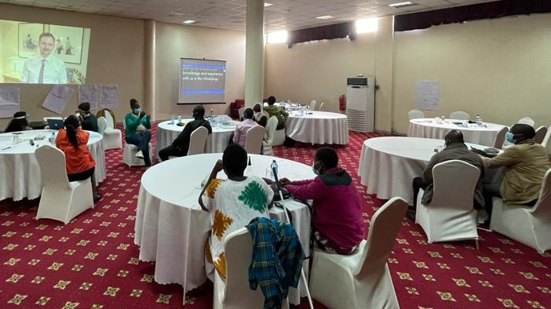
- 67% youth with deafblindness
- 50% from indigenous groups
- 33% women with deafblindness
- 67% from rural or remote areas

