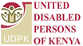
Meet the Indigenous women in Kenya
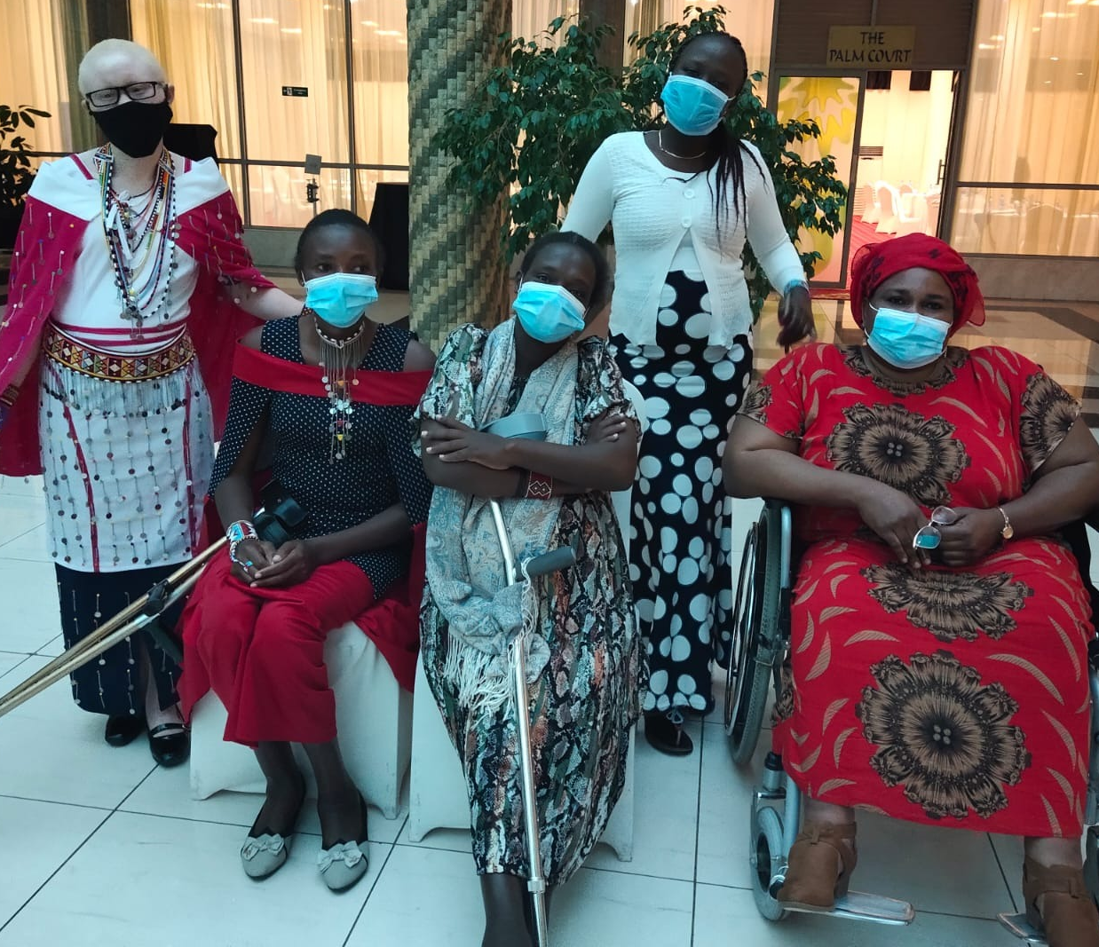
Zipporah Kimimti (Kipeto, first from the left), Jasmine Kutatoi (Kajiado), Christine Kandie (Narok), Anne Simaton (Kajiado, in the back), Anne Siodi (Kajiado, last one on the right)

“We, women with disability, especially indigenous women with disability go through a lot, from education to cultural perception and discrimination by family members. We do not have a right to: have children, to own the land or make decision on our own. We face with a lot of barriers and on that way, we do not have support either by government or our communities.”

More information at: www.internationaldisabilityalliance.org/technical-workshop-kenya-june2021

