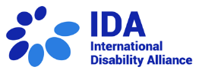
MEET OUR INDIGENOUS YOUTH IN KENYA
“In our communities, the communication channels are very limited. We came to this workshop as we want networking and connecting with others to work as one, and to impact both locally and globally”.
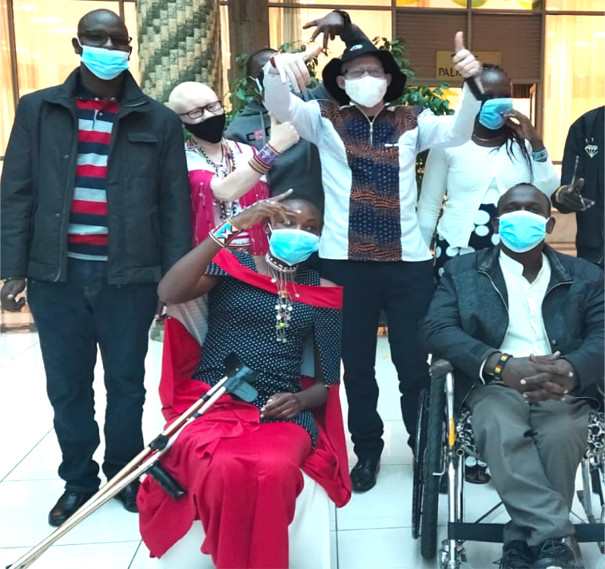

Peter Nampere (Samburu), Zipporah Kimimti (Kajiado West), Jackson Lekatap (Samburu North),
Reuben Mpatiany (Narok), Anne Simaton (Kajiado) (in the back)
Jasmine Kutatoi (Kajiado South), John Lenasalon (Baragoi) (in the front)

More information at: www.internationaldisabilityalliance.org/technical-workshop-kenya-june2021

