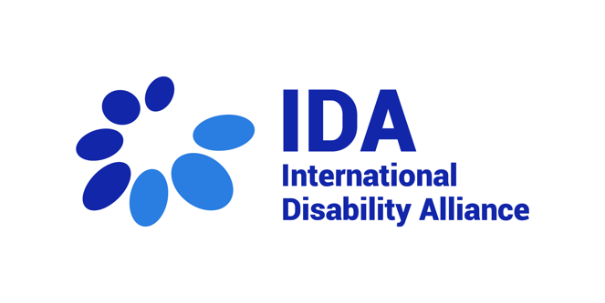

IDA Membership
Membership Demographics Form

May 2023

Please fill in this Membership Demographics form and send it with all the attachments (Page 3) to: membership@ida-secretariat.org

Type of Membership
Type of Membership (Full Member, Observer Member or Associate Member)
Type of Organization (Global, Regional or National Umbrella Organization)

General Information

Information of the organization
Full legal name of the organization
Acronym
Official address
Address of Head Office
City
Postcode
Country
Phone
E-mail
Website
Number of members

Legal and financials
Legal form (profit, non-profit or other to be specified)
Status as a DPO (led by a person with disability, members are persons with disabilities)
Registration No/Main Registration Number
Date of legal incorporation
Name of domestic regulatory authority under which registration was done
Budget of last year
Name of President/Chairperson of the organization
Name of the Organization’s legal representative
Name of the organization contact person
Date of last General Assembly

Vision and Mission
Vision
Mission

Attachments checklist
Letter of interest and agreement to the purpose and principles of IDA
Constitution of the association and its bylaws (Articles of Association)
Proof of legal establishment (Registration certificate)
List of member organizations to fill in the Excel in Annex
List of members of its governing body (Board Members) to fill in the Excel in Annex
Financial statements and/or last financial audit of the organization if available
If available, last year’s annual activity report
Photocopy of Tax card
Photocopy of any unique ID number of the DPO other than registration number (if applicable)
Bank account details
Policies related to safeguarding and management of malpractice and misconduct

Full Members can be global or regional organizations of persons with disabilities. Their representatives in the IDA Board have the right to vote and be elected by Board members to participate in the governance of IDA.
Observer Members are global or regional organizations without the right to vote or participate in the governance of IDA.
Associate Members are national umbrella organizations of persons with disabilities representing the diversity of constituencies of persons with disabilities, whose mission and objectives are in line with the purposes and principles of IDA. These are members without voting rights and their representatives in the Board of IDA do not have the right nor responsibility to participate in the governance of IDA.
Please refer to the Excel “Annex Application Form”

