National Consultation and Learning Workshop on COVID,
Issues of Indigenous Youth and Women with Disabilities in
Preparation of 2nd World Conference on Indigenous Women
&
Evaluating the Progress made by Nepal in the Implementation of Global Disability Summit 2018 Commitments

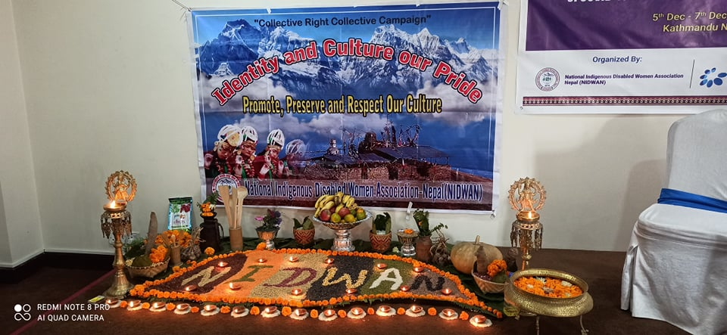

Organized by:

National Indigenous Disabled Women Association Nepal (NIDWAN)
Lalitpur Metropolitan City
Post Box No. 21535, Nepal
Email: nidwan2015@gmail.com, info@nidwan.org.np
Tel: +977311423, +9841457270
website: www.nidwan.org.np

Supported by:

International Disability Alliance (IDA)
and
Indigenous Persons with Disabilities Global Network (IPWDGN)
5-11th December 2020
Kathmandu, Nepal

Table of Content

List of Figures and Tables 4
List of Figures 4
List of Tables 4
Abbreviations 5
1. Background 6
2. Overview of the workshops 7
2.1. Workshop I: National Consultation & Learning Workshop on the Impacts of COVID-19 on Indigenous Peoples with Disabilities 7
2.1.1. Materials 7
2.1.2. Methodology 7
2.1.2.1. Formal Opening and the Interactive Lectures 8
2.1.2.2. Province-wise Exercise 9
2.1.3. Learning Sharing and Case Studies 12
2.1.6. Province-wise COVID Impact Outcomes Error! Bookmark not defined.
2.2. Workshop II: National Consultation Workshop on the Issues of Indigenous Youth and Women with Disabilities in Preparation of 2nd World Conference on Indigenous Women 14
2.2.1. Materials 14
2.2.2. Methodology 14
2.2.2.1. Interactive Lectures 14
2.2.2.2. Group Exercises 15
2.2.2.3. Individual Reflection and Sharing 18
2.2.2.4. Audio-visual Media 18
2.2.2.5. Solidarity Night and Cultural Exchanges 18
2.2.2.6. Connection between research, documentation and evidence generation 19
2.2.2.7. Action Plans and Recommendations 19
2.3. Workshop III: Evaluating the Progress made by Nepal in the Implementation of the Global Disability Summit 2018 Commitments 21
2.3.1. Materials 21
2.3.2. Methodology 21
2.3.2.1. Interactive facilitation and presentations 21
2.3.2.2. Individual sharing 22
2.3.2.4. Action plans and Recommendations 22
3. Participants information 22
4. Lessons Learned 24
5. Evaluation and feedbacks from the participants 26
6. Overall Recommendations and Way Forward 31

List of Figures and Tables

List of Figures

Figure 1: Gender and ethnicity of the participants in the workshops 23
Figure 2: Types of disabilities among the participants in the workshops 24
Figure 3: Participants familiarity on the topics and fulfillment of the expectations in the Workshop on Issues of Indigenous women and youth 27
Figure 4: Satisfaction on the distribution of materials during Workshop on Issues of Indigenous women and youth 27
Figure 5: Satisfaction of the participants on the facilitation and presentation in the session and logistic support during Workshop on Issues of Indigenous women and youth 28
Figure 6: Most promising topics and aspects during Workshop on Issues of Indigenous women and youth 29
Figure 7: Participants’ interest to engage with NIDWAN after the Workshop on Issues of Indigenous women and youth 31
Figure 8: Participants’ opinions on their engagement with NIDWAN after the Workshop on Issues of Indigenous women and youth 31

List of Tables

Table 1: Province-wise exercise on social and economic aspect 16
Table 2: Province-wise action plans and stakeholders identified by the participants in the group discussion 19
Table 3: Experiences of the participants on the issues related to disability, indigenous, women and indigenous women with disabilities 24

Abbreviations

CEDAW Convention for the Elimination of All Forms of Discrimination against Women
DFID Department for International Development
DPOs Disabled Persons Organizations
GDS Global Disability Summit
HI Humanity International (HI – previously known as Handicap International
IDA International Disability Alliance
IPWDGN Indigenous Persons with Disabilities Global Network
MoWCSC Ministry of Women, Children and Senior Citizens
NEFIN Nepal Federation of Indigenous Nationalities
NFDIN National Foundation for Development of Indigenous Nationalities
NFDN National Federation of Disabled – Nepal
NHRC National Human Rights Commission
NIDWAN National Indigenous Disabled Women Association – Nepal
NIWF National Indigenous Women’s Federation
UNCRPD United Nations Convention on the Rights of Persons with Disabilities
UNDP United Nations Development Programme
UNDRIP United Nations Declaration on the Rights of Indigenous Peoples

Background

National Indigenous Disabled Women Association (NIDWAN) has been working for the promotion and protection of rights and aspirations of indigenous women with disabilities since its establishment in 2015. They have been continuously discriminated, exploited and oppressed by the family members, society and policies and programs based on their intersectional ties of caste, races, ethnicities, gender and disabilities. Moreover, these intersectional, marginalized and underrepresented groups have faced the profound and aggravated impacts due to COVID-19 pandemic in their livelihoods including the health, education, economic, social and other sectors. Thus, it is crucial to build the skills and capacities of this marginalized group to encourage and strengthen themselves to tackle the emerging issues by themselves and also to effectively engage and contribute to the overall community and societal development. Since its establishment, NIDWAN has been continuously respecting the diversity within the group and building solidarity ad cooperation among themselves for more inclusive and better society. Moreover, NIDWAN focuses on education, employment, environmental justice, art and culture and sports for the most marginalized and vulnerable group of peoples, mainly, youth women, indigenous women, women with disabilities and indigenous women with disabilities. Though NIDWAN is a new organization, it has provided required support to the indigenous peoples and women with disabilities, in addition to the reliable information in the virtual sharing sessions during the COVID-19 pandemic.

As part of fulfilling and achieving the organizational vision, missions, goals and objectives and celebrating 29th International Day of the Persons with Disabilities, 3 consecutive national workshops were organized from 5 to 11 December 2020 at Pension Vasana Hotel in Kathmandu with the representatives of indigenous peoples, indigenous women and marginalized groups with disabilities from 7 provinces in Nepal. It has been organized with a slogan of “Nothing about us, without us” to build the skills and capacities of indigenous peoples/women with disabilities to take the lead with their innovative initiations for their own issues, concerns and rights. All these three national workshops were supported by the International Disability Alliance (IDA) and Indigenous Persons with Disabilities Global Network (IPWDGN). The first workshop was the National Consultation and Learning Workshop on the Impacts of COVID-19 particularly focusing on Indigenous Peoples with Disabilities (3-day workshop). The second workshop was mainly focusing on the national level consultation on the issues of indigenous women and youths with disabilities for the preparation of 2nd World Conference on Indigenous Women (3-day workshop) and the last one was mainly concentrated on the Evaluating the Progress made by Nepal in Implementation of the Global Disability Summit 2018 Commitments (one day workshop).

The overall aim of these national and evaluating workshops was to encourage and create the pathways for the inclusion of marginalized and under-represented groups particularly indigenous peoples and indigenous women with disabilities. Moreover, it also aimed to building the capacities and solidarity among the participants coming from different provinces with different levels of knowledge and understanding the issues and rights of indigenous peoples, indigenous women and indigenous peoples/indigenous women with disabilities. The workshops have been facilitated by the diverse group of experts in the fields of indigenous, women, disabilities at the national and international levels.

Overview of the workshops

2.1. Workshop I: National Consultation & Learning Workshop on the Impacts of COVID-19 on Indigenous Peoples with Disabilities
5 – 7 December 2020, Pension Vasana Hotel, Kathmandu Nepal

The three-day workshop kicked off on the 5th December commemorating the 29th International Day of Persons with Disabilities. The chief guest, Ms. Gita Satyal, Deputy Mayor of Lalitpur Metropolitan City Office and Dr. Shree Kumar Maharjan, Deputy Secretary General of Asia Indigenous People Pact (AIPP) did the Official inaugural of the workshop by the lighting the Panas Batti. Before the formal inaugural session, the guests were welcomed with Khadaa (a garland) and Pheta (indigenous blessing from ancestors a white long cloth that is wrapped by youngers) putting in the forehead for guests. For the successful completion of the workshops and blessing and wishes from ancestors, Ms. Pratima Gurung recited the traditional prayers and chants in local Gurung language.
Highlighting on the objectives and the modality of the three workshops Ms. Gurung welcomed all the participants from different provinces of Nepal and thanked their time and support in crucial time of pandemic. She also recognized and acknowledged International Disability Alliance (IDA) and Indigenous Peoples with Disabilities Global Network (IPWDGN) for the continuous support to indigenous peoples with disabilities from local to global level. During the session, the COVID safety protocols, safety measures and precautions were informed and all the necessary materials required were provided in a bag to all the participants. Then the sessions ended with tea break and the 2nd discussions were carried out. The objectives of the 2nd discussion was to share the situation of persons with disabilities and the challenges and issues faced by them during the COVID-19 pandemic and lockdown and also inform about the attempts made by the governmental and non-governmental organizations and way forward.

2.1.1. Materials

The workshop materials included program schedule, required materials: bag, notebooks, dairy, pens, COVID-19 safety materials like masks, sanitizers, gloves, face shield, logistic information, survey form links, and publications, COVID related fliers and banner. The instructions of every material were provided to follow in different sessions. Before starting every sessions, the participants were instructed with social distancing to follow to be safe from COVID-19 and the program itinerary.

2.1.2. Methodology

For the effective execution of the program and to assure the effective flow of the information, power point presentations, simultaneous sign language interpretation and captioning were provided. To reduce the monotonous environment, short tea breaks, group discussion, province wise discussion, a short sharing session with daily briefing sessions and different games/exercises were introduced in between the sessions.

2.1.2.1. Formal Opening and the Interactive Lectures

The workshop had formal opening session on the first day followed by the presentations and sharing session of the participants. During the formal session, Ms. Gurung highlighted on the objectives of three workshops and its link with the issues of indigenous peoples/women with disabilities from local to global level and focused on upcoming 2nd World Conference on Indigenous Women and 2nd Global Disability Summit in that would be taking place on 2021 ad 2022 respectively. She stressed the initiatives of IDA and IPWDGN's to mainstream Indigenous Peoples with Disabilities at global level that is connected at national level in this workshop, which is crucial at all. Likewise, the chief guest of the program Ms. Gita Satyal, Deputy Mayor of Lalitpur Municipality, highlighted the work NIDWAN had done in collaboration with local government during the COVID. She shared the initiatives and efforts made by Lalitpur Metropolitan City Office in creating a more disability inclusive and friendly society followed by the 10 disability inclusive programs initiated by the office marking the celebration of the 29th International Day of Persons with Disabilities. She inclined the exclusion of the Indigenous women with disabilities in disability movement and the need to work on these issues. Similarly, Mr. Shree Maharjan, Deputy General Secretary of AIPP acknowledged the efforts done by NIDWAN at national level and the linkages at regional level. He further added that the importance of disability inclusion in crucial in indigenous movement and discourse. Further, Mr. Krishna Gahatraj, one of the resource person of the workshop shared on the need to recognize and acknowledge the intersecting form of identities based on their different aspects such as their diversity, gender, age, ethnicity, economic condition, access to government and other services, disability, ethnicity, geographic location to ensure inclusion and equity, lack of disability inclusive relief response and considerations in the COVID-19 related programs.

The 2nd session was interactive learning session facilitated by Mr. Krishna Gahatraj and Ms. Pratima Gurung. He shared presentation on Understanding Disability and Intersectionality and gave updates on COVID 19 response and emerging issues related to COVID and Persons with Disabilities. Both shed light upon the concept of intersectionality, linkage of disability, necessity of inclusion in the disability movement, substantial lack in consideration of persons with disabilities in the recovery and relief response by the government, and the issues and limitations in policies formation and implementation. The interactive session was divided ino various sessions with group discussion and sharing sessions.
Other resource persons in the following days include: Ms. Maheshwori Bista, Chief Women Development Officer, Lalitpur Metropolitan City Office, Mr. Mitra Lal Sharma, President, National Federation of Disabled Nepal (NFDN), Mr. Murari Kharel, National Human Rights Commission, and Dr. Madhav Prasad Lamsal, from Ministry of Health and Population, and Mr. Bharat Sharma, Ministry of Women, Children and Senior Citizen. Ms. Bista highlighted on the initiatives carried out by the municipality during the COVID-19: Information Dissemination, Relief Response program and coordination, after lockdown activities and the working mechanism and facilities provided under One Stop Crisis Management Center (OCMC). Similarly, actions of NFDN during the COVID-19 pandemic, special program launched in Kavre & Sindhualchowk based on the consortium model, and different awareness raising program and report and research conducted. While Mr. Kharel gave overview on the international conventions, treaties, national policies and provision, impacts of COVID on the persons with disabilities: on health, education, discrimination and violence, relief and response, challenges, guiding principles for persons with disabilities and health personnel, violation of human rights during the period, lack of accessible services and information, and way forward. He also stressed the critical situation faced by peoples with disabilities during COVID that are considered as human rights violation. On the last day of workshop, Dr. Lamsal underlined the key National Commitments for disability inclusive health, classification, development of disability management from charity and welfare based model to right based approach, national and international status of disability, key accomplishment, and challenges. Similarly, Mr. Sharma from Ministry of Women Children and Senior Citizen elaborated on the act and policies related to disability, inclusion of disability in the policies, initiatives of the ministry, COVID-19 response and way forwards.

2.1.2.2. Province-wise Exercise

To engage and ensure the effective participation of the province level focal person and to know the existing issues and challenges faced by the persons with disabilities a province level activity was assigned to the participants where they had to explore the social and economic impact of COVID-19 on the persons with disabilities. Following are the outcomes of the activity as stated by the participants.

Table 1 Province-wise exercise on social, economic and other aspects during COVID
PROVINCE | SOCIAL ASPECT | ECONOMIC ASPECT
Province 1 | - Lack of flow of inclusive information (Mother Tongue, Sign, plain, picture Language) related to COVID-19  - Quarantine and isolation wards are not disability and indigenous inclusive  - Lack of Persons with Disabilities inclusion on trainings given on different issues like hand-washing from government and other agencies  - Not all Persons with Disabilitiess were able to access relief materials; power relation and institution matter and indigenous peoples with disabilities were left behind and had no acess.  - Barriers to access medication, health facilities, other services required for spinal, haemophilia and others  - Persons with Disabilities and indigenous persons/women with Disabilities including other marginalized groups are being more vulnerable, risk and prone to getting infected  - Psychological impact and stress in Persons with Disabilities but lack of counselling services and sensitization on mental health. | - Persons with Disabilities who are mostly self-employed and having small business owners have lost their job and no provision to provide them another source of income  - Difficulty in affording daily expenses  - Financial problems leading to family disputes and even divorce cases rising  - Rise in physical and sexual abuse due to lack of economic stability.  - Some people have returned back to their native lands seeking work an engaging in agricultural works  - No any jobs provisions and enabling environment for peoples with disabilities to run their work  - The PCR and other test remained challenge to peoples with disabilities and they were severely stigmatized so all of them did not open about the infection in most places.
Province 2 | - Quarantine places and toilets are not disabled friendly  - COVID related information are suitable for Persons with Disabilities and indigenous communities at rural places;  - Increase in cases of rape, abuse and murder but are mostly unreported;  - Lack of community and social support due to fear of getting infected;  - Deprived of free movement leading to psychosocial issues;  - Stigmatization of disabled people and fear of getting infected from them;  - Rise in mental stress and fear;  - High influence of Political Parties and exclusion of disabled peoples during plans and policies making and distributing foods and relief; | - More than 40% of blind people have lost job;  - Unable to get loan or in meter interest (i.e. 10% interest per week) and saving have run out;  - Lack of programs from the Government to address unemployment for most marginalized groups within disability.  - Only people with disabilities who had institutional access got support for relief and recovery  - No any awareness on health and PCR test and measures, all remained limited within home
Bagmati Province 3 | - Only 46% can understand Nepali language properly and lack of access of interpreters, unaffordable media and news outlets makes information inaccessible;  - Trainings are conducted virtually which are difficult to access and understand due to internet issues and limited knowledge;  - Discrimination by family members in their own home;  - Increase in mental stress, GBV, and rise of feeling of isolated; loss of life due to starvation  - Local Government's relief packages and rules are not clear;  - Limited resources, mobility, fear, dilemma, lack of accurate information  - Peer counseling and online programs are required but not all have access on it  - Marginalized Peoples with disabilities issues are left within reports, documents and OPDs and in government process for COVID intervention | - Loss of job of indigenous communities, loss of traditional customary practices, hard for daily wage earners like road singers, road shops,  - Information regarding COVID insurance, PCR test were expensive and were denied to infected peoples with disabilities and most of them did not do 2nd test and became normal, peer counseling support were not provided and people lose hope  - Hard to maintain social distance for some disabled peoples like people having spinal cord injury who needs personal assistant  - Mask, sanitizer and other sanitization materials are expensive for indigenous communities and were not acquainted with it and haven't used it till now;  - No specific support for marginalized groups were given most Indigenous peoples did not have citizen and disability card and were denied from relief and had no access.
Gandaki Province | - Communication gap between government, media and local community/indigenous people ;  - Lack on information on relief distribution  - Rise in GBV (Marital Rape) and many cases do not come is public sphere;  - Parents difficulties to look after intellectual and other disabilities;  - Increase in suicide rate than the actual death caused by COVID; | - Difficulty in fulfillment of basic needs for marginalized groups;  - Stress due to news of not providing social security and other links;  - Discrimination in distribution of relief materials;
Province 5 & 6 (Karnali Province) | - Due to dissemination of incomplete and false COVID related information via social networking sites, it promoted negative behavior and approach towards immigrants  - Fear in families and society resulting in increase in discrimination and negative attitude in community;  - Lack of disabled friendly environment;  - Fear of mental illness, more false rumors;  - Rise in fear of death due to being located in rural area;  - Rural areas are deprived of necessary infrastructures and access to resources; | - Rise in unemployment  - Rise in close down of shops and small business  - Daily wage earners are highly affected  - Poor and marginalized indigenous peoples had hard life who relied on daily wage work
Sudur Paschim Province 7 | - Lack of dissemination of information on native language and sign languages including easy to read versions  - Social and ethnic discrimination in relief distribution as the relief receiver was discriminated and the whole “Magar” (indigenous) community were indicated as “beggars” by Brahmans (non-indigenous) communities  - The relief is not distributed in equal manner people who are well connected in power and had link received  - Quarantine are not safe for women and Persons with Disabilities, group rape happened in quarantine  - Rise in suicide due to mental stress  - Couldn’t celebrate traditional rituals, customs of indigenous communities | - Daily wage worker and small business owner are unable to manage their daily basic needs  - Huge negative impacts on education  - No source of income  - No access to online meetings and trainings due to lack of resources, data pack of Internet for indigenous peoples with disabilities.  - Disparity and differences have occurred in daily lives and poor,

The province-wise group exercises specifically highlighted on the common and some different issues related within their provinces. All the information’s were well captured in the group discussion and was presented by the team leader.

2.1.3. Learning Sharing and Case Studies
Harikala Gharti Magar: Harikala Gharti Magar representing the Province 7 shared her story that the ethnic discrimination has increased during COVID but people do not generally discuss on these issues. She shared, "Our indigenous Magar communities are tagged as 'beggers' by other Brahmins (non-indigenous communities). They considered 'Magars' with low income, uneducated, arrogant and are suitable, eligible to receive relief and support. Such perception and attitudes humiliates us, we and our communities feel inferior, stigmatized, have negative impact and lose self dignity in society without doing any harm, Where is human rights for us, Are we really equal??” .

Shivnath Raut and Sakun Chaudhary from province 2 shared on the inconsistency and discrepancy during the relief distribution by the local government where only those having direct link with the representatives. The political parties supported only to their party cadres, which made a huge difference among peoples, Hatred, anger and rebellion rose among peoples. Mr. Raut shared a very emotional story of a blind beggar who could not even beg and starved for numerous days during the lockdown. Likewise, Ms. Chaudhary shared her story; "I was discarded from my village and isolated from my family during lockdown as I used to move at community to support women having severe disabilities and all used to see me and say the CORONA Virus is coming".

Tilak Tharu: Tilak Tharu, a young indigenous disable representative from Province 5 shared his story where his family consisted 3 persons with disability in a family. He shared, "we had a small tea shop and we lost it during lockdown and there was no source of income and food in our house so we are 4 members and we had to make routine who is going to have food and who remains with empty stomach so I have gastric these day there was imbalance in food intake as COVID started and which still remains a challenge". He is facing numerous issues related with from economic and health during the pandemic.

Tripta Magar and Chandra Rai from Province 1 basically focused on the violence and rape case issues which greatly elevated during the lockdown, unsafe situations of indigenous young girls and women and specially the women with disabilities. Mr. Chandra shared, "Even I was not aware how to handle the rape case of girl with intellectual disability from a rural part, we were called but we had many limitation regarding the medical, legal, and justice mechanism. Most often such cases are resolved with mutual understanding and we were in mental and physical pressure. When I made a video of that girl and asked for support and heIp, I had many telephone inquiries from different people not to handle and engage in such case. I was threatened and scolded with many slang words and had to switch off my telephone for a week but we could not support and provide justice, the case in filed and have been public but who is going to follow up, you will require link, access, money, power and all which OPDs have no access."

Ms. Sajana Gurung and Asha Gurung from Province 4 (Gandaki) inclined on the issues of dissemination of information in easy to read versions and local languages even in the city areas of Pokhara, the traditional thoughts of visualizing women with disabilities as a burden of family and strictly restricted in the family. Likewise Ms. Asha Gurung said, "Local language matters a lot, even I read at university, I am not familiar with Nepali language, so if information are provided in local language foe local communities, it will be practical, disability needs and gender, indigenous, geographical needs are also important because we are so diverse." She added the needs of communication for Hard of hearing and Deaf blind people.

Bhai Bahadur Aidi from the Province 6 (Sudurpaschim) shared the geological barrier being the most prominent barrier followed by the lack of information as the secondary barrier reinforced by complementary factors. He said, "Our Karnali peoples have nothing to do with VIRUS, we have hunger, poverty, lack of information, geographical constraints, language problems all time not only during COVID, that is our reality. No people with disabilities including indigenous peoples are aware about their rights and UNCRPD; they have disability card and all. We are not afraid of CORONA and life is normal in our communities, we don't use all these mask, sanitizers and we have no money to afford, instead of buying mask and sanitizers, we will buy rice to fill out stomach".

2.2. Workshop II: National Consultation Workshop on the Issues of Indigenous Youth and Women with Disabilities in Preparation of 2nd World Conference on Indigenous Women
8 – 10 December 2020, Pension Vasana Hotel, Kathmandu Nepal

The workshop was inaugurated by Mr. Gokul Prasad Gharti Magar, Vice Chairperson of the National Federation for Development of Indigenous Nationalities (NFDIN) and Ms. Manju Dhimal, Secretary of National Indigenous Women Federation (NIWF). The workshop was kicked off with welcome message by Ms. Pratima Gurung, President, NIDWAN, followed by the opening remarks by Mr. Gharti Magar and other invited guests. Both the invited guest Mr. Gharti and Ms. Dhimal focused on the protection and promotion of rights of women with disabilities and its present context in Nepal with a commitment walking together in collective movement. The main purpose of this workshop was to acquaint the indigenous youth and indigenous women with disabilities about the national and international mechanisms, instruments, policies, acts relevant to them; build the skills and capacities of indigenous women and youth with disabilities on the specific issues and concerns; and strengthen their network targeting the 2nd World Conference on Indigenous Women in 2021.

2.2.1. Materials

All the participants were provided with the set of materials including the programme schedule, the notebook, logistic information, presentations, the related publications of NIDWAN and other organizations and evaluation form.

2.2.2. Methodology

Several methods and tools were applied in the workshop in order to actively and effectively engage and motivate the participants throughout the sessions. Even in the evening, the interactive sessions had been planned and fully utilized with the participants by motivational speeches, videos and documentaries in addition to the reviews and feedbacks of the everyday session. All the participants fully cooperated and actively participated in the day and evening sessions. Moreover, the solidary night was organized to engage and orient the participants with their cultural exchanges since participants represent different ethnic groups. This program enabled the participants to be familiar with indigenous culture, language and traditional practices.

2.2.2.1. Interactive Lectures

The facilitators and resource persons presented on the specific topics and themes providing the theoretical concepts and practical case studies. The specific issues and concerns covered in the interactive lectures mainly covered on general scenario and context of indigenous women and youth with disabilities. Dr. Shree Maharjan facilitated the sessions on the the specific rights enshrined in the United Nations Convention on the Rights of Persons with Disabilities (UNCRPD) and United Nations Declaration on the Rights of Indigenous Peoples (UNDRIP), the voices from the ground particularly focusing on issues, concerns, barriers and challenges faced by the indigenous women and youth with disabilities and Ms. Pratima Gurung highlighted on the existing global to local situation and also the international instruments related to indigenous youth and women with disabilities. Moreover, the interactive session was facilitated by Dr. Krishna Bhattachan, an IP expert, on strategies to move forward framing the issues of Indigenous women with disabilities aligning the rights reflected in the UNCRPD, UNDRIP and CEDAW (Convention for the Elimination of All Forms of Discrimination against Women). He highlighted the specific cases and issues faced by indigenous peoples, indigenous women and indigenous peoples/women with disabilities. Furthermore, Mr. Bibek Luitel shared the concept of intersectionality, its understanding, and link with indigenous women with disabilities and also shared the research findings and outcomes with all the participants. All the participants provided their observations and feedbacks that ultimately helped in minimizing the research gaps.

Additionally, Ms. Binda Thapa presented the initiatives of UNDP concentrating persons with disabilities in the context of COVID-19 and implementation status of UNCRPD by the UN agencies. She further highlighted the UNDP’s working modality and principles specifically focusing women, gender and persons with disabilities. UNDP led the formulation of the UN Framework for responding to the socio-economic impacts of COVID-19 in Nepal and carried out the rapid assessment on the impact of COVID-19 on persons with disabilities. Furthermore, she informed the upcoming study of country analysis of COVID-19 on persons with disabilities. Ms. Kailash Rai, an independent researcher highlighted indigenous, gender and women’s rights perspectives and importance of multiple identities and intersectionality. Mr. Prakash Pant, Hon. Parliamentary Member, who is also disability rights activist in the past highlighted the scenario and strategies of persons and women with disabilities in Nepalese context in line with the UNCRPD. All of these interactive sessions were enriching, motivating to all the participants and eye-opening for some of the participants. All of the participants had interacted with the facilitators and resource persons by asking questions, queries and also provided the local contexts with specific examples and cases.

2.2.2.2. Group Exercises

The province-wise group exercises had been planned and executed on the specific issues and concerns of indigenous women and youth with disabilities in relation to the Acts, Policies/Plans, Programmes and Practices at the national, provincial and local contexts. Moreover, the participants discussed and planned for networking and strengthening of the movements at the local and provincial levels. The clear instructions and methodologies were explained to the participants beforehand to instigate the discussion among the participants from the respective provinces. Since there was only one participant from the province 6, he joined the province 5 to discuss the issues and concerns together and presented as the consolidated issues and concerns. The summarization of the group work on the issues, concerns and possible solutions are presented hereunder:

Table 2:Province issues, concerns and possible solutions in the group work
Provinces | Issues and Concerns | Possible Solutions
1 | - Lack of meaningful social representation and participation, even if the voices are raised, they are blamed as Sectarian disintegrators  - Lack of groups, networks, organizations of indigenous person with disabilities at local level  - Lack of adequate knowledge about the basic rights, community and collective rights including the basic services provided by the government to person with disabilities.  - Implementation of policies affect them. E.g., community forest policies restrict them to collect forest products  - Discriminations and isolation in the politics, federations and organizations and other services services and facilities  - Lack of access of indigenous peoples with disbilities in the disability quota | - Capacity building and advocacy on the rights of indigenous peoples with disabilities and person with disabilities for meaningful participation and to be promoted as Human Rights.  - Network, programs need to trengthen at communiy level in regular basis  - Sensitization through discussion series on the International Policies, Instruments, Rules and Regulations, Provisions and related documents at local level  - Interaction programmes on the inter-linkage of the land, water and forest resources and the Indigenous Peoples (IPs)  - Raise awareness of the local people on the issues of IPs as the Basic Human Rights rather than as a 'Racial discrimination'  - Conduct related survey, research, study, data collection and others
2 | - Lack of access and inclusiveness of indigenous peoples/women with disabilities in the education, health and employment sector and information system  - No access to in the federal structure of the government  - Discriminations and violences in every sector in day-to-day lives | - Capacity building and sensitization programmes in all sectors at all levels  - Ensure meaningful participation in the government and other institutions in the local and provincial level plans and policies  - Involve in the sanitation and community development and sensitization programs, protection of public monuments
3 | - Cultural and linguistic repression  - Barred from fundamental rights, mainly land rights, education, health and freedom of expression and to seek legal justice  - Negligence and non-prioritization in legal justice & compensation mechanism  - Lack of accessibility in all forms of services and facilities, non-considerate on the quota system for indigenous peoples, indigenous peoples/women with disabilities  - Limited knowledge and skills  - Difficulty in communication due to Sign Language, Interpretation, Captioning & Braille script and low economic condition | - Capacity building and skill enhancement with economic opportunities  - Requirement of Sign Language & Captioning, Braille script, mother toungue and local language  - Production of skill human resources mainly Sign Language Interpreters  - Conservation and protection of traditional customs and practices  - Development of tools and promotion of local resources (natural resources and forest)  - Despite of multiple barriers, if able to reach and be a part of government and social service, contribute as much as possbile
4 | - High illiteracy and unemployment rate among person with disabilities  - No provision of education in mother-tongue/Sign Language/braille materials for person with disabilities  - Lack of accessible physical infrastructures; limited reservations in public services  - Demotivating and demoralizing terms to refer to the person with disabilities | - Increase awareness on disability  - Peripheral and decentralized development with inclusion of the issues of person/ indigenous peoples/ women with disabilities  - Meaningful and effective participation of person/ indigenous peoples/ women with disabilities to make decisions on the issues and concerns that affect them.  - Persons with disability centered awareness programs are required.
5 & 6 | - Lack of recognition of indigeneity among the person with disabilities and their fundamental rights.  - No or limited access to the information and services provided by the government.  - Government has not specified special needs and services of person/ indigenous peoples/ women with disabilities  - No education in local language  - Limited health services and facilities to indigenous peoples/ women with disabilities  - IPs and indigenous peoples/ women with disabilities are often left out in committees at the local level  - Lack proper nutrition, thus, suffer from numerous health issues | - Capacity building and development programs should integrate their indigenous culture and traditional practices too  - Meaningful participation in local level programs and as well as in political and economic sector  - IPs rich cultures, traditions should be protected and promoted. Likewise, indigenous peoples/ women with disabilities’ rich cultures, customs and traditions need to be promoted and protected essential means.
7 | - Lack of disability inclusive infrastructures and curriculum  - Lack of disability inclusive hospital and health services  - Racial and caste-based discrimination and stigmatization  - Ensuring disability inclusive facilities, services and infrastructure | - Need-based assessment and capacity building training, particularly on leadership development, livelihoods and meaningful participation  - Formation of the committee indigenous peoples/ women with disabilities  - Coordination with local and national organizations including NIDWAN

2.2.2.3. Individual Reflection and Sharing

All the participants were enthusiastic and active in sharing their own understandings on the specific topics and thematic issues since they have been facing multiple issues, and discriminations in their day-to-day lives. Almost every participant had taken specific responsibilities, participated and shared their experiences in the sessions, which boosted the peer learning among the participants. The participants voluntarily agreed to take notes, summarized and reflected their learning and understanding of the sessions every day, which was impressive and informative.

2.2.2.4. Audio-visual Media

As part of the consultation workshop, the audio-visual media had been effectively utilized with multiple inspiring videos, documentaries, motivational speeches particularly focusing on indigenous women and persons with disabilities. These animated videos and documentaries were shown to the participants with the aim to inspire, strengthen and motivate them to continue their work, expand their network and strengthen their movements and self-determined development for the benefits of the indigenous women and youth with disabilities in their respective localities and provinces. In fact, some of the participants had already watched and inspired with such audio-visual media in the national and English languages. Moreover, the participants were excited to share their observations and opinions in the video documented by the Indigenous Television.

2.2.2.5. Solidarity Night and Cultural Exchanges

The special session of solidarity night had been planned in the evening of 8 December 2020 with active participation of all participants, some invited guests and NIDWAN secretariat. This night was mainly for cultural exchanges among the participants with their traditional dances and songs, ethnic dresses, specific cultural shows (dance, song and tradition). This session was useful to understand and respect the cultural differences and diversities in their disabilities and ethnicities, gender and races. In a way, it also helped to know each other and the talents of the participants well.

2.2.2.6. Connection between research, documentation and evidence generation

This workshop had integrated some specific sessions on research and documentation for the generating the evidence, which would be helpful for raising the awareness, building capacities and ultimately in advocacy and lobby. This session also helped in sharing the research findings, receiving the feedbacks on the findings from the participants and ultimately bridging the gaps between national and local levels.

2.2.2.7. Action Plans and Recommendations

At the end of the sessions, all the participants agreed to discuss and present their specific and prioritized action plans for the period of 6-12 months after going back to their origins. The session was very encouraging since everyone discussed and made specific action plans to be implemented within the timeframe. Some actions plans were very ambitious, whereas some of them are implementable by the participants within 3-6 months. They had identified mainly 3 most prioritized actions to be implemented (for whom, how, why and how much resources required), the potential stakeholders (including the supporters and opposers). It’s impressive that some of them decided to negotiate with the local governments for the resources to execute the action plans. Moreover, they have also identified the concerned stakeholders mainly the organizations that may support or oppose these interventions at the local, district, provincial and national levels These action plans need to be shared to their respective organizations and networks that need to be circulated to the NIDWAN since they may need technical and financial support to implement and also need to be monitored by the NIDWAN. The key action plans and identified stakeholders in each province are as follows.

Table 3: Province-wise action plans and stakeholders identified by the participants in the group discussion
Provinces | Key Action plans | Key stakeholders
1 | - Organize discussion session/workshop  - Seek suggestions/comments from all  - Present agendas and memorandum (gyapanpatra) at the local level after the discussions and workshops  - Search and raise required budget for the necessary activities and program at the local level or with NIDWAN Nepal | Supporters: NEFIN, Indigenous local committees, Rural Municipalities/ Muicipality and Local Ward Office  Opponents: Political parties and mainstream organizations  Non-indigenous groups and people
2 | - Share learnings within the organization  - Reach out to the person with disabilities at grassroot level (household and ward level)  - Advocate for the rights of the person with disabilities at the local level | Chandranagar Rural Municipality-Sarlahi, Disability Network, NIDWAN Nepal, Dhangadimai Municipality-Siraha, Disability Rehabilitation Center-Lahan, Lahan Municipality- Siraha
3 | - Organize discussion on the issues and identities of indigenous peoples with disabilities with NIDWAN  - Organize sensitization programmes on person with disabilities and their issues in coordination with local governments and wards  - Raise awareness and sensitization programmes on UNCRPD, UNDRIP to person with disabilities, Indigenous peoples, women with disabilities in the local level (Rural Municipality and wards). | Rural Municipalities/Municipalities, DPOs, provincial ministries, Federation of Nepali Journalists, NGOs/CBOs, Women, Children and Senior Citizen Department, Women's Commission, NHRC, NFDN, Federation of the Deaf, NIDWAN Nepal, Police Office, Cooperatives, Disaster Management Committee
4 | - Find out the precise number of Indigenous peoples/ women with disabilities  - Spread the awareness about the rights of Indigenous peoples/ women with disabilities  - Empower them with skill development training to make them able to express their thoughts, share their stories and put forward their views in the mass | Supporters: Tamu Dhee Nepal, NFDN, NIDWAN, NFDIN, District Administration Office, Municipalities and ward offices, District Court, Tamang Ghedung Kaski, Magar Samaj Pokhara, Newa Khalak Kaski, Kaski Association of Blind, Deafblind, deaf
5 & 6 | - Organize discussions, meeting with relevant people with the support of ward officials, rural municipalities/municipalities  - Reach out to the Indigenous peoples, women with disabilities who have limited movements, interactions with the local representatives from ward office, rural municipality & Municipality  - Coordinate with NIDWAN and other organizations for technical and other supports | Provincial ministries (Social Welfare, Local Development), District Coordination Committee, Local government bodies (Rural municipality & Municipality & Ward office), National Human Rights Commission, MoWCSC, DPOs, Users Groups, Cooperatives, Schools/ Academic Institutions, Health Posts, District chapters of NEFIN, District chapters of NFDN
7 | - Organize municipal level discussions on the disability, indigenous and women issues  - Identify supporters and opposers and form the committee at the local level  - Collect the relevant information of Indigenous peoples/women with disabilities and their needs and supports required so that they are not left behind  - Organize awareness raising programs in local languages | Local government offices (Rural Municipality & Ward Office), Sub-health posts, Police Office, Women Development & Cooperatives, Clubs, Political Parties, School (teachers), Village & tole leaders, MoWCSC,  Local post office, Human rights, NFDN, Ministry of Federal affairs

2.3. Workshop III: Evaluating the Progress made by Nepal in the Implementation of the Global Disability Summit 2018 Commitments
11 December 2020, Pension Vasana Hotel, Kathmandu Nepal

The third workshop in the series was concentrated on the Global Disability Summit (GDS) particularly the commitments made in 2018 and planning for 2022 summit on the occasion of 29th International Day of the persons with Disabilities. The main theme of it was “Building Back Better: Actions towards a Disability-Inclusive, Accessible and Sustainable Post COVID-19 World”. Like other workshop in a sequence, it was started with the formal opening session with the invited guest Ms. Jamuna Mishra, Joint Secretary Ministry of Women, Children and Senior Citizen (MoWCSC) and Mr. Mitra Lal Sharma, President of National Federation of Disabled – Nepal (NFDN) followed by Humanity International (HI – previously known as Handicap International) and Disabled Peopled Organization (DPO)’s representatives. The session was facilitated and hosted by Ms. Pratima Gurung, President of NIDWAN providing the brief background of 2nd Global Disability Summit. The workshop aimed to review the implementation status of the commitments of the government in Global Disability Summit – 2018 and also to initiate the planning discussion of the upcoming Global Disability Summit – 2022.

2.3.1. Materials

Although the workshop had been planned for a single day, all the participants were provided with the set of materials with a bag including the programs schedule, the notebook, logistic information, presentations, related publications like CEDAW and UNCRPD and NIDWAN's publications.

2.3.2. Methodology

2.3.2.1. Interactive facilitation and presentations

The facilitator, Ms. Pratima Gurung and invited speakers made the sessions very interactive with the specific topics focusing on the Global Disability Summit 2018 and related questions and answers and additions to the sessions by the related experts after the sessions. Based on the presentations, the participants raised their specific issues, concerns and shared their observations on the implementation of the commitments. Moreover, the sessions on the key departments and agencies responsible for the GDS; development on the advocacy strategy on GDS 2018 Humanity and Inclusion in Nepal had been planned and executed. Joint Secretary of the MoWCSC, Rights of Persons with Disabilities Promotion Section, Ms. Jamuna Mishra highlighted the rights of persons with disabilities and the provisions in the constitutions, acts and policies of government. Likewise, Mr. Sudarshan Subedi, former president of NFDN and disability rights advocate and Mr. Mitra Lal Sharma, President of NFDN had highlighted the commitments made by Nepal in the GDS and the efforts of NFDN in the implementation process. He committed to follow up the GDS process and plan for the upcoming in 2022. Similarly, Ms. Neeta Keshari Bhattrai, President of SHRUTI also shared her experiences and representation in GDS in 2018 and its outcomes among the groups and highlighted to move collectively for 2nd GDS in 2022. Organizations of Persons with Disabilities (OPDs) and their representatives from Parents Association, Physical Disabled Association, Down Syndrome Society, Disabled Women Organizations and Federations, Shutters, Deaf, Hard of Hearing, Deaf Blind Associations, Independent Living Center and others opined the lack of implementation of those commitments at grass root level, which need to be further, exercised by persons with disabilities. Most of the participants and the speakers appreciated and thanked the NIDWAN for this initiative to bring the people in the forum, discuss on the issue and plan ahead for the GDS 2022 in advance.

2.3.2.2. Individual sharing

Most of the participants were active in sharing their own observations, individual and organizational concerns regarding the GDS Commitments 2018 and the initiatives of the government and concerned authorities including the NFDN. Moreover, some of the participants raised the issues and concerns of persons with disabilities to the speakers. For instance, the representative of Nepal Stutters Association (NSA) raised the issue of negativity of the television shows on the children as some of such shows have exposed disabilities in different ways. He highlighted the issue of children caricaturing the stuttering after watching such shows which may impact them the whole life. Ms. Rama Dhakal, Vice chair of NFDN emphasized to ensure the engagement and participation of underrepresented groups

2.3.2.4. Action plans and Recommendations

This is just the beginning for the GDS 2022 and its important to review and reflect the progresses and achievements made with regards to the GDS 2018 and consolidated efforts of the government and concerned authorities and stakeholders. It would be lessons for the upcoming summit in 2022 to move forward and better prepared for effective implementation in future.

Participants information

Altogether 38 participants (11 Male and 27 Female) including participants, facilitators and resource persons, NIDWAN staffs and personal assistant for the participants needing assistance actively participated in the workshop I & II. In terms of ethnicity, there were Tamang (18%) & Gurung (18%) participants, followed by Tharu (13%), Magar (13%), Newar (13%) indigenous nationalities and one each from Byansi, Kahar, Sherpa, Chyantyal, Majhi, and Rai ethnicity (Figure 1).

Figure 1: Gender and ethnicity of the participants in the workshops

In terms of types of disabilities among the participants, maximum participants (58%) have physical disabilities, whereas 18% of them were blind or vision impairment and rest of the participants have vision impairment and hard of hearing, deaf, cerebral palsy, deaf blind, dwarf, hard of hearing and polio (Figure 2).

Figure 2: Types of disabilities among the participants in the workshops

Most of the participants, either indigenous youth or women, have been actively engaging and contributing to different events, activities, demonstrations, movements and activisms relating to disability, women and indigenous issues with different levels of experiences at the local and national levels. Some of them just started in the related issues whereas some of them have been continuously engaging and contributing for more than 25 years. In fact, it was good combination of young vs. experienced participants in the workshops as it opened up the discussions, sharing and learning among the participants in addition to the planned sessions. Out of the total participants, 37% have experiences of 6-10 years on disability issues, 58% of the participants have experiences of 1-5 years on indigenous peoples’ issues, 47% of the participants have experiences on women issues and 68% of the participants have 1-5 years experiences on indigenous women with disabilities (Table 3). This indicates that maximum of the participants is young and have few years of experiences on the specific issues, thus it is crucial to engage and motivate them in the similar exposures and learning platforms for their continued supports and commitments.

Table 4: Experiences of the participants on the issues related to disability, indigenous, women and indigenous women with disabilities
Number of years | Exp. on disabiity issues | Exp. on IP issues | Exp. on women issues | Exp. on IWwDs
1-5 years | 5 (26) | 11 (58) | 9 (47) | 13 (68)
6-10 years | 7 (37) | 2 (11) | 4 (21) | 1(5)
11-15 years | 2 (11) | 1 (5) | 0 | 0
16-20 years | 2 (11) | 0 | 3 (16) | 1 (5)
21-25 years | 1 (5) | 0 | 0 | 0
More than 26 years | 1 (5) | 1 (5) | 1 (5) | 0
No experiences | 1 (5) | 4 (21) | 2 (11) | 4 (21)
Total | 19 (100) | 19 (100) | 19 (100) | 19 (100)
Note: the figure in the parenthesis represents the percentage.

Lessons Learned

This is a wonderful opportunity for the indigenous women and youth to share their experiences and learn from the experts in the related fields of indigenous peoples’ rights, women rights and disability rights. This is an important initiation, which was also acknowledged by the participants and resource persons to minimize the gap between the indigenous women and youth with disabilities at the national and local levels, particularly focusing on the issue of intersectionality and international mechanisms, instruments and forums; national level acts, policies, plans and programmes; and local level programmes and practices. Despite the challenging situation due to COVID-19 pandemic, the participants enthusiastic participants and contributions to the workshops are appreciative and will be helpful to move forward with their commitments and action plans, which certainly need to be followed up by the NIDWAN in terms of its effective implementation and needed technical and other supports. This momentum of solidarity and cooperation with the local level leaders and their organizations should be continued in the future as well. The major lessons learned during the workshops are summarized here under:

- The issues and concerns faced by the persons with disabilities (PwDs), more specifically indigenous women/youth with disabilities are different across the regions based on the socio-economic including the family, geographical, political contexts, types of disabilities and their ethnicity specifically. They are somehow addressing these issues and challenges by themselves and with the support of some organizations as well.
- There is a huge gap in understanding the issues, concerns and rights related to disability, indigeneity, women and intersectionality at the national and local levels. For example, some of the indigenous women participants have been continuously engaging the disability issues and advocating for their rights, but they are not aware of the indigenous and women issues and related international mechanisms and instruments.
- Government of Nepal and multiple agencies including UN agencies, International and National Non-governmental Organizations, Civil Society Organizations have also integrated the issues of disability, indigenous peoples, women and indigenous women in their policies, plans and programmes. However, some of the disabled organizations have not integrated the issues of indigenous and women in their policies and programmes.
- There are enormous knowledge and skills of persons with disabilities, indigenous peoples/women with disabilities. With the favorable policies and technical support, they can represent and build their own future and also contribute to the society and nation as a whole. They need continuous motivations, capacity building support, enabling environment to follow their dream and achieve it.
- The network and solidarity building among the persons with disability within and with others have been stronger over the years. However, the network of indigenous peoples/women with disabilities is yet to be formed, strengthened and mobilized at the national and local levels.
- The level of awareness on disability issues, indigenous peoples’ issues among the general public are still very low. For instance, general public still uses different terminologies and derogatory words for the persons with disabilities, which may touch and demoralize the emotions of the persons with disabilities.
- This sort of events is required to be organized on regular basis where the persons with disabilities and indigenous peoples/women with disabilities come together, share their issues, concerns and learn new knowledge from the experts and apply it in their lives to improve their livelihoods, which was also expressed by the participants in the feedback sessions. More importantly, the actions they have committed needs some technical and financial supports and proper monitoring of their actions.

Evaluation and feedbacks from the participants

Feedback and evaluation of the workshop and the session have significant importance to the organizers as they form the baseline for the effective execution of the workshop and helps to run the sessions smoothly. Keeping this in mind, two modality of evaluation were adopted for the workshops i.e. written evaluation at the end of the workshop and daily/regular evaluation meeting with the organizing team and the participants.

Regular Evaluation

The workshops have the regular sessions of review and feedback collection after the last session with selected participants on the rotational basis. The main aim of this regular review and feedback collection was to check the level of understanding, get feedback on the strengths and weaknesses and to improve the sessions on the following day. It was quite helpful for the organizers to have these sessions regularly to understand the views and opinions of the participants particularly focusing on the sessions. Regular sessions include feedback on: the content of the presentations, sharing and discussions led by the resource person, time table, understanding of the participants, and logistic facilities. For each regular session one male and one female participants were chosen from the list. Participants taking part in the feedback session gave critical feedback regarding the sessions while some were very delighted by the hospitality of the organizers. Ms. Chandra Rai, Mr Hem Gurung, Mr. Tilak Tharu, Mr. Shivnath Raut, Ms. Pratima Lama, Ms. Chitra Rana Magar, Ms. Hari Kala Gharti Magar, Ms. Sakun Chaudhary, Mr. Bhai Bahadur Aidi, Ms. Kesari Tamang, Mr. Yuvraj Lama, and Ms. Imojani Shrestha.

National Consultation Workshop on the Issues of Indigenous Youth and Women with Disabilities (based on Written Evaluation Form)

Moreover, the overall feedback collection and evaluation of the workshops was also carried out to assess the level of knowledge and understandings of the participants after participating the workshops.

Almost 95% participants were familiar with the overall titles and topics discussed in the workshops though their level of understandings of the participants are different based on their experiences. However, some of the participants expressed that the issue of indigenous is new to them. They have not looked and understood the indigenous perspectives. In terms of fulfilment of their expectations from the workshop, maximum (68% of the participants) conveyed they are fully satisfied with the workshop and sessions whereas 32% of the participants communicated they are somehow satisfied (Figure 3). Likewise, the participants’ satisfactions on the distribution of materials during the workshop II was overall satisfactory, since 95% of the participants were satisfied with the materials distributed including the relevant publications and presentations (Figure 4).

Figure 3: Participants familiarity on the topics and fulfillment of the expectations in the Workshop on Issues of Indigenous women and youth

Figure 4: Satisfaction on the distribution of materials during Workshop on Issues of Indigenous women and youth

Moreover, 63% of the participants were fully satisfied with the facilitation and presentations made by the resource persons, whereas 37% of the participants were somehow satisfactory. Likewise, the 74% of the participants were satisfied with the logistic arrangement and supports provided, 16% were someway satisfied and 10% did not want to express their satisfaction on the logistics (Figure 5).

Figure 5: Satisfaction of the participants on the facilitation and presentation in the session and logistic support during Workshop on Issues of Indigenous women and youth

Among the sessions planned and executed sessions in the workshop II, which was on the issues of indigenous women and youth, the most promising topics and aspects were issues of rights of indigenous women and youths on disabilities and their efforts, and sessions being interactive. Despite different levels of understanding on the issues, all the participants were quite expressive since this is a forum, they can share their experiences and learn from others. The resource persons and facilitators also encouraged them to express their views, opinions and observations. Moreover, some participants liked the intersectionality and wider coverage of the issues from international level to the local level, whereas others liked the sessions since it had clarified and covered the aspects of the individual rights vs collective rights for indigenous peoples, freedom of expression, diversified and inclusiveness, CEDAW and UNDRIP, and opening session, group work and recreational activities during the sessions (Figure 6).

Figure 6: Most promising topics and aspects during Workshop on Issues of Indigenous women and youth

Almost all participants are willing to continue their engagement with the NIDWAN in different possible forms and ways (Figure 7). Maximum of the participants (5 out of 19) would like to continue strategic collaboration and cooperation with NIDWAN in coming days for the rights and recognition of indigenous peoples/women with disabilities at the local and national levels. Some of the would like to work as the facilitators and trainers at the local level, whereas other would like to work as a regular staff and fulfill their dreams to serve for the indigenous people/women with disabilities (Figure 8).

Moreover, the participants have specific suggestions to the organizers (NIDWAN and others) for the programs to be more effective in coming days.
- It would be better to allocate time for recreational, entertaining, energetic and motivational breaks on regular basis.
- NIDWAN has tried the best to follow the precautions during the workshops, however, the hotel needs to be accessible in terms of isolation and quarantine, if COVID is infected.
- There should be good sound system and support to the persons with disabilities in the hotels that need to be considered in future as well.
- The workshops and the topics covered in the workshops are important and impressive. Hence, additional stakeholders and marginalized people including the persons with disabilities, indigenous peoples and women from the remote areas need to be involved, engaged and motivated in future. It would be good to bring people from all districts of Nepal and should be organized on regular basis, most likely in every 6 months, if possible.
- It needs to be involved all kinds of persons with disabilities, marginalized groups and communities from all regions
- It is necessary to provide the IEC materials on human rights including the HR forms to be filled up and submit to the relevant and authentic organizations/institutions. While providing the materials, it needs to be considered for the people with low visionary problems
- These are new knowledge and life learning process thus, needs to be continue in future as well and build collaboration at all levels.
- The information and knowledge of CEDAW and UNDRIP are important, thus it is necessary to organize separate sessions on these important topics in future and also print the doc in braille in coming days.
- While organizing these kinds of workshops, it would be better to prioritize the poor, marginalized persons with disabilities
- The knowledge and lessons learned in the workshops are impressive, thus, similar kind of workshops and sharing should be organized at the local level as well.
- Time management is very important; thus, it would be good if the programs schedule is fixed in advance and the resource persons follow the specific allotted time with interactive sessions
- The knowledge and understanding the issues should be implemented and acted for the better future. The resource persons should be sensitive to the specific issues and topics, thus, NIDWAN should provide required information to the resource persons in advance.

Figure 7: Participants’ interest to engage with NIDWAN after the Workshop on Issues of Indigenous women and youth

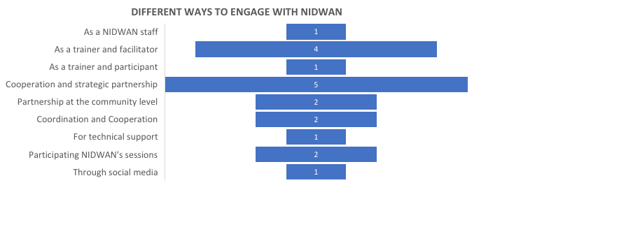

Figure 8: Participants’ opinions on their engagement with NIDWAN after the Workshop on Issues of Indigenous women and youth

Overall Recommendations and Way Forward

Despite the fear of COVID-19 pandemic, NIDWAN has successfully organized these workshops back-to-back with all the required precautions. All representative participants from the provinces, resource persons, facilitators, NIDWAN board members & staffs and advisor fully cooperated and supported to make these workshops successful. The meaningful participation and interactions of the participants and resource persons are appreciative and enriching for the successful execution of the workshops. It is necessary to follow up the action plans, the networks and solidarity building among the participants and their representing organizations in future on regular basis. The following recommendations would be productive and constructive to NIDWAN and concerned authority to fulfill the rights and recognitions of the persons with disabilities, indigenous peoples/women & youth with disabilities and poor, marginalized persons with disabilities.

- The concerned ministries, departments, and line authorities of the government at the national, provincial and local level should ensure the equal access, facilities and services to the persons with disabilities, indigenous peoples/women/youth with disabilities in COVID response and recovery.
- The government of Nepal including the UN agencies should implement and integrate effectively in national policies the concluding observation of CEDAW, UNCRPD, CERD, CRC, other international instruments and commitments like SDG 2030, UNDRIP, ILO 169 and WCIP and ensure the rights of all groups and share the outcomes on regular basis.
- The government, non-government organizations and private sectors should enable the favorable environment and assure the services, employment with fair renumeration and benefits to the persons with disabilities, indigenous peoples/women/youth with disabilities in every sector at all levels.
- The government, private and community educational and health institutions should provide the free education and health services to the persons with disabilities and indigenous peoples/women/youths at all levels.
- The government and concerned agencies and authorities must guarantee the safety and security the persons with disabilities and indigenous peoples/women/youths at all levels.
- It is necessary to ensure the assurance of basic & fundamental rights and needs of the persons with disabilities and indigenous peoples/women/youths at all levels based on the signed and adopted international and national mechanisms, treaties, and instruments including the UNCRPD, UNDRIP, ILO-169, CEDAW, Disability Rights Act-2074 among others.
- The government and concerned authorities should disaggregate the data of the persons with disabilities and indigenous peoples/women/youths with disabilities aligning the national census and disseminate on regular interval. It should integrate the disaggregated data compilation program while submitting the facts of multiple marginalizations in the concluding observations and documentations for the evidences
- Moreover, the government should prepare and disseminate the report by analyzing the individual and collective rights of the indigenous persons/women/youth with disabilities.
- The government and other concerned agencies including UN agencies, CTEVT should provide regular and quality livelihood enhancement training/skill development training and required technical and other supports to persons with disabilities and indigenous peoples/women/youths with disabilities.
- The UN agencies and concerned agencies should provide specific opportunities to the persons with disabilities, indigenous peoples/women/youth with disabilities their capacity building training programs and internship/fellowship programs, livelihood related support programs and employment opportunities.
- It is recommended to integrate the data and information of persons with disabilities and indigenous peoples/women/youth with disabilities and their issues and concerns in the work and reports of UN agencies, including UNDP and other concerned other agencies.
- The government and development partners should invest for ensuring and promoting the rights and networks/organizations of persons with disabilities and indigenous peoples/women/youth with disabilities. They should prioritize to strengthen, support and involve them in every sphere of socio-economic development, politics and nation building processes and mechanisms at the national, provincial and local levels
- Right-based approach needs to be ensured for the rights, respect and recognition of persons with disabilities, indigenous peoples/women/youth with disabilities in the policies and programs at the national and local levels. The voices of the person with disabilities representatives in the Parliamentary should be heard and integrated in the process of national policies and plans to ensure the rights and recognition of their issues and concerns.
- The 2017 Disability Act and new 2020 Regulations including policies and plans needed to amended and integrate the issues of indigenous peoples/women with disabilities and their meaningful participation from respective organization need to be ensured and implemented.
- NIDWAN should strengthen the network of indigenous peoples/women with disabilities at province and local level and work on issues on continuously; collect data, information/research and programs at community levels.
- International Disability Alliance (IDA) and other organization working on disability IDDC, GLAD should bridge the link from local to global level and facilitate with development partners to ensure meaningful participation of indigenous peoples/women with disabilities and support the work at national level with programs and activities.

Annex: i

Participant's List:

Workshop I: National Consultation & Learning Workshop on the Impacts of COVID -19 on Indigenous Peoples with Disabilities
Organized by National Indigenous Disable Women Association (NIDWAN) In Collaboration with International Disability Alliance (IDA) and Indigenous Persons with Disabilities Global Network (IPWDGN)
5-7 December 2020

S.No. | Participant’s Name | Types of Disability | M/F | Contact No.
1 | Sajana Gurung | Blind | F
2 | Imojani Shrestha | Cerebral Palsy | F
3 | Yuvraj Lama | Blind | M
4 | Shivnath Raut Kahar | Polio | M
5 | Krishna Pyari Nakarmi | SLI | F
6 | Sharmila Manandhar | Deaf | F
7 | Santoshi Ghimire | SLI | F
8 | Asha Gurung | Deaf blind | F
9 | Kesari Tamang | Physical | F
10 | Pratima Lama | Blind | F
11 | Tilak Tharu | Physical | M
12 | Bhai Bahadur Aidi | Physical | M
13 | Harikala Gharti Magar | Physical | F
14 | Ramnani Chaudhary | Physical | F
15 | Tripta Magar | Wheel chair | F
16 | Pramila Kumari Magar | PA of Tripta | F
17 | Chandra Rai | Wheel Chair | M
18 | Padam Gurung | PA of Chandra | M
19 | Nuva Rai | CART | F
20 | Fupu Sherpa | Hard of hearing | F
21 | Selina Nakarmi | NIDWAN Program Officer | F
22 | Brigid Shrestha | CART | F
23 | Mira Tamang | Physical | F
24 | Ganga Chhantyal | Physical | F
25 | Chitra Rana Magar | Physical | F
26 | Sakun Chaudhary | Physical | F
27 | Sumitra Majhi | Blind | F
28 | Renu Shrestha | Dwarf | F
29 | Jamuna Tamang | NIDWAN | F
30 | Rashmi Tamang | Parent of Intellectual Disability | F
31 | Indra Maya Gurung | Wheel chair | F
32 | Pema Wangmo Lama | PA of Indra maya | F
33 | Hem Gurung | Wheel Chair user | M
34 | Ganesh KC | PA of Hem Gurung | M
35 | Pratima Gurung | NIDWAN | F
36 | Bibek Luitel | Expert | M
37 | Ishwor Roila | NFDN | M
38 | Bishnulal Shrestha | Physical | M
39 | Jeevan Gyawali | NFDN | M
40 | Parwati Lma | NIDWAN | F
41 | Tej Kirati | Indigenous Television | M
42 | Gita Satyal | Resource Person | F
43 | Krishna Gahatraj | Expert | M
44 | Bharat Sharma | Resource Person | M
45 | Murari Kharel | Resource Person | M
45 | Maheswari Bista | Resource Person | F
47 | Madhav Prashad Lamsal | Resource Person | M
48 | Mitra Lal Sharma | Resource Person | M
49 | Shree Kumar Maharjan | Expert | M

Workshop II: National Consultation Workshop on the Issues of Indigenous Youth and Women with Disabilities in Preparation of 2nd World Conference on Indigenous Women
Organized by National Indigenous Disable Women Association (NIDWAN) In Collaboration with International Disability Alliance (IDA) and Indigenous Persons with Disabilities Global N-etwork (IPWDGN)
8-10 December 2020
S.No. | Participant’s Name | Types of Disability | M/F
1 | Sajana Gurung | Blind | F
2 | Imojani Shrestha | Cerebral Palsy | F
3 | Yuvraj Lama | Blind | M
4 | Shivnath Raut Kahar | Polio | M
5 | Krishna Pyari Nakarmi | SLI | F
6 | Sharmila Manandhar | Deaf | F
7 | Santoshi Ghimire | SLI | F
8 | Asha Gurung | Deaf blind | F
9 | Kesari Tamang | Physical | F
10 | Pratima Lama | Blind | F
11 | Tilak Tharu | Physical | M
12 | Bhai Bahadur Aidi | Physical | M
13 | Harikala Gharti Magar | Physical | F
14 | Ramnani Chaudhary | Physical | F
15 | Tripta Magar | Wheel chair | F
16 | Pramila Kumari Magar | PA of Tripta | F
17 | Chandra Rai | Wheel Chair | M
18 | Padam Gurung | PA of Chandra | M
19 | Nuva Rai | CART | F
20 | Fupu Sherpa | Hard of hearing | F
21 | Selina Nakarmi | NIDWAN Program Officer | F
22 | Tej Kirati | Indigenous Television | M
23 | Mira Tamang | Physical | F
24 | Ganga Chhantyal | Physical | F
25 | Chitra Rana Magar | Physical | F
26 | Sakun Chaudhary | Physical | F
27 | Sumitra Majhi | Blind | F
28 | Renu Shrestha | Dwarf | F
29 | Jamuna Tamang | NIDWAN | F
30 | Rashmi Tamang | Parent of Intellectual Disability | F
31 | Indra Maya Gurung | Wheel chair | F
32 | Pema Wangmo Lama | PA of Indra maya | F
33 | Hem Gurung | Wheel Chair user | M
34 | Ganesh KC | PA of Hem Gurung | M
35 | Pratima Gurung | NIDWAN | F
36 | Krishna Gahatraj | Expert | M
37 | Gokul Prashad Gharti | Resource Person | M
38 | Manju Dhimal | Resource Person | F
39 | Shree Kumar Maharjan | Expert | M
40 | Krishna Bhattachan | Resource Person | M
41 | Binda Thapa | Resource Person | F
42 | Prakash Pantha | Resource Person | M
43 | Bibek Luitel | Expert | M
44 | Kailash Rai | Resource Person | M

Workshop III: Evaluating the Progress made by Nepal in the Implementation of the Global Disability Summit 2018 Commitments
Organized by National Indigenous Disable Women Association (NIDWAN) In Collaboration with International Disability Alliance (IDA) and Indigenous Persons with Disabilities Global Network (IPWDGN)
11 December 2020

S.No. | Participant’s Name | Types of Disability | M/F
1 | Imojani Shrestha | Cerebral Palsy | F
2 | Ramesh Lama | Physical | M
3 | Anita Ghimire | Physical | F
4 | Shila Thapa | Parent of Intellectual Dissability | F
5 | Meena Poudel | Physical | F
6 | Jeevan Gyawali | NFDN | M
7 | Surya Bahadur Budathoki | NFDN | M
8 | Ishwor Roila | NFDN | M
9 | Mukunda Dahal | NAIDP | M
10 | Rabin Kumar Mainali | Speech | M
11 | Nirmala Dhital | Physical | F
12 | Kishor Rijal | NFYN | M
13 | Yuvraj Lama | Blind | M
14 | Krishna Pyari Nakarmi | SLI | F
15 | Sharmila Manandhar | Deaf | F
16 | Santoshi Ghimire | SLI | F
17 | Kesari Tamang | Physical | F
18 | Padam Gurung | PA of Chandra Rai | M
19 | Nuva Rai | CART | F
20 | Fupu Sherpa | Hard of hearing | F
21 | Selina Nakarmi | NIDWAN Program Officer | F
22 | Rama Dhakal | Physical | F
23 | Mira Tamang | Physical | F
24 | Ganga Chhantyal | Physical | F
25 | Chitra Rana Magar | Physical | F
26 | Pratima Lama | Blind | F
27 | Renuka Shrestha | Dwarf | F
28 | Jamuna Tamang | NIDWAN | F
29 | Rashmi Tamang | Parent of Intellectual Disability | F
30 | Indra Maya Gurung | Wheel chair | F
31 | Kiran Shilpakar | Physical | M
32 | Tej Kirati | Indigenous Television | M
33 | Ganesh KC | PA of Hem Gurung | M
34 | Pratima Gurung | NIDWAN | F
35 | Shree Kumar Maharjan | Expert | M
36 | Bibek Luitel | Expert | M
37 | Bhai Bahadur Aidi | Physical | M
38 | Fupaji Sherpa | NIDWAN | F
39 | Pema Wangmo Lama | PA of Indra maya | F
40 | Sumitra Majhi | Blind | F
41 | Brigid Shrestha | CART | F
42 | Sudarshan Subedi | Resource Person | M
43 | Neeta Kesari Bhattrai | Resource Person | F
44 | Jamuna Mishra | Resource Person | F
45 | Shiva Acharaya | Resource Person | M
46 | Mitra Lal Sharma | Resource Person | M

Annex: ii

Provincial Participant's List:

S.No. | Province No. | Participant’s Name | Types of Disability | M/F
1 | 1 | Tripta Magar | Spinal Cord Injury, Wheel Chair | F
2 | 1 | Pramila Kumari Magar | PA of Tripta | F
3 | 1 | Chandra Rai | Spinal Cord Injury, Wheel Chair | M
4 | 1 | Padam Gurung | PA of Chandra | M
5 | 2 | Shivnath Raut Kahar | Polio, Physical | M
6 | 2 | Sakun Chaudhary | Physical | F
7 | 3 | Imojani Shrestha | Cerebral Palsy | F
8 | 3 | Yuvraj Lama | Blind | M
9 | 3 | Sharmila Manandhar | Deaf | F
10 | 3 | Kesari Tamang | Physical | F
11 | 3 | Pratima Lama | Blind | F
12 | 3 | Fupu Sherpa | Hard of hearing | F
13 | 3 | Sumitra Majhi | Blind | F
14 | 3 | Renu Shrestha | Dwarf | F
15 | 3 | Rashmi Tamang | Parent of Intellectual Disability | F
16 | 4 | Asha Gurung | Deaf blind | F
17 | 4 | Indra Maya Gurung | Physical, Wheel chair | F
18 | 4 | Pema Wangmo Lama | PA of Indra maya | F
19 | 5 | Hem Gurung | Spinal Cord Injury, Wheel Chair user | M
20 | 5 | Ganesh KC | PA of Hem Gurung | M
21 | 5 | Sajana Gurung | Blind | F
22 | 5 | Tilak Tharu | Physical | M
23 | 5 | Chitra Rana Magar | Physical | F
24 | 6 | Bhai Bahadur Aidi | Physical | M
25 | 7 | Harikala Gharti Magar | Physical | F
26 | 7 | Ramnani Chaudhary | Physical | F

Annex: iii

Resource Person's List

Wo Workshop I: National Consultation & Learning Workshop on the Impacts of COVID -19 on Indigenous Peoples with Disabilities
Organized by National Indigenous Disable Women Association (NIDWAN) In Collaboration with International Disability Alliance (IDA) and Indigenous Persons with Disabilities Global Network (IPWDGN)
5-7 December 2020

SN | Date /Day | Resource Person | Contact No.
1. | 5 Dec/ Day 1 | Ms. Gita Satyal, Deputy Mayor, Lalitpur Metropolitan City Office | 9851234440
2. | 5 Dec/ Day 1 | Mr. Krishna Gahatraj, Disability Inclusion Expert | 9851089693
3. | 6 Dec/ Day 2 | Mr. Bharat Sharma Ministry of Women, Children & Senior Citizen | 9841273825
4. | 6 Dec/ Day 2 | Mr. Murari Kharel, National Human Rights Commission (NHRC) | 9841286738
5. | 6 Dec/ Day 2 | Ms. Maheswari Bista, Chief, Women Department Lalitpur Metropolitan City Office | 9841410725
6. | 7 Dec/ Day 3 | Dr. Madhav Prasad Lamsal, Ministry of Health and Population | 9851234229
7. | 7 Dec/ Day 3 | Mr. Mitra Lal Sharma, President, NFDN | 9857051466
8. | 7 Dec/ Day 3 | Dr. Shree Kumar Maharjan, Indigenous Expert and Deputy General Secretary AIPP | 9840826433

Workshop II: National Consultation Workshop on the Issues of Indigenous Youth and Women with Disabilities in Preparation of 2nd World Conference on Indigenous Women
Organized by National Indigenous Disable Women Association (NIDWAN) In Collaboration with International Disability Alliance (IDA) and Indigenous Persons with Disabilities Global N-etwork (IPWDGN)
8-10 December 2020

SN | Date /Day | Resource Person | Contact No.
1. | 8 Dec/ Day 1 | Mr. Gokul pd. Gharti, Vice-chair, NFDIN | 015553175
2 | 8th Dec/ Day 1 | Ms. Manju Dhimal, General Secretary, NIWF | 9841364691
3. | 8 Dec/ Day 1 | Dr. Shree Kumar Maharjan, Indigenous Expert, Deputy General Secretary AIPP | 9840826433
4. | 9 Dec/ Day 2 | Dr. Krishna Bhattachan,  IPs Expert | 9851176803
5. | 9 Dec/ Day 2 | Ms. Binda Thapa, UNDP | 9851137646
7. | 9 Dec/ Day 2 | Hon. Parliamentary Member Mr. Prakash Pantha | 9851007932
8. | 10 Dec/ Day 3 | Mr. Bibek Luitel, Researcher | 9851132555
9. | 10 Dec/ Day 3 | Ms. Kailash Rai, Indigenous Women Expert and Resaercher | 9841332288
10 | 10 Dec/ Day 3 | Dr. Shree Kumar Maharjan, Deputy General Secretary AIPP | 9840826433

Workshop III: Evaluating the Progress made by Nepal in the Implementation of the Global Disability Summit 2018 Commitments
Organized by National Indigenous Disable Women Association (NIDWAN) In Collaboration with International Disability Alliance (IDA) and Indigenous Persons with Disabilities Global Network (IPWDGN)
11 December 2020

SN | Date | Resource Person | Contact No.
1. | 11 December | Advocate Sudarshan Subedi, Disability and Human Rights Promotion Society | 9851059360
2. | 11 December | Neeta Kesari Bhattatai , President Shruti | 9849501416
3 | 11 December | Ms. Pratima Gurung, President NIDWAN | 9841457270
2. | 11 December | Mr. Jamuna Mishra, Joint Secretary Ministry of Women, Children & Senior Citizen | 9841273825
4. | 11 December | Mr. Shiva Acharya, Humanity & Inclusion Nepal | 9801975961
5. | 11 December | Mr. Mitra Lal Sharma, President, NFDN | 9857051466

Annex: iv
Photographs
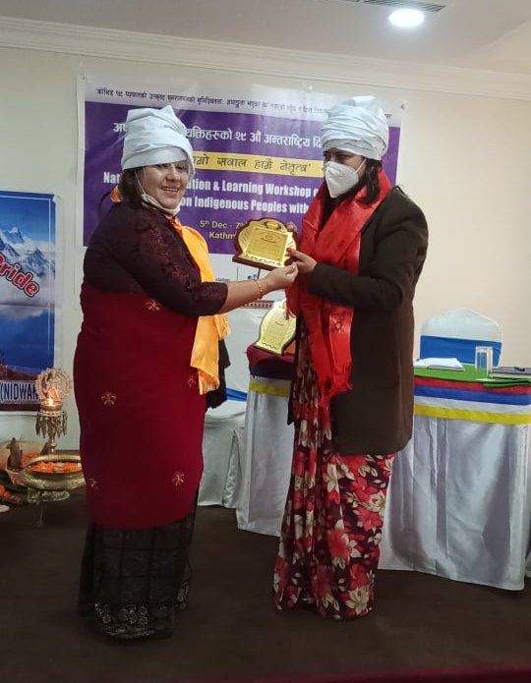 | 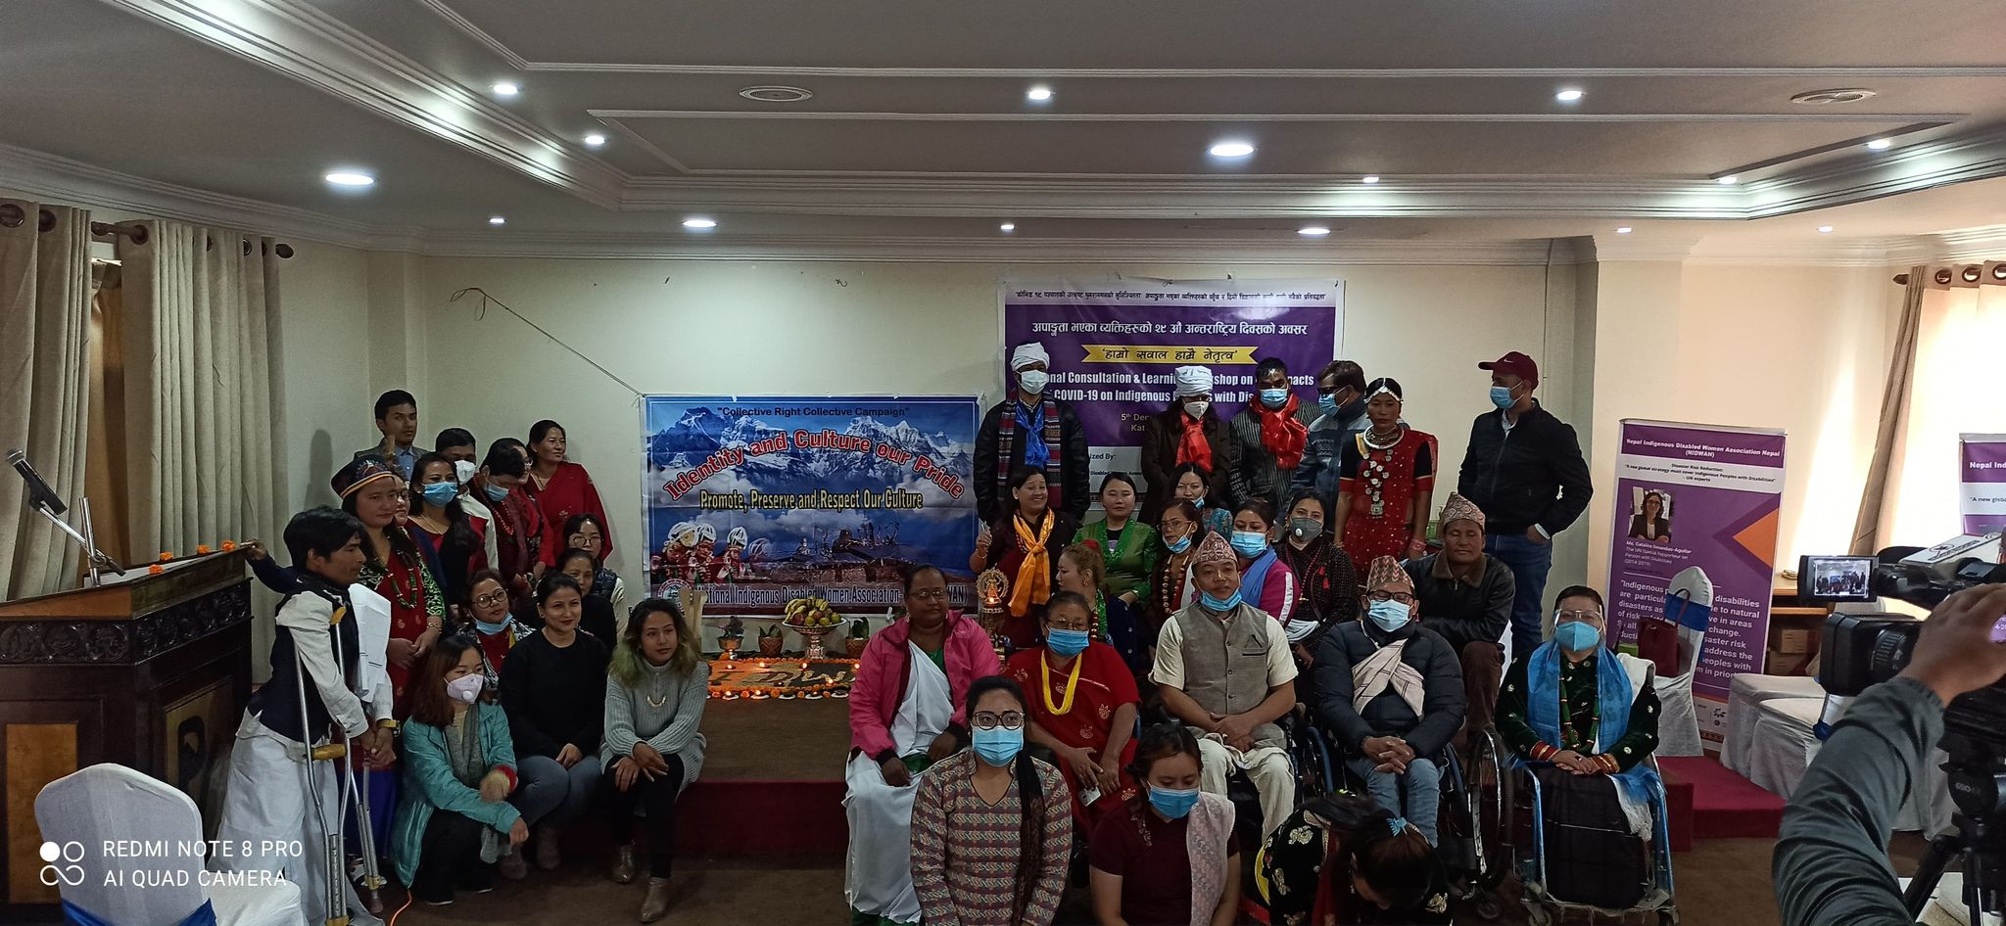
Photo 1: Providing token of love to Gita Satyal By Pratima Gurung. | Photo 2: Group picture of Day 1, Workshop 1.
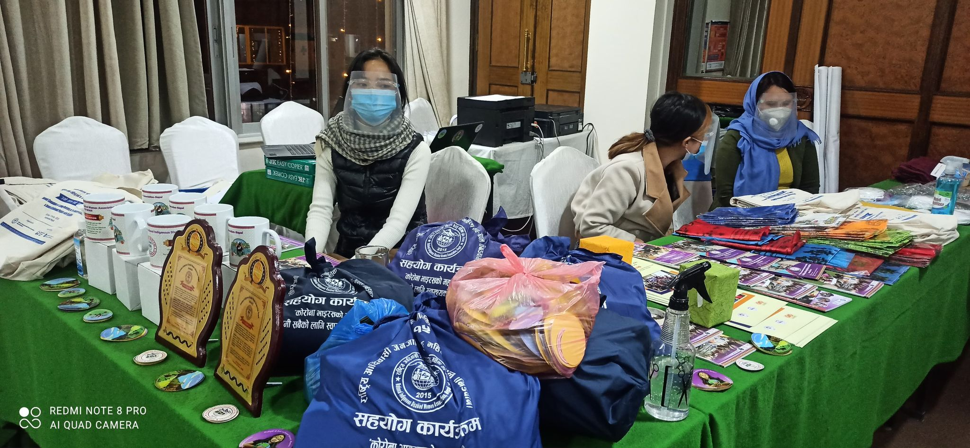 | 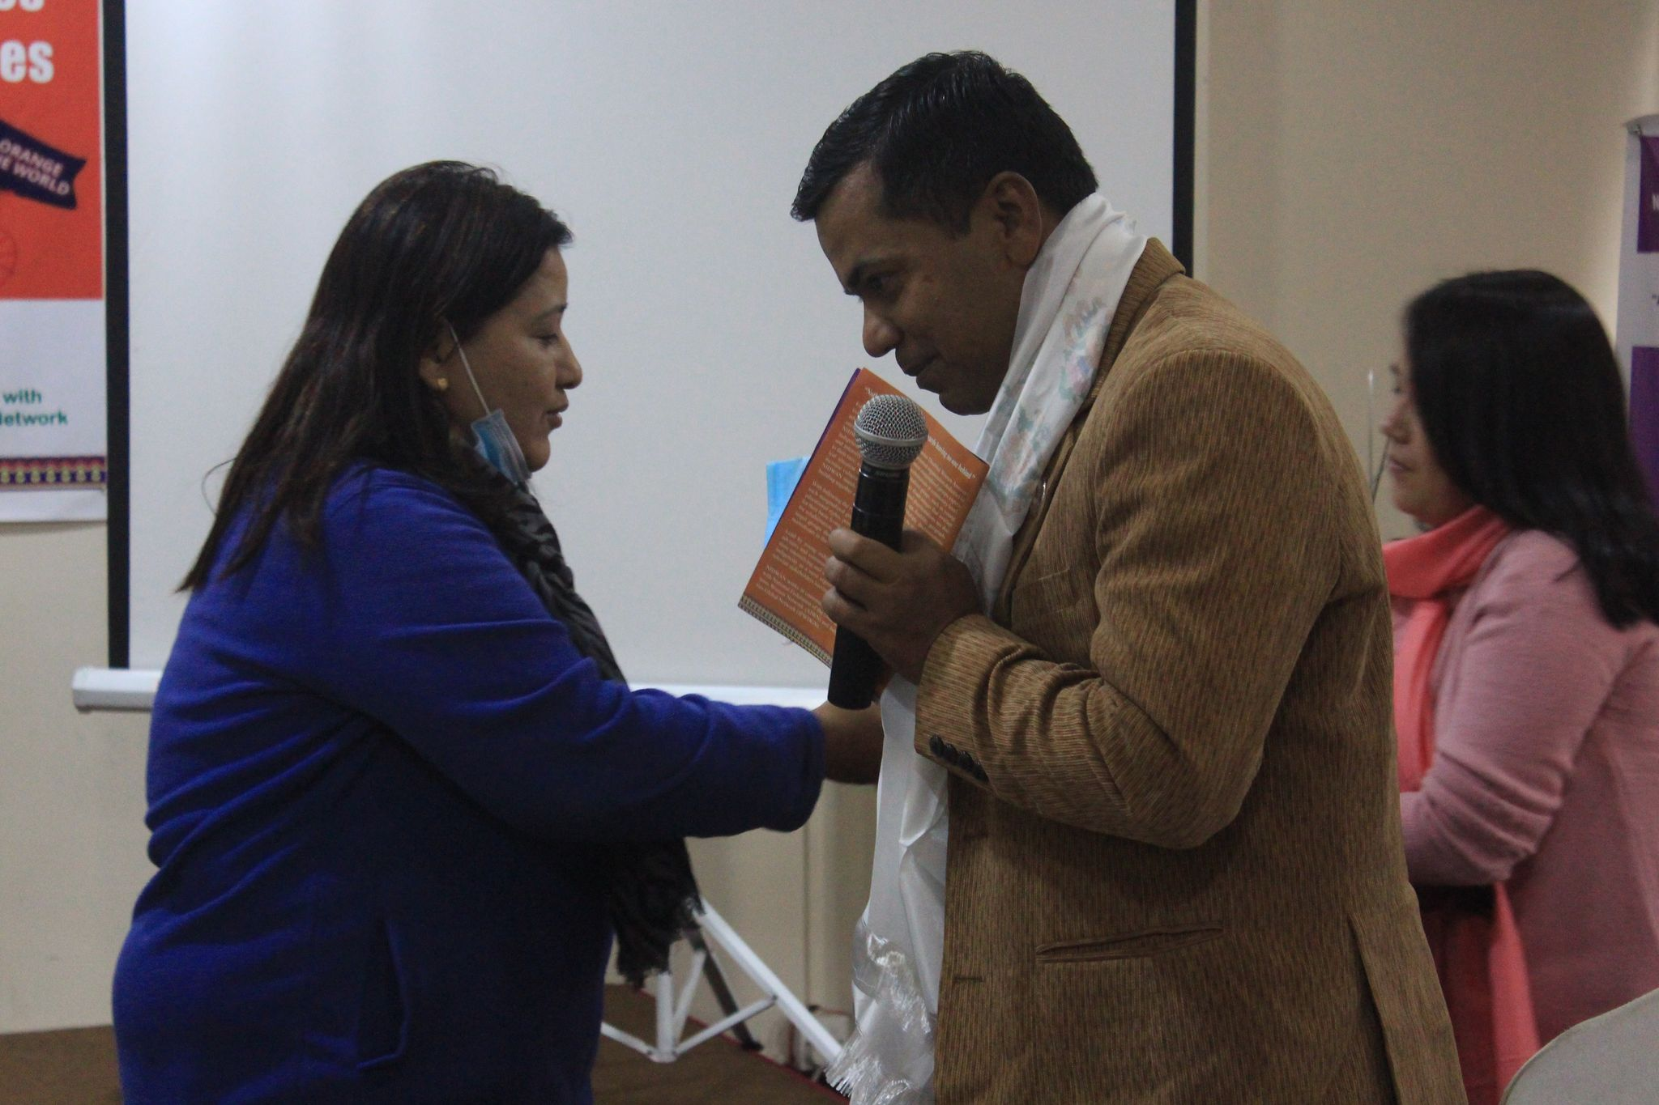
Photo 3: Display of hygiene kits, token of love and NIDWAN publications to be distributed to participants. | Photo 4: Pratima Gurung putting khada on the guest
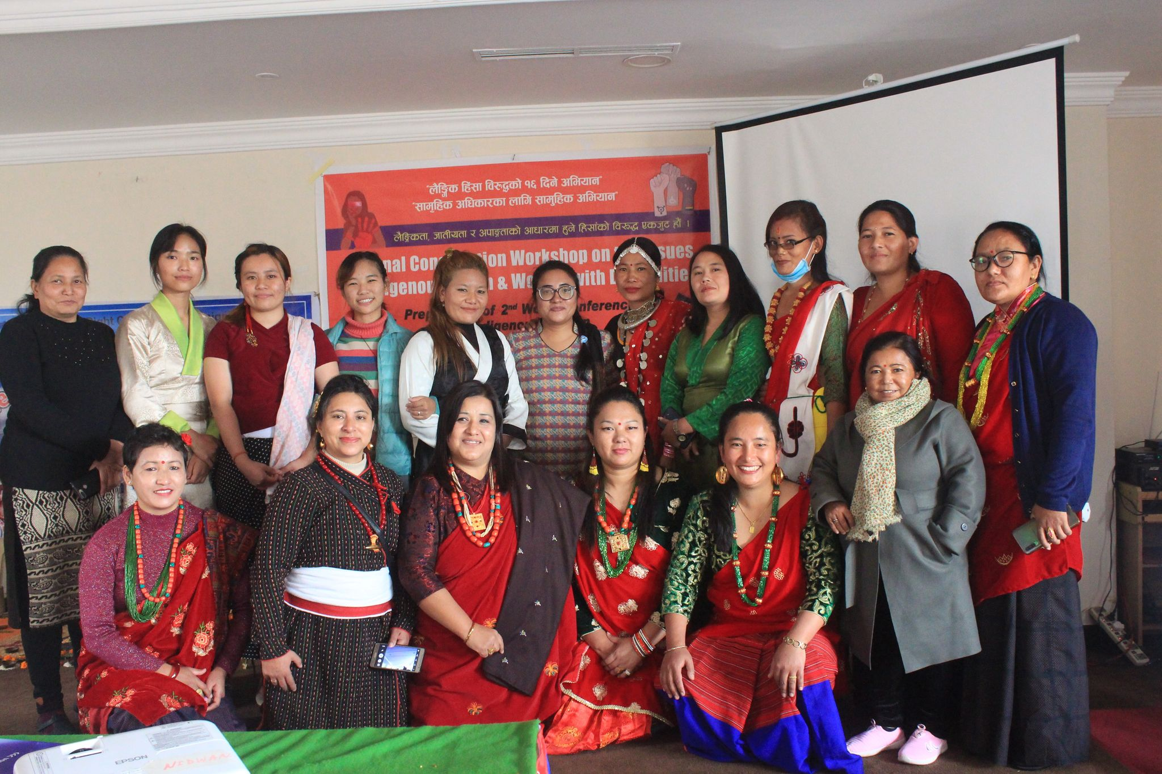 | 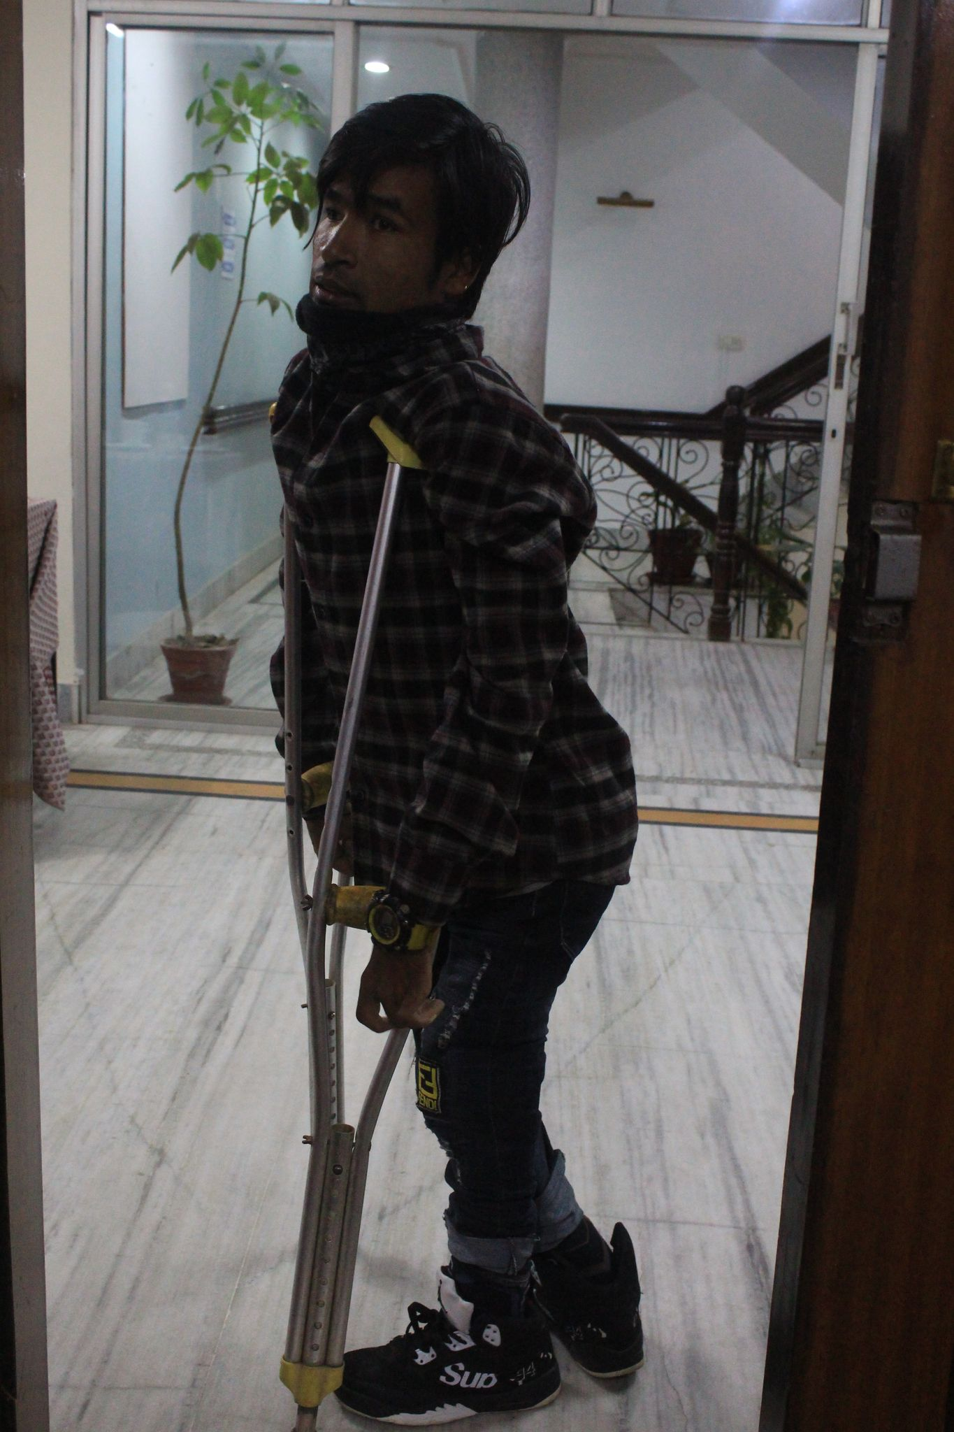
Photo 5: GroUp Photo of NIDWAN Members and staff. | Photo 6: Representative from Province 5 Tilak Tharu.
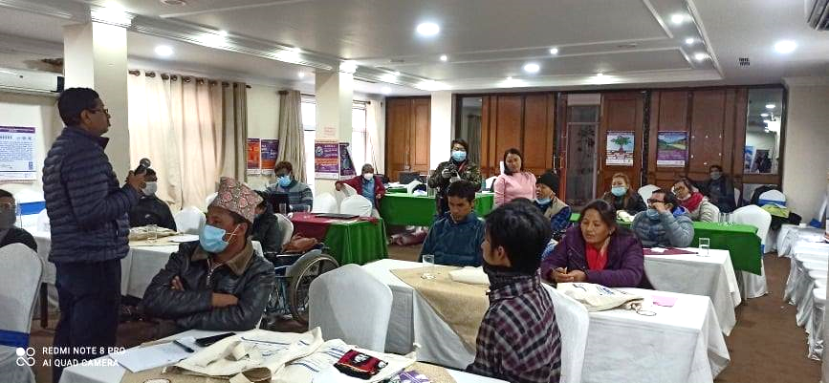 | 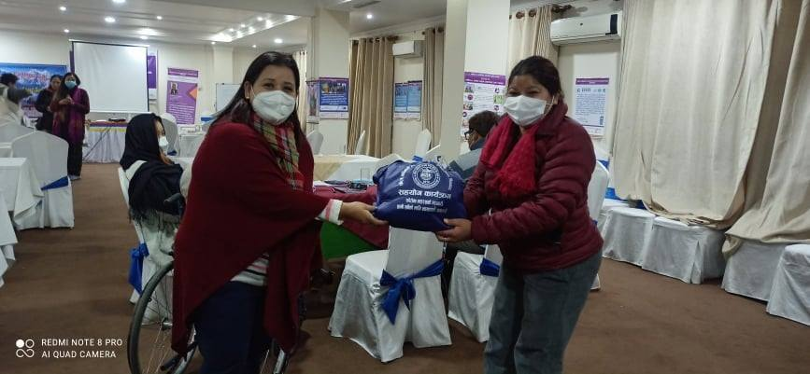
Photo 7: Resource Person presenting to the participants. | Photo 8: Pratima Gurung providing hygiene kit to

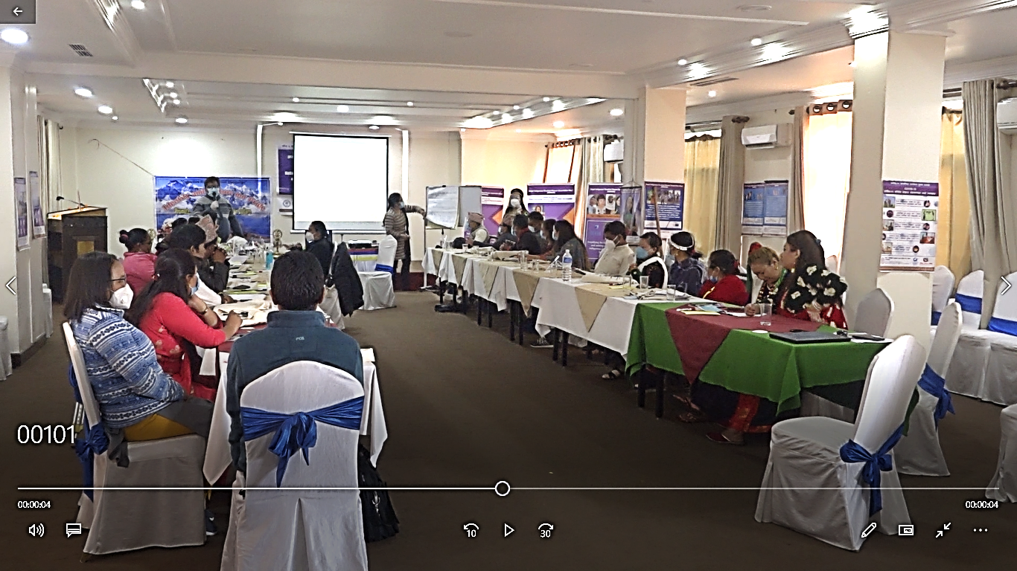 | 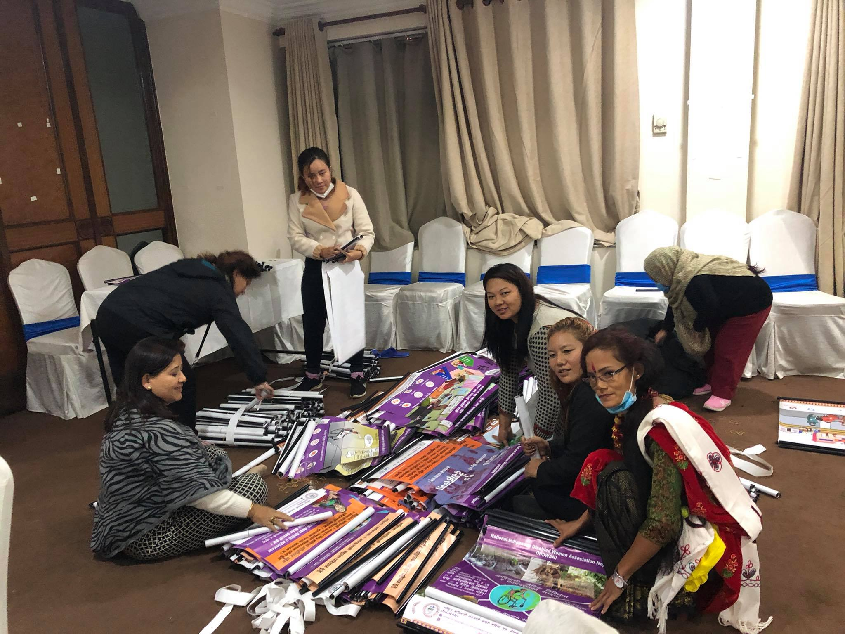
Photo 9: | Photo 10: NIDWAN team preparing flyers for the distribution for provincial reporsentatives.
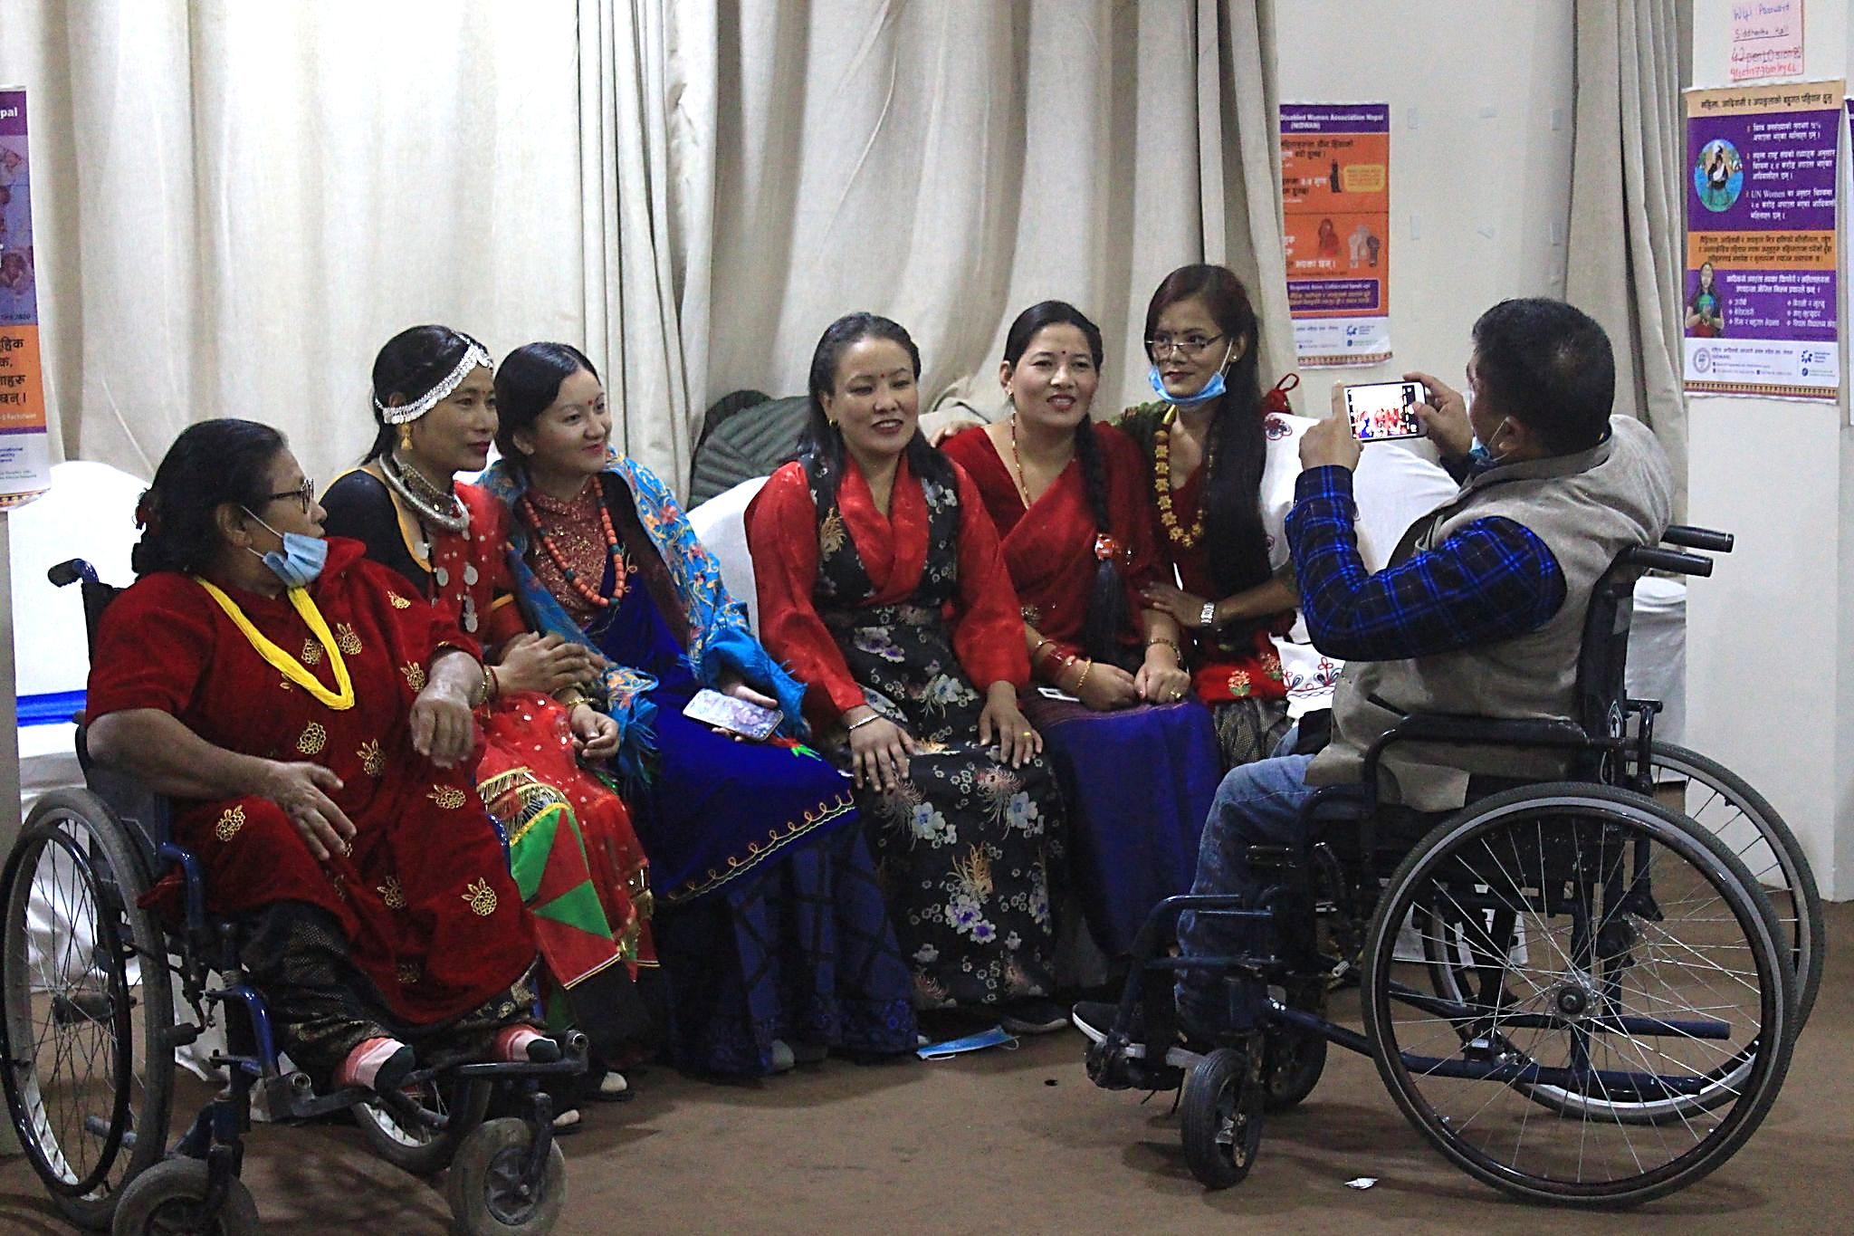 | 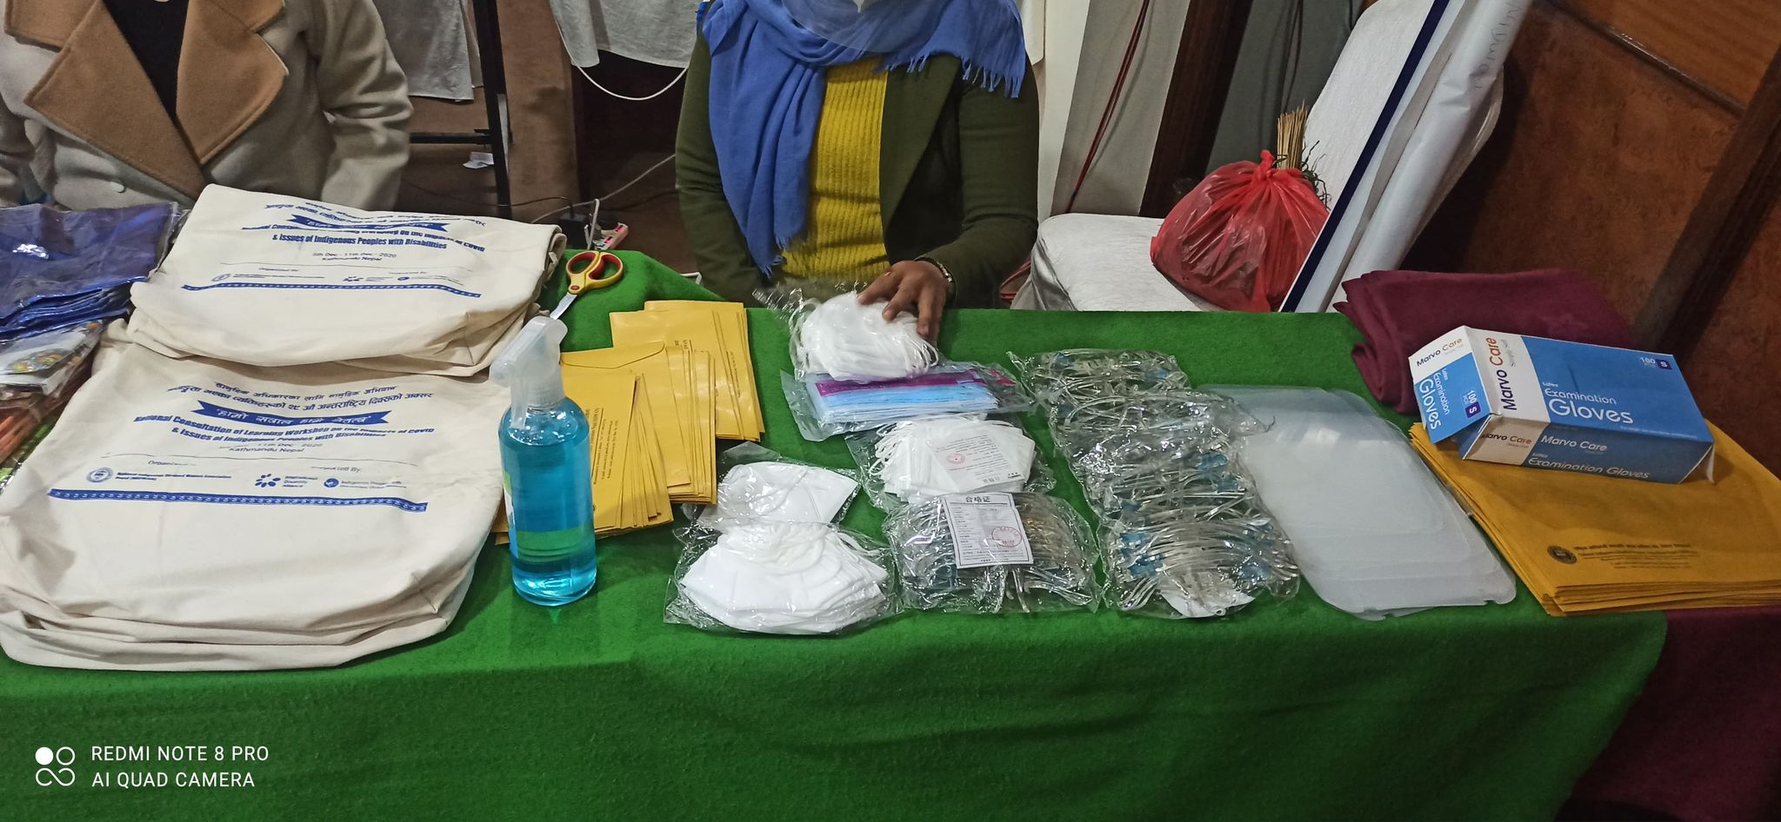
Photo 11: Participants from different province taking pictures wearing their respective cultural dress. | Photo 12: Bags, Mask, Sanitizer, Face shields to be provided to the participants and guest.
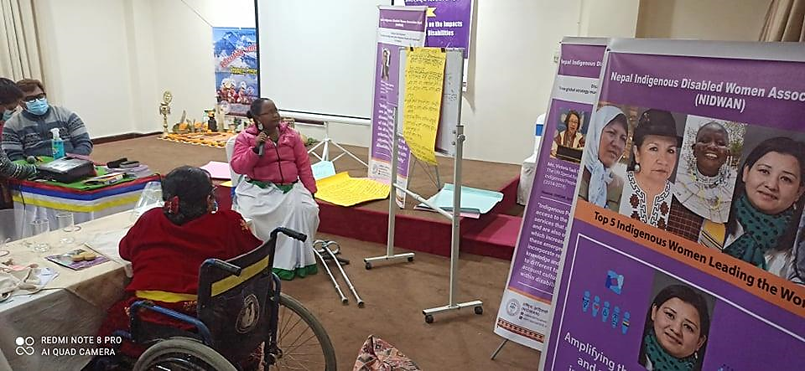 | 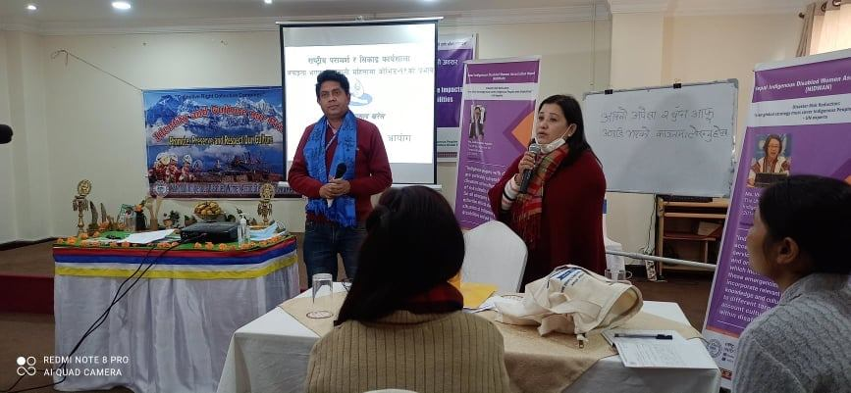
Photo 13: Sakun Chaudary, representative from Province 2 presenting thoughts of respective group. | Photo 14: Resource Person
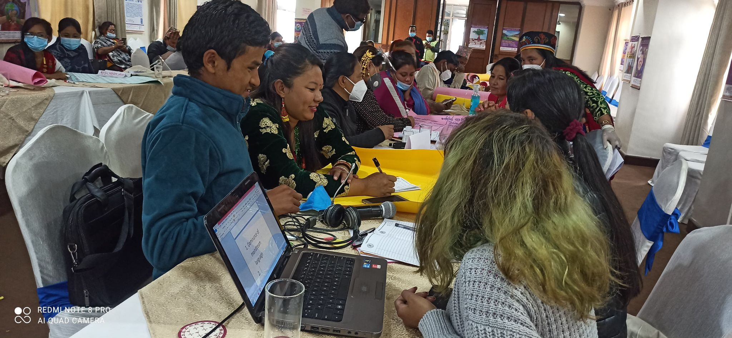 | 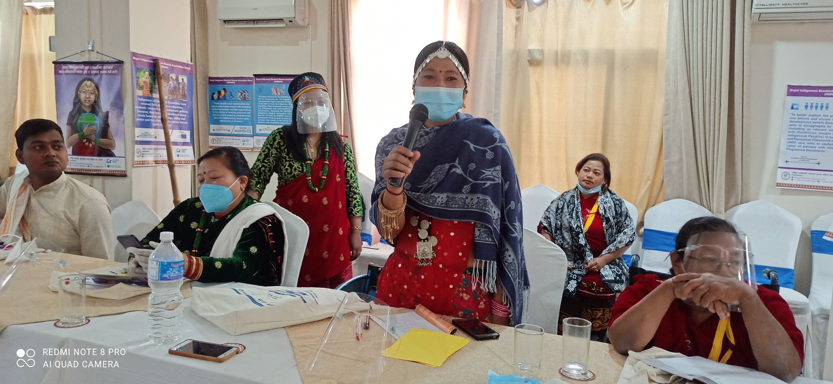
Photo 15: Representatives from Province 3 carrying out group discussion. | Photo 16: Ramnani Choudary, representative from province 7 presenting her views.

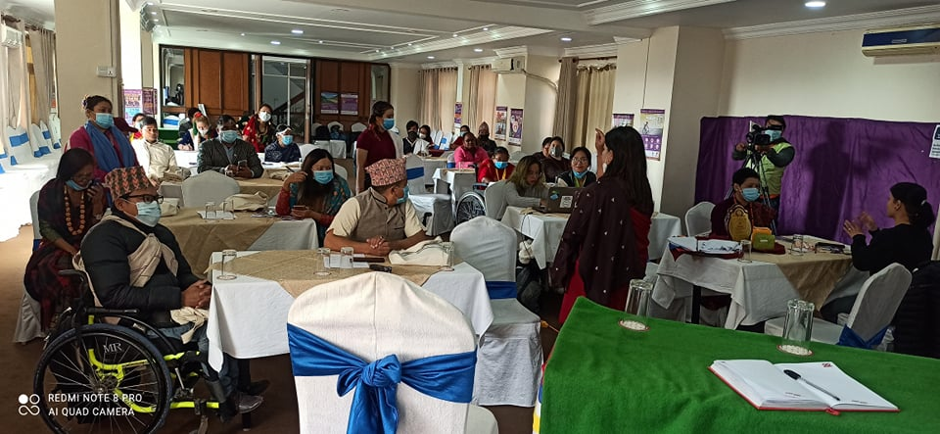 | 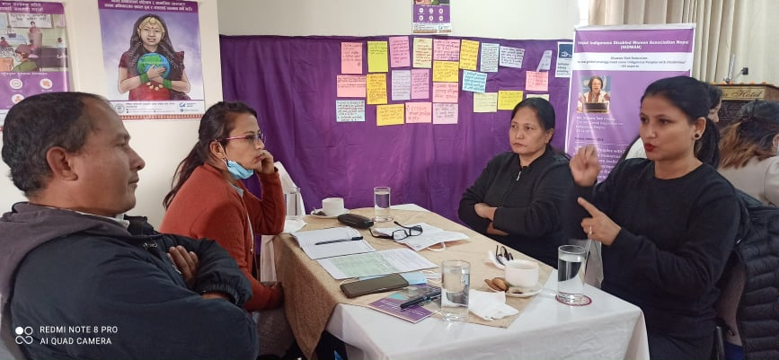
Photo 17: Resource person explaining to the participants. | Photo 18: Sign Language Interpreter interpreting to deaf participant.
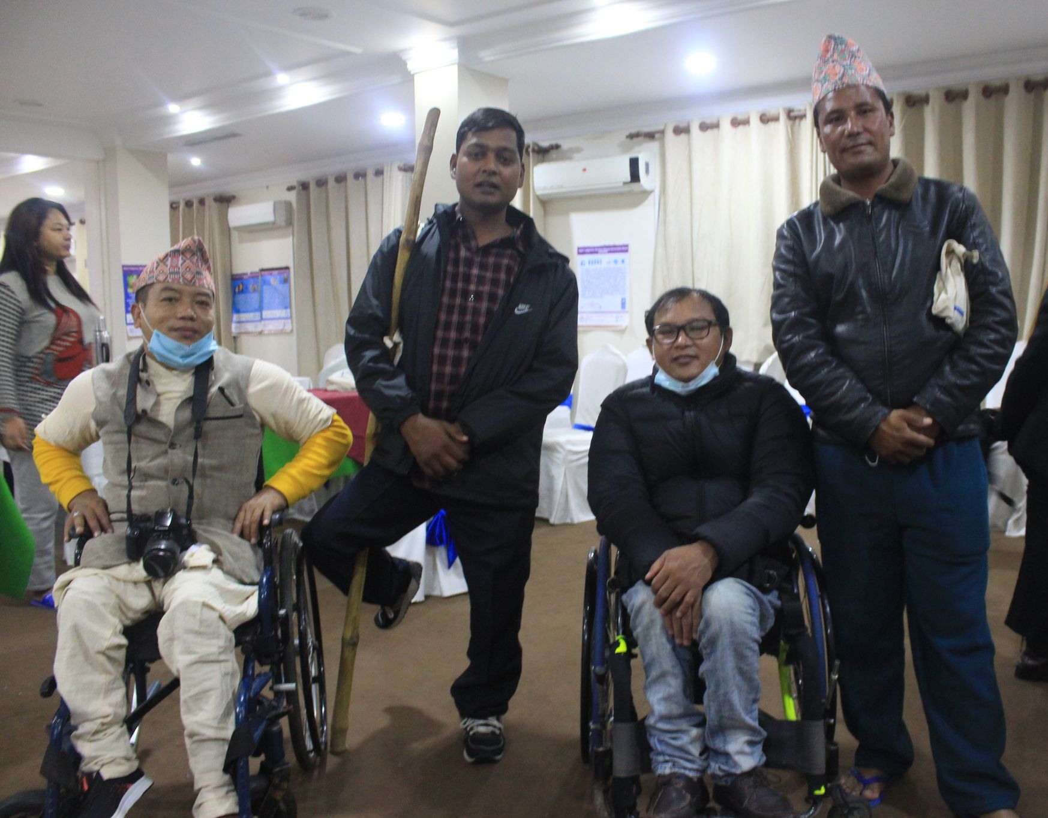 | 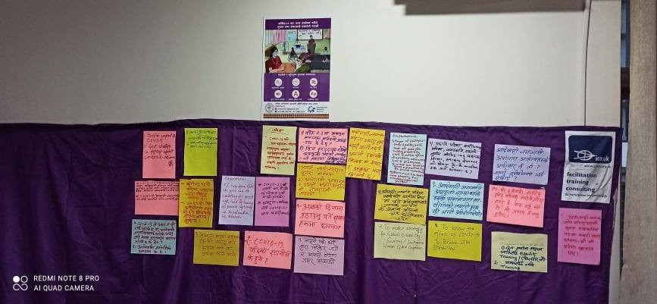
Photo 19: Representatives From Province 1, 2, 5 and 6. (From left to right) | Photo 20: Expectations of participants displayed.

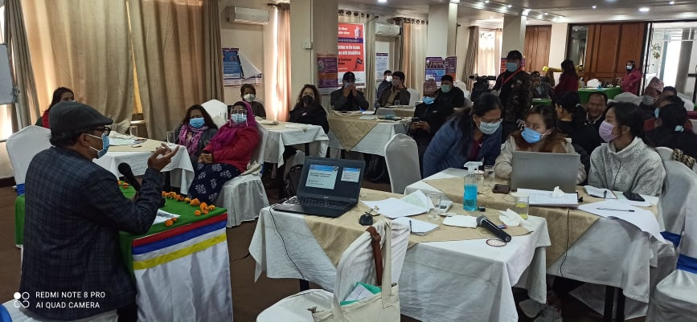 | 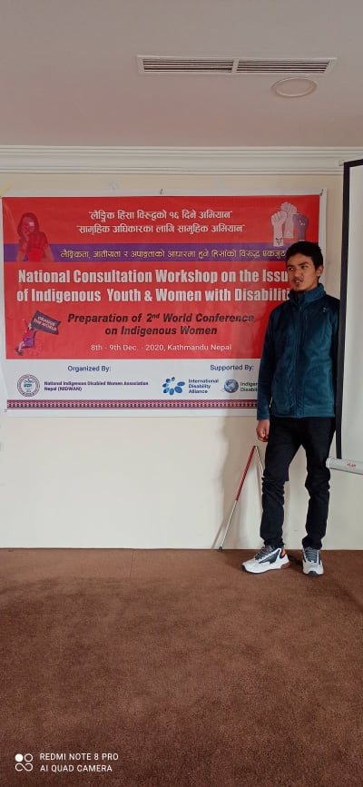
Photo 21: | Photo 22: Yuvraj Lama standing infront of the banner.
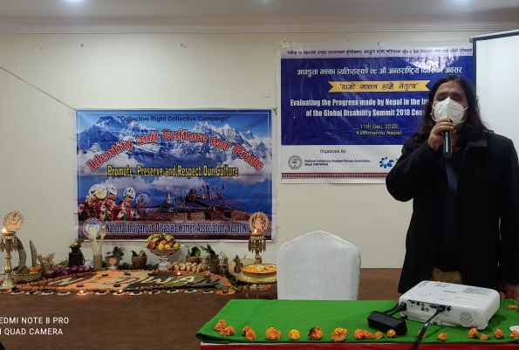 | 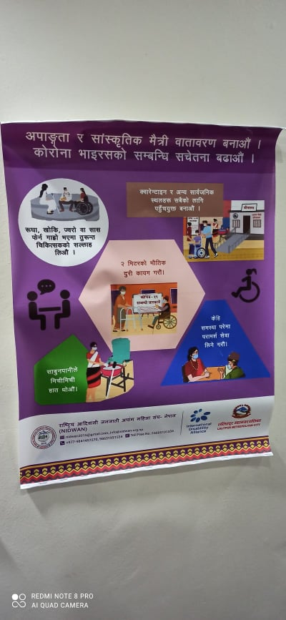
Photo 23: | Photo 24:

NFDIN is autonomous and independent government of body for ensuring the overall welfare and mainstreaming the issues and concerns of indigenous nationalities in Nepal.
NIWF is an umbrella organization of indigenous women’s organizations in Nepal with the network of indigenous women’s organization throughout the country.

