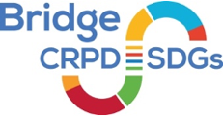

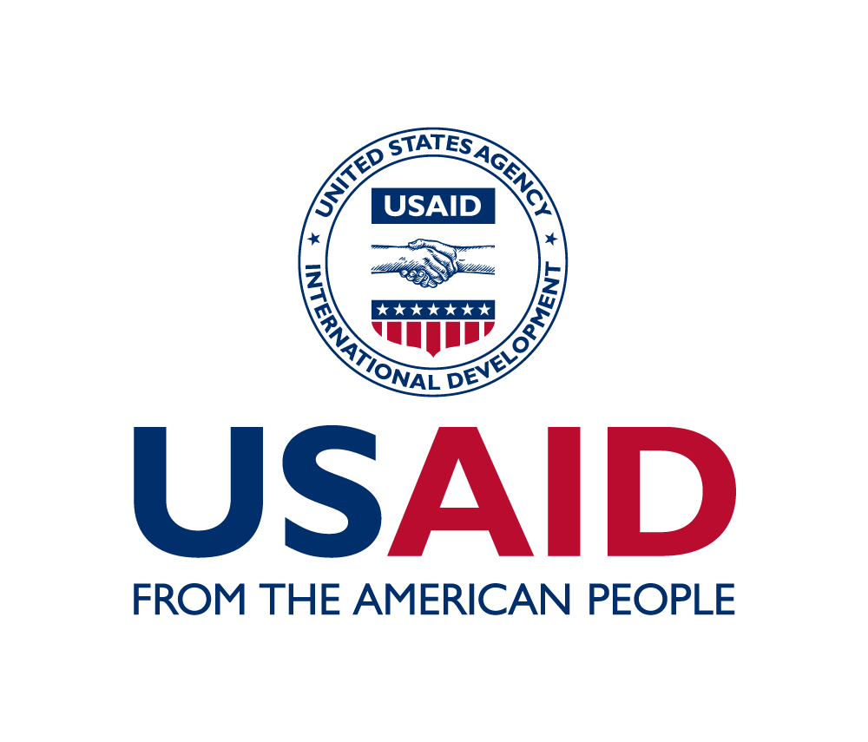
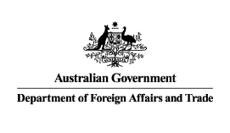

Bridge CRPD-SDGs Bangladesh Module 2
16 to 23 February 2023
Pan Pacific Sonargaon Dhaka Hotel
List of participants
Participants
- Mr Abdul Samad, Saidpur Protibondhi Unnon Sonstha
- Ms Anamika Pandey, Uttaran protibondhi Sangstha
- Mr Edrish Ali, Protibondhi Kallyan Somity
- Ms Esrat Jahan, Handicap International
- Ms Hosna Akter, Agradut Protibondhi Unnayan
- Mr Jalal Uddin Akber, SEID Trust
- Mr Md Abdullah Abdullah, Society of Deaf and Sign Language Users
- Mr Md Ahsan Ullah Sarker, Promoting Rights and Inclusion for Youth and All
- Mr Md Jahirul Islam, Team Inclusion Bangladesh
- Mr Md Rasel Rana, Uttaran protibondhi Sangstha
- Mr Md Shaidul Islam, Tangail Disabled Peoples Organization to Development
- Ms Morjina Ahmed, Disabled Welfare Society
- Mr Nahidul Kazi, Jagoran Protibandhi Unnayan Sanstha
- Mr Najmul Huda, Leprosy and Disabled Development Association
- Ms Niluka Gunawardena, The Spectrum, Union of Abilities
- Ms Nurajahan Rad, Right Action for Disability
- Ms Rokeya Begum, Seba Protibondhi Nari Parishad
- Ms Roushon Ara Chowdhury, Khulna Mohanogar Protibondi Unnion Prorisod,
- Ms Seema Sarker, Agrogami Disabled Development Association
- Ms Shilamoni, SEID Trust
- Ms Sultana Musfika, Down Syndrome Society of Bangladesh
- Ms Umma Hafsa Moni, Down Syndrome Society of Bangladesh
Facilitators
- Ms Amba Salelkar, IDA, India
- Ms Dorodi Sharma, IDA, India
- Ms Dulamsuren Jigjid, IDA DRG Fellow, Mongolia
- Mr Rejaul Karim Siddiquee, IDA, Bangladesh
- Ms Sarna Shah, CDD, Bangladesh
Observers
- Mr Abdur Rakib, ADD Bangladesh
- Ms Abhilsha Sharma, Sightsavers, UK
- Mr Ayon Debnath, Sightsavers, Bangladesh
- Mr Christopher Elliott, Sightsavers, UK
- Ms Daisy Akter, BRAC, Bangladesh
- Ms Farjana Reja, ILO, Bangladesh
- Ms Fatema Janeez, IFES, Bangladesh
- Ms Imam Shawni, IFES, Bangladesh
- Mr Jibon Gomes, FCDO, Bangladesh
- Mr Johannes Trimmel, Sightsavers, UK
- Ms Lisa Morris, Sightsavers, UK
- Ms Syeda Asma Rashida, Sightsavers, Bangladesh
- Mr Yuta Momose, ILO, Geneva
Support people
- Mr Alam Nunalam, Sound Technician, Bangladesh
- Mr Alfesany Rahnik, Personal Assistant, Bangladesh
- Mr Amaresh Gopalakrishnan, International Sign Language Interpréter, India
- Ms Arafat Sultana, Bengali Sign Language Interpréter, Bangladesh
- Mr Ariful Islam, Bengali Sign Language Interpréter, Bangladesh
- Ms Farjhana Musfika, Personal Assistant, Bangladesh
- Mr Imran Al Biozid, Captioner, Bangladesh
- Mr Iqram Al Biozid, Captioner, Bangladesh
- Ms Israt Jahan, Personal Assistant, Bangladesh
- Ms Khatun Mukta Afroja, Bengali Sign Language Interpreter, Bangladesh
- Mr Khandakar Mu Azhar Ali, Personal Assistant, Bangladesh
- Mr Md Abu Bakar, Personal Assistant, Bangladesh
- Mr Md Ruhil Amin, Braille Technician, Bangladesh
- Mr Md Sher Ali, Braille Technician, Bangladesh
- Mr Molla Motiur Rahman, Personal Assistant, Bangladesh
- Mr Muazzem Hosain Akter,Personal Assistant, Bangladesh
- Ms Ranu Kazi, Personal Assistant, Bangladesh
- Ms Riva Akter, Personal Assistant, Bangladesh
- Mr Saleh Noor, Language Interpréter, Bangladesh
- Mr Samuel Chew, International Sign Language Interpreter, Malaysia
- Ms Shirin Akter, Personal Assistant, Bangladesh
- Mr Molla Motiur Rahman, Personal Assistant, Bangladesh
- Mr Niloy Al Kahavee, Personal Assistant, Bangladesh
- Mr Shahnawaz Khan Chandan, Language Interpreter, Bangladesh
- Ms Sufia Begum, Personal Assistant, Bangladesh
- Mr Tajrin Majhar, Personal Assistant, Bangladesh
- Ms Zarina Khatun, Personal Assistant, Bangladesh

Logistics and Communication
- Ms Aleksandra Jovcic, Logistics Support, IDA, Serbia
- Ms Bishnu Sapkota, Reporting, IDA, Nepal
- Ms Marija Rankovic, Logistics Support, IDA, Serbia
- Ms Nitya Agrawal, Communication, IDA, India

