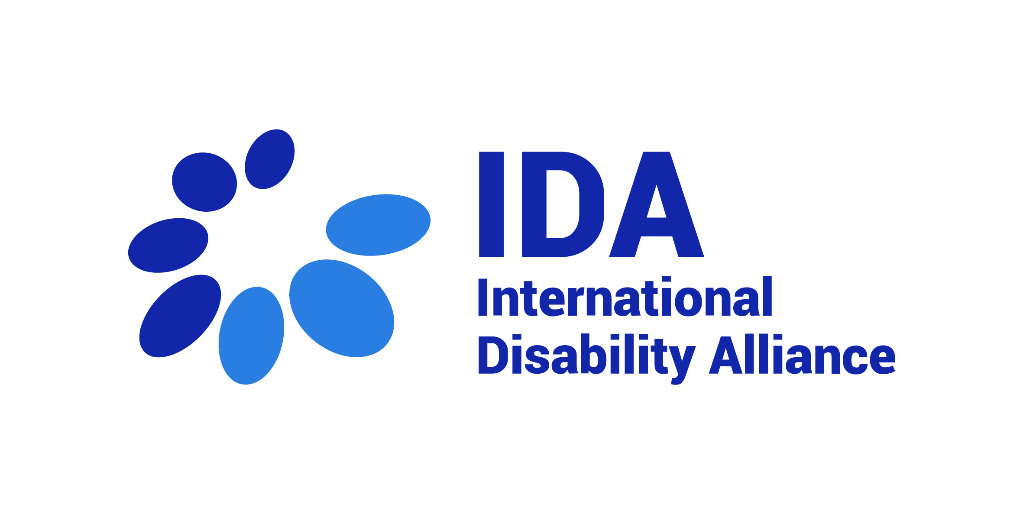

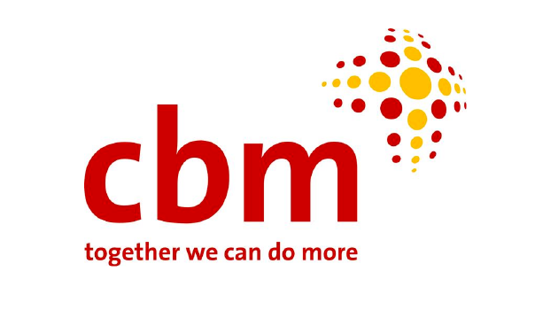
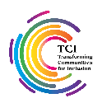
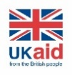
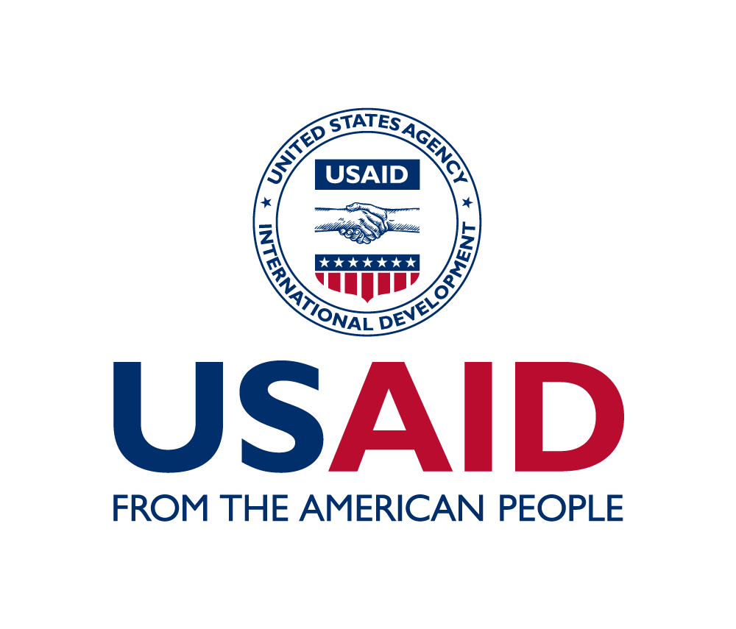
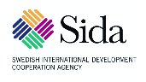

Bridge CRPD-SDGs Training of Trainers (ToT) Cycle A
From 12 to 19 March 2023
Geneva, Switzerland
List of participants
Participants
Africa
- Mr Adetunde Ademefun, Joint National Association of Persons with Disabilities (JONAPWD), Nigeria
- Ms Agnes Abukito, National Association of the Deafblind (NADBU), Uganda
- Mr Alexander Bankole Williams, Ghana Federation of Disability Organisations (GFD), Ghana
- Ms Christine Kirungi, Uganda National Association of Cerebral Palsy (UNAC) Uganda
- Mr Mark Kato, Uganda parents with Deafblind Children Association, Uganda
- Mr Moses Serwadda, International Federation of Hard of Hearing (IFHOH), Uganda
- Mr Umoru UsmanYahaya, Joint National Association of Persons with Disability (JONAPWD), Nigeria
- Mr Yatma Fall, West African Regional Portal on the Rights of People with Disabilities (FOAPH), Senegal
Asia
- Ms Krishnamaya Adhikari, Deafblind Association Jhapa, Nepal
- Ms Neeta Keshary, SHRUTI, Nepal
- Mr Rejaul Karim Siddiquee, IDA, Bangladesh
- Ms Sarna Shah, Centre for Disability in Development (CDD), Bangladesh

Latin America
- Ms Elisabeth Campos, Blind ladies Commission of Peru (CODIP), Peru
- Mr Juan Angel De Gouveia, RIADIS, Venezuela
- Mr Juan Cobenas, Inclusion International (II/DRG Fellow), Argentina
- Ms Maithy Capuma, Diaccon, Bolivia
- Mr Matias Ferreyra, Latin America Blind Union (ULAC), Argentina
- Mr Otto Amilcar Mazariegos, RIADIS, Guatemala
- Ms Patricia Rodriguez, National Network of Organizations of Persons with Disabilities of Colombia (REDESCOL), Colombia
Pacific
- Ms Faatino Utumapu, Nuanua O Le Alofa, Pacific Disability Forum (PDF), Fiji
- Mr Katabwena Tawaka, Pacific Disability Forum (PDF), Samoa

Facilitators
- Mr Alradi Abdalla, IDA, Sudan
- Ms Amba Salelkar, IDA, India
- Ms Bhargavi Davar, TCI, India
- Mr Imed Ouertani, IDA, Tunisia
- Mr Michael Njenga, CBM Global, Kenya
- Ms Rosario Galaraza, IDA, Peru
- Ms Tchaurea Fleury, IDA, Brazil
Resource people

- Ms Agnes Tilinac, IOM, France
- Mr Henry Murillo Salazar, RIADIS, Colombia
- Ms Janina Arsenjeva, IDA, Russia
- Mr Marc Workman, WBU, Canada
- Mr Ricardo Pla Cordero, UNHCR, Spain
- Ms Shitaye Astawes, African Disability Forum (ADF), Ethiopia
- Ms Victoria Austin, GDI Hub, UK

Observers
- Ms Alexis Buettgen, External Evaluator, Canada
- Ms Aurora Saares, Ministry of Foreign Affairs, Finland
- Ms Barbara Goedde, AT Scale, Switzerland
- Ms Catalina Devandas, DRF, Costa Rica
- Ms Ceridwen Johnson, AT Scale, Switzerland
- Mr Daryl Lloyd, FCDO, UK
- Ms Emmi Kemppainen, UNHCR, Finland
- Ms Ethiopia Abera, IOM, Ethiopia
- Ms Grema Mustapha, IOM, Nigeria
- Ms Harriet Knowles, FCDO, UK
- Ms Jennifer Kvernmo, IOM, US
- Mr Manon Caguard, IOM, France
- Ms Maryam Bandukda, GDI Hub, UK
- Mr Mika Mugogo, IOM, Zimbabwe
- Ms Munmun Flora, IOM, Bangladesh
- Mr Musab Raddad, IOM, Jordan
- Mr Solomon Kantha, IOM, Papuwa New Guinea
- Mr Terhas Clark, IOM, US
- Ms Victoria Nyawara, IOM, Kenya
- Ms Vivian Alt, IOM, Brazil
- Mr Yuta Momose, ILO, Japan
- Ms Victoria Lee, DRF
- Ms Wan S Sophonpanich, IOM, Thailand
Support people
- Ms Betty Nkrumah, Personal Assistant, Ghana
- Mr Bo Hatch, Remote Captioner
- Mr Carlos Edgardo Valdez, Personal Assistant, Argentina
- Ms Chedlia Ltaief Ep Ouertatani, Personal Assistant, Tunisia
- Mr Claudinei Nunes Da Silva, SP-EN Interpreter, Switzerland
- Mr Daniel Amilcar Mazariegos Mejia, Personal Assistant, Guatemala
- Mr Dinesh Shrestha, Guide Interpreter, Nepal
- Ms Dolores Belmonte, Personal Assistant, Argentina
- Mr Enny Giselky Corro Landaez, Sign Language Interpreter, Venezuela
- Ms Elena Dal Bo, Personal Assistant, Argentina
- Ms Elisa Hinojosa, Personal Assistant, Peru
- Ms Fatima Abdelsalam, Personal Assistant, Sudan
- Mr Fernando Barbosa, Sign Language Interpreter, Colombia
- Mr Gabriel Onyango, Guide Interpreter, Uganda
- Ms Henly Sofia Murillo Silva, Personal Assistant, Colombia
- Mr Jaime Del Castillo, Personal Assistant, Peru
- Ms Jalia Namiiro, Sign Language Interpreter, Uganda
- Ms Kabita Adhikari, Personal Assistant, Nepal
- Ms Kate Richardson, Remote Captioner
- Ms Pamela Valdes, SP-EN Interpreter, Switzerland
- Ms Santoshi Ghimire, Guide Interpreter, Nepal
- Ms Tigist Astawes, Personal Assistant, Ethiopia
Logistics, Communication and Reporting
- Ms Bishnu Sapkota,Reporter, IDA, Nepal
- Ms Gayatri Sekar, Methodology support, IDA, India
- Ms Marija Parojcic, Log support, IDA Serbia
- Ms Marija Rankovic, Log support, IDA, Serbia
- Ms Nitya Agrawal, Communication, India
- Ms Paula Hearn, Reporter, IDA, Canada

