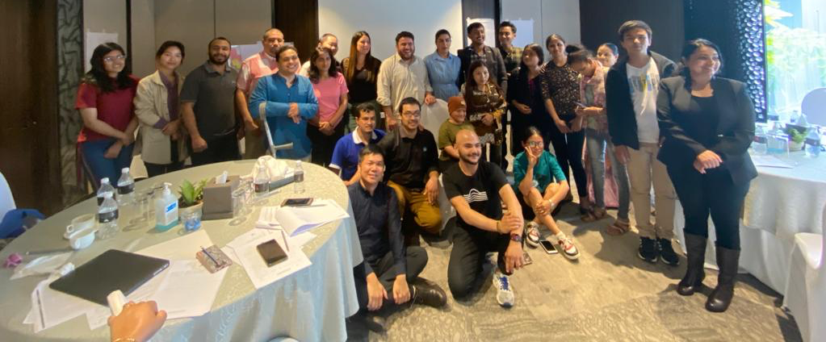
In brief

Designed and driven by youth:

Exciting Asian youth caucus meeting in Nepal!

The meeting

The Asian Youth with Disabilities Caucus Meeting at Kathmandu, Nepal, started off strong with participants reflecting on the outcome of the Youth Global Disability Summit and its Call for Action. 15 participants from cross-disability constituencies from Nepal, India, Bangladesh, Indonesia and Pakistan drawn from the IDA Youth Caucus and identified by local partners such as the National Federation of the Disabled Nepal (NFDN) and the National Indigenous Disabled Women’s Association (NIDWAN), a member of the Indigenous Peoples with Disabilities Global Network (IPWDGN), took an active part in the workshop. Along with facilitators from the IDA Youth team and IDA Youth Committee, experts on Article 11, Climate Change and Intersectionalities were also involved in the workshop. The workshop also had representation from the Indigenous and Dalit communities in Nepal.

Before the Asian meeting, we have had regional youth meetings in Kenya (December 2021 and March 2022), and in Bolivia (February 2022). Although this is a global youth caucus, IDA, its members and partners are building capacity at the local level, engaging with the most underrepresented youth. The meetings are designed and implemented in a participatory way, adapting to the contexts of the region, designed and driven by, with and for youth. The meetings drive home why youth is critical in the larger disability movement.

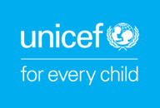
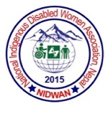
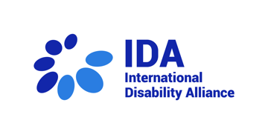
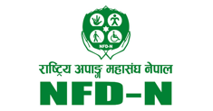
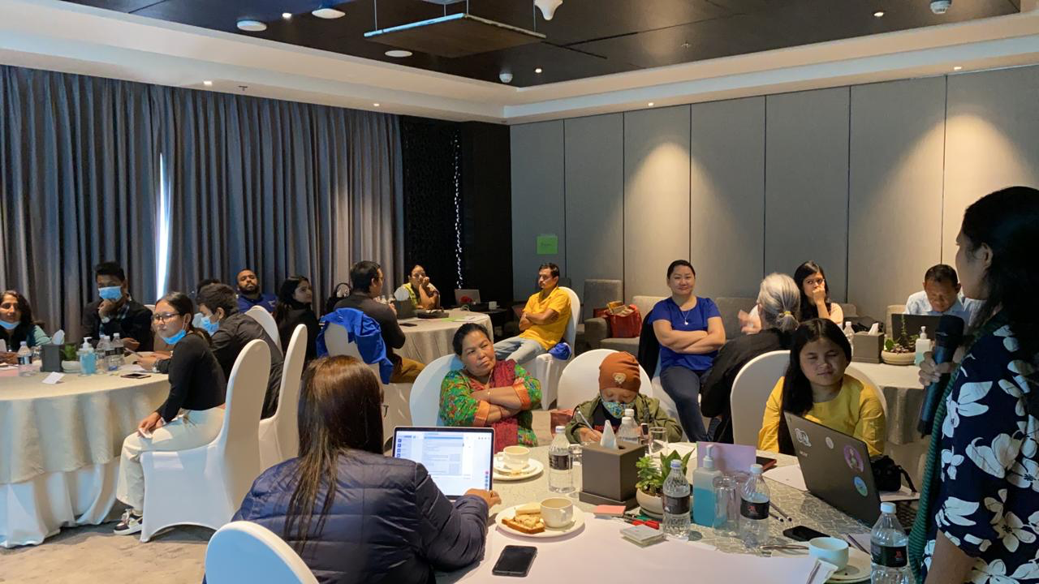
First day: 30 March 2022

The day started with a round of introductions and icebreakers. Participants agreed upon a set of inclusive ground rules collectively and to take on the role of cross-disability champions actively working to include all disability constituencies. Key expectations included:

- Networking with national and international youth advocates,
- Gaining an in-depth understanding of disability rights during humanitarian crises, and
- Learning about the youth movement in Nepal, particularly with a focus on LGBTIQ+ and indigenous youth.

The first substantive session covered the how, when and why of the UNCRPD. Facilitators presented the evolution of the CRPD and the critical role that disability activists and civil society played in creating the CRPD, including several IDA members. Participants reflected on how the narrative around persons with disabilities was as people always needing help, people who were ‘sick and in need of being fixing’, and then how the CRPD promoted the shift in that narrative. The CRPD, therefore, is a sacred document for persons with disabilities because it recognizes us as having inherent agency.

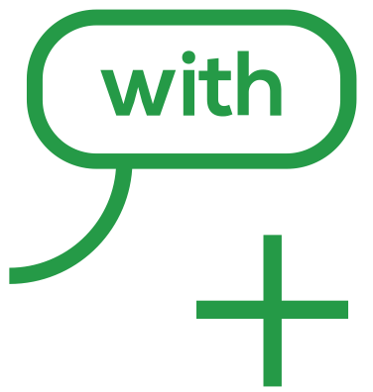

2
Intersectionalities

Participants discussed the intersections of their vary identities to answer the question of whether persons with disabilities are asking to have rights that are different from other people. A participant shared her experience about the intersections of being a woman, youth, indigenous and a person with a disability. A Deaf Dalit participant reflected on his right to be free of untouchability and to have access to sign language interpretation. Talking about the intersections of caste and disability in his life, he
shared that his caste location has made it hard to find sign language interpreters who are willing to work with him. Many times, they often refuse to work with him once they learn that he is Dalit - just as many people refuse to share water or food with him.

Participants agreed that all human rights for all persons with disabilities is the goal we should work towards. The facilitators then lead the discussions toward the state obligations for active and specific measures to put us on an equal footing with those around us.

Several times, I could not find sign language interpreters that wanted to work with me, sometimes even to access water or food was very difficult. People avoided me because I’m a Dalit youth with disabilities.
“
”

The CRPD

The structure of the Convention was introduced, as well as how CRPD does not establish new human rights. However, it does introduce evolving concepts like supported decision making, reasonable accommodation, accessibility and meaningful participation to exercise human rights on an equal basis with others. Participants reflected on the state obligations to include “all persons with disabilities”.
In Nepal, for instance, people with leprosy and albinism are not given disability cards. The group stressed the importance of creating spaces like this workshop where an inclusive exchange of ideas occurs in the interest of the larger disability rights movement.

3
Four corners
A constructive exchange of ideas and passionate debates were promoted around questions on inclusive education, right to play and leisure, cultural rights, and state responsibilities. The age criteria for defining youth was a key point raised. It was agreed that the law should adopt the broadest possible interpretation of the 'youth' concept.

Barriers to meaningful participation
Participants did a deep dive discussion on the barriers to meaningful participation, specifically concerning their rights to access to employment, education, recreation, and culture.

Youth Caucus

The final session of the day was dedicated to an overview of the timeline from IDA’s support to youth with disabilities from all over the world, the constitution of the Youth Caucus until the Youth GDS and the Call to Action, in 2022. Then, participants worked on action points of the GDS Youth Call to Action and linkages with key stakeholders, including on inclusive education, disaggregated data and awareness-raising as well as on how to use the GDS Youth Charter as an advocacy tool ahead of the next GDS 2025.

Second day: 31 March 2022

Agenda 2030
“
”

It was the first time that several youth participants heard about the SDGs and the Agenda 2030.
The first session of the second day was dedicated to the UN 2030 Agenda and its 17 Sustainable Goals, with a brief explanation of the links between Human Rights and Development, as well as between the CRPD and the SDGs.

4
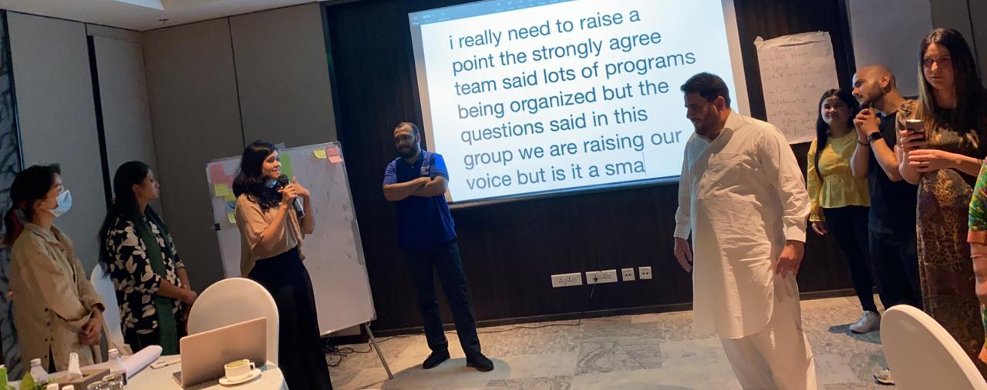
Participants, then, did an interactive group exercise working on practical connections between the articles of the CRPD and the SDG Goals. For most of the participants, it was the first time they were learning about the SDGs.

Art 11, COVID-19 Pandemic and the IASC Guidelines

The session was followed by a presentation about Article 11 of the CRPD on Situations of Risk and Humanitarian Emergencies as well as on the IASC guidelines, including the youth section. Participants were invited to a group activity on the different types of humanitarian emergencies and actions to be taken for better inclusion of youth with disabilities in these situations, including in armed conflicts, displacement, natural disasters and health emergencies.

Discussions were made on how access by persons with disabilities to fundamental human rights is impacted during humanitarian emergencies as well as on its impact to underrepresented groups, including people with psychosocial and intellectual disabilities, internally displaced people, and refugees during humanitarian emergencies, stressing the intersecting forms of discrimination.

Participants highlighted how women and girls with disabilities lack access to sanitary pads and accessible toilets; Deaf persons face an absence of sign language interpreters at the rescue shelters, indigenous peoples face a lack of access to information in their mother tongue and the barrier to information that was created during the COVID-19 pandemic.

5
Reflecting on the impact of COVID-19 pandemic on their lives, participants shared that domestic violence and early marriages had increased during the pandemic in Nepal. They also reflected on the patriarchal cultural attitudes faced by women with disabilities. An example was shared of how families often prioritised men when faced with a shortage of food during the COVID-19 pandemic.

The workshop then introduced participants to the concept of ‘peace continuum’ and how peace starts with the prevention of war. Facilitators pointed out that we, as people with disabilities, have conflict prevention skills and can be a valuable asset in peacebuilding. An animated video on COVID-19 and how it affects a woman's psychosocial disability was then played for the participants.

Climate change

Another key discussion was about how Nepal is in 12th position, out of the rest of the world's countries, at risk of global warming and how, when advocating for accessible public transportation, disability activists could use the climate change argument.

Participants then shared their own experiences living through the 2015 earthquake in Nepal. Once again, the women in the group spoke about the lack of access to menstrual products and privacy that they navigated. They reflected on how none of them was prepared to face an earthquake, despite living in an area prone to climate change disasters.

6
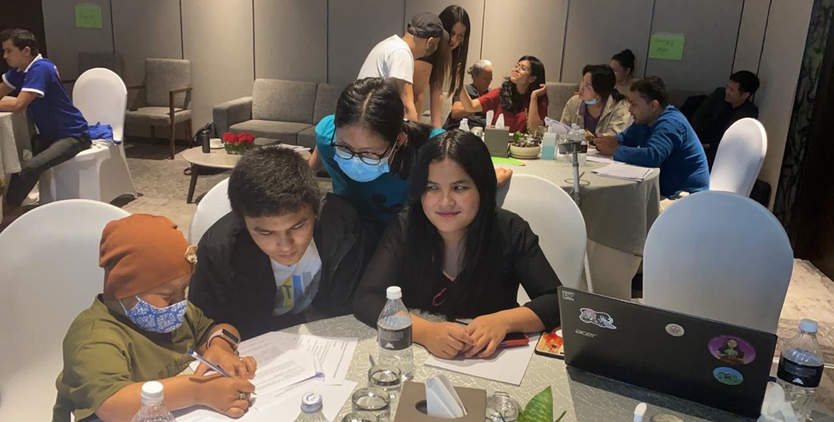

Facilitators stressed the importance of pre-disaster education and training and encouraged Nepali disability rights activists to participate in global climate change advocacy

Conclusions

Members of the Youth with Disabilities Asian Caucus shared their hopes for the future and highlighted how youth with disabilities are often neither visible nor included within the mainstream movement, both youth and disability movements. Thus, they made charts with specific, measurable, achievable, tangible solutions and strategic plans for the most significant barriers they face within the contexts of their country and disability constituencies.

For further information, contact gkoca@ida-secretariat.org.

End

