Citizen-generated data and persons with DISABILITIES
Case studies of data generated by organizations of persons with disabilities
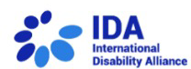
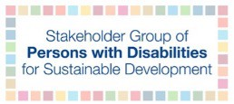
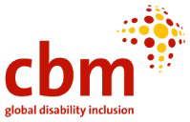
2023

About the author

Sara Rocha is a disability advocate with expertise in data management.

Acknowledgments
I would like to thank all the organizations and disability advocates who shared their research and initiatives on disability data to make this report possible, and to the Stakeholder Group of Persons with Disabilities, CBM Global Disability Inclusion and International Disability Alliance for making this report possible. A special thank you to Elizabeth Lockwood from CBM Global for the essential support and guidance on this project.
Table of Contents
Citizen-generated data 4
Case Studies 5-27
- ​Pacific Disability Dashboard 5
- ​Leave No One Behind Partnership 6
- ​Experience of Persons with Disabilities Adapting to the COVID-19 Global Pandemic 7
- ​Learning from COVID-19 through the experiences of blind and partially sighted persons 8
- ​COVID-19 Disability Rights Monitor 9
- ​Sexual and Reproductive Health Education and Rights Toolkit 10
- ​Profiling of Persons with Disabilities in Las Pinas City 11
- ​Autistic People's Priorities 12
- ​Restraint and Seclusion in England’s Schools 13
- ​European Human Rights Report 14
- ​The storytellers collection 15
- ​Barriers to Healthcare Access for Deaf Nigerian Women and Girls during Emergencies 16
- ​Women and Young People with Disabilities: A Needs Assessment 17
- ​Best Practices in the Employment of Persons with Intellectual Disabilities 18
- ​Listen Include Respect guidelines 19
- ​A Study on Identifying Barriers To Accessing Justice For Persons With Disabilities 20
- ​Gender-based violence and human rights violations experienced by women with disabilities 21
- ​Participation of Persons with Disabilities in 2022 General Elections 22
- ​Global Reports on the situation and rights of persons with deafblindness 23
- ​Experiences of sexuality and relationships of autistic women and non-binary people 24
- ​Independent Living Survey 25
- ​An independent guide on quality care for autistic people 26
- ​Disability Rights Promotion International 27
Mainstreaming disability data 28
Guides on citizen-generated data 29
Human rights-based approach to data 31
Conclusions 32

Citizen-generated data
Citizen-generated data refers to the data that individuals or their respective organizations produce to directly monitor, demand, or drive change on issues that profoundly impact them. This type of data is generated through various means, such as surveys, texts, phone calls, emails, reports, storytelling, and social media. It can take the form of quantitative or qualitative information, structured or unstructured, and can either be open or closed.
It is important to note that citizen-generated data is not intended to replace institutional data, but rather serves as a valuable complement to it (Refer to Datashift 2017 'Making use of citizen-generated data' for more information).
In recent times, numerous organizations representing persons with disabilities across the globe have embarked on projects aimed at collecting data on the experiences and priorities of individuals they advocate for. These efforts are meant to address significant gaps in information on the situation of persons with disabilities and insufficient data gathering from governmental organizations, which contributes to the invisibility of persons with disabilities and the difficulty in monitoring progress on their rights.
This report features noteworthy examples of projects and initiatives that have successfully gathered data on persons with disabilities and aims to empower advocates and other organizations of persons with disabilities to develop their own regional, national, or international projects to collect data for advocacy purposes.
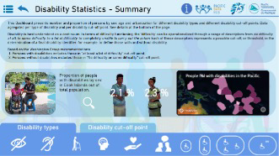
Case Study 1
Pacific Disability Dashboard
How many persons with disabilities are in the Pacific, and what is their employment situation?

Organization responsible: Pacific Disability Forum
Location: Pacific
Website: Pacific Disability Hub website
Goals: The Pacific Data Hub (PDH) is a centralized repository of data pertaining to the Pacific region, offering a single point of entry for all relevant data for this region. By providing easy access to population data, the PDH promotes enhanced coordination in data management, dissemination, and decision-making processes.
Methodology: The Pacific Data Hub obtains data from Population and Housing census, which employs the Washington Group Short Set on Functioning (with Tonga utilizing the Extended set in 2018) to ascertain the number and proportion of persons with disabilities based on sex, age, and urbanization (rural or urban). This includes different disability types and various levels of functional difficulty, encompassing individuals with one, two, three, or more disabilities. In terms of employment, the census presents data on the population within the labor force, employment statuses, youth unemployment rates, and proportions based on disability type and number. The Disability monographs provide information and census results specific to each country, covering aspects such as prevalence, education, work and employment, and key policy issues.
Key findings: The Disability Dashboard allows for country-specific key findings to be presented and consolidates census results in one centralized location. The Disability monographs offer accessible and in-depth information tailored to each country. For instance, the 2018 Samoa Disability Monograph reveals that only one in twenty individuals with disabilities are employed, while the 2018 Tonga monograph highlights that boys and girls with disabilities of secondary school age have considerably lower attendance rates (53% and 59%, respectively) compared to the overall population (79% and 85%, respectively).
Results: See the Pacific Disability Dashboard. Additionally, the Pacific Disability Forum has developed Disability monographs for Nauru and Kiribati in 2015, Tonga in 2016, Fiji in 2017, and Samoa in 2018. See Country specific disability monographs.
Case Study 2
Leave No One Behind partnership
How can data of marginalized groups be collected?

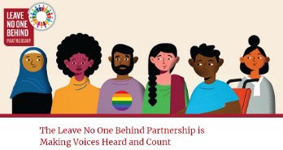
Organization responsible: Partnership with several organizations
Location: Bangladesh, Denmark, India, Kenya, Malawi, Nepal, and Vietnam
Website: Leave No One Behind Partnership website
Goals: The Leave No One Behind partnership intends to develop community-driven data for monitoring Sustainable Development Goals (SDG), with a specific focus on marginalized groups, such as persons with disabilities, older persons, youth, women and girls, ethnic minorities, transgender people, and others. The pilot project was conducted from 2018 until March 2019 in five countries: Bangladesh, India, Kenya, Nepal, and Vietnam.
Methodology: Across the five countries, a variety of community-driven monitoring tools were employed, including scorecards, key informant interviews, household surveys, focus groups, social audits, and regular surveys, to identify and collect data on marginalized groups. The interviews involved members of these groups, local service providers, and decision-makers. The community-driven data was utilized to delve deeper and complement the existing official national data produced by over 2000 representatives of marginalized communities.
Key findings: In-depth reports containing key findings for each country can be accessed on the partnership's official website. Nepal and India have created a Data tracking website, while Bangladesh has published a report concerning basic public services for marginalized groups. Additionally, Kenya has reported on the determination of drivers and the level of marginalization among persons with disabilities.
Results: Numerous reports, pilot results, and initial Data tracking websites are available on the platform. See LNOB resources or consult country specific information
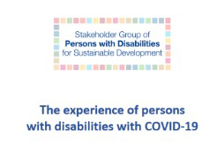
Case Study 3
Experience of Persons with Disabilities Adapting to the COVID-19 Global Pandemic
What was the impact of the COVID-19 pandemic on persons with disabilities?

Organization responsible: Stakeholder Group of Persons with Disabilities (SGPwD)
Location: Global
Website: Stakeholder Group of Persons with Disabilities page
Goals: The Stakeholder Group of Persons with Disabilities (SGPwD) conducted a study on the impacts of the COVID-19 pandemic on persons with disabilities. Led by researchers with disabilities, the study consisted of two phases. The first phase, carried out in 2020, involved engaging with disability movement leaders from various countries. The second phase, conducted in 2021, analyzed in more detail the experiences of persons with disabilities in Bangladesh, Bolivia, and Nigeria.
Methodology: The aim of the study was to identify and understand the additional challenges faced by persons with disabilities because of the pandemic. To achieve this, semi-structured interviews were conducted with disability movement leaders, followed by regional focus group webinars to collect empirical data and testimonials, and finally, gathered empirical data from organizations of persons with disabilities in three countries. The study examined seven key themes: living conditions, safety concerns, housing conditions, healthcare, social protection, employment, and COVID-19 disability data.
Key findings: The report highlights that persons with disabilities worldwide have been significantly impacted by the pandemic. The study identified several barriers that they faced, including limited access to COVID-19-related information, challenges in accessing social protection measures and employment opportunities, both formal and informal, accessibility barriers in the virtual working environment, and lack of disability inclusion in COVID-19 response efforts at all levels of government, leading to disconnections between national and local actions.
Results: Download the full report of the study on the first phase or see phase two Bangladesh, Bolivia, and Nigeria case studies. Additionally, the International Disability Alliance COVID-19 portal provides further resources, guidelines, and advocacy tools related to the pandemic.
Case Study 4
Learning from COVID-19 through the experiences of blind and partially sighted persons
What were the challenges faced by blind and partially sighted persons during the COVID-19 pandemic?
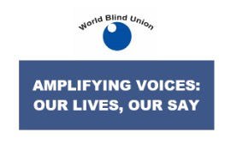
Organization responsible: World Blind Union
Location: Global
Website: World Blind Union website
Goals: The main objective of the survey was to map and analyze the experiences and challenges encountered by blind and partially sighted individuals across the globe amid the COVID-19 pandemic.
Methodology: The survey was conducted in April 2020 and was available in three languages - Spanish, French, and English. It aimed to gather valuable insights from blind and partially sighted individuals regarding the impact of COVID-19 on their daily lives. A total of 853 participants, from 75 different countries, responded to the survey. They were given the opportunity to select the three most significant challenges they were facing during the pandemic, either from a predetermined list or by providing their own inputs. The respondents also shared their personal testimonials on each of the identified challenges. Additionally, the survey explored resilience strategies adopted by persons with disabiliteis during the outbreak.
Key findings: The respondents highlighted Transportation and Mobility, Independence, Autonomy, and Dignity, and Mental Health and Wellbeing as the three most prevalent challenges faced during the COVID-19 pandemic. These key findings were augmented by quantitative data on the challenges, individual testimonials, and personal observations related to each of the identified topics. Together, they provide a comprehensive overview of the difficulties encountered by blind and partially sighted individuals throughout the course of the pandemic.
Results: See the full report titled "Learning from COVID-19 through the experiences of blind and partially sighted individuals across the globe".
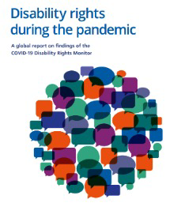
Case Study 5
COVID-19 Disability Rights Monitor
What are the difficulties and experiences by persons with disabilities during the COVID-19 pandemic?

Organizations responsible: The Validity Foundation, The European Network on Independent Living (ENIL), The International Disability Alliance (IDA), Disability Rights International (DRI), The Disability Rights Unit at the Centre for Human Rights, University of Pretoria, The International Disability and Development Consortium (IDDC).
Location: Global
Website: COVID-19 Disability Rights Monitor website
Goals: The objective of this study was to collect information on the experiences of persons with disabilities during the COVID-19 pandemic and subsequent lockdowns. This entails identifying the barriers and challenges encountered while accessing essential services and examining the emergency response of different states concerning persons with disabilities.
Methodology: An online survey was used to gather both quantitative and qualitative data from a diverse sample of 2152 respondents across 134 countries in the year 2020. The survey covered a wide range of variables, including the respondents' country of origin, type of disability, intersectionality factors such as gender and indigeneity, and the role of the respondent (e.g., person with disabilities, family member, governmental organization, etc.).
Key findings: The analysis of the collected data revealed significant themes, such as a pervasive sense of isolation experienced by persons with disabilities, concerns regarding discriminatory barriers in the access to health care services, the lack of accessible information, and evidence highlighting the increased risks faced by persons with disabilities who are institutionalized. The qualitative analysis allowed for an in-depth exploration of the diverse barriers and issues encountered across various countries.
Results: The outcomes of this study are presented through a user-friendly Dashboard, equipped with an interactive map and dedicated country pages. Read the PDF 2020 report titled "Disability Rights during the Pandemic: A global report on findings of the COVID-19 Disability Rights Monitor".
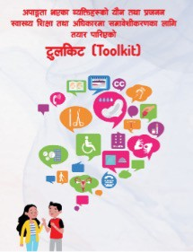
Case Study 6
Sexual and Reproductive Health Education and Rights Toolkit
What are the sexual and reproductive health rights of persons with disabilities and how to develop inclusive programs?

Organization responsible: Blind Youth Association Nepal
Location: Nepal
Website: Blind Youth Association Nepal website
Goals: The Blind Youth Association from Nepal has developed a comprehensive Toolkit aimed at promoting the inclusion of youth and adolescents with disabilities in sexual and reproductive health education and rights programs.
Methodology: The Toolkit serves as a practical guide, drawing from the organization's own experiences, extensive research, consultations with experts, and input from various other organizations of persons with disabilities to create good practices for disability-inclusive sexual and reproductive health education and rights programs and provide information on youth and adolescents rights in this area.
Key findings: The findings of this Toolkit highlight the importance of creating disability-inclusive programs and provide guidance on program development, ensuring accessibility in training and capacity building, and other key aspects of disability inclusion in sexual and reproductive health education and rights programs.
Results: See the PDF Sexual and Reproductive Health Education and Rights Toolkit.

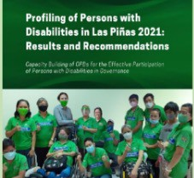
Case Study 7
Profiling of Persons with Disabilities in Las Pinas City
What are the profiles and situations of persons with disabilities?

Organization responsible: Las Pinas Persons with Disabilities Federation, Inc. (LPPWDFI)
Location: Philippines
Website: LPPWDFI Facebook
Goals: The Las Pinas Persons with Disabilities Federation, Inc., with the support of CBM Global Philippines, has successfully implemented a comprehensive data profiling project on persons with disabilities in Las Pinas City, involving the development, implementation, monitoring, and evaluation of the project.
Methodology: In order to collect data, it was used video recordings, an online survey, and community outreach efforts. The survey was adopted from the Department of Health's Philippine Registry on Persons with Disabilities, with additional enhancements made by LPPWDFI to capture vital information. Various channels were engaged to improve coverage, such as satellite registration, door-to-door visits, telephone interviews, online registration, and community activities with announcements made through megaphones.
Key findings: The study obtained disaggregated data on persons with disabilities, which includes their demographic information (age and address), disability type, education, health status, employment situation, among others. A total of 7221 persons with disabilities have been identified across all 20 villages in Las Pinas City. The success of this project has also led to increased engagement of 131 organizations of persons with disabilities (OPDs) and community volunteers, who are now actively participating in local councils and political spaces. The data generated through this initiative provides robust evidence for informed policy-making and program development at both the village and city levels.
Results: Download the report in Word titled 'Profiling of Persons with Disabilities in Las Pinas City 2021'. For a more detailed understanding of the methodology, see 'Disaggregated Data: Making sure that excluded peoples are included' in PDF.

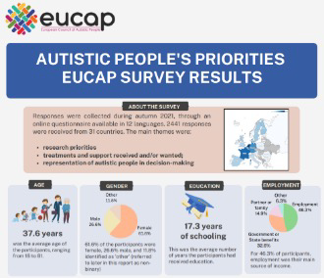
Case Study 8
Autistic people's priorities
What are the priorities and needs of autistic persons in research, policy and advocacy?

Organization responsible: European Council of Autistic People
Location: Europe
Website: European Council of Autistic People website
Goals: This survey aimed to gather the perspectives of autistic persons across Europe on three key topics: research priorities and desired areas of study, the various available and needed types of support, therapy, and the desired representation and involvement of autistic individuals in decision-making processes.
Methodology: The survey was conducted online in 2021 and was available in 12 different languages. A total of 2441 responses were collected from 31 countries. The questionnaire was developed by a team of autistic persons with a research background.
Key findings: The survey highlighted that the most sought-after services by autistic individuals were those related to mental health treatment and support. Research on service systems aimed at assisting autistic persons was generally perceived as having more benefits than risks, whereas attempts to prevent the birth of autistic individuals were viewed as carrying higher risks than benefits. Professional assistance for mental health issues was identified as the most received or desired service (81.9%), while support for navigating and accessing services was frequently desired but not obtained (52.5%). Autistic individuals expressed a preference for advocacy representation predominantly led by fellow autistic persons. The main results have been compiled into a factsheet, which contains the findings, recommendations, and key priorities.
Results: See more information on the Autistic people's project or see the Factsheet on Autistic People's priorities. EUCAP used similar methodology to also explore the experiences of violence against autistic persons and access to reporting and support services. The survey results have been disseminated through platforms such as the European Women's Lobby, the European Disability Forum, EUCAP members, and policymakers.

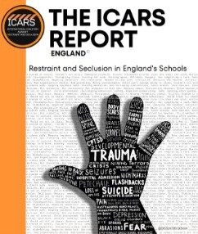
Case Study 9
Restraint and Seclusion in England’s Schools
How common is the practices of restraint and seclusion against children with disabilities, in schools?

Organization responsible: International Coalition Against Restraint and Seclusion (ICARS)
Location: England
Website: ICARS website
Goals: The ICARS Report on England comprehensively documents the experiences of children with disabilities in England who have been subjected to practices of restraint and seclusion within their school environments.
Methodology: The report uses both quantitative and qualitative data collected over the course of one year (December 2020 to 2021). This data was collected from 560 children and their families across various regions in England. To improve the survey data, the report also incorporates information from public records, media reports, and academic sources. It provides insightful comparisons across different disabilities, gender identities (including transgender and non-binary individuals), and age demographics. While the report does not specifically disaggregate data for Black, Asian, and other racial and ethnic populations, it thoroughly examines scholarly research to highlight any existing disparities.
Key findings: The report presents a worrying trend of physical restraint and seclusion practices in schools, with nearly half of the surveyed children experiencing physical injuries, and a staggering 90% reporting psychological injuries. Notably, restraint is frequently employed as an intervention for mild behavioral issues related to sensory dysregulation and insufficient support systems. Furthermore, the report uncovers that autistic children are disproportionately affected by these practices.
Results: See the ICARS Report or a report with personal testimonies from survivors and their families. The ICARS website includes a call to action, urging individuals to engage with policymakers, as well as an opportunity to share relevant information with the Department of Education.
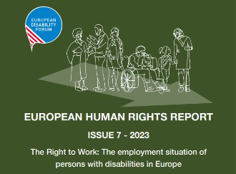
Case Study 10
European Human Rights Report
What are the barriers to employment in the European Union?

Organization responsible: European Disability Forum (EDF)
Location: Europe
Website: European Disability Forum website
Goals: The Seventh Edition of the European Disability Forum's Human Rights Report, published in 2023, focuses on the right to work of persons with disabilities, and examines the barriers to employment that individuals with disabilities face within the European Union and EU Member States. The report includes testimonies and maps existing policies aimed at promoting the employment of individuals with disabilities in the EU. It also investigates the disability pay gap, reasonable accommodations, and the disparities faced by women with disabilities.
Methodology: The data for this report was collected from sources such as DOTCOM: The Disability Online Tool of the Commission, Eurostat Disability statistics, and other relevant sources, to create a comprehensive mapping of the variations in policies and employment data among EU Member States, providing a comparative analysis. The report also incorporates first-hand testimonies from persons with disabilities to provide additional context and insight.
Key findings: The results highlight the significant disparity in employment rates between persons with and without disabilities, as well as the notable disability pay gap prevalent across Europe. While it is encouraging to note that almost all EU Member States offer support for reasonable accommodations, the provision of such accommodations remains a prominent barrier in accessing employment. The report extensively explores the barriers, testimonies, and challenges experienced by individuals with disabilities across different countries. Additionally, it offers valuable recommendations to policy-makers aimed at fostering inclusive employment practices.
Results: See the different formats available to download of the 2023 EDF Human Rights Report page, including Easy-Read. The European Disability Forum has also developed reports on various other topics in previous years, including the political participation of individuals with disabilities in 2022 and the Impact of COVID-19 in 2021. See previous EDF reports.
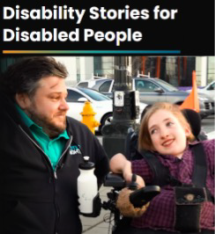
Case Study 11
The Storytellers featured collections
How to capture the experiences of persons with disabilities on video for advocacy?

Organization responsible: Rooted in Rights
Location: United States of America
Website: Rooted in rights website
Goals: Rooted in Rights has developed storytelling project aimed at sharing the stories of persons with disabilities. This initiative includes a curated collection of video projects, collaborations, and other initiatives featuring storytellers with disabilities. who share their own narratives, either by self-producing advocacy videos using mobile phones or by contributing to podcast episodes.
Methodology: To empower individuals with disabilities, Rooted in Rights offers workshops that equip them with the skills to script, film, and edit their own self-advocacy stories using mobile phones. This approach not only enables the creation of high-quality video content but also generates valuable qualitative data on the personal experiences of participants. The Storytellers collection serves as a platform for disability advocates to convey their stories through engaging videos, self-produced advocacy content, or podcasts.
Key findings: A crucial outcome of teaching advocates how to produce their own advocacy videos is the accessibility and affordability it brings to the sharing of personal stories, barriers, difficulties, and experiences faced by individuals with disabilities. This approach has resulted in an extensive collection of videos, podcasts, and articles that provide personal insights and experiences.
Results: See the Storytellers Collection, which includes the Mental Voices Africa, showcasing the stories of individuals with mental health disabilities in Africa, and Parenting without Pity with videos that explore the experiences of parents with disabilities. These collections not only offer glimpses into personal experiences but also serve as powerful advocacy tools. It is also available a range of best practices guides on accessible media, providing further resources for individuals seeking valuable insights in this field.

Case Study 12

Barriers to Healthcare Access for Deaf Nigerian Women and Girls during Emergencies
How to capture the experiences of persons with disabilities in video, and use it for advocacy?

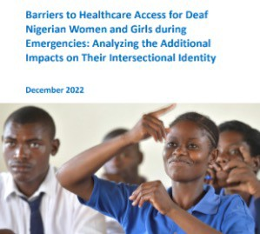
Organization responsible: World Federation of the Deaf
Location: Nigeria
Website: World Federation of the Deaf website
Goals: This report presents preliminary research on the health care experiences of deaf women and girls in Nigeria, specifically focusing on the recent emergency and disaster situation related to the COVID-19 pandemic. The report aims to provide recommendations to address the inequities at the intersection of gender, disability, and linguistic minorities.
Methodology: The research consists of a combination of quantitative and qualitative data collected from deaf women and girls in Nigeria during emergency situations. A survey was conducted with the assistance of the Nigerian National Association of the Deaf (NNAD), and in- depth interviews were carried out with women with disabilities in 2021.
Key findings: The study reveals several challenges faced by deaf women and girls when it comes to accessing healthcare during emergencies. These challenges include limited accessible forms of communication channels between the state local government and the deaf community, the absence of sign language interpreters, inadequate accessibility of public health service announcements and health campaigns. Furthermore, the research highlights disparities in healthcare quality, reproductive health, and available resources for deaf women and girls.
Results: See the "Barriers to Healthcare Access for Deaf Nigerian Women and Girls during Emergencies: Analyzing the Additional Impacts on Their Intersectional Identity" report. The report includes personal experiences shared by the participants as well as policy recommendations.
Additionally, the World Federation of the Deaf (WFD) has also developed a report on Baseline Data Collection on Deaf Education in Nepal.

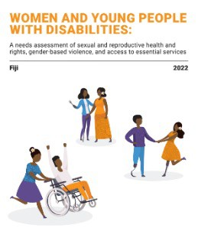
Case Study 13

Women and young people with Disabilities: A Needs Assessment

What are the needs of women and young people with disabilities on sexual and reproductive health and rights, gender-based violence, and access to essential services?

Organization responsible: Women Enabled International, UNFPA, AustraliaAid, Pacific Disability Forum
Location: Fiji
Website: Women Enabled International website
Goals: In 2020, UNFPA, AustraliaAid, Women Enabled International, and the Pacific Disability Forum, developed a research initiative in Fiji to evaluate the sexual and reproductive health and rights (SRHR) as well as the gender-based violence (GBV) needs of women and young people.
Methodology: The research methodology encompassed interviews with organizations of persons with disabilities (OPDs), organizations providing sexual and reproductive health (SRH) and GBV services, and UN agencies operating in the country. Additionally, focus groups were conducted with women and young persons with disabilities in Fiji. Local policies were also examined to discern priority needs and formulate recommendations.
Key findings: The research determined that formal and informal deprivations of legal capacity are still permitted, and that cases of sexual and gender-based violence involving women with disabilities are rarely processed through the formal justice system. Harmful stereotypes and stigma were identified as major barriers, limiting access to services and discouraging discussions on sexual and reproductive health and gender-based violence. Negligence and stigma within the health care and gender-based violence sectors were found to impact the quality of services provided. Furthermore, geographic barriers, lack of accessible information and inadequate sign language interpretation were identified as preventing women and young persons with disabilities from accessing necessary SRH and GBV service providers.
Results: See a comprehensive understanding of the research findings, the full report and an executive summary titled 'Women and Young People with Disabilities: A Needs Assessment for Sexual and Reproductive Health and Rights, Gender-Based Violence, and Access to Essential Services - Fiji'.

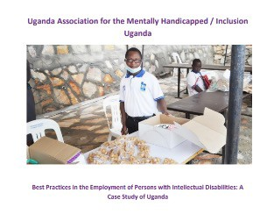
Case Study 14

Best Practices in the Employment of Persons with Intellectual Disabilities

What are the best practices in the employment of persons with intellectual disabilities?
Organization responsible: Down Syndrome International and Inclusion Uganda
Location: Uganda
Website: Inclusion Uganda website and Down Syndrome International website
Goals: Inclusion Uganda and Down Syndrome International examined the barriers faced by individuals with intellectual disabilities in accessing employment in Uganda and develops best practices for the employment of persons with intellectual disabilities.
Methodology: The methodology employed qualitative methods of data collection, focusing on three main target groups: employers from both the formal and informal sectors, individuals with intellectual disabilities, and their parents or guardians. The study included interviews and focus group discussions with a total of 80 participants. These participants consisted of 25 employers, 25 individuals with intellectual disabilities, and 30 parents or guardians.
Key Findings: The report highlight several major barriers to inclusive employment of persons with intellectual disabilities, which include a lack of access to education, leading to lower levels of educational attainments, social stigma, safety concerns, and discrimination.
Results: See the full report titled "Best Practices in the Employment of Persons with Intellectual Disabilities: A Case Study of Uganda", undertaken as part of a project dedicated to supporting meaningful participation and self-advocacy of individuals with disabilities in the realm of employment.
Case Study 15
Listen Include Respect guidelines
How to include persons wtih intellectual disabilities in the disability movement?

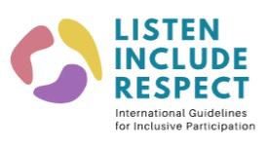
Organization responsible: Inclusion International and Down Syndrome International
Location: Global
Website: Inclusion International website and Down Syndrome International website
Goals: The Listen Include Respect guidelines are resources for organizations seeking to ensure the inclusion of individuals with intellectual disabilities in their advocacy efforts. These guidelines were collaboratively developed with the assistance of over 1500 individuals with intellectual disabilities and their families representing almost 100 countries.
Methodology: These guidelines were collaboratively developed with the assistance of over 1,500 individuals with intellectual disabilities and their families representing almost 100 countries. The guidelines were created through the collection of personal stories through a global survey conducted in 10 languages, both online and in Easy Read format, and 60 consultation meetings with self-advocates and experts to gain insights into their experiences. Throughout the development process, a reference group composed of individuals with intellectual disabilities, their families, and other experts ensured that the guidelines were continuously reviewed and refined at every stage. Moreover, the guidelines were rigorously tested through 7 projects, both internally and with external organizations, to ensure their efficacy and applicability.
Key findings: The guidelines effectively address various aspects of inclusive practices, such as organizing inclusive meetings, engaging and consulting individuals with intellectual disabilities, and communicating in an accessible manner. These findings consolidate the importance of the guidelines in promoting the inclusion of individuals with intellectual disabilities within the disability movement.
Results: See a complete and comprehensive overview of the 'Listen Include Respect guidelines'.
Case Study 16
A Study on Identifying Barriers To Accessing Justice For Persons With Disabilities
What are the barriers and gaps to access to justice for persons with disabilities?

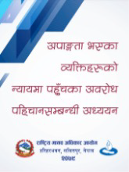
Organizations responsible: National Federation of the Disabled Nepal and National Human Right Commission
Location: Nepal
Website: National Federation of the Disabled Nepal website
Goals: The primary objectives of the study were to identify and describe the barriers to accessing formal justice for persons with various disabilities and analyze the accessibility of district courts, district police offices, and local levels in all provinces of Nepal.
Methodology: This study collected and analyzed both qualitative and quantitative data to identify the obstacles faced by women, men, children, and girls with all types of disabilities in accessing formal justice across all provinces of Nepal. Qualitative data was obtained through focus group discussions, key informant interviews, and interviews with persons with disabilities of all genders and age groups, as well as government officials, policymakers, law enforcement agencies, community police, and representatives of civil society organizations. This approach was guided by the principle of "Leaving No One Behind" and ensuring equal access to justice. Quantitative data was gathered from various sources, including police records, government attorney offices, courts, and non-governmental organizations.
Key findings: Persons with disabilities face discrimination and exclusion within their own families, and they experience several forms of violence, such as social stigma, sexual assault, and domestic violence, due to their disabilities. Moreover, they are deprived of the services, facilities, and legal access provided by the state, and encounter challenges due to inaccessible infrastructure and the lack of disability-friendly services provided by government offices.
Results: See the 2023 report on identifying barriers and gaps in accessing justice for persons with disabilities was published in both English and Nepali.
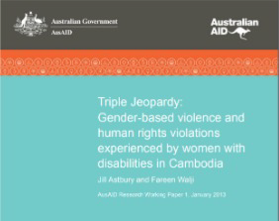
Case Study 17
Gender-based violence and human rights violations against women with disabilities
What are the gender-based violence and human rights violations being committed against women with disabilities?
Organization responsible: Cambodian Disabled People’s Organization (CDPO), CBM Australia, the International Women’s Development Agency (IWDA) and Monash University
Location: Cambodia
Website: Cambodian Disabled People’s Organization website
Goals: This research project aimed to investigate the prevalence and experiences of gender-based violence among women with disabilities in comparison to women without disabilities. Additionally, it sought to assess the inclusion of women with disabilities in existing policies and programs and examine the support or denial of access to these programs.
Methodology: A total of 354 women, consisting of 177 women with disabilities and 177 women without disabilities, from both urban and rural areas in Cambodia were included in the study. In-depth interviews were conducted with 30 women with disabilities who had reported experiencing violence. Furthermore, 8 focus groups, each consisting of approximately 10 women with disabilities, were organized. Fifteen key informants' interviews were also conducted, involving various organizations such as organizations of persons with disabilities, national and international nongovernmental organizations, United Nations organizations, donors, and local and national Cambodian Government.
Key findings: The study revealed that women with disabilities in Cambodia face a higher incidence of controlling behaviors from their partners and experience significantly higher levels of all forms of violence from their family members compared to women without disabilities. Additionally, women with disabilities reported higher levels of psychological distress, regardless of their exposure to violence. The barriers to disclosure and access to services are exacerbated by the limited financial autonomy and power that many women with disabilities have in their lives.
Results: For further information, see the full report and policy brief titled 'Triple Jeopardy: Gender- based violence and human rights violations experienced by women with disabilities in Cambodia'.
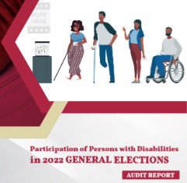
Case Study 18
Participation of Persons with Disabilities in 2022 General Elections
How are persons with disabilities participating politically, as voters and candidates?
Organization responsible: United Disabled Persons of Kenya
Location: Kenya
Website: United Disabled Persons of Kenya website
Goals: The study conduct an extensive audit on the inclusion of voters and candidates with disabilities in the 2022 election, and seeks to identify, assess, and reflect upon the progress, gaps, and lessons learned regarding the extent and nature of inclusion, participation, and representation of persons with disabilities. Furthermore, it aims to establish and evaluate the level of participation of persons with disabilities in the 2022 general election, as well as the progress made in their inclusion, participation, and representation in political and governance bodies such as political parties, national and county legislatures.
Methodology: This audit has relied on data provided by Electoral Management Bodies, election monitoring and observation missions, as well as the electoral work conducted by Organizations of Persons with Disabilities. Additionally, internet searches of reputable newspaper articles and other relevant sources have been carried out to gather further information.
Key findings: The study reveals that although the language of disability-inclusion is now widely used in the policy frameworks of all electoral stakeholders, the actual implementation of these practices remains insufficient, and not effectively translated into concrete actions. The barriers that prevent the full participation of persons with disabilities in elections include attitudinal, communication, environmental, and institutional factors. The report proposes various measures and strategies to ensure the comprehensive inclusion, meaningful participation, and proper representation of persons with disabilities in future election cycles.
Results: See the audit report titled "Participation of Persons with Disabilities in the 2022 General Elections - Audit Report". In the political participation topic, UDPK also developed the "Guidelines for Disability Inclusive Public Participation", and the "Amplifying Voices of Women with Disabilities" project, to further investigate the specific needs and barriers of women with disabilities for their effective participation in decision-making processes.

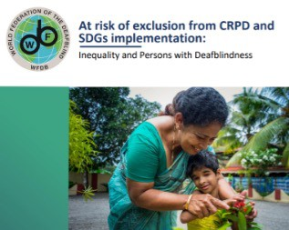
Case Study 19
Global Reports on the situation and rights of persons with deafblindness
What is the situation and rights of persons with deafblindness at the global level?

Organization responsible: World Federation of the Deafblind (WFDB)
Location: Global
Website: World Federation of the Deafblind website
Goals: The primary objective of this report is to build upon the findings and recommendations of the initial global report, by consolidating evidence from diverse regions on persons with deafblindness, as well as professionals in the field, and serving as both an identification tool for the needs of persons with deafblindness and as an advocacy instrument to promote their rights.
Methodology: The data collection process in this study encompasses a review of academic literature, two surveys conducted among members and partners of WFDB and Sense International, and the inclusion of relevant case studies. A quantitative analysis was undertaken, utilizing census and other large-scale survey data. This analysis stands as the most extensive and internationally representative examination of the deafblindness situation to date, encompassing a total of 97.6 million individuals from 22 countries.
Key findings: The study estimates that the population with deafblindness comprises approximately 2% of the global population. Persons with deafblindness are face a tenfold decrease in employment rates compared to persons without disabilities, and they are 30% less likely to be employed compared to persons with other types of disabilities. When it comes to education, children with deafblindness are faced with even greater obstacles, being 17 times less likely to be enrolled in school compared to children without disabilities, and twice as likely to be out of school compared to children with other types of disabilities. It is worth noting that households that include persons with deafblindness are more likely to fall within the bottom 40% of socio-economic status, in comparison to households without disabilities or those with other disabilities. Lastly, between 20% and 75% of persons with deafblindness are found to have additional disabilities.
Results: For further information and consultation regarding the 2nd Global Reports on the situation and rights of persons with deafblindness.
23

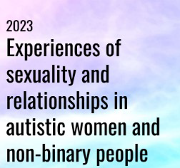
Case Study 20
Experiences of sexuality and relationships of autistic women and non-binary people
What are the experiences with sexuality and relationships of autistic women and non-binary people?

Organization responsible: Associação Portuguesa Voz do Autista (Association of Autistic Voices)
Location: Portugal
Website: Associação Portuguesa Voz do Autista website
Goals: The primary objective of this project was to gain insights into the experiences of autistic women and non-binary individuals regarding sexuality, relationships, sexual education, and exposure to violence within this specific context.
Methodology: An online survey was administered, with a total of 160 autistic women and non-binary individuals from various countries participating. The survey encompassed both quantitative and qualitative questions, delving into their personal experiences, barriers faced, and specific needs relating to sexual education, gender-based violence, support services, and other relevant topics, thereby exploring the unique requirements of this demographic.
Key findings: Around 91% of the respondents expressed a lack of sufficient sexual education, highlighting a pressing need for further instruction on matters such as consent, boundaries, and the social dynamics surrounding relationships. Additionally, approximately 81% of the participants had been or were currently in an abusive relationship, while 75% reported experiencing sexual abuse, with only one person reporting never experiencing a negative sexual encounter. The report also presents recommendations for subsequent research endeavors and policymakers seeking to address these issues.
Results: See the report on "Experiences of Sexuality and Relationships in Autistic Women and Non- Binary Individuals". This report is being utilized as an advocacy tool to promote enhanced research into the sexual experiences of autistic women and non-binary individuals, as well as to advocate for improved sexual education initiatives.

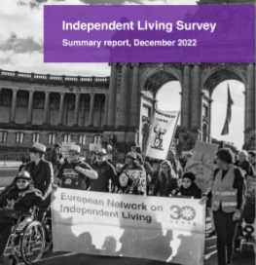
Case Study 21
Independent Living Survey
How is the access to Independent Living and personal assistance schemes in Europe?

Organization responsible: European Network of Independent Living
Location: Europe
Website: European Network of Independent Living website
Goals: The objective of this 2022 survey was to gather comprehensive information regarding access to Independent Living for persons with disabilities across Europe, as well as to obtain in-depth insights into the various Personal Assistance schemes and systems.
Methodology: A meticulously designed online survey consisting of a total of 97 questions was utilized to explore both the general aspects of Independent Living and specific details concerning the Personal Assistance (PA) scheme/policy. These questions encompassed various areas, including funding, eligibility and needs assessment, provision, and recruitment and working conditions of PAs. We received a total of 143 responses, predominantly from individuals with disabilities and their affiliated organizations.
Key findings: The survey reveals a notable increase in the number of countries that have adopted publicly funded personal assistance schemes, and an increase in the number of recipients benefiting from these schemes. However, respondents from 33 countries reported significant shortcomings and expressed dissatisfaction with their countries' personal assistance programs, underscoring the urgent need for improvement. Notably, a significant majority of countries (85% of 29 countries) restrict the number of assistance hours per user, thereby depriving users who require round-the-clock support of the necessary assistance and potentially leading to institutionalization.
Results: You can consult the PDF summary report of the Independent Living Survey, as well as a Independent Living map with an overview of survey responses. Furthermore, ENIL also has established a dedicated Task Force comprising representatives from Organizations of Persons with Disabilities to create a proposal for the European Commission Guidance on Independent Living.

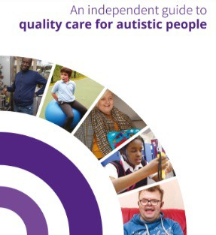
Case Study 22
Independent guide to quality care for autistic people
How can we improve care for autistic people?

Organization responsible: National Autistic Taskforce (NAT)
Location: United Kingdom
Website: National Autistic Taskforce website
Goals: In April 2019, the National Autistic Taskforce (NAT) published 'An Independent Guide to Quality Care for Autistic People', authored exclusively by autistic individuals. The guide offers invaluable insights into what constitutes high-quality care and support for individuals across the autistic spectrum, regardless of age.
Methodology: The guide is the result of the extensive collective knowledge and firsthand experiences of autistic authors who are well-versed in social care provision for autistic individuals. Its purpose is to provide guidance applicable to the entire autism spectrum, encompassing both children and adults.
Key findings: Primarily intended for Care Providers, Care Commissioners, and Inspectorates, this guide serves as a vital resource for those working within the care industry. The guide covers a wide range of care settings, including conventional housing options, homelessness, shared living arrangements, supported living, residential care environments, and institutional settings, this comprehensive guide leaves no area unaddressed.
Results: See the PDF Independent guide to quality care for autistic people guide. Additionally, the National Autistic Taskforce has also published two other reports: 'Quick Guide: Legal Literacy' and 'Support Decision-making in social care services for autistic people'.

Case Study 23
Monitoring System to Address Disability Discrimination Globally
What is the global progress on disability rights?

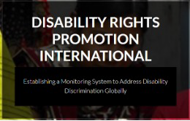
Organization responsible: Disability Rights Promotion International
Location: Global
Website: Disability Rights Promotion International website
Goals: Disability Rights Promotion International (DRPI) is a collaborative project aimed at establishing a comprehensive and sustainable international system to monitor the human rights of persons with disabilities. Although it was not created by an organization of persons with disabilities, DRPI actively monitors the progress of disability rights on a global scale and persons with disabilities were involved in their development. In addition, it provides valuable resources and training to enhance organizations' knowledge of data collection and management.
Methodology: DRPI employs an approach that encompasses various aspects such as systems, personal experiences, and media to evaluate the advancement of disability rights in each country. By using this approach, DRPI has developed a comprehensive report that includes recommendations on data indicators required for effective advocacy. The People's Indicators report, based on qualitative data gathered from persons with disabilities, takes into account the concept of intersectionality and transforms it into data indicators that reflect their specific needs as outlined in the UNCRPD article.
Key findings: DRPI developed a methodology that utilizes the gathered data on disability rights to evaluate progress and establish new indicators for monitoring human rights. Detailed findings for each country can be found in the published reports.
Results: See the People's Indicators report or explore a training platform for learning about disability data gathering and downloadable templates for methodology.

Mainstreaming disability data
Although citizen and OPD-generated data were the primary focus in the examples provided, it is crucial to incorporate disability in mainstreaming initiatives undertaken by organizations advocating for other causes. The projects and initiatives below, despite not being specifically developed for disabilities, actively include disability as part of their advocacy efforts.
One notable initiative is the Girls' Education South Sudan (GESS) program in South Sudan, which aims to enhance girls' educational attainment, increase school enrollment, eliminate barriers to education, and promote equal access for all children. The program also collects data on school absenteeism, with a recent focus on children with disabilities. See more information on disability in the GESS program.
The Disabled & Deaf Trans People's Survey, developed by the Transgender Law Center in the United States, aims to gather the experiences of disabled and deaf transgender individuals in relation to discrimination, gender expression, their connection to the LGBTQIA+ , especially trans, and disability communities, and their experiences during the ongoing COVID-19 pandemic.
Black Lives Music published the "Unseen, Unheard" report in collaboration with Attitude is everything in the United Kingdom. This report sheds light on the experiences of black persons with disabilities working in the music industry.
The Indigenous Navigator offers a range of tools and resources to empower indigenous communities in monitoring their rights, which collects information on whether schools have adapted their infrastructure and materials to accommodate students with disabilities, the percentage of the population covered by social protection, and whether the country has implemented special measures to promote and protect the rights of indigenous individuals with disabilities. See the Indigenous Navigator website.
The Humanity & Inclusion organization, dedicated to assisting conflict victims, provides valuable insights into inclusive humanitarian responses. See their toolkits and data tools to gather information on persons with disabilities in situations of conflict and humanitarian action.
Additionally, the Inter-Agency Standing Committee Task Team on Inclusion of Persons with Disabilities in Humanitarian Action developed the 2019 IASC Guidelines on Inclusion of Persons with Disabilities in Humanitarian Action report, which includes a section on humanitarian response during the COVID-19 pandemic. UNICEF also offers a Disability-Inclusive Humanitarian Action Toolkit to aid in this regard.

Guides on citizen-generated data and persons with disabilities

Resources | Produced by | Links
Disability Data advocacy toolkit | Stakeholder Group of Persons with Disabilities, the International Disability  Alliance, and CBM | https://cbm- global.org/resource/dis ability-data-advocacy- toolkit
 | Global Disability Inclusion
Disability Data Advocacy Workshop for  OPDs | Stakeholder Group of Persons with Disabilities, the International Disability  Alliance, and CBM | https://cbm- global.org/news/disabili ty-data-advocacy- workshop-for-opds
 | Global Disability Inclusion
CBM Global initiatives on data and persons with disabilities | CBM Global | https://cbm- global.org/news/data- and-persons-with- disabilities
 |  | https://voicescount.org
Citizen-Generated Data (CGD) A Toolkit for Data Production | Leave No One Behind Partnership in Nepal | /wp- content/uploads/sites/ 34/2022/11/CGD-  Toolkit_Nepal.pdf

Guides on citizen-generated data

Resources | Produced by | Links
Data4SDGs Toolbox | Global Partnership for Sustainable Development Data | https://www.data4sdgs.org/ initiatives/data4sdgs- toolbox
Choosing and engaging with citizen-generated data: A guide | Global Partnership for Sustainable Development Data | https://www.data4sdgs.org/ resources/choosing-and- engaging-citizen-generated- data-guide
A Human Rights-Based Approach to Data: Leaving No One Behind in the 2030 Agenda for Sustainable Development | Office of the United Nations High Commissioner for Human Rights | https://www.ohchr.org/sites  /default/files/Documents/Is sues/HRIndicators/Guidanc eNoteonApproachtoData.pdf
Citizen-generated data and sustainable development evidence from case studies in Kenya and Uganda | Development Initiatives | https://devinit.org/resources  /citizen-generated-data-and- sustainable-development- evidence-from-case-studies- in-kenya-and-uganda-2/
CIVICUS Toolkit on citizen- generated data and methodology guidelines | CIVICUS | https://www.civicus.org/ind ex.php/media- center/resources/toolkits/ci vicus-resources/citizen- generated-data
DataShift initiative research and guides on citizen- generated data | Datashift initiative, CIVICUS | https://thedatashift.civicus. org/learning-zone/research
Methodological guidelines on the collection and use of citizen-generated data for reporting SDG 5 and gender specific indicators in other SDGs | UN Women | https://data.unwomen.org/p ublications/methodological- guidelines-collection-and- use-citizen-generated-data- reporting-sdg-5
Goal 16 Advocacy Toolkit | Transparency, Accountability & Participation (TAP) Network | https://tapnetwork2030.org/ goal-16-advocacy-toolkit/

Human Rights-Based Approach to Data
To facilitate the development of a project on data collection within your organization, it is advisable to refer to the methodologies employed by organizations outlined in this guide. Additionally, consult the previous pages for comprehensive guidance on creating citizen- generated data. To ensure adherence to professional standards, it is recommended to follow the principles outlined by the Human Rights-Based Approach to Data (HRBAD) developed by the UN Office of the High Commissioner for Human Rights (OHCHR).

Accountability:  The organization responsible for the  collection of data has the  responsibility of upholding human rights in their processes and use the results to hold States and others accountable regarding human rights. |  | Participation:  Persons with disabilities should be empowered to not only partake, but also assume leadership roles in conducting data collection. |  | Data Disaggregation:  It is crucial to collect data not only on persons with disabilities, but also on their intersectional attributes, including gender, age, race/ethnicity, and other relevant factors.
Privacy:  Personal data should be kept private and confidential.  Organizations and researchers need to implement robust measures to ensure the complete protection of any data received. |  | Transparency:  The organization responsible for data collection should provide clear and accessible information about the procedure, methodology, and the intended use of their data. |  | Self-identification:  Persons with disabilities should have the autonomy to define themselves, and they should be given the choice to disclose or withold information about their personal characteristics.

Collecting data on individuals with disabilities entails a sense of responsibility towards them, which brings the need for the responsible utilization of such data. It is crucial to ensure that the efforts of persons providing the data are channeled towards advocating for the betterment of the conditions faced by persons with disabilities within their respective regions or nations.

Conclusions
There are several gaps in data gathered by census and national surveys on disability, which does not allow us to fully understand the situation of persons with disabilities. Citizen-generated data empowers communities that have been excluded from these data collections to develop initiatives that complement those data gaps to appropriately advocate for their needs.
Several organizations of persons with disabilities are creating projects on disability data at local, national or international levels to understand the situation of persons with disabilities and to use that data in advocacy efforts to influence policies.
It is essential to develop projects responsibly with appropriate methodologies and tools to ensure reliable data, privacy of respondents, transparency on data use and that results can inform advocacy efforts to improve the situation of persons with disabilities.
Data on the situation of persons with disabilities are the pillars to sustain more efficient advocacy efforts to monitor policies and progress of the work of disability advocates and organizations of persons with disabilities toward improving the rights of their communities. Methodologies that empower these communities and allow them to lead these efforts, are not only essential, but urgent.

Contacts
José Viera: jmviera@ida-secretariat.org
Elizabeth Lockwood: elizabeth.lockwood@cbm-global.org
Sara Rocha: sararppcrocha@outlook.com

