Our Right to Education:
A compilation of evidence gathered by OPDs on progress towards SDG 4 and CRPD Article 24

Prepared by the International Disability Alliance
April 2021

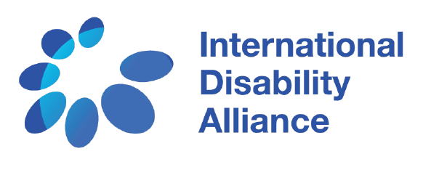

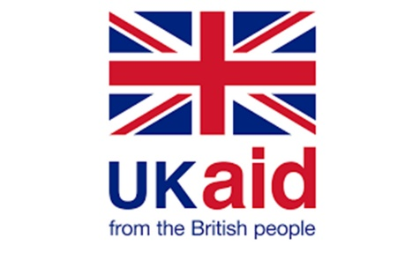
Our Right to Education:
A compilation of evidence gathered by OPDs on progress towards SDG 4 and CRPD Article 24

This compilation report has been developed as part of the second phase of Inclusive Education Flagship initiative of the International Disability Alliance (IDA), a component of the Disability Capacity Building Programme of the United Kingdom’s Foreign Commonwealth Development Office (FCDO). This was led by a consultant engaging with the IDA Inclusive Education Task Team and informed by the evidence collected from reports from Organisations of Persons with Disabilities (OPDs).

The findings, interpretations, and conclusions expressed in this report do not necessarily reflect the views of donors and/or partners

The International Disability Alliance is committed to ensuring digital accessibility for people with disabilities in its publications by applying relevant accessibility standards. This publication includes alternative texts on figures, a contrast checker and an interactive table of contents. If you encounter any accessibility barriers on this document, please contact us at accessibility@internationaldisabilityalliance.org. “

© 2021 International Disability Alliance
https://www.internationaldisabilityalliance.org/

This work is licenced under the Creative Commons Attribution 4.0 International license (CC BY 4.0). This license allows reusers to distribute, remix, adapt, and build upon the material in any medium or format for non-commercial purposes only, and only so long as attribution is given to the creator.

Acknowledgments
IDA and its members are particularly grateful to Ms. Rahma Mustafa for her expertise and support to compile this report.

Acronyms
ADF (African Disability Forum)
AOPD (Arab Organization of Persons with Disabilities)
AsDF (ASEAN Disability Forum)
CRPD (Convention on the Rights of Persons with Disabilities)
IDA (International Disability Alliance)
IFHOH (International Federation of Hard of Hearing People)
II (Inclusion International)
OPD (Organization of Persons with Disabilities)
PDF (Pacific Disability Forum)
RIADIS (Latin American Network of Non-Governmental Organizations of Persons with disabilities and their Families)
SDGs (Sustainable Development Goals)
WBU (World Blind Union)
WFD (World Federation of the Dead)

Contents
Introduction 6
Summary 7
1. Legal and policy frameworks for protection of the right to inclusive education 9
Africa 9
North Africa and the Middle East 14
Asia 15
The Pacific 17
Latin America and the Caribbean 18
2. Data and statistics on access to education for learners with disabilities 19
2a. Enrolment and Completion Rate 19
Africa 19
North Africa and the Middle East 22
Asia 22
The Pacific 24
Latin America and the Caribbean 25
2b. Training of teachers and education personnel 26
Africa 26
North Africa and the Middle East 27
Asia 28
The Pacific 29
Latin America and the Caribbean 29
2c. Budget allocation: 30
Africa 30
Asia 31
North Africa and the Middle East 32
The Pacific 33
3. Education strategies, programs and services 34
3a. Existence of Special Schools & Segregated Settings: 34
Africa 34
North Africa and the Middle East 36
Asia 37
The Pacific 39
Latin America and the Caribbean 39
3b. Action Plans for transition to Inclusive Settings 40
Africa 40
North Africa and the Middle East 43
Asia 44
The Pacific 44
3c. Discrimination and Negative Attitudes towards Learners with Disabilities 46
Africa 46
North Africa and the Middle East 47
Asia 48
The Pacific 50
Latin America and the Caribbean 50
4. Enabling Mechanisms (Accessibility, Support Services and Accommodations) 51
Africa 51
North Africa and the Middle East 53
Asia 54
The Pacific 56
Latin America and the Caribbean 56
5. Gaps and challenges identified by OPDs 57
6. Good Practices 59
7. Recommendations and the way forward 61
Conclusion and way forward 66

Introduction
The Convention on the Rights of Persons with Disabilities (CRPD) is the first legally binding instrument containing a reference to the concept of quality inclusive education. However, despite progress achieved since its entry into force (2008), millions of persons with disabilities worldwide continue to be denied the right to education and, for many more, only education available to them, often of lower quality, is in segregated school settings, in isolation from their peers. According to the CRPD General Comment No. 4 on Article 24 (Education), persistent discrimination and stigma against persons with disabilities results in significant numbers of children and youth with disabilities being denied the right to education. Due to lack of adequate support systems and accessible environments, many children with disabilities are never enrolled in school, they constitute a disproportionate number among out-of-school children, and the literacy gap between children with disabilities and children without disabilities keeps rising.
In such a context of lack of evidence on what works to achieve SDG 4 on inclusive quality education by 2030 for all children with disabilities, the IDA Inclusive Education Flagship (component of the Disability Catalyst Programme funded by the United Kingdom’s
Foreign Commonwealth Development Office (FCDO)) was conceived as a way to create a space for IDA members to discuss, coordinate positions towards strategic, evidence-based advocacy in this sector. In 2020, the Task Team, with representatives from Inclusion International (II), the International Federation of Hard of Hearing People (IFHOH), the World Blind Union (WBU) and the World Federation of the Deaf (WFD), developed an OPD-led, evidence based consensus perspective on how to achieve SDG 4 – ensure inclusive and equitable quality education and promote lifelong learning opportunities for all – in line with the CRPD and its Article 24, enshrined in the IDA Inclusive Education Global Report.
Following the development and adoption of a common position through the Global Report, a second phase was initiated with the aim to disseminate this position, enrich and consolidate it with good practices and case studies (from diverse disability constituencies and regions), and to work on ways to advance it at country level.

Purpose
To better inform this second phase of the IE Flagship, the IDA IE Task Team decided to produce, again with the support of FCDO through the Disability Capacity Building Program, this compilation of OPD-led evidence around CRPD Article 24 and SDG4.
This compilation report looks at the enabling mechanisms and/or key barriers that impede the right to inclusive education for learners with disabilities, as identified by OPDs. It outlines key challenges and gaps in implementation of SDG 4 and Article 24 of the CRPD and identifies common trends across countries and regions. The objective is to understand what OPDs are highlighting as major challenges facing the implementation of inclusive education in their countries, and their priorities in this area. As such, the report is meant to serve as a source of evidence and examples to inform further work of IDA and its members to advance the right to education, particularly in our work with OPDs at the national level. Complementing the vision set in the Inclusive Education Global report, it will inform and support the next phase of the IDA Inclusive Education Flagship, to disseminate the vision, train OPDs on a common understanding of CRPD Article 24, while also exploring how to localize this vision and adapt it to a diversity of contexts.

Summary
This compilation provides a review of the legislative education framework in the countries and regions considered, a collection of data (including related to the enrolment rate, trained personnel, and budgetary allocation) and of the information available on the existence of segregating school settings and transition plans to inclusive systems. The compilation then focuses on the enabling mechanisms identified by OPDs in those countries and regions, such as the provision of accessibility and reasonable accommodation. Based on these analyses, the compilation summarizes the most common gaps and challenges, captures good practices identified by OPDs, and provides recommendations from an OPD perspective on the way forward. Although this compilation is based on the analyses of a restricted number of OPDs reports, it provides nonetheless a good evidence-based overview of the status of inclusive education in the global South, highlighting the most common trends and challenges that learners with disabilities encounter in the education system, complementing and reinforcing the findings of the IDA’s Global Report on Inclusive Education.

Scope and methodology
To review progress with SDG 4 (inclusive and equitable quality education for all for learners with disabilities, this compilation report reviewed five (5) regional and nine (9) national reports on implementation of the SDGs from a CRPD perspective, as well as four (4) alternative reports produced by OPDs from Global South countries for the CRPD review cycle.
- 5 regional SDGs reports developed by IDA regional members:
  - Africa: report by the African Disability Forum (ADF) – with a focus on women and girls with disabilities - 2020
  - MENA: report by the Arab Organization of Persons with Disabilities (AOPD) - 2020
  - ASEAN: report by the ASEAN Disability Forum (AsDF) - 2020
  - Latin America: report by the Latin American Network of Organization of Persons with Disabilities and their Families (RIADIS) - 2019
  - Pacific: report by the Pacific Disability Forum (PDF) - 2018

- 9 national SDGs reports from a CRPD perspective developed by national members of IDA members:
  - Colombia: report by Nodo Comunitario de Salud Mental y Discapacidad Psicosocial, Asdown Colombia, Liga Colombiana de Autismo – LICA - 2019
  - Peru: report by Comisión De Damas Invidentes Del Perú (CODIP) - 2019
  - Indonesia: report by the ASEAN Disability Forum -2020
  - Iraq: report by the Iraqi Alliance of Disability (IADO) - 2019
  - Kenya: report by the Kenya Union of the Blind - 2019
  - Niger: report by Niger Federation of Persons with disabilities (FNPH) - 2018
  - Pakistan: report by the Pakistan Association of the Blind (PAB) - 2019
  - Rwanda: report by the Rwanda Union Of the Blind - 2019
  - Vietnam: report by ACDC Vietnam and the Vietnam Federation of the Disabled - 2019

- 4 CRPD alternative reports developed by national member organizations of IDA members in the Global South:
  - Bangladesh: report by the Disabled Peoples’ Organizations, Community Based Organizations and Non-Government Organizations in Bangladesh working for the rights of People with Disabilities - 2021
  - Niger: report by the National Federation of Persons with Disabilities (FNPH) - 2019
  - Rwanda: report by the National Union of Disability Organization (NUDOR) - 2019
  - Senegal: report by the Senegalese Federation of organizations of persons with disabilities - 2019
Those countries were all reviewed by the CRPD Committee in the last three years. In addition, these countries provide unique perspectives on the focus on inclusive education among OPDs as well as other stakeholders. For examples, Bangladesh is a programme country under the FCDO funded Inclusive Futures consortium which has a focus on education. Rwanda is a one of the focus countries for the World Bank’s Inclusive Education Initiative. In Niger, OPDs have been very active in recent times, in advocating for inclusive education.
Evidence was extracted from the OPD-led reports, focusing on the extent to which measures taken by the States to achieve SDG4 include and consider learners with disabilities and comply with commitments under Article 24 of the CRPD, particularly with regard to the principles of equality and non-discrimination, accessibility, full and effective participation and inclusion.
Specifically, the report reviews and document information on the following areas:
- Legal and policy frameworks for protection of the right to inclusive education
- Data and statistics on access to education for learners with disabilities
  - Enrolment and completion rates
  - Trained teachers and education personnel
  - Budget allocation
- Education strategies, programs and services
  - Existence of special schools & segregated settings
  - Action plans for transition to inclusive settings
  - Discrimination and Negative Attitudes towards Learners with Disability
- Enabling Mechanisms (accessibility, access to assistive technology, recognition of national sign languages).
- Gaps and challenges identified by OPDs
- Good practices
- Recommendations and the way forward

Please note that this compilation is based on information, including the text as is, from existing OPD reports. There may be inconsistencies in language and phrasing, particularly in terms of CRPD compliance. This does not reflect IDA’s position.

1. Legal and policy frameworks for protection of the right to inclusive education
Despite some progress in realizing the right of persons with disabilities to education, evidence collected by OPDs shows significant gaps in securing adequate, comprehensive legislation and relevant strategies for inclusive, equitable quality education for all. Reports reviewed show that legal frameworks on education are far from fully complying with the CRPD Article 24 and largely inadequate to ensure inclusive quality and equitable education. In particular:
- Education laws do not define inclusive education in which all children with disabilities have the right to access free primary and secondary education within the mainstream education system. Instead, laws often call for the creation of a separate education system for learners with disabilities.
- Laws on education do not prohibit discrimination, harassment, or violence on the basis of disability in education including in educational assessments and in the classroom.
- Education laws do not provide a non-rejection clause that ensures no child can be deemed uneducable.
- Laws do not provide for reasonable accommodation in accessing education or recognize the denial of reasonable accommodation as disability-based discrimination and too often they still rely on the medical/charitable model of disability (such as in the MENA region). As specified by CRPD Article 24, the education laws should protect the right of all learners to be taught in their language, including national sign language, an issue that is not regulated by the education laws. Finally, the reviewed education laws are lacking redress mechanisms for reporting discrimination with effective remedies and sanctions.

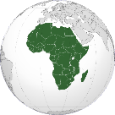 Africa

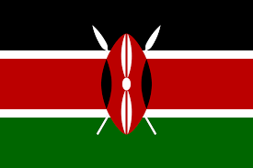
Kenya
- Despite progress towards the development of laws, policies, plans and programs that promote the realization of rights of persons with disabilities, some of these frameworks are still not fully in line with the CRPD principles. For instance, the Basic Education Act Number 14 of 2013 ensures the right of all children to education but it also creates a system in which children with disabilities are required to attend separate schools, solely based on their disability. In Part IV, section 28 (d), the law calls for special (separate) and integrated schools for learners with disabilities and the establishment of a special needs education system. The law adopts a medical model when defining special needs education in which there is a separate curriculum. The law also fails to provide reasonable accommodation in education which is considered as disability-based discrimination. Secondly, the law fails to ensure an inclusive education system is established in Kenya as required by Article 24 of the CRPD. Finally, the law does not provide a non-rejection clause in education ensuring all learners with disabilities can go to mainstream school. While the law does provide for free compulsory education in Kenya for the first time, it does not do enough to promote equal educational opportunities for children with disabilities as required by the CRPD.
- Also, there still remains a challenge on the implementation of such policies, plans and programs due to several factors which includes: the massive resources required, the low capacity of policy implementers on how to operationalize some provisions and lack of goodwill from the implementers.
Mali
- The Act No. 99-046 of 28 December 1999, as amended, the Education Act, guarantees the right to education for every citizen. It prohibits discrimination on grounds of “sex, social origin, race or religion" (article 9). It does not include disability as basis of discrimination. This law defines Special Education as type of education. It refers to both special and inclusive education.
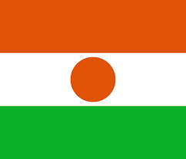
Niger
- The Education and Training Sector Program (PSEF 2014-2024) is the only policy framing the education sector. It takes into account the education of persons with disabilities with some planned actions focusing on persons with physical disability. However, there is no reference to people who are deaf or hard of hearing, blind people, and people with intellectual disabilities and people with albinism. It should also be noted that OPDs have never been involved in the development of this program and even less in its implementation in accordance with the role that the CRPD confers on civil society.
- The definition of disability in several legislations and regulations, including regarding prevention and detection of disability, is not in conformity with the Convention, particularly, Act No. 60-36 of 29 July 1960 on the expulsion from school of persons affected by leprosy, article 2 of Ordinance No. 93-012, and Articles 42 and 43 of the draft law on Equal Opportunities and the Reintegration of Persons with disabilities (LOSEN). Eight years after the ratification of the Convention, and two years after starting the implementation of the 2030 program (2018), the analysis of the legislative and regulatory framework shows that there are some laws on promotion of disability rights, however, the lack of budget allocation and enforcement mechanisms limited their impact on the inclusion of persons with disability in education. In 2017, persons with disability represented less than one percent of the national education system at all levels. For some groups of persons with disability, they are still excluded from the national education system, mainly because the educational services and structures are not accessible.
- OPDs noted the discriminatory nature of Articles 42 and 43 of Law 98-12 of 1 June 1998, modified by Law 2007-24 of 3 July 2007 (LOSEN), on the orientation of the Nigerien education system. Articles 42 and 43 reaffirm the right of persons with disabilities to special education "The mission of special education is to educate or re-educate and train citizens with physical or mental disabilities in order to facilitate their social integration or reintegration”, and Ordinance 93/012 of 2 March 1993, which, in its article 7, reaffirms the right of children and adolescents with disabilities to special education, which must be integrated into the national education system. Despite the attempt to harmonise the two pieces of legislation, through Ordinance 2010-028 of 20 May 2010 and its implementing decree, specialised education remains privileged in Niger's legislation, in contradiction with Article 24 of the CRPD and SDG 4, whose ultimate objective is to promote inclusive quality education for all.
- Significant efforts have been made by both the state and development partners to improve access to education, with improvement at all levels in access to education for the general population. However, access for people with disabilities remains very low at all levels. For example, people with intellectual disabilities are excluded from secondary education and deaf people are limited to upper secondary education due to the lack of professional sign language interpreters.
Nigeria
- The Compulsory Universal Basic Education Act 2004 in Nigeria regulates primary and secondary education. The act mandates free, universal education for all at the primary and secondary levels, it does not have any provisions prohibiting discrimination on the basis of disability or gender. Learners with disabilities and girls are included in the list of those who can attend mainstream basic education. However, the law does not regulate access to education, accessibility of the school system and curriculum or provide for reasonable accommodation in accessing education as enshrined in CRPD Article 24 on right to education.
- The Disability Rights Act of 2018 prohibits discrimination on the basis of disability but does not provide for reasonable accommodation nor that its denial constitutes discrimination in accessing education or for a non-rejection clause protecting learners with disabilities from being deemed ‘uneducable’. The law has a provision that all primary and secondary schools shall be inclusive and that special facilities will be provided for the effective education of learners with disabilities. While the legal text is somewhat vague, it seems to contradict the premise of inclusive education as defined in CRPD Article 24 by establishing separate facilities for students with disabilities outside the mainstream education system. There is no complaint mechanism for reporting discrimination with effective remedies or sanctions. The law only calls for physical accessibility without consideration of accessible information and communication.
- Vision 2020 is the main development strategy driving economic development. The strategy includes women and persons with disabilities. It aims to address disability issues by reviewing the educational system and laws on discrimination as well as awareness raising but there are no clear policy directives, initiatives, indicators, or budgets to address gender and disability inequality. In the mid-term implementation report, there is no mention of persons with disabilities. Vision 2020 does not include goals and targets that are inclusive of persons with disabilities.
This Photo by Unknown Author is licensed under CC BY-SA
Rwanda
- The National Constitution of Rwanda of 2003 (amended in 2015) protects the right of everyone to education, provides for free and compulsory primary education to all and prohibits discrimination on the basis of disability and gender amongst other statuses. Also, the Constitution mandates the duty for the State to establish special measures for the education of persons with disabilities. However, the Constitution does not explicitly state that students with disabilities must be educated in mainstream schools.
- The Law on Establishing Higher Education Council sets the standards for higher education and monitors how these standards are implemented. However, the law does not explicitly mention disability or gender when defining how higher education will be governed nor does it include any articles on monitoring the inclusion of students with disabilities or women and girls in higher education. There is also no mention of how the special education system will connect to higher education system.
- Law n. 01/2017 of 31/01/2017 governing the Organisation and Functioning of Higher Education and the Law no 22/2017 of 30/05/2017 Establishing Rwanda Polytechnic Higher Learning Institution define the functioning of higher education and polytechnic and vocational training programmes respectively. None of the laws addresses disability or gender in accessing education nor is there a mention of inclusive education, accessibility or promotion of access to higher education, polytechnic or vocational education for women and girls.
- OPDs have noted that, generally, all public schools have inadequate infrastructure and are inadequately resourced. Moreover, education in Rwanda at primary, secondary and university or tertiary education does not fully respond to the requirements of persons with disabilities. There are no trained personnel at all levels of education, and there is lack of accessible learning materials. The highest education level offered to refugees, in refugee camps is 9 years, instead of 12 instituted by the government of Rwanda for others. To OPDs’ knowledge, there is no existing plan for transition from segregated or special school to inclusive schools. The policy on girl’s education does not explicitly mention any strategy for inclusion of girls with disabilities. There is still gender disparity with high rate of illiteracy among women with disabilities with a half of them having no education. The data show similar enrolment of both boys and girls with disabilities in mainstream primary education; however things tend to change when it comes to secondary education where the number of girls with disabilities declines to 5% compared to 8% among males with disabilities and 11.2% among girls without disabilities.

Senegal
This Photo by Unknown Author is licensed under CC BY-SA
- Measures to ensure the implementation of an inclusive education system are not yet adopted but an inclusive education policy document is being developed.
Despite the appointment of an inspector to coordinate inclusive education still there is a weaknesses in coordination of actions between different actors and decision-making centres (Presidency of the Republic, Ministries of Health, Education, Justice, Ministry of Women, the Family and Children, etc.) in the elaboration of an "Inclusive Education Orientation Document" by the Directorate of Elementary Education and the establishment of a Consultation Framework on Inclusive and Special Education Interventions in the elementary education sub-sector; as identified by the disability coalition as a factor that strongly contribute to the difficulty of Senegalese schools to achieve universal schooling .
- Due to lack of quality education, the school system has contributed to producing a large number of school dropouts, or even graduates who are unqualified or have few qualifications and are unemployed. To promote access to vocational training the state has taken several initiatives and programmes (vocational training, construction of vocational and technical training centres, multipurpose centres, etc.). However, the supply of training still falls far short of needs, with very inadequate facilities and technical education accounting for only 1% of middle and secondary school enrolments. This situation does not encourage the inclusion of young girls and boys with disabilities. The reasons are the insufficient number of centres, the architectural barriers, and the requirements for admission (4th year of secondary education) which is not within the reach of learners with disabilities, most of whom were dropped out of school at a very early stage or are simply not in school.
- Multi-purpose centres have been created by associations of persons with disabilities. However, as the support of the State and local authorities is limited, it remains minimal or non-existent, these centres are confronted with difficulties of operation and trained personnel. The examples of the centre in Tambacounda, which is closed, and the inclusive centre in Louga, which is not far from this situation despite the support of the NGO Aide et Action.

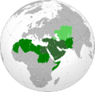 North Africa and the Middle East

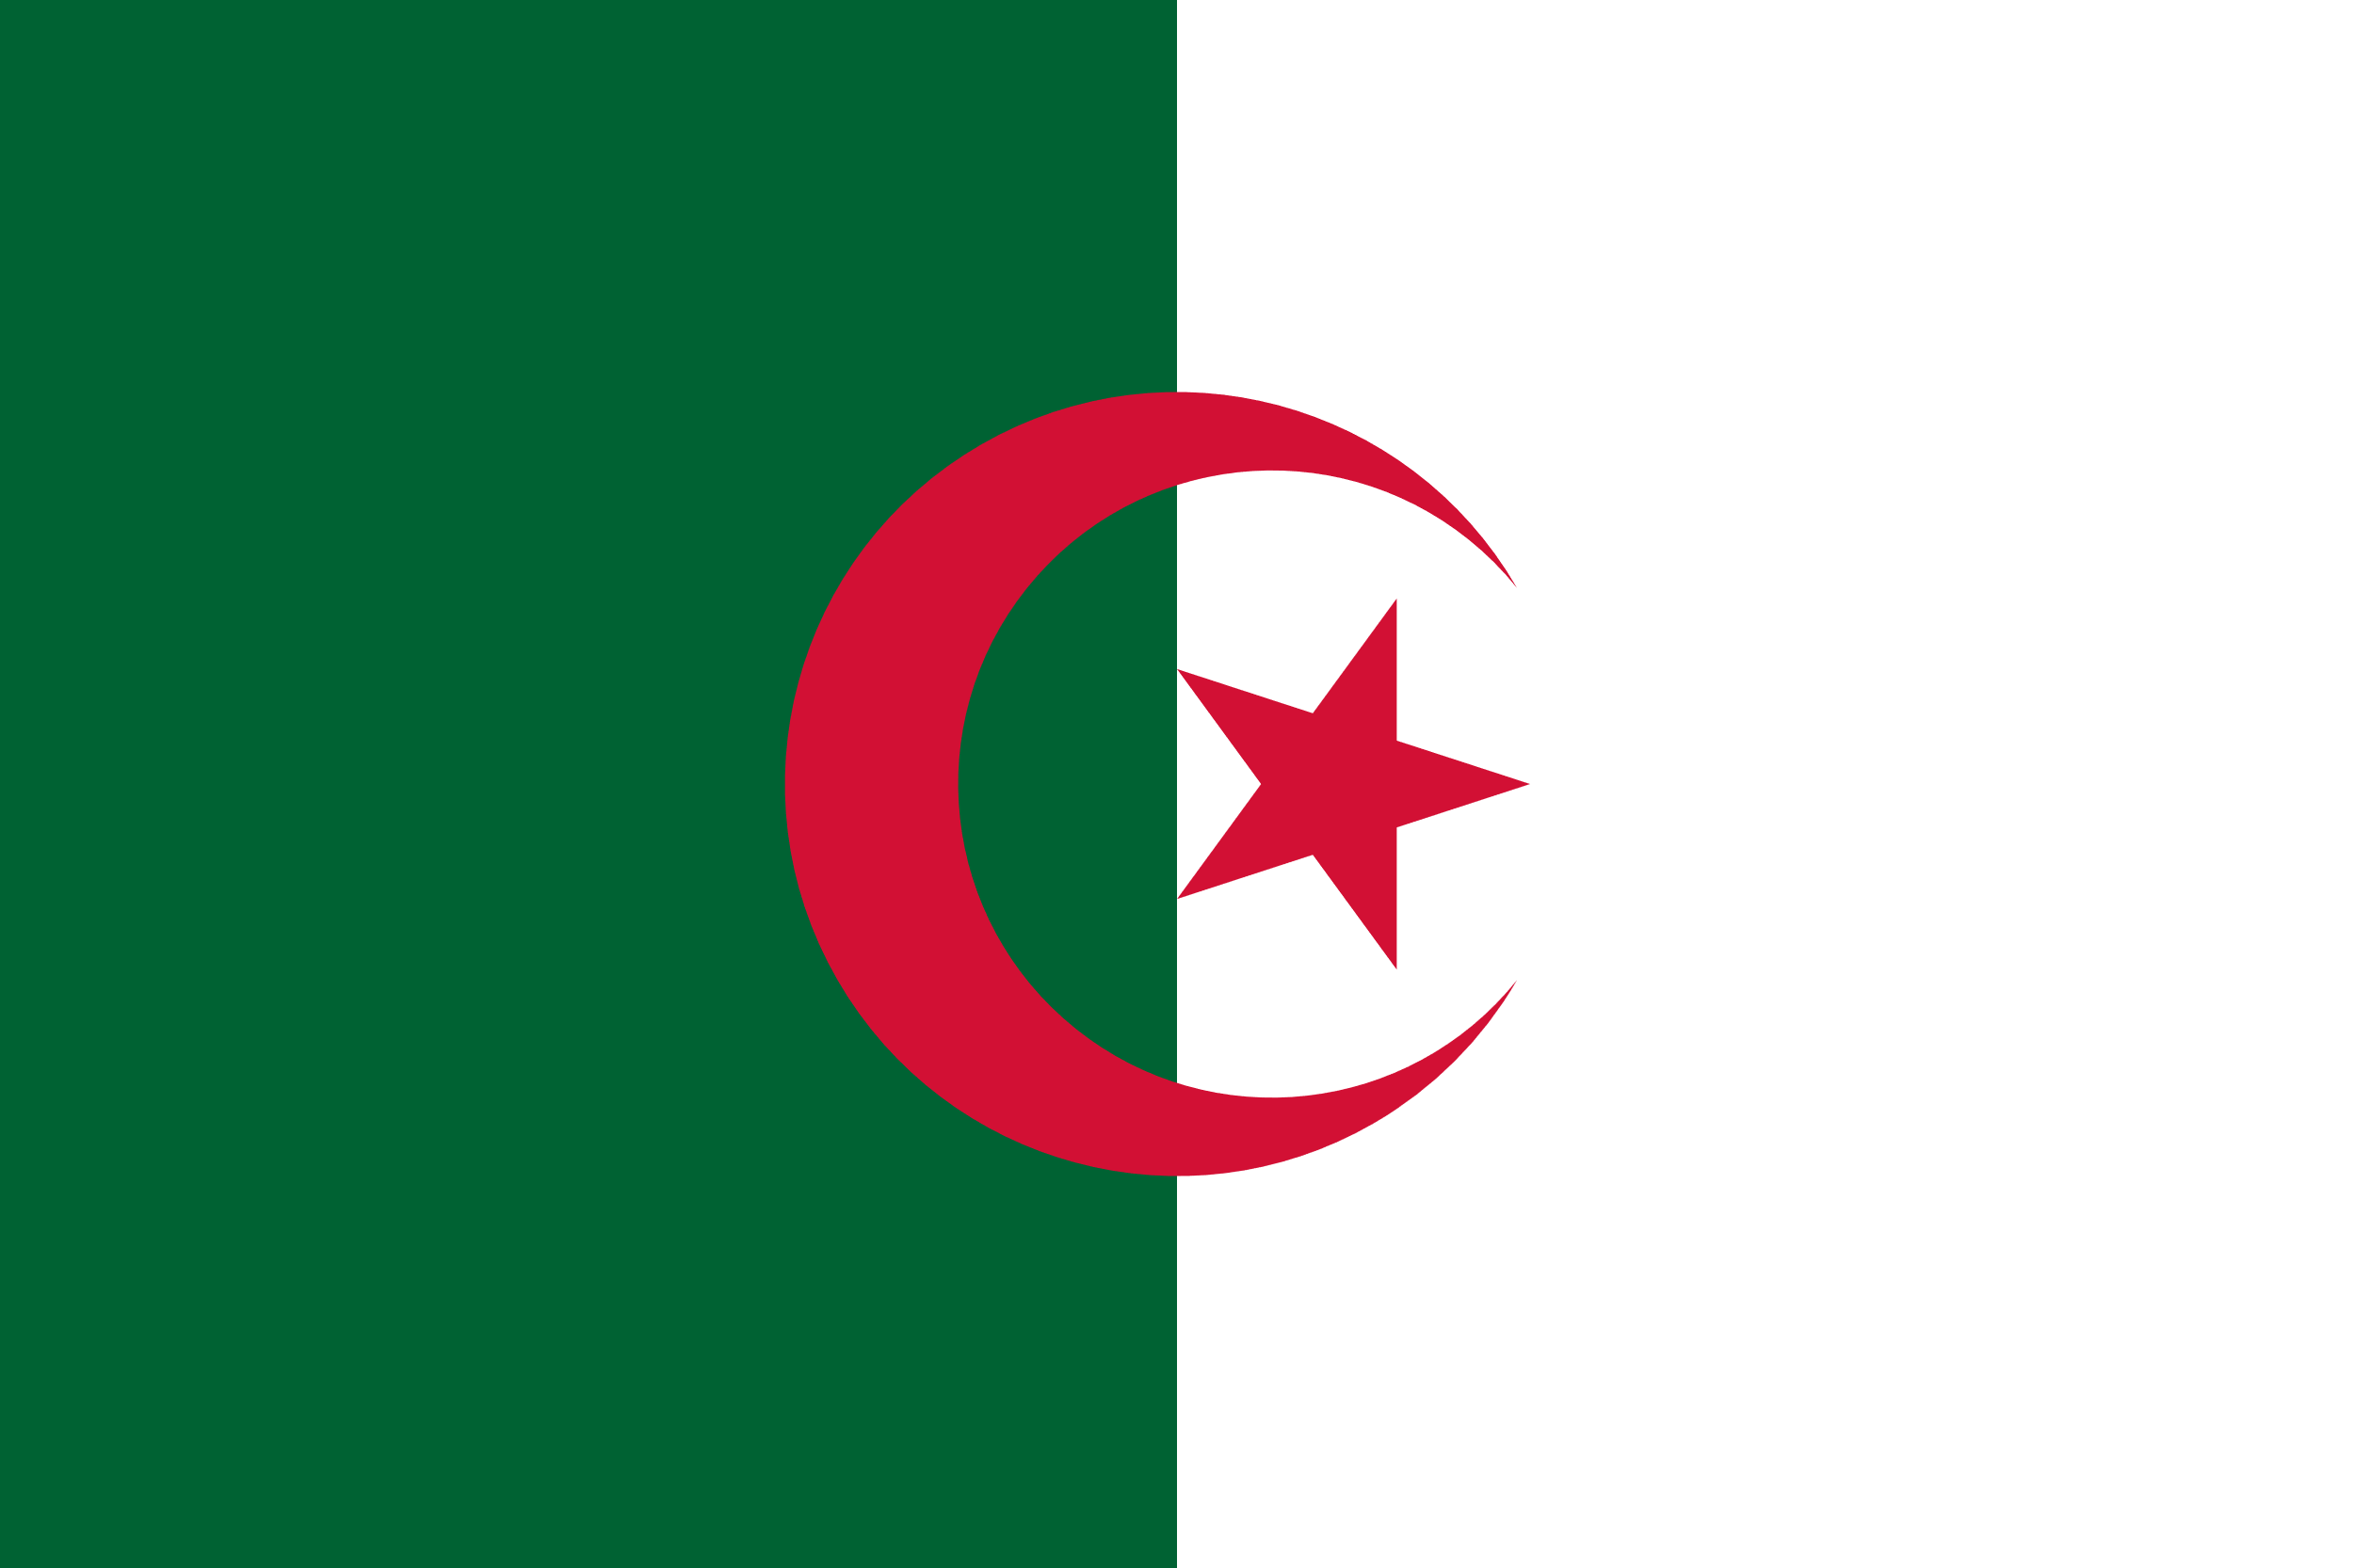
Algeria
This Photo by Unknown Author is licensed under CC BY-SA-NC
- There is no legal and policy framework on the right to inclusive education for children with disabilities or strategy to transform specialized settings into inclusive education environments, including revised curricula and teachers training.
This Photo by Unknown Author is licensed under CC BY-SA
Egypt
- Education is characterized more by explicit medical model rather than with conformity to the standard of the CRPD. This also becomes apparent upon reviewing the ministerial order 252 of 2017, which permits the admission of students with “light disabilities” into all kinds of regular schools, from kindergartens to upper classes. It also allows guardians of students with disabilities the right to choose inclusive schools or special institutes for their children.
This Photo by Unknown Author is licensed under CC BY-SA
Jordan
- Jordan currently achieved limited inclusion of students with disabilities. Students complain that the schools agreeing to include them are mostly inaccessible and do not provide reasonable accommodations after having admitted these students.
- The Ministry of Education and Higher Education has developed a 10-year plan for the rights of persons with disabilities. The plan involves providing quality inclusive education while taking into account all the needs of students with disabilities by preparing the school environment and arranging reasonable accommodations.
This Photo by Unknown Author is licensed under CC BY-SA
Iraq
- OPDs have noted the discriminatory nature of Article 32 of Iraq Constitution and of Article 1 of Iraq Law No. 38 on the “care for persons with disabilities and special needs 2013”. This leads to depriving persons with disabilities from accessing basic services including education.
- A study conducted by the British Council in eight provinces of the Republic of Iraq indicated that “one of the main challenges facing inclusion and equality in education is the reliance on medical model in addressing educational issues related to students with disabilities, which is prevalence in current practices related to policies implementation, or existing regulations in schools and classrooms.

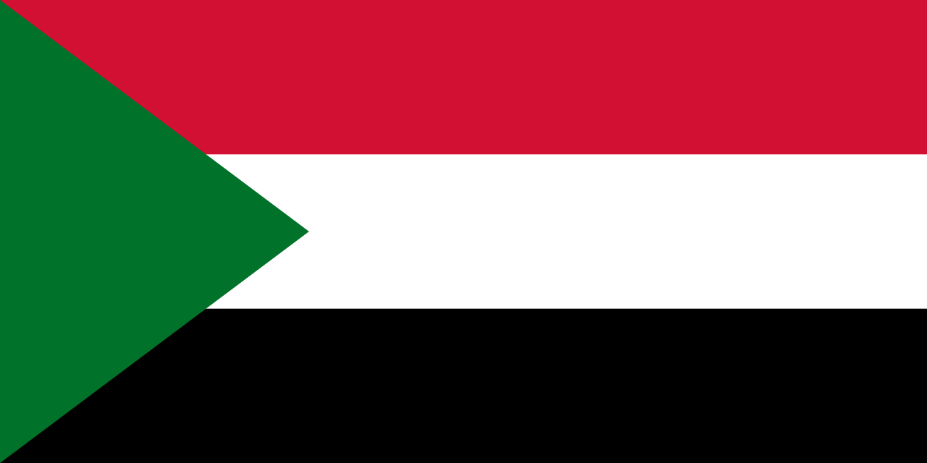
Sudan
This Photo by Unknown Author is licensed under CC BY-SA
- The National Act on the Rights of Persons with Disabilities 2017 does not prohibit discrimination on the basis of disability and not recognize the provision of reasonable accommodations to guarantee the participation of persons with disabilities in their communities, on equal basis with others, hampering access to education for persons with disabilities.

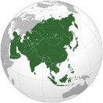Asia

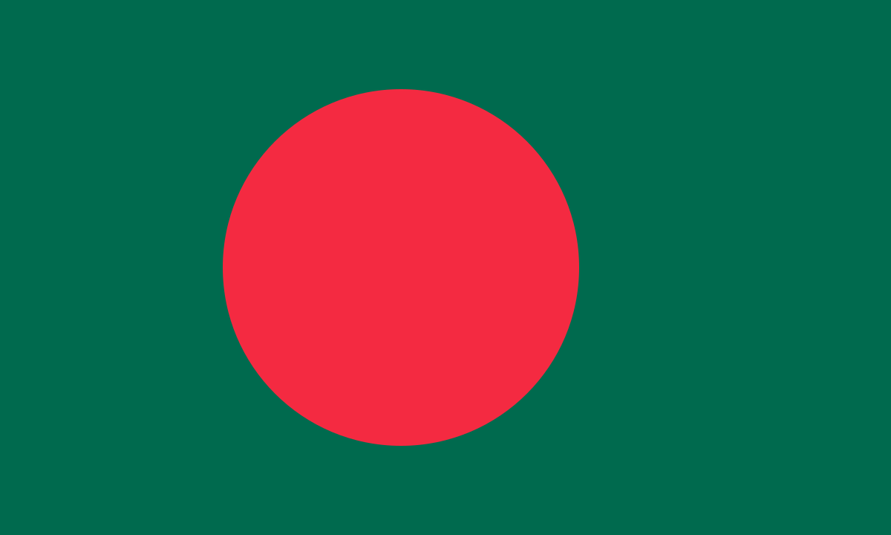
Bangladesh
This Photo by Unknown Author is licensed under CC BY-SA
- OPDs have highlighted the following points: the Rights and Protection of Persons with Disabilities Act 2013 (RPPDA) was enacted in 2013 and it is intended to provide persons with disabilities equal and effective legal protection against all types of discrimination, including the provision of reasonable accommodation. It also provides for the rights to quality inclusive education. However, the duty to ensure reasonable accommodation has been recognized only for education and employment. Also, the Act does not recognize the diversity of persons with disabilities based on gender, age, ethnicity, religion, caste, profession and grade/extent/type of disability properly.
This Photo by Unknown Author is licensed under CC BY-SA
Indonesia
- The implementation of inclusive education is regulated by Regulation No. 70 of 2009 on Inclusive Education for Disordered Student with Potential Intelligence and Special Talent. However, the 2017 Directorate of Education and Religion of National Planning and Development report revealed “inclusion” is still limited simply to “encouraging” children with special needs to attend the nearest school” (Prapto, 2017). Indonesia’s Presidential Regulation No. 59 of 2017 on the Implementation of SDGs marked Indonesia’s commitment to the SDGs. However, Indonesia’s portraits of persons with disabilities, particularly in SDG 4 of quality of education and SDG 8 of decent work and economic growth, are not compliant with the CRPD.
- Indonesia enacted Law No. 8 Year 2016 on the rights of persons with disabilities. Nevertheless, several evaluations note that despite this progressive law, there is inadequate policy frameworks and regulations to implement the law. For example, Article 10 emphasizes the right to education for persons with disabilities to quality education in all types, lines and levels of education. However, to realize this right, Article 40 of the law requires government to organize and/or facilitate education for Persons with Disabilities through inclusive education and special education.
- Law No. 8 Year 2016 on Disabilities mandates the provision of reasonable accommodations and disability service units for persons with disabilities in schools and higher education facilities; however, it requires executive regulations to implement this right. Various OPDs have provided recommendations to the Ministry of Education and Culture on how to implement reasonable accommodations as a draft for government regulation. However, until now (2020) the draft regulation has not been passed and there are always concerns that the recommendations from OPDs will be omitted from draft regulation.
- Government Regulation No. 13 Year 2020 on Reasonable Accommodation for Students with Disabilities establishes the formation of Disability Service Units by government at all levels of education, early childhood, elementary, secondary and higher education. However, the Government Regulation on Reasonable Accommodation for Students with Disabilities still regulates the special education for persons with disabilities which is not in line with the CRPD. The Government Regulation also does not explicitly state the transformation of the special education system towards inclusive education in accordance with the mandate of Article 24 of the CRPD. The main principle of inclusive education is often forgotten in the education system developed in Indonesia. There is a lack of formal legal definition of inclusive education.
- The definition of both inclusive education and persons with disabilities in the Minister of National Education and Culture Regulation No. 70 Year 2009 concerning Inclusive Education are not in conformity with the CRPD.The regulation does not recognize the provision of individualized support and reasonable accommodation to learners with disabilities in mainstream schools. Also, it does not mandate the reforming of the curricula.
- Students with disabilities are still excluded from higher education. The Regulation of Ministry of Research, Technology and Higher Education No. 60, of 2018 concerning the admission of students into bachelor’s degree does not include the rights of persons with disabilities. For example, some universities make IQ Tests as one of the mandatory admission requirements, in addition to personality tests such as BAUM Test (showing pictures of humans, trees, and homes) and DAP Test (showing human pictures) are incorporated into admission procedures. These procedures exclude persons with disabilities and lower their chances of getting admitted into universities. The disability service unit in universities are not yet appropriately implemented as mandated by Law No. 8 Year 2016, and Government Regulation No. 13 Year 2020 on the Reasonable Accommodation for Students with Disabilities. Consequently, there is a lack of disability awareness and knowledge among students, academics and service providers in higher education institutions.

Pakistan
This Photo by Unknown Author is licensed under CC BY-SA
- There is no legislation regulating inclusive education and government policies do not explicitly mention children with disabilities. In 1959 for the first time, the national commission for education placed the education of children with disabilities on the government agenda.
- Under the Disabled Persons’ (Employment and Rehabilitation) Ordinance 1981, the department of special education was established at federal level. After the 18th Amendment in the Constitution in 2008, special education has been devolved to the provinces. Now, special education centres are working under provincial special education ministries or in Social Welfare Departments. This decision has a huge negative impact on the education of children with disabilities. Provincial government lack a comprehensive and consistent set of regulations and adequate resource planning for inclusive and quality education to respond to the educational needs of children with disabilities.
This Photo by Unknown Author is licensed under CC BY-SA
Philippines
- As of 2020, no national law on inclusive education ensures the operationalisation of "inclusive, equitable and quality education for all". Another challenge is the lack of data, especially on vulnerable and marginalised groups including persons with disabilities. (Social Watch Philippines, 2019).

Singapore
This Photo by Unknown Author is licensed under CC BY-SA-NC
- The Compulsory Education Act and Private Education Act do not intend to regulate explicitly the rights to education for children with disabilities as the government of Singapore enacted laws that belong and relevant to all Singaporeans, including persons with disabilities. However, the Singapore governments address the rights of education to children with disabilities through several programmes which regulated in derivative regulations such as special education and early intervention programmes for infants and children with disabilities.

Vietnam
This Photo by Unknown Author is licensed under CC BY-SA
- The Education Law contains a non-discrimination clause (Article 3) that protects citizens against discrimination in accessing education on many grounds excluding disability. For persons with disability, the same article puts the obligation on the State to give priority to and create conditions for persons with disability and “handicapped people” and beneficiaries of other social policies to realize their learning rights and obligations.

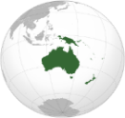The Pacific
This Photo by Unknown Author is licensed under CC BY-SA
Most Pacific Island Countries (PIC) governments have committed to make reforms required to achieve inclusive education, as evidenced by signing various frameworks such as the CRPD, the Incheon Strategy and more recently the Pacific Framework on the Rights of Persons with Disabilities (PFRPD). However, despite significant commitments of PICs towards inclusive education and efforts made since, much remains to be done as legal frameworks on education in Pacific still present large gaps in CRPD compliance. The laws usually do not provide a non-rejection clause that ensures no child can be deemed uneducable. Laws do not provide for reasonable accommodation in accessing education or recognize the denial of reasonable accommodation as disability-based discrimination.
Almost in all countries across the Pacific there is a lack of adequate regulatory changes and clear allocation of responsibilities across government, which are required for effective enforcement of legislation. OPDs noted the main barriers for realization of inclusive education in Pacific region include: “absence of or inadequate policies and policy implementation on education for children with disabilities. Problems include a lack of clarity, discriminatory policies or misalignment with international human rights frameworks”.
A lack of clear policy in PICs results in resistance from within the mainstream education system to prioritise inclusion. With regards to non-discrimination and reasonable accommodation, to date only Marshall Islands, Cook Islands and Fiji have established legal definitions and obligations of these issues. However, it is either restricted to employment (Cook Islands) or too recent to assess any actual enforcement.

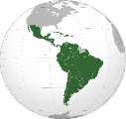Latin America and the Caribbean
This Photo by Unknown Author is licensed under CC BY-SA

Colombia
This Photo by Unknown Author is licensed under CC BY-SA
- In 2019, Colombia promulgated the Bases of the National Development Plan 2018-2022 (BPND). The BPND refer explicitly to persons with disabilities and includes objective on implementation of inclusive education aims to include persons with disabilities. However, these objectives are not clear about the difference between inclusive education and special education, proposing measures that seem more akin to the former rather than the latter. In this sense, there is a contradiction between the BPND and the CRPD. Furthermore, the government’s plan does not incorporate an intersectional perspective that recognizes the multiple forms of discrimination that persons with disabilities may be subject to because of their sex, gender, sexual orientation, race, ethnicity or socioeconomic status.
- There is misinterpretations of the right to reasonable accommodation, the denial of reasonable accommodation is not acknowledged as a form of discrimination, and reasonable accommodation is rarely provided. For example, the government claims that it is providing reasonable adjustments when it allows blind students to be exempt from the English test in public examinations. Under this logic, schools exclude blind students from English classes and ask to discharge persons with disabilities from State tests, in order “to secure that their institutional ranking is not affected” and “ensure reasonable accommodations”.
- In most cases, the inclusion of persons with disabilities occurs as part of the diversity approach, which considers the impact of public policies on specific population groups. In this sense, the inclusion of persons with disabilities operates through an additive logic, in which the government generates a list of “vulnerable” groups that require special protection.

2. Data and statistics on access to education for learners with disabilities

2a. Enrolment and Completion Rate
Generally, the reports reviewed show low rates of enrolment of learners with disabilities at all levels of education, high dropout rates in both mainstream and special education schools and the consequent higher rate of illiteracy among persons with disabilities compared to their peers. Data also show that most of learners with disabilities enrolled are in special/segregated schools in both urban and rural areas. Moreover, most special schools only teach primary and secondary education with no higher education level schooling available for students to continue their education. It also evident that the gender disparity between girls and boys with disabilities still exists all regions considered in this compilation, with the former most often excluded from education due to intersectional forms of discrimination.

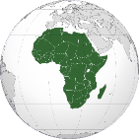 Africa
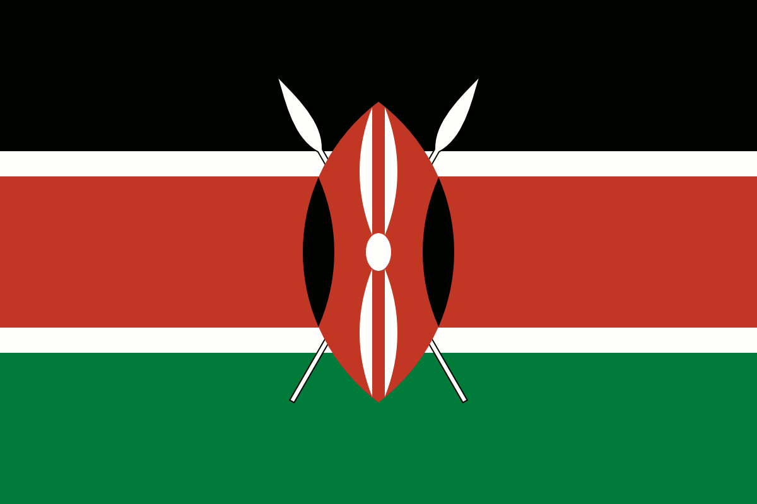
This Photo by Unknown Author is licensed under CC BY-SA
Kenya
- Children with disabilities are still out of school and if enrolled, a significant number drop out of the education system According to the Sector Policy for Learners and Trainees with Disabilities (Republic of Kenya, 2018), a significant number of learners and trainees with disabilities are out of school (MoE, 2016). The National Special Needs Education Survey that was carried out by the Ministry of Education and Voluntary Services Overseas (2014) revealed that the majority of out-of-school children in Kenya have a disability, with 16% of all children and young people with disability being out of education. The report further reveals that learners with disabilities in secondary schools in Kenya make up 5% of the total number of learners. According to the Kenya Statistical Year Booklet (MoE, 2015), the gender parity for boys and girls with disabilities in primary school was 0.54% and 0.46% respectively. At the secondary school level, the gender parity was 0.58% and 0.42% for boys and girls with disabilities respectively. This shows that the enrolment of boys is slightly higher than that of girls with disabilities
- An online survey that looked at the situation for women and girls with disabilities on implementation of SDG 4 in line with CRPD Article 24 and Article 6 shows that girls with disabilities are not accessing primary education within mainstream schools. About retention and drop-out rates, the survey shows that girls with disabilities do not complete primary education and do not go on to complete secondary education. Regarding tertiary levels of education, the overwhelming majority of respondents felt that girls and women with disabilities rarely complete university or vocational schooling.

This Photo by Unknown Author is licensed under CC BY-SA
Niger
- The enrolment rate of persons with disability attending mainstream education, particularly for girls and children with psychosocial or intellectual disabilities, is low. The number of students enrolled in primary education for the 2016-2017 year is 2,768,305; number of students with disabilities for the same period is 11,203 or 0.40%, of which 0.16% are girls with disabilities. According to statistics from the Ministry of Secondary Education, the number of students enrolled in all secondary level of education for the year 2016-2017 is 0.30 % of all students in the country. Students with intellectual disabilities are totally absent from both lower secondary school and upper secondary school levels. Deaf students drop out from secondary second cycle because of the lack of professional interpreters of sign languages.
- For the vocational and technical education in Niger, Article 8 of Ordinance n°93-012 provides for education and training of persons with disabilities. According to statistics from the Ministry of Vocational and Technical Training the total number of learners of formal VTT were 169,381 in 2016, only 206 (0.12%) were young persons with disabilities, of which only 50 were girls with disabilities (0.24%).
- The Higher Education sector is still less developed in Niger. The enrolment rate of Nigerien student in general is very low, it was 2.63% in 2015. For students with disabilities, the number enrolled for the academic year 2014-2015, was 123 according to Niger Students with Disability Association (AEEHN) at the same period the total number of the students in the University of Niamey was 12361 that means students with disabilities was only 0.99%. It should be noted that the inclusion of those 123 students with disabilities was only possible through scholarships based on the Decree 2010-761/PCSRD/MESS/RS dated December 09th 2010.

Nigeria
This Photo by Unknown Author is licensed under CC BY-SA
- In the northeast and northwest, female attendance in primary school is 47.7% and 47.3% respectively, meaning that more than half of all girls are not in schools. Exclusion from school is driven by different factors including economic barriers, socio-cultural norms and practices that discourage attendance in formal education. For girls with disabilities, the barriers are even greater including inaccessible schools, inaccessible school materials and information, stigma around disability and discriminatory attitudes within families themselves discouraging their members to attend school.
- Participants in focus group discussion in Nigeria on the rights of women with disabilities in the implementation of SDGs and CRPD generally observed that girls with disabilities enrol in primary and secondary schools very late; mostly around the age of 10 to 15 and they face various challenges including sexual harassment, age discrimination, pressure for marriage, poverty etc. Consequently, only about 3% of girls with disabilities can complete primary and secondary education due to these problems. Participants with intellectual disabilities indicated that “girls with intellectual disabilities are worst hit in terms of acquiring formal education, only a very few manage to pull though primary education with lots of difficulty before they are transited to vocational skills training institutions”.

Rwanda
This Photo by Unknown Author is licensed under CC BY-SA
- Rwanda is one of the top performing countries with 98% of children enrolled in primary education. However, according to the Ministry of Education, in 2016, students with disabilities represented less than 1% of all enrolled students in primary education.
- The Ministry of Education collects data about learners with disabilities in its schools. The table below shows the number of children with disabilities attending government schools as of 2018:
Table 1. Source: Ministry of Education 2018 Education Statistics.
Level | Male | Female | Number of students with disabilities | Total number enrolled
Nursery | 743 | 510 | 1,253 | 226,706
Primary | 9,669 | 7,464 | 17,133 | 2,503,705
Secondary | 2,445 | 2,240 | 4,685 | 658,285
TVET | 254 | 235 | 489 | 102,485
University | 98 | 75 | 173 | 89,160

An analysis of the statistics above shows that the numbers of students with disabilities attending school are disproportionately lower than those of their counterparts without disabilities. The disabilities mentioned in the statistics provided include the following: hearing impairment, visual impairment, speaking, learning disabilities, physical disabilities, and multiple disabilities. Learners with physical disabilities form the majority of learners with disabilities in school.
Although students with disabilities are attending regular schools in larger and larger numbers, not all schools are equipped to cater for their needs.

Senegal
This Photo by Unknown Author is licensed under CC BY-SA
- As reported by OPDs, there is no reliable data on children with disabilities as statistics do not systematically disaggregate by disability, and stakeholders are generally not trained in aspects related to the identification of children with disabilities.
- A study on children outside or on the margins of the traditional school system in Senegal carried out by UNICEF, IRD and UCAD in 2016 highlights how children with disabilities are impacted by school exclusion. Indeed, the number of children with disabilities aged 7 to 16 is estimated at 35,369 (source ANSD, based on data from the 2013 general population census). Of these, 66% are out of school, while the proportion is 47% for Senegal as a whole. Among these children with disability, a large proportion have never been to school (87.5% compared to 79% for all out-of-school children aged 7 to 16 in Senegal).

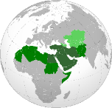 North Africa and the Middle East
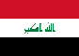
This Photo by Unknown Author is licensed under CC BY-SA
Iraq
- Statistics from the Ministry of Education for the academic year 2017-2018 indicate that the total number of students with disabilities enrolled in regular schools, at the primary level is 15,683. The number of students in special classes between the first and fourth grades is 15,390, (98%), while the number of students with disabilities in the fifth and sixth grades is 293 (2%). The same statistics showed that the enrolment rate of male’s students with disabilities (8,471) in the primary level was 54%, while the percentage of females (7,212) in the same school level was 46%. Studies show that the largest number of students with disabilities who are studying within the special education system have learning difficulties.

Lebanon
This Photo by Unknown Author is licensed under CC BY-SA
- It is estimated than less than 8% of disability card holders attend school. The number of students with sensory (visual and hearing) disabilities included in regular schools is few at best and on rare occasions. If their number exceeds 100 in one academic year, it dwindles sharply in the next year because of lower enrolment rates than graduation at many intermediate and secondary schools.

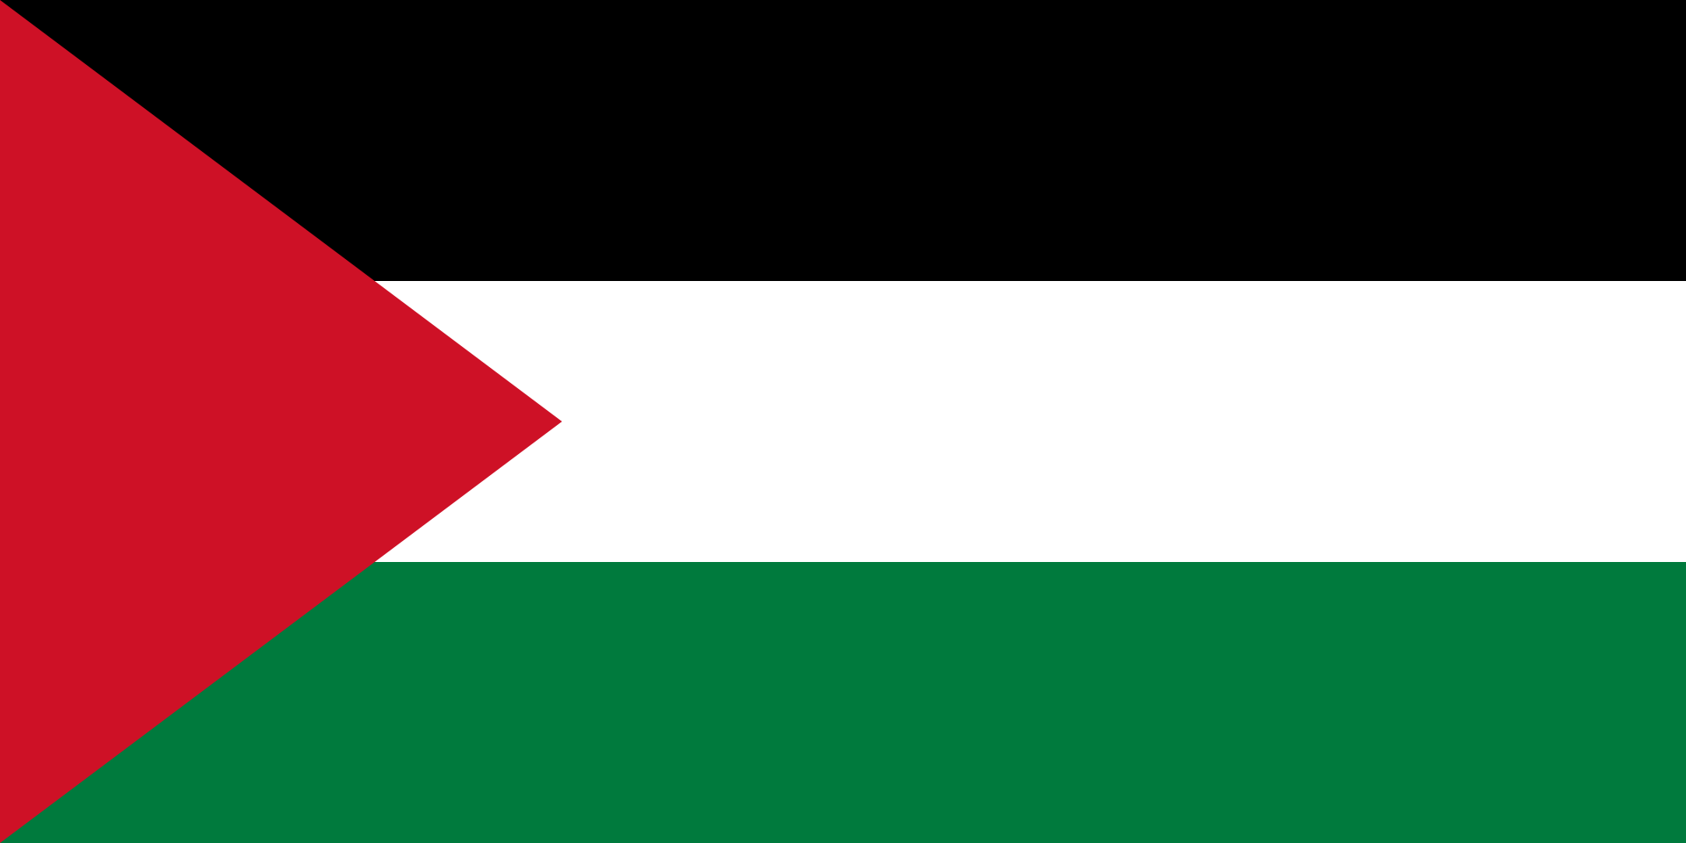
Palestine
This Photo by Unknown Author is licensed under CC BY-SA
- The 2011 census showed that 53.3% of persons with disabilities are illiterate. Official data shows a failure among the three stakeholders in the education.

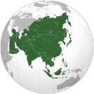Asia
The 2017 data by United Nations Economic and Social Commission for Asia and the Pacific (UNESCAP) shows that, the percentage of children with disabilities enrolled in secondary education in the region is drastically low, only 52.7%. A UNICEF study of 15 countries in the region shows that the disability gap in enrolment in primary and secondary education is statistically significant at an average of 30%. At all levels of education, there is a gap between enrolments when it comes to disability. The data collected in the 2016 national disability survey also shows how gaps between the net enrolment ratios widen as one goes higher in education levels. It is safe to assume that barriers to education increase as the level of education is higher. (Mizunoya, 2016).

Indonesia
This Photo by Unknown Author is licensed under CC BY-SA
- Many children with disabilities are unable to attend school - out of some 1.6 million children with disabilities only 18% can access education, according to the Ministry of Education.
- According to the Central Bureau of Statistics (BPS) in the 2018 Indonesia Education Statistics Portrait Report, the higher the level of education, the wider the gap between learners with disabilities and those without disabilities. This can be seen in all data indicators presented. Rough Participation Rate (APK) of PAUD (Early Childhood Education and Development) for children with disabilities aged 3-6 years is lower than for those without disabilities. The APK of early childhood education (PAUD) for children with disabilities aged 3-6 years is 28.62% while those without disabilities is 36.98%
- Based on 2018 Education Statistics, the percentage of the population of learners with disabilities aged 5 year and above who are still in school is only 5.48% and increase to 5.90 in 2019. This percentage is far from the population of learners without disabilities aged 5 year or above reaching 25.83% in 2018 and 25.49 in 2019. While the percentage of learners with disabilities who do not or never attended school altogether reach 23.91%, the population of learners without disabilities aged 5 years and over and not yet in school is only 6.17%. The percentage of learners with disabilities who have not attended school reach 70.62%. The higher the age group, the lower the school participation rate (APS). The highest APS occurred in the 7-12 years age group, which is 91.12% for persons with disabilities and 99.29% for learners without disabilities. The lowest APS occurred in the 19-24 years age group, which is 12.96% for the learners with disabilities and 24.53% for those without disabilities.
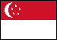
This Photo by Unknown Author is licensed under CC BY-SA
Singapore
- The Ministry of Education states that there are a total of 1700 children per cohort with special needs, 25% of which – or 400, are children with “moderate to severe conditions”. 10% of these 400 students, or about 40 children, do not go to special education schools for various reasons. They could either be home-schooled, enrolled in private education institutions, or are unable to attend due to physical or intellectual disabilities (Chia, 2016). Intellectual and physical disabilities are identified to encounter challenges in social barriers to attend SPED (special education) as they might spend extra costs to attend schools and less support or knowledge from their own families than dedicated trained educators and teachers in SPED.

Vietnam
This Photo by Unknown Author is licensed under CC BY-SA
- The Vietnam Disability Survey VDS indicated that only 66.5% of primary school-aged children with disabilities attend school, compared to the national average of 96.8%, leaving around 700,000 children with disabilities behind. The Ministry of Education and Training (MOET) lists the main reasons for this are severe disabilities (36.20%), children without special learning needs (17.16%), children lacking confidence in learning (16.03%), the community refused to allow children with disabilities to be enrolled (9.56%), difficult family situations (5.34%), lack of familial awareness about enrolling children in school (4.93%) and "complex" children (3.29%). The VDS also indicates lower school attendance rates for children with disabilities at the secondary level, below one-third of children with disabilities went to school at the right age, compared to the proportion of two-thirds among children without disabilities. In Vietnam, a vast majority of persons with disabilities or 75% live in rural areas and attend school at rates far below those of persons without disabilities. Literacy rates are much lower for adult persons with disabilities (76.3%) than those without disabilities (95.2%).

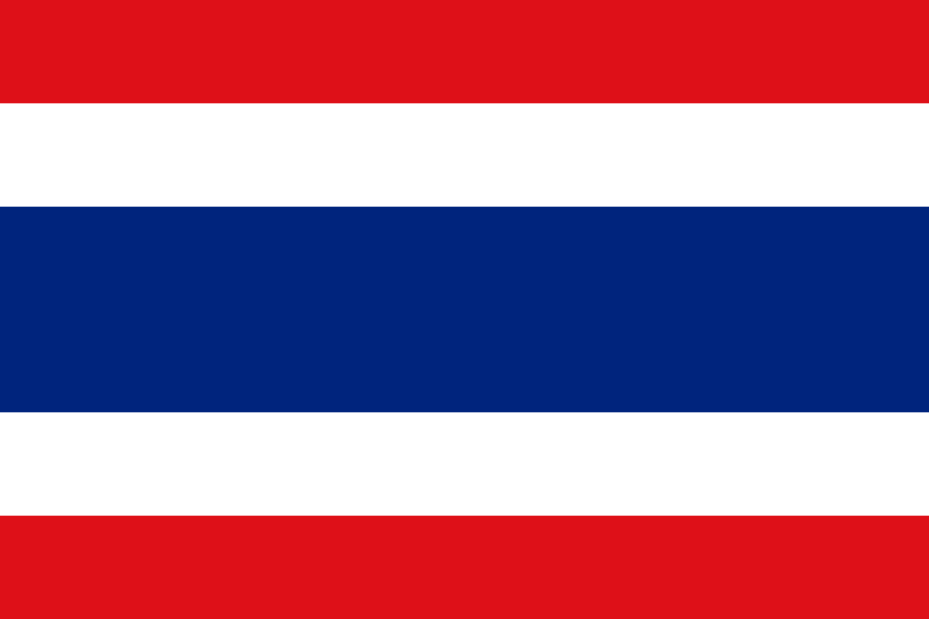
Thailand
This Photo by Unknown Author is licensed under CC BY-SA
- In the country, approximately 427,467 children with disabilities are in the basic education level. Of these, 387,678 students attend 23,488 mainstream schools, 12,854 students attend 48 public special schools, and 26,935 students are in specialised education centres (Special Education Bureau, 2019).

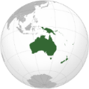 The Pacific
This Photo by Unknown Author is licensed under CC BY-SA
In Pacific Island Countries PICs, according to the most recent censuses of Samoa, Kiribati and Palau, persons with disabilities are substantially less likely to have ever attended school, less likely to have completed secondary or tertiary education, and have lower rates of literacy compared to persons without disabilities. These trends are in line with evidence from other PICs. The Solomon Islands Ministry of Education, for example, estimated that less than 2.0% of children with disabilities were in school.
 | Disability status | Highest level attained |  |  |  | Literacy rates (reading/writing)
 |  | Never been to school | Primary School | Secondary school | Higher education
Samoa^{A} 18-49 years | With disability | 17.1 | 18.1 | 44.4 | 10.3 | 51.3/48.9
 | Without | 0.6 | 6.8 | 67.9 | 24.0 | 97.3/94.5
Palau* 18-49 years | With disability | 23.3 | 20.6 | 46.6 | 8.2 | 48.0/48.0
 | Without | 1.3 | 4.7 | 48.8 | 45.2 | 98.6/98.6
Kiribati®18-9 years | With disability | 13.7 | 10.6 | 25.4 | 3.2 | 64.9
 | Without | 3.8 | 5.7 | 50.8 | 3.9 | 83.6
Educational attainment and literacy rates, by disability status, in Samoa, Palau and Kiribati; based on census data using the 18–49-year-old age bracket

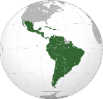 Latin America and the Caribbean
This Photo by Unknown Author is licensed under CC BY-SA

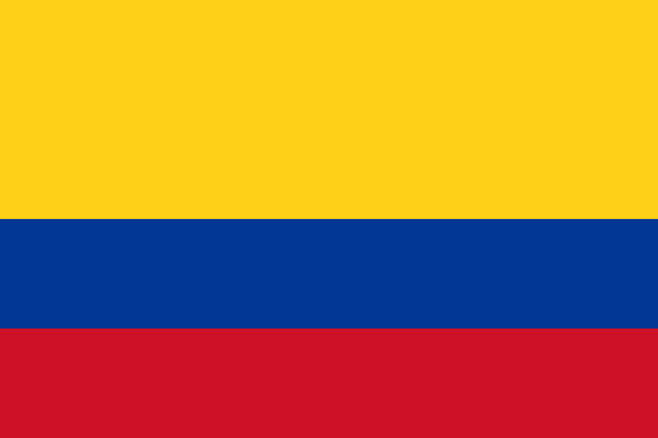
Colombia
This Photo by Unknown Author is licensed under CC BY-SA
- According to the United Nations, only 1.92% of the students enrolled in the regular education system in Colombia are students with disabilities (Naciones Unidas 2016, para. 16). Likewise, the National Administrative Department of Statistics (2012) has revealed that about 80% of children with disabilities between five and nine do not have any level of education, and 47.1% of those 10 to 17 do not have any level of education. Accordingly, Colombia has one of the highest illiteracy rates for persons with disabilities, compared to the index for the general population (Naciones Unidas 2016).
- Moreover, some organizations have expressed their concern with the gender disparities in education, underscoring the high rate of unschooling of girls and adolescents with disabilities. Other organizations have commented on the disparities in the education of children with specific disabilities (Colectiva Polimorfas, 2008). For instance, parents of children and youth with psychosocial and intellectual disabilities are frequently forced to demand legal protection to guarantee their children’s education.
- The disparities on education also depend on the educational level. For example, there are low enrolment numbers of children with disabilities in kindergarten and high school, when compared to the number of children in primary school . Furthermore, only 55% of the persons with disabilities between 5 and 24 (244,943 people) registered in the Registry for the Location and Characterization of Persons with Disabilities RLCPD attend school or university. That is, 101,111 (41.2%) of the persons with disabilities in this age range do not attend school or university. Furthermore, three out of ten people with disabilities do not have any level of schooling, and only four out of ten have primary school education. Additionally, the RLCPD reports that 367,633 people over 24 are illiterate.
- Generally there is a lack of data regarding the number of students with disabilities who withdraw or do not complete their education. However, according to several international studies, young people with disabilities are much less likely to graduate from school than youth without disabilities (Shandra and Hogan, 2009).

2b. Training of teachers and education personnel
Overall, the reports reviewed highlight the lack of teachers trained on inclusive education and methodologies globally, in particular with regards to persons with intellectual and psychosocial disabilities, sign language, Braille and Easy Read as well as the lack of training for teachers on the skills and competencies to promote inclusive education as a major barrier to the achievement of SDG 4 and Article 24 of CRPD. When trained, the personnel and staff is largely insufficient compared to the number and requirements of students with disabilities and, in some regions, families of students with disabilities are often the ones bearing the extra costs, hampering the access to education of students with disabilities from low-income households. In addition, report from Latin America indicated that the risk that the lack of trained teachers can become an excuse for exclusion of learners with disabilities from education.

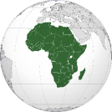 Africa

Kenya
This Photo by Unknown Author is licensed under CC BY-SA
- According to two different surveys by the Ministry of Education and Voluntary Services Overseas VSO (2014) & National Gender and Equality Commission NGEC (2016), generally, teachers are inadequately trained on disability issues.
This Photo by Unknown Author is licensed under CC BY-SA
Niger
- The insufficiency of specialists and trained teachers is one of main challenges to inclusive education in Niger. A report on situational analysis of integrated and specialized schools (CBM, March 2016) highlights the existence of 162 teachers in specialized and integrated schools, 95 of whom are visually impaired, 51 have hearing difficulties and 16 with intellectual disabilities. It should be noted that based on this number, only ten are qualified teachers trained to teach children with disabilities.
This Photo by Unknown Author is licensed under CC BY-SA
Nigeria
- During a Focus Group Discussion on the rights of women with disabilities, blind participants indicated that “most blind girls go to special schools” and noted that the current practice of inclusive education in Nigeria was not meeting the needs of blind girls. This, according to them is due to lack of trained teachers, absence of Braille textbooks and assistive technologies.
- Participants to the focus group discussion also noted that “there is very little access for girls with intellectual disabilities to primary and secondary schools because there are very few public primary and secondary schools which support girls with various intellectual disabilities. In addition, there are few teachers with requisite professional skills to support girls with intellectual disabilities”.

Rwanda
This Photo by Unknown Author is licensed under CC BY-SA
- Mainstream public schools often face lack of adequate teacher training, lack of an adapted curriculum and a lack of accommodating materials and services. Moreover, the number of schools adequately prepared to accommodate the requirements of learners with disabilities in terms of having trained teachers and accessible infrastructure were very few in 2018 compared to the total number of schools.
This Photo by Unknown Author is licensed under CC BY-SA
Senegal
- Initial teacher training does not integrate inclusive education. Indeed, despite a pilot initiative developed in 2015 with the support of UNICEF, Humanity & Inclusion and Sighsavers, for the introduction of a module on inclusive education in the Regional Education Staff Training Centres (Crfpe), particularly in the Dakar region, the initial training curricula do not allow for the training of new teachers on inclusive education (including Braille or sign language). In-service training in inclusive education has so far been provided on an ad hoc basis in the context of inclusive education projects.

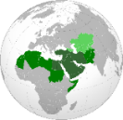North Africa and the Middle East

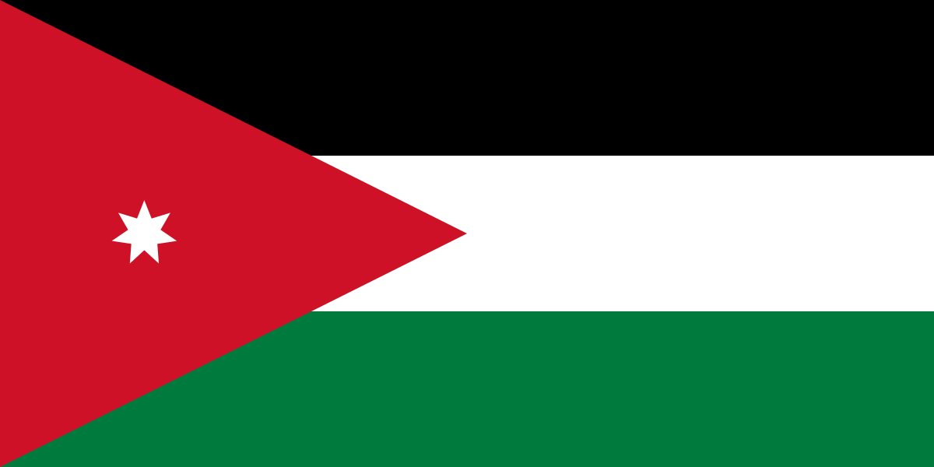
Jordan
This Photo by Unknown Author is licensed under CC BY-SA
- Jordan recently adopted a law to eliminate special schools. However, no clear information is available on how well teachers are trained to teach students with disabilities, especially students with sensory and intellectual disabilities, and treat them on an equal basis with others in the classrooms. Nor is it known for certain how much schools and their amenities are accessible to students with all types of disabilities.

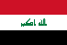
Iraq
This Photo by Unknown Author is licensed under CC BY-SA
- OPDs have reported a lack of trained teachers and lack of specialized cadres who are capable of providing quality inclusive education as a main barrier for inclusion of persons with disability from mainstream education.

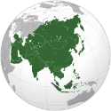Asia
This Photo by Unknown Author is licensed under CC BY-SA
Indonesia
- The most frequently recorded problem by the OPDs is the limited number of teachers who have sufficient knowledge and skills on inclusive education. Existing practice is that the inclusive teacher, also known as special assistant/shadow teacher (Guru Pendamping Khusus, GPK), are the teachers ‘borrowed’ from the school with special needs for teaching twice a week in inclusive school. Based on the information from the Association of Parents of Children with Autism and Cerebral Palsy (WKCP), the cost to provide special assistant/shadow teacher in many public and private schools is being paid by the parents. It means that children with disabilities do not have free education.
- The government tends to neglect invisible disabilities and focused mostly on building physical infrastructure, overlooking the reasonable accommodation and support services for persons with disabilities like the provision of teachers to assist students with different types of disabilities.
This Photo by Unknown Author is licensed under CC BY-SA
Vietnam
- There is a lack of knowledge of inclusive education methodologies among teachers. Special educators are not trained in inclusive education. The number of teachers trained to accommodate children with disabilities in schools is quite low. A study on readiness for education of children with disabilities in eight provinces of Vietnam revealed that a majority of teachers – 65% - reported that they do not receive any training in inclusive education, special education or disability.
- On average, there are 33 teachers per school in Vietnam, and on average each school has 5 teachers who are trained to enable inclusive educational settings. These teachers are not evenly distributed, so in effect only 14.1% of schools have teachers who are trained for teaching learners with disabilities (2016 disability survey).
- The lack of skilled teachers for educating learners with disabilities was the top difficulty reported by schools in educating children with disabilities in the 2016 survey (Table 16.6), by 72.3% of respondent schools. This is also a concern for parents of children with disabilities. Many children and their parents reported that some schools had tendency not to accept children with severe disabilities because there was no staff taking care of them. Even their own families felt insecure when schools’ facilities and human resources were too inadequate to support children with disabilities, so they preferred to not send them to school.

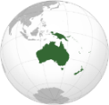 The Pacific
This Photo by Unknown Author is licensed under CC BY-SA
In Pacific Island Countries, evidence collected shows lack of focus on inclusive education in pre-service and in-service teacher training, resulting in teachers lacking the necessary skills, knowledge and confidence to teach inclusively and therefore exclusion of students with disabilities from education.

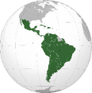Latin America and the Caribbean
This Photo by Unknown Author is licensed under CC BY-SA
This Photo by Unknown Author is licensed under CC BY-SA
Colombia
- OPDs have noted that one of the main obstacles to guaranteeing the education of persons with disabilities continues to be the lack of trained teachers to advance inclusive pedagogical processes. OPDs representatives have confirmed that; “teachers do not have the tools or adequate training in inclusive education”, and that “the high level of rotation of instructors makes it challenging to implement inclusive education processes. As a result, even when training spaces are provided, the variation of the teaching staff becomes a barrier to the continuity of inclusive education programs.
- Moreover, “the argument of the lack of teachers and training has become an excuse to justify the exclusion of children with disabilities from learning institutions”. Likewise, another participant argues that “the professionalization of inclusive education has become an obstacle in itself. In this sense, although the schools are aware of the prerogatives and legal obligations, they do not implement the norm, citing the lack of capabilities, training, and resources. They reject students with disabilities by claiming that they do not want “to incur in a pedagogical error”. For this reason, the notion of inclusive education as a specific area of knowledge is a setback in the rights of persons with disabilities. As such, this expertise logic tends towards the exclusion of people with disabilities”.

2c. Budget allocation:
Most reports reviewed highlights a lack of information available on budgetary allocations for the promotion of inclusive education including the training of teachers, individualized and classroom support, accessible learning environments, teaching methods and materials. Overall, when information is available, OPDs reported that the budget allocation to support inclusive education is inadequate and that, because of legislations and policy still largely foreseeing segregating settings next to inclusive schools, the latter are usually deprioritized.

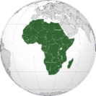Africa
This Photo by Unknown Author is licensed under CC BY-SA
Kenya
- Learners with disabilities are not accessing adequate learning materials and aids in the classroom due to limited government resources dedicated to inclusive education, especially for those with visual impairments and Deaf students or hard of hearing students. School fees are also cited as a major barrier for families with a member with disability: prohibitive costs of school fees force families to make choices about which member they can support to attend school. Given the pervasive gender and disability discriminatory attitudes, families will often send their male family members without disabilities to school and keep their female members with disabilities at home.
This Photo by Unknown Author is licensed under CC BY-SA
Niger
- Inadequate budget allocation is one of the main challenges to inclusive education in Niger. Over the period 2016-2017, the proportion of disability-specific expenditure in the primary school education budget is around 23%. It should be noted that these amounts allocated to disability have been used exclusively for the purchase of specialized equipment.
This Photo by Unknown Author is licensed under CC BY-SA
Nigeria
- The National Inclusive Education Policy defines inclusive education in accordance with CRPD Article 24 (Education), however, there are no significant resources allocated to re-train and provide continuous training to teachers on inclusive education and adapted learning methodologies. The policy does not spell out the budgets, timeline or responsible authorities to implement wide scale reforms such as: adaptations to all schools to make them accessible with the needed support services such as Sign Language interpretation, Braille printers, hearing loops etc.
This Photo by Unknown Author is licensed under CC BY-SA
Senegal
- OPDs have reported that a budget line of FCFA 100 million was also allocated for special and inclusive education in 2018. Despite the presence of a specific budget line, the use of this fund lacks transparency and seems to be used essentially to support special schools.

Asia

Indonesia
This Photo by Unknown Author is licensed under CC BY-SA
- Special Education provided through the School with Special Needs (SLB) is still the main approach for the education of students with disability and have been allocated higher funding by the government, compared with the inclusive education funding allocation. However, quality of the teaching and learning activities is very low and inadequate to prepare the student for work.

Thailand
This Photo by Unknown Author is licensed under CC BY-SA
- Both public and private schools are entitled to professional and financial support from the government. In this regard, the Ministry of Education supports 48 special schools, 77 provincial special education centres, 23,488 inclusive education schools and 100 colleges and universities. Despite progress regarding the promotion of inclusive education. Many factors such as inadequate resources and personnel, shortage of assistive equipment in schools and general inflexibility of the education system to tailor infrastructure and services to the specific needs of children with disabilities constitute an important challenge.

Vietnam
This Photo by Unknown Author is licensed under CC BY-SA
- More than half of the respondent schools (53.9%) in the National Disability Survey 2016 have reported the lack of budget as a considerable barrier to inclusive education. Schools are unable to purchase educational assistive devices or appoint additional support staff to enable the inclusion of children with disabilities. Schools are permitted to apply for additional funds to support inclusive education. In Dien Bien, the provincial education office issued guidelines in budget allocation and implementation of the circular to all districts and schools in the province a month after the circular was released (UNICEF, 2015) but not all provinces have taken similar steps. In a study of schools in 8 provinces by UNICEF, the majority of schools were found to have no defined budget allocation for the education of children with disabilities. While primary education was free, which meant that schools could not charge tuition, schools were charging students for uniforms, sanitation, traffic guards, gardeners, pens, notebooks, and even to have the buildings repainted (Hoang, 2013). This led to many students having to drop out of school. In 2013, a draft text of the Constitution sought to incorporate a clause on education which stated that "Citizens have a right and obligation to study" instead of a commitment to free and universal education. This met with a large backlash when the draft was opened to public comment, however, it remains retained in the 2013 Constitution (Hoang, 2013), but the State obligations in this regard elaborate this.

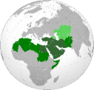 North Africa and the Middle East

Iraq
This Photo by Unknown Author is licensed under CC BY-SA
- A major barrier which faces the implementation of inclusive programs in the country is the financial resource. To ensure access to education for students with disabilities requires the activation of compulsory free primary education and the provision of human, materialistic, financial and technological resources that are needed to support students with disabilities to continue their education beyond the compulsory education level.

Lebanon
This Photo by Unknown Author is licensed under CC BY-SA
- The Ministry of Social Affairs continues to pay no less than USD 44 million annually to provide education for around 8,500 students with disabilities in special schools, meaning that only very few students enjoy an inclusive education experience.

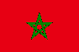 Morocco
This Photo by Unknown Author is licensed under CC BY-NC
- Law No. 51.17 for the system of education, training and scientific research. Article 22 of that law stipulates that “the state acts to mobilise all available resources and take the necessary measures to facilitate the inclusion of persons with disabilities”. However, only 7,000 students with disabilities were able to utilise the improved school conditions in the three consecutive years of 2015, 2016 and 2017.

Palestine
This Photo by Unknown Author is licensed under CC BY-SA
- The lack of adequate funding for education is cited as a biggest challenge among the many limitations that affect education quality and outputs. In Palestine, students pay nominal fees to join government or UNRWA schools. Cost of attendance is relatively higher in NGO-funded and private schools. Colleges and universities charge high tuition for college degrees, according to Birzeit University researcher, Adel el-Zaghagh. Data on state for education show a remarkable increase in average spending during the last three fiscal years.

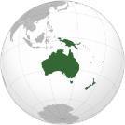 The Pacific
This Photo by Unknown Author is licensed under CC BY-SA
In the Pacific Region, the level of disability-related expenditure is not yet adequate to allow significant progress towards inclusion of persons with disabilities, overall domestic resource allocation for the inclusion of persons with disabilities is still below 0.15% of the GDP for most countries. There remains a strong reliance on official development assistance to invest in developing required disability-specific and disability-inclusive services. Countries often prioritise few issues and have not yet adopted a whole-of-government approach to inclusion.

Fiji
This Photo by Unknown Author is licensed under CC BY-SA
- Fiji has one of the highest levels of domestic spending and little disability-related donor support. Fiji’s budget allocation for persons with disabilities nearly doubled in the 2018 budget following strong DPO advocacy, CRPD ratification, and adoption of the new domestic disability rights law. However, it is to be noted that not all of this budget allocation is CRPD compliant, with significant amounts invested in psychiatric institutions or special schools.

3. Education strategies, programs and services

3a. Existence of Special Schools & Segregated Settings:
Evidence collected highlights the prevalence of special and segregated education and the persistence of legislations providing for a dual education system that excludes children with disabilities form mainstream education. Legal and policy frameworks on education often set up two different education systems for learners with disabilities that operate separately: special schools established outside the mainstream education system and inclusive/integrated schools within the mainstream education system that have not yet been transformed to fully inclusive quality and equitable education.
Finally, when trying to access mainstream schools, students with disabilities are turned away mainly because of persistent stigma and discrimination.

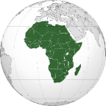 Africa

Mali
This Photo by Unknown Author is licensed under CC BY-SA
- The education system in the Republic of Mali includes special education as well as regular education. Mali has a national policy and action plan on special education, initiated pursuant to the amended Act No. 99-046 of 28 December 1999, the Education Act, which stipulates that special education is aimed at persons with serious disabilities. The organization and modalities of operation of special education are determined by a decree issued by the Council of Ministers. “Mildly disabled persons” are accommodated in the various orders and types of education. They receive the same learning opportunities as non-disabled learners while at the same time benefiting from special educational care. (The Education Act Articles 30, 46, 47, 48 and 55).
This Photo by Unknown Author is licensed under CC BY-SA
Niger
- Despite the attempt to harmonize the ordinance 2010-028 dated 20 May, 2010 on Education and its enforcement decree, segregated special education remains prevalent in the Niger legislation, in contradiction with article 24 of the CRPD and SDG 4.
- There are three educational approaches for learners with disability: specialized, integrated and inclusive education.
  - Specialized Approach: children with disability are educated in a separate learning environment such as private centre or special institution. The specialized nature also stems from the specialty of the teaching methods, learning materials and the qualification of management staff adapted to each type of disability.
  - Integrative approach: Children with disability attend regular schools. The child is accepted within the school but receives a special education in a separate class. Here, the system does not adapt to take into account the needs of the child, but rather the child who must adapt to the school system.
  - Inclusive Approach: Inclusive education refers to an education system that takes into account the specific educational and learning needs of all children including children with disabilities in the same school and classroom together with their peers. There are currently 61 schools in Niger that include persons with disability, including 27 integrated schools, 4 special schools and 30 inclusive schools. In addition, there are 3 private centres for children with intellectual disabilities.

Nigeria
This Photo by Unknown Author is licensed under CC BY-SA
- Participants from a Focus Group Discussion confirmed that “girls with disabilities go to both special and mainstream schools and enrolment in a particular school depends on the type of disability”. It was generally agreed that girls with disabilities go to both special and mainstream schools at primary and secondary levels. However, participants noted that most of the mainstream schools and special schools are too few in number, located in far distances, poorly staffed, poorly equipped and underfunded.

Rwanda
This Photo by Unknown Author is licensed under CC BY-SA
- Law on the organization of the education system in Rwanda sets out a separate education system for learners with disabilities especially for students with physical or “mental” disabilities or those with unusual intellectual ability through special education and special schools. The law defines special schools as institutions outside of mainstream education. The Law governs nursery, primary and secondary education in Rwanda states that “a student with disabilities may attend mainstream schools only when “the obstacles that prevented [that] pupil from attending ordinary schools is overcome.” The responsibility rests on the student with a disability to overcome barriers in order to attend mainstream school.
- The Education Sector Strategic Plan for Basic Education (ESSP) 2018/19 TO 2023/24 in Rwanda calls for equitable access to education for children with disabilities within mainstream schools as well as special schools, thus creating two separate systems of education. The focus of ESSP’s strategy is to integrate leaners with disabilities within the mainstream system, “where possible,” and create a separate system for those deemed ‘uneducable’ thus creating two separate systems of education.

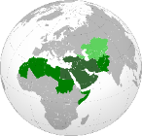 North Africa and the Middle East

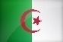 Algeria
This Photo by Unknown Author is licensed under CC BY-SA-NC
- The education of children with disabilities falls under the purview of the Minister of National Solidarity and that segregated education for children with disabilities still exists.

Iraq
This Photo by Unknown Author is licensed under CC BY-SA
- There is explicit reference to segregated classes in Iraq’s legislation, such as article 9 of Law No. 118 (1976) on compulsory education “The Ministry of Education shall expand the opening of special education classes in the primary education phase in regular schools for slow learners, students with visual and hearing impairments, and other students who are not classified as students with disabilities, covered by the amended Social Welfare Law No. 126 of 1980, to ensure their education, care, guidance and capacity development to the required level.”
- Students with disabilities receive their education in 3 types of schools:
a) Specialized institutes: these institutes provide educational services for students with disabilities using the educational curriculum adopted in the regular schools, receiving students aged between 6 and 16 years, each according to its specialty (hearing, visual, physical, intellectual).
b) Rehabilitation institutes accept ages between (15 and 19 years).
c) Special education classes: these classes are for students with disabilities and special learning needs from first grade to 4th, and they are in a limited number of regular schools and do not exceed 0.5% of the total number of regular schools. There are no special classes after this educational level. Some of the students with light disabilities such as hearing and visual impairment and students with difficulties in communication and language, attend regular classes between first and fourth grades, with their peers without disabilities.

Sudan
This Photo by Unknown Author is licensed under CC BY-SA
- The government follows special education system for students with disabilities. Never has this system been deemed fit to provide them with quality education, education that would enable them to be competitive for opportunities in college or higher education. Over 66% of Sudanese persons with disabilities are reported to have complete primary school. However, about 30% of them are illiterate.

Tunisia
This Photo by Unknown Author is licensed under CC BY-SA
- Students with visual and physical disability are the only group of students with disabilities admitted into mainstream schools. Students with hearing, intellectual and multiple disabilities must attend “special educational institutes” controlled by OPDs. Since 2011, the latter group have suffered the worst conditions ever, especially after the government ceased financial support to them as part of “rationalising public spending.”

Asia

Indonesia
This Photo by Unknown Author is licensed under CC BY-SA
- Law No. 8 of 2016 with regard to right to education for children with disabilities. It provides for inclusive and special education mechanisms to be integrated into the national education system. The provisions in the education chapter also add that inclusive and special education shall be implemented at all levels, with adequate facilitation, trained professionals and reasonable accommodation, without discrimination and in the best interest of children with disabilities. There is a wide-spread increase in the number of inclusive and special schools in Indonesia. In 2015, the number of Special Schools for Persons with Disabilities (SLB) was 2,036, increasing to 2,236 schools in 2019. The number of inclusive schools was expanded from 2,610 to 29,315 in 2015 and 2019, respectively (Ngadirin, Interview, 2019).
- However, the country maintains special and segregated schools since the independence. No measures adopted to abolish Law Number 4 of 1950 and later Law Number 12 of 1954 on the Education and teaching for children with disabilities and compulsory learning for the blind; as a result the number of special schools increased rapidly. Even after the enactment of Formation of the National Education System Law 2003 and Law No. 8 Year 2016 on Disability Rights, special education has been provided for many children and youth with disabilities as part of education system in Indonesia. The inadequate special education system encourages parents of persons with intellectual disabilities to register their children in other community centres to learn soft skills and capabilities. As told by the parents of intellectual disabilities in ASEAN Disability Forum focus group discussions, it is more convenient their children to learn dancing in community centres rather than in special or inclusive schools.
This Photo by Unknown Author is licensed under CC BY-SA
Pakistan
- There are around 700 special education schools in Pakistan, established under the Disabled Person (Employment and Rehabilitation) Ordinance 1981, Out of these schools, 400 are public while 300 are private special education schools. However, their condition is also unsatisfactory according to many OPDs: “These institutions claim to provide education to persons with disabilities but the dismal condition of the institutions, coupled with lack of capacity of teaching staff, cannot equip the students with education and training to compete in open market for either getting jobs or continuing education at tertiary level. Resultantly, only few lucky ones having the support of family and friends are able to acquire higher education. Some even outperform even those students who have no physical/sensory impairment”.
This Photo by Unknown Author is licensed under CC BY-SA-NC
Singapore
- Government enacted and brought into action the Compulsory Education Act, which states that all children, who are above the age of 6 to below the age of 15, with moderate to severe special educational needs, can access education in various special education schools (Kunashakaran, Interview, 2019). Therefore, in Singapore, the majority of children of disabilities attend Government-funded special education (SPED) schools run by voluntary welfare organisations like Association for Persons with Special Needs (APSN), and Movement for the Intellectually Disabled of Singapore (MINDS).
This Photo by Unknown Author is licensed under CC BY-SA
Thailand
- The Education Provision for Persons with Disabilities Act B.E 2552 (2008) regulates special education nationwide, providing particularly for reasonable accommodation and special needs of children with disabilities. Families and children with disabilities might choose on their own to attend inclusive public schools or special schools.

Vietnam
- Although inclusive education remains to be chosen as the most common approach. Children and persons with disabilities enrolled in public and special schools within general education establishments shall follow the specialised education curriculum for each type of disability as regulated by the Ministry of Education and Training.
- Education that is provided to children with disabilities is often not of the same quality and purpose for which it is available to others, and is delivered in segregated setting. Children and youth with disabilities typically do not get the same choices when it comes to education. The Education Law 38/2005/QH11 amended 44/2009/QH12 recognizes several types of ‘special schools’ in Section 3, which includes ‘Schools and classes for disabled and handicapped people’ (Article 63). The State is to establish, as well as encourage individuals and organizations to set up, schools and classes for persons with disabilities in order to “help them restore their functions or receive education and vocational training and integrate themselves into the community.” The Disability Law defines three modes of education for persons with disabilities: Integrative education: a mode of education integrating persons with disabilities with persons without disabilities in educational institutions. Exclusive education: a mode of education used exclusively for persons with disabilities in educational institutions. Semi-integrative education: a mode of education combining integrative education with exclusive education for persons with disabilities in educational institutions. Integrated education is to be the main mode of education for persons with disabilities, and in the interim, if facilities for integrated education are not yet available, exclusive and semi-integrative education are to be used (Article 28 (1)).

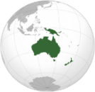 The Pacific
This Photo by Unknown Author is licensed under CC BY-SA
- OPDs from the region noted that there is an over-reliance on special schools in many Pacific Island Countries PICs. These schools, located in urban areas, mostly provide primary education. Children with disabilities in rural and the outer islands have no options and are excluded even from special schools.

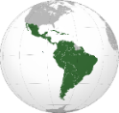 Latin America and the Caribbean
This Photo by Unknown Author is licensed under CC BY-SA
This Photo by Unknown Author is licensed under CC BY-SA
Colombia
- Most schools maintain a segregated vision of education which considers that professionals in special education should conduct the learning processes of children with disabilities. For this reason, inclusive education training programs remain scarce. In it is concluding observations on the initial report of Colombia, the CRPD Committee expressed its concerned about the low levels of enrolment of persons with disabilities at all levels of education, and the prevalence of publicly funded “special classrooms” located within mainstream schools. The Committee expresses its concern that discrimination on the basis of disability is one of the main reasons that persons with disabilities are turned away by mainstream schools, particularly in municipalities and local administrations.

3b. Action Plans for transition to Inclusive Settings
Based on the findings of the reviewed reports both at regional and national level, special education is, to a certain extent, already engaged into being transformed. However, it can be argued that these efforts are often not aligned with the CRPD standards because they are not occurring within the spirit of whole-system collaboration. In fact, despite “inclusive education strategies” are present in many countries, most of these policies does not entail a vision of inclusive education in line with the CRPD and often use “inclusive education” and “special education” interchangeably. Moreover, it is to be noted that underrepresented groups of persons with disabilities are often not duly considered in such policies.

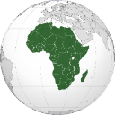Africa

Kenya
- The National Education Sector Strategic Plan- NESSP (2018-2022) for Learners and Trainees with Disabilities recognizes the need for Kenya to progressively move towards inclusive education. The strategic plan identifies learners with disabilities as a target group in reducing disparities in access to and retention in primary education. The strategy also outlines activities to support more effective early intervention services in education and support for quality inclusive education through enhanced curriculum and teacher training. The strategy lays out targets and activities to ensure schools are accessible and inclusive. Finally, the strategy outlines activities and targets to ensure stakeholder collaboration, accountability and awareness raising on inclusive education.
- However, while it acknowledges that learners with disabilities should learn alongside their peers in mainstream schools, it also provides for home based and special schools out of the realization that not all learners will be accommodated in mainstream schools. Therefore, it confuses terms alternating between inclusive education reforms and special education. The policy is also not clear on how the country will transition to a fully inclusive education system. The policy does not go far enough to outline needed initiatives to promote access to education on an equal basis with others. For example, the policy does not address the need for reasonable accommodation in accessing education, the need for a non-rejection clause which ensures that no child can be deemed uneducable. The policy also does not outline plans and budget to transition to a fully inclusive education system. The policy does not outline how children will be taught in their own language including Kenyan Sign Language. Finally, the policy does not do enough to outline the programs needed to address the discrimination and exclusion girls and women learners with disabilities face in accessing education. For example, there are no programs proposed to address gender and disability discrimination in the classroom or to prevent bullying, harassment and/or gender-based violence in schools against girls and women with disabilities.

Niger
- The Education and Training Sector Programme (PSEF 2014-2024) is the only policy that takes into account the education of persons with disabilities. The policy calls for development and implementation of an action plan to gradually take care of the needs of students with disability. These actions include provision of teacher training on education of children with physical disabilities; systematic construction of classrooms with ramps to facilitate access for children with physical disability who use wheelchairs and building toilets adapted to the needs of persons with physical disability. The policy makes no reference to people who are deaf and hard of hearing, blind people, people with intellectual disabilities and people with albinism. On the other hand, some of the planned actions focus on physical disability.
Nigeria
- The National Inclusive Education Policy 2017 calls for a shift from segregated education under the Special Education model to mainstream schools where all learners will be educated together within the general education system. The policy outlines an education system where teachers are trained to teach students with diverse learning styles and needs and where supports and resources are available to teachers and students for specific needs. However, the policy uses a definition for disability that is not compliant with the CRPD; “disability is a condition where a person cannot function optimally without an aid either in a long term or in a permanent basis. Fundamental to a policy aimed at generating a paradigm shift, the definition must comply with the CRPD”.
- While the National Inclusive Education Policy defines inclusive education in accordance with CRPD Article 24 (Education), it does not spell out the necessary measures to implement these reforms in practice. There are not significant resources allocated to re-train and provide continuous training to teachers on inclusive education and adapted learning methodologies. The policy does not spell out the budgets, timeline or responsible authorities to implement wide scale reforms such as: adaptations to all schools to make them accessible with the needed support services such as Sign Language interpretation, Braille printers, hearing loops etc. For example, the policy calls for refurbishing one special school per year to serve as a resource center on inclusive education. Finally, the National Inclusive Education Policy also lacks a gender lens looking at the multiple and intersecting forms of discrimination girls and women with disabilities face in accessing and completing education.

Rwanda
This Photo by Unknown Author is licensed under CC BY-SA
- The Education Sector Strategic Plan Framework for Basic Education (ESSP) 2018/19 TO 2023/24 does not clearly define its vision for inclusive education nor does it propose a clear transition from special education to a fully inclusive mainstream education system. Instead, it uses the terms special education and inclusive education interchangeably and it is not clear from the policy what the government’s vision for inclusive education is or how they define it. The policy does call for all learners to be accommodated in community schools but confuses special needs education with inclusive education with no clear messaging about the schools and classrooms responding to the individual needs of all learners.
- The Revised Special Needs and Inclusive Education Policy 2018 sets up two different schooling systems for learners with disabilities that operate separately: special schools established outside the mainstream education system and Child-Friendly School (CFS) or and Inclusive Education (IE) schools (terms that are used interchangeably). There is no system of accreditation or quality standards being used for these schools. Furthermore, it is unclear how child friendly and inclusive schools adhere to the mainstream education curriculum and how well they comply with the definition of inclusive education outlined in CRPD 24. This policy also calls for the development of two curricula – a special needs education curriculum and an inclusive education one. This call for alternative curriculum is not in-line with inclusive education reforms that comply with the CRPD. The policy does call for special education needs assessments and education interventions/support services to be implemented progressively in all schools. It also confuses the role of education with the development of community-based support services. Community-based rehabilitation and the provision of assistive devices should not be provided within schools under the Ministry of Education. Furthermore, the model outlined in the policy does not aim to keep all students in the same classroom and learning the same curriculum with adaptations and support but rather providing services and an adapted curriculum to learners with disabilities under a special needs paradigm.
- Both policies look at disability and gender in accessing education but not from an intersectional approach. The Special Needs Education Policy points out that there are inequalities in accessing education based on disability, gender and urban/rural dichotomies that make accessing education even more challenging. However, the policy does not propose policy interventions to address these intersectional forms of discrimination. For example, neither education policy looks at the issue of gender or disability-based violence, harassment or abuse in schools or its impact on girls with disabilities staying in or attending school. Furthermore, neither education policy identifies girls with disabilities as a specific target group in ensuring equitable access to education.
Senegal
This Photo by Unknown Author is licensed under CC BY-SA
- In recent years, civil society projects, particularly those initiated by non-governmental organisations, have made it possible to develop inclusive education on the ground and show that this approach is possible in Senegal. For example, the NGO Humanity & Inclusion has been developing an intervention in Casamance to promote inclusive education since 2008 in around 100 public elementary schools, an experience that was extended to 31 schools in the Dakar region in 2015. In addition, in 04 ordinary schools in this region, since 2016, inclusive education for deaf children is a reality thanks to a pilot scheme that includes training teachers in Sign Language and support from school life assistants - AVS. In addition, 5 elementary schools (in Thiaroye-sur-mer, Guédiawaye, Rufisque, Louga and Kaolack) have been experimenting with inclusion since 2011, on the initiative of Sightsavers and with the technical support of the State. In these schools, specific mechanisms allow for the inclusion of children with visual disabilities (training of teachers in Braille, provision of adapted teaching materials, etc.).
- All these experiments initiated by NGOs were carried out in consultation and partnership with the Ministry of Education and its decentralised structures, however, it is worth noting here the difficulty for the State to move on to the institutionalisation and scaling up of inclusive education pilot projects. In 2018, the process of revising the sectoral education policy (PAQUET) made it possible to make this policy more inclusive by integrating aspects related to making schools accessible, training teachers in inclusive education, and the provision of materials adapted to disabled pupils. In addition, in order to respond to the need for a clear strategy for the education of children with disabilities, a process of developing an inclusive education policy has been launched by the Ministry of National Education with the technical and financial support of partners (UNICEF, Italian Cooperation, Humanity & Inclusion and Sightsavers) and is expected to be completed in 2018-2019 (as noted in the report at the time it was published).

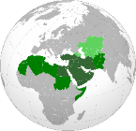 North Africa and the Middle East
Despite the many attempts made at the individual and group levels to plan and implement basic inclusive education, they fall short of achieving the ambitious goal. The basic orientation towards inclusive education thus remains in most—if not all—Arab countries more idealistic than realistic.
The data and evidence confirm this worrying conclusion. It appears so, especially given the rapid attempts at enacting laws on the rights of persons with disabilities in the Arab countries. Even if tens of thousands of students with disabilities should join regular schools in one Arab country by ministerial directive, this will not necessarily mean inclusion. Rather, it will be an attempt to merely admit larger numbers of students in this category, most of them with ‘light disabilities’ so that their inclusion in regular classrooms don’t demand special personnel or intensive teacher training on special education. In fact, the product of this sort of inclusion seems unpromising.

Asia
Evidence collected shows that countries such as Indonesia, the Philippines, Singapore, Thailand, and Vietnam have adopted appropriate national education systems and recognise equal rights to education for persons with disabilities, through specified laws or inclusive derivative regulations. The five countries planned and budgeted for mainstream, public schools as inclusive education institutions by developing inclusive curricula to be implemented by trained education providers deploying learning methodologies that are accessible for every student, including children with disabilities.
However, the implementation may be varied in different levels of communities as quality standards of schools are dependent on the availability of advanced curricula, methodologies, facilities (Braille, sign language interpreters, various learning formats), professional teachers and accessible building features. Mainstream schools that were ill prepared for these supporting mechanisms may have encountered difficulties that would typically contribute to discrimination and stigmatisation of students with disabilities.
Another important point that should be assessed further is to understand the effective implementation of inclusive education within society; to what extent the mainstream schools have provided quality education for children with disabilities; and how viable the education and information centres for disability are in primary schools and universities in disseminating appropriate information on disability inclusion in education and whether the principles enshrined in CRPD Article 24 are understood. Evidently, no assessment has been done by government or OPDs on this centre; thus, it is highly recommended to conduct further advocacy and assessment on this issue.
For instance, in Vietnam, in accordance with inter-ministerial Circular #58/2012/TTLT-BGDDT-BLDTBXH, past specialized schools and institutions are now being turned into new support centres to develop and advocate for inclusion.

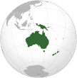 The Pacific
This Photo by Unknown Author is licensed under CC BY-SA
In the Pacific Region, many positive steps have been taken in recent years to implement inclusive education in several Pacific countries. Despite these examples of good practice, obstacles exist in gaining broader attention for the issue of inclusive education. Pacific education ministries grapple with persistently poor literacy and numeracy outcomes in the broader student population, making it difficult for them to decide to prioritise inclusive education. The impact of climate change requires attention and funding for urgent issues such as disaster-recovery, school re-building or addressing water shortages in schools. These and other general budgetary and resource constraints often force countries to make an artificial choice between expanding equity/access or investing in greater quality, even though making the education system inclusive is the cost-effective way to reach both objectives. Despite growing evidence for the benefits of inclusive education, there is still resistance and inclusive education continues to be considered a sub-component of an equality or access policy rather than an overall objective for all children.
Fiji
This Photo by Unknown Author is licensed under CC BY-SA
- The University of the South Pacific has a Disability Resource Centre in Fiji specifically set-up to support students with disabilities, providing student to student buddy support, sign language interpreters and ensuring equal access to services.
- Fiji has recently validated and implemented a method for disability disaggregation in its education administrative data, which has been recognised globally as a novel and useful solution.

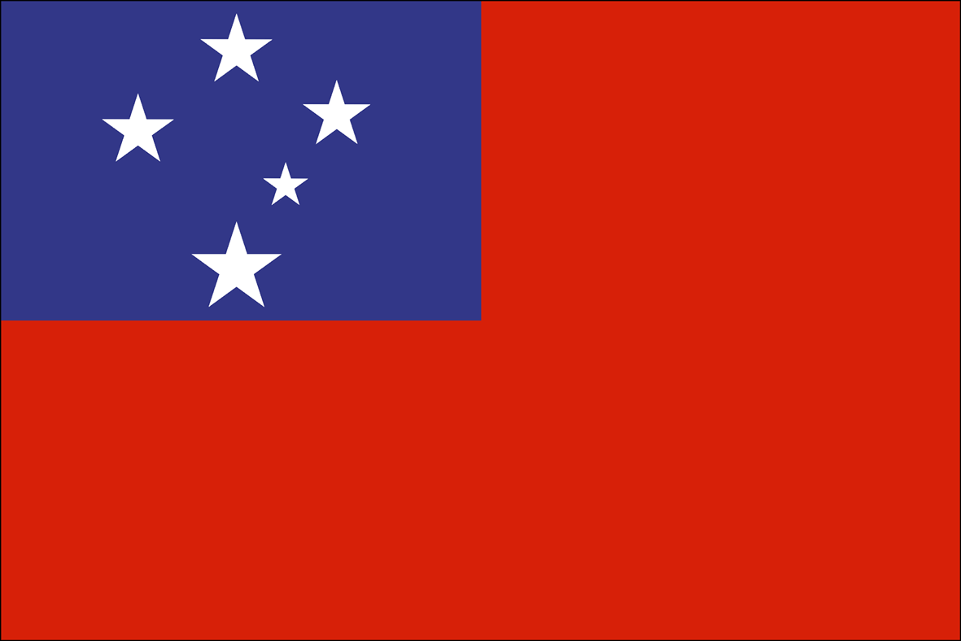
Samoa
This Photo by Unknown Author is licensed under CC BY-SA-NC
- The inclusive education demonstration program increased awareness of the right to education for children with disabilities and collaboration between service providers and the Ministry of Education.

Solomon Islands
This Photo by Unknown Author is licensed under CC BY-SA
- Solomon Islands Ministry of Education and Human Resource Development set up a National Resource Learning Centre in 2014 to provide training and resource materials to teachers and schools implementing inclusive education.

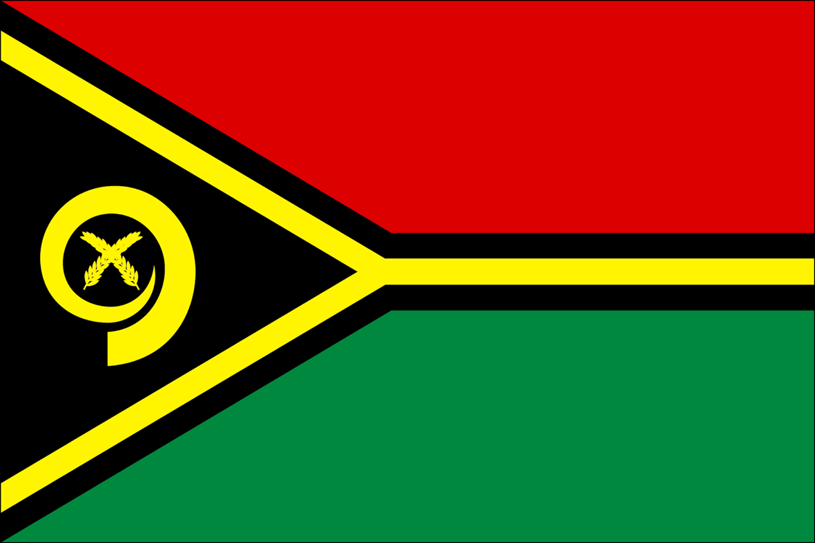 Vanuatu
This Photo by Unknown Author is licensed under CC BY-SA-NC
- The Vanuatu Skills Partnership has made significant contributions to the establishment of a disability-inclusive post-school education and training / technical vocational education and training sector, and youth with disabilities experience greater access to participation in skills development opportunities.

3c. Discrimination and Negative Attitudes towards Learners with Disabilities
In all regions considered in this compilation, stigma and attitudinal barriers are identified as the most significant barrier to inclusive education. These barriers include misconceptions, lack of acceptance, lack of knowledge and co-operation from families, education administrators, schoolteachers and staff, and other students, which negatively affect their inclusion. There is a general assumption that persons with disabilities, in particular persons with intellectual and psychosocial disabilities, lack the skills to participate in society and are therefore deemed uneducable. Lack of awareness and understanding in particular by parents, schoolteachers and education personnel and lack of knowledge about the nature of inclusive education have been reported globally.
Moreover, there is very little access for girls and women with disabilities to education who are more prone to exclusion due to negative socio-cultural beliefs and practices, pressure for marriage, gender-based discrimination, and sexual abuse.

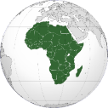Africa

Kenya
- Persons with disabilities have reported “various barriers to accessing education include stigma and discriminatory attitudes from the community and schools; lack of trained teachers to support students with disabilities and unwillingness of family members to support their daughter with a disability to attend school; gender and disability discrimination by both families and communities”.
- Another respondent from Kenya affirmed that “without widespread campaigns to prevent bullying and dismantle stigma and discriminatory attitudes, learners with disabilities and in particular girls with disabilities will continue to face violence including sexual and gender-based violence, harassment and abuse in school”. According to the women with disabilities surveyed in Kenya the barriers to accessing mainstream education are vast. On an individual and community level, respondents felt that gender and disability discriminatory attitudes within families as one of the major barriers in which families do not see value in their daughter with a disability attending school
- The quality of education for children with disabilities still does not meet appropriate quality standards. This may also imply that they are hindered by the other barriers to accessing education including parents not feeling safe letting their children with disabilities attend school due to bullying.
Niger
This Photo by Unknown Author is licensed under CC BY-SA
- The negative perceptions and attitudes against the enrolment of children with disabilities in education from both their families and the community in general still constitute one of the most important barriers to a true social inclusion of persons with disability. Many families use children with disability to earn income through begging, depriving them of their rights to education and training; On the other hand, some families hide those children in their huts. The alternative report on CRPD shows the insufficient awareness on the part of parents and communities of the possibility and necessity of educating their disabled children.

Nigeria
This Photo by Unknown Author is licensed under CC BY-SA
- Stigma and lack of awareness and understanding by schoolteachers. Persons with albinism from Nigeria indicated that “the major challenge face girls with albinism are the lack of visual aids, stigma and lack of awareness and understanding by schoolteachers.”
- Blind persons have indicated that “Blind girls and women are confronted with acute inaccessibility challenges due to lack of learning aids, trained teachers and poor attitude of teachers and administrators”.
- Generally, “girls and women with intellectual disabilities are often not welcomed in schools unlike other disabilities. It was also noted that there are inadequate special teachers, no appropriate teaching aids”.
- Discriminatory attitudes within families themselves discouraging their members with disability to attend school: “Most parents, especially those in the rural areas are grossly lacking in awareness and knowledge of how to support their children’s education. This is why most parents in such areas still keep their children at home.”; “When I got blind, my parents were not aware of where or which school to take me for a long time.”
- “Parents are often not committed to education of girls with disabilities. Parents often prefer to leave them at home because they think the girls with disability are not socio-economically relevant and viable.” She further noted that “most parents don’t know sign language”. As such, deaf children don’t enjoy communication at home”.

Rwanda
This Photo by Unknown Author is licensed under CC BY-SA
- Negative attitudes of the community (including teachers and other members of the school community) that make it difficult for children with disabilities to attend and stay in school.

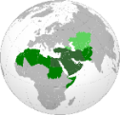North Africa and the Middle East
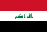
Iraq
This Photo by Unknown Author is licensed under CC BY-SA
- Students with disabilities face a number of barriers to access education, including attitudinal barriers. Social stigma which faces children with disabilities at school by their non-disabled peers, families and the society as a whole.

Asia

Indonesia
This Photo by Unknown Author is licensed under CC BY-SA
- OPDs report have highlighted the existence of disability stereotypes and stigmas and lack of awareness about discrimination against persons with disabilities, particularly women and girls with disabilities, through the existence of many reported cases of discrimination on the basis of disability.
- Based on the sociocultural perspective, parents forced their child (with disability) not to go to school. In West Nusa Tenggara, a 16-year-old girl with autism enrolled in a public special school for only one week before her parents forced her to drop out. Another case happened in West Nusa Tenggara, where a teenage girl with physical disability could not continue her education in high school because her parents did not allow her because they feared that she would be bullied by her classmates.
- Children with intellectual disabilities are denied access to mainstream schools because they are deemed incapable of keeping pace with the curricula. Moreover, some schools list IQ tests as one of the admission requirements. Other reasons for exclusion are the unavailability of accessible infrastructure or trained teachers.
- Many persons with psychosocial disabilities drop out of school, especially at higher education level, because when they encounter mental health problems, reasonable accommodation is not available. Many students who experience mental health problems cannot attend classes and are eventually expelled as their study period has expired. Perhimpunan Jiwa Sehat (Indonesian Mental Health Association/IMHA) advocated several cases of students about to be expelled from universities. In many cases there is a lack of understanding and support from the university towards students who experience such issues.
- In 2017, a fourth-grader student with disability at an inclusive school was forced to move to a special education school because he was deemed incapable of following the lessons. His mother refused it but ultimately bowed to the pressure. Another child with cerebral palsy was denied entry to a kindergarten because he was considered too old.
- A case of an 11-year-old girl with intellectual disability in Central Sulawesi had been constantly bullied by her classmates ever since she was in elementary school. Even her teacher sometimes made discriminatory comments to her parents. Her mother eventually decided to take her out of the school. Other known cases are as follows; In Semarang (Central Java), Central Lombok (West Nusa Tenggara), and Banda Aceh (Aceh). Rude and discriminative treatment also happened to a deaf woman in an inclusive school in Semarang, Central Java (2019). Such treatment was committed by the teacher and headmaster. On top of that, her classmates also bullied her. Unfortunately, the school administration did not take any remedial actions and simply ignored the case.
- In Central Lombok, West Nusa Tenggara, a mother of a daughter with intellectual disability had to transfer her child to a special school because the administration in the old school said that “she does not belong in this school” (the student was slow in learning). Because of this harsh comment, the student refused to go to school because she was embarrassed and lost her self-confidence (the case is documented by HWDI of West Nusa Tenggara).
- In Banda Aceh, in the year 2016, a 10-year-old girl with physical disability suffered from bullying and sexual harassment committed by her classmates until she had to leave the school. The perpetrator inserted his dirt-covered fingers to her vagina, which caused her pain and infection. She was taken to t She was taken to the local community health centre.

Vietnam
This Photo by Unknown Author is licensed under CC BY-SA
- One of the greatest barriers to inclusive education is the attitude and knowledge of parents, carers and other of stakeholders which influencing access to education of children with disabilities. In a survey conducted by ACDC in 2017 it was reported by the majority of children with disability participating in the consultation that they wanted to go to school, but not all of them could. A grandmother of a 7-year-old with hearing impairment explained the predicament:
“They are old enough to go to primary school, but we do not have any intention to let them go to school because there are no such cases in the commune. We know one school for children with disability, named Thụy An school; however, since they are too young to take care of themselves, we feel pity for them and have not let them go to school yet. Also, we do not know any schools for deaf children.”
- A significant number of parents do not want their children to be registered as 'children with disabilities' because they are concerned that their children will be discriminated against by their friends and surrounding people; or if their child is classified as having a 'mild disability', he or she will not receive many social protection benefits.
- It is likely that the parents’ refusal to register for identification of a disability has led to the fact that some students with disabilities are not currently benefiting from relevant state policies such as Joint Circular 42/2013 on supporting the education for people with disabilities (ACDC, 2017).
- Even so, there is discrimination at the entry level, despite the fact that the law prohibits refusal of admission for students with disabilities. Phùng Thị Phương Vy, a parent, reported their experience (ACDC, 2017): “When Vy was old enough to go to kindergarten, we wanted to let her go to school, but the kindergarten did not accept her because her disability was so severe that teachers could not take care of them.”
- Sadly, this is also reflected in the wording used in the scheme for assistance of persons with disabilities, which only includes children with disabilities who have “studying ability”.
- Among the schools that supported students with disabilities, these were the reported methods of accommodation adopted: Even where children with disabilities were accepted into schools, they would often be excluded from classrooms for fear of bringing down standards for other children, or because they were deemed ‘uneducable’ for certain subjects (ACDC, 2017).

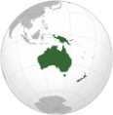 The Pacific
This Photo by Unknown Author is licensed under CC BY-SA
In Pacific Island Countries PICs, almost in all countries there is lack of awareness raising and counselling, which leads many parents to keep their children at home as they cannot afford the costs, fear bullying, believe their children cannot learn, or do not feel schooling will lead to employment or income.

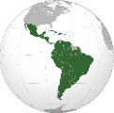Latin America and the Caribbean
This Photo by Unknown Author is licensed under CC BY-SA

Colombia
This Photo by Unknown Author is licensed under CC BY-SA
- As reported by the CRPD Committee (2016, para. 21-22), public and private education campaigns tend to adopt a charitable model of disability. This approach replicates the negative stereotypes, which serve to exclude persons with disabilities from educational programs. Likewise, the Committee expresses its concern that discrimination on the basis of disability is one of the main reasons that persons with disabilities are turned away by mainstream schools, particularly in municipalities.

4. Enabling Mechanisms (Accessibility, Support Services and Accommodations)
OPDs reports both regional and national levels indicate the lack of accessibility standards of school infrastructures, information and communications, and the lack of transport facilities for students with disabilities, particularly in rural areas. Also, the lack of provision of assistive technology and accessible information and communication formats, including easy read, is severely limited, particularly for persons with visual impairments and those with intellectual disabilities.
The lack of accessible and inclusive environments in schools and universities, buildings, educational material, services, equipment, information and communication technologies, as well as individualized support provided to students with disabilities all are not accessible to learners with disability.
Moreover, evidence collected show that as sign language is not yet recognized as an official language in many countries and the consequent insufficient availability of sign language interpreters results in an insufficient number of teachers who are proficient in sign language, hampering the access of deaf children to bilingual education.

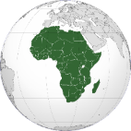Africa

Kenya
This Photo by Unknown Author is licensed under CC BY-SA
- The majority of regular schools are not accessible to learners with disabilities in terms of physical environment, adapted curricula and inaccessible learning materials. Long distances to schools further exacerbate this problem. Two different surveys by the Ministry of Education and Voluntary Services Overseas VSO (2014) & National Gender and Equality Commission NGEC (2016) in Kenya, identified similar challenges that limit the provision of inclusive quality education as articulated in the CRPD article 24. The challenges include lack of appropriate tools and skills for early identification and educational assessment; inadequate infrastructure in most schools that can accommodate children with disabilities; costly assistive devices which are not always adequately availed for all children with disabilities and inadequate learning materials.
- The Sector Policy for Learners and Trainees with Disabilities from 2018 calls for inclusive education and a curriculum that is adapted to the individual needs of all learners. It sets out to provide inclusive and education and training at all education levels. However, the policy does not outline how children will be taught in their own language including Kenyan Sign Language. The Parliament of Kenya has developed the Kenyan Sign Language Bill (2019) through which Sign Language has become an official language. There are also efforts by the Kenya Institute for the Blind and the Kenya Institute of Curriculum Development to develop a code of practice on the national curriculum for teaching Braille. This will ensure improved standards of Braille teaching in the country and the use of Sign Language.

Niger
This Photo by Unknown Author is licensed under CC BY-SA
- Despite the existence of a national standard for accessibility since 1993, accessibility remains a major obstacle to the inclusion of persons with disability in education. The inaccessibility of school infrastructures, lack of accessibility standards for information and communications technologies; the distance of schools from the homes of children with disabilities, the lack of transport facilities for students with disabilities, particularly in rural areas, lack of adapted teaching materials, are major challenges for students with disabilities in accessing education.
- Deaf students face additional challenges in education, in particular due to the lack of sign language professionals in the school system and the consequent the lack of proficiency from schoolteachers in this language.

Nigeria
This Photo by Unknown Author is licensed under CC BY-SA
- During a Focus Group Discussion on the rights of women with disabilities, a participant with physical disability stated that “the major barrier to girls with disability in primary and secondary schools is the inaccessible school buildings and inaccessible public transport. She also noted that most available public inclusive schools are too few and far from residential locations”. A participant with physical disability shared her experience as a student in a tertiary institution: “I acquired my disability as an adult and attending tertiary institution was hell. The classes are very far from the hostels; the school management is not sensitive to my disability and needs. I had to struggle for everything including sitting spaces in class.” (Participant with physical disability)
- Blind participants indicated that “most blind girls go to special schools. They noted that the current practice of inclusive education in Nigeria was not meeting the needs of blind girls. This, according to them is due to lack of trained teachers, absence of Brailed textbooks and assistive technologies”.
- OPDs have highlighted the insufficient provision of sign language interpretation for students who are deaf or hard of hearing. Consequently, “the deaf student prefers to go to special primary and secondary schools due to the need to build proper skills in sign language culture”. Inclusive education is not effective for deaf girls at primary and secondary levels due to inadequate trained teachers, subject teachers who understand sign language and interpreters”.
This Photo by Unknown Author is licensed under CC BY-SA
Rwanda
- Few schools are accessible and there is a severe lack of accessible transportation to and from schools. These are major reasons for high dropout rates for learners with disabilities. In addition, mainstream public schools often lack adequate teacher training, lack of an adapted curriculum and a lack of accommodating materials and services. OPDs’ reports show large class sizes which make it difficult for teachers to pay learners with disabilities (and other learners as well) the individual attention they may require; and lack of adequate materials for learners with disabilities.
- Education laws do not provide for the right of all learners to be taught in their language, including national sign language. Therefore, many deaf and deafblind people often experience communication barriers which make it difficult for them to access public services including healthcare, education, and justice.
This Photo by Unknown Author is licensed under CC BY-SA
Senegal
- Hundreds of schools have been built or rehabilitated in recent years, but without taking into account the right to education of children with disabilities. There are no aisles, no access ramps, even less adapted toilets, no soundproofing of classrooms, to accommodate this category of children through an adapted pedagogy

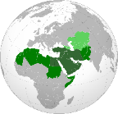 North Africa and the Middle East

Iraq
This Photo by Unknown Author is licensed under CC BY-SA
- Students with disabilities face a number of barriers to accessing education, including attitudinal, institutional, environmental and physical barriers. Schools are usually very far from where children with disabilities live, facilities are inaccessible with stairs, narrow entrances and unsuitable seating spaces.
- OPDs have reported general lack of individualized support, lack of financial, human and material resources, lack of guidelines on implementing good practices in the fields of inclusion and equality in education.
- Therefore, persons with disabilities have no access to inclusive quality education based on international standards, and there is spread of illiteracy among them due to the negligence in the role of the State who is not doing its duty. Based on that, reaching universities is very difficult because of the lack of adequate infrastructure at the primary and secondary levels of education, which entrenches the lack of accessibility to higher education.

Palestine
This Photo by Unknown Author is licensed under CC BY-SA
- Although the Ministry of Education is the official entity with oversight on the education sector, it lacks special policies targeting students with disabilities. The 2011 census showed that 53.3% of persons with disabilities are illiterate. Official data shows a failure among the three stakeholders in the education process (UNRWA, the Government and the private sector) in properly addressing suitable physical environments for children with disabilities. For example, bathrooms in over 60% of UNRWA schools and 63% of government schools are inaccessible to students with physical disabilities and not suitable for other students with disabilities. Schools in general lack ramps for students using wheelchairs. This prevents them from accessing school. Government schools are the least fit and accessible with the lack of ramps among 53.3% of them. They are also the support service with no reasonable accommodations available in most of them.

Asia

Bangladesh
This Photo by Unknown Author is licensed under CC BY-SA
- A study conducted by the Bangladesh National Grassroots Organization of Persons with Disability (NGDO), the National Council of Women with Disability (NCDW) and Bangladesh Legal Aid and Services Trust (BLAST) highlighted the following findings on education: no statistics are available on the number of children with disabilities attending primary schools; 19% of the respondents noted that children with visual impairments could not study in schools due to schools not being disability-friendly; 21% said that Braille was not used in schools; 41% were of the opinion that there was a lack of accessible educational materials in schools; 57% of respondents felt that teachers were not given appropriate training to help them deal with children with disabilities and speech and hearing difficulties; accessibility and distance of schools remain an obstacle for students with disabilities; most educational institutions lack ramps and wheelchair-accessible toilets; and students with disabilities face discrimination and are more than often denied admission on the basis of their disability.
- No books or materials in Braille are available at the higher secondary education level for students with visual impairments and the cost of printing these books is very high and most students are unable to afford them.
- Students with visual impairments and physical impairments, if informed earlier, are allowed scribes. However, since there is no approved policy on scribes, schools, colleges and universities have their individual systems, which is often confusing for students with disabilities.
- Special schools for children with visual impairment and hearing and speech disabilities have poor infrastructure and lack teachers with sufficient training and capacity. Buildings of educational institutions are also not accessible for persons with physical disabilities. It is necessary for any type of special and integrated education to reach children with disabilities at the grassroot level, particularly children with neuro-developmental disabilities, but this is currently lacking.

Indonesia
This Photo by Unknown Author is licensed under CC BY-SA
- The “Zoning” system restricts persons with disabilities from choosing their own schools. In 2014, a student with disabilities was denied access to an inclusive elementary school in Banda Aceh on the ground that he was from a different zone. Once they found an inclusive school within the allowed zone, he was still denied access because his teacher felt distracted by the presence of the teacher assistant during the class. Disappointed, the parents decided to send him to a special school in the City of Banda Aceh. (The case has been advocated by OPDs in Aceh. The student’s parents had tried to explain to the school administrator concerning inclusive school and its obligation to accept their child. However, the school remained adamant).
- The Deaf Welfare Movement or GERKATIN records that almost in all of special schools, deaf students are forced to use oral language, while the use of sign language is not recognized even more forbidden in school. One of the reasons why this is happening is because of the limited number of teachers who are able to use sign language.
- OPDs have documented discriminatory practices due to inflexibility of curricula, methods and lack of support services and accommodations. In 2019, there was a case of discrimination based on disability for a girl with hearing disability in Banda Aceh. She was denied access to vocational school because she is deaf. The girl was able to go back to school thanks to the intervention of the Acting Governor’s wife in the case.

Vietnam
This Photo by Unknown Author is licensed under CC BY-SA
- Children with disabilities still lag in their educational attainment, more than half of children with disabilities do not have access to education. Some of the reasons for these inequities include remoteness and distance (such as schools located too far away) and poor infrastructure (such as broke road conditions leading to concerns about children's safety, poor classroom buildings, and water and sanitation facilities). Only 2% of primary and secondary schools in the country had been designed to accommodate the needs of children with disabilities. Children with disabilities and their parents report that they are not given access to individualized support plans or reasonable accommodation. Many families are forced to seek alternative education for their children with disability through special schools or private home tutors. These are associated with significantly higher fees that are not affordable by all households (Palmer, 2015).
- A national disability survey in 2016 shows that schools at the primary and lower secondary level were evaluated if they have both paths and sanitation facilities designed to be suitable for persons with disabilities, they would be considered accessible schools. As per the survey, only 2.9% of all schools were found to be accessible for students with disabilities, with 8.1% of schools having accessible paths and 9.9% of schools having accessible sanitation facilities. Lack of appropriate infrastructure was a reason cited by 68.1% of respondent schools as a difficulty in educating children with disabilities in the 2016 survey. (ACDC, 2017). Additionally, kindergarten, primary and lower secondary schools are located at the commune level. Beyond the lower secondary level, schools are located in the centre of the district, which is farther and makes it more difficult for children with disabilities to go to school as they have to negotiate accessible transportation (ACDC, 2017).

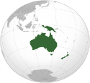The Pacific
This Photo by Unknown Author is licensed under CC BY-SA
- In Pacific Island Countries (PICs), reports identify the main barriers to inclusive education include, inaccessible school facilities, curriculum and teaching materials, inaccessible transport, which is magnified in remote areas and outer islands. For example, in some places in Kiribati the age of attendance is determined by the weight and mobility of the child: when he or she is too heavy to be lifted into the school bus, the child can no longer attend as the buses are not wheelchair accessible. With regards to accessibility regulations, the report noted that, several countries (such as Samoa) have revised their building codes, but there are few consistent technical standards and little enforcement on accessibility around the region. No country yet has a comprehensive set of regulations that would cover public infrastructure, transportation, private services open to the public, information and communication services in line with the CRPD. The report also highlights the lack of funding or effective systems to meet individual learning and support needs, including sign language interpreters, braille materials, and teacher aides. Lack of support to families, including financial assistance, poor access to services required to enable optimal education, including early identification and intervention, rehabilitation, therapies, medical services and assistive devices/technologies.
- In PIC countries, OPDs have reported a general limited access to sign language and bilingual education for deaf children and identified it as a major common barrier to inclusive education.

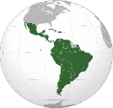Latin America and the Caribbean
This Photo by Unknown Author is licensed under CC BY-SA
This Photo by Unknown Author is licensed under CC BY-SA
Colombia
- As reported by the CRPD Committee in it is concluding observations on its initial report, the committee is concerned about the lack of teaching and reading materials in accessible formats and modes of communication.

5. Gaps and challenges identified by OPDs
The review of this compilation has highlighted the following gaps and challenges:
- Lack of comprehensive legal and policy framework. Absence of or inadequate legislations and policies on education for learners with disabilities, policy implementation a lack of clarity, discriminatory policies or misalignment with international human rights frameworks have been highlighted in the reports reviewed. This along with the lack of reasonable accommodation, lack of zero-discrimination policies, evident discrimination and exclusion of learners with disability in mainstream education institutions; lack of government monitoring mechanisms; and lack of accountability for children who drop out of education or face disability-based discrimination by school officials are among the legal barriers to achievement of the right to quality education for learners with disability. A lack of clear policy results in resistance from within the mainstream education system to prioritise inclusion.

- Lack of adequate support systems and accessible environments. The inaccessible school buildings, inaccessible transport, schools being far from where children with disabilities are living; non-compliant curricula, inadequacy of educational material, needs for support services like sign language interpreters, occupational therapists etc. are reported as significant barriers to inclusive education.

- The Low Enrolment and Completion Rate. Low rates of enrolment of persons with disabilities at all levels of education and high dropout rates in both mainstream and special education schools are evident across all regions and countries. High illiteracy rate among persons with disabilities, particularly persons with intellectual disabilities and women and girls with disabilities, and the low number of students with disabilities enrolled in mainstream inclusive education at all levels; high drop-out and low completion rate among girls with intellectual disabilities compared with other disability groups pose barriers to the implementation of Article 24 of the CRPD

- Discrimination and Negative Attitudes towards Learners with Disability. The lack of awareness, misconceptions, lack of acceptance, lack of knowledge and co-operation from families, education administrators, schoolteachers and staff, and other students, have been seen to negatively affect the inclusion of learners with disabilities.

- Lack of trained personnel at all levels of education. Lack of teachers trained in inclusive education, sign language, Braille and Easy Read and the lack of training for teachers on the skills and competencies to promote inclusive education is a major barrier to the achievement of SDG 4 and Article 24 of CRPD.

- Budgetary and resource constraints and lack of financial support. Inadequate budget allocation, no significant resources allocated to re-train and provide continuous training to teachers on inclusive education and adapted learning methodologies, to create accessible environments, to facilitate access to assistive devices/technologies (AT) and/or Information and Communication Technologies (ICT) have been reported by OPDs

- Intersectional forms of discrimination. Inequalities in accessing education based on disability, gender and urban/rural dichotomies make accessing education even more challenging.

- The impact of climate change and the challenges of disaster-recovery, school re-building or water shortages in schools. This was reported from the Pacific region but is an issue that needs more attention as the impact of climate change become more and more evident across the globe.

- The lack of coordination and synergy actions between different partners on inclusive education. The gap in coordination among different government ministries Ministry of Education – Ministry of Higher Education – MP – NGO – OPDs – Local authorities – Communes); lack of mechanisms to coordinate the various actors engaged in the special needs education sector; low involvement in the field by the private sector make the implementation of inclusive education even more challenging

6. Good Practices
This compilation review has collected the following good practices:
With regard to legal and policy frameworks for protection of the right to inclusive education:
- The Sector Policy for Learners and Trainees with Disabilities from 2018 in Kenya: This policy calls makes a step forward in inclusive education in Kenya calling for inclusive education and a curriculum that is adapted to the individual needs of all learners. It sets out to mainstream and provide inclusive education at all education levels while providing access to quality and relevant education and training at all levels. It also sets out to implement assessment and early intervention standards and regulations in education. The policy also prioritizes equity and gender mainstreaming and the establishment of barrier-free learning environments at all levels of education. Inclusive education is seen as the main approach, while recognising the role of special institutions of learning, special units/classes and home-based education programmes.
- The law governing nursery, primary and secondary education in Rwanda outlines the participation of NGOs in education and gives a role to the National Council of Persons with Disabilities as well as to the Coordination of the National Women’s Council giving opportunities for DPOs and organizations led by women to input into the governing of nursery, primary and secondary education.

With regard to data collection:
- Disability disaggregated education management information systems (EMIS) are pivotal for providing data to track progress towards SDG 4 and implementation of CRPD Article 24. Fiji has recently validated and implemented a method for disability disaggregation in its education administrative data, which has been recognised globally as a novel and useful solution. UNESCO's International Institute for Educational Planning and UNICEF are including Fiji's system in their training courses as an example of best practice.

With regard to sign language and bilingual schools:
- Kenyan Sign Language Bill. The government is developing the Kenyan Sign Language Bill, 2019 (as included in the report at the time of publication). This Bill provides for the inclusion of Sign Language in education curriculum; the use of Sign Language in legal proceedings, provision of reasonable accommodation for persons who are Deaf or hard of hearing and for government to take all necessary steps to proliferate Sign Language competency among hearing people by offering Kenyan Sign Language as a language subject in the mainstream education curriculum. Kenyan Sign Language is also to be offered as a discipline of study at technical and vocational training institutions, public colleges and public universities. Once this Bill is enacted, Sign Language will become an official language in Kenya; hence promoting communication for people with hearing impairments. There are also efforts by the Kenya Institute for the Blind and the Kenya Institute of Curriculum Development to develop a code of practice on the national curriculum for teaching Braille. This will ensure improved standards of Braille teaching in the country.

With regard to training of personnel and staff:
- In Singapore, the Ministry of Education provides training for all teachers in mainstream schools to ensure that they have a basic understanding and awareness of disabilities. Besides, every school has a group of teachers who undergo more extensive training to equip them with greater knowledge and better skills to support students with disabilities in their respective schools. All primary schools are also provided with specially trained Allied Educators (Learning and Behavioural Support), who work closely with teachers to identify and provide additional learning support to students with mild disabilities (Singapore CRPD State Report, 2016).
- The Solomon Islands Ministry of Education and Human Resource Development set up a National Resource Learning Centre in 2014 to provide training and resource materials to teachers and schools implementing inclusive education.
- Training teachers in inclusive education. In Rwanda, the government is committed to ensuring that public schools are all accessible and have adequate number of teachers. The number of teachers trained in inclusive education is expected to rise thanks to a dedicated curriculum at the University of Rwanda College of Education. The Rwanda Education Board (REB) is also now engaged in training teachers in inclusive education practices

With regard to action plans to support transition to inclusive settings:
- In Samoa, the inclusive education demonstration program increased awareness of the right to education for children with disabilities and collaboration between service providers and the Ministry of Education.
- Pacific INDIE – Pacific Indicators for Disability-Inclusive Education is helping PICs to know how to implement disability-inclusive education in a context-specific way, and to be able to evaluate their efforts and develop future plans for providing quality education for children and youth with disabilities is a key step. Pacific INDIE is a set of contextually specific indicators for disability-inclusive education in the Pacific and guidelines for implementation. It was developed through research in 14 countries, with in-depth work in four countries – Samoa, Vanuatu, Solomon Islands and Fiji. Designed to support appropriate data collection to inform policy development and monitor and report progress towards disability-inclusive education, the tool has 48 indicators across 10 dimensions: Policy and legislation, Awareness, Education, training & professional development, Presence and achievement, Physical environment and transport, Identification, Early intervention and services, Collaboration and shared responsibility, Curriculum and assessment practices, transition pathways.
- Access to Quality Education Program (AQEP) in Fiji: In Fiji in 2011, most children with disabilities who were enrolled in school were attending one of seventeen segregated special education centres, in urban areas. Access in rural, remote and maritime areas was limited and many children with disabilities were out of school. With support from the Australian aid program, the Fiji Ministry of Education implemented AQEP to enable more children with disabilities to attend school. Four rural schools plus one school in Suva, were selected as ‘demonstration schools’ for modelling inclusive education. These five demonstration schools had a focus on: teacher training; funding and training for teacher aides; community awareness-raising about the importance of education for children with disabilities; referrals to health services including rehabilitation and assistive devices; and renovations to school buildings including water and sanitation facilities to increase accessibility. Lessons from this approach informed revisions to the policy and development of the Special and Inclusive Education Policy Implementation Plan 2017-2020. Because of these efforts, 60 primary schools across Fiji reported children with disabilities attending in 2017, and there are now 22 secondary schools in Fiji which have students with a variety of impairments attending, all of whom passed the necessary entrance examination on academic merit.
- ASEAN members’ States in 2019 set a new milestone on the protection of the rights of persons with disabilities, by adopting the ASEAN Enabling Masterplan 2025. This important document will be an essential tool for monitoring and evaluating mechanisms that are inclusive and that involve the participation of OPDs and multi-stakeholders in the implementation of SDGs-CRPD, in alignment with the 2030 Agenda. The Masterplan consists of 76 key action points traversing the three ASEAN community pillars, namely, the Political-Security Community, the Economic Community and the Socio-Cultural Community. Performance on these action points will be reviewed at the projected mid and end-term milestones in 2021 and 2025, respectively (Secretariat, 2018).
- The Moroccan government is drafting a national plan to operationalize inclusive education for persons with disabilities (as mentioned in the report at the time of publication). The plan involves, for the short term, teacher training, curricula improvement, educational approaches, system evaluation and using pedagogical tests and evaluations for all forms of disability. Official examinations are being modified to fit the conditions of students with disabilities and regulate the conditions for how they take these exams.

With regard to enabling mechanisms:
- The Vanuatu Skills Partnership has made significant contributions to the establishment of a disability-inclusive post-school education and training / technical vocational education and training sector, and youth with disabilities experience greater access to participation in skills development opportunities.
- The University of the South Pacific has a Disability Resource Centre in Fiji specifically set-up to support students with disabilities, providing student to student buddy support, sign language interpreters and ensuring equal access to services.

7. Recommendations and the way forward
To ensure inclusive and equitable quality education and promote lifelong learning opportunities for all learners with disabilities in accordance with Article 24 of the CRPD and SDG 4 of the 2030 Agenda, OPDs suggest the recommendations below. Such recommendations are complementary and build upon to some of the recommendations of the IDA Inclusive Education Global Report:
Recommendations from the IDA Inclusive Education Global Report | Recommendations from OPDs collected evidence
(To governments)  1. Whether managed by the public or private sectors, all education facilities must be regulated by ministries of Education or relevant ministries for inclusive vocational  training, early childhood development and life-long learning. | - Legal frameworks on education should ensure that learners with disabilities have access to general higher education, vocational training, adult and lifelong learning without discrimination and on an equal basis with others through inclusive and accessible learning opportunities and reasonable accommodations.  - Promote positive measures to promote access to education by women and girls with disabilities such as affirmative action policies and scholarships to women and girls with disabilities to attend school.
2. Non-discrimination policies, Zero Rejection policies, and reasonable accommodations –  as defined in the UNCRPD – must be enforced across the country and at all levels of the  system. | - Legal frameworks on education must be reformed to promote access to accessible, equitable, quality, inclusive education with provisions that explicitly prohibit discrimination in accessing education on the basis of disability and gender. The legal framework on education must also provide for reasonable accommodations in accessing education as required by CRPD Article 24 (Education).  - Policy implementation mechanisms should also include anti-bullying programmes in schools and communities to prevent gender and disability-based violence in schools, one of the leading factors in high drop-out rates for girls with disabilities in many surveyed countries.  - Put in place measures to address the heightened risk for women and girls with disabilities of becoming victims of violence, abuse, exploitation and harmful practices in their homes, community and institutions that prevent them equal access to education, and adopt measures to ensure that services, including shelters, and information are accessible to victims with disabilities.
3. Significant investments (human, social and financial) must be made in:  a) recruiting and training qualified teachers, including teachers with disabilities, who  can provide inclusive and quality learning for all learners;  b) ensuring accessibility of all education facilities, teaching and learning materials,  curricular and extra-curricular activities;  c) providing assistive products and technology, and the training thereof;  d) ensuring support services at all levels, including in engaging parents and the  community, to assist all schools in providing quality and inclusive learning for all. | - Invest in State sponsored raising awareness campaigns amongst families and communities on the importance of educating children with disabilities, and in particular, girls with disabilities and promote messages about the rights of women and girls to education and the contributions of women and girls to society.
4. Teacher education and curriculum reforms must foster the principles of Universal Design  for Learning, including equal access and participation in learning and assessment.  Ministries of Education must engage in the planning, design and implementation of a  single, flexible, national curriculum that recognises the diversity of the country and  encourages an individualised learning approach that is fit-for-purpose. | - Education policies must promote reforms to ensure all schools within the mainstream education system are accessible, inclusive with a flexible and adaptive curriculum with modified and adapted teaching methods and materials and adequate support services, such as sign language interpretation, occupational therapy, Braille materials and tactile interpretation. The policy framework must also provide resources and training to teachers and schools personnel on inclusive education to support them in implementing inclusive education in the classroom
5. A diversity of languages – including national sign languages and tactile sign languages –  and modes of communication must be used throughout the system (with teachers who  have full fluency). | - The education policy framework should also facilitate the learning of the national Sign Language and the promotion of the linguistic identity of the Deaf community through inclusive bilingual schools.  - Ensure that the education of all learners with disabilities, and in particular learners who are blind, deaf or deaf-blind, is provided in the languages, modes and means of communication most appropriate to the individual, and in environments which maximize academic and social development.
6. Data must be consistently collected, disaggregated to the extent possible by disability  type, and analysed to ensure adequate monitoring and resourcing of inclusive and  equitable quality education. | - Mandate the collection of disaggregated data on disability in the education sector, using the Washington group short set of questions
8. Communities, families, parents and students themselves must be active participants in  monitoring and evaluation activities. Education reform with a view to equitable  participation requires governments and professionals to actively engage at the  community level, in order to determine the strengths of each community and their preferences. Meaningful consultation and engagement with communities, families and  parents are essential to the fruitful realisation of SDG4. | - Provide resources and staffing to roll-out anti-bullying campaigns to reduce discrimination, violence and abuse in schools. Ensure the involvement of parents and guardians in anti-bullying campaigns.
(To civil society)  2. Donors and external funding sources to INGOs comply with SDG4 and the CRPD by  making all available funds contingent on disability-inclusive provisions. In addition,  governments ensure all INGOs have an opportunity to actively and purposefully engage  in reform efforts but continue leading in the provision of adequate and inclusive services.  All INGOs must pledge their support to the design and implementation of inclusive  education systems. | - Strengthen regional cooperation to exchange innovative and successful practices on inclusive education.

Conclusion and way forward
This compilation review of OPD reports tackling education is an important step in consolidating the IDA Inclusive Education Global Report and in informing the second phase of the IDA Inclusive Education Flagship initiative with the perspectives of OPDs from the global South.

In fact, the evidence gathered from OPDs from different regions clearly show that, for each topic considered, the key barriers and issues impeding the right to inclusive education for learners with disabilities are similar. From the lower enrolment and school completion rates of learners with disabilities to the lack of accessibility, reasonable accommodation and trained personnel, these common patterns, especially those related to the interchangeable use of “special schools” and “inclusive schools” in legislations and policies, can be all linked to a lack of a common understanding of the provisions enshrined in the CRPD Article 24 on education as well as of what it actually takes to implement inclusive education in practice.

The findings of this compilation report, including gaps, recommendations and good practices identified complement and strengthen the vision enshrined in the IDA inclusive Education Global Report and can provide a good basis to inform the operationalization of IDA’s vision on inclusive education within the country context, and therefore should be built upon to frame inclusive education practices in line with the CRPD.

“What an inclusive, equitable, quality education means to us”, Report of the International Disability Alliance, 2020
William Aseka and Arlene Kanter, The Basic Education Act of 2013: Why it is One Step Forward and Two Steps Back for Children with Disabilities in Kenya, (2014) 2 ADRY 33-50: http://www.saflii.org/za/journals/ADRY/2014/2.pdf
Act No. 99-046 of 28 December 1999 https://www.ilo.org/dyn/natlex/docs/ELECTRONIC/97009/114926/F-568307560/MLI-97009.pdf
Ministry of Education Nigeria, Compulsory Free Universal Basic Education Act 2004: https://www.lawyard.ng/wp-content/uploads/2016/01/COMPULSORY-FREE-UNIVERSAL-BASIC-EDUCATION-ACT2004.pdf
Nigeria Vision 20: 2020 The 1st NV20:2020 Medium Term Implementation Plan (2010 – 2013): https://www.preventionweb.net/files/14632_1stnipeditedversionvol1.pdf
Rwanda’s Constitution of 2003 with 2015 amendments, Article 20: Right to education, available at the Constitute Project : https://www.constituteproject.org/constitution/Rwanda_2015.pdf?lang=en
Ibid Article 16 Protection from discrimination
Ibid Article 51
Law no 20/2017 of 28/04/2017 Establishing Higher Education Council in Rwanda and Determining its Mission.
Special Education and Inclusive Education Strategic Plan (2011–2015).
Reply from CSOs to the List of Issues in relation to the initial State Report of the Republic of Rwanda
Republic of Rwanda, Girls Education Policy, 201
National Institute of Statistics in Rwanda, Fourth Population and Housing Census, Rwanda, 2012, Thematic report: Socio-economic characteristics of persons with disabilities, 2014, p. xvii
National Institute of Statistics in Rwanda, Fourth Population and Housing Census, Rwanda, 2012, Thematic report: Socio-economic characteristics of persons with disabilities, 2014, p. 28
Indonesia Minister of National Education and Culture Regulation No. 70 Year 2009 concerning Inclusive Education, Article 1, states: “Inclusive education is a system of education that provides opportunities for all students who have abnormalities and have the potential for intelligence and/or special talents to attend education or learning in one education environment together with students in general". This basis underlies the implementation of inclusive education for children with disabilities, which in juridical nomenclature is referred to as "children who have abnormalities”.
Participation of Jorge Muñoz y Anderson Henao at the workshops.
UNICEF, Nigeria Education Programme: https://www.unicef.org/nigeria/education
UNICEF, Rwanda Education Programme : https://www.unicef.org/rwanda/education
Technical and vocational education and training.
For reference, in 2017, of the 17.4 million school-age population (aged 5 – 24 years) only 2.6 hundred thousand (1.5% ) had disabilities. For this age group, there was a disparity in accessing education between those with and without disabilities, because only one third of the population with disabilities were attending schools at various levels - primary level (15.2%), followed by lower secondary school (8.9%), and diploma or higher (1.2%). Source: http://www.nso.go.th/sites/2014en/Survey/social/SocialSecurity/Disabilitysurvey/2017/Full_Report.pdf
Participation of Natalia Moreno in the Validation workshop of the National Report on the Implementation of SDGs and CRPD in Colombia. 2019
Ibid, Participation of Mónica Cortés y Betty Roncancio in the workshop.
Ibid, Participation of Nubia Suta in the workshops.
Republic of Rwanda Ministry of Education, Education Sector Strategic Plan 2018/19-2023/24, page 17, available at: http://www.minecofin.gov.rw/fileadmin/templates/documents/NDPR/Sector_Strategic_Plans/Education.pdf
(Castro and Correa, 2016; Programa de las Naciones Unidas para el Desarrollo, 2016; Defensoría del Pueblo de Colombia, 2016; Ministerio de Salud y Protección Social, 2018).
Salam Gómez, National Councilor for Disability,Colombia
Alejandra León, director of the business program of labor promotion for persons with disabilities,
Dean Lermen, Secretary of Human Rights of the Latin American Union of the Blind,
Anderson Henao of Humanity & Inclusion Colombia
https://research.sightsavers.org/wp-content/uploads/sites/8/2018/05/Senegal-Costing-Study-English.pdf
African regional report on the implementation of the SDGs and the CRPD for women and girls with disabilities in Rwanda, Nigeria, Kenya, Mali and Niger
Law on the organization of the education system in Rwanda no 36/2018 of 29/06/2018, Article 2 (5).
Ibid in Article 13.
The Law Establishing the Organisation and the Functioning of Nursery, Primary, and Secondary schools (Law no 23/2012 of 15/06/2012), Article 47.
Interview with Mr. Khalid Naeem, CEO of the Social and Economic Development Association, Islamabad
Interview with Mr Muhammad Babar Shahzad from Empower Pak (EP) is an OPD
Comité de los Derechos de las Personas con Discapacidad, 2016.
Republic of Kenya, Ministry of Education, Sector Policy for Learners and Trainees with Disabilities 2018, available at: https://planipolis.iiep.unesco.org/sites/planipolis/files/ressources/kenya_sector_policy_learners_trainees_disabilities.pdf
Republic of Kenya, Ministry of Education, Sector Policy for Learners and Trainees with Disabilities 2018, available at: https://planipolis.iiep.unesco.org/sites/planipolis/files/ressources/kenya_sector_policy_learners_trainees_disabilities.pdf
Jacqui Mattingly and Patrick Suubi, Education Development Trust, A Study on Children with Disabilities and Their Right to Education: Republic of Rwanda (UNICEF: 2015), available at : https: //www.unicef.org/esaro/Rwanda-children-with-disabilities-UNICEF-EDT-2016.pdf
Sithabile Ntombela and Roshanthni Soobrayen, 'Access Challenges for Students with Disabilities at the University of KwaZulu-Natal: A situational analysis of the Edgewood Campus ' [2013] 73(2) Journal of Social Sciences 149-155<http://www.krepublishers.com/02-Journals/JSS/JSS-37-0-000-13-Web/JSS-37-2-000-13-PDF-Abst/JSS-37-2-149-13-1632-Ntombela-S/JSS-37-2-149-13-1632-Ntombela-S-Tx [6]. pmd.pdf> accessed 11 July 2017
Republic of Rwanda Ministry of Education, Education Sector Strategic Plan 2018/19-2023/24, page 17, available at: http://www.minecofin.gov.rw/fileadmin/templates/documents/NDPR/Sector_Strategic_Plans/Education.pdf
Ibid : page 17
Grassroots recommendations: Rights of Persons with Disabilities [2017]
For example, recently Sima Sarkar, mother of a student with physical disability, had to physically carry her son to the exam hall at the University of Dhaka so he could sit for the admission test. Reported here: Bangladesh Post, Staff Correspondent (2018), “Disabled children are blessings from heaven”, 09 December 2018 (accessed 20 January 2019)
The Law Establishing the Organisation and the Functioning of Nursery, Primary, and Secondary schools (Law no 23/2012 of 15/06/2012).

