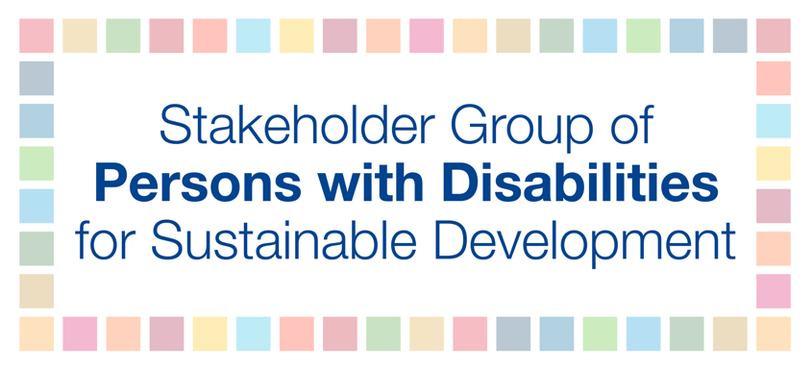

Language recommendations to the Ministerial Declaration of the HLPF 2020

The moment the pandemic hit, the principles of “leave no one behind” and “reach the furthest behind” evaporated into thin air. Persons with disabilities and older persons have been left to die, often not because they contracted the COVID-19 virus, but because of the situation the pandemic created around the world and subsequent effects.

Since the adoption of the UN Convention on the Rights of Persons with Disabilities (CRPD), followed by the adoption of the 2030 Agenda for Sustainable Development and its Sustainable Development Goals (SDGs) we have witnessed a positive development and change in the lives of persons with disabilities. Slowly societies began to move away from the traditional charity and medical model approach to inclusion into a social and human rights approach granting persons with disabilities more rights than ever in history.

The disability movement is in survival mode, more than ever in recent times. What has been achieved since the adoption of the CRPD and the SDGs is at risk. Inclusion has been disrupted by the COVID-19 pandemic and we are at risk of going backward. The pandemic has taken away the curtain, historical inequalities are deepening and discrimination is on the rise, but we must fight for inclusion more than ever.

As such we wish to request the co-facilitators to consider strengthening the language of the Ministerial Declaration the following way:

5. Recognizing that the poor and the most vulnerable are the most affected by the COVID-19 crisis, we will undertake every effort to leave no one behind and to reach the furthest behind first. We recognize the urgent need to support those who are vulnerable or in vulnerable situations, including women and girls, youth, persons with disabilities, older persons, indigenous peoples, refugees, displaced persons, migrants, and other marginalized groups, protect human rights for all and ensure that no country or person is left behind. (Financing for Development Forum outcome document 2020, para 5).

9. We commit to placing the poor and the most vulnerable people at the center of our policies and actions, ensuring that no one is left behind, with an endeavor to reach the furthest behind first. We intend to see the Goals and targets met for all nations and peoples and for all segments of society, particularly all children, youth, persons with disabilities, people living with HIV/AIDS, older persons, indigenous peoples, refugees and internally displaced persons and migrants. (2030 Agenda, para 23)

20. We pledge to increase our level of ambition to mobilize and effectively use all available means of implantation, in line with the Addis Ababa Action Agenda, and to fully implement the agreed conclusions and recommendations of the 2020 ECOSOC Forum on Financing for Development follow-up. We are deeply concerned about the impact of high debt levels on countries’ ability to withstand the impact of the COVID- 19 shock, and to invest in the implementation of the 2030 Agenda. We commit to addressing the needs of the developing countries, especially those highly indebted and most vulnerable, and invite the international community and relevant stakeholders to urgently and properly address those needs. We are determined to improve access to finance and to working capital liquidity for micro, small and medium-sized enterprises, as well as promote financial inclusion for the poor, women, young entrepreneurs and persons with disabilities, who are most vulnerable to the adverse effects of COVID-19. (Financing for Development Forum outcome document 2020, para 16)

22. We commit to strengthening our national statistical capacities to address the gaps in data on the 2030 Agenda in order to allow countries to provide high quality, timely, reliable, disaggregated data and statistics and to fully integrate the Goals in our monitoring and reporting systems. We encourage international cooperation supporting statistical capacity-building in developing countries, in particular the most vulnerable countries, which face the greatest challenges in collecting, analyzing and using reliable data and statistics, taking urgent action to disaggregate data by income, sex, age, race, ethnicity, migratory status, disability and geographic location, or other characteristics. (Global Indicator Framework).

24. Finally, we will promote public engagement and innovative partnerships through a whole of society approach, regional and local mobilization and actions, involvement of communities, people, civil society and the private sector. We also acknowledge the role of the volunteers in the implementation of the Goals. We will invest more in human capital, to empower children, adolescents and youth, as well as persons with disabilities and older persons as critical agents of change, and support their meaningful participation in realizing the vision of the 2030 Agenda.

Link to 2020 FfD Forum outcome document:
https://www.un.org/esa/ffd/ffdforum/wp-content/uploads/sites/3/2020/04/20-FfDF-Outcome-Document.pdf

